**How the Web Works**

In this lab, you’ll be working with a partner to explore a little more about the internet, the web, requests, responses and more. You’ll be reading and writing about concepts as well as practicing some of the commands that we saw during the lecture earlier.

**Topic 1: The Internet and the World Wide Web**

1. What is the internet? A worldwide network of networks that uses the Internet protocol suite.(hint: [here](https://developer.mozilla.org/en-US/docs/Glossary/Internet))
2. What is the world wide web? Commonly referred to as WWW. An interconnected system of public webpages accessible through the [Internet](https://developer.mozilla.org/en-US/docs/Glossary/Internet) (hint: [here](https://developer.mozilla.org/en-US/docs/Glossary/World_Wide_Web))
3. Partner One: read [this page](https://developer.mozilla.org/en-US/docs/Learn/Common_questions/How_does_the_Internet_work) on how the internet works, Partner Two: read [this page](https://developer.mozilla.org/en-US/docs/Learn/Getting_started_with_the_web/How_the_Web_works) on how the world wide web works. When you’re done reading, come back together and answer the following questions
   1. What are networks?

A connection between two or more computers using Ethernet or wifi/bluetooth

* 1. What are servers?

Computers that provide functionality for other programs or devices called ‘clients’

* 1. What are routers?

Signaler that manages traffic between networks by allowing devices to use the same internet connection

* 1. What are packets?

Small amounts of data sent over a network

1. Come up with a metaphor for the internet and the web, you can do a single one if you think of one that puts them together or two separate ones (feel free to use one you’ve heard today or read about if you can’t think of a new one, but spend at least 10 minutes trying to think of something different before you resort to that) The World Wide Web is a like a city, with stores, colleges, arcades, coffee shops, billboards, movie theaters. The Internet would be the highways, sidewalks, power lines, and general infrastructure of the city.
2. Draw out a diagram of the infrastructure of the internet and how a request and response travel using your metaphor (like the map and letters we saw during the lecture). Insert the drawing into this document (can be a picture of a physical drawing, a Google Drawing, a Figma drawing, etc)

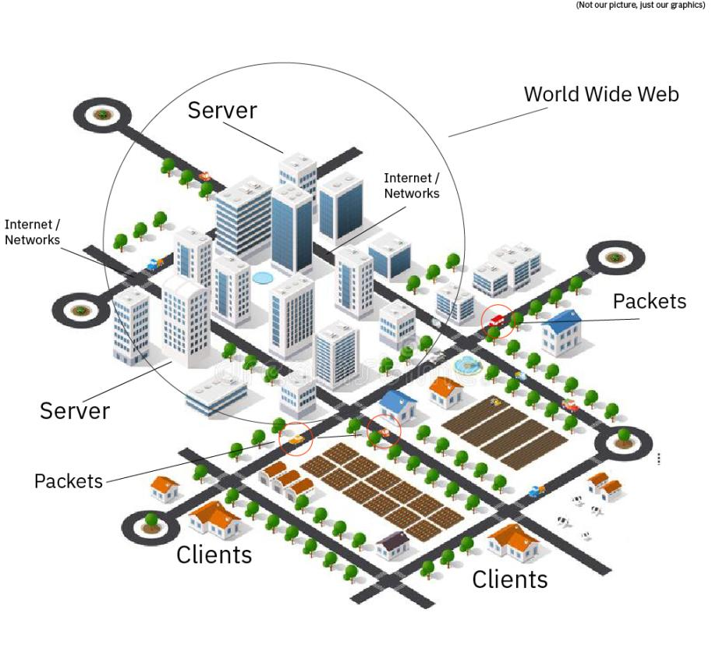

**Topic 2: IP Addresses and Domains**

1. What is the difference between an IP address and a domain name?

An IP address is the numerical address of a website. Domain name is a nickname for that IP address so you don’t have to remember the actual IP address.

1. What’s devmountain.com’s IP address?

172.67.9.59 (Hint: use ‘ping’ in the terminal)

1. Try to access devmountain.com by its IP address. It shouldn’t work because we have our sites protected by a service called CloudFlare. Why might it be important to not let users access your site directly at the IP address?

Security purposes and to protect sensitive data

1. How do our browsers know the IP address of a website when we type in its domain name? (If you need a refresher, go read [this comic](https://howdns.works/) linked in the handout from this lecture)

The domain name functions as a link to the IP address.

**Topic 3: How a web page loads into a browser**

The steps of how a web page is requested and sent are in the table below. However, **they are out of order**. Unscramble them and explain your thinking/reasoning in the second two columns of the table.

|  |  |  |
| --- | --- | --- |
| **Steps Scrambled** | **Steps in Correct Order** | **Why did you put this step in this position?** |
| *Example: Here is an example step* | *Here is an example step* | *- I put this step first because ____*  *- I put this step before/after ____ because ____* |
| Request reaches app server | Initial request | It’s the first step |
| HTML processing finishes | Request reaches app server | After the request, it needs to get sent to the server |
| App code finishes execution | Browser receives HTML, begins processing | This step comes before the page rendering as it needs to first process |
| Initial request (link clicked, URL visited) | Page rendered in browser | After the initial processing, the page needs to complete rendering |
| Page rendered in browser | HTML processing finishes | After all the rendering, HTML finishes the processing |
| Browser receives HTML, begins processing | App code finishes execution | After App code finishes, nothing else can happen after |

**Topic 4: Requests and Responses**

*Setup*

* Download the folder for this exercise from Frodo.
* Make sure you unzip it.
* Open it in VS Code
* Run `npm i` in the terminal (make sure you’re in the web-works folder you just downloaded).
  + You’ll know it was successful if you see a node_modules folder in the web-works folder.
* Run `node server.js` in the terminal (also in the web-works folder) and you should see a log to the terminal saying ‘serving up port 4500’
* You’ll be using this file to figure out what will happen when you make requests to this server, so read it over to see what’s going on. We’ll be getting into the two GET functions and the POST function.

*Part A: GET /*

* You’ll start by looking at the function that runs when we make a get request to /, which looks like this: <http://localhost:4500> or <http://localhost:4500/>
* You’ll use the curl command to make a request and read the response in your terminal

1. Predict what you’ll see as the body of the response: a lot of info regarding font styles and sizes
2. Predict what the content-type of the response will be: just words

* Open a terminal window and run `curl -i http:localhost:4500`

1. Were you correct about the body? If yes, how/why did you make your prediction? If not, what was it and why? No, as there was nothing in the body of the site.
2. Were you correct about the content-type of the response? If yes, how/why did you make your prediction? If not, what was it and why? Yes as we had an interactive lecture earlier and that’s what happened.

*Part B: GET /entries*

* Now look at the next function, the one that runs on get requests to /entries.
* You’ll use the curl command again. This time, you’ll need to figure out how to modify it to get the response that you need.

1. Predict what you’ll see as the body of the response:
2. Predict what the content-type of the response will be:

* In your terminal, run a curl command to get request this server for /entries

1. Were you correct about the body? If yes, how/why did you make your prediction? If not, what was it and why?
2. Were you correct about the content-type of the response? If yes, how/why did you make your prediction? If not, what was it and why?

*Part C: POST /entry*

* Last, read over the function that runs a post request.

1. At a base level, what is this function doing? (There are four parts to this)
2. To get this function to work, we need to send a body object with our request. Looking at the function in server.js, what properties do you know you’ll need to include on that body object? And what data types will they be (hint: look at the objects in the entries array)?
3. Plan the object that you’ll send with your request. Remember that it needs to be written as a JSON object inside strings. JSON objects properties/keys and values need to be in **double quotes** and separated by commas.
4. What URL will you be making this request to?
5. Predict what you’ll see as the body of the response:
6. Predict what the content-type of the response will be:

* In your terminal, enter the curl command to make this request. It should look something like the example below, with the information you decided on in steps 3 and 4 instead of the ALL CAPS WORDS.
  + curl -i -X POST -H ‘Content-type: application/json’ -d JSONOBJECT URL

1. Were you correct about the body? If yes, how/why did you make your prediction? If not, what was it and why?
2. Were you correct about the content-type of the response? If yes, how/why did you make your prediction? If not, what was it and why?

**Submission**

1. Save this document as a PDF
2. Go to Github and create a new repository. (Click the little + in the upper right hand corner.)
3. Name your repository “web-works” (or something like that).
4. Click “uploading an existing file” under the “Quick setup heading”.
5. Choose your web works PDF document to upload.
6. Add “commit message” under the heading “Commit changes”. A good commit message would be something like “Adding web works problems.”
7. Click commit changes.

**Further Study: More curl**

Visit [this link](https://jvns.ca/blog/2019/08/27/curl-exercises/) and do the exercises using the website provided. Keep track of the commands you used in this document. (Don’t forget to resubmit to GitHub when you complete this section)