Final Project: Genetic Algorithm and Wisdom of Crowd on 1D-Bin packing problem
Lomus Hona
Computer Science and Engineering
University of Louisville, USA
l0hona01@louisville.edu
1. What did you do in this project and why?
For this project I and my team decided that we would like to tackle 1 dimensional bin packing problem utilizing genetic algorithm (GA) and wisdom of crowd (WOC). Our 1d bin packing problem if worded would go like this: given unlimited number of bins with fixed capacity and a set of items with specific weight, find the minimum number of bins needed to pack all items, like for example image below:
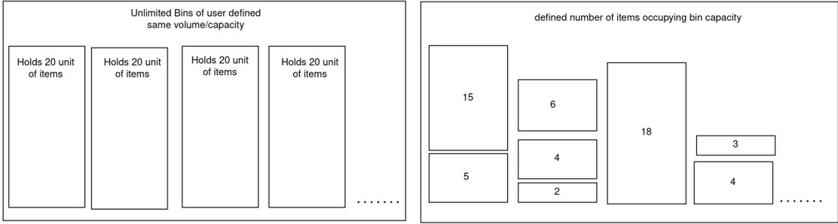
So, the goal was to first perform GA to find its solution as well as find experts/voter to perform and find WOC solution.
Before performing bin packing problem, we need to convert properties/object/attributes of bin packing problem into properties/object/attribute of GA. So, item can be considered gene, bins can be considered chromosome, and set of bins can be considered individual/parent as sown in example below:
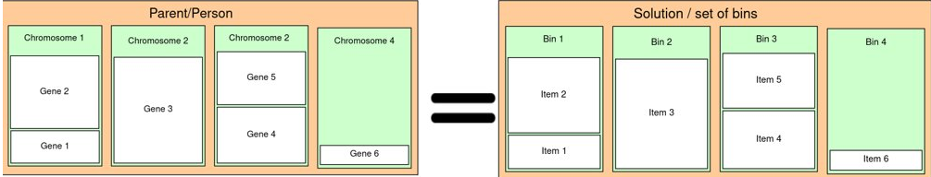
Now, to begin we have to initialize the very first population, which is a number of solutions generated based on the user specified population size, and each solution is appended to population list, example:
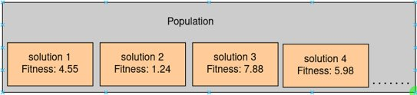
here the solutions are set of bins that combined contains all the items, and to initialize each solutions, the available items are shuffled for each solution and placed into bins utilizing first come first serve method. And fitness or solution fitness is defined by the given function:
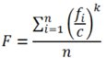
where,
with higher value representing better solution.
After we have the first population, we generate a mating pool by selecting top 25 best fit solution from the population. And from mating pool two parents are randomly selected for breeding, and the process is repeated until population for next generation is equal to population od current generate. The whole process of mating pool and next population generation is repeated for user specified number of generation.

2. Describe Algorithm you are using for the project?
Crossover method:
let bin_capacity = 5, and let us have 5 items occupying capacity of {1, 1, 2, 2, 3, 3}.
let the given two parents be picked for crossover:
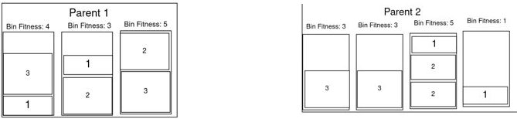

First we insert bins from both parents into one combined list:
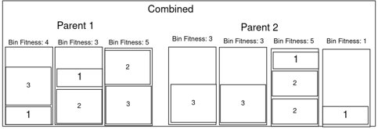
and from the list we pick the bin with the highest fitness and place it into a list child (adding chromosome to a child):
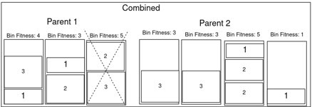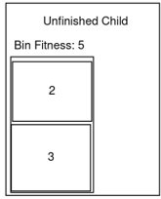
and similarly we pick the next chromosome/bin to go into child:
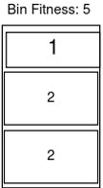
but the child doesn’t get the chromosome because it cant have duplicate gene/item {2, 2, 2} as set of items that child needs to have is {1, 1, 2, 2, 3, 3}. Thus we remove the item from selected bin and add the items into leftover items list.
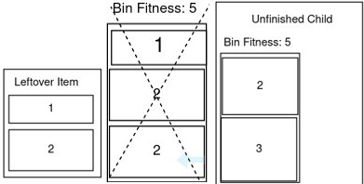

again we select next best fittest bin:
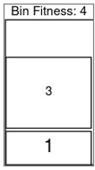

and since the items found in bin is not already in child item we give it to the child producing:
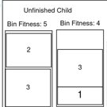
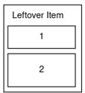

and with that we have leftover chromosomes as:
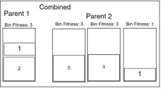
The same process is repeated again and again until there is no bins left inside the combined list of bins. And we are left with all leftover items/gene that didn’t make it via a chromosome/bins due to duplicates. To place these items back in, we first ensure leftover items are the only items that is already not in any of the bins currently in child, sort it in descending order by item weight and place it into bins in first come first serve order, creating new bins if item doesn’t fit into any bins, thus creating a children.
Mutation method
A mutation always occur after the crossover has finished producing a child. And, for mutation method we went with destroy and redistribute method. On this method a random bin/chromosome is destroyed and items inside the destroyed bin is placed on the list of leftover item, the leftover item is then redistributed to the child by first come first serve method.

Wisdom of Crowd
for wisdom of crowd top 5 individual from each generation is selected as an expert voter. And solution to wisdom of crowd Is generated by creating a matrix that counts the number of times a pair of items occur together in the same bin in the set of experts. For example let there be 3 experts:
Expert 1: Expert 2: Expert 3:
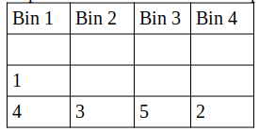
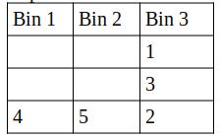
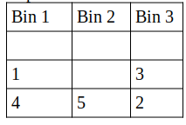

Then it would produce matrix: (if item 1, 4 occurs on same bin, increment row 1, column 4)
 | Item 1 | Item 2 | Item 3 | Item 4 | Item 5
Item 1 | 0 | 0 | 0 | 2 | 0
Item 2 | 0 | 0 | 0 | 0 | 0
Item 3 | 0 | 2 | 0 | 0 | 0
Item 4 | 0 | 0 | 0 | 0 | 0
Item 5 | 0 | 0 | 0 | 0 | 0

Utilizing this, list of pair of items are generated and sorted in descending order to number of pairs found. Using this, pair of item is placed into the bin in first come first serve and first fit manner given the pair doesn’t contain any duplicate item, and in same manner leftover items without pair are placed into the bins.

Results:
Total of 7 runs were, but only showing two in report, done each with varying parameters: (Ignore all the averages, we couldn’t get it working)
run 0: generation generated = 30, population_size = 50, mutation_rate = 0.5, item_count = 200, bin_capacity = 30.0
run_time = 19.48 sec
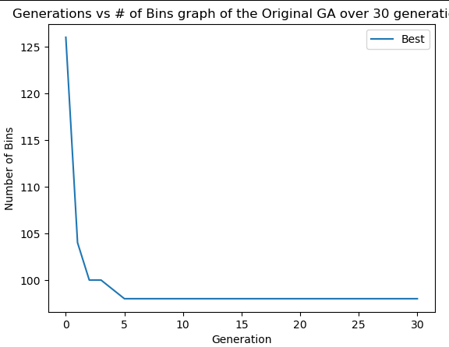
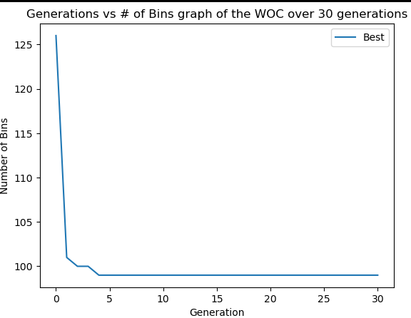

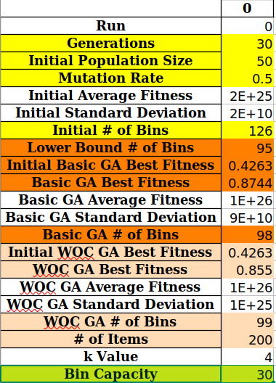
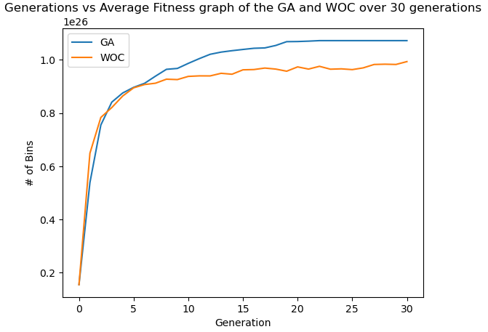
←Higher = better solution

run 1: generation generated = 500, population_size = 100, mutation_rate = 0.5, item_count = 100, bin_capacity = 10.0
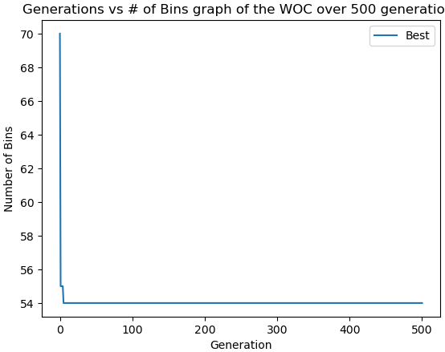
run_time = 211.68 sec
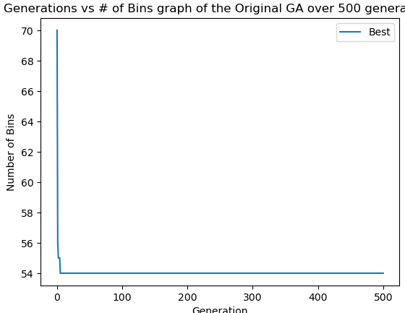

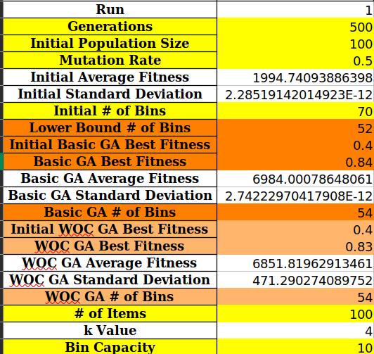
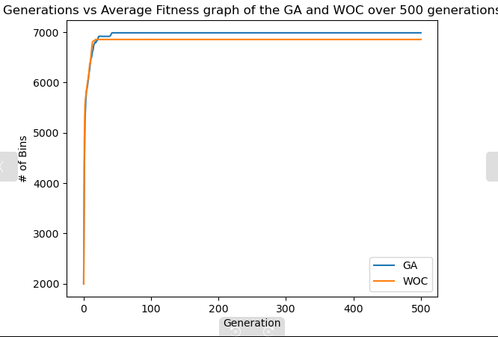
←Higher = better solution
←Higher = better solution

From the result, we can see that for GA, regardless of generation the best result is found pretty much withing 10 generation and everything stays the same. The trend is similar across entire board, and as for WOC it sometimes performs negligibly better or negligibly worse, but the result seem to be same to GA overall.
Overall Conclusion:
The GA algorithm we implemented seem to find the local minimum very quickly and fails to improve after that, it doesn’t give the best possible solution, but it can to certain point reduce the number of bins to be utilized. As for WOC, it just gives similar answer to GA overall and doesn’t improve, and even if it does its very negligible.

