Project 3: Closest Edge Insertion Heuristic
Lomus Hona
Computer Science and Engineering
University of Louisville, USA
l0hona01@louisville.edu
1. What did you do in this project and why?
For this project, I implemented a greedy search path algorithm that starts out by connecting farthest two nodes to create a edge (starting Edge), so if farthest node is 1 and 2, its visited 1 → 2 → 1 creating a always closed loop. Then, selecting each of the rest of the nodes on the map that hasn’t been visited ; I calculate the perpendicular distance (shortest distance from node to edge) to the starting edge if the given point belongs in the edges perpendicular range, else the algorithm searches for the node with least cost, each node replacing other node as next node to be visited. Also, after next node to be visited is found, it doesn’t simply connect to the node from last visited node, it connects in between two nodes which next node to be visited is perpendicular to or in between its nearest node and the nearest node its connected to. Same process is repeated until all nodes are connected.
Why I did this project in this manner? Its because starting out with two farthest node allows me to get all other nodes or most of it within its perpendicular range at all times, and this means I can perform closest Edge Insertion for most nodes, giving me path that doesn’t cross. Only scenario where the path crosses is when the shortest node is the node that isn’t perpendicular to any edge, which has 50-50 chance that it may create a path that intersects or maybe not as it stands as some intersections can be seen when running random40.tsp.

2. Describe Algorithm you are using for the project?
The Algorithm like the title says is Closest Edge Insertion, if the nodes are perpendicular to edges generated by visited nodes, else insert nearest visited node. And, of course insertion is based on shortest cost found.
Going more into detail, I will show how algorithm works by searching path for 5 nodes below, which is generalized version of the Algorithm in use where solid line represents edge and dotted line represents perpendicular range:
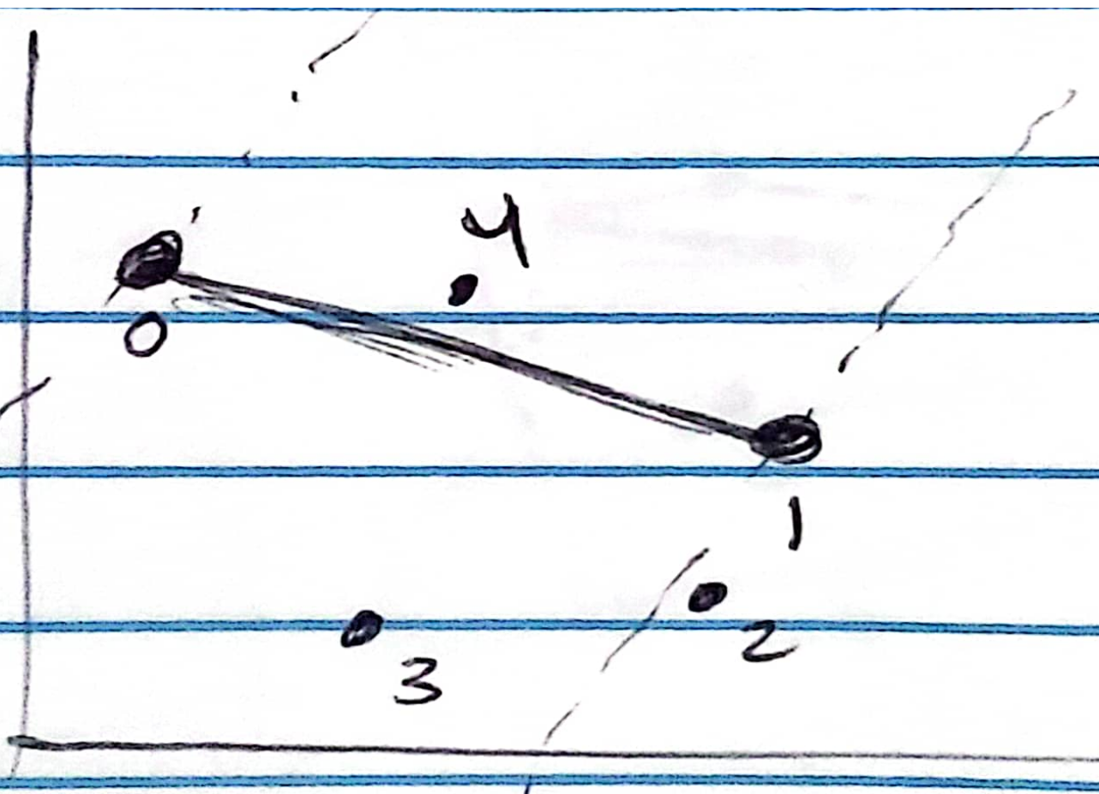

let node 4 to edge 0-1 be the least cost compared to node 2 and node 3, which produces:
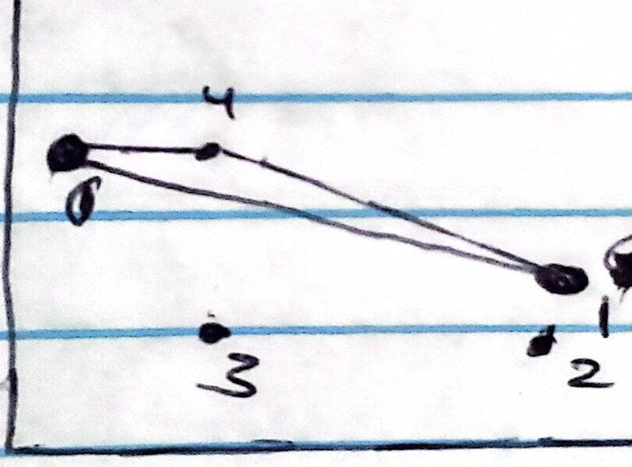

Then, the new perpendicular range is (shaded area):
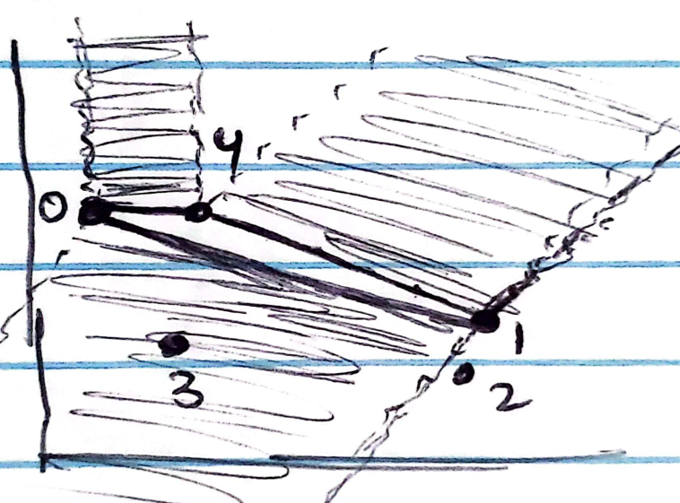

now, let node 2 to node 1 be least cost compared to node 3 to edge 0 – 2, which produces:
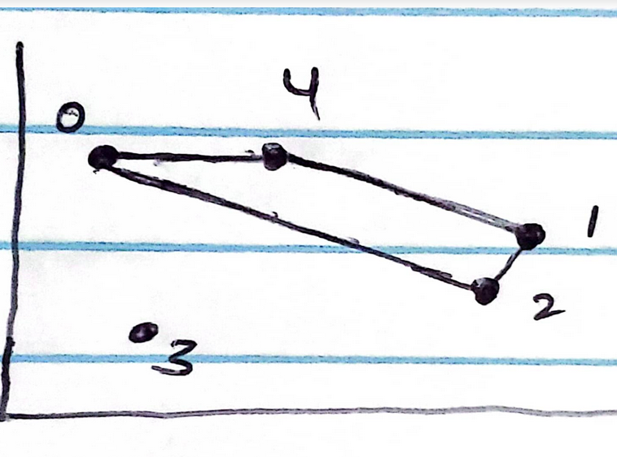

and lastly, node 3 is closest to edge 0 – 2, giving the final result with path:
[0 → 4, 4 → 1, 1 → 2, 2 → 3, 3 → 0].

So, for entire nodes, same process was applied and final result was produced.
As for finding whether a node was perpendicular to a give edge or not, I first calculate the slope of the edge:
y = m * x + b
then, found the slope perpendicular to m
-1 / m
then, using (x, y) coordinate of nodes connecting the edge I got y_intercept b1 and b2.
Now given I have perpendicular slope 1/m, and y-intercept b1 and b2
I can perform y1 = -1/m * x + b1, y2 = 1/m * x + b2; where x is x-coordinate of the node we wanna check if it lies inside the edges perpendicular range.
So y1 and y2 gives us a value, which can then be compared to check weather the node lies in the range or not in order to take perpendicular distance.

3. How well did the algorithm perform?
3.1 Data
For this project, close edge insertion heuristic, the data I used was from the two tsp file I was given. One consisting of 30 nodes and another consisting of 40 nodes.

30 nodes mapped below in 2D plane:
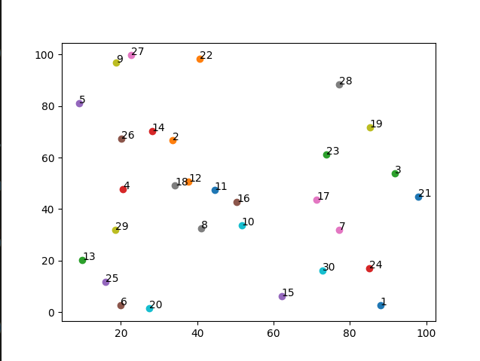

40 nodes map shown below:
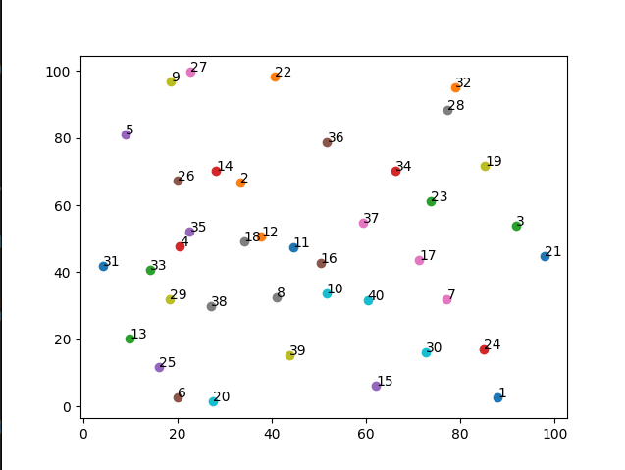

3.2 Numerical results
Applying the algorithm described above presented shown results below:
Random30.tsp:
Cost: 511.64
Path: 5, 26, 14, 2, 12, 18, 4, 29, 13, 25, 6, 20, 11, 16, 8, 10, 17, 7, 30, 15, 1, 24, 21, 3, 19, 28, 23, 22, 27, 9, 5
Time: 6.116 ms
Random40.tsp:
Cost: 626.93
Path: 31, 33, 29, 13, 25, 6, 20, 39, 38, 8, 10, 40, 16, 17, 7, 30, 15, 1, 24, 21, 3, 19, 28, 32, 23, 34, 36, 37, 11, 12, 18, 35, 26, 5, 9, 27, 22, 14, 2, 4, 31
Time: 14.95 ms

Random30.tsp graph:

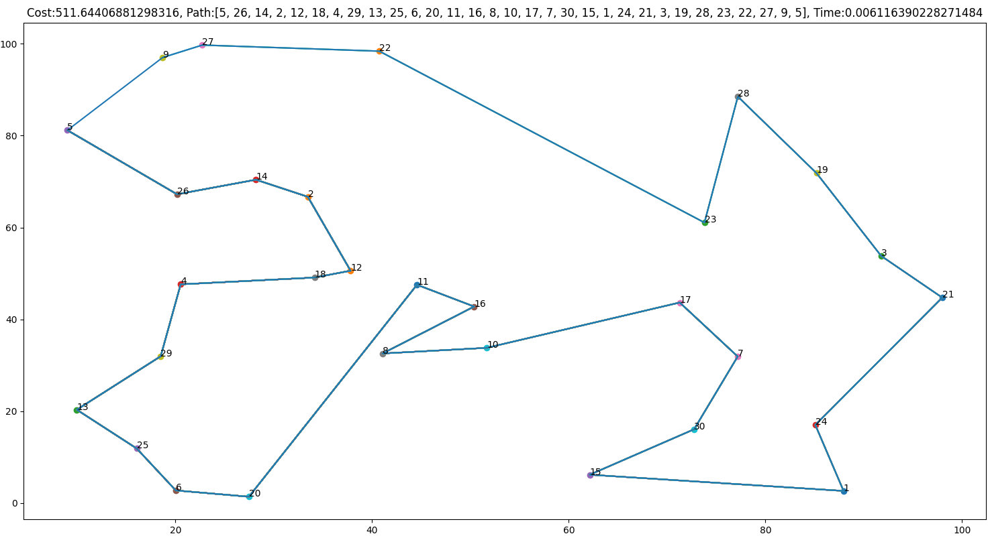
Random40.tsp graph:
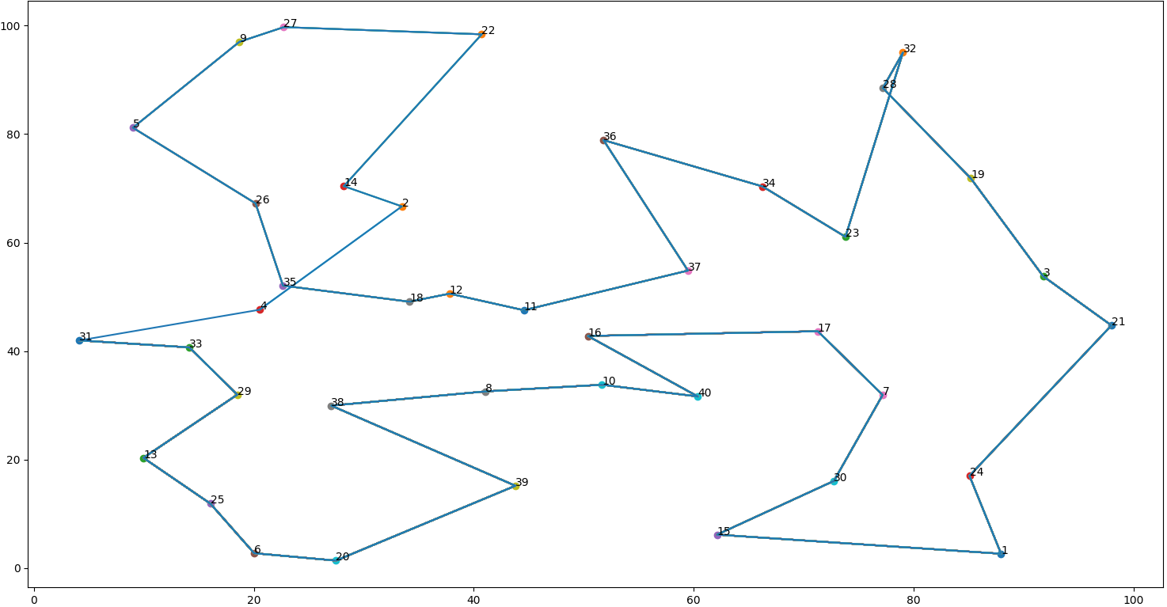
As, mentioned on part 2, you can see some edges crossing, and its due to the given node not being perpendicular, so algorithm instead finds nearest neighbor for the node that has been visited. And creates crossing. Its always offset by one edge, so for example, for node 23 → 32 → 28 → 19, it can be solved by swapping 28 → 19 and 28 → 32 producing 23 → 28 → 32 → 19.

4. Discussion: describing results of your experiments and your implementation. Which algorithm was faster? How long did it take (time and transitions)?
The algorithm found the node that is nearest to all the given edges as expected. Only issue that remains is when a node doesn’t belong or perpendicular to any of the edges, it finds the nearest neighbor that has been visited, which gives 50 – 50 chance of edges intersecting. But, it can be solved by just swapping two nodes in the list as mention above. I didn’t do it because, I couldn’t figure out how to set up an indicator to when the edges intersect. Compared to previous algorithms, BFS, DFS, and Brute Force permutation. This nearest edge algorithm gives a least cost path. But time wise its a a lot slower than BFS and DFS which were giving results in microseconds and this gives time in milliseconds, which maybe its due to BFS and DFS being tested on fewer nodes. But it is definitely much much faster than brute force which crashed on just 12 nodes and was taking minutes.

