TSP Search with BFS and DFS
Lomus Hona
[Computer Science and Engineering]
Speed School of Engineering
University of Louisville, USA
l0hona01@louisville.edu
1. What did you do in this project and why?
For this project I Implemented a basic breadth first search (BFS) and depth first search (DFS) without any optimization, for which I used the concept shown on lecture plus and a YouTube link given on references, to find the path to the target node given on the tsp file.
In order to run a BFS and DFS algorithms, I first created a class named node having node Id, x_coordinate, y_coordinate, and list of adjacent node Id, to which I loaded the Id, x_coordinate, and y_coordinate from the tsp file while hard coding the list of adjacent nodes for each node as given in the document. After having the data ready to be used I ran BFS and DFS algorithms which took starting node, target node, and all nodes in the map as array of node object from which I got the result as the path the algorithm took. With the given result I was able to calculate distance, and in order to measure time I calculated start-time and end-time, then did subtracted start-time from end-time to get elapsed-time as a result. I ran and calculated the time 1000 time using loop and calculate its average to get the average time it took for algorithm to find the target node from the starting node.

2. Describe algorithm you are using for this project?
Breadth First Search (BFS): I used a very basic breadth first search algorithm without any optimization which isn’t effected by weight or distance, or its uninformed algorithm. So, basically what the algorithm does is, beginning from the starting-node it adds starting node to a visited-node and queue. Using the queue it picks the very first node, which currently is starting-node and starts visiting all of its adjacent node and appends the value to the queue and visited-node if the node hasn’t previously been visited. After visiting all the adjacent node of the starting node it pops the starting node from the queue, and uses the new node on the queue to visit its adjacent node if it hasn’t been visited by previous nodes before, adding it to list of visited nodes. And it repeats doing it over and over again until it finds the target node. After finding target node, it empties the stack which makes the loop stop. At this point we get all the list of visited-node from start to target-node. Now the algorithm needs to start backtracking. And to do the backtracking, the algorithm contains another list that tracks the node that visited-node was visited-from. And using the visited-from list it is able to backtrack and output the path backward which after sorting from back to front gives the output of the path from starting-node to finishing-node in correct order, which then later is used to calculate the distance/cost of the path taken.

Depth First Search (DFS): Like the BFS, DFS is also an uninformed algorithm, it doesn’t take weight of the path into consideration. The algorithm for DFS unlike BFS visits only one of the adjacent node if its not been visited and continues to visit adjacent node’s adjacent node until the node has no more adjacent node that is left to visit, in which case the node current pointer is on backtracks to previous node using which was stored in stack when its adjacent node got visited and looks for other nodes that it maybe able to visit, if not pops the current node from stack and backtrack again and it goes on until target node is found or there is simply no more node that can be visited. With this process, once the target-node is found, algorithm starts backtracking to get the entire paths and transitions into list which then is sorted from back to front and distance/cost is calculated just like for BFS.

3. How well did the algorithm performance?
3.1 Data
For Both DFS and BFS, the data I used was from the tsp file that was given, which had 11 nodes with each having different x-coordinates and y-coordinates. Below image is what data looks like mapped to 2D graph:

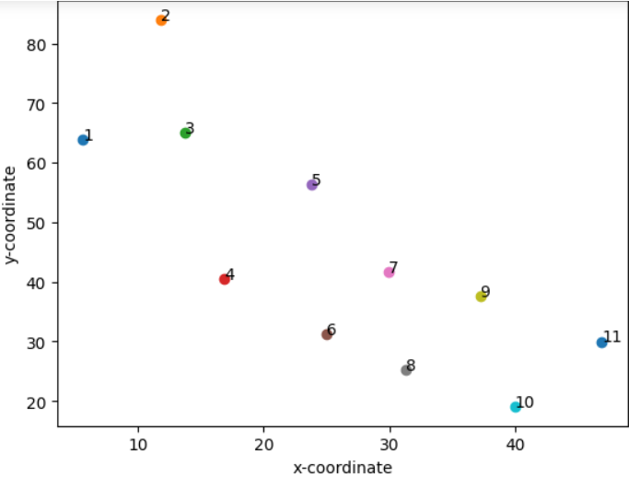

3.2 Numerical results
The goal of the project was to apply from starting node, node-1 to node-11 using both DFS and BFS.
And below are the results:
Breadth First Search:
3 program execution for average time:

BFS Average Time: 1.9037246704101e-05 = 19.037 μs

BFS Average Time: 1.3713836669921e-05 = 13.714 μs

BFS Average Time: 1.3288497924804e-05 = 13.289 μs

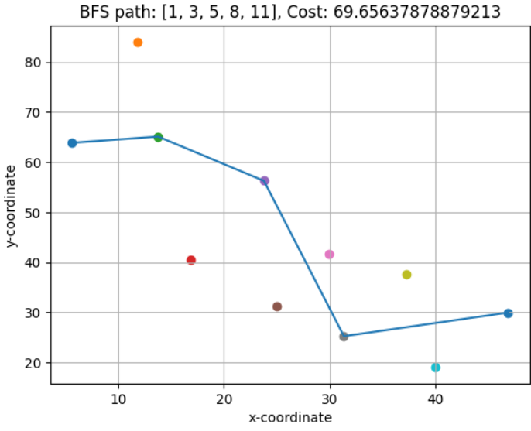
Depth First Search:

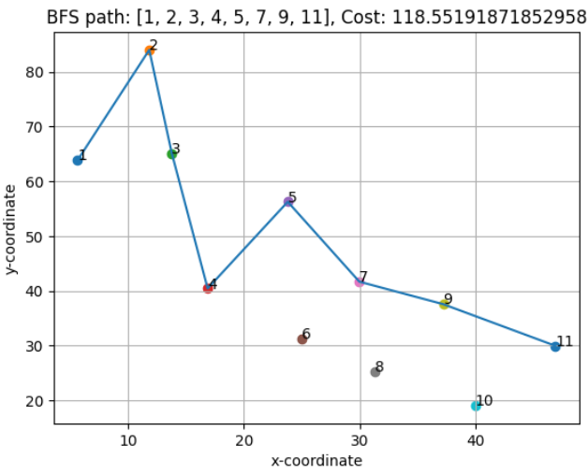
3 program execution for average time:

DFS Average Time: 1.39689445e-05 = 13.969 μs

DFS Average Time: 1.95300579e-05 = 19.530 μs

DFS Average Time: 2.05645561e-05 = 20.565 μs

4. Discussion: describing results of your experiments and your implementation. Which algorithm was faster in finding the target city? How long did it take (time and transitions)?
For most part both BFS and DFS seem to have similar execution time both near or under 20 micro seconds. I would say BFS is faster in this case because it give lower than 20 microsecond more consistently while DFS is seems mostly near 20 microsecond mark. But overall the performance really depends on the way data is organized and the transitions, and adding bias or greedy approach to both algorithms which is just would just optimize the algorithm. Though both BFS and DFS are kind of similar in performance, they do DFS with its stack doesn’t take as much space as BFS with queue data structure. As for transitions, DFS visited more nodes than BFS and also costed more in distance. So, overall for the given data, tsp, file BFS is better algorithm because it produced faster results on more occasion and most importantly gave cost less which is the main goal.

5. References
- https://www.youtube.com/watch?v=pcKY4hjDrxk&t=895s
- https://www.youtube.com/watch?v=vf-cxgUXcMk

