Team 2936 Gatorzillas Spec Sheet

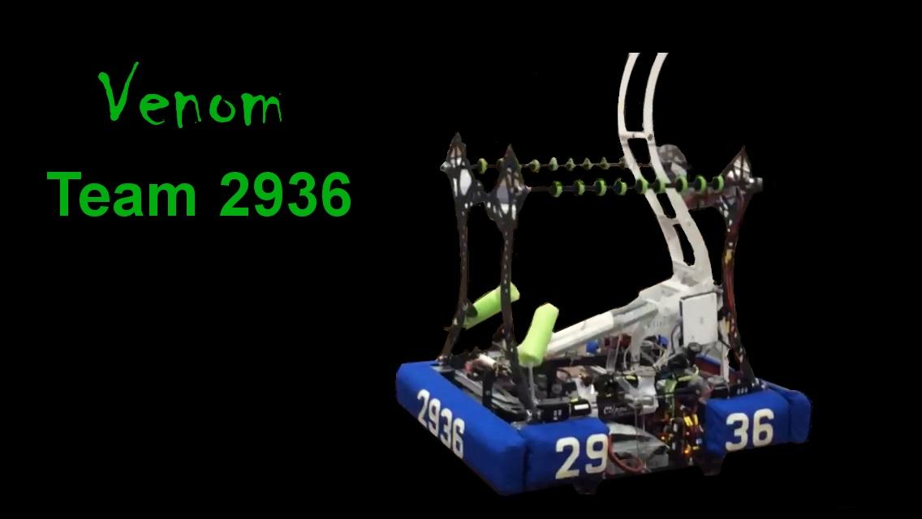

|  |
| --- |
| Autonomous |
| * Shoot 2 balls into High Goal * Move forward for 5 points |
| Teleop |
| * Score in High Goal or Low Goal * Toss over Truss for points * Catch from human player * Catch from another robot * Pick up balls from floor * Pass ball for assists |
| Drive Capabilities |
| * Crab + Tank Drive Steering * 4 CIM Drivetrain |