

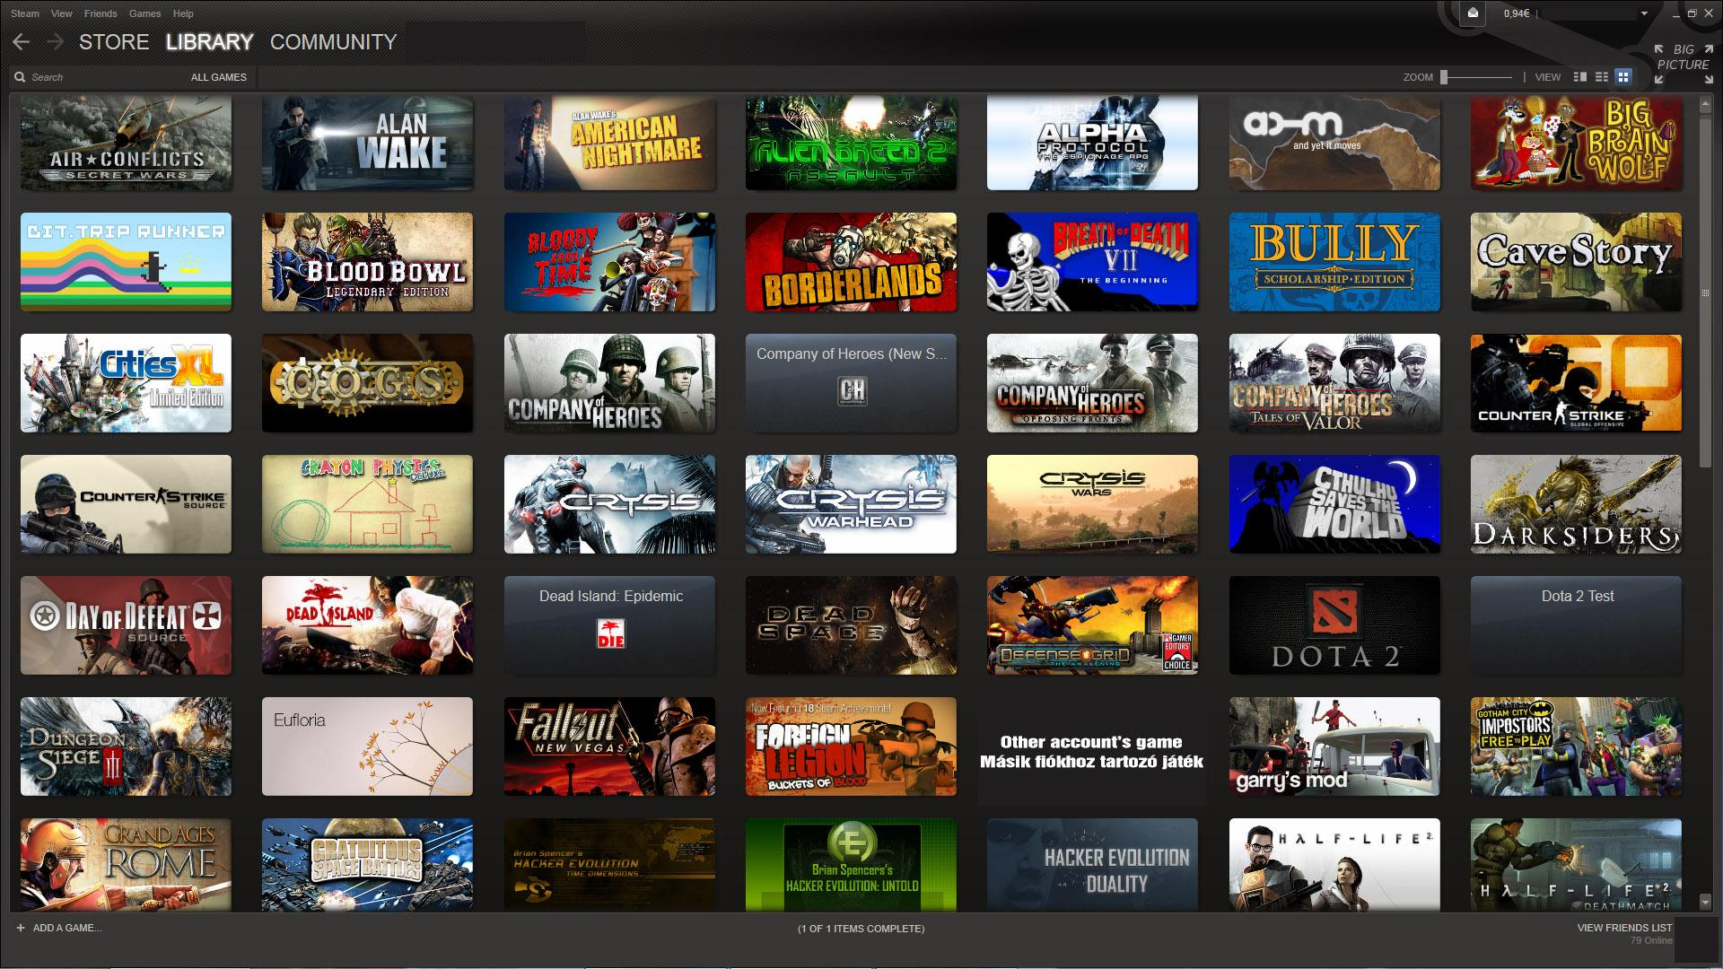

By

Lewis Petty, Niloy Goswami, Joseph Braunstein

CPI 310: Final Project

# **About The Project**

Steam provides a platform for over 125 million gamers to interact directly with each other, resulting in more than 400 million pieces of user-generated content. Millions of which are constructive, intelligent, and well-spoken discussions, millions more are humorous and elicit a chuckle from the most straight-faced of readers. While numerous more are downright unintelligible, unmentionable, or worse. There are so many, in fact, that it could justify a whole database to be made for it.

In this project, we will construct an HTML/CSS website that will allow users to register for accounts and post on our website, where our website will store this information in a database. Users can also view, comment, and rate these posts on the website as well. A user can post on our website by clicking the post button and pasting a screenshot, or Steam URL.

From the home page, our website will grab entries in the database and populate the home page with them. When a user posts to the website, it will add their post’s attributes (Title, Content, Date Published, etc.) to a database. This system will be cautious, however, for posts ranked low enough will be hidden to guests and users by default. Users will be able to enable showing posts that have a low rating in their settings.

When a user registers to the website, they will need to confirm that they are not a robot before finishing registration. From there, they can start interacting with the website. A user can interact by posting to the website, posting comments, rating a post, and rating a comment. More user interaction elements will be added later such as comment ratings, reputation, comment sorting, comment threads, notifications/thread subscribing, Inbox/Outbox, and more.

# **Specifications**

Our project was motivated by the posts on Steam Reviews and Steam Discussions that baffle users on either how funny or how stupid they can be. This project’s purpose is to expose these posts for the internet’s enjoyment in terms of comedy.

Deliverables:

1. Common Page Elements
   1. Navigation Bar
      1. Site Navigation (Home, Categories, Account, etc.)
   2. Footer
      1. Contains copyright information
2. Home Page
   1. Populates posts with no regard to category
   2. Posts populated will contain titles thumbnails, and ratings. Will link to post page.
3. Post Page
   1. Displays Post Title, Author, Date, Rating, Content, Description, and Comments.
4. Categories Page
   1. Will display posts similar to the home page, but filtered by category
5. User Profile Page
   1. Will display user statistics, any non-private contact information provided.
6. Account Page
   1. Unregistered
      1. Login and Register forms will appear on the page
   2. Registered
      1. Will show account details and preferences for the user to edit

Use Case Analysis:

The user starts on the homepage of the website which features the featured posts, search bar, and sub menus to make it easy for the user to navigate through the website. Users can post screenshots of their Steam client, with the ability to add a short description, to the website in a specific category for other users to view, rate, and comment on.

Database Design:

As stated above the database will use PHP with SQLite. The database will add entries depending on the data being written. One form of data that can be written to the database is a post, where the attributes of the post are all recorded into this entity. These attributes include the category, comments, details, etc. The database will also hold account information for users to register and login to their accounts, as well as keeping other important information such as their post statistics, reputation, contact information, user preferences, and more.

# **Project Plan**

Milestones: Creating a main page, Creating a database for the website in PHP with SQLite, Post pages that are automatically generated when added to database, Basic User Accounts System

Milestones Deadline: Before Thanksgiving Break

Features that may be added if time permits: Rating System, Videos, Reputation System, Inbox, Main Page Sort By Dropdown, Categories, Steam Integration, YouTube Integration, UI Customization

# **Team Page**

Lewis Petty - Informatics major with a love for music, gaming, movies, anime, and puzzles. Also has a dream of getting a career within cyber security.

Niloy Goswami - Informatics major that goes to FA (Final Fantasy XIV Anonymous) every weekend.

Joseph Braunstein - Game developer and gaming addict with no life.