CS6650 HW7 — Part II Report
Sync vs. Async Order Processing under Flash Sale Load
Infrastructure Setup
The system is built on AWS us-west-2 using Terraform (IaC). A single Go service runs on ECS Fargate behind an ALB, handling both HTTP order receiving and background SQS consumption. SNS fans out to SQS, which the ECS service polls via long-polling worker goroutines.
Component | Details
ALB | hw7-alb-619950210.us-west-2.elb.amazonaws.com (port 80)
ECS Cluster | hw7-cluster, Fargate, 256 CPU / 512 MB, us-west-2
ECR Image | 591389222803.dkr.ecr.us-west-2.amazonaws.com/hw7-order-service:latest
SNS Topic | arn:aws:sns:us-west-2:591389222803:hw7-order-processing-events
SQS Queue | hw7-order-processing-queue (Standard, 4-day retention, 20s long poll)
Terraform | 27 resources created (VPC, subnets, IGW, NAT, ALB, ECS, SNS, SQS, IAM)

Terraform provisioned all 27 resources in a single apply:
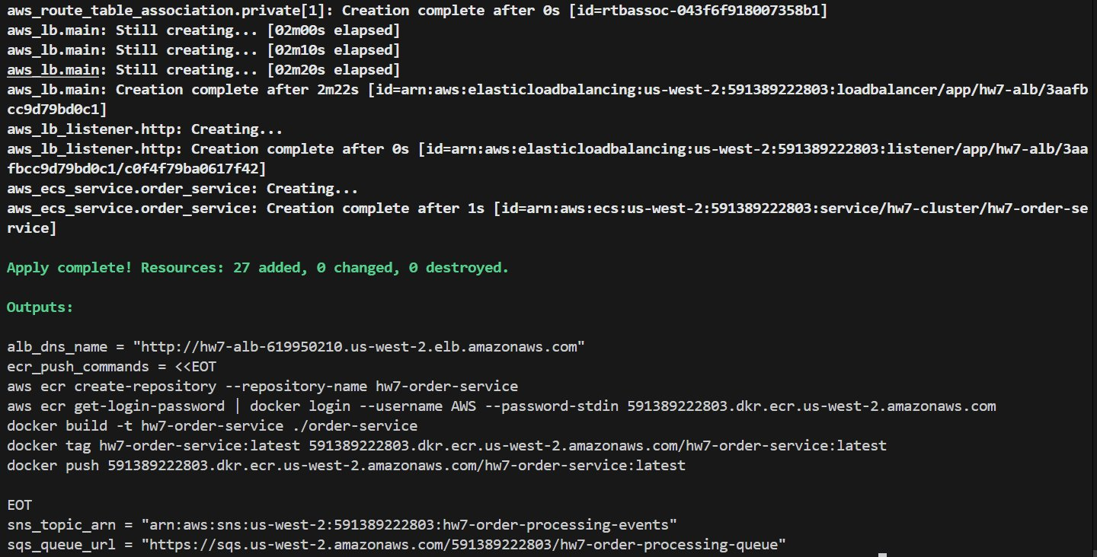
Figure S1 — terraform apply: 27 resources created, ALB DNS, SNS ARN and SQS URL output.
The Go service was built as a multi-stage Docker image and pushed to ECR:
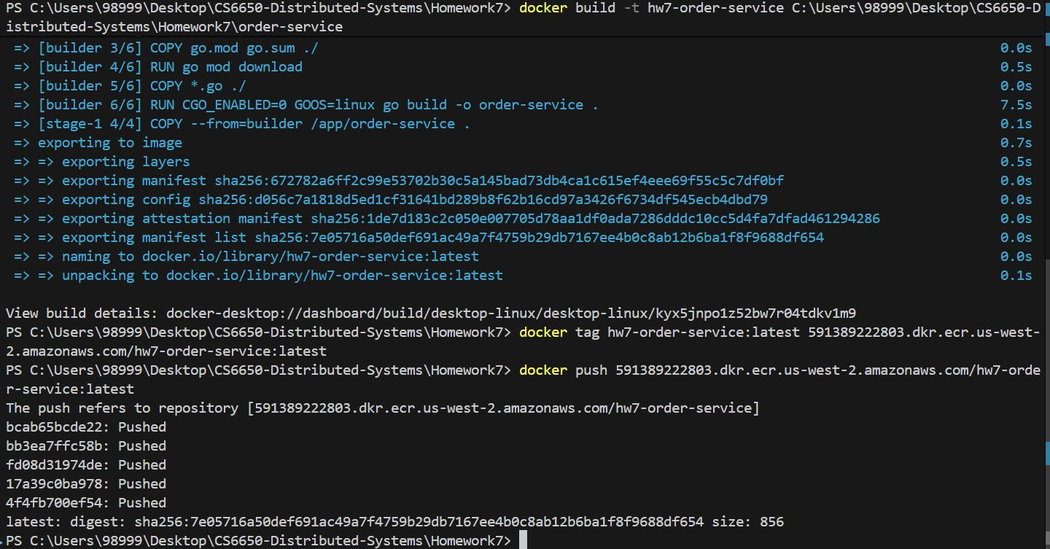
Figure S2 — docker build + push to ECR (591389222803.dkr.ecr.us-west-2.amazonaws.com/hw7-order-service:latest).
After ECS deployed the container, the ALB health check and sync endpoint were verified:
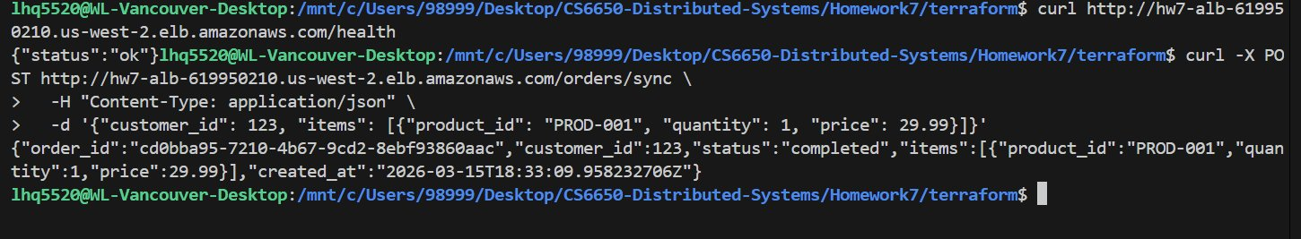
Figure S3 — GET /health returns {"status":"ok"}; POST /orders/sync returns completed order after 3 seconds.
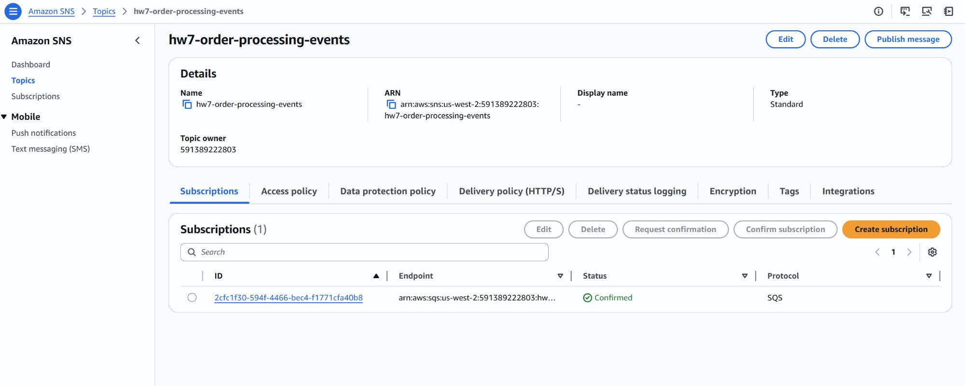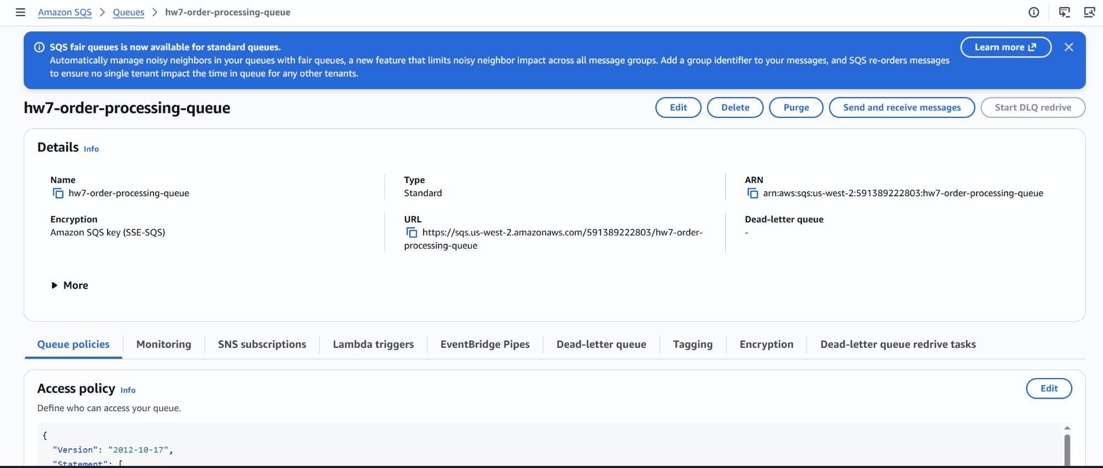
Figure S4 — SNS Topic with confirmed SQS subscription (left); SQS Queue details showing ARN and endpoint URL (right).

Phase 1 — Sync Endpoint Baseline
The /orders/sync endpoint blocks for 3 seconds per request (simulating payment verification). Two load tests were run: normal load (5 users) and flash sale (20 users, 60s).
Test | Requests | Failures | Avg (ms) | p95 (ms) | RPS
Normal Load (5 users, 30s) | 40 | 0 | 3,017 | 3,000 | 1.35
Flash Sale (20 users, 60s) | 344 | 0 | 3,016 | 3,000 | 5.74

Key observation: 20 concurrent users did not cause failures — Go's HTTP server queued the requests. However, throughput was hard-capped at 5.74 req/s because every goroutine is held for 3 seconds. The server did not crash; it simply cannot accept more orders.

Phase 2 — Throughput Math Analysis
With 20 concurrent users each holding a connection for 3 seconds, the theoretical maximum throughput is:
Max Sync Throughput = 20 users ÷ 3s = 6.67 req/s
Measured: 5.74 req/s (86% of theoretical — network overhead accounts for the gap).
If real flash sale demand is 60 req/s, the sync system accepts only 5.74 req/s, losing approximately 54 orders every second. Over a 60-second sale: ~3,240 orders lost.
Metric | Sync (20 users) | Demand (60 req/s) | Gap
Throughput | 5.74 req/s | 60 req/s | −54.26 req/s
Orders lost per second | — | — | ~54 orders/s
Orders lost in 60s sale | — | — | ~3,240 orders

Phase 3 — Async Endpoint Flash Sale
The /orders/async endpoint publishes the order to SNS → SQS and immediately returns HTTP 202 Accepted. The 3-second processing is offloaded to background worker goroutines. Same test: 20 users, 60 seconds.
Endpoint | Requests | Failures | Avg (ms) | p95 (ms) | RPS | vs Sync
/orders/sync | 344 | 0 | 3,016 | 3,000 | 5.74 | 1×
/orders/async | 3,537 | 0 | 25 | 32 | 58.82 | 10.3×

Async accepted 10.3× more requests with 120× faster response time. All 3,537 orders were queued in SNS/SQS instantly — the bottleneck moved from the HTTP layer to the background worker.

Phase 4 — Queue Buildup (1 Worker)
With only 1 background worker goroutine processing at 0.33 orders/s, the 3,537 orders queued during the 60-second flash sale created a massive SQS backlog.
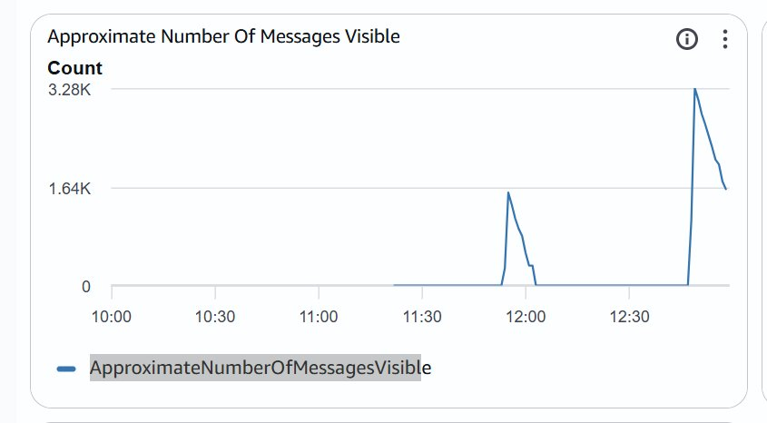
Figure 1 — SQS ApproximateNumberOfMessagesVisible: queue peaked at 3.28K and drained slowly over ~15 minutes with 1 worker.
Queue drain time with 1 worker: ~15 minutes to process 3,280 messages at 0.33 orders/s.

Phase 5 — Worker Scaling (5 / 20 / 100 Goroutines)
NUM_WORKERS was updated via Terraform and the same flash sale test repeated. The goal: find the minimum worker count to keep up with 60 req/s demand.
5 Workers
Processing speed: 5 × 0.33 = 1.67 orders/s. Queue still builds but drains ~5× faster than with 1 worker.
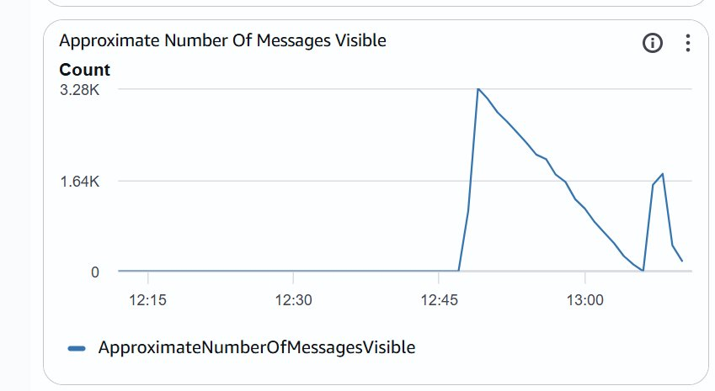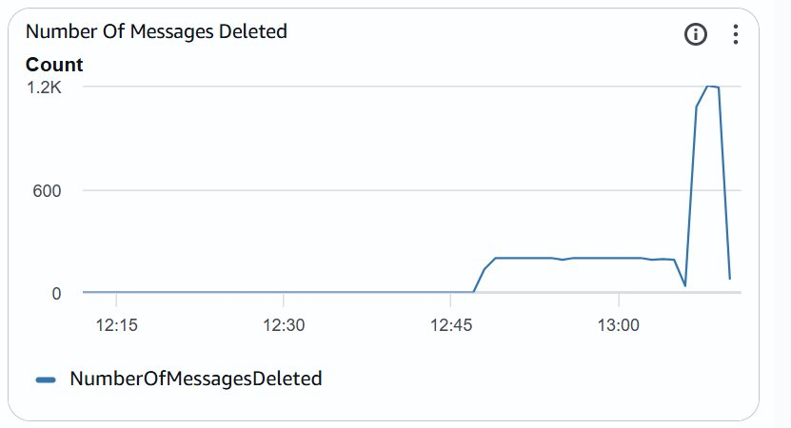
Figure 2 — 5 Workers: queue peaked at 1.64K (left); NumberOfMessagesDeleted jumped to ~1.2K/interval vs ~200/interval with 1 worker (right).
20 Workers
Processing speed: 20 × 0.33 = 6.67 orders/s. Queue accumulated backlog was cleared rapidly. However, p95 latency on the async HTTP endpoint rose from 39ms to 94ms — 100 goroutines competing for CPU/network within the same ECS container caused resource contention with the HTTP server.
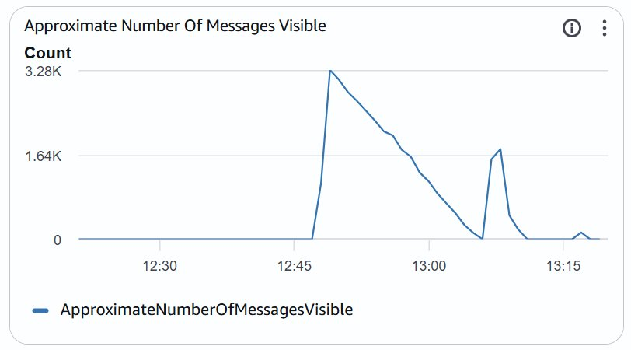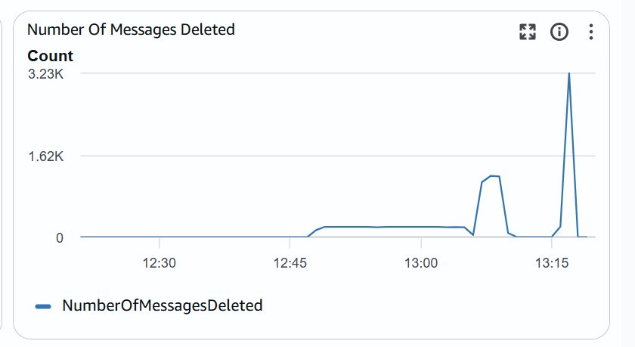
Figure 3 — 20 Workers: queue peaks and clears faster (left); deletion rate peaked at 3.23K/interval clearing prior backlog (right).
100 Workers
Processing speed: 100 × 0.33 = 33 orders/s. Queue depth stayed near zero — incoming orders were consumed almost as fast as they arrived. This is the closest configuration to real-time processing.
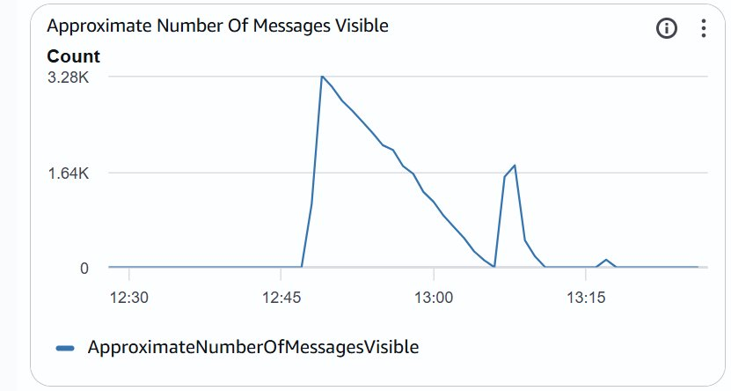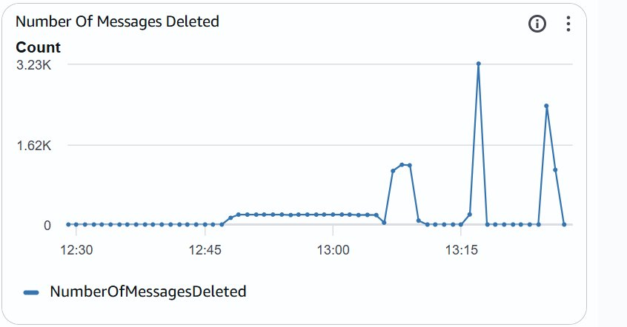
Figure 4 — 100 Workers: queue barely accumulates (left); deletion rate sustained at ~2K/interval, clearing backlog in one burst (right).
Worker Scaling Summary
Workers | Process Speed | Queue Peak | Drain Time | HTTP p95 Latency
1 | 0.33 orders/s | 3,280 | ~15 min | 32ms
5 | 1.67 orders/s | 1,640 | ~5 min | 39ms
20 | 6.67 orders/s | ~200 | < 1 min | 94ms ⚠
100 | 33 orders/s | ≈ 0 | Real-time | —

Conclusion
The sync endpoint is fundamentally throughput-limited: every request holds a goroutine for 3 seconds, capping output at ~6.67 req/s regardless of concurrency. Under a 60 req/s flash sale, it loses ~90% of orders.
The async endpoint decouples acceptance from processing. HTTP response time drops from 3,000ms to 25ms and throughput jumps 10×. All orders are safely persisted in SQS — none are lost.
The trade-off shifts to the worker tier: 1 goroutine creates a 15-minute backlog; 100 goroutines achieve near-real-time consumption. Theoretically 180 workers are needed to fully match 60 req/s, but resource contention with the HTTP server becomes a concern above 20 workers — suggesting a separate worker service (or Lambda, explored in Part III) would be the correct production architecture.

