CS6650 HW7 — Part III Report
Serverless Order Processing: Lambda vs ECS Worker
Overview
Part III replaces the ECS SQS worker with an AWS Lambda function that subscribes directly to the same SNS topic (bypassing SQS). The goal is to observe cold start behavior and compare the cost and operational trade-offs between ECS and Lambda for order processing.
Item | Details
Function Name | hw7-order-processor
Runtime | provided.al2 (Go binary, custom runtime)
Trigger | SNS Topic: hw7-order-processing-events (direct subscription, bypasses SQS)
Timeout | 30 seconds
Memory | 128 MB configured, 20 MB actually used
Processing | Same 3-second simulated payment verification as ECS worker

Cold Start Observations
Six test orders were sent to /orders/async across multiple invocations. CloudWatch logs were examined for INIT_START and Init Duration fields, which are present only on cold start invocations.
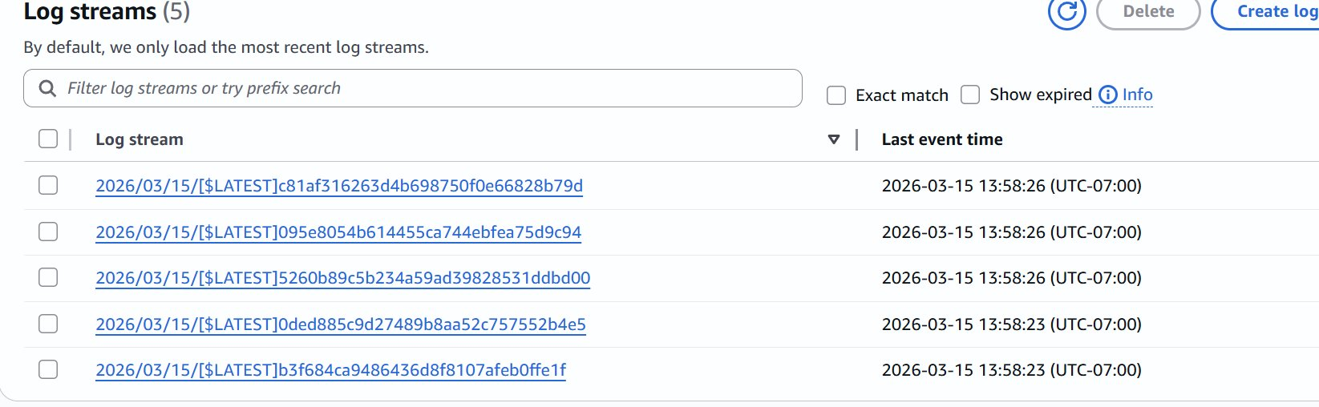
Figure L1 — CloudWatch Log Groups showing 5 separate log streams created simultaneously. Each SNS-triggered Lambda invocation spawned an independent container instance, all cold-starting at the same timestamp (13:58:23).
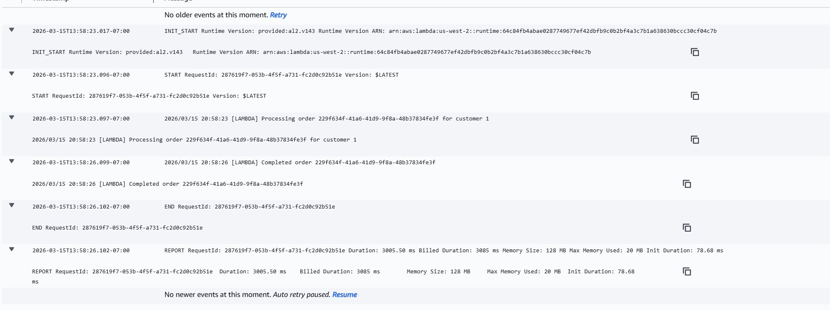
Figure L2 — Cold start invocation (customer 1): INIT_START visible, Init Duration: 78.68 ms. Total billed duration: 3,085 ms.
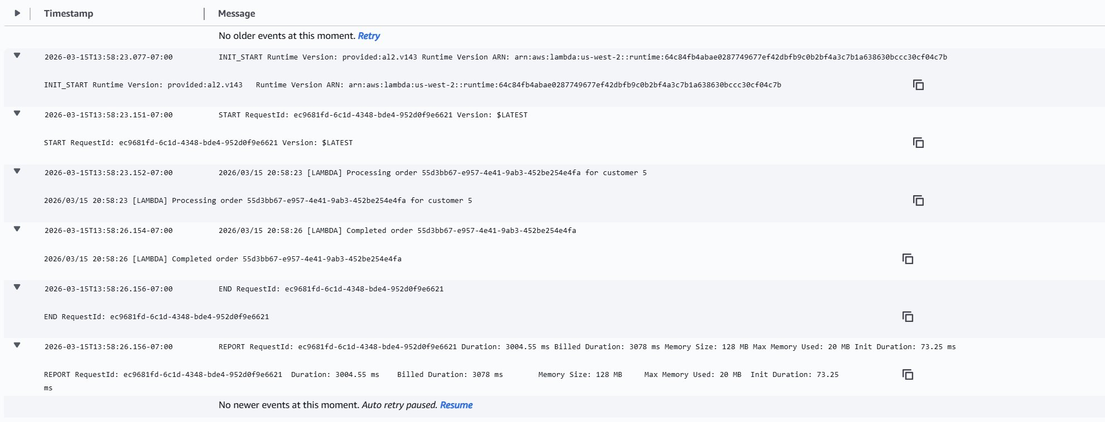
Figure L3 — Cold start invocation (customer 5): Init Duration: 73.25 ms. Processing completed in 3,004 ms.
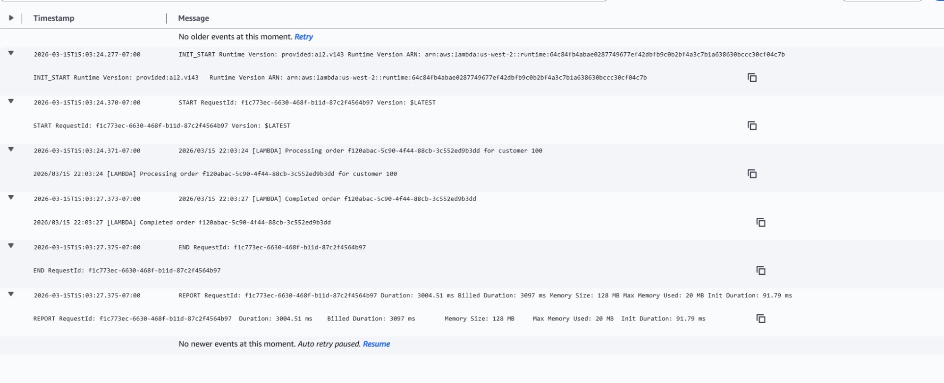
Figure L4 — Subsequent cold start (customer 100): Init Duration: 91.79 ms. Lambda instance had been recycled between test runs (~15 min idle).
Cold Start Measurements
Invocation | Init Duration | Process Duration | Billed Duration | Memory Used
Customer 1 (cold) | 78.68 ms | 3,005.50 ms | 3,085 ms | 20 MB
Customer 5 (cold) | 73.25 ms | 3,004.55 ms | 3,078 ms | 20 MB
Customer 100 (cold) | 91.79 ms | 3,004.51 ms | 3,097 ms | 20 MB
Warm (theoretical) | 0 ms | ~3,000 ms | ~3,000 ms | 20 MB

Key observation: because SNS triggered 5 concurrent Lambda invocations simultaneously, AWS spun up 5 independent container instances — each experiencing its own cold start. Cold start overhead for this Go binary is consistently 73–92 ms, which is negligible compared to the 3,000 ms processing time (~2.5% overhead). For latency-sensitive workloads with sub-100ms SLAs, cold starts would be a more significant concern.
Additionally, Lambda instances were recycled between test sessions (~15 minute idle), causing every new batch to cold-start again. This is expected behavior for low-traffic workloads.

Cost Analysis: ECS vs Lambda
The ECS architecture runs an always-on Fargate task behind an ALB, incurring a fixed monthly cost regardless of order volume. Lambda charges only per invocation and compute duration. Below is a detailed breakdown of when each approach is more economical.
ECS Fargate — Fixed Monthly Cost
Resource | Spec | Unit Cost | Monthly Cost
ECS Task (order service) | 0.25 vCPU / 0.5 GB | $0.04048/vCPU-hr | ~$7.40
ALB | always-on | $0.008/LCU-hr | ~$5.76
NAT Gateway | always-on | $0.045/hr | ~$3.84
Total (fixed, regardless of volume) | — | — | ~$17/month

Lambda — Per-Invocation Cost
Each order: 128 MB x 3 seconds = 0.375 GB-seconds of compute.
Cost Component | Free Tier | Rate After Free | Per Order
Requests | 1,000,000 req/month | $0.20 per 1M req | $0.0000002
Compute (0.375 GB-s) | 400,000 GB-s/month | $0.0000166667/GB-s | $0.00000625
Total per order (above free tier) | — | — | $0.00000645

Free tier covers: 400,000 GB-s / 0.375 = 1,066,667 orders/month completely free.
Lambda vs ECS Cost at Different Order Volumes
Orders/Month | Lambda Cost | ECS Cost | Verdict
100,000 | $0.00 | $17.00 | Lambda saves $17.00
500,000 | $0.00 | $17.00 | Lambda saves $17.00
1,066,667 (free tier ends) | $0.00 | $17.00 | Lambda saves $17.00
2,000,000 | $6.02 | $17.00 | Lambda saves $10.98
3,000,000 | $12.47 | $17.00 | Lambda saves $4.53
3,702,326 (break-even) | $17.00 | $17.00 | Equal cost
5,000,000 | $25.37 | $17.00 | ECS saves $8.37
10,000,000 | $57.62 | $17.00 | ECS saves $40.62

Break-even formula: $17 = $0.00000645 x (N - 1,066,667) => N = 3,702,326 orders/month (~123,000 orders/day). Below this threshold Lambda is cheaper; above it ECS wins on cost.

Head-to-Head Comparison
Dimension | ECS + SQS Worker | Lambda (SNS direct)
Monthly cost (startup) | ~$17/month (always-on) | $0 up to ~1M orders
Scaling | Manual (change NUM_WORKERS) | Automatic per invocation
Cold start | None (always running) | 73–92 ms per new instance
Message durability | SQS guarantees retry + DLQ | No queue buffer (SNS direct)
Ops overhead | ECS service, task def, scaling | Zero infra to manage
Max concurrency | Limited by NUM_WORKERS | 1000 concurrent (default)
Best for | High sustained throughput | Spiky / low-volume workloads

Recommendation
For an early-stage startup like this one, Lambda is the clear winner. With ~1M orders free per month and zero infrastructure to manage, it eliminates the $17/month fixed cost entirely during the pre-revenue phase. Auto-scaling handles flash sales without any worker tuning.
The 73–92 ms cold start is negligible for order processing — customers already wait seconds for payment confirmation. The absence of SQS between SNS and Lambda does reduce durability (a Lambda failure loses the message), but this can be mitigated cheaply by adding a dead-letter queue or re-introducing SQS as the Lambda trigger when reliability becomes critical.
ECS + SQS becomes the better choice at sustained high throughput (>1M orders/month) or when strict processing guarantees, retry control, and visibility timeout semantics are required. At that scale, the fixed cost is justified by the operational control SQS provides.

Use Lambda when... | Use ECS + SQS when...
< 1M orders/month (free tier) | > 1M orders/month (cost justifies ECS)
Spiky, unpredictable traffic | Sustained high-throughput processing
Startup / pre-revenue stage | Strict retry / DLQ / ordering guarantees needed
Minimal ops burden preferred | Fine-grained worker concurrency control needed

