Smart Gear — Milestone 1 Report

Problem, Team, and Experiments
Mechanics at independent shops spend too much time on diagnostics. They read OBD-II fault codes, manually look up TSBs, check repair history, and interpret sensor data across separate tools. Smart Gear is a platform that connects to a vehicle’s OBD-II port and uses an LLM to pull all of this together into a single diagnostic report with actionable next steps.
Team: Solo project. I handle architecture, backend (Node.js/Fastify), React Native app, ML pipeline, LLM integration, and infrastructure (AWS, Docker, Terraform).
AI role: Claude LLM generates diagnostic reports (product feature) and assists development (Claude Code for scaffolding and architecture). Experiments measure AI’s latency, cost, and reliability tradeoffs.

Project Plan and Progress
Week | Tasks | Status
1 | Implement tool functions + agentic loop; async vs. sync LLM load test | In Progress
2 | MCP server; circuit breaker experiment; fixed vs. agentic comparison; report + video | Planned

Done so far: obd-core edge module working (BLE + PID parsing), monolithic Fastify backend running (PostgreSQL), literature review complete (8 papers)
AI cost/benefit: Claude Code saves ~40–60% on scaffolding time. Risk: over-reliance on generated code, mitigated by manual review.

Objectives
Short-term: End-to-end prototype (OBD scan → AI report), three experiments with results, real-vehicle test at Howe Sound Automotive (Bowen Island).
Long-term: Commercial product for independent shops. Cost control via token budgets and response caching. Reliability via circuit breakers and BullMQ retries with dead-letter queues.

Related Work
Academic: XGBoost/Random Forest achieve 85–92% on DTC classification but struggle with multi-fault cases. AUTODIAG (2023) is closest to Smart Gear but has no LLM explanations. Commercial: FIXD shows raw codes only; Autel MaxiSys is $2,000+ and dealer-focused; MUCAR uses DeepSeek but without vehicle-specific context. Smart Gear’s agentic approach (LLM dynamically queries repair history, TSBs, ML predictions) is not offered by any current tool.

Methodology
Current system: Monolithic Fastify server. PostgreSQL for vehicle/repair data, Redis + BullMQ for async jobs. React Native app connects to OBD-II adapter via BLE, sends parsed data to the backend.
Fixed pipeline (baseline): Every scan runs ML model + LLM in parallel, merges results. Never checks TSBs or repair history.
Agentic loop (experiment): LLM receives scan data and decides which tools to call: run_ml_prediction(), lookup_dtc(), get_tsb(), query_repair_history(), detect_anomalies(). Exposed as an MCP server so any compatible client can use the tools.
Exp 1 — Fixed vs. Agentic: 50+ scenarios, measure accuracy, latency, token cost.
Exp 2 — Async vs. Sync: Locust load test (10–500 users), measure throughput and P95 latency.

Preliminary Results
No formal experiment results yet. The agentic loop and MCP server are designed but not implemented — that is Week 1 of the sprint. What I can report from development so far: OBD-II PID parsing runs in sub-10ms on-device. Worst case workload: 100+ simultaneous scans with 4–5 tool calls each. Base case: single vehicle, single DTC, target under 3 seconds.
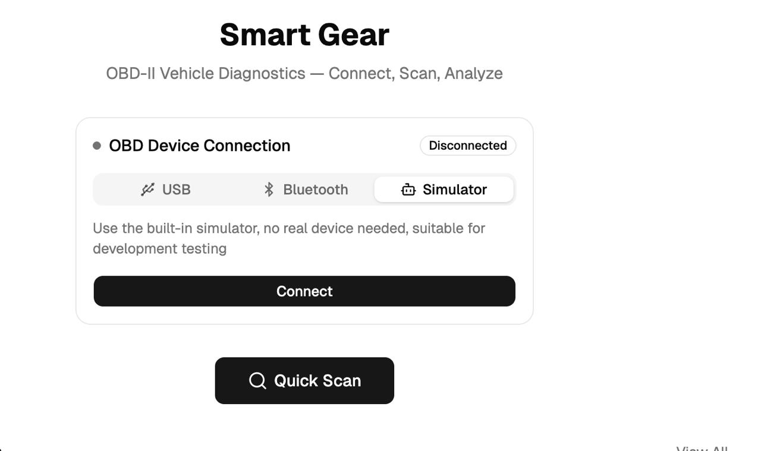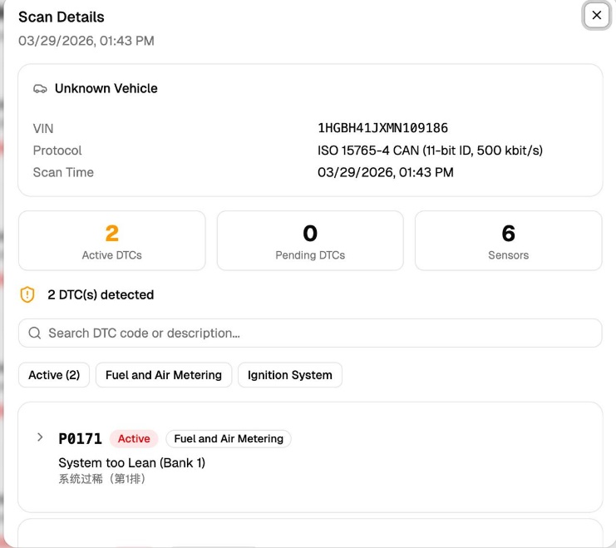

Impact
Reduces diagnostic research time for mechanics. For the course: practical data on fixed vs. agentic AI orchestration tradeoffs. The MCP server shows how standardized protocols decouple AI tools from specific apps. Classmates with an ELM327 adapter ($10–20) can test by scanning their own vehicles.

