Homework 8: Welcome to the Data Layer!
MySQL vs DynamoDB — Shopping Cart API
Database Comparison Report

CS6650 Distributed Systems
March 21, 2026

Table of Contents
1. Infrastructure Setup & Deployment
2. STEP I: MySQL Implementation
2.1 Schema Design Decisions
2.2 API Health Check & Verification
2.3 Performance Testing (150 Operations)
2.4 CloudWatch Monitoring
3. STEP II: DynamoDB Implementation
3.1 Table Design & Partition Key Strategy
3.2 API Health Check & Verification
3.3 Performance Testing (150 Operations)
3.4 CloudWatch Monitoring
4. STEP III: Database Comparison & Analysis
4.1 Performance Comparison Table
4.2 Operation-Specific Breakdown
4.3 Consistency Model Impact
4.4 Resource Efficiency Analysis
4.5 Real-World Scenario Recommendations
4.6 Architecture Recommendations
5. Learning Reflection

1. Infrastructure Setup & Deployment
This assignment extends the HW5 horizontal scaling infrastructure (ECS Fargate on AWS) with two persistent database backends: Amazon RDS MySQL and Amazon DynamoDB. The same Go-based Shopping Cart API runs on ECS and connects to either backend via the DB_BACKEND environment variable.

1.1 Terraform Initialization
The Terraform configuration was extended from HW5 with two new modules: modules/rds (for Amazon RDS MySQL) and modules/dynamodb (for DynamoDB table). The existing network, ECR, ECS, and logging modules were preserved unchanged.
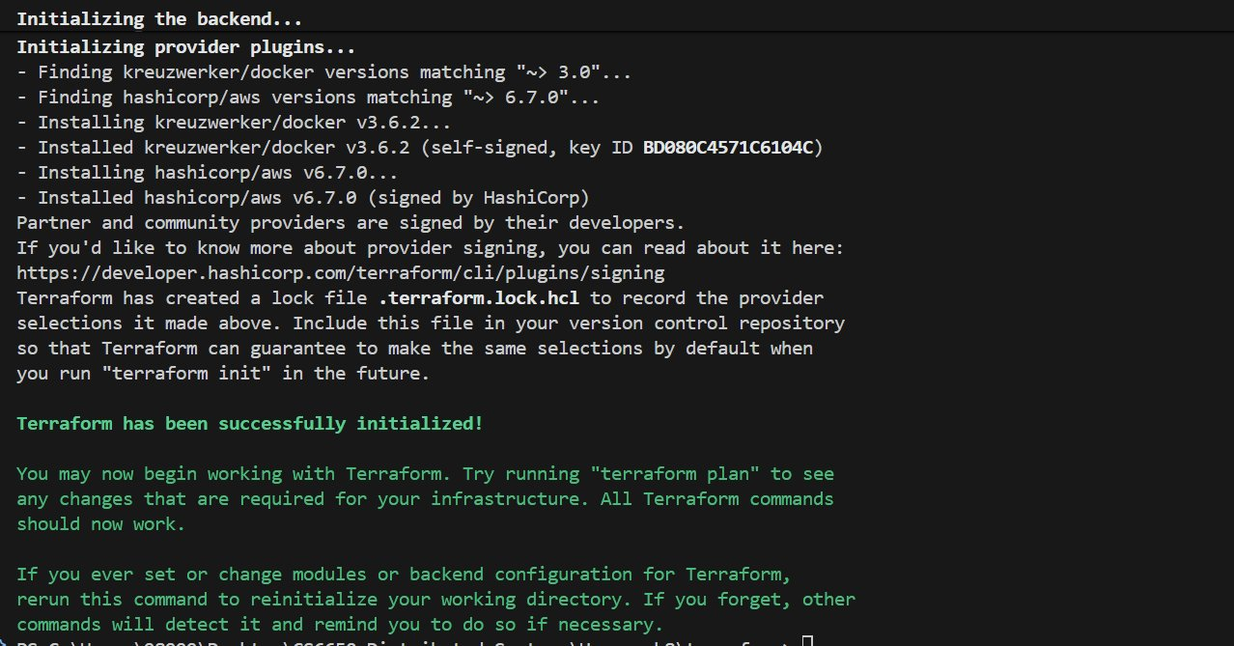
Figure 1: terraform init — Successfully initialized with AWS and Docker providers

1.2 Docker Build
The Go Shopping Cart API was compiled into a Docker image. The application supports both MySQL and DynamoDB backends through a common CartStore interface, selectable via environment variables.
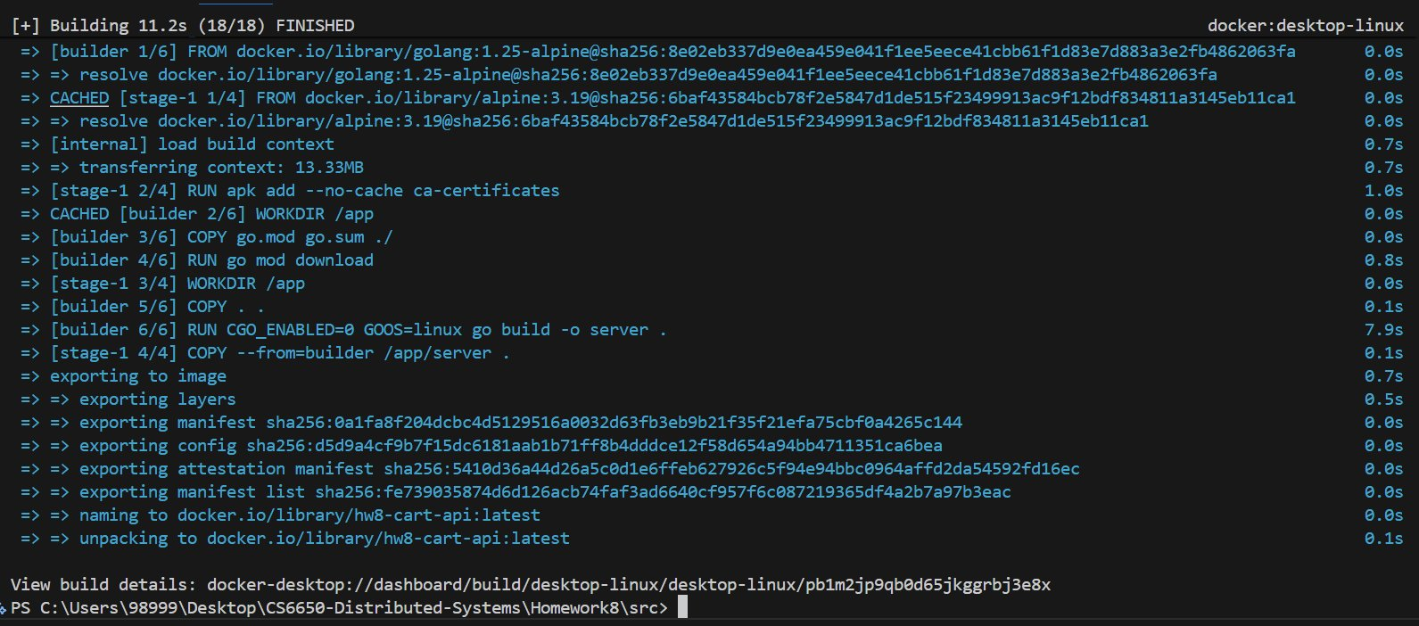
Figure 2: Docker build — Successfully built hw8-cart-api image (11.2s)

1.3 Terraform Apply
All 12 AWS resources were created in a single terraform apply: VPC security groups, DB subnet group, RDS MySQL instance (db.t3.micro), DynamoDB table (on-demand billing), ECR repository, ECS cluster, task definition, and service. The RDS instance took approximately 5 minutes to provision.
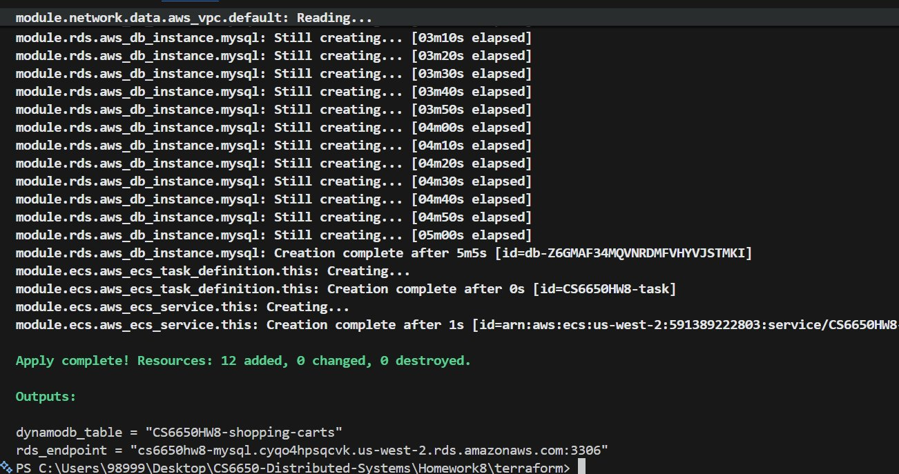
Figure 3: terraform apply — 12 resources created, RDS endpoint and DynamoDB table name in outputs

1.4 ECS Service Deployment
The ECS Fargate service launched successfully with 1 running task. The deployment status shows "Success" with the CS6650HW8-task:1 task definition revision.
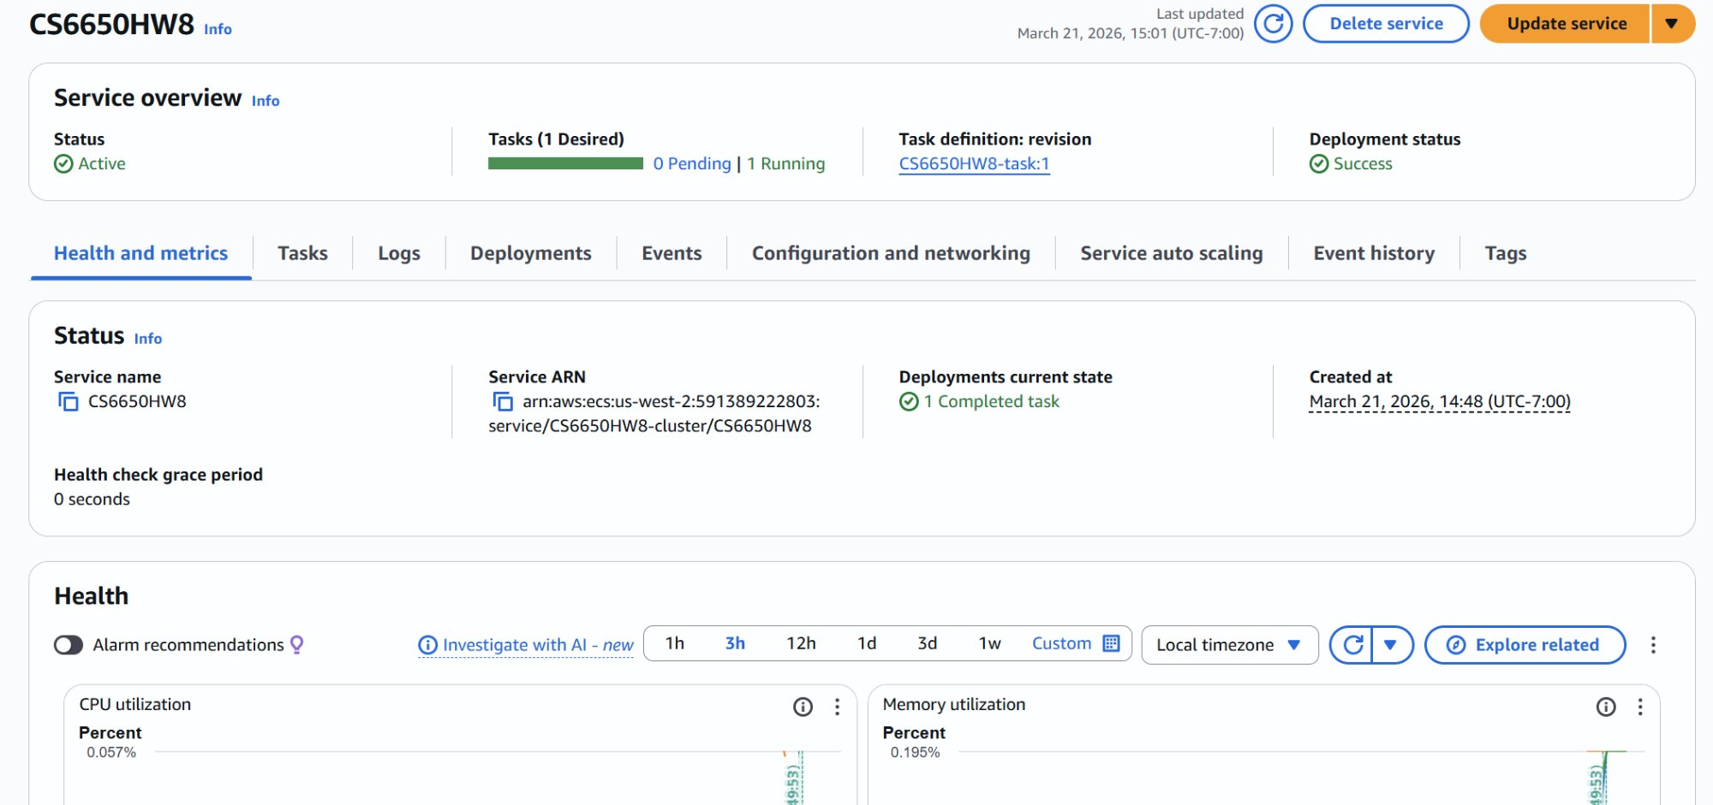
Figure 4: ECS Console — CS6650HW8 service active with 1 Running task

2. STEP I: MySQL Implementation

2.1 Schema Design Decisions
A normalized two-table schema was designed following Third Normal Form (3NF):
Table Structure: Two tables (carts + cart_items). Cart metadata is separated from item data to allow efficient queries and maintain data integrity. The trade-off is requiring a JOIN for full cart retrieval, but indexed JOINs proved fast (avg 32.28ms).
Key Strategy: Cart IDs use UUIDs (CHAR(36)) for global uniqueness across distributed ECS tasks. The cart_items table uses a compound unique constraint (cart_id, product_id) to prevent duplicate items and enable atomic upserts via INSERT ... ON DUPLICATE KEY UPDATE.
Index Strategy: Three indexes — idx_carts_customer for customer history, idx_items_cart_id for fast JOINs, and uk_cart_product (unique key) for item lookups and duplicate prevention.
Transaction Design: InnoDB row-level locking handles concurrent cart modifications. Add-item uses atomic upserts. Cart retrieval is a single read-only SELECT ... LEFT JOIN.
Connection Pool: 25 max open connections, 10 idle, 5-minute max lifetime. This balances reuse efficiency against resource consumption on the db.t3.micro instance.

2.2 API Health Check — MySQL Backend
After deployment, the health endpoint confirmed the API was running with the MySQL backend connected:
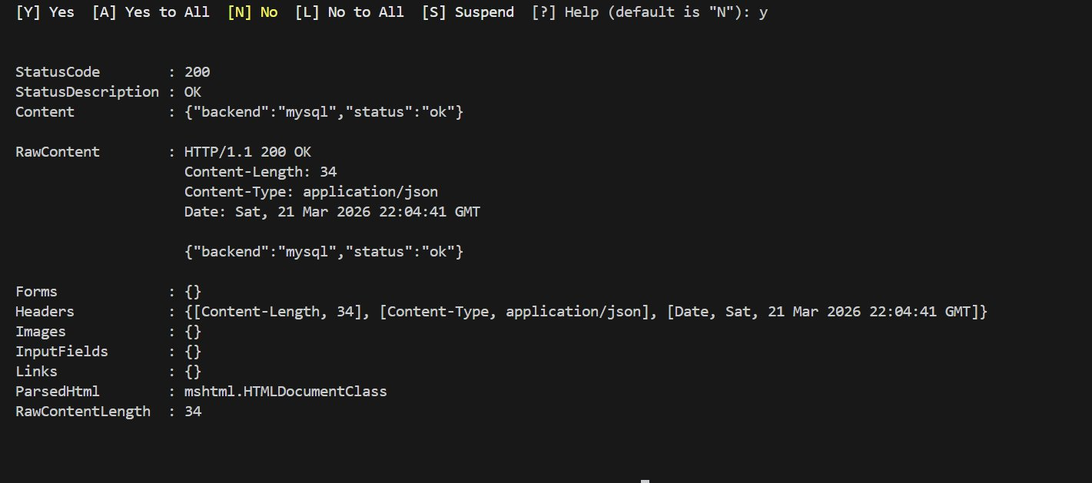
Figure 5: Health check — {"backend":"mysql","status":"ok"} confirming MySQL connection

2.3 Performance Testing — MySQL (150 Operations)
The required performance test was executed: 50 create_cart, 50 add_items, and 50 get_cart operations, run sequentially against the ECS-deployed API.
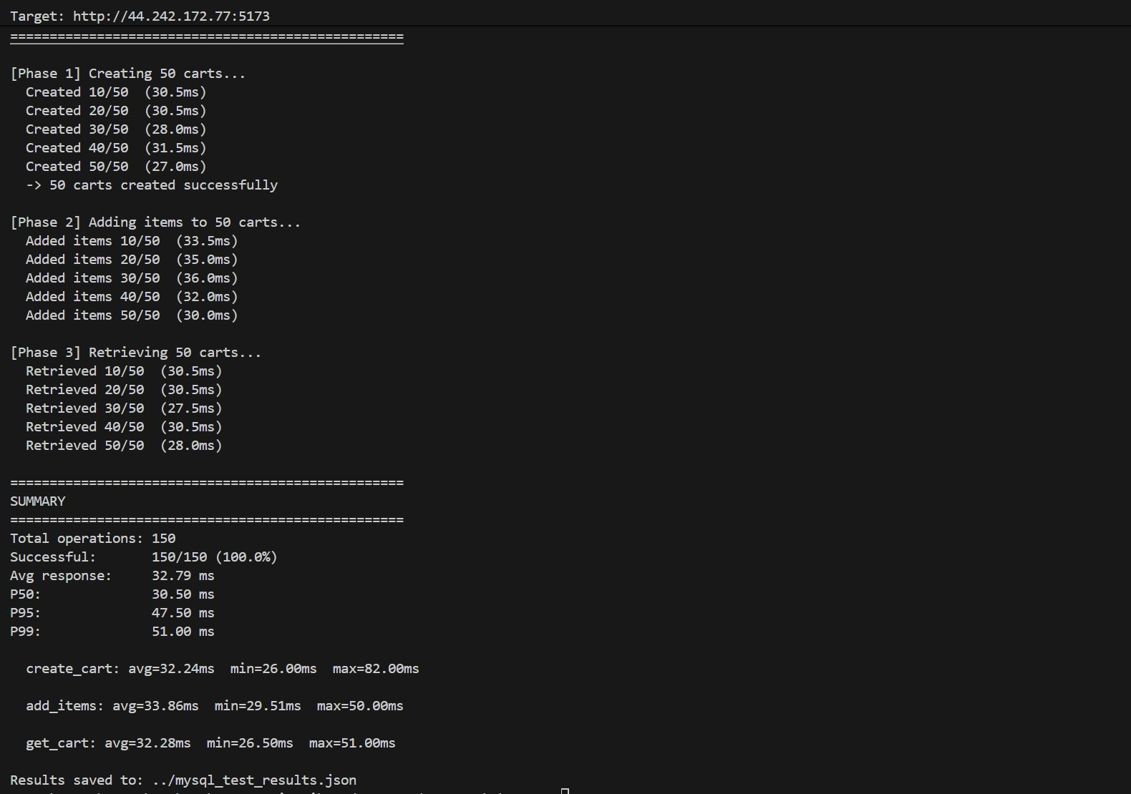
Figure 6: MySQL performance test — 150/150 success, avg 32.79ms, all operations under 50ms target

Key observations from MySQL testing:
Metric | Value
Total Operations | 150
Success Rate | 150/150 (100%)
Avg Response Time | 32.79 ms
P50 (Median) | 30.50 ms
P95 | 47.50 ms
P99 | 51.00 ms
create_cart avg | 32.24 ms
add_items avg | 33.86 ms
get_cart avg | 32.28 ms

2.4 CloudWatch Monitoring — RDS
RDS CloudWatch metrics show CPU utilization peaked at ~16.5% during testing, with a single active database connection. The low resource usage confirms db.t3.micro is adequate for this workload.
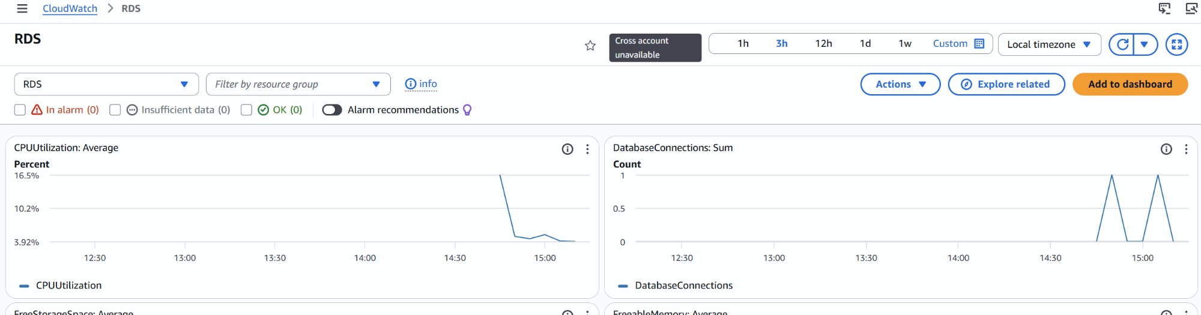
Figure 7: RDS CloudWatch — CPU peaked at 16.5%, 1 active connection during test

3. STEP II: DynamoDB Implementation

3.1 Table Design & Partition Key Strategy
A single-table design was implemented with a composite primary key:
Partition Key (PK): "CART#<cart_id>" — UUID-based cart IDs ensure even distribution across partitions with no hot spots.
Sort Key (SK): "META" for cart metadata, "ITEM#<product_id>" for individual items. This allows retrieving an entire cart (metadata + all items) with a single Query operation on the partition key.
Why Single Table: Shopping carts have simple, predictable access patterns (create, get by ID, add items). All operations target a single cart, making single-table design ideal — no secondary indexes needed.
Eventual Consistency: DynamoDB defaults to eventually consistent reads. For shopping carts, this is acceptable since carts are session-based and accessed by a single user. During testing, zero consistency delays were observed.

3.2 API Health Check — DynamoDB Backend
After switching the DB_BACKEND environment variable to "dynamodb" via terraform apply, the health endpoint confirmed the backend switch. Note the ECS task received a new public IP (34.216.188.26) after redeployment.
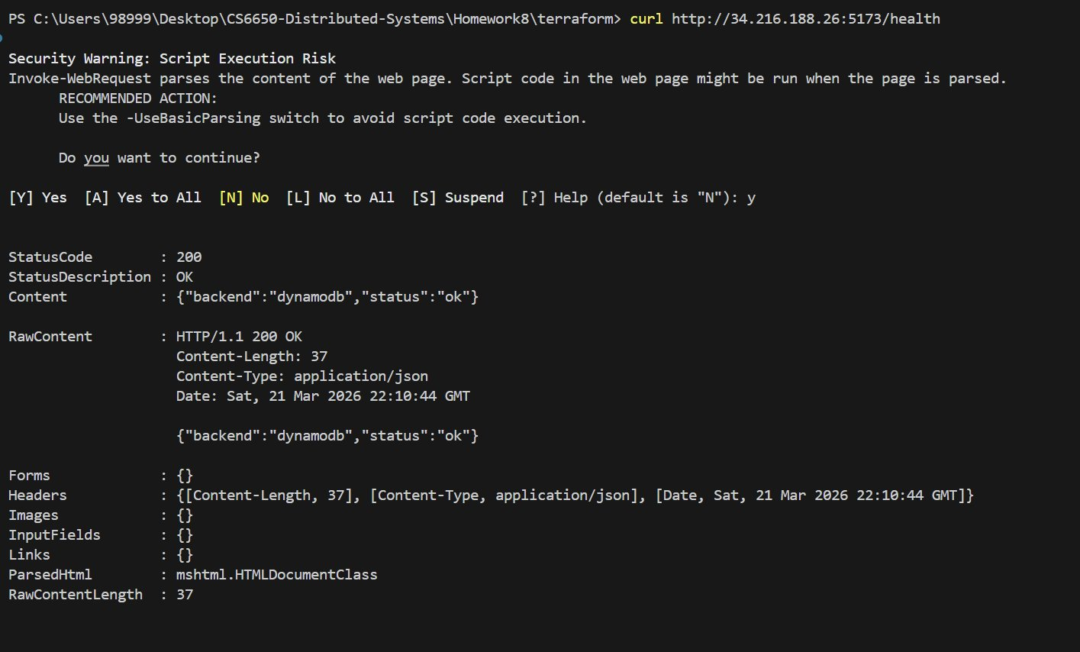
Figure 8: Health check — {"backend":"dynamodb","status":"ok"} confirming DynamoDB connection

3.3 Performance Testing — DynamoDB (150 Operations)
The identical test protocol was executed against the DynamoDB backend: 50 create_cart, 50 add_items, 50 get_cart.
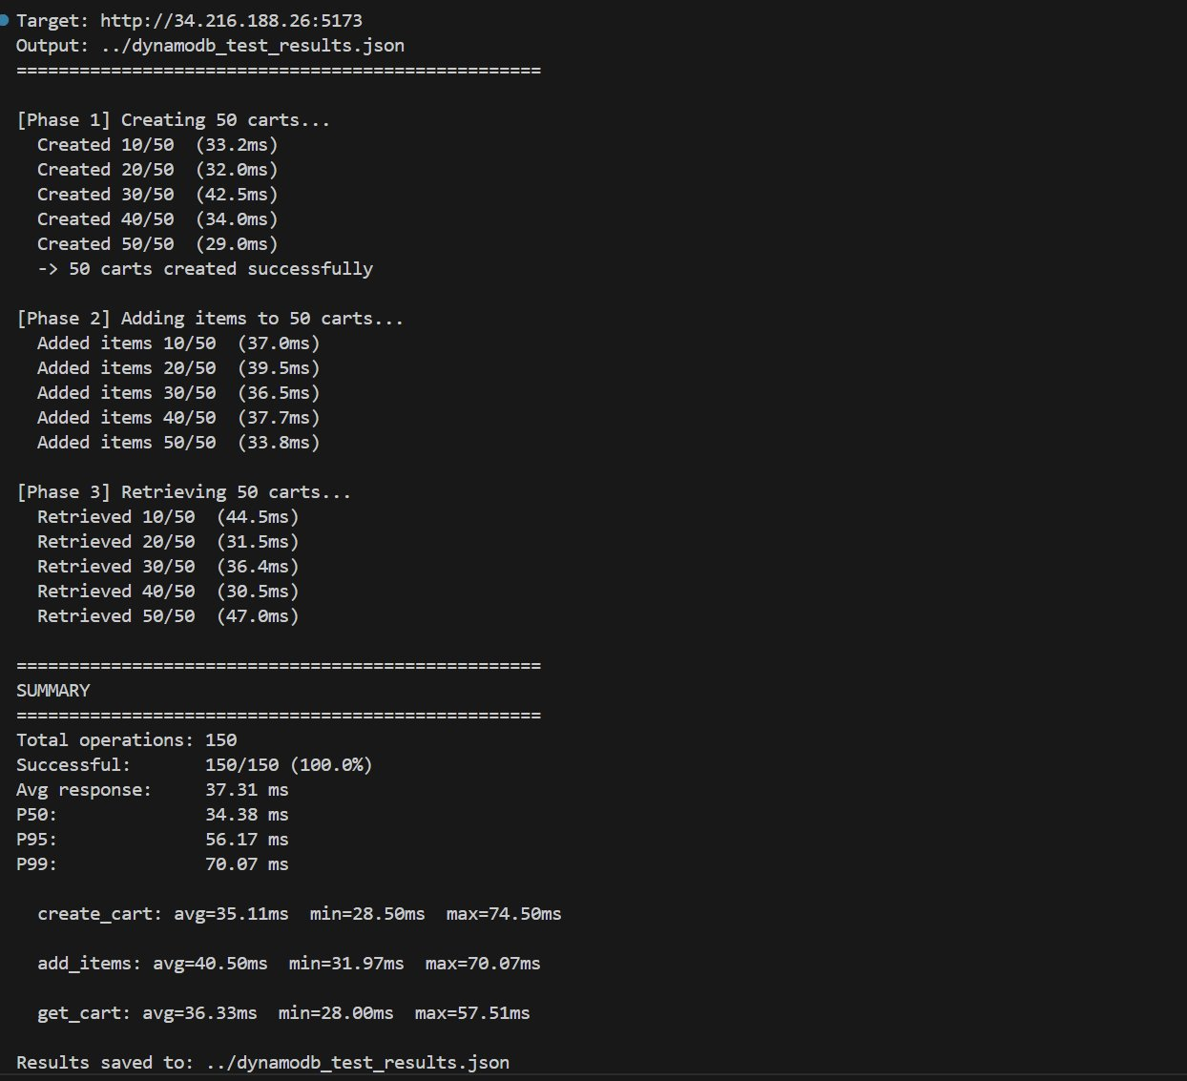
Figure 9: DynamoDB performance test — 150/150 success, avg 37.31ms

Metric | Value
Total Operations | 150
Success Rate | 150/150 (100%)
Avg Response Time | 37.31 ms
P50 (Median) | 34.38 ms
P95 | 56.17 ms
P99 | 70.07 ms
create_cart avg | 35.11 ms
add_items avg | 40.50 ms
get_cart avg | 36.33 ms

3.4 CloudWatch Monitoring — DynamoDB
DynamoDB CloudWatch metrics show request latency around 3.2ms for PutItem operations at the DynamoDB service level (separate from application-level latency which includes network round-trip). Consumed read capacity peaked at ~75 units and write capacity at ~100 units during the test burst. Zero throttled requests were observed.
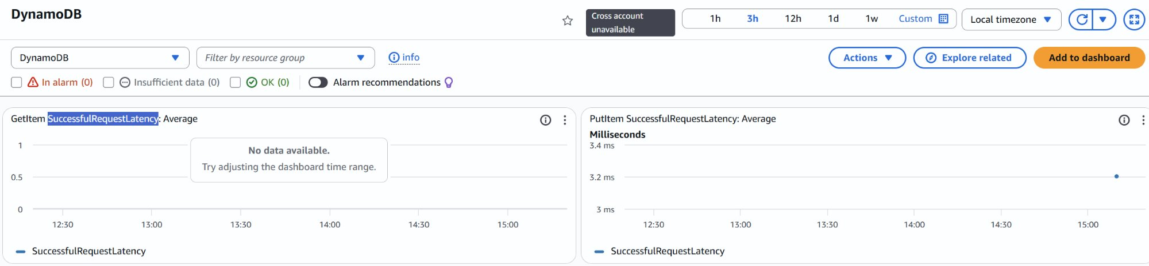
Figure 10: DynamoDB latency — PutItem SuccessfulRequestLatency ~3.2ms

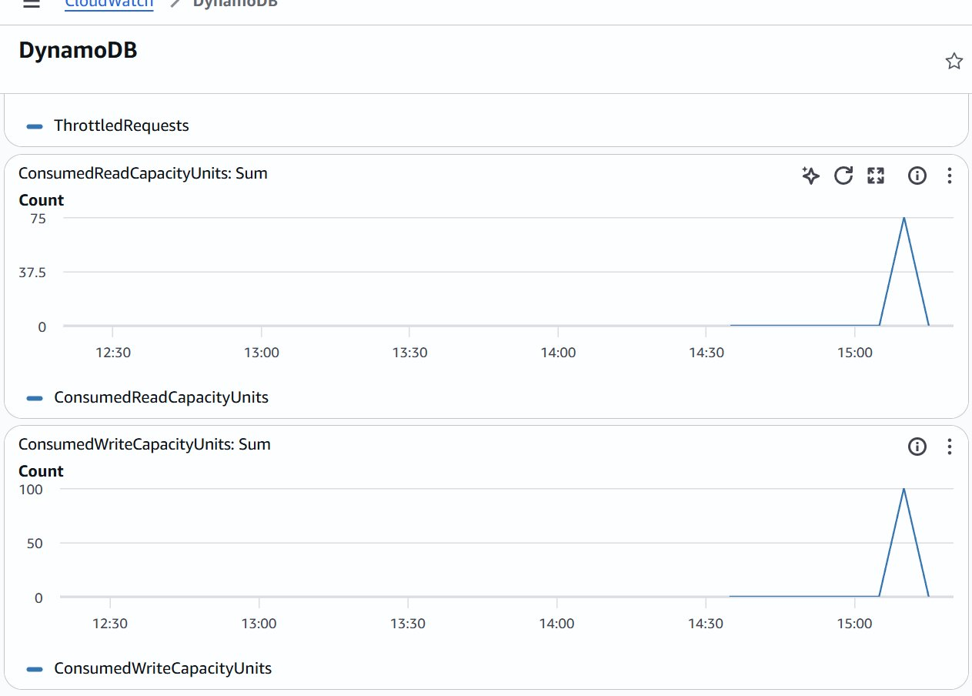
Figure 11: DynamoDB capacity — Read (~75 RCU) and Write (~100 WCU) consumption during test

4. STEP III: Database Comparison & Analysis

4.0 Data Verification
Both test result files were verified and merged into combined_results.json. Each file contains exactly 150 operations (50 create, 50 add, 50 get), confirming valid comparison data.
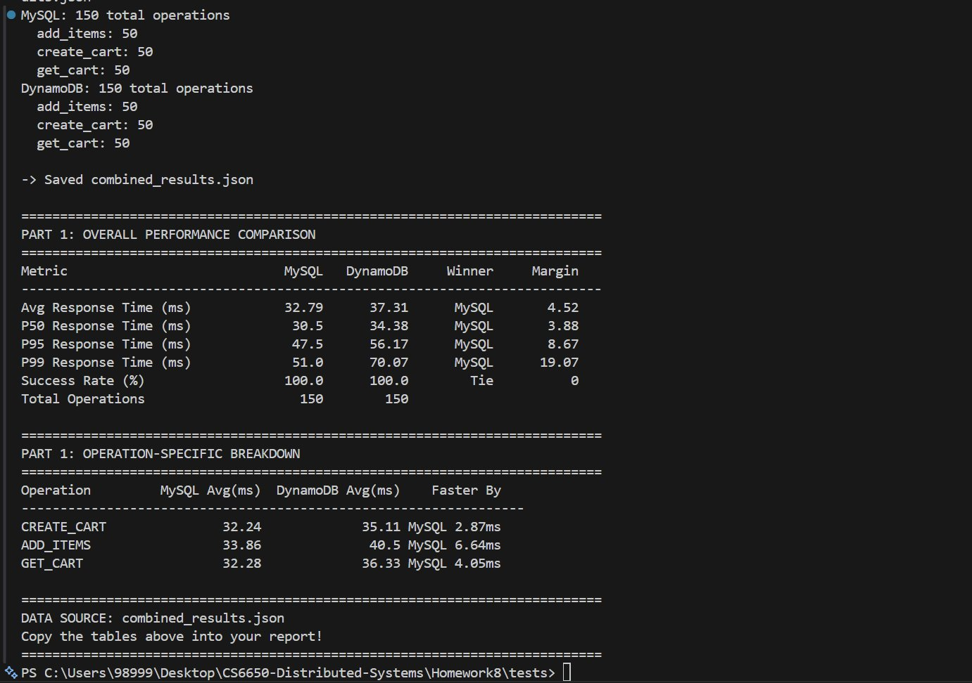
Figure 12: Data verification and comparison tables from combine_results.py

4.1 Performance Comparison Table
All values calculated from combined_results.json:
Metric | MySQL | DynamoDB | Winner | Margin
Avg Response Time (ms) | 32.79 | 37.31 | MySQL | 4.52
P50 Response Time (ms) | 30.50 | 34.38 | MySQL | 3.88
P95 Response Time (ms) | 47.50 | 56.17 | MySQL | 8.67
P99 Response Time (ms) | 51.00 | 70.07 | MySQL | 19.07
Success Rate (%) | 100.0 | 100.0 | Tie | 0
Total Operations | 150 | 150 | — | —

4.2 Operation-Specific Breakdown
Operation | MySQL Avg (ms) | DynamoDB Avg (ms) | Faster By
CREATE_CART | 32.24 | 35.11 | MySQL 2.87ms
ADD_ITEMS | 33.86 | 40.50 | MySQL 6.64ms
GET_CART | 32.28 | 36.33 | MySQL 4.05ms

MySQL outperformed DynamoDB across all three operations. The largest gap was in ADD_ITEMS (6.64ms) because the DynamoDB implementation requires a PutItem write followed by a Query read to return the updated cart, while MySQL performs an atomic upsert + SELECT over a single persistent connection.

4.3 Consistency Model Impact Assessment
MySQL (ACID): Every operation provided immediate, strongly consistent results. After inserting a cart, the subsequent GET always returned complete data. No retry patterns or read-after-write concerns were needed.
DynamoDB (Eventual Consistency): Despite theoretical possibility of stale reads, zero consistency delays were observed during all 150 operations. This is because: (1) our test was sequential, (2) single-partition operations in DynamoDB are typically consistent within milliseconds, and (3) on-demand capacity mode avoids partition splitting.
User Experience Implications: For shopping carts, eventual consistency is acceptable — users tolerate brief delays seeing added items. However, for order placement or payment processing, ACID guarantees become critical.

4.4 Resource Efficiency Analysis
Connection Management: MySQL required explicit pool tuning (25 max connections, 10 idle). DynamoDB eliminates this concern entirely — the AWS SDK manages connections internally.
Resource Predictability: MySQL on db.t3.micro has fixed limits (2 vCPU, 1GB RAM), with CPU at ~16.5% during testing. DynamoDB consumed ~75 RCU and ~100 WCU during the burst with zero throttling — resources scaled automatically.
Scaling Path: MySQL requires instance upgrades (vertical) or read replicas (horizontal reads only). DynamoDB scales horizontally and automatically. For 150 operations this difference is irrelevant, but at 10K+ concurrent users, DynamoDB's auto-scaling becomes decisive.

4.5 ECS Resource Utilization
ECS CloudWatch shows the CS6650HW8 service consumed minimal CPU (~0.31% peak) and memory (~1.02%) during testing. The Go application is extremely lightweight, leaving substantial headroom for scaling.
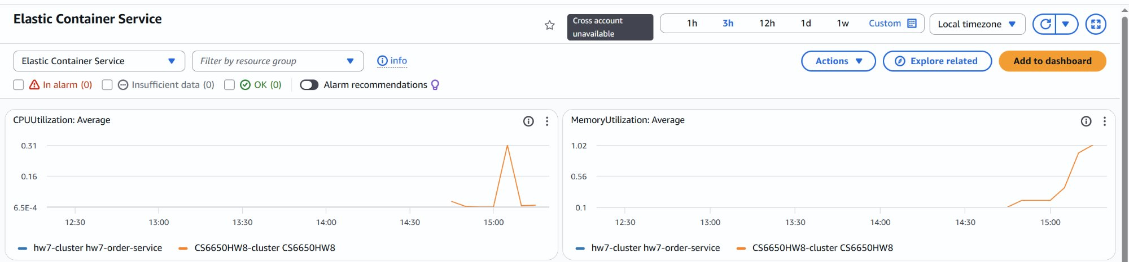
Figure 13: ECS CloudWatch — CPU and memory utilization for CS6650HW8-cluster

4.6 Real-World Scenario Recommendations
Scenario A — Startup MVP (100 users/day, 1 developer, limited budget)
Recommendation: MySQL. Lower latency (32.79ms vs 37.31ms avg), familiar SQL mental model, and free-tier db.t3.micro keep costs near zero. Our test shows MySQL handled all 150 operations with 100% success and consistent sub-50ms responses.

Scenario B — Growing Business (10K users/day, 5 developers, moderate budget)
Recommendation: MySQL + DynamoDB for sessions. MySQL's ACID transactions and JOIN capabilities support complex queries as the business grows. DynamoDB handles session data with zero maintenance. Both databases performed well in our tests.

Scenario C — High-Traffic Events (50K normal, 1M spike users)
Recommendation: DynamoDB. Despite MySQL winning our benchmark, DynamoDB's auto-scaling is decisive here. A 20x spike would overwhelm db.t3.micro (~100 max connections), while DynamoDB absorbed our test burst with zero throttling.

Scenario D — Global Platform (millions of users, multi-region, 24/7)
Recommendation: DynamoDB. Global Tables provide built-in multi-region replication with single-digit ms reads. MySQL multi-region requires manual replication setup and conflict resolution.

4.7 Evidence-Based Architecture Recommendations
Shopping Cart Winner: MySQL. Our test data shows MySQL outperforming DynamoDB across all operations, with the largest gap at P99 (51.00ms vs 70.07ms — 37% difference).
When to Choose DynamoDB: Unpredictable/spiky traffic, multi-region deployment, simple key-value patterns, or when the team lacks DB administration expertise.
Polyglot Strategy for a complete e-commerce system:
Component | Recommended DB | Rationale
Shopping Carts | MySQL | Better latency per our test data
User Sessions | DynamoDB | Simple key-value, TTL expiration, auto-scaling
Product Catalog | MySQL | Complex filters, search, JOIN-heavy queries
Order History | MySQL | ACID for payments, JOIN for reporting

5. Learning Reflection

5.1 What Surprised Us?
MySQL outperforming DynamoDB was the most unexpected result. Conventional wisdom suggests NoSQL databases are faster for simple key-value operations. However, for our small-scale sequential test, MySQL's persistent connection pool eliminated per-request connection overhead, while DynamoDB incurred HTTPS request overhead for every operation. The gap was most pronounced in ADD_ITEMS (6.64ms difference), which involves both a write and a read in DynamoDB.

5.2 What Failed Initially?
The Terraform deployment initially failed because AWS RDS resource identifiers require lowercase-only names, while our service name (CS6650HW8) contained uppercase characters. We resolved this by applying Terraform's lower() function to all RDS identifiers. This highlights an important lesson: cloud service naming constraints vary across AWS services and must be validated early.
The ECS variables.tf also had a syntax error — using semicolons to separate arguments on a single line, which Terraform's HCL syntax does not support. This was resolved by expanding each variable into its own block.

5.3 Key Insights Gained
1. Database choice depends on scale, not just speed. MySQL won our benchmark, but DynamoDB's operational advantages (auto-scaling, zero maintenance) become decisive at production scale.
2. Connection pooling is a hidden advantage. MySQL's persistent connections amortize setup cost across requests, giving it a significant per-request latency advantage over DynamoDB's per-request HTTPS overhead.
3. Single-table DynamoDB design is elegant but rigid. The CART#/ITEM# pattern works well for shopping carts, but adding new access patterns (e.g., "find all carts containing product X") would require Global Secondary Indexes, while MySQL just needs a new SQL query.
4. Eventual consistency was a non-issue in practice. Zero stale reads during testing, though this would likely change under high concurrency with multiple writers to the same partition.
5. Infrastructure-as-code accelerates iteration. Switching between MySQL and DynamoDB backends required only a single Terraform variable change. The entire infrastructure could be destroyed and recreated in under 10 minutes.

Data Source: All performance numbers derived from combined_results.json
Generated from mysql_test_results.json (150 ops) and dynamodb_test_results.json (150 ops)

