Terraform apply :
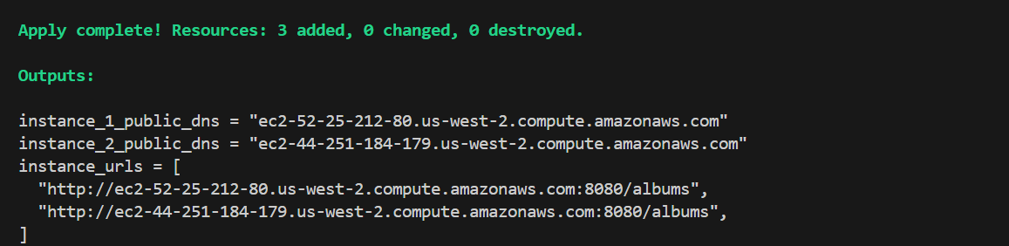

Terraform destroy:
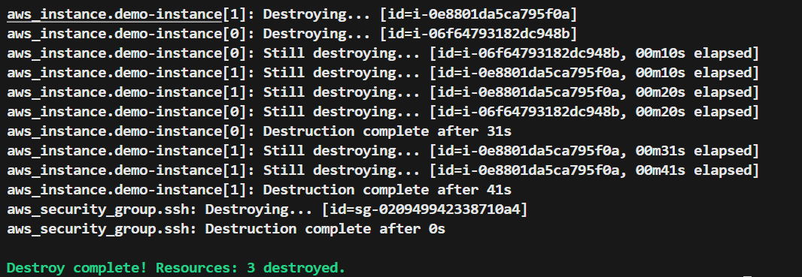

Docker:
- scp -i ~/aws_learner.pem docker-album.tar ec2-user@ec2-44-249-250-141.us-west-2.compute.amazonaws.com:docker-app
- ssh -i ~/aws_learner.pem ec2-user@ec2-54-184-12-146.us-west-2.compute.amazonaws.com
- docker load -i docker-album.tar
- docker run -d -p 8080:8080 docker-go-album:multistage
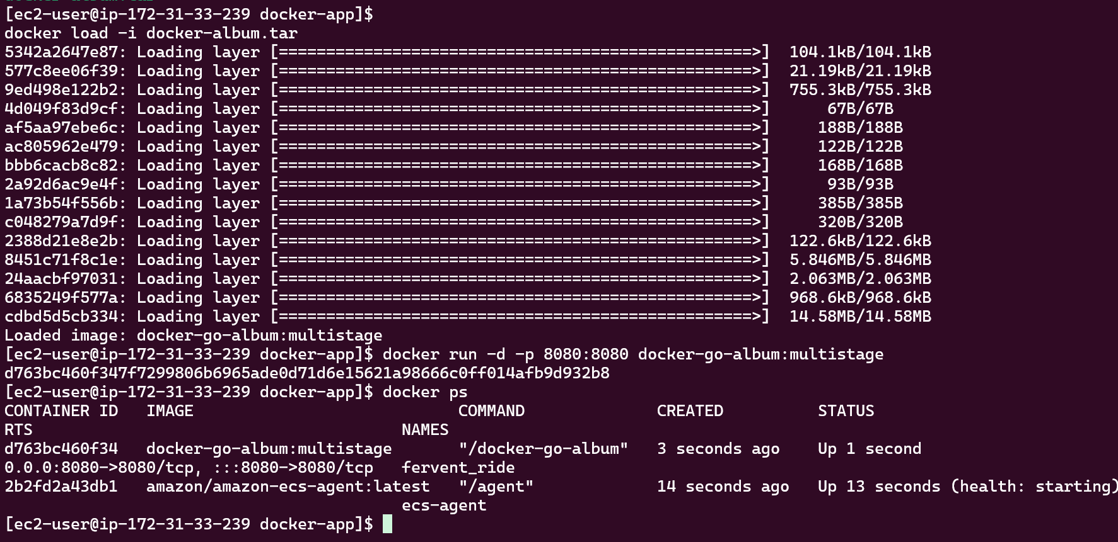
Dockerfile 1: Single-Stage Build
- Uses golang:1.25 as base (~900MB)
- Contains full Go toolchain + compiled binary
- Final image size: ~900MB
- Includes shell, compiler, and development tools
- Good for: Development
Dockerfile 2: Multi-Stage Build
- Stage 1: Build with golang:1.25
- Stage 2: Copy binary to distroless (~20MB)
- Final image size: ~30MB (30x smaller!)
- Only contains the compiled binary
- No shell, no tools, minimal attack surface
- Good for: Production

Key Differences
Aspect | Single-Stage | Multi-Stage
Size | ~900MB | ~30MB
Security | Lower (more tools) | Higher (minimal)
Debugging | Easy (has shell) | Hard (no shell)
Deploy Speed | Slower | Faster
Use Case | Development | Production

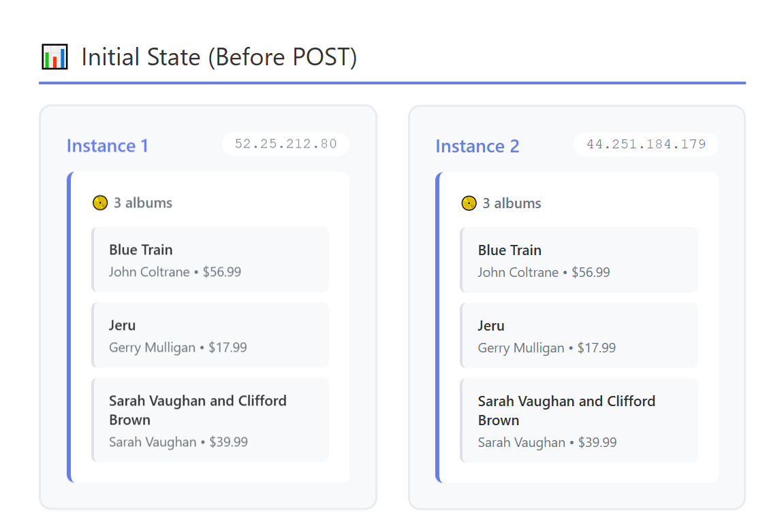
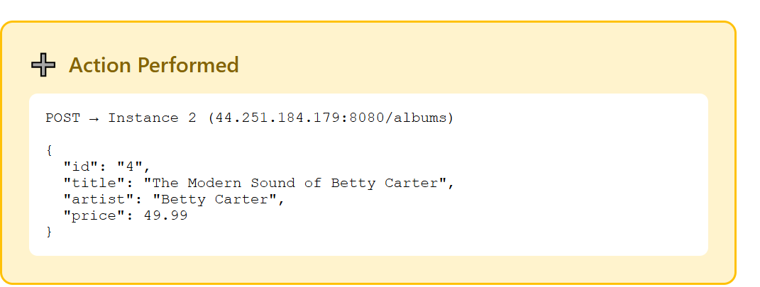
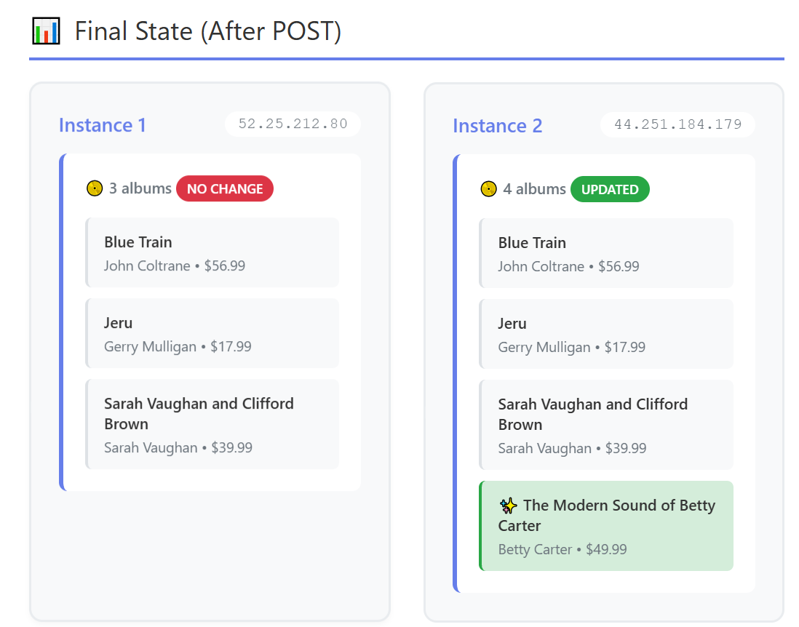
Issue: After adding a new album to Instance 2, Instance 1 remains unaware of the change. Each instance maintains its own independent data storage with no synchronization mechanism.
Result: Instance 1 has 3 albums, while Instance 2 has 4 albums. This demonstrates a classic distributed system consistency problem.

