HW4 Part III: MapReduce with ECS & S3

Architecture Overview
A simplified MapReduce pipeline using 3 Go microservices, deployed as ECS Fargate tasks, with S3 as shared storage. Input: Shakespeare's Hamlet (~159KB).

Input File (S3: input.txt)
↓
Splitter Service (ECS Task)
↓
3 Chunks (S3: chunks/)
↓ ↓ ↓
Mapper 1 Mapper 2 Mapper 3 (Parallel ECS Tasks)
↓ ↓ ↓
3 Result JSONs (S3: results/)
↓
Reducer Service (ECS Task)
↓
Final Result (S3: final.json)

Each service is a standalone Go program that reads from S3, processes data, and writes results back to S3. Tasks are triggered via AWS CLI with --overrides to pass S3 URLs as command-line arguments.

Step 1: ECR — 4 Container Repositories
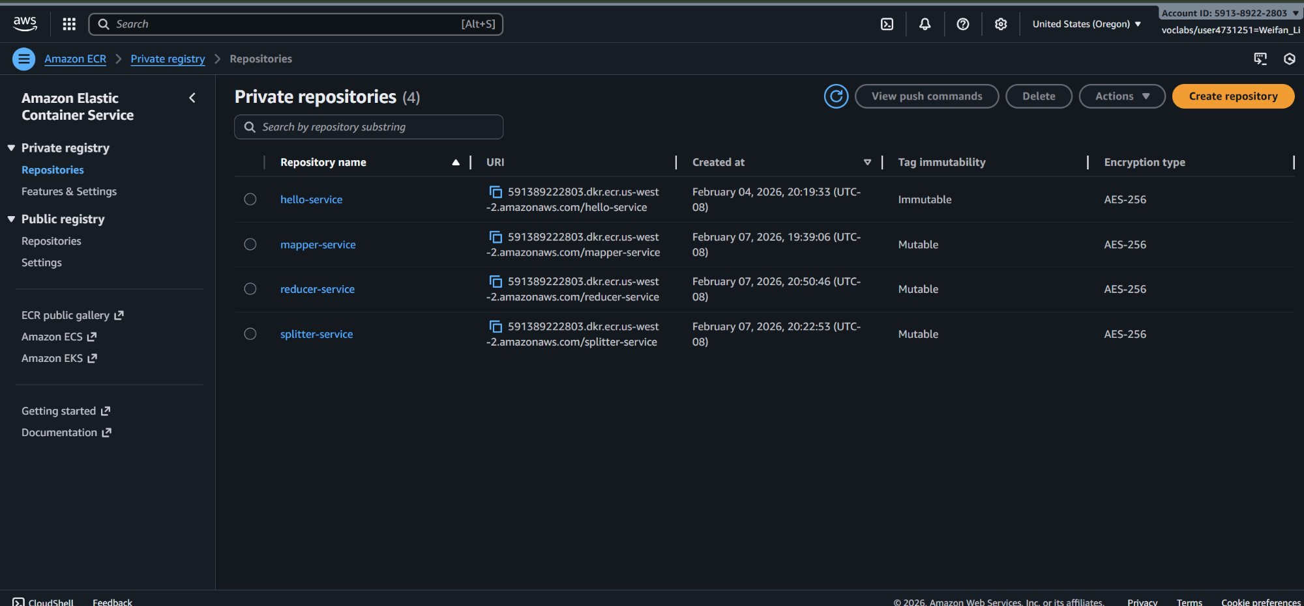
- 4 private ECR repositories: hello-service (Part II), splitter-service, mapper-service, reducer-service
- Each MapReduce service is a separate Go program, containerized with Docker, and pushed to its own ECR repo
- All 3 MapReduce services created on Feb 7, 2026; hello-service from Part II on Feb 4

Step 2: ECS Task Definitions — Blueprints for Each Service
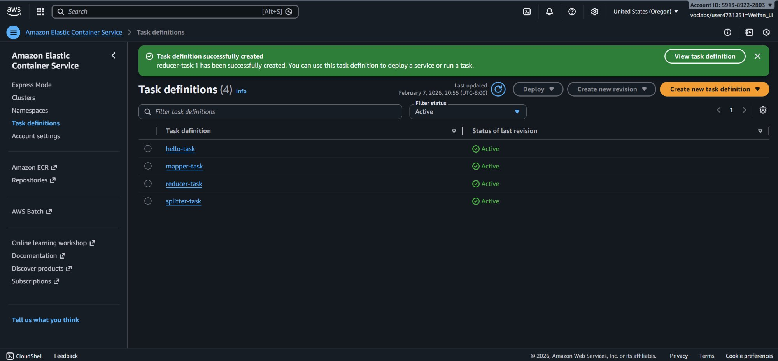
- 4 active task definitions: hello-task (Part II), splitter-task, mapper-task, reducer-task
- Each task definition specifies: container image (from ECR), CPU/memory allocation, IAM role (LabRole)
- All tasks use FARGATE launch type — no EC2 instances to manage

Step 3a: Run Splitter Task
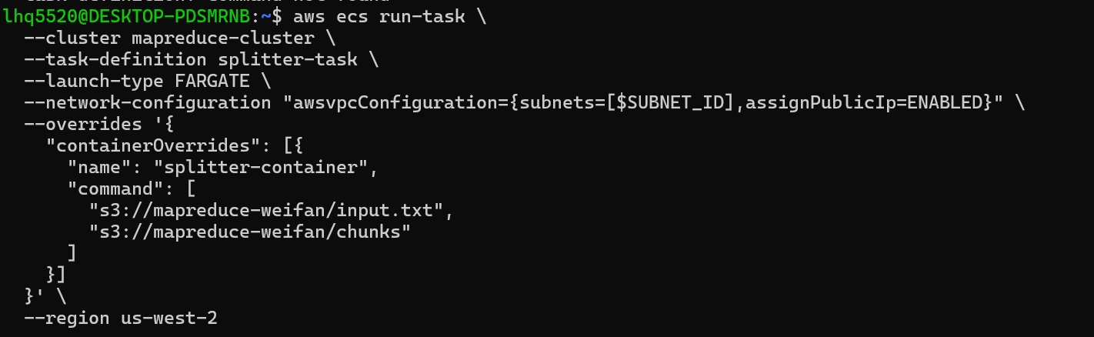
- Command: aws ecs run-task with splitter-task definition on mapreduce-cluster
- Input args via --overrides: s3://mapreduce-weifan/input.txt (source file)
- Output destination: s3://mapreduce-weifan/chunks (where chunks will be stored)
- Splitter reads the full text file from S3, splits it into 3 roughly equal chunks by line count

Step 3b Result: 3 Chunks in S3
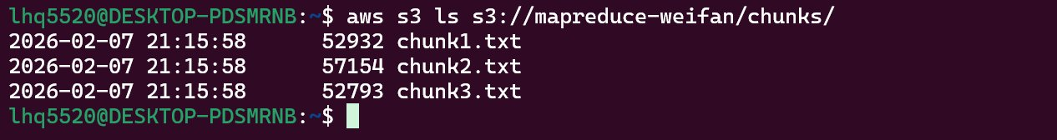
- aws s3 ls confirms 3 chunk files created in s3://mapreduce-weifan/chunks/
- chunk1.txt (52,932 bytes), chunk2.txt (57,154 bytes), chunk3.txt (52,793 bytes)
- Chunks are roughly equal in size (~52-57KB each), split by line boundaries

Step 4a: Run 3 Mapper Tasks (in Parallel)
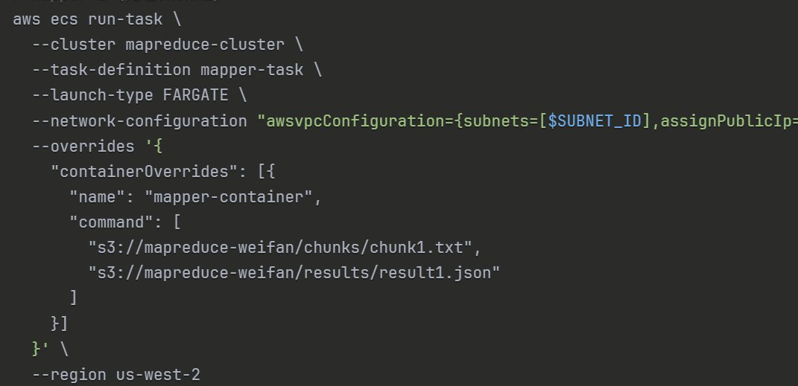
- Ran this command 3 times, once for each chunk: chunk1.txt → result1.json, chunk2.txt → result2.json, chunk3.txt → result3.json
- Each mapper reads its assigned chunk from S3, counts word frequencies using a Go map, and writes JSON output to S3
- All 3 mappers launched as separate ECS tasks and ran in parallel on Fargate
- Input/output S3 URLs passed
Step 4b Result: 3 JSON Result Files in S3
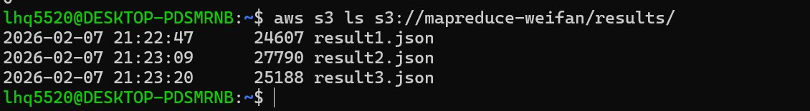
- aws s3 ls confirms 3 result JSON files in s3://mapreduce-weifan/results/
- result1.json (24,607 bytes), result2.json (27,790 bytes), result3.json (25,188 bytes)
- Each file contains a JSON object mapping words to their counts for that chunk

Step 5a: Run Reducer Task
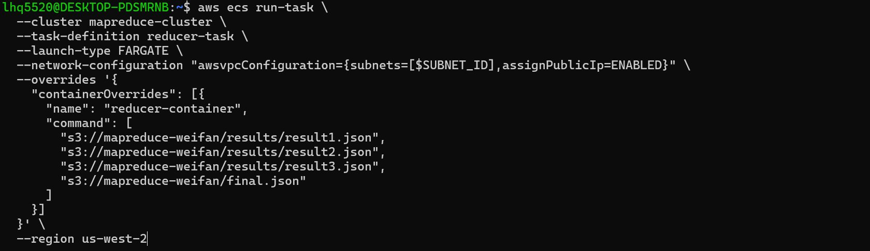
- Reducer task takes all 3 result JSON URLs as input + 1 output URL for final result
- Command args: result1.json, result2.json, result3.json → final.json
- Reducer reads all 3 JSON files, merges word counts by summing duplicate keys
- Final consolidated word frequency JSON written to s3://mapreduce-weifan/final.json
Step 5b Result: Final Word Frequency JSON
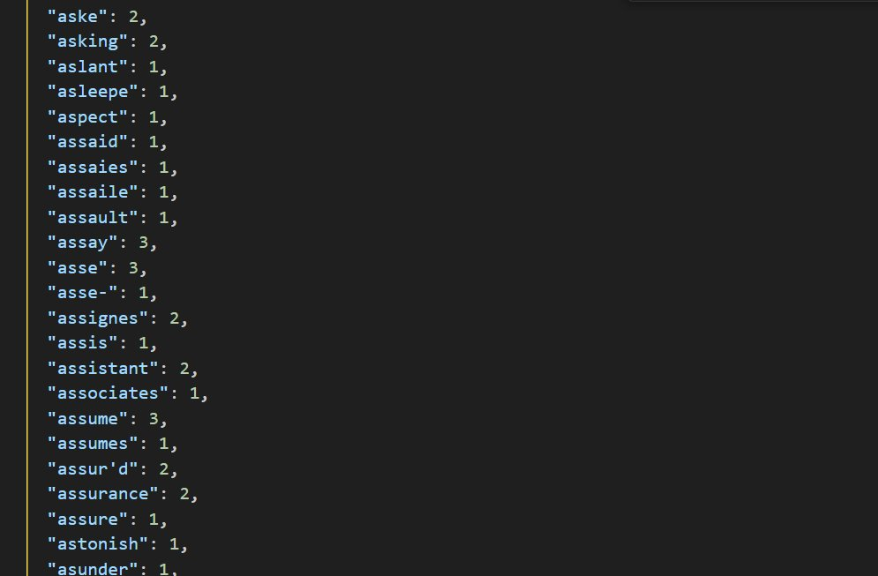
- Final JSON shows merged word counts from all 3 mappers
- Includes Shakespeare-era words like "assur'd", "assaies", "assaile" — confirms we processed Hamlet
- Example entries: "assume": 3, "assistant": 2, "assault": 1
- Top words across the full text: "the" (993), "and" (862), "to" (683)
- Total unique words: ~4,218 | Total word count: ~32,000

End-to-End Data Flow Summary

1. Hamlet.txt (159KB) uploaded to S3 bucket: s3://mapreduce-weifan/input.txt
2. Splitter ECS task reads input.txt, splits into 3 chunks, writes to s3://mapreduce-weifan/chunks/
3. 3 Mapper ECS tasks run in parallel, each reads one chunk, counts words, writes JSON to s3://mapreduce-weifan/results/
4. Reducer ECS task reads all 3 result JSONs, merges counts, writes final output to s3://mapreduce-weifan/final.json
5. Verified: final word counts match expected results for Hamlet

