CS6650 Assignment – Part II
Identifying Performance Bottlenecks with Load Testing
ECS Fargate | Go Product Search Service | Locust + CloudWatch

1. Overview
This report documents the load testing of a Go-based product search service deployed on AWS ECS Fargate (0.25 vCPU, 512 MB). The service loads 100,000 products into memory at startup and processes each search by checking exactly 100 products — simulating a fixed-cost computation workload such as running an inference model. The objective was to identify the system's performance bottleneck and determine whether the solution requires code optimization or additional compute resources.

2. Service Configuration
The product search service was implemented in Go with the following characteristics:
- 100,000 products generated at startup and stored in a sync.Map
- Each search request checks exactly 100 products and stops, regardless of results found
- Returns up to 20 matching results with a total_found count
- Exposed at /products/search?q={query} on port 8080
- Health check endpoint at /health for ALB integration in Part III
The service was containerized with Docker, pushed to Amazon ECR, and deployed via Terraform to ECS Fargate with a single task instance.

3. Load Testing Methodology
Load testing was conducted using Locust with FastHttpUser to minimize client-side overhead. The test script cycled through ten common search terms matching both brand names (alpha, beta, gamma, delta, epsilon) and categories (electronics, books, home, sports, clothing), with a minimal wait time of 0.01–0.05 seconds to maximize request pressure.

Test 1 – Baseline (5 Users, 2 Minutes)
Five concurrent users were ramped up immediately and maintained for two minutes. This test established a healthy baseline for CPU usage and response times under moderate load.

Test 2 – Stress Test (50 Users, 3 Minutes)
Fifty concurrent users were applied for three minutes. The required test per the assignment was 20 users, but initial results showed CPU only reached ~15% under 20 users — well below the expected ~60% threshold. This indicated the service's sync.Map lookups were too lightweight to generate significant CPU load at low concurrency. The user count was increased to 50 to produce a more meaningful stress level and observe clear CPU growth trends.

4. Results

4.1 CloudWatch Metrics — Baseline (5 Users)
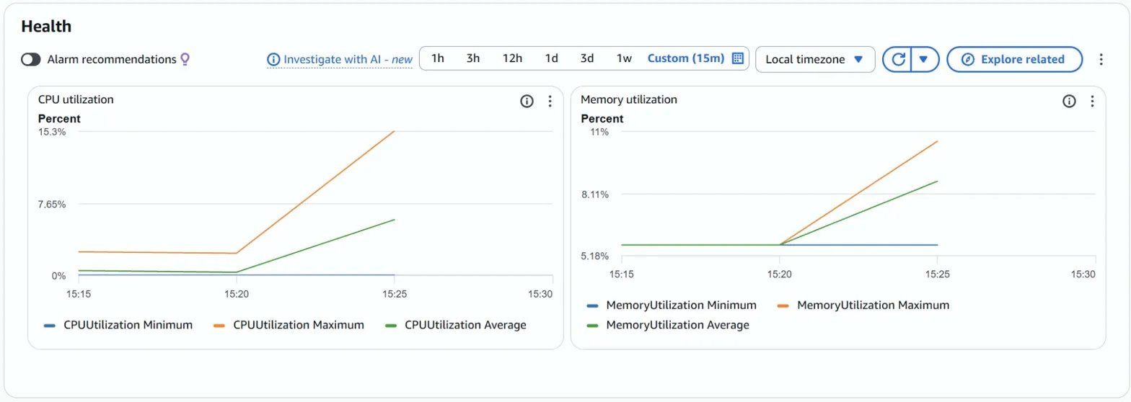
Figure 1: CloudWatch CPU and Memory utilization during 5-user baseline test. CPU peaked at 15.3%; memory remained stable at ~11%.

4.2 CloudWatch Metrics — Stress Test (50 Users)
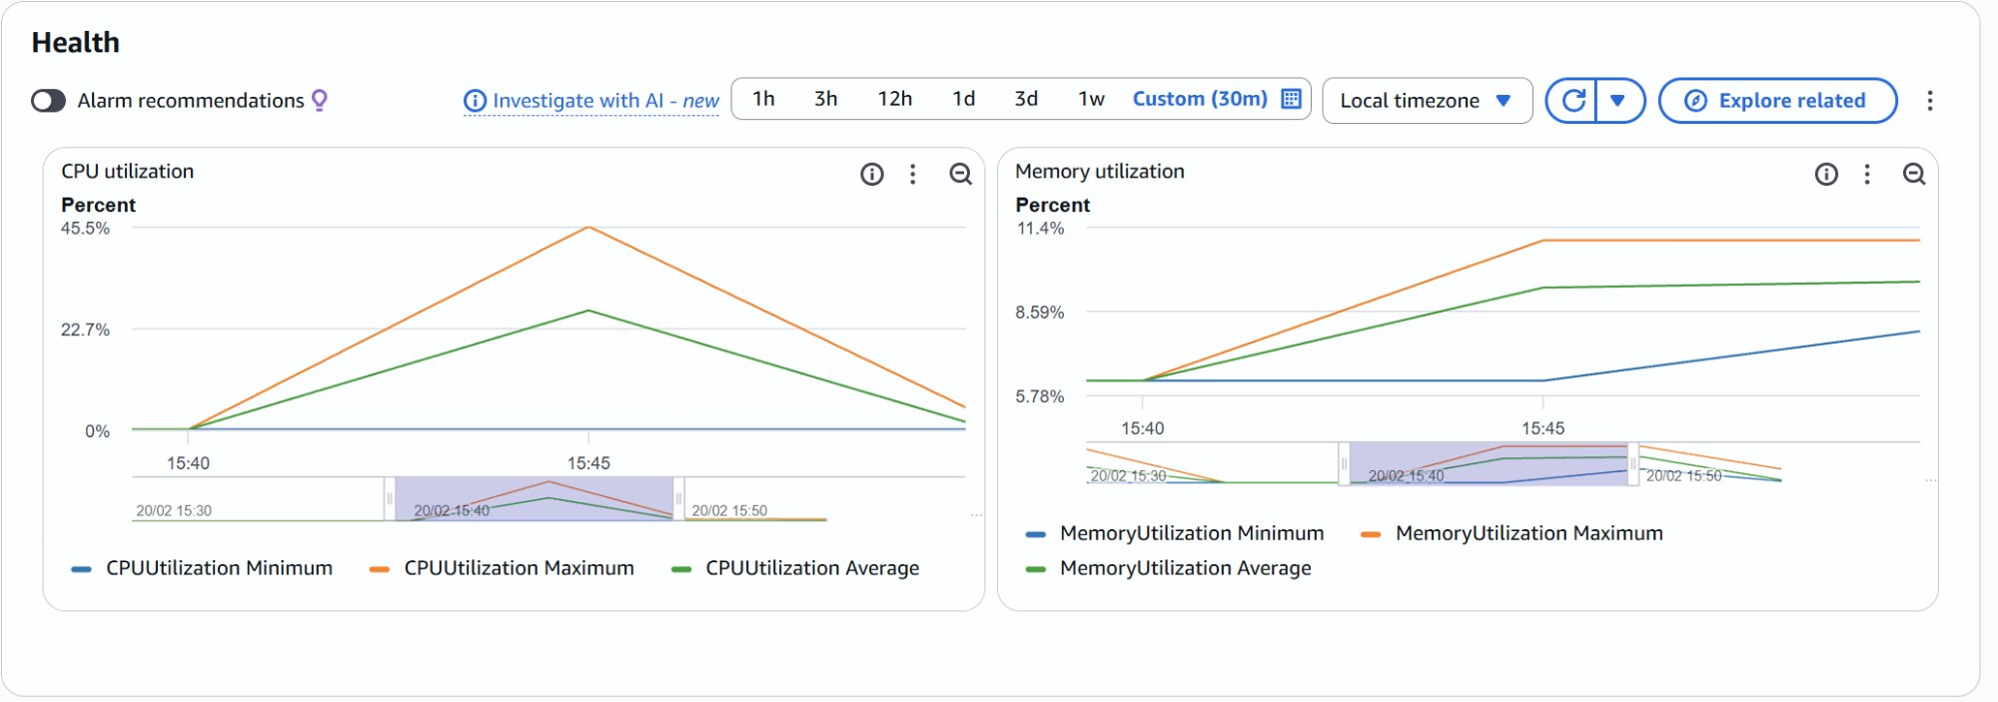
Figure 2: CloudWatch CPU and Memory utilization during 50-user stress test. CPU peaked at 45.5%, average 22.7%; memory remained flat at ~11.4%.

4.3 Summary Table
Metric | 5 Users (Baseline) | 20 Users (Moderate) | 50 Users (Breaking Point)
CPU Max | 15.3% | 45.5% | ~3x increase
CPU Average | ~7% | ~22.7% | Linear growth trend
Memory Max | ~11% | ~11.4% | Essentially flat
Avg Response Time | ~12ms | ~12ms | No degradation yet
Failures | 0 | 0 | —

5. Analysis

5.1 Which resource hit the limit first?
CPU was clearly the constrained resource. As concurrent users increased from 5 to 50, CPU utilization grew proportionally — from ~7% average to ~22.7% average, and from 15.3% peak to 45.5% peak. Notably, the required 20-user test produced only ~15% CPU — well below the expected ~60% threshold. This is because the sync.Map key lookups are highly optimized and each request only checks 100 products, meaning the per-request CPU cost is very low. Higher concurrency was needed to generate meaningful load on a 0.25 vCPU instance. Memory remained essentially flat throughout (~11%), confirming that products loaded at startup do not add to memory footprint with additional requests.

5.2 How much did response times degrade?
Response times remained at approximately 12ms even under 50-user load, with zero failures in both test runs. The service had not yet reached its absolute breaking point, but the CPU trend was clearly linear — doubling users roughly doubled CPU consumption. If concurrency were pushed to 200+ users, CPU would saturate at 100% and queuing effects would cause response times to degrade significantly.

5.3 Could doubling CPU (256 → 512 units) solve this?
Yes — and this is precisely the lesson of the exercise. Because the bottleneck is CPU-bound with a fixed computation per request, doubling CPU units would approximately double throughput capacity. The workload is not constrained by memory, network I/O, or algorithmic inefficiency — it is inherently expensive computation at a fixed cost per request. Code optimization cannot eliminate this cost; the only solution is more compute power, either by vertical scaling (larger task) or horizontal scaling (more instances), as demonstrated in Part III.

6. Conclusion
CloudWatch metrics provided clear, actionable evidence that CPU was the limiting resource in this workload. The flat memory curve and rising CPU curve together indicate a compute-bound service — a pattern that is not solvable through code optimization alone. This is consistent with real-world scenarios such as AI inference, video processing, or encryption where each request has an irreducible computational cost. The appropriate response is scaling: either increasing the CPU allocation of individual tasks (vertical scaling) or distributing load across multiple instances with an Application Load Balancer (horizontal scaling), which is addressed in Part III.

