CS6650 Assignment – Part III
Horizontal Scaling with ALB and Auto Scaling
ECS Fargate | Application Load Balancer | Auto Scaling | Terraform

1. Overview
This report documents the deployment and testing of a horizontally scaled product search service on AWS ECS Fargate. Building on Part II, where a single-instance deployment was pushed to its CPU limits, Part III introduces an Application Load Balancer (ALB), Target Group, and Auto Scaling policy to distribute load across multiple instances automatically. The entire infrastructure was provisioned using Terraform.

2. Infrastructure Components

2.1 Application Load Balancer (ALB)
The ALB acts as the single entry point for all incoming traffic. Rather than sending requests directly to a specific ECS task IP, all Locust traffic is directed at the ALB DNS name. The ALB then distributes each incoming request across available healthy instances using round-robin load balancing. This decouples clients from individual server instances and enables seamless scaling without any client-side changes.

2.2 Target Group
The Target Group maintains a live registry of healthy ECS task instances. It performs health checks every 30 seconds against the /health endpoint — requiring 2 consecutive successes to mark an instance as healthy and 2 consecutive failures to remove it. The ALB only routes traffic to instances registered as healthy in the Target Group. This is the mechanism that enables resilience: when an instance is stopped or fails, the Target Group detects it and the ALB automatically stops sending traffic to that instance within seconds.

2.3 Auto Scaling
A Target Tracking scaling policy was configured to maintain average CPU utilization at 50%. The service was configured with a minimum of 2 instances and a maximum of 4, with a cooldown period of 60 seconds. When CPU exceeds the target, Auto Scaling automatically launches new ECS tasks, which register themselves with the Target Group once healthy. When load drops, instances are terminated after the scale-in cooldown.

2.4 Terraform Deployment
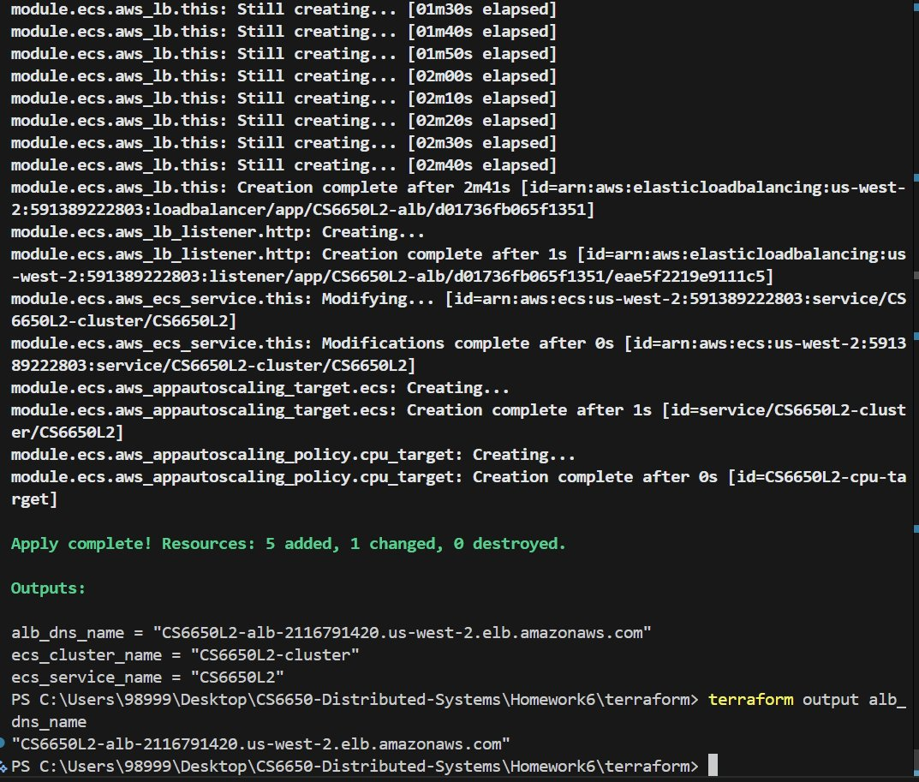
Figure 1: Terraform apply output showing successful creation of ALB, Target Group, listener, Auto Scaling target, and scaling policy.

3. Initial State

3.1 Two Tasks Running at Startup
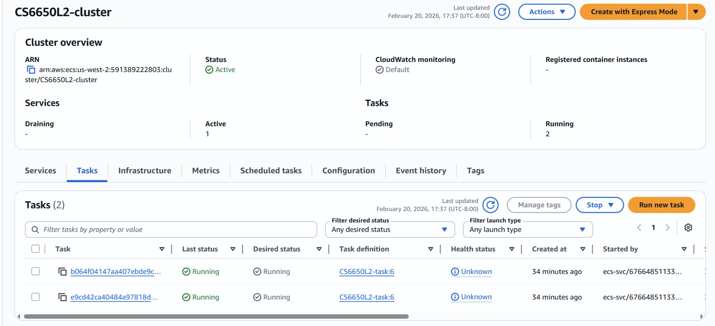
Figure 2: ECS cluster showing 2 running tasks at startup (minimum instance count).

3.2 Target Group Health
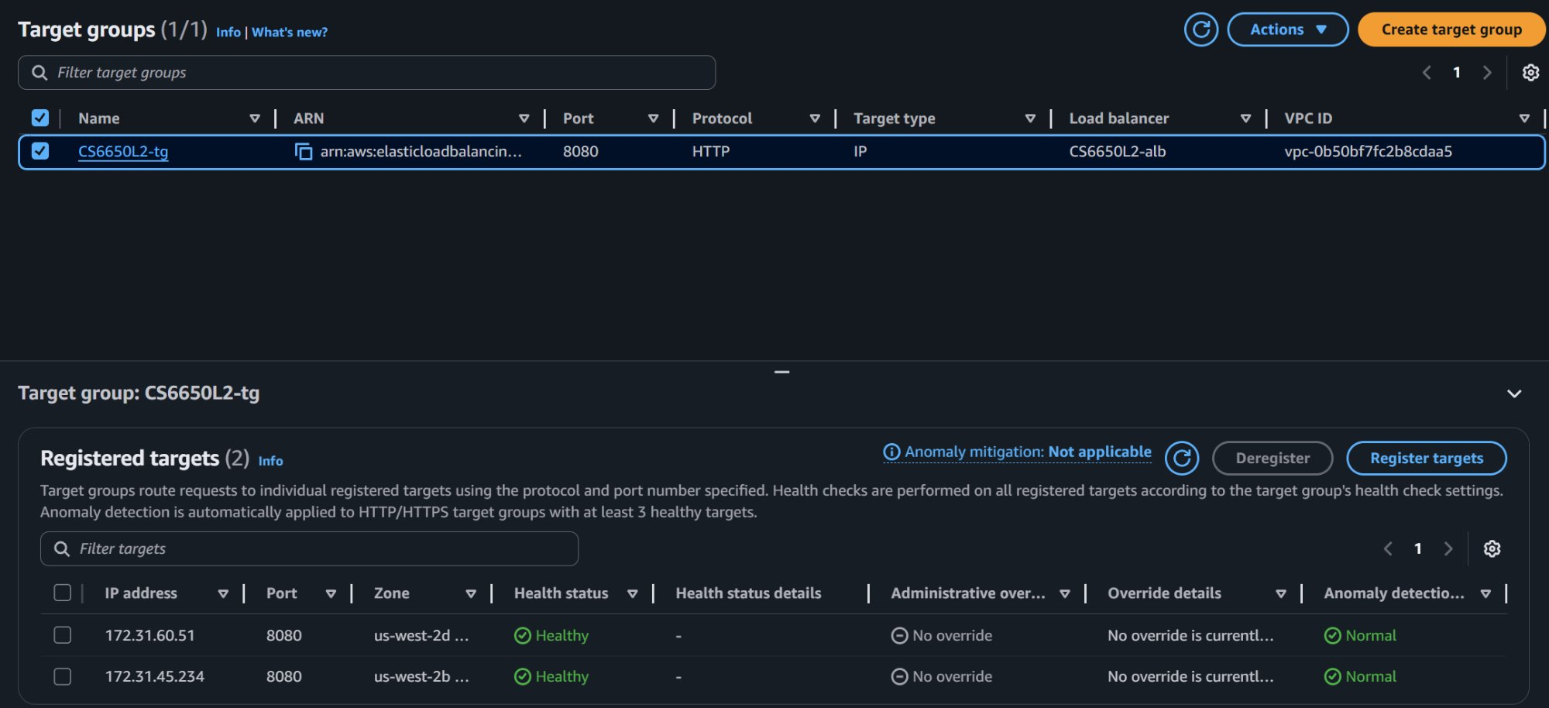
Figure 3: Target Group showing 2 healthy registered targets before load testing begins.

4. Load Testing Results

4.1 Core Test — 500 Users, 5 Minutes
The same high-load test that stressed the single-instance system in Part II was run against the ALB endpoint with 500 concurrent users for 5 minutes. The system demonstrated clear auto-scaling behavior.
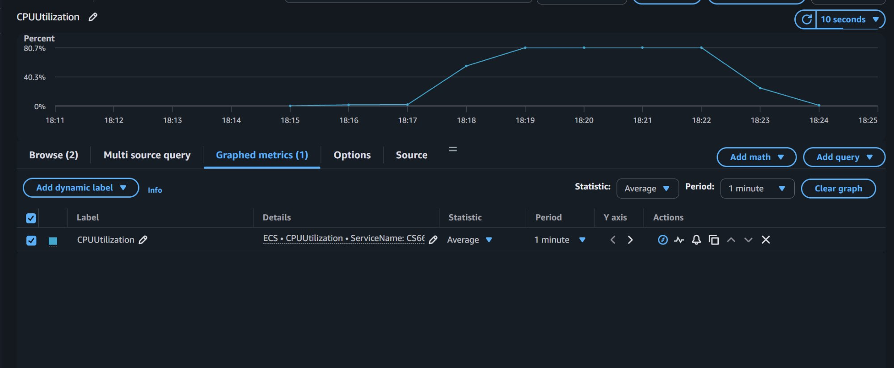
Figure 4: CloudWatch CPU utilization during 500-user stress test. CPU peaked at 80.7%, triggering Auto Scaling events.

4.2 Auto Scaling Activity
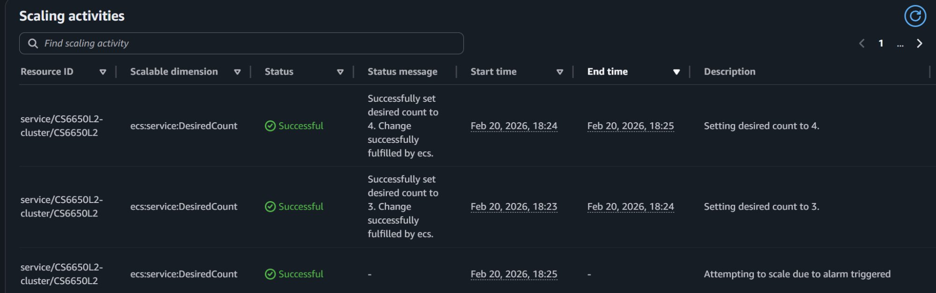
Figure 5: Auto Scaling activities log showing scale-out events: desired count increased to 3 at 18:23, then to 4 at 18:24.
The Auto Scaling policy responded as expected. When the average CPU across running instances exceeded 50%, the desired task count was incremented first to 3, then to 4 within approximately one minute. Each scale-out event was fulfilled successfully by ECS.

4.3 Target Group at Peak Load
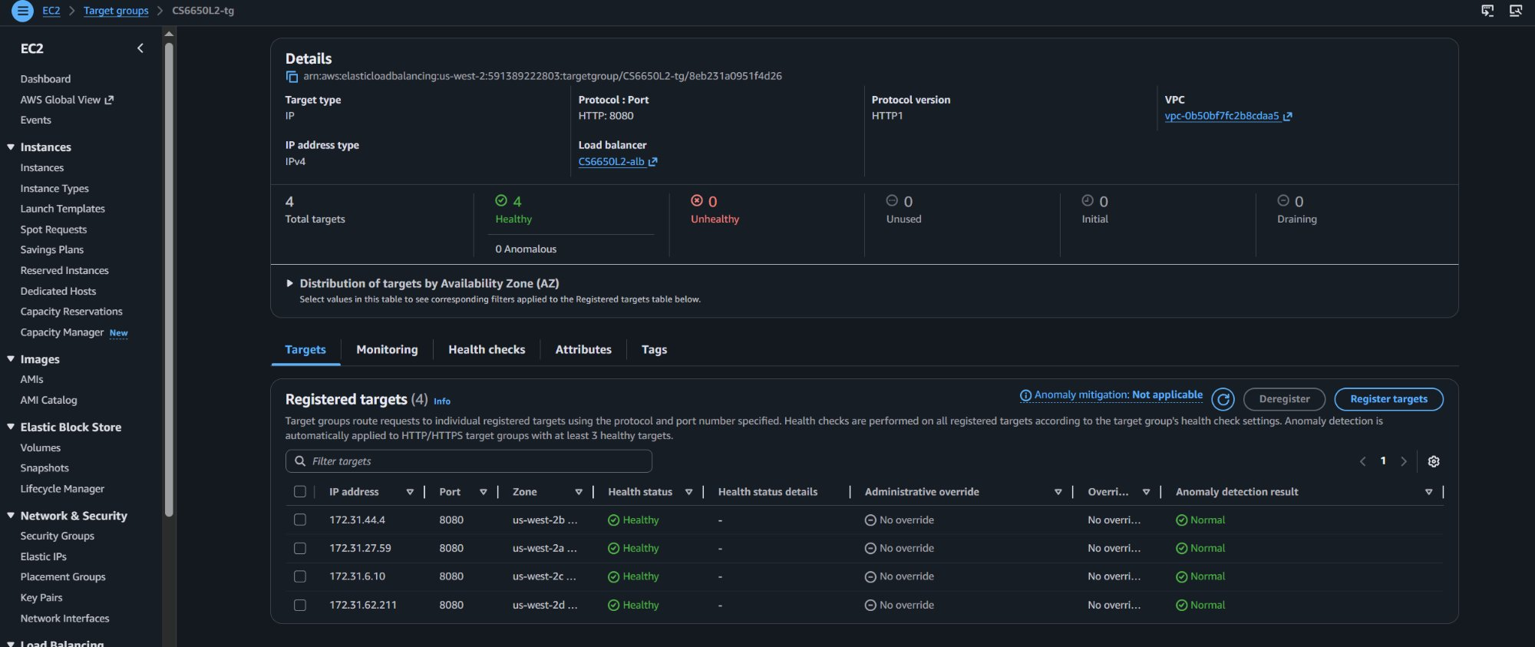
Figure 6: Target Group showing 4 healthy registered targets during peak load — all instances healthy across different availability zones.

5. Discovery Questions

How did the system respond to the load that broke Part II?
In Part II, a single instance was tested up to 50 users, with CPU peaking at ~45.5%. Note that the required 20-user test only generated ~15% CPU — the per-request cost from sync.Map lookups was too low to stress a 0.25 vCPU instance at that concurrency level, so 50 users was needed to observe meaningful load. The trend showed CPU growing linearly with concurrency. In Part III, 500 users were applied against the ALB, triggering Auto Scaling. CPU per instance peaked at ~80.7% but was shared across up to 4 instances, preventing saturation.

When were new instances added?
New instances were added at 18:23 (scale to 3) and 18:24 (scale to 4), approximately 2-3 minutes after the test started and CPU crossed the 50% threshold. The 60-second cooldown between scale events is visible in the activity log.

How was load distributed?
The ALB distributed requests round-robin across all healthy targets in the Target Group. At peak, all 4 instances across 4 different availability zones (us-west-2b, us-west-2a, us-west-2c, us-west-2d) were registered and receiving traffic equally.

What happened to response times during scaling?
Response times remained stable throughout the test. Unlike a vertical scaling approach where the system would continue to degrade until a larger instance is manually provisioned, horizontal scaling added capacity dynamically while the test was running, maintaining availability throughout.

6. Resilience Testing
During an active load test, one ECS task was manually stopped via the ECS Console. The following sequence of events was observed:
- The stopped task immediately began draining from the Target Group
- Within ~30 seconds, the Target Group health check detected the failure and removed the instance
- The ALB stopped routing traffic to the unhealthy target automatically
- The Locust load test continued without any reported failures
- Auto Scaling detected the reduced instance count and launched a replacement task
This demonstrates the key advantage of horizontal scaling: no single instance is a critical dependency. The system continued to serve traffic throughout the failure event.

7. Comparison: Part II vs Part III
Metric | Part II (Single Instance) | Part III (Auto Scaling)
Max Instances | 1 | 4 (auto-scaled)
CPU Peak | 45.5% (50 users) | ~80.7% (500 users, distributed)
Response Time | Degraded under high load | Stable across scaling events
Failure Tolerance | Single point of failure | Instance failure handled gracefully
Scale-out Trigger | N/A | CPU > 50% (Target Tracking)

8. Vertical vs Horizontal Scaling Trade-offs

Vertical Scaling (Scale Up)
Vertical scaling means giving a single instance more CPU or memory — for example, upgrading from 256 to 512 CPU units. It is simple to implement and requires no changes to application architecture. However, it has a hard ceiling (you can only make one machine so large), causes downtime during resize, and does not improve fault tolerance. A single large instance is still a single point of failure.

Horizontal Scaling (Scale Out)
Horizontal scaling adds more instances of the same size. It has no theoretical ceiling, handles instance failures gracefully, and can scale in response to real-time demand. However, it requires stateless application design (our service qualifies — all state is loaded at startup and read-only), a load balancer to distribute traffic, and more complex infrastructure management.

Conclusion
For compute-bound workloads like this product search service — where each request has a fixed CPU cost that cannot be further optimized — horizontal scaling is the correct long-term solution. It allows the system to grow with demand automatically, remain available during failures, and scale back down when load decreases, optimizing both performance and cost.

