CS6650 – Distributed Systems Homework 6
Performance Bottlenecks & Horizontal Scaling
AWS ECS Fargate | ALB | Auto Scaling | Terraform | Locust

Part II — Identifying Performance Bottlenecks

Service Setup
A Go product search service was deployed to ECS Fargate (0.25 vCPU, 512 MB). At startup it generates 100,000 products in a sync.Map. Each search checks exactly 100 products — simulating fixed-cost computation — and returns up to 20 results.

Load Testing
Tests were run using Locust with FastHttpUser and minimal wait time (0.01–0.05s). The initial 20-user test produced only ~15% CPU — too low to observe meaningful load, as sync.Map lookups are very fast. The user count was raised to 50 to generate observable stress.

Results
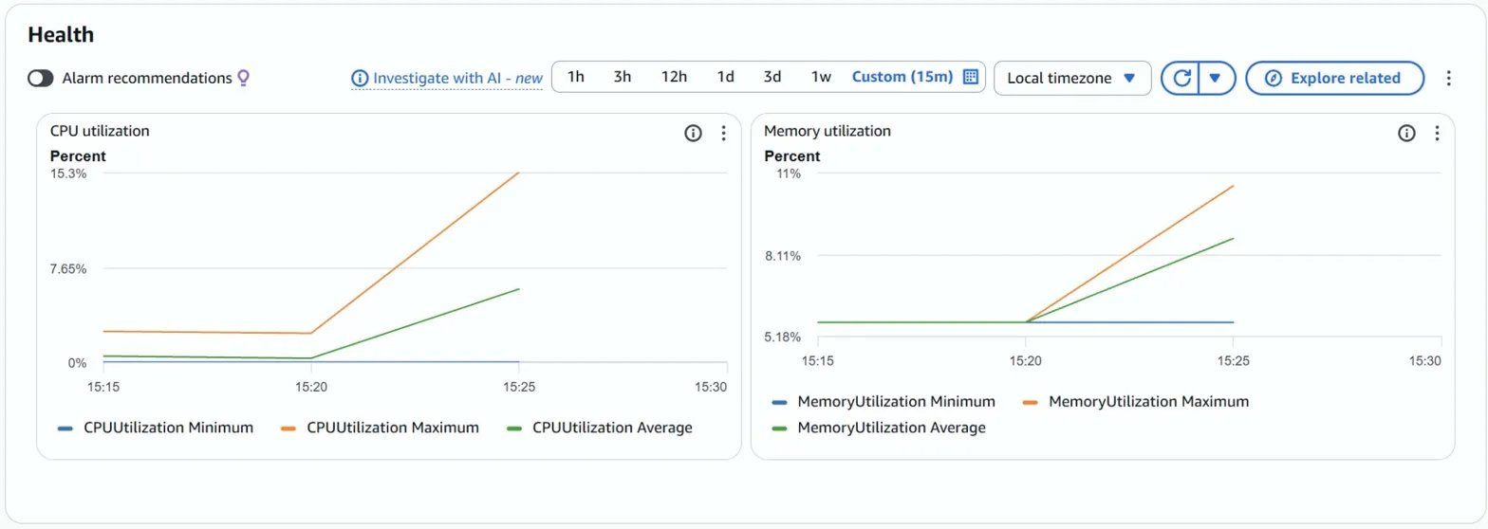
Figure 1: Baseline (5 users) — CPU peaked at 15.3%, memory stable at ~11%.
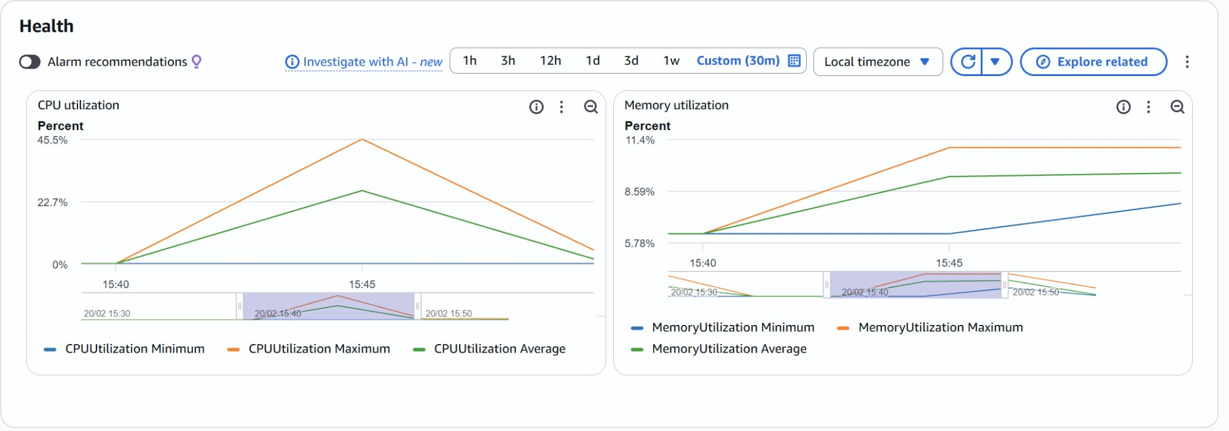
Figure 2: Stress test (50 users) — CPU peaked at 45.5%, average 22.7%. Memory remained flat.

Metric | 5 Users (Baseline) | 50 Users (Stress)
CPU Max | 15.3% | 45.5%
CPU Average | ~7% | ~22.7%
Memory | ~11% | ~11.4% (flat)
Avg Response | ~12ms | ~12ms
Failures | 0 | 0

Analysis
CPU scaled linearly with concurrency while memory stayed flat — confirming a CPU-bound workload. Each request has a fixed compute cost (100 product string comparisons) that cannot be optimized away. Response times were stable because the service had not yet fully saturated, but at higher concurrency CPU would hit 100% and queuing would cause degradation. The solution is not better code — it is more compute power.
Doubling CPU (256 → 512 units) would roughly double throughput, but hits a ceiling and remains a single point of failure. The better answer is horizontal scaling, implemented in Part III.

Part III — Horizontal Scaling with ALB & Auto Scaling

Infrastructure
Three components were added via Terraform on top of the Part II service:
- Application Load Balancer (ALB) — receives all traffic and distributes requests across healthy instances
- Target Group — tracks which ECS tasks are healthy via /health checks every 30s; unhealthy instances are automatically removed from rotation
- Auto Scaling — target tracking policy: maintain average CPU at 50%, min 2 / max 4 instances, 60s cooldown

Initial State (2 Tasks)
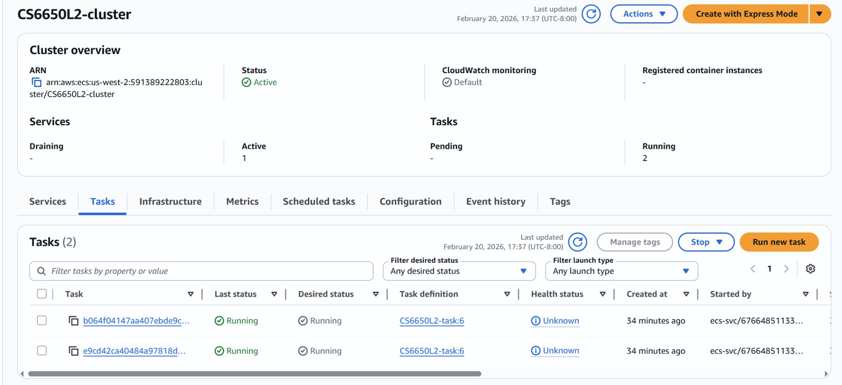
Figure 3: ECS cluster with 2 running tasks at startup (minimum instance count).
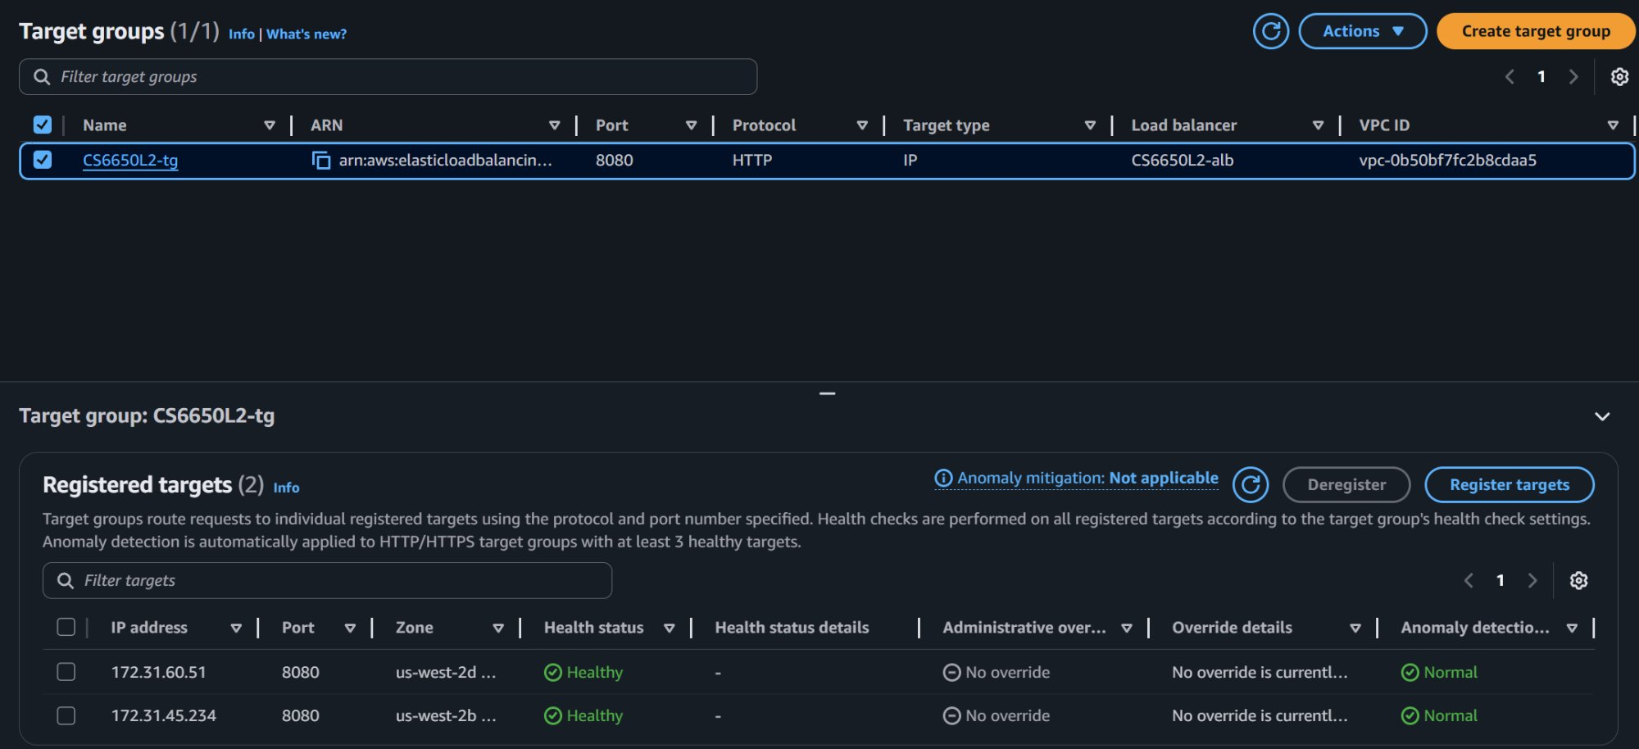
Figure 4: Target Group showing 2 healthy registered targets before load testing.

Stress Test — 500 Users, 5 Minutes
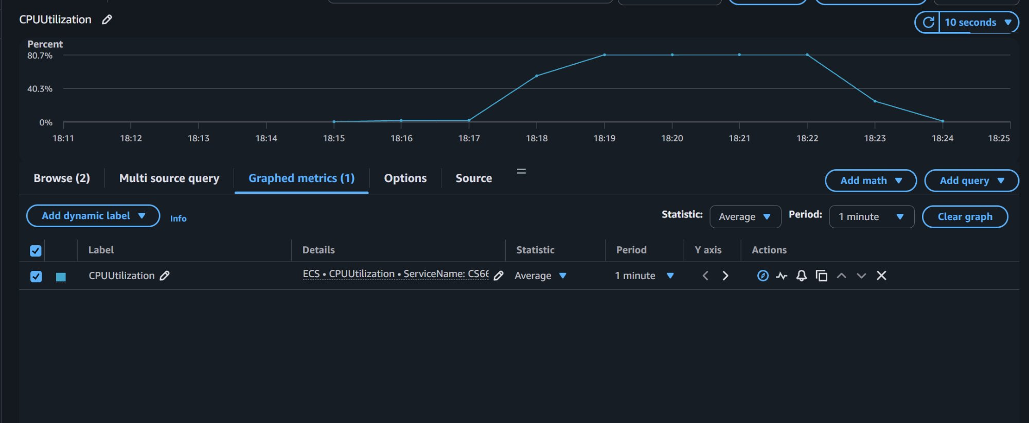
Figure 5: CloudWatch CPU during 500-user test. CPU peaked at ~80.7%, triggering Auto Scaling events.
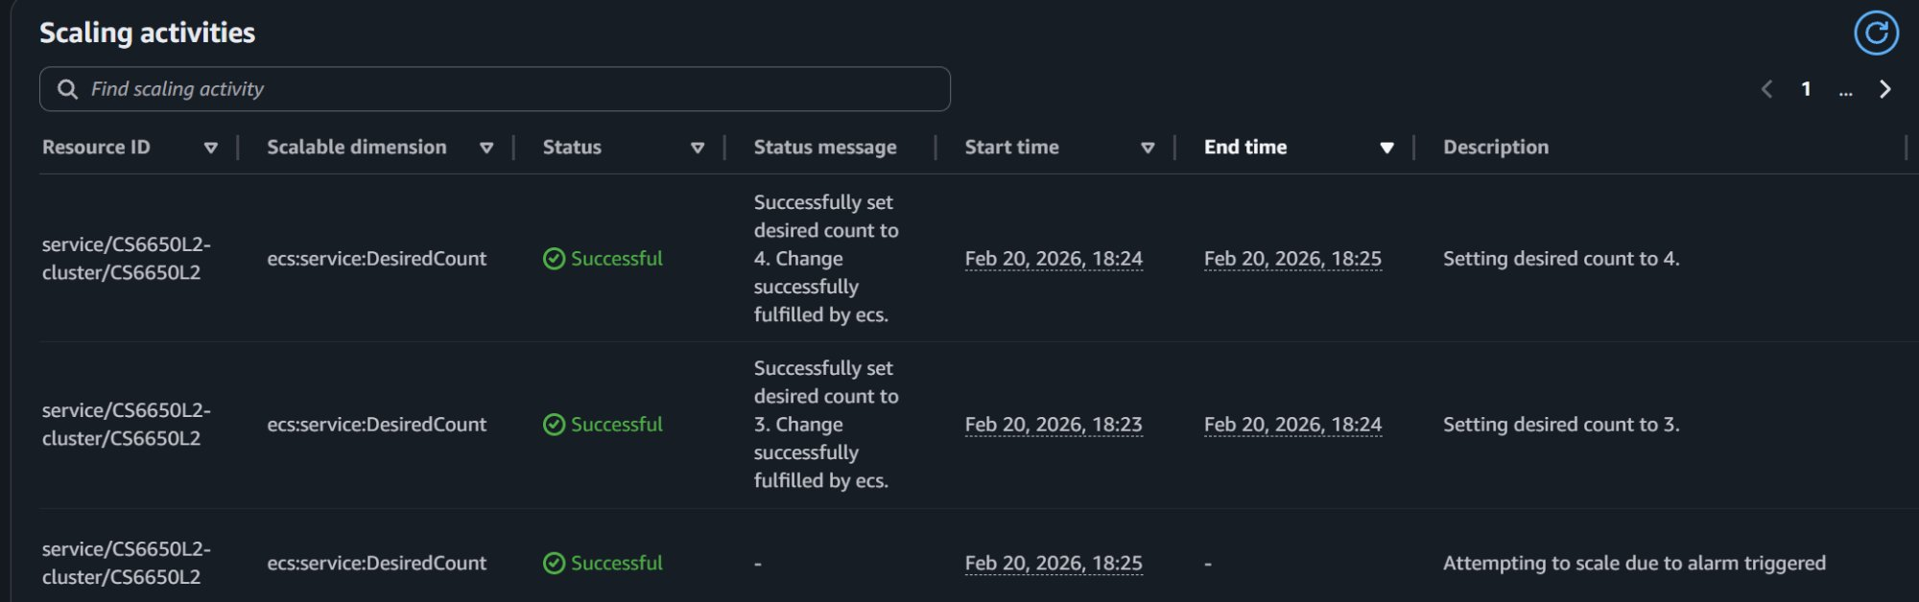
Figure 6: Auto Scaling activities — desired count increased from 2 → 3 (18:23) → 4 (18:24) as CPU exceeded 50% threshold.
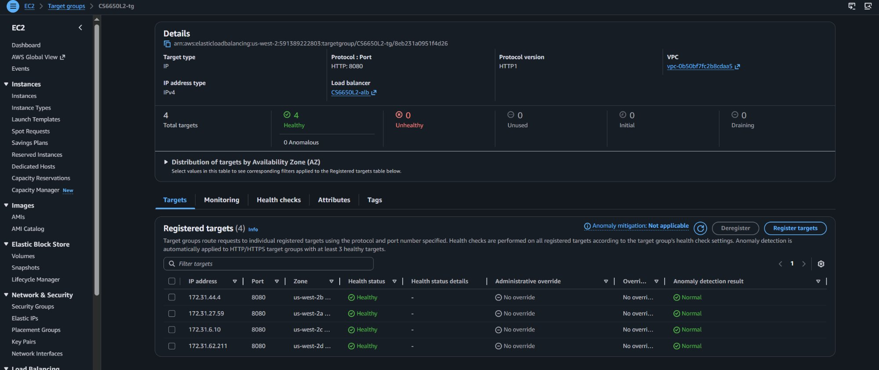
Figure 7: Target Group at peak load — 4 healthy targets across 4 availability zones.

Key Observations
- Auto Scaling fired within ~2 minutes of sustained high CPU, incrementally adding instances
- All 4 instances registered as healthy in the Target Group and received traffic
- Response times remained stable throughout scaling events — no degradation observed
- Resilience test: manually stopping one task caused the Target Group to remove it within ~30s; Locust reported zero failures

Vertical vs Horizontal Scaling
 | Vertical (Scale Up) | Horizontal (Scale Out)
Approach | Larger instance (more CPU/RAM) | More instances of same size
Ceiling | Hard limit per instance | No practical limit
Fault Tolerance | Still single point of failure | Instance failures handled gracefully
Best For | Simple, stateful workloads | Stateless, compute-bound workloads
This Service | Would help short-term | Correct long-term solution

Conclusion
Part II identified CPU as the bottleneck for a compute-bound workload where code optimization cannot reduce per-request cost. Part III demonstrated that horizontal scaling with an ALB and Auto Scaling policy resolves this bottleneck dynamically — distributing load across multiple instances, recovering from failures automatically, and scaling back down when demand drops.

