CS6650 Homework 5
Product API with Terraform & Load Testing

Part II: Product API

API Endpoints
Based on the OpenAPI specification, the following two endpoints are implemented:
Method | Endpoint | Description | Status Codes
GET | /products/{productId} | Get product by ID | 200, 404, 500
POST | /products/{productId}/details | Add/update product details | 204, 400, 404, 500

Product Schema (all fields required)
Field | Type | Constraints
product_id | int32 | ≥ 1
sku | string | 1-100 chars
manufacturer | string | 1-200 chars
category_id | int32 | ≥ 1
weight | int32 | ≥ 0
some_other_id | int32 | ≥ 1

How to Run

Run Locally
cd src
go mod tidy
go run main.go
Server starts on http://localhost:5173

Run with Docker
docker build -t product-api .
docker run -p 5173:5173 product-api
Docker image size: ~24.71 MB (multi-stage Alpine build)

Response Code Examples

204 — Product Details Added (POST)
curl -i -X POST http://localhost:5173/products/1/details \
-H "Content-Type: application/json" \
-d '{"product_id":1,"sku":"SKU-001","manufacturer":"Acme","category_id":10,"weight":5,"some_other_id":99}'
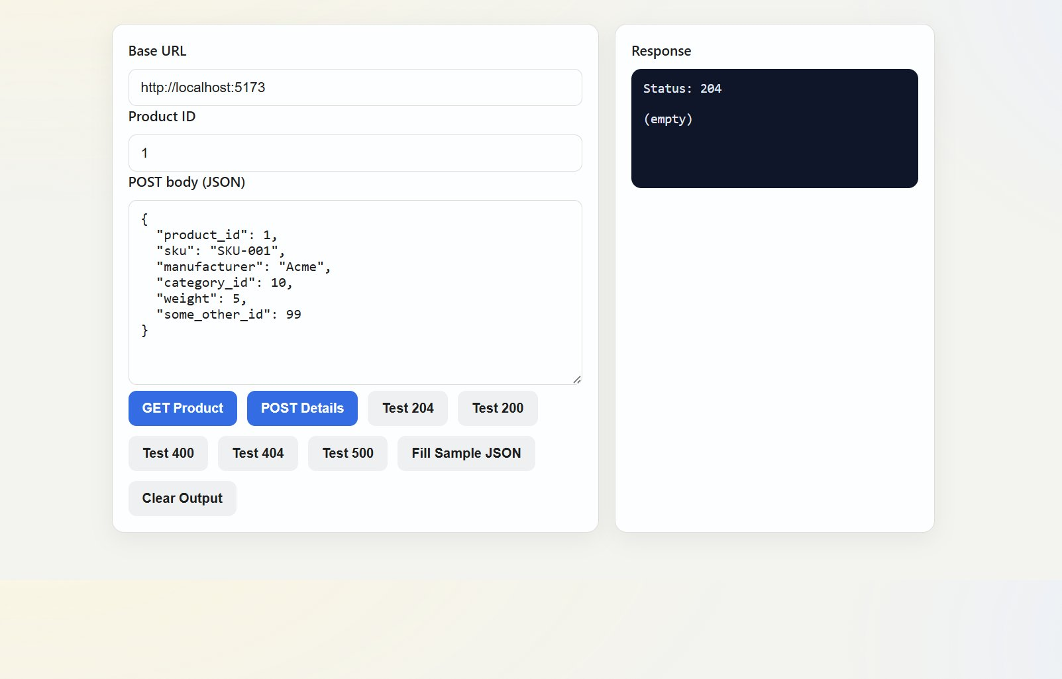

200 — Product Found (GET)
curl http://localhost:5173/products/1
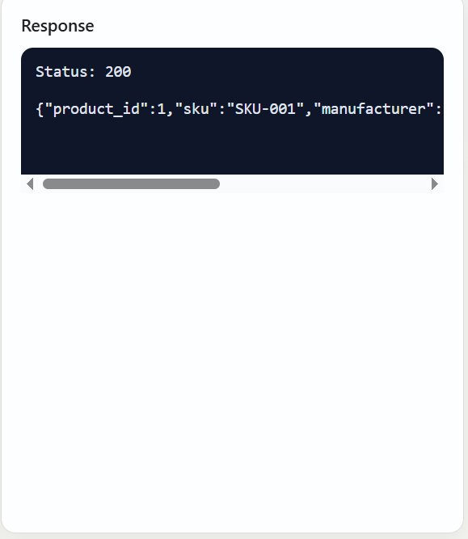

400 — Invalid Input
curl -X POST http://localhost:5173/products/1/details \
-H "Content-Type: application/json" \
-d '{"product_id":1,"sku":"","manufacturer":"Acme","category_id":1,"weight":100,"some_other_id":1}'
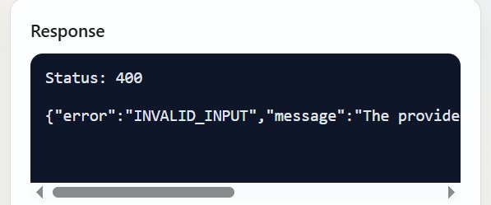

404 — Product Not Found
curl http://localhost:5173/products/9999
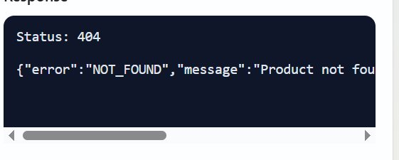

500 — Internal Server Error
The server includes a panic recovery middleware. Any unexpected panic is caught and returns a 500 JSON response.

Data Storage
Products are stored in-memory using a Go map[int]*Product protected by sync.RWMutex for thread-safe concurrent read/write access. Data does not persist across server restarts.

Part III: Terraform Deployment to AWS

Deployment Steps
- Configure AWS credentials: aws configure
- Initialize Terraform:
cd terraform && terraform init -upgrade
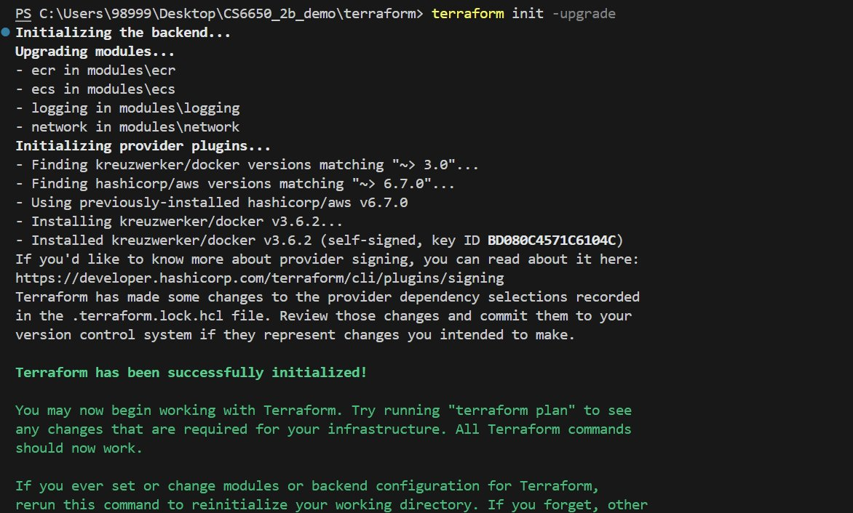
- Deploy: terraform apply
- Get public IP from ECS task network interface:
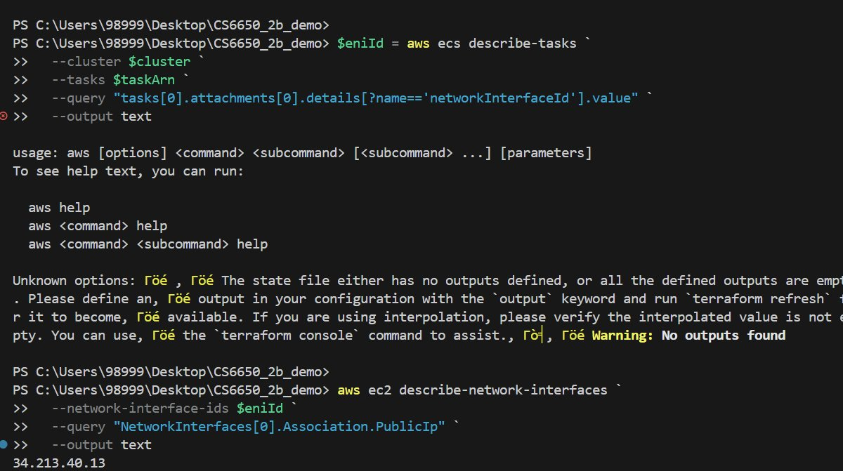
- Test on AWS:
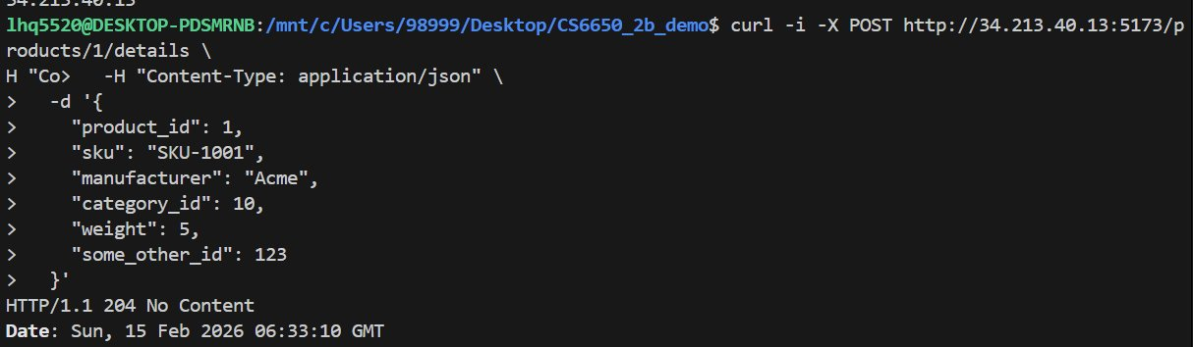
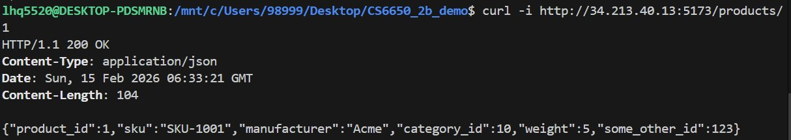
- Tear down: terraform destroy

Part IV: Load Testing with Locust

Test Script Design
- GET:POST = 3:1 ratio — simulates real-world read-heavy e-commerce traffic
- on_start pre-populates 50 products — ensures GET requests hit valid data
- Both HttpUser and FastHttpUser included for comparison
- wait_time = between(1, 3) — realistic think time

How to Run Locust
pip install locust
locust -f locustfile.py --host=http://localhost:5173
Open http://localhost:8089 to configure users and spawn rate.

Test Results Summary
Environment | Users | Spawn Rate | Total Requests | Failures | Avg RT (ms) | RPS | Duration
Local | 10 | 2 | 1,337 | 0 (0%) | 1.1 | 8.0 | 2m 47s
Local | 100 | 10 | 24,468 | 0 (0%) | 2.1 | 62.0 | 6m 35s
Local | 500 | 50 | 142,191 | 0 (0%) | 25.8 | 295.3 | 8m 1s
AWS | 10 | 2 | 1,592 | 0 (0%) | 13.4 | 7.1 | 3m 43s
AWS | 100 | 10 | 18,248 | 0 (0%) | 12.9 | 67.1 | 4m 33s
AWS | 500 | 50 | 89,546 | 0 (0%) | 38.7 | 332.0 | 4m 30s

Key Observations
- Zero failure rate across all tests — the Go server handled all load levels without errors.
- Local vs AWS latency: Local tests show ~1ms average response time at low load, while AWS adds ~12ms of network latency due to the round-trip to AWS Fargate.
- Scaling behavior: As users increase (10 → 100 → 500), average response time grows gradually (1.1ms → 2.1ms → 25.8ms locally), showing graceful degradation.
- RPS scales well: RPS increased roughly proportionally with users (8 → 62 → 295 locally), indicating no bottleneck at these levels.

HttpUser vs FastHttpUser
In our tests, we did not observe a significant difference between HttpUser and FastHttpUser. Reasons:
- The bottleneck is the server, not the client. Our Go server responds in ~1ms locally. Both HTTP clients keep up easily at this speed.
- Network latency dominates. When testing against AWS, the ~12ms round-trip far outweighs any client-side overhead difference.
- FastHttpUser shines when generating extremely high RPS from a single worker, or when response times are sub-millisecond and client overhead becomes significant.

Read vs Write Ratio
In a real e-commerce system, reads (GET) vastly outnumber writes (POST). This is why our test uses a 3:1 GET:POST ratio. A sync.RWMutex-protected hashmap is ideal because it allows concurrent reads while only blocking for writes — much better throughput than a regular Mutex for read-heavy workloads.

Discussion Questions

Scalable Backend Design for the Full API
The complete api.yaml defines four services: Products, Shopping Cart, Warehouse, and Payments. A scalable design would use:
- Microservices architecture — separate each service for independent scaling.
- Database per service — Products: read-replica PostgreSQL; Cart: Redis; Warehouse: PostgreSQL with transactions; Payments: ACID-compliant DB.
- Message queue (SQS/Kafka) for async checkout, decoupling services.
- API Gateway for routing, rate limiting, and authentication.
- Caching layer (Redis/Memcached) for frequently accessed product data.

Terraform: Declarative vs Imperative
Declarative means you describe WHAT the desired end state should be, not HOW to get there. You write "I want an ECS cluster with this task" — Terraform figures out the steps.
Imperative languages (like shell scripts) require specifying every step and handling ordering/errors yourself.
Terraform's declarative approach helps by automatically handling dependency ordering, detecting drift, and previewing changes (terraform plan), making infrastructure safer and reproducible.

