a)

if you want to store a new gate without any assigned airline, you are not able to do so.

For example, if KLX Airport wants to add a new Terminal D with 25 gates but has no airlines assigned yet, there is no way to insert this information into the table

b)

if a gate is closed, so you wan to delete it form the table. You can not do that since the gate information is tied to multiple airlines

Ex. Suppose KLX Airport wants to remove Terminal A because it is being decommissioned.

c)

if you want to update departing gate of delta airline, you may not be able to update it. Since, the there are two date tied to delta airline

Ex. Suppose Delta Airlines (DL) moves to Terminal C instead of Terminal B

1)

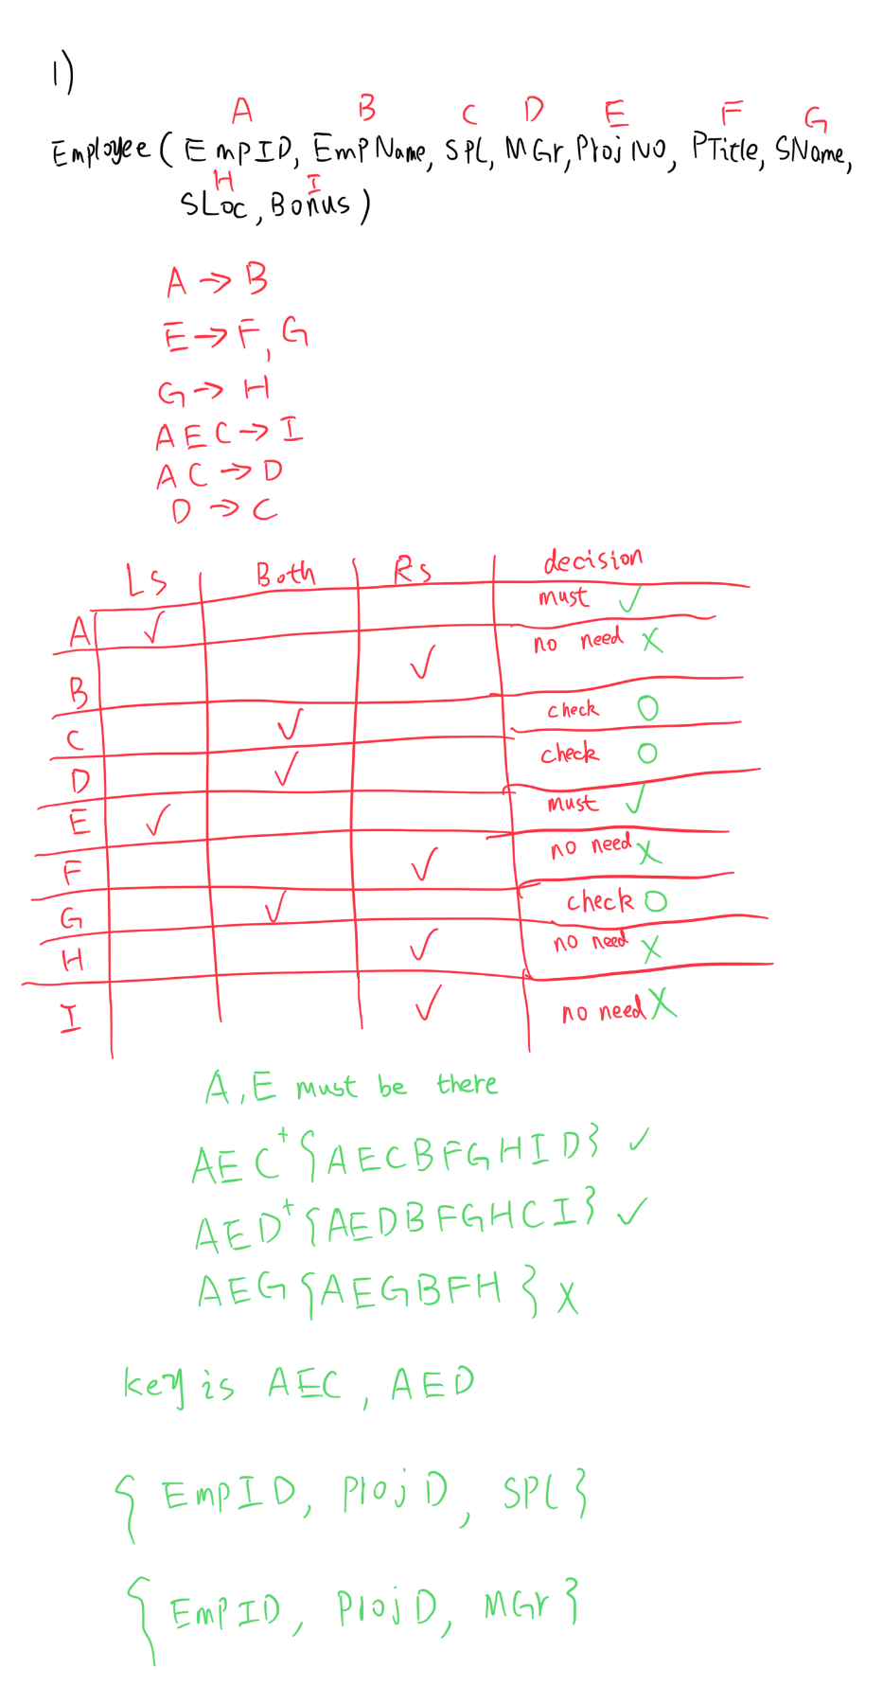

2)

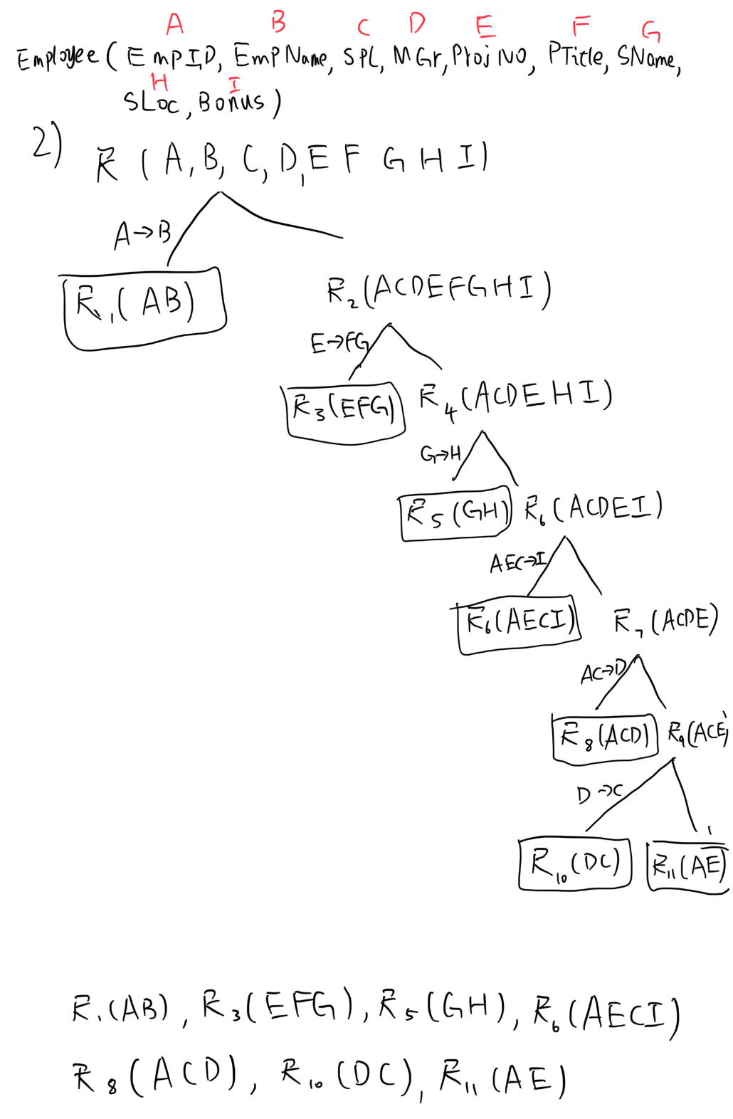

3)

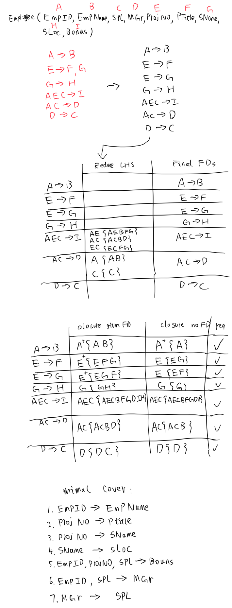

4)

