**Early Season**

|  |  |
| --- | --- |
| Ecoregion | Number of Lakes |
| Mixed Wood Plains | 454 |
| Mixed Wood Shield | 82 |
| Temperate Prairies | 37 |

**Prime Season**

|  |  |
| --- | --- |
| Ecoregion | Number of Lakes |
| Mixed Wood Plains | 1055 |
| Mixed Wood Shield | 860 |
| Temperate Prairies | 180 |

**Late Season**

|  |  |
| --- | --- |
| Ecoregion | Number of Lakes |
| Mixed Wood Plains | 278 |
| Mixed Wood Shield | 28 |
| Temperate Prairies | 19 |

|  |  |  |  |  |  |  |
| --- | --- | --- | --- | --- | --- | --- |
|  | **Chlorophyll a** | | | **Secchi Depth** | | |
| **Predictor** | **Early** | **Prime** | **Late** | **Early** | **Prime** | **Late** |
| Intense Urban |  | **-0.0101** | **-0.0133** |  | **0.0042** | **0.0039** |
| Open Urban | **-0.0108** | **-0.0252** | **-0.0238** | **0.0124** | **0.0156** | **0.0145** |
| Barren |  |  |  | **0.0196** | **0.0076** |  |
| Forest | **-0.0153** | **-0.0245** | **-0.0249** | **0.0123** | **0.016** | **0.0162** |
| Grass Shrub |  | **-0.0253** | **-0.0281** | **0.0102** | **0.0145** | **0.0176** |
| Wetland |  | **-0.0125** | **-0.0113** |  |  |  |
| Pasture | **0.0085** |  |  |  | **0.0033** |  |
| Row Crop | **0.0032** | **-0.0069** |  |  | **0.0046** |  |
| Lake IWS Ratio | **-0.3086** | **-0.4174** | **-0.2633** | **0.2144** | **0.3943** | **0.2467** |

|  |  |  |  |  |  |  |
| --- | --- | --- | --- | --- | --- | --- |
|  | **Chlorophyll a** | | | **Secchi Depth** | | |
| **Predictor** | **Early** | **Prime** | **Late** | **Early** | **Prime** | **Late** |
| Intense Urban |  | **-2.30%** | **-3.00%** |  | **1.00%** | **0.90%** |
| Open Urban | **-2.50%** | **-5.60%** | **-5.30%** | **2.90%** | **3.70%** | **3.40%** |
| Barren |  |  |  | **4.60%** | **1.80%** |  |
| Forest | **-3.50%** | **-5.50%** | **-5.60%** | **2.90%** | **3.80%** | **3.80%** |
| Grass Shrub |  | **-5.70%** | **-6.30%** | **2.40%** | **3.40%** | **4.10%** |
| Wetland |  | **-2.80%** | **-2.60%** |  |  |  |
| Pasture | **2.00%** |  |  |  | **0.80%** |  |
| Row Crop | **0.70%** | **-1.60%** |  |  | **1.10%** |  |
| Lake IWS Ratio | **-50.90%** | **-61.80%** | **-45.50%** | **63.80%** | **147.90%** | **76.50%** |

Early Chlorophyll a

Early Secchi Depth

Prime Chlorophyll a

Prime Secchi Depth

Late Chlorophyll a

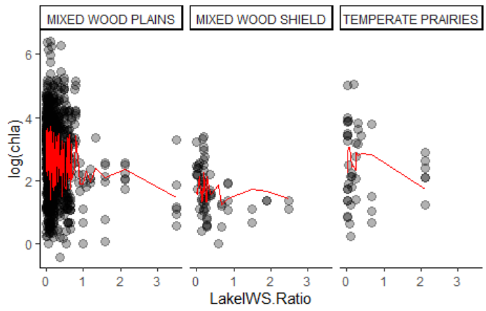

Late Secchi Depth



