Assignment6 – aws

Tasks
- Deploy your Flask backend and Express frontend on a single Amazon EC2 instance.
- Deploy your Flask backend and Express frontend on separate EC2 instances.
- Deploy your Flask backend and Express frontend as Docker containers using AWS ECR, ECS, and VPC services.
Task1:

- 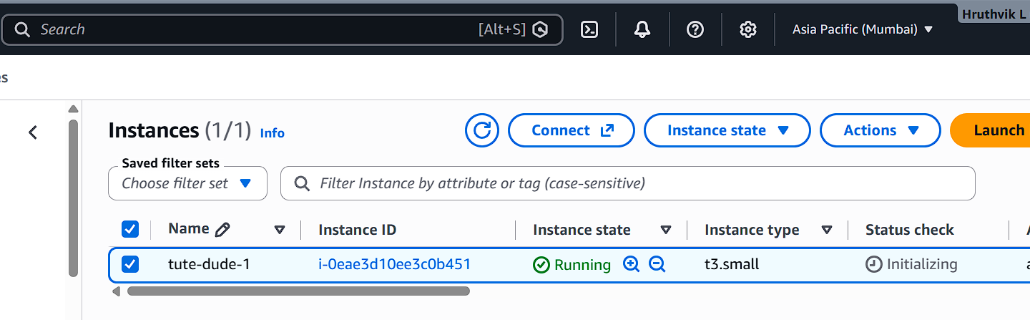
- Created An ec2 instance on Mumbai server
- Ssh into the server (buntu@52.66.51.130 1st machine)
- Git pulled my 5th assignment from my git repo
- Used scp to copy my mongo cred from .envfile
- Installed all the required dependencies
- Running the backend and front end app on a single ec2 instance:

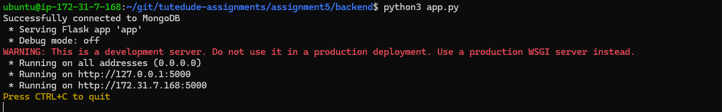

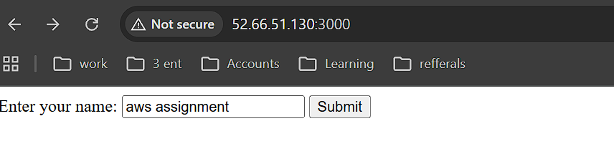

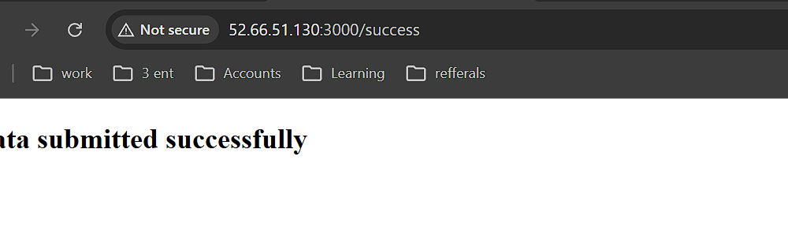
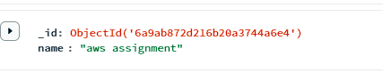

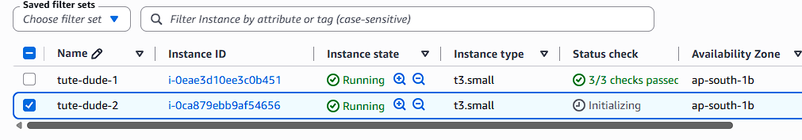
Task2: for the 2nd task I’ve launched another instance with same key pair and security as for the old one.
- Copied git dir from server 1 using ->
scp -i "tute-dude.pem" -r ~/git ubuntu@13.127.89.26:~/git
- Sudo apt update
- Sudo apt install python env
- Sourcing the env pip install requirements for backend
- Installing npm and node for front end
- Changed the localhost to 1st host public ip
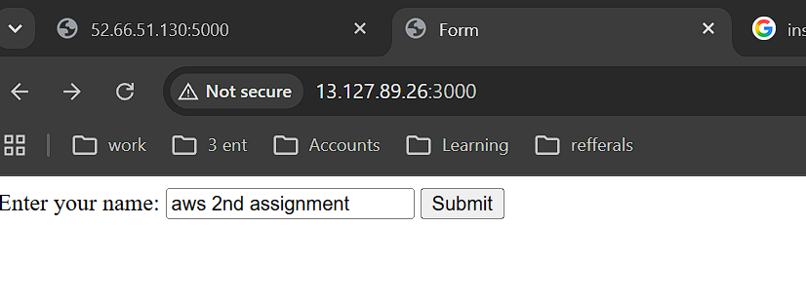

Above 2 images to show the front end running on host 2

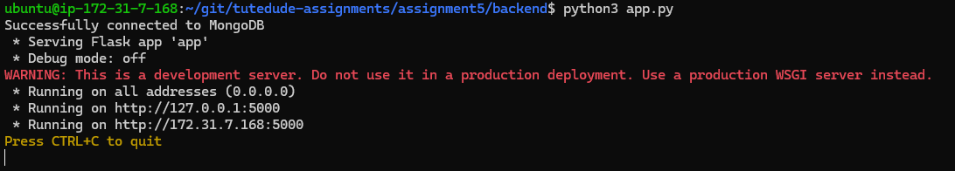
While backend runs on host one

On host 2 front end we see data submitted successfully:
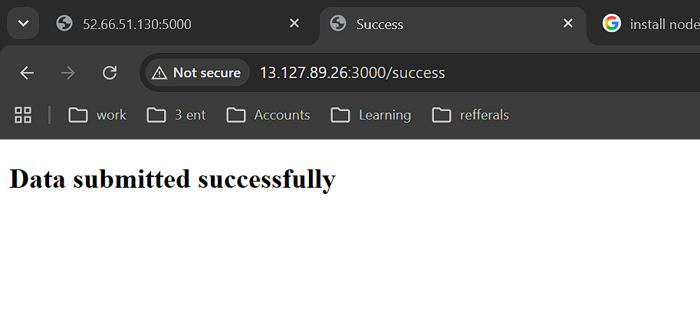
And here is the db entry:
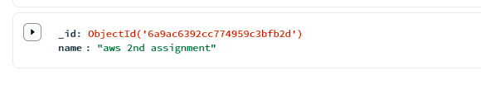

Task 3

Created 2 ecr’s:
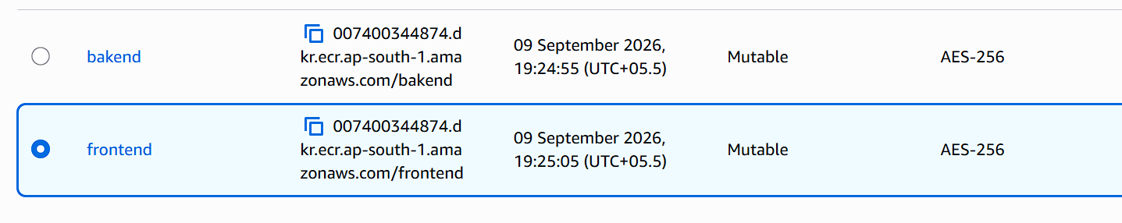

Then created a ecs cluster:

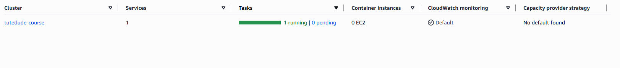
Created a task
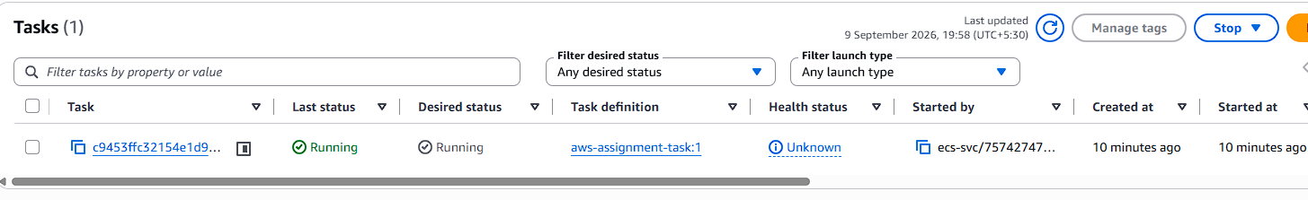

With 2 containers

While container-1 the backend container had mjy mongo uri as env variable:
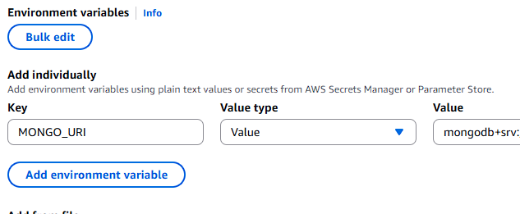

Then created the service:

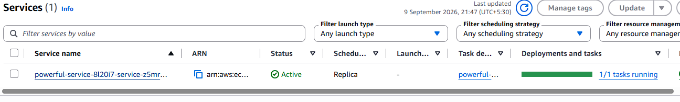

Results:

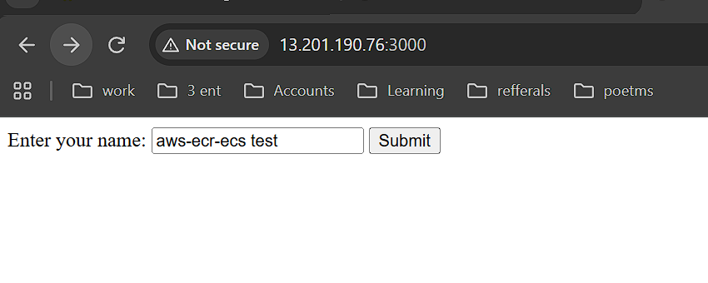
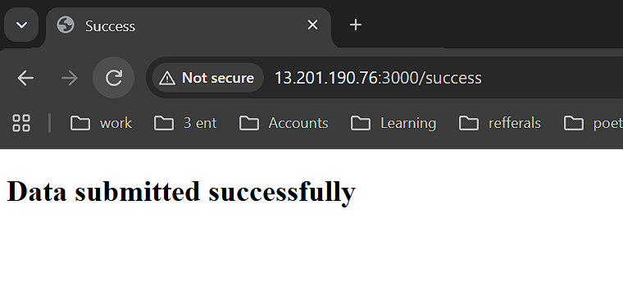
Entry in mongodb:
