### Equipment Calibrations / Inventory

#### Application Description

The equipment calibrations database maintains the latest calibration records for test equipment used throughout the department. While all inventory that is received in shipping gets logged in and given a company asset number (monitors, laptops, servers, test equipment, etc), not all inventory is related to the testing environment. The Equipment Calibration Database application (EquipCal), contains all test equipment across all testing departments and provides a searchable GUI to pull up records.

#### Functionality (Current)

1. Stores equipment identifier information (Make, Model, S/N, etc).
2. Associates a given piece of equipment with a given type of testing.
   1. It is possible for a single piece of equipment to be used for multiple tests.
   2. It is possible for a single piece of equipment to require calibration, but not used in any specific test.
3. Associates a picture file to the record.
4. Provides a file path to the user’s manual and calibration certificate (latest) which can be viewed
5. Perform search queries based on
   1. Asset Number entered by the user
   2. All equipment calibrated by a specific company entered by the user
   3. All equipment used for a specific test entered by the user
      1. The user can type the search criteria
      2. The user can select the various tests from a drop down list
   4. All equipment matching the description entered by the user
   5. All equipment set to expire within 60 days
   6. All equipment that have been flagged
   7. All equipment from a specific manufacturer entered by the user
   8. All equipment for a specific model entered by the user
   9. All equipment matching a specific serial number entered by the user
   10. All equipment from a specific department entered by the user
       1. Multiple tests are classified under a given department. Example: aGPS, CDG, LTE Conf, and OTA are all classified under the “Wireless” department.
       2. The user can type the search criteria
       3. The user can select the departments from a drop down list.
6. Search criteria supports wild cards to find variants
7. Items in the search grid can be formatted to highlight expiring soon equipment (within 30 days turns yellow) and already expired equipment (red)
8. Clicking an item in the search grid will load the record
9. Once an item is pulled up / loaded, the user can add it to a new grid (new form) which can then be used to export to Excel a custom list of test equipment
10. All Items in the search grid can be exported to Excel and are formatted for direct insertion into the company’s test report.
11. Keeps track of whether the equipment is associated with the California lab or the MD HQ lab.
12. The user can scroll through the record set (first, previous, next, last)

#### Additional Functionality

1. Change the database to use SQL Server instead of MS Access
2. Change the application from a desktop to a web app
3. Retains a history of all calibration records instead of just the most recent calibration. Need to keep track of the following fields for each calibration instance
   1. Calibration Date
   2. 17025 Check (Either Yes, No, or Waiver List)
   3. Calibration Lab Name
   4. Calibration Certificate & Data Received (Yes, No)
   5. Calibration Certificate Approved by (Initials)
   6. Calibration Due Date
   7. QC Functional Test Upon Receipt by PCTEST (Pass, Fail)
   8. Functional Incoming QC Date
   9. QC Initials
   10. PCTEST Facility Location or Dept
   11. Notes
4. Add a field to keep track of the equipment’s general location (Annex, NM, OM, Cali, etc)
5. Add a field to keep track of the equipment’s placed in service date
6. Add a field to keep track if the equipment was initially purchased New, Used, or Leased/Rental
7. Provide a way of adding new locations for future expansions of PCTEST
8. Provide a way of adding new tests for which a piece of test equipment may be used for future testing
9. Automatically scale / resize the image associated with a given record when displayed
10. Provide audit trails of who made what changes (User, date, time, fields changed)
11. Add QR/Bar code functionality for tracking samples and equipment

#### Screenshots

1. Main GUI

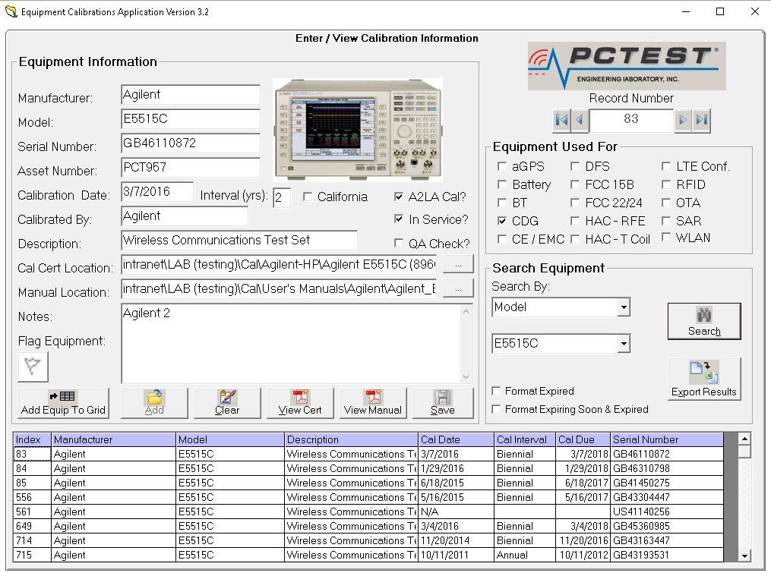

1. Custom List GUI

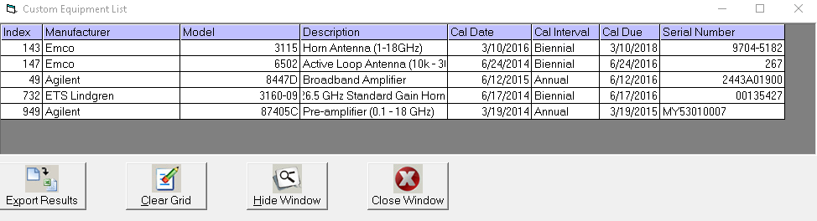

1. Sample Export Data

