TeamCity Continuous Integration Configuration

The following figures illustrates the configurations of TeamCity to automatically build, test and deploy application to Amazon EC2 Tomcat server.

Figure I - Configuration of connection to GitHub

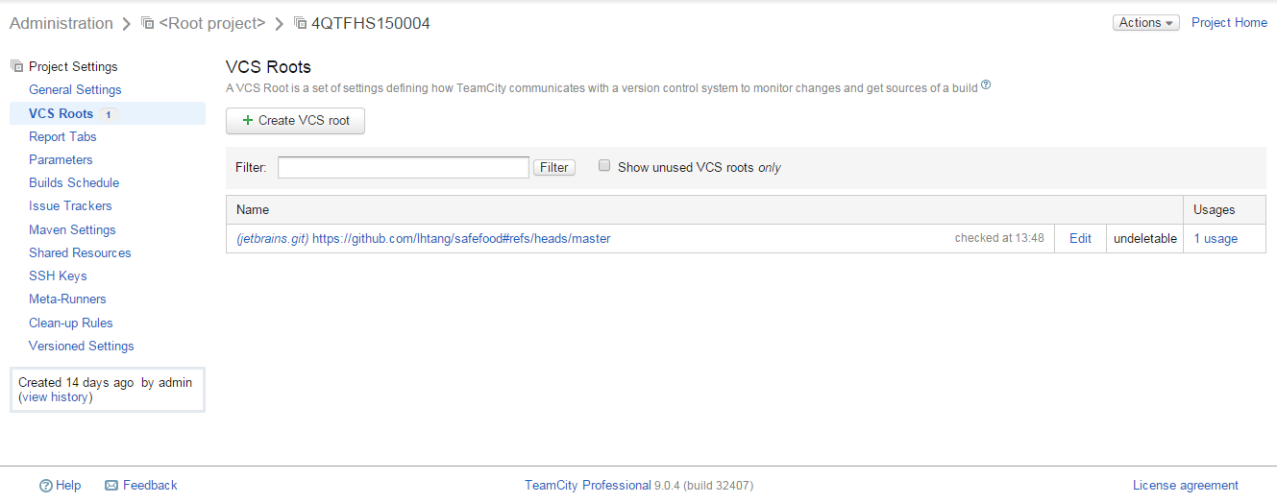

Figure II - Configuration of build steps (build, test, deploy)

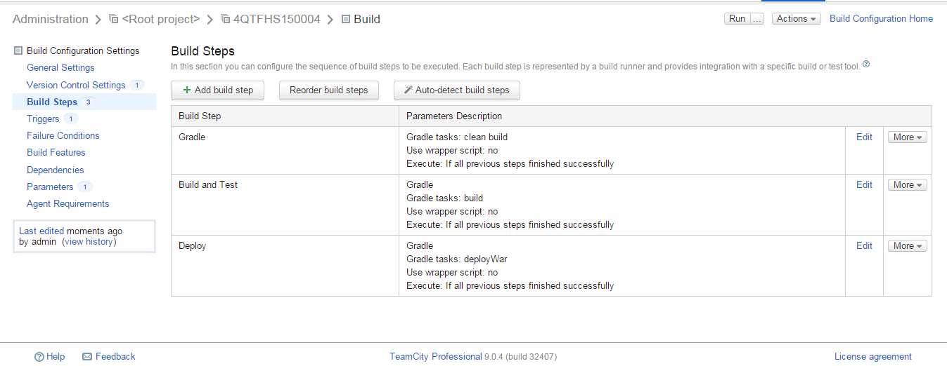

Figure III - Configuration of build scheduler (builds every 20 minutes)

