Setup Hadoop 2.9 Multi-node Cluster on Ubuntu 16.04 Virtual Machine

Hadoop multi-node cluster has 5 machines. One of them is the master and the other four are the slaves.

* Master 192.168.40.129
* Slave1 192.168.40.130
* Slave2 192.168.40.131
* Slave3 192.168.40.132
* Slave4 192.168.40.133

Requirements:

|  |  |
| --- | --- |
| Master | Slaves |
| 2 GB RAM | 2 GB RAM |
| Hard Disk 50 GB | Hard Disk 50 GB |
| Network Adapter Bridge | Network Adapter Bridge |
| Static IP address | Static IP address |
| Java 8 | Java 8 |
| Hadoop 2.9 | Hadoop 2.9 |
| Spark 2.3.0 | Spark 2.3.0 |

**1. Setup in all machines (Master and Slaves)**

**1.1 Create virtual machines**

Download and install VMware® Workstation 15 Player (available at <https://www.vmware.com/products/workstation-pro/workstation-pro-evaluation.html>).

**1.2. Install Operating System**

Download and install Ubuntu 16.0.4 (available at <http://releases.ubuntu.com/16.04/>). The virtual machine will be creating with the following settings:

* Hard Disk: 50 GB
* Memory: 2 GB

**1.3. Update and Install on Ubuntu**

Launch virtual machine and login. Open a terminal (CTRL + ALT + T) and type the following sudo command to install the latest updates.

$ sudo apt-get update

$ sudo apt-get install ssh

**1.4. Hostname Identification**

Change the name of the hostname for the master and all slaves.

* Type the following sudo command to change the name of the hostname for the master.

$ sudo gedit /etc/hostname

Type master and save for the Master node.

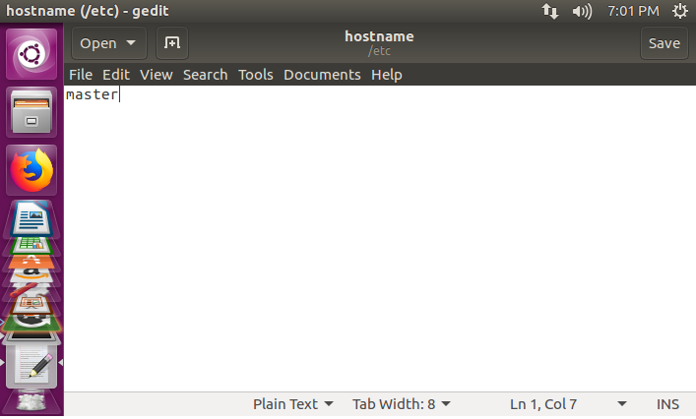

* Type the following sudo command to change the name of the hostname for all the slaves.

$ sudo gedit /etc/hostname

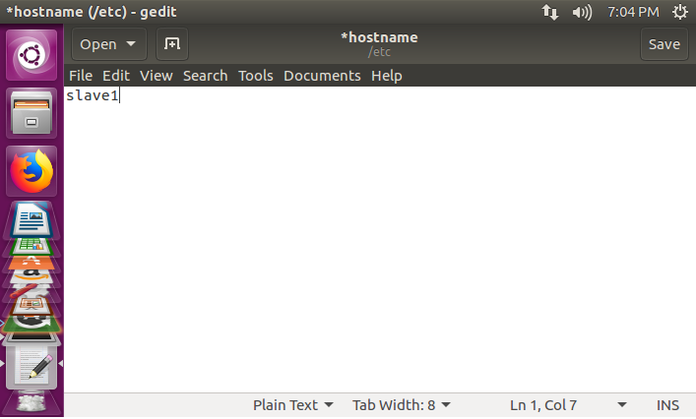

* Reboot all the machines.

$ sudo reboot

**1.5. Creating User Account**

Create a user account for Hadoop. This user account must be the same for the master and slaves.

* Create group

$ sudo addgroup hadoop_group

* Create user for the group

$ sudo adduser -–ingroup hadoop_group hadoop_user

* Add hadoop_user to group sudo

$ sudo adduser hadoop_user sudo

* Change user

$ sudo hadoop_user

hadoop_user@master:~$

**2. Setup the Master**

**2.1. Download Java, Hadoop, and Spark**

* Go to the Firefox Web Browser

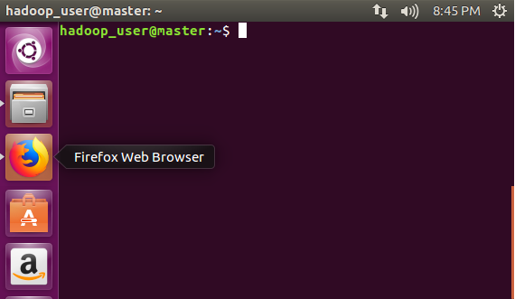

* Download Java JDK 8

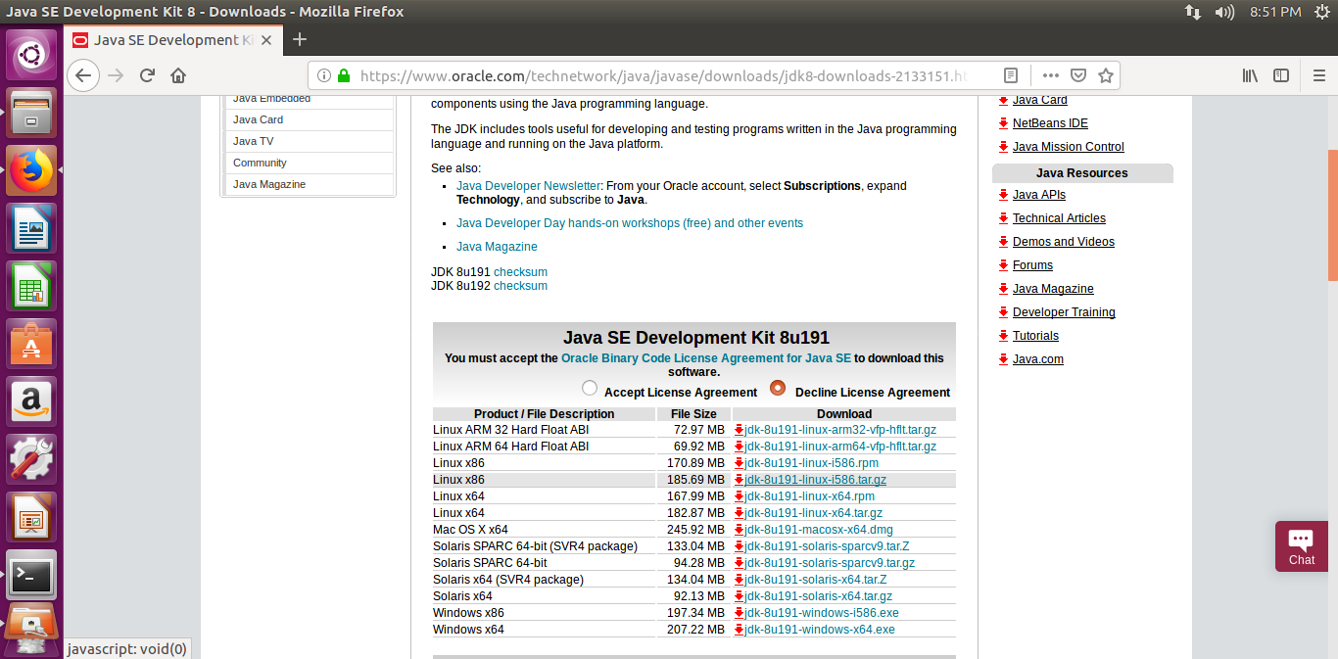

* Save File

The file is going to be saved in /home/hadoop_user/Downloads

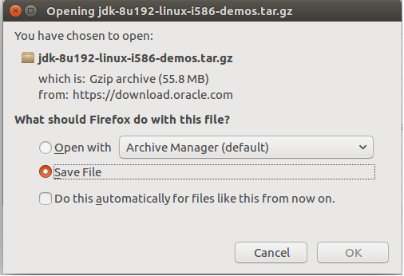

* Download Hadoop

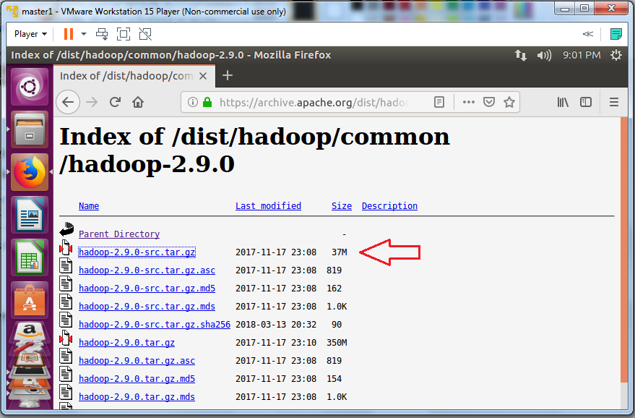

* Save File

The file is going to be saved in /home/hadoop_user/Downloads

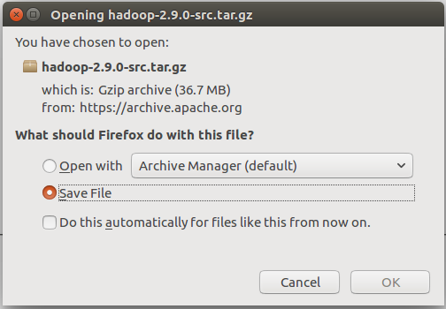

* Download Spark

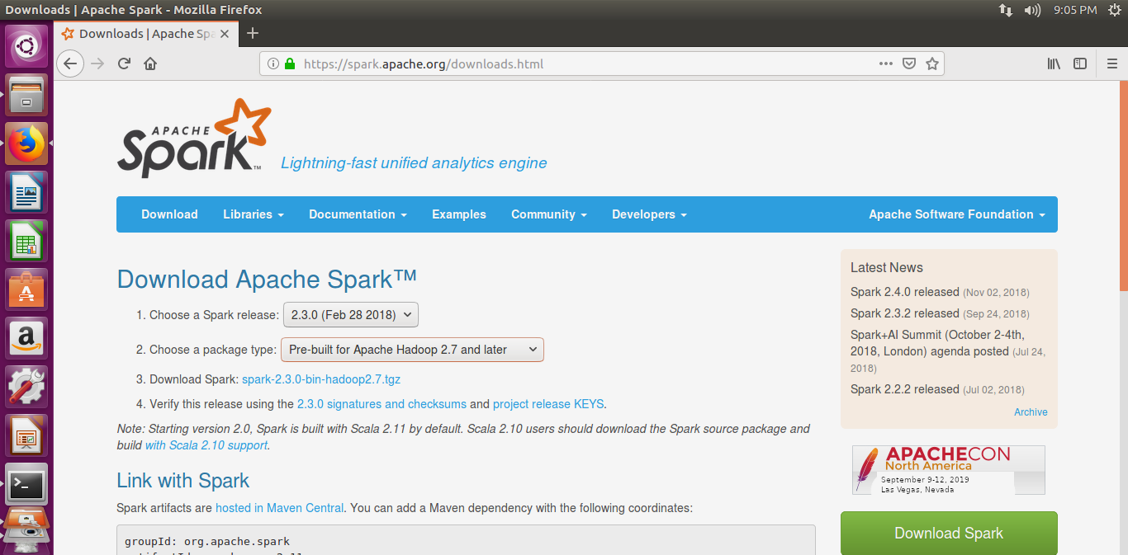

* Save File

The file is going to be saved in /home/hadoop_user/Downloads

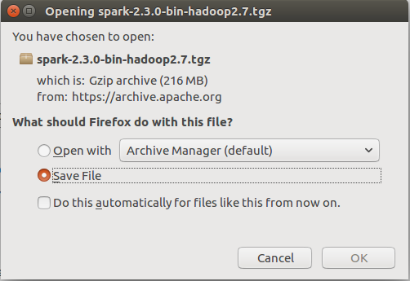

**2.2. SSH**

**SSH** ("Secure Shell") is a protocol for securely accessing one computer from another. All the machines must communicate with one another without any prompt for password. Setup ssh in all the machines master and slaves so they can communicate.

* Update /etc/host and add the IP address and hostname of each machine.

$ hadoop_user@master:~$ sudo gedit /etc/hosts

* Save and close

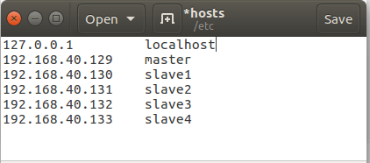

* Ping from one machine to another machine to be sure that all the machines can communicate. This is an important step.

hadoop_user@master:~$ ping 192.168.40.130

* Create the key that will replace the use of the password

hadoop_user@master:~$ ssh-keygen -t rsa =P “”

* Copy the key to the authorized_key

hadoop_user@master:~$ cat ~/.ssh/i_rsa.pub >> ~/.ssh/authorized_keys

* Reboot the master node to be sure all changes are take.

hadoop_user@master:~$ reboot

* Setup ssh in every node such that they can communicate with one another without any prompt for password.

hadoop_user@master:~$ ssh-copy-id -i ~/.ssh/id_rsa.pub hadoop_user@slave1

hadoop_user@master:~$ ssh-copy-id -i ~/.ssh/id_rsa.pub hadoop_user@slave2

hadoop_user@master:~$ ssh-copy-id -i ~/.ssh/id_rsa.pub hadoop_user@slave3

hadoop_user@master:~$ ssh-copy-id -i ~/.ssh/id_rsa.pub hadoop_user@slave4

**2.3 Installing Java**

* Create directory /usr/lib/java/java/ jdk1.8.0

hadoop_user@master:~$ cd sudo mkdir -p /usr/lib/java/jdk1.8.0

* Go to /home/hadoop_user/Downloads

hadoop_user@master:~$ cd /home/Hadoop_user/Downloads

* Unpack jdk-8u171-linux-x64.tar.gz

hadoop_user@master:~/Downloads$ tar -xvzf jdk-8u171-linux-x64.tar.gz

* Move jdk1.8.0_171 to /home/hadoop_user/Downloads

hadoop_user@master:~/Downloads$ move /home/hadoop_user/Downloads/ jdk1.8.0_171/* /usr/lib/java/jdk1.8.0

**2.4 Setup Environment Variables**

* Update file ~/.bashrc and add the following lines at the end of the file.

hadoop_user@master:~$sudo gedit ~/.bashrc

* After update the file, save and close the file.

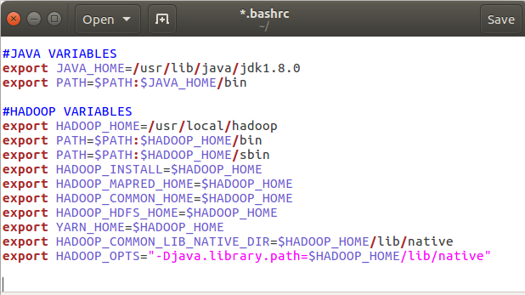

* Source the environment variables.

hadoop_user@master:~$ source ~/.bashrc

**2.5. Installing Hadoop**

* Create directory to copy hadoop files and give access to hadoop_user

hadoop_user@master:~$sudo mkdir -p /usr/local/hadoop

hadoop_user@master:~$sudo chown -R hadoop_group:hadoop_user /usr/local/hadoop

* Create directory /usr/local/hadoop_store/hdfs/datanode file to store all datanode information and give access to hadoop_user

hadoop_user@master:~$sudo mkdir -p /usr/local/hadoop_store/hdfs/namenode

hadoop_user@master:~$sudo chown -R hadoop_group:hadoop_user /usr/local/hadoop_store/hdfs/namenode

* Extract the contest from the hadoop package

hadoop_user@master:~$sudo /home/hadoop_user/Downloads

hadoop@user@master:~/Downloads$ sudo tar -xvzf hadoop-2.9.0.tar.gz

* Move all the files from hadoop-2.9.0 directory to /usr/local/hadoop

hadoop_user@master:~$sudo move /home/Hadoop_user/Downloads/ hadoop-2.9.0/* /usr/local/hadoop

* Disable IPv6.

Hadoop does not support IPv6. If you are using IPv6, you need to switch Hadoop host machines to use IPv4.

Update file /etc/sysctl.conf and add the following lines at the end of the file.

hadoop_user@master:~$sudo gedit /etc/sysctl.conf

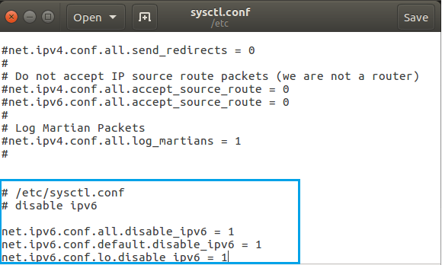

* Update masters file

hadoop_user@master:~cd $HADOOP_HOME/etc/hadoop

hadoop_user@master:/usr/local/hadoop/etc/hadoop

hadoop_user@master:/usr/local/hadoop/etc/hadoop/sudo gedit masters

* Add master to the file. Save and close.

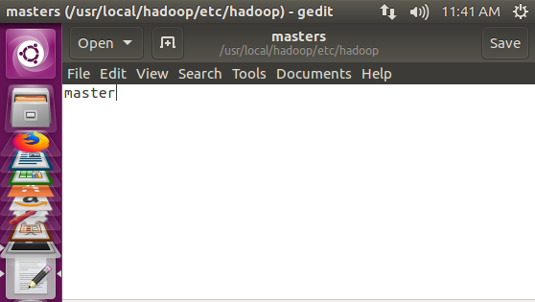

Save and close

* Update slaves file

hadoop_user@master:/usr/local/hadoop/etc/hadoop/sudo gedit slave

* Add all the slaves: slave1, slave2, slave3 and slave4 to the file. Save and close.

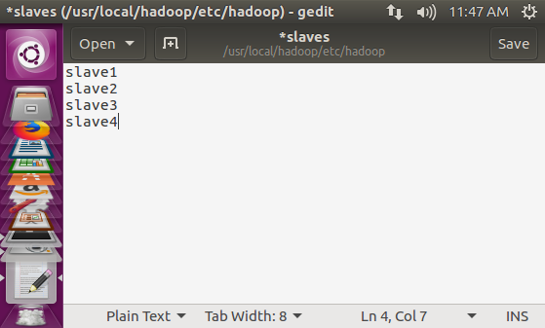

* Update core-site.xml file

hadoop_user@master:/usr/local/hadoop/etc/hadoop/sudo gedit core-sire.xml

* Add the following lines:

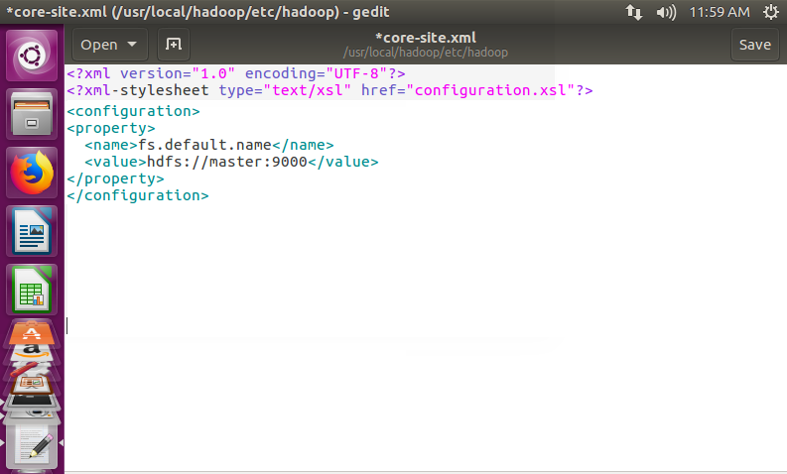

* Update mapred-site.xml file

hadoop_user@master:/usr/local/hadoop/etc/hadoop/sudo gedit mapred-site.xml

* Add the following lines:

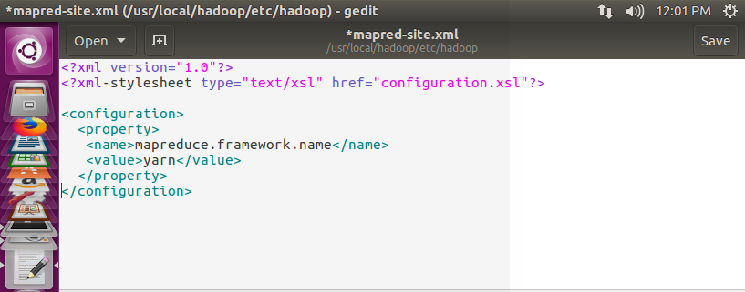

* Update hdfs-site.xml file

hadoop_user@master:/usr/local/hadoop/etc/hadoop/sudo gedit hdfs-site.xml

* Add the following lines:

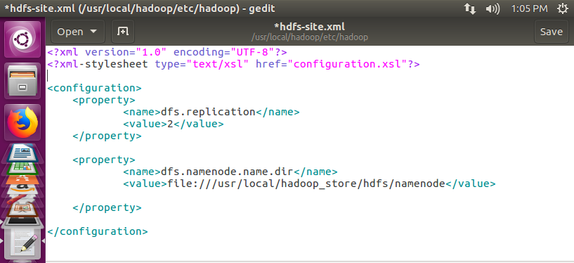

* Update yarn-site.xml file

hadoop_user@master:/usr/local/hadoop/etc/hadoop/sudo gedit yarn-site.xml

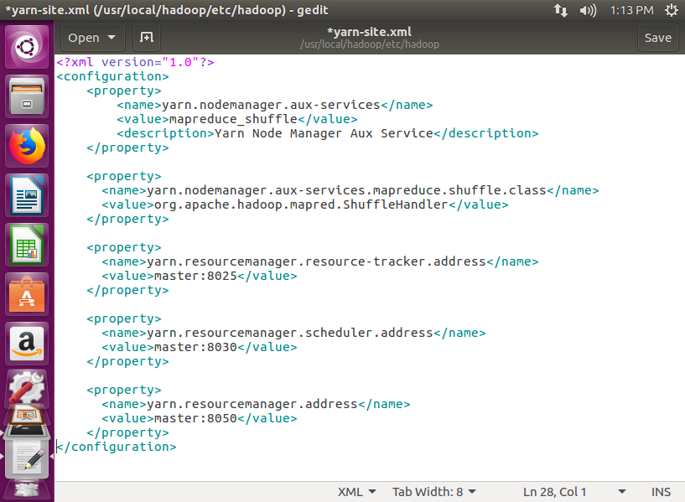

* Add all the following lines:

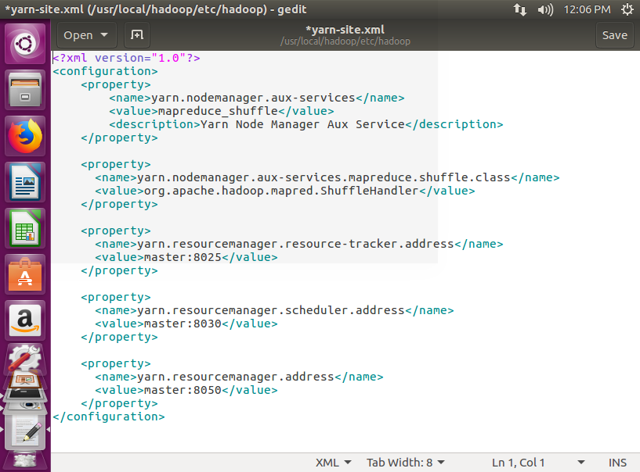

* Update hadoop-env.sh file

hadoop_user@master:/usr/local/hadoop/etc/hadoop/sudo gedit hadoop-env.sh

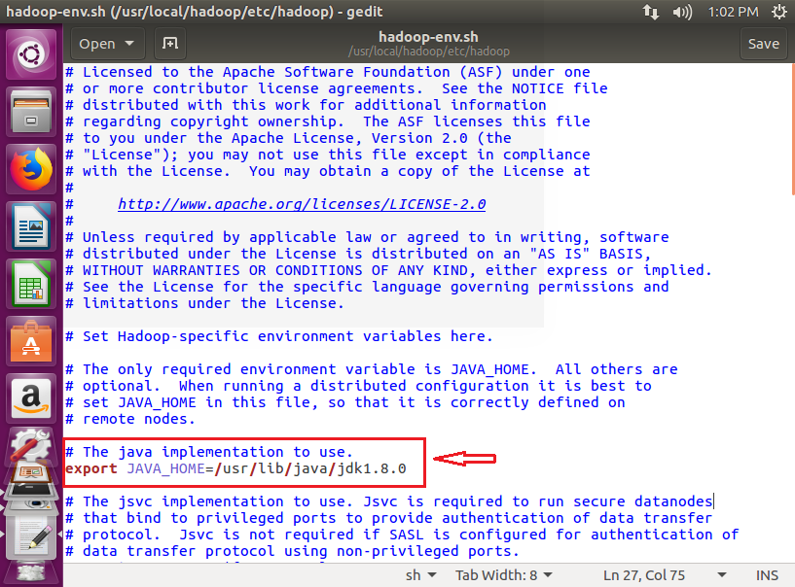

**3. Setup the Slaves**

**3.1. SSH**

**SSH** ("Secure Shell") is a protocol for securely accessing one computer from another. All the machines must communicate with one another without any prompt for password. Setup ssh in all the machines master and slaves so they can communicate.

* Update /etc/host and add the IP address and hostname of each machine.

$ hadoop_user@slave1:~$ sudo gedit /etc/hosts

* Save and close



* Ping from one machine to another machine to be sure that all the machines can communicate. This is an important step.

hadoop_user@slave1:~$ ping 192.168.40.130

* Create the key that will replace the use of the password

hadoop_user@slave1:~$ ssh-keygen -t rsa =P “”

* Copy the key to the authorized_key

hadoop_user@slave1:~$ cat ~/.ssh/i_rsa.pub >> ~/.ssh/authorized_keys

* Reboot the master node to be sure all changes are take.

hadoop_user@slave1:~$ reboot

* Repeat this step in each node: slave1, slave2, slave3, slave4

hadoop_user@slave1:~$ ssh-copy-id -i ~/.ssh/id_rsa.pub hadoop_user@master

hadoop_user@slave1:~$ ssh-copy-id -i ~/.ssh/id_rsa.pub hadoop_user@slave2

hadoop_user@slave1:~$ ssh-copy-id -i ~/.ssh/id_rsa.pub hadoop_user@slave3

hadoop_user@slave1:~$ ssh-copy-id -i ~/.ssh/id_rsa.pub hadoop_user@slave4

**3.2 Copy Java, Hadoop, Spark from the Master node to the all the slaves**

* Login into the master node and copy the following files to all the slaves

hadoop_user@master:~$ scp -r /home/hadoop_user/Downloads/hadoop-2.9.0.tar.gz hadoop_user@master:/home/hadoop_user/Downloads/

hadoop_user@master:~$ scp -r /home/hadoop_user/Downloads/ jdk-8u171-linux-x64.tar.gz hadoop_user@slave1:/home/hadoop_user/Downloads/

hadoop_user@master:~$ scp -r /home/hadoop_user/Downloads/ spark-2.3.0-bin-hadoop2.7.gz gz hadoop_user@slave1:/home/hadoop_user/Downloads/

* Login into slave1

hadoop_user@slave1:~$

* Create directory /usr/lib/java/java/ jdk1.8.0

hadoop_user@slave1:~$ cd sudo mkdir -p /usr/lib/java/jdk1.8.0

* Go to /home/hadoop_user/Downloads

hadoop_user@slave1:~$ cd /home/Hadoop_user/Downloads

* Unpack jdk-8u171-linux-x64.tar.gz

hadoop_user@slave1:~/Downloads$ tar -xvzf jdk-8u171-linux-x64.tar.gz

* Move jdk1.8.0_171 to /usr/lib/java/jdk1.8.0

hadoop_user@slave1:~/Downloads$ move /home/hadoop_user/Downloads/ jdk1.8.0_171/* /usr/lib/java/jdk1.8.0

**3.3 Setup Environment Variables**

* Update file ~/.bashrc and add the following lines at the end of the file.

hadoop_user@slave1:~$sudo gedit ~/.bashrc

* After update the file, save and close the file.



* Source the environment variables.

hadoop_user@slave1:~$ source ~/.bashrc

**3.4 Installing Hadoop**

* Create directory to copy hadoop files and give access to hadoop_user

hadoop_user@slave1:~$sudo mkdir -p /usr/local/hadoop

hadoop_user@slave1:~$sudo chown -R hadoop_group:hadoop_user /usr/local/hadoop

* Create directory /usr/local/hadoop_store/hdfs/datanode file to store all datanode information and give access to hadoop_user

hadoop_user@slave1:~$sudo mkdir -p /usr/local/hadoop_store/hdfs/datanode

hadoop_user@slave1:~$sudo chown -R hadoop_group:hadoop_user /usr/local/hadoop_store/hdfs/datanode

* Extract the contest from the hadoop package

hadoop_user@slave1:~$sudo /home/hadoop_user/Downloads

hadoop@user@slave1:~/Downloads$ sudo tar -xvzf hadoop-2.9.0.tar.gz

* Move all the files from hadoop-2.9.0 directory to /usr/local/hadoop

hadoop_user@slave1:~$sudo move /home/Hadoop_user/Downloads/ hadoop-2.9.0/* /usr/local/hadoop

* Disable IPv6.

Hadoop does not support IPv6. If you are using IPv6, you need to switch Hadoop host machines to use IPv4.

Update file /etc/sysctl.conf and add the following lines at the end of the file.

hadoop_user@slave1:~$sudo gedit /etc/sysctl.conf



* Update core-site.xml file

hadoop_user@slave1:/usr/local/hadoop/etc/hadoop/sudo gedit core-sire.xml

* Add the following lines:



* Update mapred-site.xml file

hadoop_user@slave1:/usr/local/hadoop/etc/hadoop/sudo gedit mapred-site.xml

* Add the following lines:



* Update hdfs-site.xml file

hadoop_user@slave1:/usr/local/hadoop/etc/hadoop/sudo gedit hdfs-site.xml

* Add the following lines:

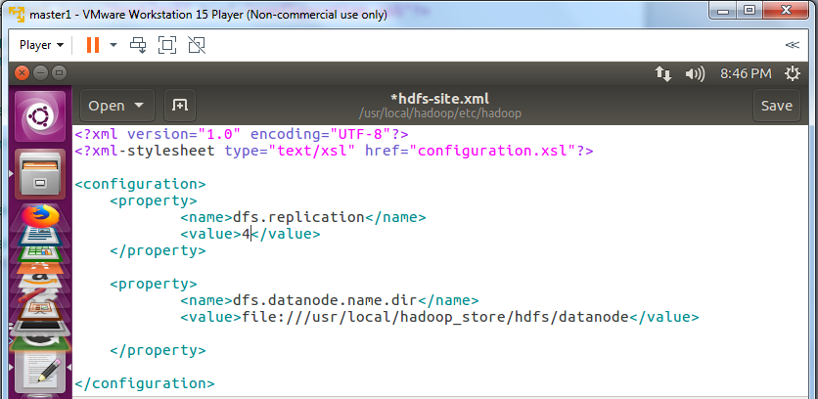

* Update yarn-site.xml file

hadoop_user@slave1:/usr/local/hadoop/etc/hadoop/sudo gedit yarn-site.xml

* Add all the following lines:



* Update hadoop-env.sh file

hadoop_user@slave1:/usr/local/hadoop/etc/hadoop/sudo gedit hadoop-env.sh



**4. Format HDFS**

* Format HDFS

hadoop_user@master:~$hdfs namenode -format

**5. Start and Stop HDFS**

* Start Namenode daemon, DataNode daemon and Yarn daemon

hadoop_user@master:~$cd $HADOOP_HOME/sbin

[hadoop_user@master:/usr/local/hadoop/sbin/start-dfs.sh](mailto:hadoop_user@master:/usr/local/hadoop/sbin/start-dfs.sh)

hadoop_user@master:/usr/local/hadoop/sbin/start-yarn.sh

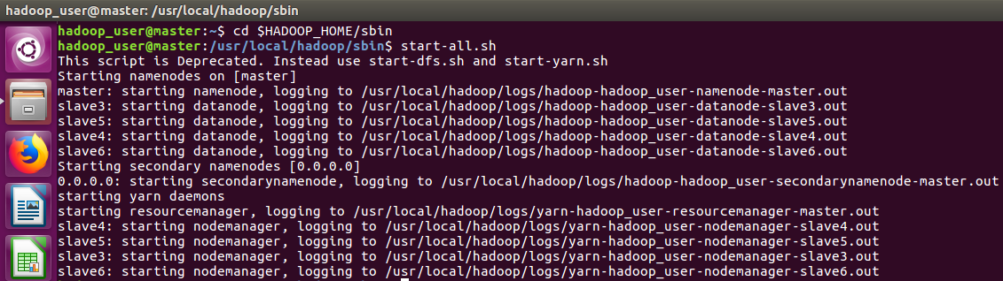

* Check if every process is running with the jps command on each node

hadoop_user@master:~$cd $HADOOP_HOME/sbin$jps

* jps Master

3185 SecondaryNameNode

3656 Jps

2991 NameNode

3375 ResourceManager

* jps Slaves

5497 Jps

5196 DataNode

5310 NodeManager

* Stop HDFS

hadoop_user@master:~$cd $HADOOP_HOME/sbin$stop-all.sh

* Hadoop Web UI

Go to the Firefox Web Browser and type:

http://master:50070

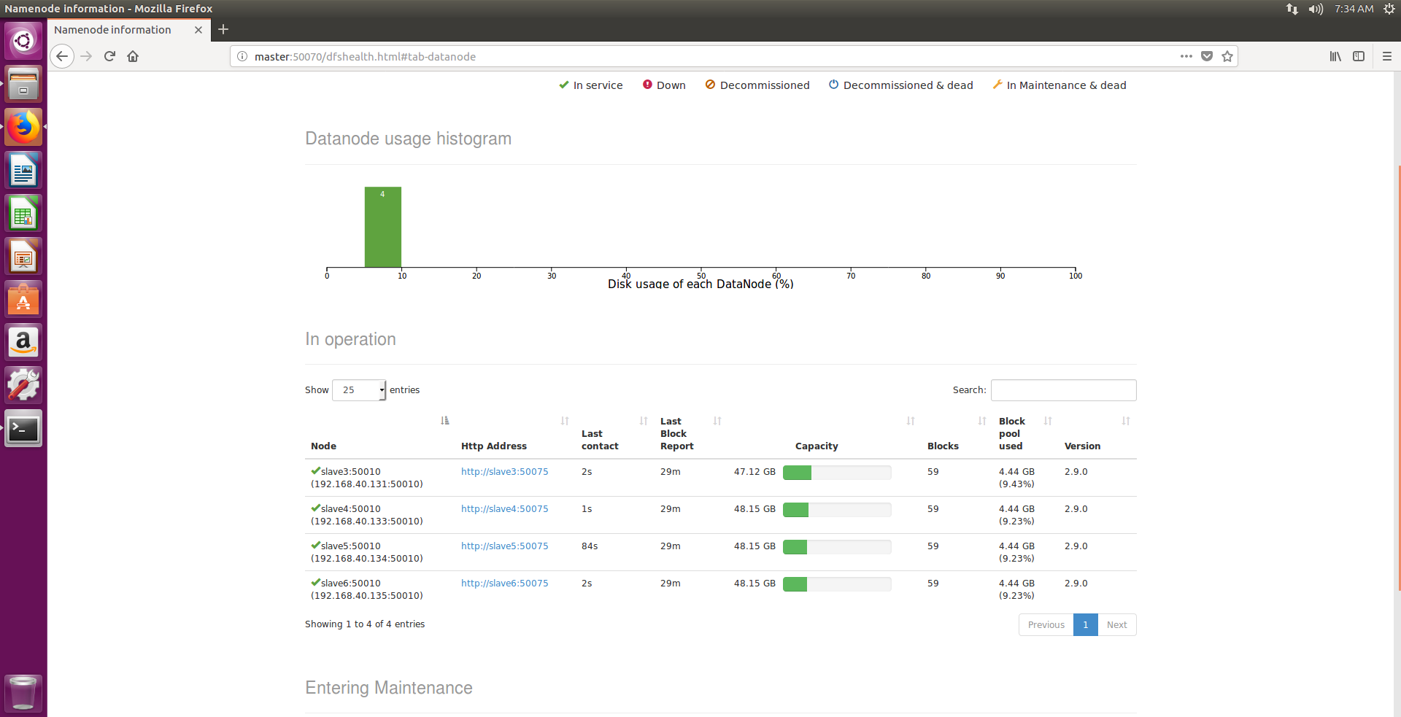

**6. Setup Spark**

* Create directory to copy Spark files and give access to hadoop_user

hadoop_user@master:~$sudo mkdir -p /usr/local/spark

hadoop_user@master:~$sudo mkdir -p /usr/local/spark/log

hadoop_user@master:~$sudo mkdir -p /usr/local/spark/work

hadoop_user@master:~$sudo chown -R hadoop_group:hadoop_user /usr/local/spark

* Extract the contest from the spark package

hadoop_user@master:~$sudo /home/hadoop_user/Downloads

hadoop@user@master:~/Downloads$ sudo tar -xvzf spark-2.3.0-bin-hadoop2.7.gz

* Move all the files from hadoop-2.9.0 directory to /usr/local/spark

hadoop_user@master:~$sudo move /home/Hadoop_user/Downloads/ spark-2.3.0/* /usr/local/spark

* Update environment variables in .bashrc file

hadoop_user@master:~$sudo gedit ~/.bashrc

* Add the following lines at the end of the file:

#SPARK VARIABLES

export SPARK_HOME=/usr/local/spark

export PATH=$PATH:$SPARK_HOME/bin

export PYSPARK_PYTHON=python2.7

* Update spark-env.sh

hadoop_user@master:~$cd $SPARK_HOME/conf

hadoop_user@master:/usr/local/spark/conf$

hadoop_user@master:/usr/local/spark/conf$cp spark-env.sh.template spark-env.sh

hadoop_user@master:/usr/local/spark/conf$sudo gedit spark_env.sh

* Add the following lines at the end of the file:

export JAVA_HOME=/usr/lib/java/jdk1.8.0

export SPARK_HOME=/usr/local/spark

export HADOOP_CONF_DIR=$HADOOP_HOME/etc/hadoop

export SPARK_WORKER_DIR=/usr/local/spark/work

export SPARK_LOG_DIR=/usr/local/spark/log

export SPARK_MASTER_IP=master

* Update spark-defaults.conf

hadoop_user@master:/usr/local/spark/conf$cp spark-defaults.conf.template spark-defaults.conf

hadoop_user@master:/usr/local/spark/conf$sudo gedit spark-defaults.conf

* Add the following lines at the end of the file

spark.master spark://master:7077

* Update slaves file

hadoop_user@master:/usr/local/spark/conf$cp slaves.template slaves

hadoop_user@master:/usr/local/spark/conf$sudo gedit slaves

* Add the following lines at the end of the file

slave1

slave2

slave3

slave4

* Start standalone master server.

hadoop_user@master:~$cd $SPARK_HOME/sbin

hadoop_user@master:/usr/local/spark/sbin~

hadoop_user@master:/usr/local/spark/sbin$./start-all.sh

starting org.apache.spark.deploy.master.Master, logging to /usr/local/spark/log/spark-hadoop_user-org.apache.spark.deploy.master.Master-1-master.out

slave1: starting org.apache.spark.deploy.worker.Worker, logging to /usr/local/spark/log/spark-hadoop_user-org.apache.spark.deploy.worker.Worker-1-slave1.out

slave2: starting org.apache.spark.deploy.worker.Worker, logging to /usr/local/spark/log/spark-hadoop_user-org.apache.spark.deploy.worker.Worker-1-slave2.out

slave3: starting org.apache.spark.deploy.worker.Worker, logging to /usr/local/spark/log/spark-hadoop_user-org.apache.spark.deploy.worker.Worker-1-slave3.out

slave4: starting org.apache.spark.deploy.worker.Worker, logging to /usr/local/spark/log/spark-hadoop_user-org.apache.spark.deploy.worker.Worker-1-slave4.out

* Execute jps to check if all workers are running

hadoop_user@master:/usr/local/spark/sbin$jps

* Spark Web UI

Go to the Firefox Web Browser and type:

http://master:8080

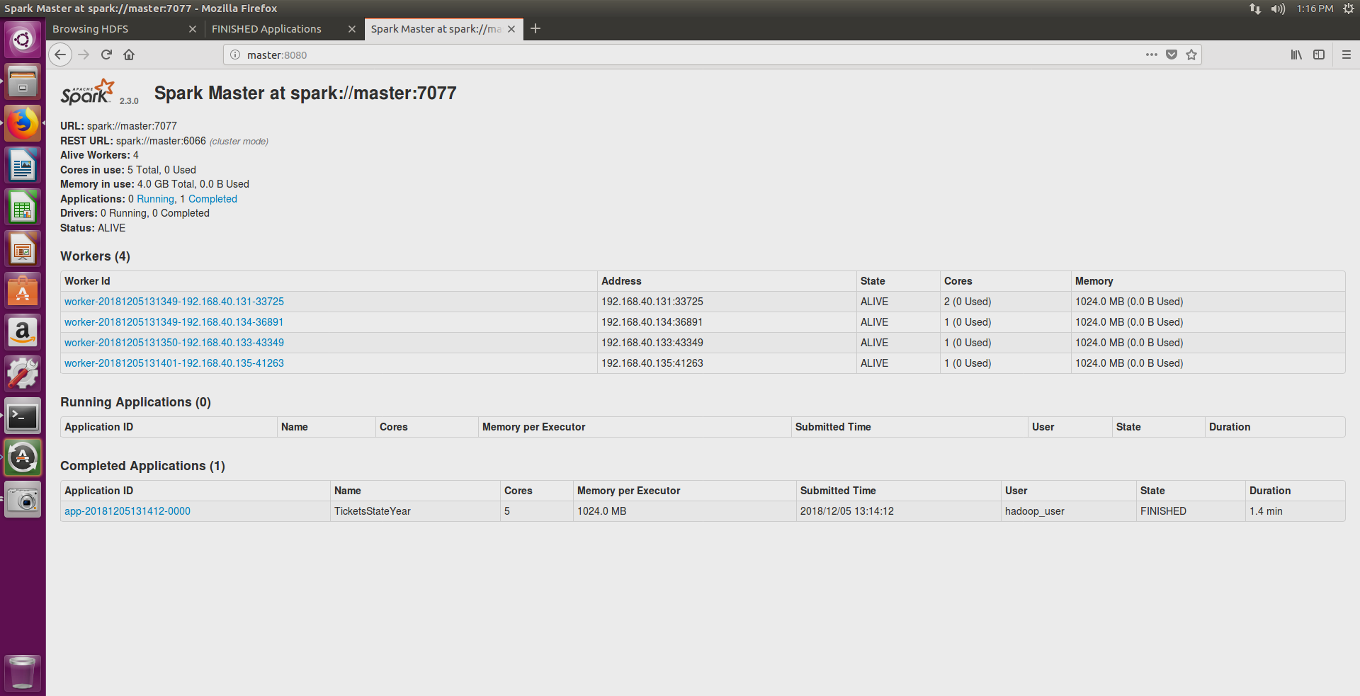

* Run PySpark MapReduce job

hadoop_user@master:/usr/local/spark/sbin$ spark-submit --master spark://master:7077 /home/hadoop_user/Desktop/tickets_month_year.py

* Stop Spark

hadoop_user@master:/usr/local/spark/sbin$./stop-all.sh

slave1: stopping org.apache.spark.deploy.worker.Worker

slave2: stopping org.apache.spark.deploy.worker.Worker

slave3: stopping org.apache.spark.deploy.worker.Worker

slave4: stopping org.apache.spark.deploy.worker.Worker

stopping org.apache.spark.deploy.master.Master