**PHOSPHORUS DISCOVERED ON SATURN’S ENCELADUS, A CRUCIAL SIGN THAT LIFE IS POSSIBLE**

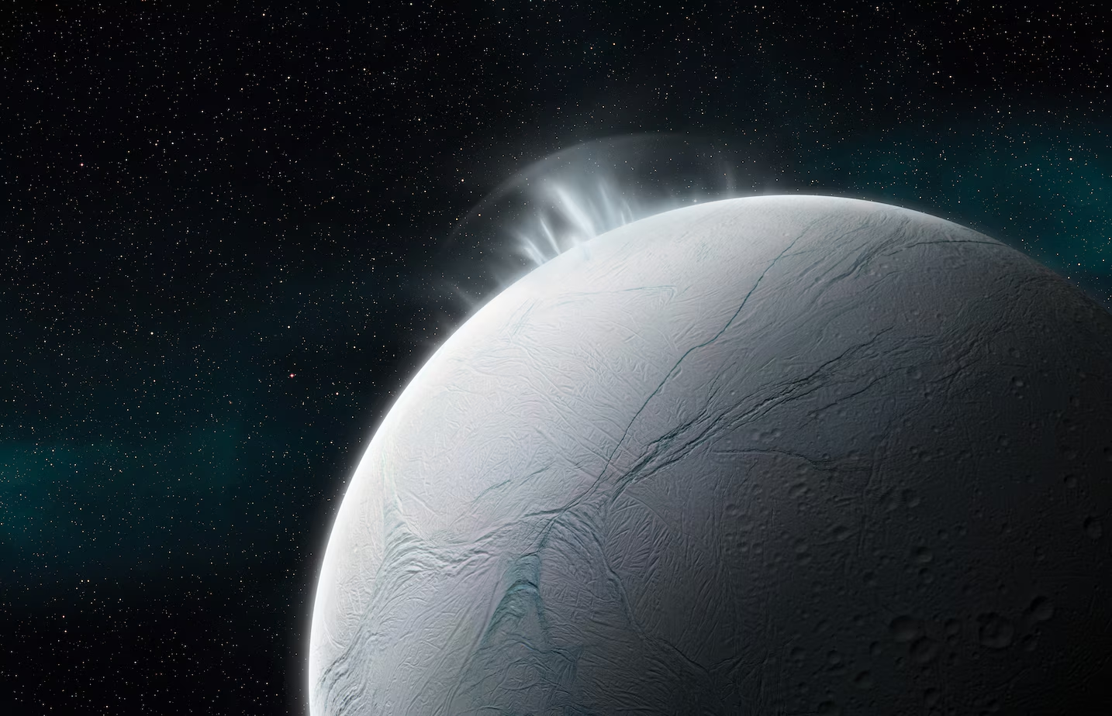**Phosphorus Found on Saturn's Moon Enceladus**

Scientists have discovered phosphorus, a crucial element for life on Earth, in an ocean outside our planet for the first time. This phosphorus originates from Saturn's icy moon Enceladus. Phosphorus plays a vital role in making Earth's soil fertile. Researchers believe that Enceladus's hidden seas may contain phosphorus concentrations at least 100 times higher than those found in Earth’s oceans. Similar findings are anticipated on other icy moons like Europa (Jupiter's moon) and Titan (Saturn's moon). Phosphorus is essential for DNA, RNA, and cell membranes—the building blocks of life alongside carbon, hydrogen, nitrogen, oxygen, and sulfur. Despite its importance, phosphorus is one of the rarest elements in the universe. The discovery was made using data from NASA's Cassini spacecraft, which detected phosphorus in ice grains from Saturn's E ring, composed of particles ejected from Enceladus. This breakthrough, detailed in a Nature study, marks phosphorus as the last of the six key ingredients for life identified on Enceladus. Enceladus, the sixth largest moon of Saturn, was initially thought to be a frozen sphere until geysers emitting water vapor and ice particles were discovered in 2005. These geysers originate from a subsurface ocean beneath Enceladus's icy crust, suggesting the potential for hydrothermal activity and the presence of complex organic molecules. The findings position Enceladus as a prime candidate for extraterrestrial life within our solar system. Future missions, such as NASA's Europa Clipper, aim to further explore these promising environments.

<https://www.nationalgeographic.com/premium/article/astronomers-detect-key-element-for-life-on-saturns-moon-enceladus>

**Questions**:

1. What is the significance of phosphorus discovery on Saturn's moon Enceladus?
2. How does the phosphorus concentration on Enceladus compare to Earth's oceans?
3. What method was used to detect phosphorus on Enceladus?

**Word List**

enceladus - энцелад

cassini spacecraft - космический аппарат Кассини

cosmic Dust Analyzer - анализатор космической пыли

phosphorous - фосфор

habitability - обитаемость

**Title:** PHOSPHORUS DISCOVERED ON SATURN’S ENCELADUS, A CRUCIAL SIGN THAT LIFE IS POSSIBLE

**Answers to questions**:

1. The discovery of phosphorus on Enceladus is significant because it marks the first time this crucial element for life on Earth has been found outside our planet. Phosphorus is essential for DNA, RNA, and cell membranes, making it a key building block of life.
2. Researchers suggest that phosphorus concentrations in Enceladus's hidden seas may be at least 100 times greater than those found in Earth’s oceans. This makes Enceladus potentially richer in phosphorus than any known aquatic environment on Earth.
3. The discovery was made using data from NASA's Cassini spacecraft, which detected phosphorus in ice grains from Saturn's E ring. These ice grains are composed of material ejected from Enceladus, providing insights into the elemental composition of the moon's subsurface ocean.

**Comment**:

This text about the study of phosphorus on Saturn's icy moon, Actually, Enceladus, is of significant importance to science and the possible search for extraterrestrial life. He emphasizes that phosphorus, an important element for life on Earth, was discovered in the ocean outside our planet for the first time. You know what I mean? The text discusses not only the importance of phosphorus for basic biochemical processes such as DNA and RNA, but also its rarity in the universe. It is noted that the discovery was made using data from the Cassini spacecraft, which analyzed ice grains from Saturn's rings consisting of material ejected from Enceladus. The potential significance of these discoveries for future missions exploring worlds such as Europa and Titan is also discussed.

This text is not only informative, but also highlights the importance of space exploration in the search for life beyond Earth.

**Test questions**:

1. Where did scientists discover phosphorus outside our planet for the first time?

a) Mars

b) Jupiter

**c) Enceladus**

d) Titan

2. What role does phosphorus play in making Earth's soil fertile?

**a) It enhances plant growth**

b) It regulates soil pH

c) It supports water retention

d) It promotes nitrogen fixation

3. How was phosphorus detected on Enceladus?

a) Using the Hubble Space Telescope

b) By analyzing rock samples from the moon's surface

**c) Data from the Cassini spacecraft**

d) By drilling into the moon's ice crust

4. Which moon, apart from Enceladus, is mentioned to potentially have similar findings?

a) Io

**b) Europa**

c) Ganymede

d) Callisto

5. What makes Enceladus a prime candidate for extraterrestrial life?

a) Its proximity to Saturn

**b) The discovery of phosphorus and water geysers**

c) Its large size among Saturn's moons

d) Its rocky surface composition