@RestController 报红 ，

@RestController
public class test {
@RequestMapping("/hello")
public String index() {
return "Hello World";
}
}
解决方法：在pom.xml里加
下载
<dependency>
<groupId>org.springframework</groupId>
<artifactId>spring-web</artifactId>
<version>4.3.14.RELEASE</version>
</dependency>
并且引入
import org.springframework.web.bind.annotation.RestController;

Application.java 启动立马关闭的问题
在pom.xml加入
<dependency>
<groupId>org.springframework.boot</groupId>
<artifactId>spring-boot-starter-web</artifactId>
</dependency>
<dependency>
<groupId>com.jayway.jsonpath</groupId>
<artifactId>json-path</artifactId>
<scope>test</scope>
</dependency>

spring boot返回字符串而不是界面
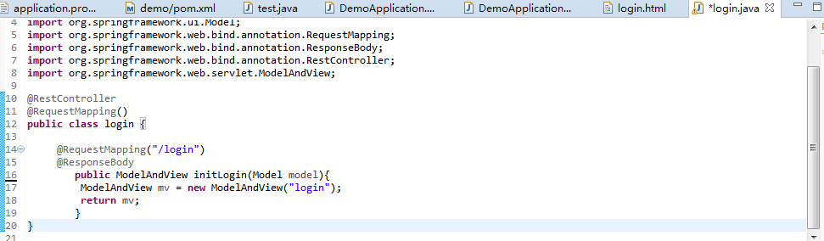

引入实体：
import javax.persistence.*;

