中南大学

Web应用开发技术
实验报告

姓 名： | 罗华熹
学 号： | 8209190606
班 级： | 软件工程1906
指导老师： | 宋 铁
完成时间：
分 数：
批阅日期：
实验一 基于MVC用JSP/Servlet实现JPetStore

- 实验内容——基本任务。
- 商品展示业务模块，包括大类Category、小类Product和具体商品Item的展示和搜索功能。

Category展示如下：

Fish类运行界面如下：

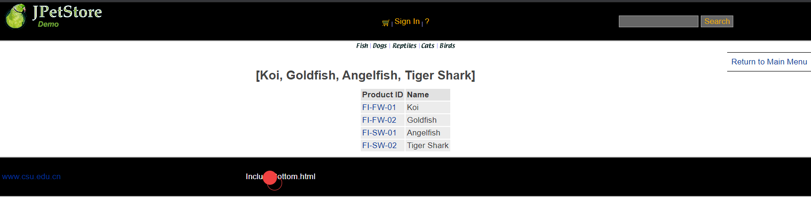
核心代码如下：
View：Category.jsp
<div id="Catalog">
<h2>${sessionScope.productList}</h2>
<table>
<tr>
<th>Product ID</th>
<th>Name</th>
</tr>
<c:forEach var="product" items="${sessionScope.productList}">
<tr>
<td>
<a href="viewProduct?productId=${product.productId}">${product.productId}</a>
</td>
<td>${product.name}</td>
</tr>
</c:forEach>
</table>
</div>
ViewCategoryServlet.java
public class ViewCategoryServlet extends HttpServlet {
private static final String VIEW_CATEGORY = "/WEB-INF/jsp/catalog/Category.jsp";
private String categoryId;

protected void doPost(HttpServletRequest request, HttpServletResponse response) throws ServletException, IOException {
doGet(request, response);
}

protected void doGet(HttpServletRequest request, HttpServletResponse response) throws ServletException, IOException {
categoryId = request.getParameter("categoryId");
CatalogService service = new CatalogService();
Category category = service.getCategory(categoryId);
List<Product> productList = service.getProductListByCategory(categoryId);

//保存数据
HttpSession session = request.getSession();
session.setAttribute("category", category);
session.setAttribute("productList", productList);

//跳转页面
request.getRequestDispatcher(VIEW_CATEGORY).forward(request, response);
}
CategoryImpl 中相关方法：
private static final String getCategoryListString = "SELECT CATID AS categoryID,NAME,DESCN AS descrption FROM CATEGORY";
private static final String getCategoryString = "SELECT CATID AS categoryId,NAME,DESCN AS description FROM CATEGORY WHERE CATID = ?";
@Override
public List<Category> getCategoryList() {
List<Category> categoryList = new ArrayList<Category>();
try {
Connection connection = DBUtil.getConnection();
PreparedStatement preparedStatement = connection.prepareStatement(getCategoryListString);
ResultSet resultSet = preparedStatement.executeQuery();
while(resultSet.next()){
Category category = new Category();
category.setCategoryId(resultSet.getString(1));
category.setName(resultSet.getString(2));
category.setDescription(resultSet.getString(3));
categoryList.add(category);
}
DBUtil.closeResultSet(resultSet);
DBUtil.closePreparedStatement(preparedStatement);
DBUtil.closeConnection(connection);
}catch (Exception e){
e.printStackTrace();
}
return categoryList;
}
@Override
public Category getCategory(String categoryId) {
Category category = null;
try {
Connection connection = DBUtil.getConnection();
PreparedStatement preparedStatement = connection.prepareStatement(getCategoryString);
preparedStatement.setString(1,categoryId);
ResultSet resultSet = preparedStatement.executeQuery();
if(resultSet.next()){
category = new Category();
category.setCategoryId(resultSet.getString(1));
category.setName(resultSet.getString(2));
category.setDescription(resultSet.getString(3));
}
DBUtil.closeResultSet(resultSet);
DBUtil.closePreparedStatement(preparedStatement);
DBUtil.closeConnection(connection);
}catch (Exception e){
e.printStackTrace();
}
return category;
}

Product展示截图如下：
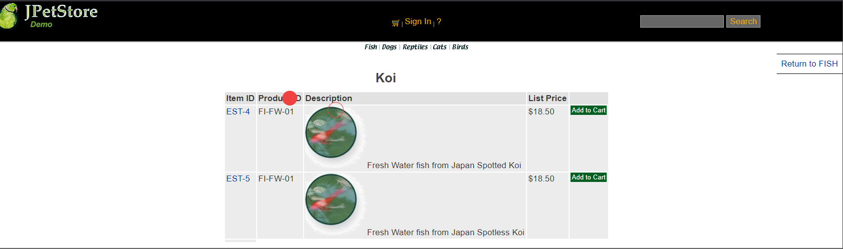
核心代码如下：
View：Product.jsp
<div id="Catalog">

<h2>${sessionScope.product.name}</h2>
<table>
<tr>
<th>Item ID</th>
<th>Product ID</th>
<th>Description</th>
<th>List Price</th>
<th>&nbsp;</th>
</tr>
<c:forEach var="item" items="${sessionScope.itemList}">
<tr>
<td><a href="viewItem?itemId=${item.itemId}">${item.itemId}</a></td>
<td>${item.product.productId}</td>
<td>
${item.product.description}
${item.attribute1} ${item.attribute2} ${item.attribute3}
${item.attribute4} ${item.attribute5} ${sessionScope.product.name}</td>
<td><fmt:formatNumber value="${item.listPrice}" pattern="$#,##0.00" /></td>
<td>
<a class="Button" href="addItemToCart?workingItemId=${item.itemId}">Add to Cart</a>
</td>
</tr>
</c:forEach>
<tr>
<td></td>
</tr>
</table>
</div>

Controller: ViewProductServlet.java
public class ViewProductServlet extends HttpServlet {
private static final String VIEW_PRODUCT = "/WEB-INF/jsp/catalog/Product.jsp";
private String productId;

protected void doGet(HttpServletRequest request, HttpServletResponse response) throws ServletException, IOException {
productId = request.getParameter("productId");
CatalogService service = new CatalogService();
Product product = service.getProduct(productId);
List<Item> itemList = service.getItemListByProduct(productId);

HttpSession session = request.getSession();
session.setAttribute("product", product);
session.setAttribute("itemList", itemList);

request.getRequestDispatcher(VIEW_PRODUCT).forward(request, response);
}
}

Item展示截图如下
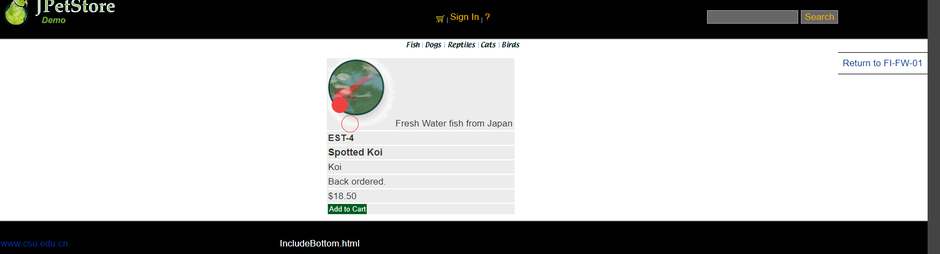
View视图：
<div id="Catalog">

<table>
<tr>
<td>${sessionScope.product.description}</td>
</tr>
<tr>
<td>
<b>${sessionScope.item.itemId} </b>
</td>
</tr>
<tr>
<td>
<b>
<font size="4">
${sessionScope.item.attribute1}
${sessionScope.item.attribute2}
${sessionScope.item.attribute3}
${sessionScope.item.attribute4}
${sessionScope.item.attribute5}
${sessionScope.product.name}
</font>
</b>
</td>
</tr>
<tr>
<td>${sessionScope.product.name}</td>
</tr>
<tr>
<td><c:if test="${sessionScope.item.quantity <= 0}">
Back ordered.
</c:if>
<c:if test="${sessionScope.item.quantity > 0}">
${sessionScope.item.quantity} in stock.
</c:if>
</td>
</tr>
<tr>
<td>
<fmt:formatNumber value="${sessionScope.item.listPrice}" pattern="$#,##0.00" />
</td>
</tr>
<tr>
<td>
<a class="Button" href="addItemToCart?workingItemId=${item.itemId}">Add to Cart</a>
</td>
</tr>
</table>
</div>

ViewItemServlet.java
public class ViewItemServlet extends HttpServlet {
private static final String VIEW_ITEM = "/WEB-INF/jsp/catalog/Item.jsp";
private String itemId;

protected void doPost(HttpServletRequest request, HttpServletResponse response) throws ServletException, IOException {
doGet(request, response);
}

protected void doGet(HttpServletRequest request, HttpServletResponse response) throws ServletException, IOException {
itemId = request.getParameter("itemId");
CatalogService service = new CatalogService();
Item item = service.getItem(itemId);

HttpSession session = request.getSession();
session.setAttribute("item", item);

request.getRequestDispatcher(VIEW_ITEM).forward(request, response);
}
}

搜索功能：
通过SearchProductServlet控制jsp中的搜索框，通过输入关键字，经过CatalogService中的方法进行查找显示

Jsp中内容
<div id="Search">
<div id="SearchContent">
<div class="ui-widget">
<form action="searchProduct" method="post">
<input type="text" name="keyword" size="14" id="searchText" class="search"/> <input type="submit"
name="searchProducts" value="Search" />
</form>
</div>
</div>
</div>

SearchProductServlet.java
keyword = req.getParameter("keyword");
CatalogService service = new CatalogService();
List<Product> productList = service.searchProductList(keyword);

HttpSession session = req.getSession();
session.setAttribute("keyword", keyword);
session.setAttribute("productList", productList);

req.getRequestDispatcher(SEARCH_PRODUCTS).forward(req,resp);

- 用户管理业务模块，包括用户注册、登录、修改用户信息、查询用户相关订单等业务功能。
用户注册：
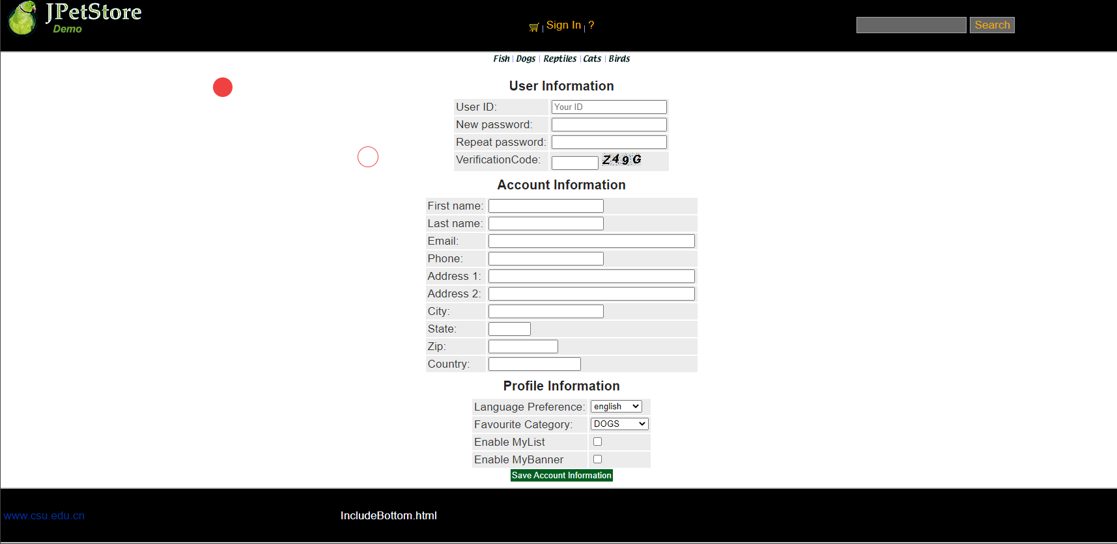
核心代码：
NewAccountForm.jsp
<div id="Catalog">
<form action="newAccount" method="post" id="signupForm">
<h3>User Information</h3>
<table>
<tr>
<td>User ID:</td>
<td><input type="text" name="username" id="username" placeholder="Your ID"/>
<div id="namemsg"></div>
</td>
</tr>
<tr>
<td >New password:</td>
<td><input type="text" name="password" id="password" />
<div id="pwdmsg"></div>
</td>
</tr>
<tr>
<td>Repeat password:</td>
<td><input type="text" name="repeatedPassword" id="repeat" />
<div id="repeatmsg"></div>
</td>
</tr>
<tr>
<td>VerificationCode:</td>
<td>
<input type="text" name="vCode" size="5" maxlength="4"/>
<a href="newAccount"><img border="0" src="verificationCode" name="checkcode"></a>
</td>
</tr>
</table>
<%@ include file="IncludeAccountFields.jsp"%>
<input type="submit" name="newAccount" value="Save Account Information" />
</form>
<script src="js/new-account-validation.js"></script>
</div>

控制器：

NewAccountServlet：
public class NewAccountServlet extends HttpServlet {
private static final String MAIN = "/WEB-INF/jsp/catalog/Main.jsp";
private static final String NEWACCOUNTFORM = "/WEB-INF/jsp/account/NewAccountForm.jsp";

private Account account;
private Account account1;
private AccountService accountService;

protected void doPost(HttpServletRequest request, HttpServletResponse response) throws ServletException, IOException {
doGet(request, response);
}

protected void doGet(HttpServletRequest request, HttpServletResponse response) throws ServletException, IOException {
HttpSession session = request.getSession();
account = (Account) session.getAttribute("account");
account = null;
session.setAttribute("account", account);

//获得输入的验证码值
String value1=request.getParameter("vCode");
/*获取图片的值*/
String value2=(String)session.getAttribute("checkcode");
Boolean isSame = false;
/*对比两个值（字母不区分大小写）*/
if(value2.equalsIgnoreCase(value1)){
isSame = true;
}

String username = request.getParameter("username");
String password = request.getParameter("password");
String firstName = request.getParameter("firstName");
String lastName = request.getParameter("lastName");
String email = request.getParameter("email");
String phone = request.getParameter("phone");
String address1 = request.getParameter("address1");
String address2 = request.getParameter("address2");
String city = request.getParameter("city");
String state = request.getParameter("state");
String zip = request.getParameter("zip");
String country = request.getParameter("country");
String languagePreference = request.getParameter("languagePreference");
String favouriteCategoryId = request.getParameter("favouriteCategoryId");
String listOption = request.getParameter("listOption");
String bannerOption = request.getParameter("bannerOption");

account1 = new Account();
account1.setUsername(username);
account1.setPassword(password);
account1.setFirstName(firstName);
account1.setLastName(lastName);
account1.setEmail(email);
account1.setPhone(phone);
account1.setAddress1(address1);
account1.setAddress2(address2);
account1.setCity(city);
account1.setState(state);
account1.setZip(zip);
account1.setCountry(country);
account1.setLanguagePreference(languagePreference);
account1.setFavouriteCategoryId(favouriteCategoryId);
account1.setListOption(Boolean.parseBoolean(listOption));
account1.setBannerOption(Boolean.parseBoolean(bannerOption));

if(isSame){
accountService = new AccountService();
accountService.insertAccount(account1);

if(account1 != null){
request.getRequestDispatcher(MAIN).forward(request, response);
}else{
session.setAttribute("messageAccount", "Invalid Verification Code.");

if(account1 != null){
request.getRequestDispatcher(NEWACCOUNTFORM).forward(request, response);
}
}
}

AccountService
public class AccountService {

private AccountDAO accountDAO;

public AccountService(){
accountDAO = new AccountDAOImpl();
}

public Account getAccount(String username) {
return accountDAO.getAccountByUsername(username);
}

public Account getAccount(String username, String password) {
Account account = new Account();
account.setUsername(username);
account.setPassword(password);
return accountDAO.getAccountByUsernameAndPassword(account);
}

public void insertAccount(Account account) {
accountDAO.insertAccount(account);
accountDAO.insertProfile(account);
accountDAO.insertSignon(account);
}

public void updateAccount(Account account) {
accountDAO.updateAccount(account);
accountDAO.updateProfile(account);

if (account.getPassword() != null && account.getPassword().length() > 0) {
accountDAO.updateSignon(account);
}
}
}

2.2用户登录

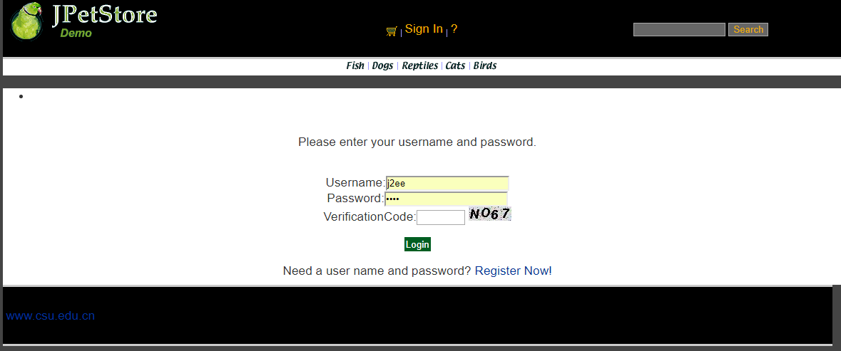

用户登录先完成SignonForm.jsp，能够使用户输入登入的账号与密码，接下来先用一个Servlet实现SignOnFormServlet实现点击登录时网页跳转到用户输入账号密码的界面，接下来使用SignOnServlet实现获取用户的账号密码对数据库进行核查，如果存在则登录，反之则给予一定的错误信息提示。

View:
<div id="Catalog">
<form action="signOn" method="post" id="register">
<p>Please enter your username and password.</p>
<p>
Username:<input type="text" name="username" id="username" /><br />
<div class = "usernameMsg"></div>
Password:<input type="password" name="password" id="password" /><br />
VerificationCode:<input type="text" name="vCode" size="5" maxlength="4"/>
<a href="signOn"><img border="0" src="verificationCode" name="checkcode"></a>
</p>
<input type="submit" name="signon" value="Login" />
</form>
Need a user name and password?
<a href="newAccountForm">Register Now!</a>
</div>

SignOnFormServlet：
public class SignOnFormServlet extends HttpServlet {

private static final String SIGNONFORM = "/WEB-INF/jsp/account/SignonForm.jsp";

private Account account;

protected void doPost(HttpServletRequest request, HttpServletResponse response) throws ServletException, IOException {
doGet(request, response);
}

protected void doGet(HttpServletRequest request, HttpServletResponse response) throws ServletException, IOException {

HttpSession session = request.getSession();
account = (Account)session.getAttribute("account");

request.getRequestDispatcher(SIGNONFORM).forward(request, response);
}
}

SignOnServlet：
public class SignOnServlet extends HttpServlet {
private static final String MAIN = "/WEB-INF/jsp/catalog/Main.jsp";
private static final String SIGNONFORM = "/WEB-INF/jsp/account/SignonForm.jsp";

private Account account;
private AccountService accountService;

protected void doPost(HttpServletRequest request, HttpServletResponse response) throws ServletException, IOException {
doGet(request, response);
}

protected void doGet(HttpServletRequest request, HttpServletResponse response) throws ServletException, IOException {

String username = request.getParameter("username");
String password = request.getParameter("password");

accountService = new AccountService();
account = accountService.getAccount(username, password);

HttpSession session = request.getSession();
session.setAttribute("account", account);

//获得输入的验证码值
String value1=request.getParameter("vCode");
/*获取图片的值*/
String value2=(String)session.getAttribute("checkcode");
Boolean isSame = false;
/*对比两个值（字母不区分大小写）*/
if(value2.equalsIgnoreCase(value1)){
isSame = true;
}

if (account == null || !isSame){
if(!isSame){
session.setAttribute("messageSignOn", "Invalid Verification Code. Signon failed.");
}else{
session.setAttribute("messageSignOn", "Invalid username or password. Signon failed.");
}
session.setAttribute("account", null);
request.getRequestDispatcher(SIGNONFORM).forward(request, response);
}else{
account.setPassword(null);
request.getRequestDispatcher(MAIN).forward(request, response);
}
}
}

2.3用户修改信息

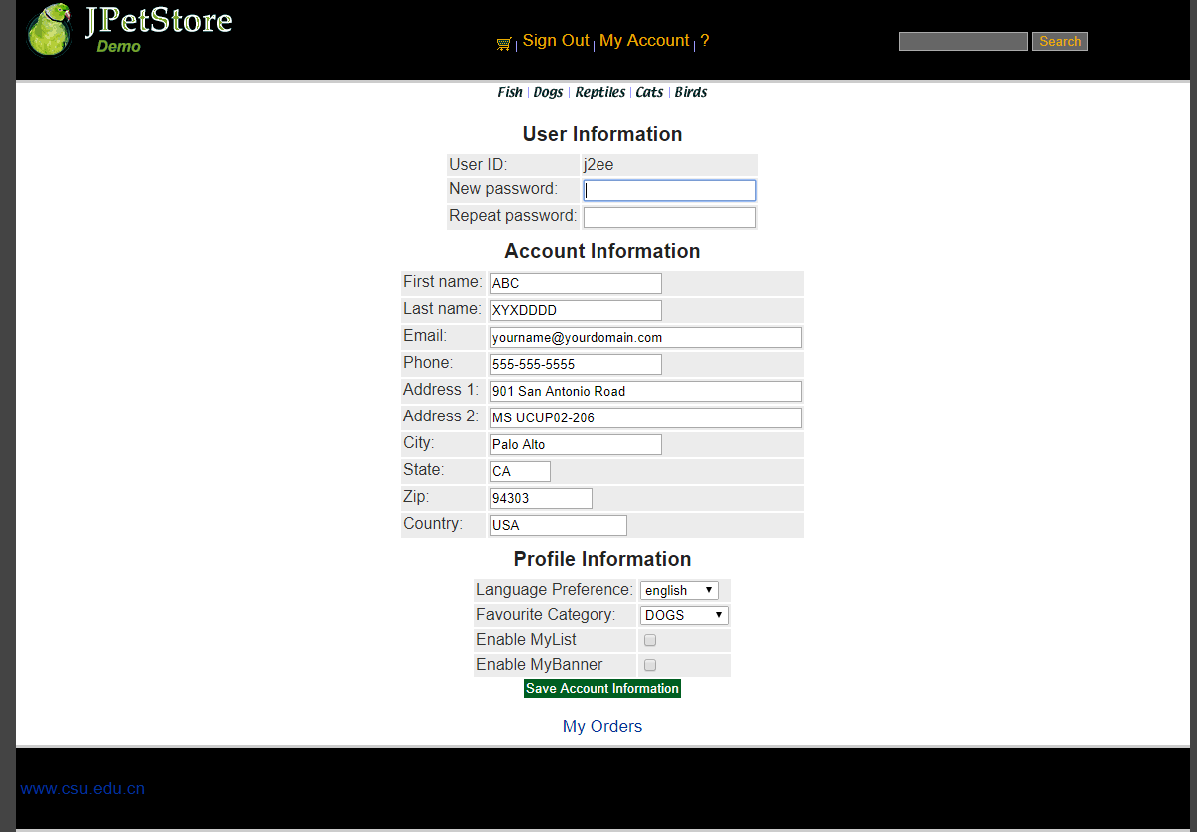

修改个人账号信息同时进行个人信息查看，也可以进行修改，修改后点击Save Account Information即可获取新的用户信息，之后进行数据库信息更新。

View：
<div id="Catalog">
<form action="saveAccount" method="post">
<h3>User Information</h3>
<table>
<tr>
<td>User ID:</td>
<td>${sessionScope.account.username}</td>
</tr>
<tr>
<td>New password:</td>
<td><input type="text" name="password" autofocus="autofocus"/></td>
</tr>
<tr>
<td>Repeat password:</td>
<td><input type="text" name="repeatedPassword" /></td>
</tr>
</table>
<%@ include file="IncludeAccountFields.jsp"%>
<input type="submit" name="editAccount" value="Save Account Information" />
</form>
<a href="viewListOrder?username=${sessionScope.account.username}">My Orders</a>
</div>

EditAccountServlet：
public class EditAccountServlet extends HttpServlet {

private static final String EDITACOUNT = "/WEB-INF/jsp/account/EditAccountForm.jsp";

protected void doPost(HttpServletRequest request, HttpServletResponse response) throws ServletException, IOException {
doGet(request, response);
}

protected void doGet(HttpServletRequest request, HttpServletResponse response) throws ServletException, IOException {
request.getRequestDispatcher(EDITACOUNT).forward(request, response);
}
}

SaveAccountServlet：
public class SaveAccountServlet extends HttpServlet {

private static final String EDITACOUNT = "/WEB-INF/jsp/account/EditAccountForm.jsp";

private Account account;
private AccountService accountService;

protected void doPost(HttpServletRequest request, HttpServletResponse response) throws ServletException, IOException {
doGet(request, response);
}

protected void doGet(HttpServletRequest request, HttpServletResponse response) throws ServletException, IOException {
HttpSession session = request.getSession();
account = (Account) session.getAttribute("account");

String username = account.getUsername();
String password = request.getParameter("password");
String firstName = request.getParameter("firstName");
String lastName = request.getParameter("lastName");
String email = request.getParameter("email");
String phone = request.getParameter("phone");
String address1 = request.getParameter("address1");
String address2 = request.getParameter("address2");
String city = request.getParameter("city");
String state = request.getParameter("state");
String zip = request.getParameter("zip");
String country = request.getParameter("country");
String languagePreference = request.getParameter("languagePreference");
String favouriteCategoryId = request.getParameter("favouriteCategoryId");
String listOption = request.getParameter("listOption");
String bannerOption = request.getParameter("bannerOption");

account.setUsername(username);
account.setPassword(password);
account.setFirstName(firstName);
account.setLastName(lastName);
account.setEmail(email);
account.setPhone(phone);
account.setAddress1(address1);
account.setAddress2(address2);
account.setCity(city);
account.setState(state);
account.setZip(zip);
account.setCountry(country);
account.setLanguagePreference(languagePreference);
account.setFavouriteCategoryId(favouriteCategoryId);
account.setListOption(Boolean.parseBoolean(listOption));
account.setBannerOption(Boolean.parseBoolean(bannerOption));

accountService = new AccountService();
accountService.updateAccount(account);

session.setAttribute("account", account);

request.getRequestDispatcher(EDITACOUNT).forward(request, response);
}
}

2.4查询订单

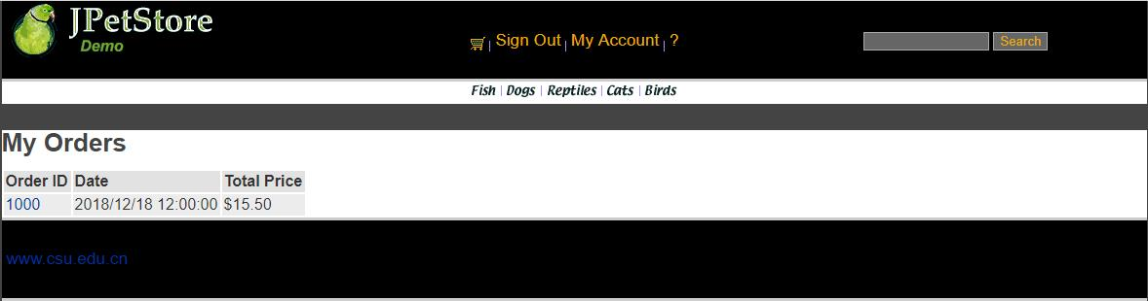

账户订单查看，先完成ListOrders.jsp的实现，接下来实现Order.java的基础模块，创建OrderDAO接口，完成数据库的具体操作OrderDAOImpl，接下来实现OrderService，成功完成业务层调用，最后完成ViewListOrderServlet实现用户可以从数据库中查看到自己的订单信息。

JSP
<div id="Catalog">
<table>
<tr>
<th align="center" colspan="2">
Order #${sessionScope.order.orderId}
<fmt:formatDate value="${sessionScope.order.orderDate}" pattern="yyyy/MM/dd hh:mm:ss" />
</th>
</tr>
<tr>
<th colspan="2">Payment Details</th>
</tr>
<tr>
<td>Card Type:</td>
<td><c:out value="${sessionScope.order.cardType}" /></td>
</tr>
<tr>
<td>Card Number:</td>
<td><c:out value="${sessionScope.order.creditCard}" /> * Fake number!</td>
</tr>
<tr>
<td>Expiry Date (MM/YYYY):</td>
<td><c:out value="${sessionScope.order.expiryDate}" /></td>
</tr>
<tr>
<th colspan="2">Billing Address</th>
</tr>
<tr>
<td>First name:</td>
<td><c:out value="${sessionScope.order.billToFirstName}" /></td>
</tr>
<tr>
<td>Last name:</td>
<td><c:out value="${sessionScope.order.billToLastName}" /></td>
</tr>
<tr>
<td>Address 1:</td>
<td><c:out value="${sessionScope.order.billAddress1}" /></td>
</tr>
<tr>
<td>Address 2:</td>
<td><c:out value="${sessionScope.order.billAddress2}" /></td>
</tr>
<tr>
<td>City:</td>
<td><c:out value="${sessionScope.order.billCity}" /></td>
</tr>
<tr>
<td>State:</td>
<td><c:out value="${sessionScope.order.billState}" /></td>
</tr>
<tr>
<td>Zip:</td>
<td><c:out value="${sessionScope.order.billZip}" /></td>
</tr>
<tr>
<td>Country:</td>
<td><c:out value="${sessionScope.order.billCountry}" /></td>
</tr>
<tr>
<th colspan="2">Shipping Address</th>
</tr>
<tr>
<td>First name:</td>
<td><c:out value="${sessionScope.order.shipToFirstName}" /></td>
</tr>
<tr>
<td>Last name:</td>
<td><c:out value="${sessionScope.order.shipToLastName}" /></td>
</tr>
<tr>
<td>Address 1:</td>
<td><c:out value="${sessionScope.order.shipAddress1}" /></td>
</tr>
<tr>
<td>Address 2:</td>
<td><c:out value="${sessionScope.order.shipAddress2}" /></td>
</tr>
<tr>
<td>City:</td>
<td><c:out value="${sessionScope.order.shipCity}" /></td>
</tr>
<tr>
<td>State:</td>
<td><c:out value="${sessionScope.order.shipState}" /></td>
</tr>
<tr>
<td>Zip:</td>
<td><c:out value="${sessionScope.order.shipZip}" /></td>
</tr>
<tr>
<td>Country:</td>
<td><c:out value="${sessionScope.order.shipCountry}" /></td>
</tr>
<tr>
<td>Courier:</td>
<td><c:out value="${sessionScope.order.courier}" /></td>
</tr>
<tr>
<td colspan="2">Status: <c:out value="${sessionScope.order.status}" /></td>
</tr>
<tr>
<td colspan="2">
<table>
<tr>
<th>Item ID</th>
<th>Description</th>
<th>Quantity</th>
<th>Price</th>
<th>Total Cost</th>
</tr>
<c:forEach var="lineItem" items="${sessionScope.order.lineItems}">
<tr>
<td>
<a href="viewItem?itemId=${lineItem.item.itemId}">${lineItem.item.itemId}</a>
</td>
<td><c:if test="${lineItem.item != null}">
${lineItem.item.attribute1}
${lineItem.item.attribute2}
${lineItem.item.attribute3}
${lineItem.item.attribute4}
${lineItem.item.attribute5}
${lineItem.item.product.name}
</c:if>
<c:if test="${lineItem.item == null}">
<i>{description unavailable}</i>
</c:if></td>
<td>${lineItem.quantity}</td>
<td><fmt:formatNumber value="${lineItem.unitPrice}" pattern="$#,##0.00" /></td>
<td><fmt:formatNumber value="${lineItem.total}" pattern="$#,##0.00" /></td>
</tr>
</c:forEach>
<tr>
<th colspan="5">
Total: <fmt:formatNumber value="${sessionScope.order.totalPrice}" pattern="$#,##0.00" />
</th>
</tr>
</table>
</td>
</tr>
</table>
</div>
</div>

OrderService
public class OrderService {

private ItemDAO itemDAO;
private OrderDAO orderDAO;
private SequenceDAO sequenceDAO;
private LineItemDAO lineItemDAO;

public OrderService(){
itemDAO = new ItemDAOImpl();
orderDAO = new OrderDAOImpl();
sequenceDAO = new SequenceDAOImpl();
lineItemDAO = new LineItemDAOImpl();
}

public void insertOrder(Order order) {
order.setOrderId(getNextId("ordernum"));
for (int i = 0; i < order.getLineItems().size(); i++) {
LineItem lineItem = (LineItem) order.getLineItems().get(i);
String itemId = lineItem.getItemId();
Integer increment = new Integer(lineItem.getQuantity());
Map<String, Object> param = new HashMap<String, Object>(2);
param.put("itemId", itemId);
param.put("increment", increment);
itemDAO.updateInventoryQuantity(param);
}

orderDAO.insertOrder(order);
orderDAO.insertOrderStatus(order);
for (int i = 0; i < order.getLineItems().size(); i++) {
LineItem lineItem = (LineItem) order.getLineItems().get(i);
lineItem.setOrderId(order.getOrderId());
lineItemDAO.insertLineItem(lineItem);
}
}

public Order getOrder(int orderId) {
Order order = orderDAO.getOrder(orderId);
order.setLineItems(lineItemDAO.getLineItemsByOrderId(orderId));

for (int i = 0; i < order.getLineItems().size(); i++) {
LineItem lineItem = (LineItem) order.getLineItems().get(i);
Item item = itemDAO.getItem(lineItem.getItemId());
item.setQuantity(itemDAO.getInventoryQuantity(lineItem.getItemId()));
lineItem.setItem(item);
}

return order;
}

public List<Order> getOrdersByUsername(String username) {
return orderDAO.getOrdersByUsername(username);
}

public int getNextId(String name) {
Sequence sequence = new Sequence(name, -1);
sequence = sequenceDAO.getSequence(sequence);
if (sequence == null) {
throw new RuntimeException("Error: A null sequence was returned from the database (could not get next " + name
+ " sequence).");
}
Sequence parameterObject = new Sequence(name, sequence.getNextId() + 1);
sequenceDAO.updateSequence(parameterObject);
return sequence.getNextId();
}

}

ViewListServlet：
public class ViewListOrderServlet extends HttpServlet {
private static final String VIEWLISTORDER = "/WEB-INF/jsp/order/ListOrders.jsp";

private String username;
private OrderService orderService;
private List<Order> orderList = new ArrayList<Order>();

protected void doPost(HttpServletRequest request, HttpServletResponse response) throws ServletException, IOException {
doGet(request, response);
}

protected void doGet(HttpServletRequest request, HttpServletResponse response) throws ServletException, IOException {
username = request.getParameter("username");
orderService = new OrderService();
orderList = orderService.getOrdersByUsername(username);

HttpSession session = request.getSession();
session.setAttribute("orderList", orderList);

//HttpSession session = request.getSession();
Account account = (Account)session.getAttribute("account");

request.getRequestDispatcher(VIEWLISTORDER).forward(request, response);
}
}

- 订单管理模块，包括购物车管理、新增订单、地址信息等业务功能。

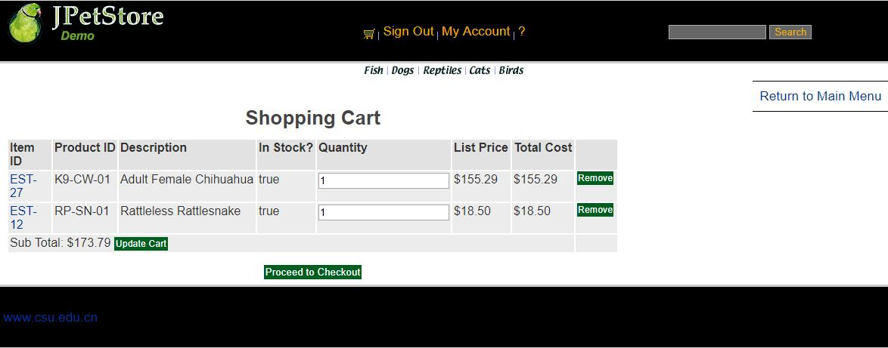

先实现Cart.jsp，能够在网页显示购物车栏目信息，接下来具体实现Cart.java使得用户可以创建Cart类，最后创建AddItemToCartServlet，当用户在浏览商品界面时，点击Add to Cart时可以将该商品加入到购物车中并显示相关信息。

AddItemToCartServlet
public class AddItemToCartServlet extends HttpServlet {

//Servlet的功能即负责中转
//1.处理完请求后的跳转页面
private static final String VIEW_CART = "/WEB-INF/jsp/cart/Cart.jsp";

//2.定义处理该请求所需要的数据
private String workingItemId;
private Cart cart; //购物车

//3.是否需要调用业务逻辑层
private CatalogService catalogService;

protected void doPost(HttpServletRequest request, HttpServletResponse response) throws ServletException, IOException {
doGet(request, response);
}

protected void doGet(HttpServletRequest request, HttpServletResponse response) throws ServletException, IOException {
workingItemId = request.getParameter("workingItemId");

Account account;
//从对话中，获取购物车
HttpSession session = request.getSession();
cart = (Cart)session.getAttribute("cart");
account = (Account)session.getAttribute("account");

if(cart == null){
//第一次使用购物车
cart = new Cart();
}

if(cart.containsItemId(workingItemId)){
//已有该物品，数量加一
cart.incrementQuantityByItemId(workingItemId);

}else{
catalogService = new CatalogService();
boolean isInStock = catalogService.isItemInStock(workingItemId);
Item item = catalogService.getItem(workingItemId);
cart.addItem(item, isInStock);
session.setAttribute("cart", cart);

request.getRequestDispatcher(VIEW_CART).forward(request, response);
}
}
}

3.2更改购物车商品的数量信息

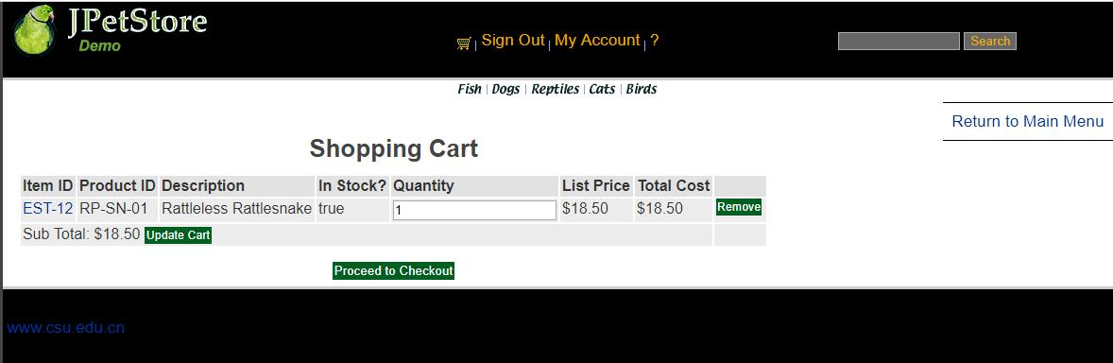

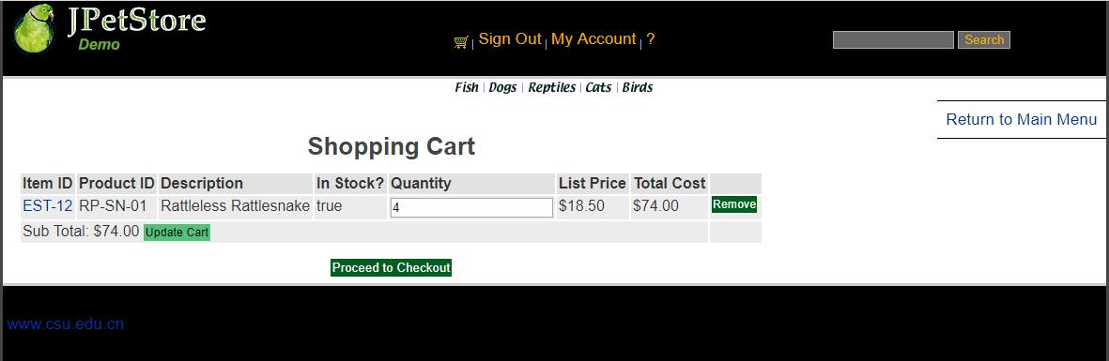

在购物车的数量栏输入想要更改后的商品数量，点击Update Cart即可更新购物车中的商品数量、总价。点击之后利用UpdateCartQuantitiesServlet实现信息更新以及页面更新，传递商品的数量信息获取后进行相关操作。

UpdateCartQuantitiesServlet：
public class UpdateCartQuantitiesServlet extends HttpServlet {

private static final String VIEW_CART = "/WEB-INF/jsp/cart/Cart.jsp";

private String workingItemId;
private Cart cart;

protected void doPost(HttpServletRequest request, HttpServletResponse response) throws ServletException, IOException {
doGet(request, response);
}

protected void doGet(HttpServletRequest request, HttpServletResponse response) throws ServletException, IOException {
workingItemId = request.getParameter("workingItemId");
CatalogService catalogService = new CatalogService();

//从对话中，获取购物车
HttpSession session = request.getSession();
cart = (Cart)session.getAttribute("cart");

Iterator<CartItem> cartItemIterator = cart.getAllCartItems();

while (cartItemIterator.hasNext()){
//产品数量增加
CartItem cartItem = (CartItem)cartItemIterator.next();
String itemId = cartItem.getItem().getItemId();

try {
int quantity = Integer.parseInt((String) request.getParameter(itemId));
cart.setQuantityByItemId(itemId, quantity);
if (quantity < 1) {
cartItemIterator.remove();
}
} catch (Exception e) {
//ignore parse exceptions on purpose
e.printStackTrace();
}

//CartItem cartItem = cartItemIterator.next();
//cartItem.incrementQuantity();
}

session.setAttribute("cart", cart);

request.getRequestDispatcher(VIEW_CART).forward(request, response);
}
}

3.3移除购物车中的商品

点击购物车中Remove按钮，获取购物车中的信息，之后进入RemoveItemFromCartServlet进行删除操作，并更新该购物车中的信息，如果误操作，则提示该误操作信息。

RemoveItemFromCartServlet：
public class RemoveItemFromCartServlet extends HttpServlet {

private static final String VIEW_CART = "/WEB-INF/jsp/cart/Cart.jsp";
private static final String ERROR = "/WEB-INF/jsp/common/Error.jsp";

private String workingItemId;
private Cart cart;

protected void doPost(HttpServletRequest request, HttpServletResponse response) throws ServletException, IOException {
doGet(request, response);
}

protected void doGet(HttpServletRequest request, HttpServletResponse response) throws ServletException, IOException {
workingItemId = request.getParameter("workingItemId");

HttpSession session = request.getSession();
cart = (Cart)session.getAttribute("cart");

Item item = cart.removeItemById(workingItemId);

if(item == null) {
session.setAttribute("message", "Attempted to remove null CartItem from Cart.");
request.getRequestDispatcher(ERROR).forward(request, response);
}else{
request.getRequestDispatcher(VIEW_CART).forward(request, response);
}
}
}

3.4新增订单——跳转到查看寄件人与收件人地址

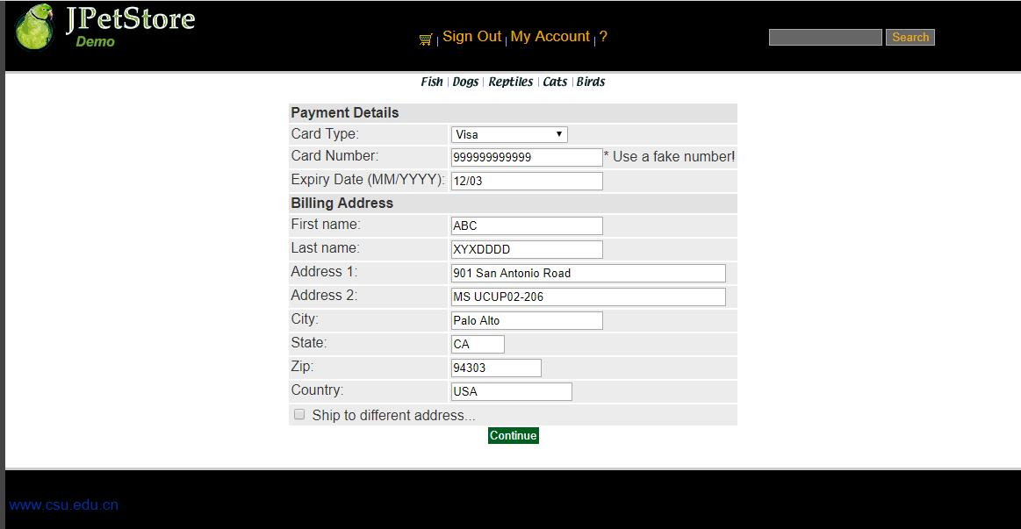

生成订单界面，包括修改地址信息时共有四个页面，第一个页面是购买方的支付与寄件地址信息确认，即NewOrderForm.jsp，接下来确认后是发货人地址与收货人地址信息确认（ConfirmOrder.jsp），或者点击修改地址即可通过ShippingFormServlet进行跳转到修改收件人地址界面，最后点击Comfirm之后即可生成最终订单（ViewOrder.jsp）。

第一个页面在购物车点击Proceed to Checkout之后利用NewOrderFormServlet进行跳转到地址信息显示界面。

NewOrderFormServlet:
public class NewOrderFormServlet extends HttpServlet {
private static final String NEW_ORDER = "/WEB-INF/jsp/order/NewOrderForm.jsp";
private static final String SIGNONFORM = "/WEB-INF/jsp/account/SignonForm.jsp";
private static final String ERROR = "/WEB-INF/jsp/common/Error.jsp";

private Account account;
private Order order;
private Cart cart;

protected void doPost(HttpServletRequest request, HttpServletResponse response) throws ServletException, IOException {
doGet(request, response);
}

protected void doGet(HttpServletRequest request, HttpServletResponse response) throws ServletException, IOException {

HttpSession session = request.getSession();
account = (Account)session.getAttribute("account");
cart = (Cart)session.getAttribute("cart");

if (account == null){
session.setAttribute("message", "You must sign on before attempting to check out. Please sign on and try checking out again.");
request.getRequestDispatcher(SIGNONFORM).forward(request, response);
} else if(cart != null){
order = new Order();
order.initOrder(account, cart);
session.setAttribute("order", order);
request.getRequestDispatcher(NEW_ORDER).forward(request, response);
}else{
session.setAttribute("message", "An order could not be created because a cart could not be found.");
request.getRequestDispatcher(ERROR).forward(request, response);
}
}
}

3.5新增订单——地址信息即修改收件人地址

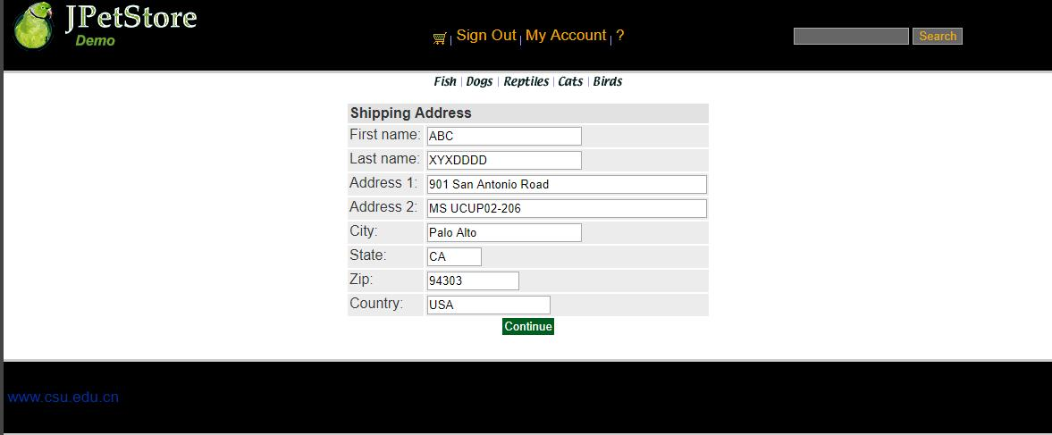

在生成订单的第一个界面时有个更改地址的选择框，选择之后点击Continue即可利用ShippingFormServlet跳转到更改收件人地址的界面ShippingForm.jsp,接下里可以进行收货人地址信息更改，再利用ShippingAdressServlet进行数据更新存入数据库接下来使用。

ShippingFormServlet：
public class ShippingFormServlet extends HttpServlet {
private static final String SHIPPINGFORM = "/WEB-INF/jsp/order/ShippingForm.jsp";
private static final String SIGNONFORM = "/WEB-INF/jsp/account/SignonForm.jsp";

private Account account;

protected void doPost(HttpServletRequest request, HttpServletResponse response) throws ServletException, IOException {
doGet(request, response);
}

protected void doGet(HttpServletRequest request, HttpServletResponse response) throws ServletException, IOException {

HttpSession session = request.getSession();
account = (Account)session.getAttribute("account");

if (account == null){
request.getRequestDispatcher(SIGNONFORM).forward(request, response);
} else{
request.getRequestDispatcher(SHIPPINGFORM).forward(request, response);
}
}
}

ShippingAdressServlet：
public class ShippingAddressServlet extends HttpServlet {
private static final String CONFIRM_ORDER_FORM = "/WEB-INF/jsp/order/ConfirmOrder.jsp";

private Order order;
private String shipToFirstName;
private String shipToLastName;
private String shipAddress1;
private String shipAddress2;
private String shipCity;
private String shipState;
private String shipZip;
private String shipCountry;

protected void doPost(HttpServletRequest request, HttpServletResponse response) throws ServletException, IOException {
doGet(request, response);
}

protected void doGet(HttpServletRequest request, HttpServletResponse response) throws ServletException, IOException {
shipToFirstName = request.getParameter("shipToFirstName");
shipToLastName = request.getParameter("shipToLastName");
shipAddress1 = request.getParameter("shipAddress1");
shipAddress2 = request.getParameter("shipAddress2");
shipCity = request.getParameter("shipCity");
shipState = request.getParameter("shipState");
shipZip = request.getParameter("shipZip");
shipCountry = request.getParameter("shipCountry");

HttpSession session = request.getSession();
order = (Order)session.getAttribute("order");

order.setShipToFirstName(shipToFirstName);
order.setShipToLastName(shipToLastName);
order.setShipAddress1(shipAddress1);
order.setShipAddress2(shipAddress2);
order.setShipCity(shipCity);
order.setShipState(shipState);
order.setShipZip(shipZip);
order.setCourier(shipCountry);

session.setAttribute("order", order);

Account account = (Account)session.getAttribute("account");

request.getRequestDispatcher(CONFIRM_ORDER_FORM).forward(request, response);
}
}

3.6新增订单——确定订单信息

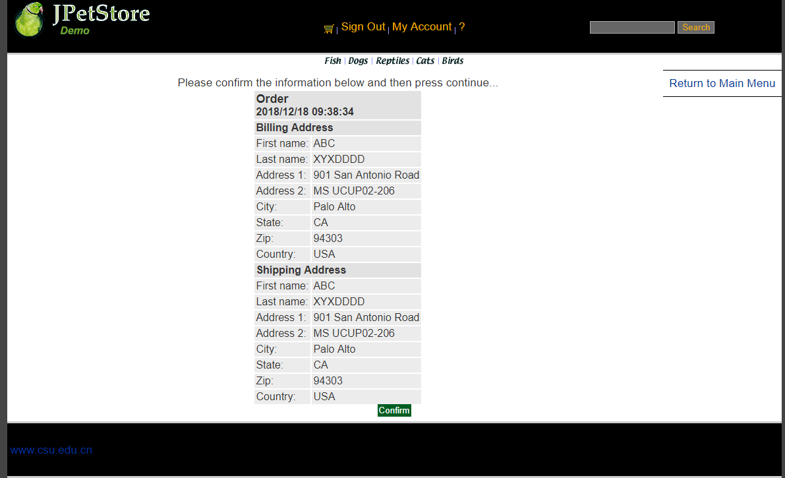

在第一个地址页面后点击Continue进入第二个地址查看界面（ConfirmOrderFormServlet），确认订单信息的正误。

public class ConfirmOrderFormServlet extends HttpServlet {
private static final String CONFIRM_ORDER_FORM = "/WEB-INF/jsp/order/ConfirmOrder.jsp";
private static final String SHIPPINGFORM = "/WEB-INF/jsp/order/ShippingForm.jsp";

protected void doPost(HttpServletRequest request, HttpServletResponse response) throws ServletException, IOException {
doGet(request, response);
}

protected void doGet(HttpServletRequest request, HttpServletResponse response) throws ServletException, IOException {
shippingAddressRequired = request.getParameter("shippingAddressRequired");
order = new Order();

HttpSession session = request.getSession();
order = (Order)session.getAttribute("order");
Account account = (Account)session.getAttribute("account");

if (shippingAddressRequired == null){
request.getRequestDispatcher(CONFIRM_ORDER_FORM).forward(request, response);
}
else{
shippingAddressRequired = null;
request.getRequestDispatcher(SHIPPINGFORM).forward(request, response);
}
}
}

3.7新增订单——生成最终订单

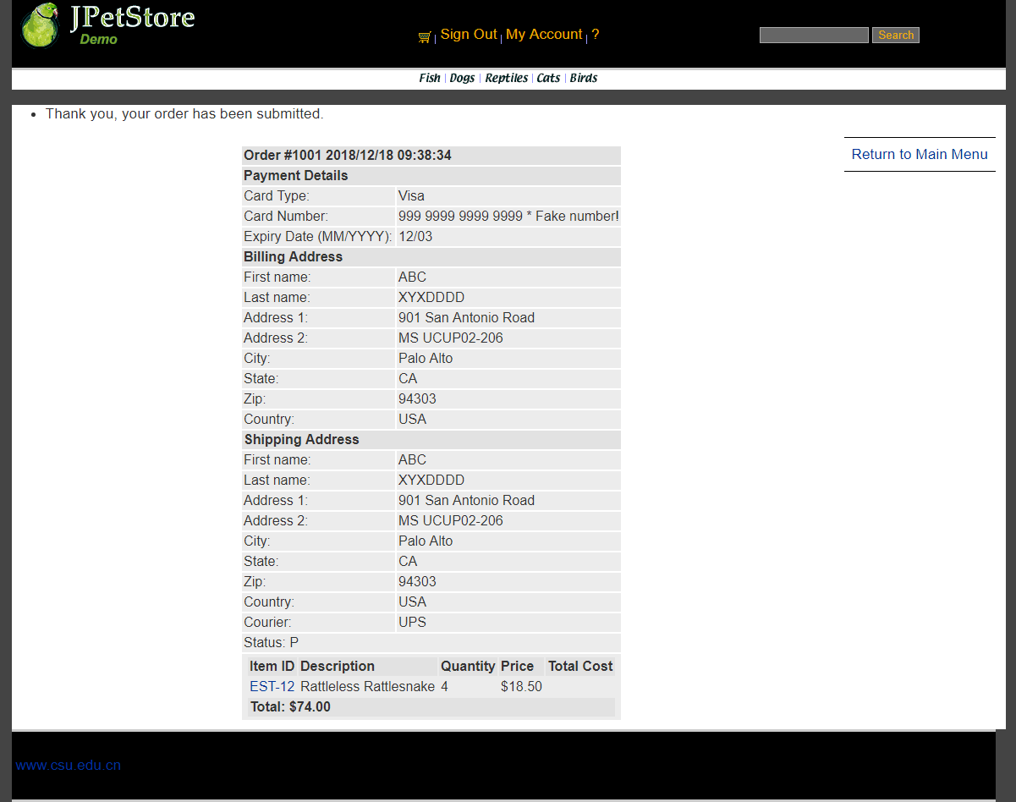

最终即可通过ViewOrderServlet生成最终的订单，包含地址信息、商品清单等信息。

ViewOrderServlet：
public class ViewOrderServlet extends HttpServlet {
private static final String VIEWORDER = "/WEB-INF/jsp/order/ViewOrder.jsp";
private static final String ERROR = "/WEB-INF/jsp/common/Error.jsp";

private Order order;
private OrderService orderService;
private Cart cart;

protected void doPost(HttpServletRequest request, HttpServletResponse response) throws ServletException, IOException {
doGet(request, response);
}

protected void doGet(HttpServletRequest request, HttpServletResponse response) throws ServletException, IOException {

HttpSession session = request.getSession();
order = (Order) session.getAttribute("order");
cart = (Cart) session.getAttribute("cart");

if (order != null) {
orderService = new OrderService();
orderService.insertOrder(order);
session.setAttribute("order", order);
//清空购物车
cart = null;
session.setAttribute("cart", cart);

session.setAttribute("message", "Thank you, your order has been submitted.");
request.getRequestDispatcher(VIEWORDER).forward(request, response);
} else {
session.setAttribute("message", "An error occurred processing your order (order was null).");
request.getRequestDispatcher(ERROR).forward(request, response);
}
}
}

//以上三个业务模块，用运行界面截图和核心代码展示功能完成情况。
- 实验内容——扩展任务。
- 添加验证码功能：在用户注册和用户登录模块中添加验证码功能。
基本原理：
声明一个由26个字母以及10个数字组成的字符表，用该字符表随机生成4个数字组成验证码，以图片形式生成，并产生120个噪点，在浏览器的固定位置中绘制渲染该图片，并将图像传到客户端
截图如下：
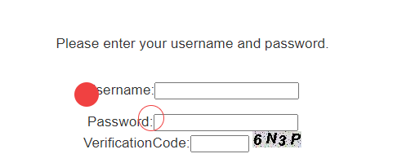‘
功能相关核心代码
VerificationCode.java
public class VerificationCode extends HttpServlet {
public VerificationCode() {
super();
}
public void destroy() {
super.destroy();
}
public void doGet(HttpServletRequest req, HttpServletResponse response)
throws ServletException, IOException {
doPost(req, response);
}
public void doPost(HttpServletRequest req, HttpServletResponse response)
throws ServletException, IOException {
response.setContentType("image/jpeg");
HttpSession session=req.getSession();
int width=60;
int height=20;
//设置浏览器不要缓存此图片
response.setHeader("Pragma", "No-cache");
response.setHeader("Cache-Control", "no-cache");
response.setDateHeader("Expires", 0);
//创建内存图像并获得图形上下文
BufferedImage image=new BufferedImage(width, height,BufferedImage.TYPE_INT_RGB);
Graphics g=image.getGraphics();
/*
* 产生随机验证码
* 定义验证码的字符表
*/
String chars="0123456789ABCDEFGHIJKLMNOPQRSTUVWXYZ";
char[] rands=new char[4];
for(int i=0;i<4;i++){
int rand=(int) (Math.random() *36);
rands[i]=chars.charAt(rand);
}
/*
* 产生图像
* 画背景
*/
g.setColor(new Color(0xDCDCDC));
g.fillRect(0, 0, width, height);
/*
* 随机产生120个干扰点
*/
for(int i=0;i<120;i++){
int x=(int)(Math.random()*width);
int y=(int)(Math.random()*height);
int red=(int)(Math.random()*255);
int green=(int)(Math.random()*255);
int blue=(int)(Math.random()*255);
g.setColor(new Color(red,green,blue));
g.drawOval(x, y, 1, 0);
}
g.setColor(Color.BLACK);
g.setFont(new Font(null, Font.ITALIC|Font.BOLD,18));
//在不同高度输出验证码的不同字符
g.drawString(""+rands[0], 1, 17);
g.drawString(""+rands[1], 16, 15);
g.drawString(""+rands[2], 31, 18);
g.drawString(""+rands[3], 46, 16);
g.dispose();
//将图像传到客户端
ServletOutputStream sos=response.getOutputStream();
ByteArrayOutputStream baos=new ByteArrayOutputStream();
ImageIO.write(image, "JPEG", baos);
byte[] buffer=baos.toByteArray();
response.setContentLength(buffer.length);
sos.write(buffer);
baos.close();
sos.close();
session.setAttribute("checkcode", new String(rands));
}
public void init() throws ServletException {
}
}

添加SignOnServlet与NewAccountServlet中内容
//获得输入的验证码值
String value1=request.getParameter("vCode");
/*获取图片的值*/
String value2=(String)session.getAttribute("checkcode");
Boolean isSame = false;
/*对比两个值（字母不区分大小写）*/
if(value2.equalsIgnoreCase(value1)){
isSame = true;
}
if(isSame){
//具体登录代码
request.getRequestDispatcher(MAIN).forward(request, response);
}else{
LogService logService = new LogService();
String logInfo = logService.logInfo(" ") + strBackUrl + " 注册账号，验证码错误";
logService.insertLogInfo(account1.getUsername(), logInfo);
}
//验证码输入错误后刷新界面，重新生成验证码
request.getRequestDispatcher(NEWACCOUNTFORM).forward(request, response);
}

- 购物车功能：原项目中购物车为内存购物车，即将用户相关的购物车存储在session中；在数据库中添加购物车表，将购物车数据持久化，以便用户下次登录时可查看或修改自己的购物车数据。
登录j2ee账号后，能看到Cart中已有物品
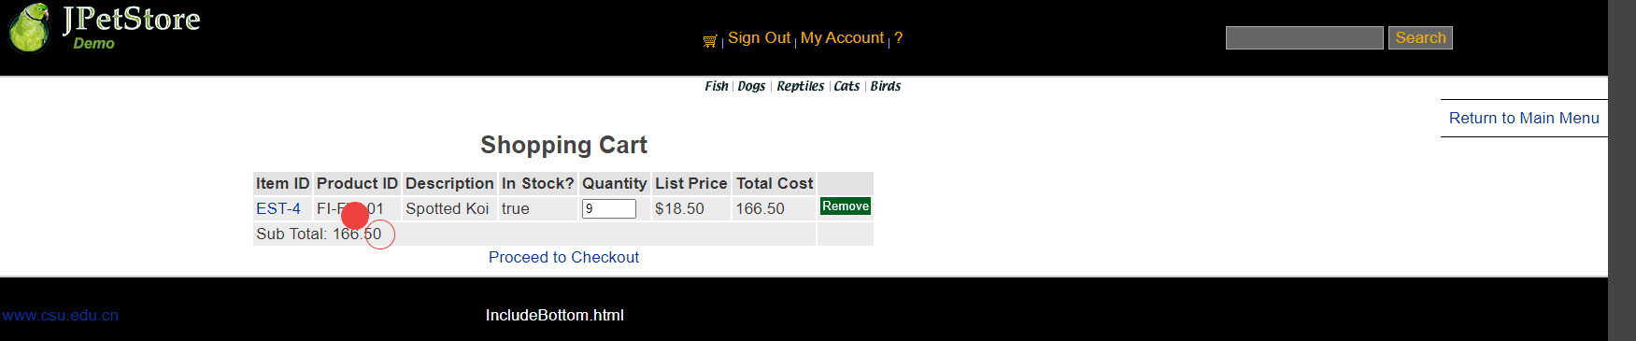
核心代码：
ViewCartServlet.java
public class ViewCartServlet extends HttpServlet {
private static final String VIEW_CART = "WEB-INF/jsp/cart/Cart.jsp";
private String userId;
@Override
protected void doPost(HttpServletRequest req, HttpServletResponse resp) throws ServletException, IOException {
doGet(req, resp);
}
@Override
protected void doGet(HttpServletRequest req, HttpServletResponse resp) throws ServletException, IOException {
HttpSession session = req.getSession();
Cart cart =(Cart)session.getAttribute("cart");
CartService cartService = new CartService();
Account account = (Account)session.getAttribute("account");
if(account != null){
userId = account.getUsername();
}
if(cart == null){
cart = new Cart();
session.setAttribute("cart",cart);
}
cartService.setCart(cart);
cartService.getAllCartItem(userId);
session.setAttribute("cart",cart);
req.getRequestDispatcher(VIEW_CART).forward(req,resp);
}
}

CartService以及CartImpl
public class CartService {
Cart cart;
CartDAO cartDAO;
public CartService(){
cartDAO = new CartImpl();
cart = new Cart();
}
public Cart getCart() {
return cart;
}
public void setCart(Cart cart) {
this.cart = cart;
}
public void incrementQuantity(String itemId, String userId){
cartDAO.incrementQuantity(itemId,userId);
cart.incrementQuantityByItemId(itemId);
}
public boolean containsItemId(String itemId,String userId){
return cartDAO.isExists(itemId,userId);
}
public void addCartItem(Item item, Boolean inStock, String userId){
cartDAO.addCartItem(item,inStock,userId);
cart.addItem(item,inStock);
}
public void getAllCartItem(String userId){
if(cartDAO.getCartItemListByUserId(userId) != null)
cart.addItem(cartDAO.getCartItemListByUserId(userId));
}
public void setQuantity(String itemId, int quantity, String userId){
cartDAO.updateQuantity(itemId, quantity, userId);
cart.setQuantityByItemId(itemId,quantity);
}
public int removeCarItem(String itemId, String userId){
cart.removeItemById(itemId);
return cartDAO.removeCartItem(itemId,userId);
}
}

public class CartImpl implements CartDAO {
private static final String getCartItemListByUserIdString = "SELECT * FROM CARTITEM WHERE USERID = ? ";
private static final String removeItemByIdString = "DELETE FROM CARTITEM WHERE ITEMID = ? AND USERID = ?";
private static final String addCartItemString = "INSERT INTO CARTITEM (ITEMID, QUANTITY, INSTOCK, USERID) VALUES (?,?,?,?)";
private static final String updateQuantityString = "UPDATE CARTITEM SET QUANTITY = ? WHERE USERID = ? AND ITEMID = ?";
private static final String isExistsString = "SELECT * FROM CARTITEM WHERE USERID = ? AND ITEMID = ?";
private static final String incrementQuantityString = "UPDATE CARTITEM SET QUANTITY = QUANTITY + 1 WHERE USERID = ? AND ITEMID = ?";
@Override
public List<CartItem> getCartItemListByUserId(String userId) {
List<CartItem> cartItemList = new ArrayList<CartItem>();
CatalogService catalogService = new CatalogService();
try{
Connection connection = DBUtil.getConnection();
PreparedStatement preparedStatement = connection.prepareStatement(getCartItemListByUserIdString);
preparedStatement.setString(1,userId);
ResultSet resultSet = preparedStatement.executeQuery();
while(resultSet.next()){
CartItem cartItem = new CartItem();
Item item = catalogService.getItem(resultSet.getString(1));
cartItem.setItem(item);
cartItem.setQuantity(resultSet.getInt(2));
cartItem.setInStock(resultSet.getInt(3) == 1);
cartItem.setUserID(userId);
cartItemList.add(cartItem);
}
DBUtil.closeResultSet(resultSet);
DBUtil.closePreparedStatement(preparedStatement);
DBUtil.closeConnection(connection);
}catch (Exception e){
e.printStackTrace();
}
return cartItemList;
}
@Override
public int removeCartItem(String itemId, String userId){
int result = 0;
try{
Connection connection = DBUtil.getConnection();
PreparedStatement preparedStatement = connection.prepareStatement(removeItemByIdString);
preparedStatement.setString(1,itemId);
preparedStatement.setString(2,userId);
result = preparedStatement.executeUpdate();
DBUtil.closePreparedStatement(preparedStatement);
DBUtil.closeConnection(connection);
}catch (Exception e){
e.printStackTrace();
}
return result;
}
@Override
public void addCartItem(Item item ,Boolean inStock ,String userId) {
try{
Connection connection = DBUtil.getConnection();
PreparedStatement preparedStatement = connection.prepareStatement(addCartItemString);
preparedStatement.setString(1,item.getItemId());
preparedStatement.setInt(2,0);
preparedStatement.setInt(3,inStock ? 1 : 0);
preparedStatement.setString(4,userId);
preparedStatement.executeUpdate();
DBUtil.closePreparedStatement(preparedStatement);
DBUtil.closeConnection(connection);
}catch (Exception e){
e.printStackTrace();
}
}
@Override
public int updateQuantity(String itemId, int quantity, String userId){
int result = -1;
try{
Connection connection = DBUtil.getConnection();
PreparedStatement preparedStatement = connection.prepareStatement(updateQuantityString);
preparedStatement.setInt(1,quantity);
preparedStatement.setString(2,userId);
preparedStatement.setString(3,itemId);
result = preparedStatement.executeUpdate();
DBUtil.closePreparedStatement(preparedStatement);
DBUtil.closeConnection(connection);
}catch (Exception e){
e.printStackTrace();
}
return result;
}
@Override
public boolean isExists(String itemId, String userId) {
boolean result = false;
try{
Connection connection = DBUtil.getConnection();
PreparedStatement preparedStatement = connection.prepareStatement(isExistsString);
preparedStatement.setString(1, userId);
preparedStatement.setString(2, itemId);
ResultSet resultSet = preparedStatement.executeQuery();
if(resultSet.next()){
result = true;
}
DBUtil.closePreparedStatement(preparedStatement);
DBUtil.closeConnection(connection);
}catch (Exception e){
e.printStackTrace();
}
return result;
}
@Override
public void incrementQuantity(String itemId,String userId){
try{
Connection connection = DBUtil.getConnection();
PreparedStatement preparedStatement = connection.prepareStatement(incrementQuantityString);
preparedStatement.setString(1,userId);
preparedStatement.setString(2,itemId);
preparedStatement.executeUpdate();
DBUtil.closePreparedStatement(preparedStatement);
DBUtil.closeConnection(connection);
}catch (Exception e){
e.printStackTrace();
}
}
}

- 日志功能：数据库中添加日志信息表，给项目添加日志功能，用户登录后记录用户行为，比如浏览了哪些商品、将商品添加进购物车、生成订单等。
记录内容：
当前的用户账号，跳转时间，操作网址URL，操作信息说明
记录方式：
向网页中添加一个message的attribute，在每个servlet中在页面跳转时修改message的内容，并通过继承HttpSessionAttributeListener重写attributeAdded,attributeRemoved以及attributeReplaced方法，向数据库中录入对应的数据。
数据库截图如下：
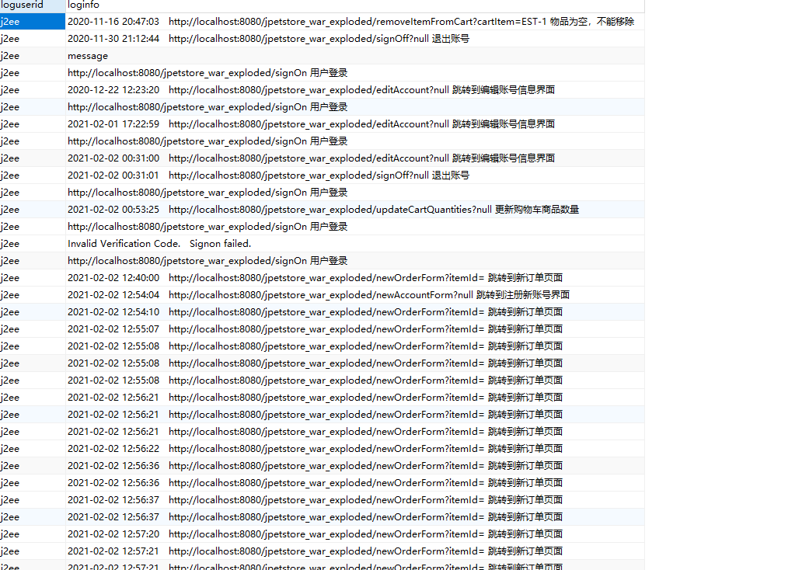
核心代码：
public class LogImpl implements LogDAO {
private static final String insertLogString = "insert into log (logUserId, logInfo) VALUES (?, ?)";
@Override
public void insertLog(String username, String logInfo) {
try {
Connection connection = DBUtil.getConnection();
PreparedStatement preparedStatement = connection.prepareStatement(insertLogString);
preparedStatement.setString(1, username);
preparedStatement.setString(2, logInfo);
preparedStatement.executeUpdate();
DBUtil.closePreparedStatement(preparedStatement);
DBUtil.closeConnection(connection);
}catch (Exception e){
e.printStackTrace();
}
}
}

SessionAttributeListener.java
@WebListener
public class SessionAttributeListener implements HttpSessionAttributeListener {
LogService logService = new LogService();
@Override
public void attributeAdded(HttpSessionBindingEvent se) {
}
@Override
public void attributeRemoved(HttpSessionBindingEvent se) {
}
@Override
public void attributeReplaced(HttpSessionBindingEvent se) {
String attributeValue = (String)se.getValue();
if(se.getSession().getAttribute("account") != null){
Account account = (Account)se.getSession().getAttribute("account");
if(account.getUsername() != null) {
String userName = account.getUsername();
String attributeName = se.getName();
if (attributeName.equals("message")) {
logService.insertLogInfo(userName, attributeValue);
}
}
}
}
}

//以上两个扩展任务，除用界面截图和核心代码展示功能完成情况外，验证码功能还需说明验证码的基本原理和实现方案，日志功能需描述项目所完成的功能情况（能记录哪些日志、怎么记录等）。
- 小组成员分工及实验总结
- 小组分工：

罗华熹一人完成全部工作。
- 实验总结

本次实验让我对MVC的开发模式有了初步的实践，并让我对如何做一个简单的软件开发有了初步的认识。更重要的是，本次实验提高了我对处理异常，不断做重复工作的耐心。

在整个实验过程中，我遇到了许多的问题，并逐一进行解决。在编写一个通用的数据库连接方法时，DriverMessage一开始出现了连接失败的异常，在Stackoverflow上查询得知要在接受连接的URL加上serverTimezone=UTC后，问题得以解决。同时，在改写原jpetstore项目至MVC开发模式时，jsp的引用文件出现了多次引用的问题，在参考了老师的教学视频后问题解决，在引用jstl时，一开始未将taglibs引用放入external libraries中，导致网页输出出现错误，后适当引入文件后问题得到解决。

在实现日志功能的时候做了几种不同的尝试，一开始尝试以log4j插件的形式实现日志，后参考了其原理通过文件I/O进行，后仔细分析了日志的需求，为保持与整体MVC开发模式保持一致，选择将日志存入数据库实现。且一开始尝试用过滤器实现日志，发现过滤器的功能逻辑与本人预想的日志需求实现不一致，在查看Java监听器的相关文档后，发现使用attribute监听器实现日志比较符合本人的想法。

在整个实验过程中，我的耐心得到了充分的培养，在编写Servlet和domain中的POJO类时需要做大量的重复工作，在经过了一段时间的编写后我曾一度感到十分的折磨，但最终还是能较完整的写出整个项目，完成了所有指定的功能和模块，还是获得了一定的满足感的。

实验二 使用AJAX和jQuery改善用户体验
- 实验内容——基本任务。
- 账号管理模块。在新建账号和修改账号信息页面上用AJAX技术进行表单验证，如“判断用户名是否已存在”等功能。
判断用户名是否已存在：注册界面输入用户名后，鼠标focus离开用户名输入框，若用户名可用，显示Username Available，否则显示Username Exist Already！
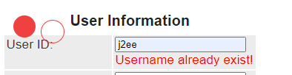

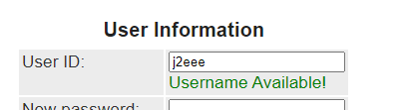
并对密码与重复密码框进行一致验证
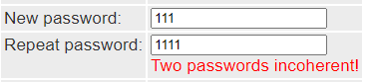
对用户名，密码框，重复密码框进行空提示
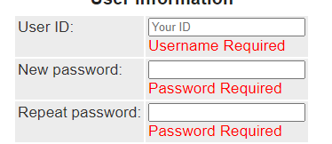
核心代码如下：
Js：
$(document).ready(function () {
$('#username').on('blur',function (e) {
$('#namemsg').hide();
if($('#username').val() === null || $('#username').val() === ""){
$('#namemsg').show();
$('#namemsg').html("Username Required").css('color','red');
}
else {
$.ajax({
url: 'CheckUsernameServlet',
dataType: "json",
data: $('#signupForm').serialize(),
type : "POST",
success: function(data){
if(data.msg){
$('#namemsg').html('Username already exist!').css('color','red');
}
else{
$('#namemsg').html('Username Available!').css('color','green');
}
$('#namemsg').show();
},
error: function(){
alert("error");
}
});
}
});
$('#password').on('blur', function () {
$('#pwdmsg').hide();
if($('#password').val() === null || $('#password').val() === "" ) {
$('#pwdmsg').html("Password Required").css('color','red');
$('#pwdmsg').show();
}
if($('#repeat').val() !== $('#password').val()){
$('#repeatmsg').html("Two passwords incoherent!").css('color','red');
$('#repeatmsg').show();
}
});
$('#repeat').on('blur',function () {
$('#repeatmsg').hide();
if($('#repeat').val() === null || $('#repeat').val() === "" ) {
$('#repeatmsg').html("Password Required").css('color','red');
$('#repeatmsg').show();
}
if($('#repeat').val() !== $('#password').val()){
$('#repeatmsg').html("Two passwords incoherent!").css('color','red');
$('#repeatmsg').show();
}
})
});
CheckUsernameServlet.java
使用json传递数据
String username = req.getParameter("username");
Account account = new Account();
account.setUsername(username);
AccountService accountService = new AccountService();
JSONObject jsonObject = new JSONObject();
resp.setContentType("application/json; charset=utf-8");
PrintWriter out = resp.getWriter();
if(accountService.getAccount(account.getUsername()) != null){
jsonObject.put("msg",true);
}
else {
jsonObject.put("msg",false);
}
out.write(jsonObject.toJSONString());
out.flush();
out.close();
}

- 查询商品模块。在主页面右上角的查询商品功能中添加自动补全功能。
自动补全功能使用Jquery-ui autocomplete插件实现
截图如下：
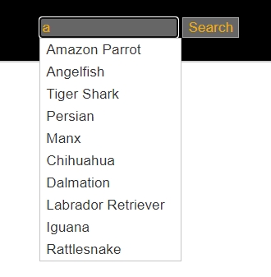
显示数据库中包含搜索字符串的商品
核心代码如下：
$(document).ready(function () {
$("input#searchText").autocomplete({
source:function(request, response){
$.ajax({
url:'SearchProductResultServlet',
dataType : "json",
data: request,
type:"get",
scroll:true,
success: function (data) {
if (typeof Array.prototype.forEach != 'function') {
Array.prototype.forEach = function(callback){
for (let i = 0; i < this.length; i++){
callback.apply(this, [this[i], i, this]);
}
};
}
let values = data;
let newArray = new Array(values.length);
let i = 0;
values.forEach(function (entry) {
let newObject = {
label: entry.name
};
newArray[i] = newObject;
i++;
});
response(newArray);
}
});
},
error: function (jqXHR, textStatus, errorThrown) {
console.log(textStatus);
},
minLength:1
})
});
SearchProductResultServlet.java
String keyword = req.getParameter("term");
System.out.println(keyword);
CatalogService service = new CatalogService();
List<Product> productList = service.searchProductList(keyword);
resp.setContentType("text/html");
PrintWriter out = resp.getWriter();
JSONArray jsonArray = new JSONArray();
//返回结果
jsonArray.addAll(productList);
out.write(jsonArray.toString());
out.flush();
out.close();
- 购物车模块。在购物车模块中修改购买数量时，通过AJAX修改购物车信息。
截图如下：
原购物车中EST-4的数量为5
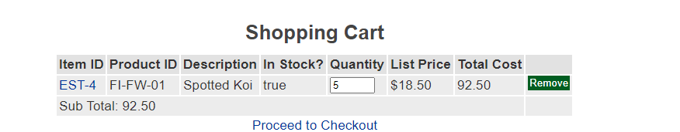
修改数量为10后按enter，购物车数据刷新
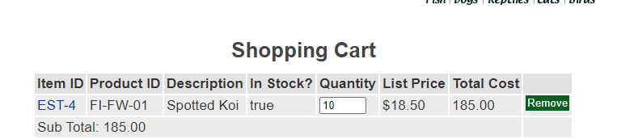
核心代码如下：
Js：
$(document).ready(function () {
$('#quantity').on('blur', function (e) {
if($('#quantity').val() === null || $('#quantity').val() === "" || isNaN(parseInt($('#quantity').val())) ){
}
else{
$.ajax({
url: 'UpdateCartServlet',
type: 'post',
data: {
quantity: $('#quantity').val(),
},
success: function (msg) {
let array = msg.split(',');
$('#total').innerText = array[1];
$('#quantity').innerText = array[0];
$('#subtotal').innerText = array[2];
}
})
}
});
});

UpdateCartServlet
HttpSession session = req.getSession();
cart = (Cart)session.getAttribute("cart");
Iterator<CartItem> cartItemIterator = cart.getAllCartItems();
while (cartItemIterator.hasNext()) {
//产品数量增加
CartItem cartItem = (CartItem) cartItemIterator.next();
String itemId = cartItem.getItem().getItemId();
try {
int quantity = Integer.parseInt((String) req.getParameter("quantity"));
cart.setQuantityByItemId(itemId, quantity);
if (quantity < 1) {
cartItemIterator.remove();
}
} catch (Exception e) {
e.printStackTrace();
}
}
session.setAttribute("cart", cart);
Cart cart2 = (Cart)session.getAttribute("cart");
Iterator<CartItem> cartItemIterator2 = cart2.getAllCartItems();
String quantityAll = "";
while (cartItemIterator2.hasNext()) {
//产品数量增加
CartItem cartItem2 = cartItemIterator2.next();
int quantity2 = cartItem2.getQuantity();
quantityAll += quantity2 + "," + cartItem2.getTotal() + "," + cart2.getSubTotal();
}
resp.setContentType("text/xml");
PrintWriter out = resp.getWriter();
out.write(quantityAll);
out.flush();
out.close();
}

//以上三个业务模块，用运行界面截图和核心代码展示功能完成情况。
- 实验内容——选做任务。
- 商品展示模块。在首页展示商品的图片上添加AJAX效果，即当鼠标移到某个商品图片上时，用悬浮窗展示该类型商品的信息。

基本原理以及实现方案：采用固定位置的样式渲染悬浮窗，使用ajax技术为图片元素添加mouseover和mouseout监听器，传递mouseover对应的

CategoryID，在servlet中返回对应的数据

截图如下：

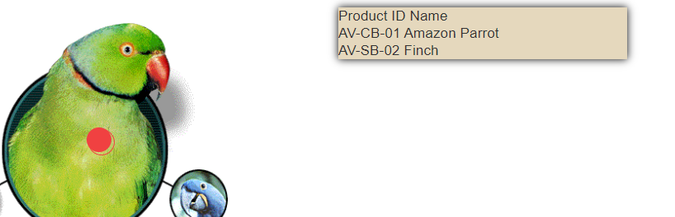

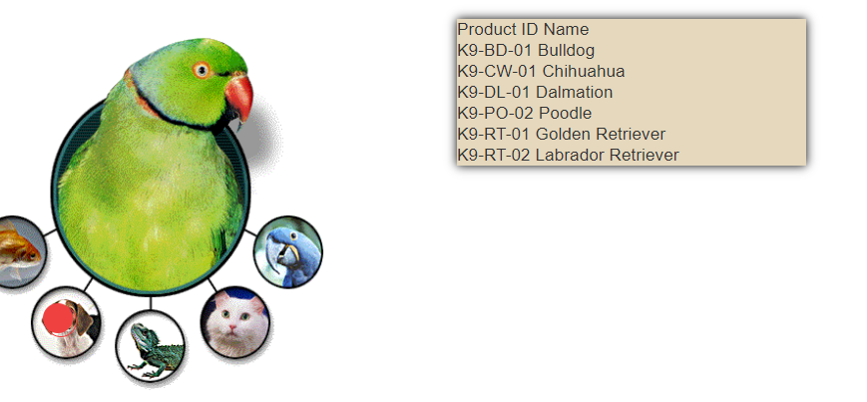

核心代码如下：

Js
$(document).ready(function () {
$('#estoremap area').mouseover(function () {
$.ajax({
url:'CategoryShowServlet',
type: 'post',
dataType:'html',
data: {categoryId: $(this).attr('alt'),},
success: function (msg) {
console.log('success');
let inform = document.getElementById("inform");
inform.innerText = msg;
inform.style.display = "block";
},
error: function () {
console.log('failed');
}
})
})
.on('mouseout',function (e) {
let informDiv = document.getElementById('inform');
let x=e.clientX;
let y=e.clientY;
let divx1 = informDiv.offsetLeft;
let divy1 = informDiv.offsetTop;
let divx2 = informDiv.offsetLeft + informDiv.offsetWidth;
let divy2 = informDiv.offsetTop + informDiv.offsetHeight;
if( x < divx1 || x > divx2 || y < divy1 || y > divy2){
document.getElementById('inform').style.display='none';
}
})
});

Servlet
String categoryId = req.getParameter("categoryId");
CatalogService catalogService = new CatalogService();
List<Product> productList = catalogService.getProductListByCategory(categoryId);
String respXML = "Product ID Name\n";
int i = 0;
while(i < productList.size()){
Product product = productList.get(i);
respXML += product.getProductId() + " " + product.getName() + "\n";
i++;
}
resp.setContentType("text/xml");
PrintWriter out = resp.getWriter();
out.write(respXML);
out.flush();
out.close();

- 订单模块。通过选项卡或模版内容实现订单多个信息部分的录入，不需要页面跳转，在一个页面完成订单所有内容的录入。

基本原理：在购物车界面点击Proceed To Checkout后进入Order Form选项卡，并根据对应的跳转添加选项卡

实现方式：使用jquery-ui的tabs插件，为每个页面的表单注册一个submit监听器，preventDefault阻止其原有行为后使用ajax技术实现页面跳转逻辑

截图如下:

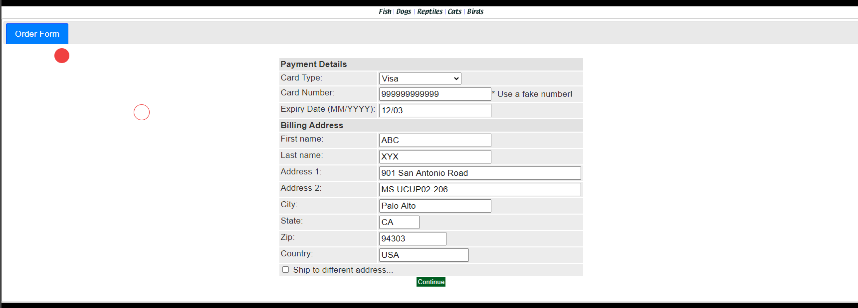

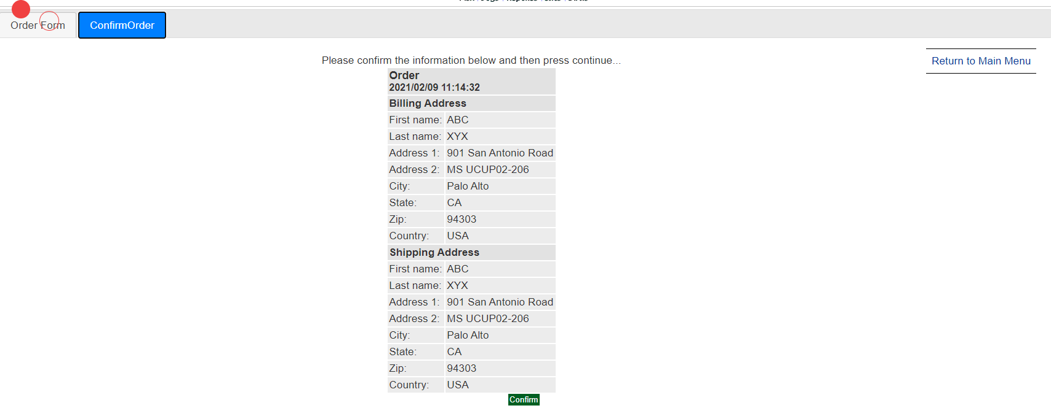

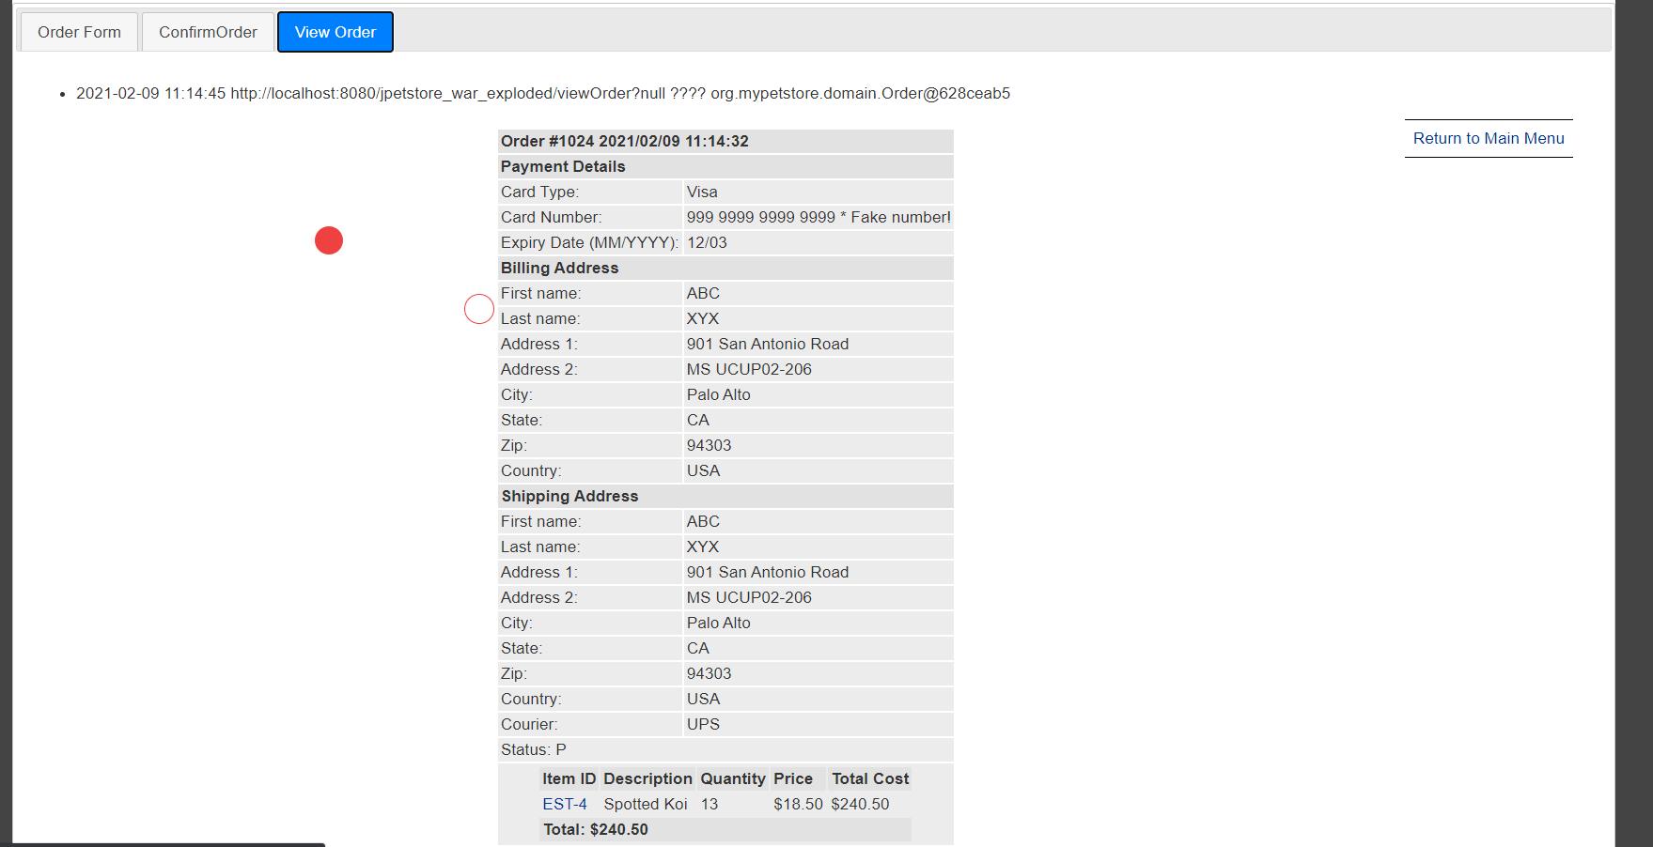

核心代码如下：
$(document).ready(function () {
let tabs = $( "#tabs" );
tabs.tabs();
$('#newOrderForm').on('submit', function (e) {
e.preventDefault();
let maxid = 0;
$('#tabs ul li').each(function () {
let value = parseInt($(this).attr('id'));
maxid = (value > maxid) ? value : maxid;
});
let tabNameExists = false;
$('#tabs ul li a').each(function (i) {
if ($.trim(this.text.toLowerCase()) === "confirmorder") {
tabNameExists = true;
}
});
if(!tabNameExists){
let newid = maxid + 1;
$.ajax({
type: "get",
url: "confirmOrderForm",
dataType: 'html',
data: $('#newOrderForm').serialize(),
success: function (data) {
let $newtabs = $("<div id='tabs-" + newid + "'></div>");
let $a = $("<li id='" + newid + "'><a href= '#tabs-"+ newid +"'>ConfirmOrder</a></li>");
if($('#shippingAddress').checked()) $a=$("<li id='" + newid + "'><a href= '#tabs-"+ newid +"'>ShppingAddress</a></li>");
$('li:last').after($a);
tabs.append($newtabs);
$newtabs.html(data);
tabs.tabs("refresh");
console.log(data);
},
error: function () {
console.log('error');
}
})
}
});
$('#shippingForm').on('submit', function (e) {
e.preventDefault();
let maxid = 0;
$('#tabs ul li').each(function () {
let value = parseInt($(this).attr('id'));
maxid = (value > maxid) ? value : maxid;
});
let tabNameExists = false;
$('#tabs ul li a').each(function (i) {
if ($.trim(this.text.toLowerCase()) === "order form") {
tabNameExists = true;
}
});
if(!tabNameExists){
let newid = maxid + 1;
$.ajax({
type: "get",
url: "confirmOrderForm",
dataType: 'html',
data: $('#shippingForm').serialize(),
success: function (data) {
let $newtabs = $("<div id='tabs-" + newid + "'></div>");
let $a = $("<li id='" + newid + "'><a href= '#tabs-" + newid + "'>Order Form</a></li>");
$('li:last').after($a);
tabs.append($newtabs);
$newtabs.html(data);
tabs.tabs("refresh");
console.log(data);
},
error: function () {
console.log('error');
}
})
}
});
});
- 其他效果：可自行选择其他UI模版，或选择其他功能点进行用户体验的优化。
基本原理：制作了一个鼠标阴影跟踪动画，默认为一个带有外轮廓的红色圆形，当鼠标悬浮到可点击的链接时变化为一个外轮廓为红，无填充的圆：
实现方案：使用TweenMax插件实现跟踪功能，编写动画相应的css文件，使用bezier-curve渲染所需的形状动画
截图如下：

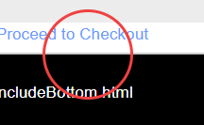
核心代码：
#cursor {
position: fixed;
background-color: rgb(240, 65, 65);
width: 30px;
height: 30px;
border-radius: 100%;
transition: 0.3s cubic-bezier(0.75, -1.27, 0.3, 2.33) transform, 0.2s cubic-bezier(0.75, -0.27, 0.3, 1.33) opacity;
user-select: none;
pointer-events: none;
z-index: 10000;
transform: scale(1);
}
#cursor.active {
opacity: 1;
transform: scale(0);
}
#cursor.menu-active {
opacity: 1;
transform: scale(0);
}
#cursor.hovered {
opacity: 1;
}
#cursor-follower {
position: fixed;
border: 1px solid rgb(240, 65, 65);
width: 30px;
height: 30px;
border-radius: 100%;
transition: 0.6s cubic-bezier(0.75, -1.27, 0.3, 2.33) transform, 0.2s cubic-bezier(0.75, -0.27, 0.3, 1.33) opacity, 0.2s cubic-bezier(0.75, -0.27, 0.3, 1.33) background;
user-select: none;
pointer-events: none;
z-index: 10000;
transform: translate(2px, 2px);
}
#cursor-follower.active {
opacity: 1;
transform: scale(3);
}
#cursor-follower.menu-active {
opacity: 1;
transform: scale(3);
}
#cursor-follower.hovered {
opacity: 1;
}

// CURSOR
let cursor = $(".cursor"),
follower = $(".cursor-follower");
let posX = 0,
posY = 0;
let mouseX = 0,
mouseY = 0;
TweenMax.to({}, 0.016, {
repeat: -1,
onRepeat: function () {
posX += (mouseX - posX) / 9;
posY += (mouseY - posY) / 9;
TweenMax.set(follower, {
css: {
left: posX - 0,
top: posY - 0
}
});
TweenMax.set(cursor, {
css: {
left: mouseX,
top: mouseY
}
});
}
});
$(document).on("mousemove", function (e) {
mouseX = e.clientX;
mouseY = e.clientY;
});
//transform into a circle
$("a").on("mouseenter", function () {
cursor.addClass("active");
follower.addClass("active");
});
$("a").on("mouseleave", function () {
cursor.removeClass("active");
follower.removeClass("active");
});
- 小组成员分工及实验总结
- 小组分工：

罗华熹一人负责全部工作
- 实验总结
本次实验让我深刻认识到了自己目前所学甚浅，以及前端世界的庞大与丰富。大部分的ajax功能，在编写了JsQuery&Ajax textbook书中的代码后我都能较为熟练的写出来。但是，我对如何实现业务逻辑缺乏相当的知识，导致了最终的实现不尽人意。
本次实验极大地培养了我查阅资料的能力，在实验过程中，我学会了勤用MDN Web Docs,Stackoverflow，Codepen等网站以及插件的使用说明文档进行资料的查阅与动画特效等相关知识的学习，codepen上的极大极多的资源和样例代码让我对js，对前端的迅猛发展有了深刻的体会。我也认识了许多优秀的网站：css-tricks，codemyui，dev community等等，同时我也逐渐学会了用纯英文关键字搜索我想要的内容的搜索方法（不得不感慨google强大的搜索功能）。
实验中我也遇到了许多问题：
1.使用了老师上课时讲到的fastJSON库创建JSON对象并进行数据传输，但一开始ajax中的成功接受函数始终收不到数据，后在不断的查阅文档后，发现要用printwriter.write发用一个toJSONString才能接受成功。
2.ajax的send数据的格式如何？最终采用了form表单序列化的方式定义数据(serialize())；
3.怎么做一个好的鼠标跟踪动画？这一点花了我许多的时间，我详细阅读了w3school，MDN，CSS-tricks中的一些文章，采用css的方式实现动画，在transition中用了cubic-bezier一步步的调试，在js文件编写好后发现圆位置与鼠标位置有较大的编译，通过使用tweenmax插件调整了动画的坐标，也是不断地调试最终实现了鼠标动画的效果。

