2026 HKDSE Paper 1A

There are 33 questions. Questions marked with * involve knowledge of the extension component. Take g = 9.81 m s⁻².

26-01. Flasks X and Y are identical except that for their outer surfaces: X is black and Y is silvery. Each flask contains the same amount of water initially at 25 °C, sealed and equipped with a temperature sensor. The flasks are then placed in the same outdoor environment at 30 °C with sunlight. After 20 minutes,
A. the water in X is hotter as a black surface is a better absorber of radiation.
B. the water in X is hotter as a black surface is a better emitter of radiation.
C. the water in Y is hotter as a silvery surface is a poorer absorber of radiation.
D. the water in Y is hotter as a silvery surface is a poorer emitter of radiation.

26-02. The resistance of a resistance thermometer is 100.0 Ω in pure melting ice. Its resistance increases linearly with temperature by 0.385 Ω °C⁻¹. Find the temperature when the resistance is 117.2 Ω.
A. 6.62 °C B. 11.5 °C
C. 44.7 °C D. 45.1 °C

26-03. A metal sphere at 90 °C is put into a cup of water. The temperature of the water increases from 25 °C to 35 °C. If a second identical metal sphere, also at 90 °C, is added to the water, what is the final temperature of the water ? Assume there is no heat loss to the cup or the surroundings throughout the process.
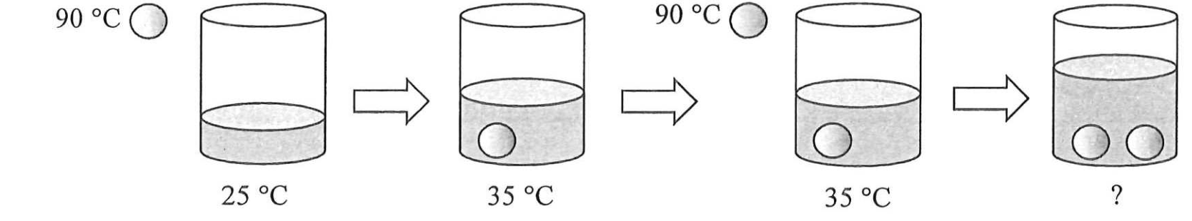
A. 41.5 °C B. 42.3 °C
C. 43.5 °C D. 45.0 °C

26-04. A sphere of weight 18 N is suspended by two light and inextensible strings. One string is attached horizontally to a wall, and the other is connected to the ceiling. The sphere rests on the smooth top surface of an electronic balance, which shows a reading of 10 N. Find the resultant force acting on the sphere by the two strings.
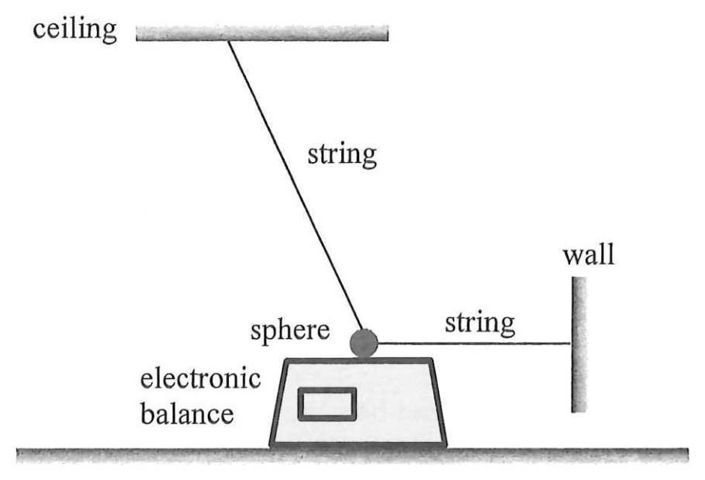
A. 0 N B. 8 N
C. 10 N D. 15 N

26-05. A train is moving horizontally along a straight line. A piece of luggage rests on the floor of the train. The diagram shows the frictional force acting on the luggage, directed to the right. Neglect air resistance.
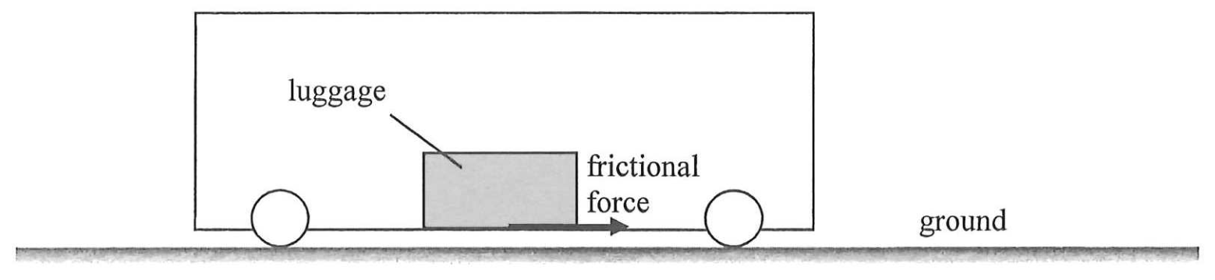
Observing from the ground, which of the following statements must be correct ?
(1) The train is travelling to the right.
(2) The train is accelerating.
(3) The direction of acceleration of the luggage is to the right.
A. (1) and (2) only B. (1) and (3) only
C. (2) and (3) only D. (1), (2) and (3)

26-06. A 1-kg block is placed on a 2-kg block, and both are on a smooth incline at 30° to the horizontal. A constant force F is applied to the 1-kg block upward along the incline so that the two blocks move up the incline together with the same constant velocity as shown.
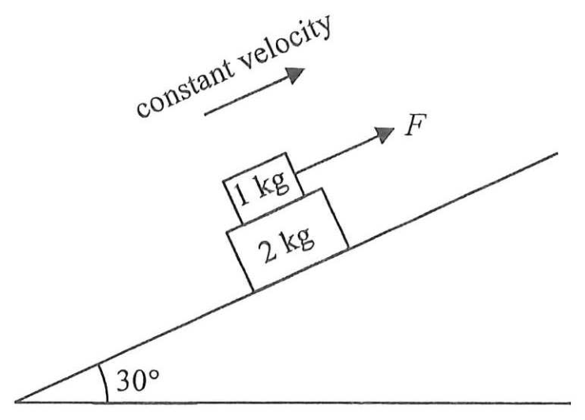
What is the frictional force acting on the 1-kg block by the 2-kg block ? Neglect air resistance. (g = 9.81 m s⁻²)
A. 4.91 N upward along the incline
B. 9.81 N upward along the incline
C. 4.91 N downward along the incline
D. 9.81 N downward along the incline

26-07. A rectangular plate of width 2 m and length 4 m is placed on a smooth horizontal surface. Three forces F₁, F₂ and F₃ of equal magnitude act on it as shown. F₁ and F₃ are parallel and opposite in direction. Taking the moment about which point below is the net moment the greatest ?
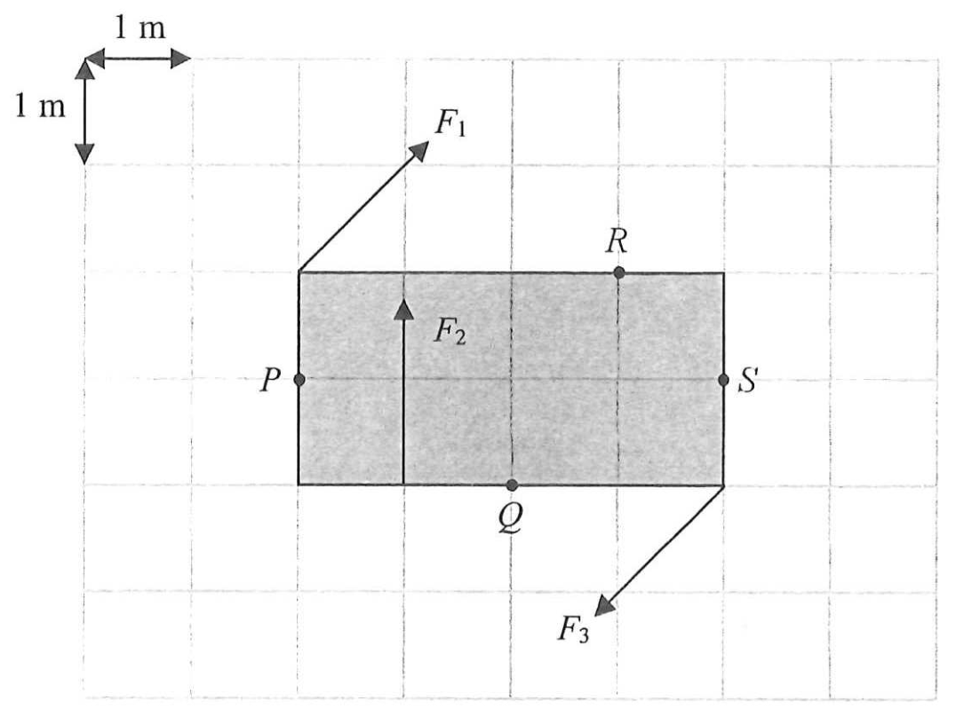
A. P B. Q
C. R D. S

26-08. One end of a light and inextensible string is connected to a floating balloon and the other end is fixed to the ground as shown. The string is taut.
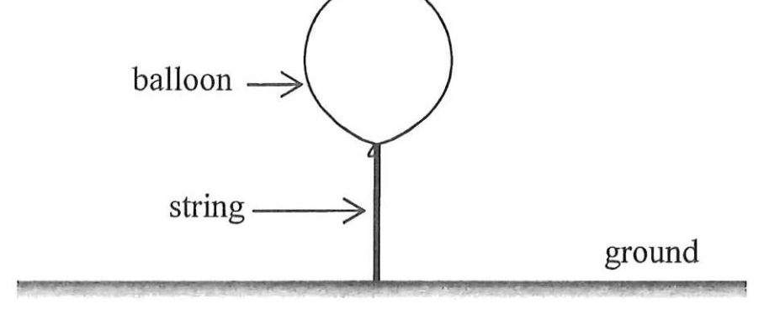
The free-body diagrams of the balloon and the string are shown below.
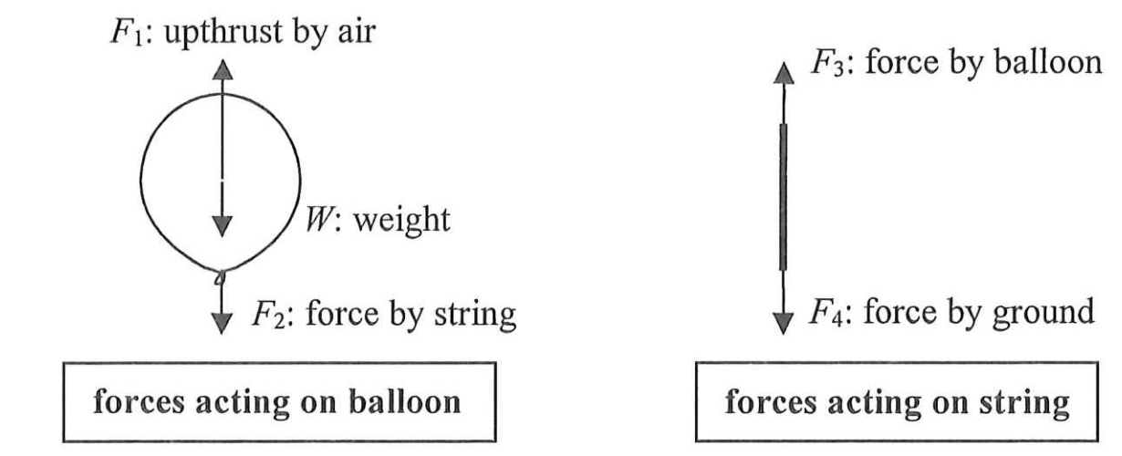
Which of the following is/are action and reaction pair(s) ?
(1) F₁ and W
(2) F₂ and F₃
(3) F₃ and F₄
A. (1) only B. (2) only
C. (1) and (3) only D. (2) and (3) only

26-09. A ball is released from a certain height. It rebounds from the ground several times before it comes to rest. Neglect air resistance. Which of the following graphs best represents the variation of the total mechanical energy E of the ball with time t ?
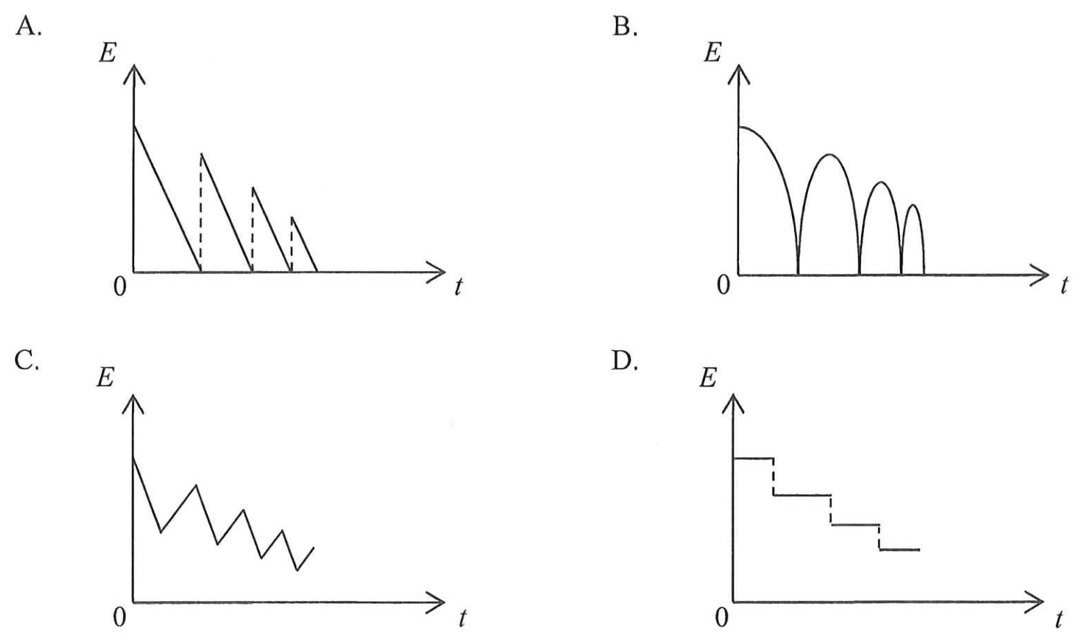

26-10. A 1-kg trolley with a 0.5-kg block placed on its horizontal platform is resting on a smooth horizontal floor. The block is then given a sharp push to the right. At an instant after the push, the block and the trolley are moving to the right at 2 m s⁻¹ and 0.5 m s⁻¹ respectively as observed from the floor.
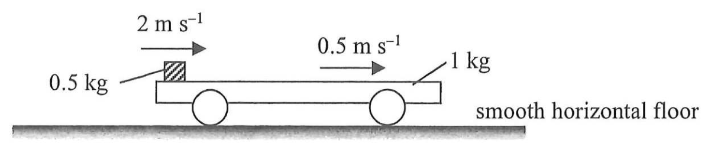
Finally, they travel together with the same speed v. Find v. Neglect air resistance.
A. 0.5 m s⁻¹ B. 1 m s⁻¹
C. 1.5 m s⁻¹ D. 2 m s⁻¹

*26-11. Satellites X and Y revolve around the Earth in circular orbits, in the same plane and in the same direction. The radii of their orbits are r and 4r respectively. The figure below shows an instant that X, Y and the Earth are on a straight line.
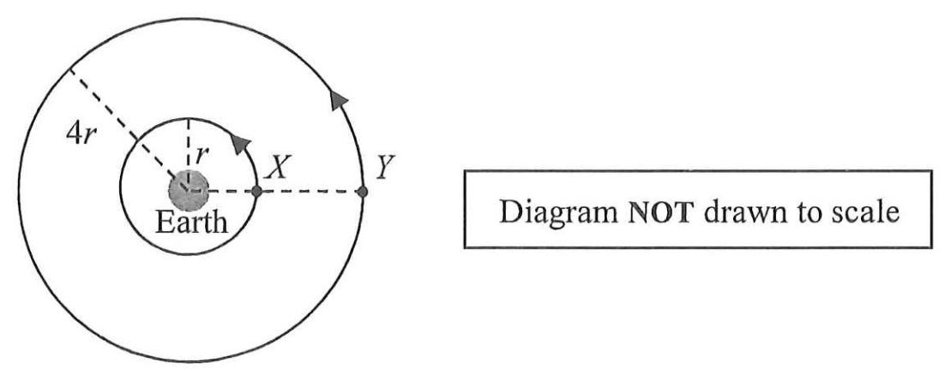
When X completes one cycle, which of the following diagrams best represents the position of Y ?
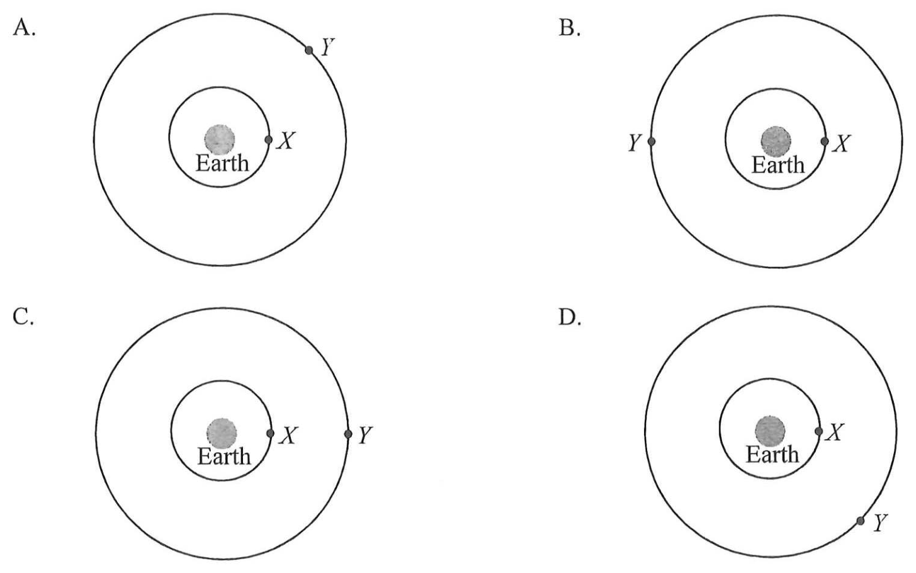

*26-12. A rocket on the Earth’s surface is launched by an upward thrust F, producing an upward acceleration g, where g is the acceleration due to gravity near the Earth’s surface, as shown in Figure (a). R is the radius of the Earth.
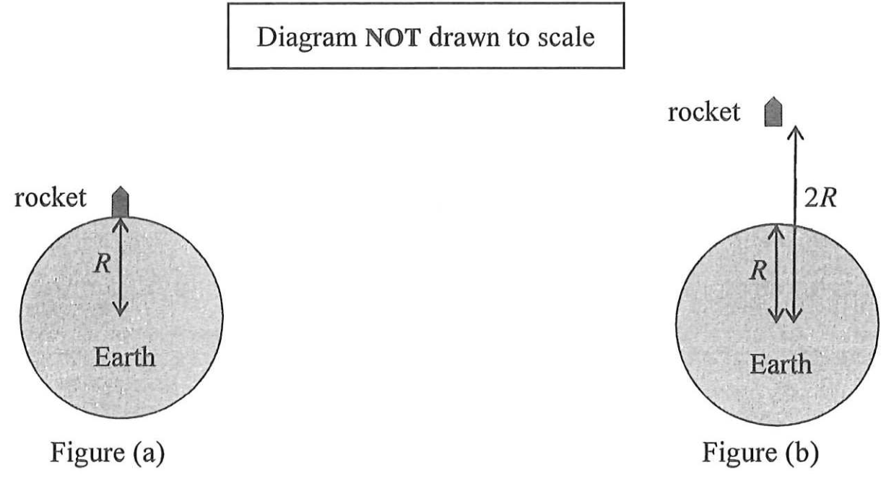
Figure (b) shows an identical rocket at a distance 2R away from the Earth’s centre. What is the upward thrust required for producing the same upward acceleration g ? Neglect air resistance.
A. $\frac{F}{4}$ B. $\frac{F}{2}$
C. $\frac{5F}{8}$ D. $\frac{3F}{4}$

26-13. The figure shows a string with one end fixed on the wall and the other end tied to a vibrator with frequency f. A stationary wave is formed as shown at a certain instant. The distance between the vibrator and the wall is L.
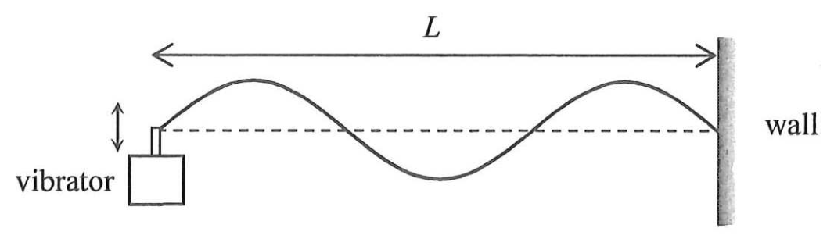
Which of the following statements are correct ?
(1) All particles on the string between two successive nodes are vibrating in phase.
(2) If the tension in the string increases while L remains unchanged, f must increase to maintain the same stationary wave pattern.
(3) The wavelength of the stationary wave is L/3.
A. (1) and (2) only B. (1) and (3) only
C. (2) and (3) only D. (1), (2) and (3)

26-14. Which of the following phenomena involve(s) the principle of superposition of waves ?
(1) Ripples in a pond overlap and create regions with different amplitudes.
(2) Stationary wave patterns are formed when two waves of the same frequency travel in opposite directions.
(3) The speed of waves changes when they travel from one medium to another.
A. (1) only B. (3) only
C. (1) and (2) only D. (2) and (3) only

26-15.
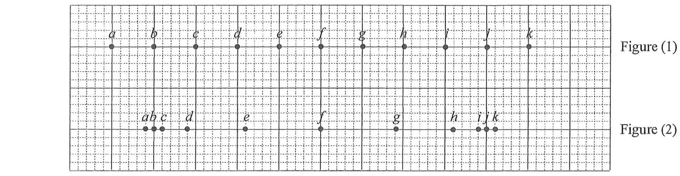
Figure (1) shows the equilibrium positions of particles a to k in a medium. A longitudinal wave is travelling through the medium and the positions of the particles at a certain instant are shown in Figure (2). Which of the following statements is/are correct at that instant ?
(1) The separation between c and k is one wavelength.
(2) f is momentarily at rest.
(3) i and k are moving in the same direction.
A. (2) only B. (3) only
C. (1) and (2) only D. (1) and (3) only

26-16. The image of an object formed by a convex lens is virtual and is situated at the focus F as shown.
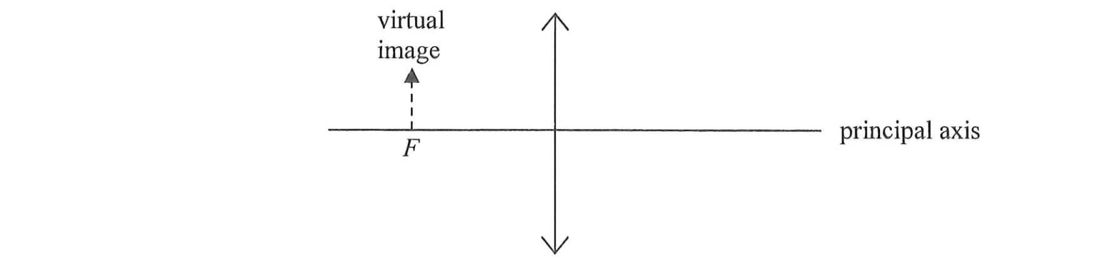
Which of the following statements is/are correct ?
(1) The object is at infinity.
(2) The object is larger than the image.
(3) The object and the image are on the same side of the lens.
A. (2) only B. (3) only
C. (1) and (2) only D. (1) and (3) only

26-17. Light ray Y is incident on a concave lens as shown. F and F′ are the foci of the lens. Which light ray best represents the emergent ray ?
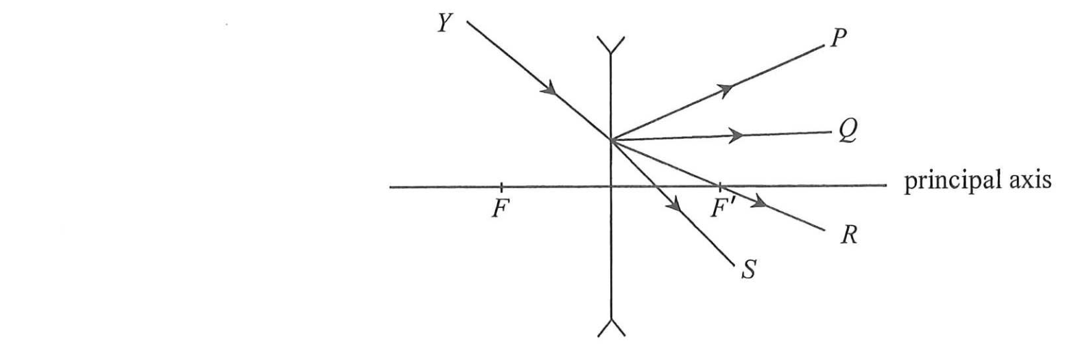
A. P B. Q
C. R D. S

*26-18. A convex lens is used to project sharp images of an object onto a screen at different object distances u. For each value of u, the corresponding image distance v and the linear magnification m are recorded. Which of the following best represents the graph of m against v ?
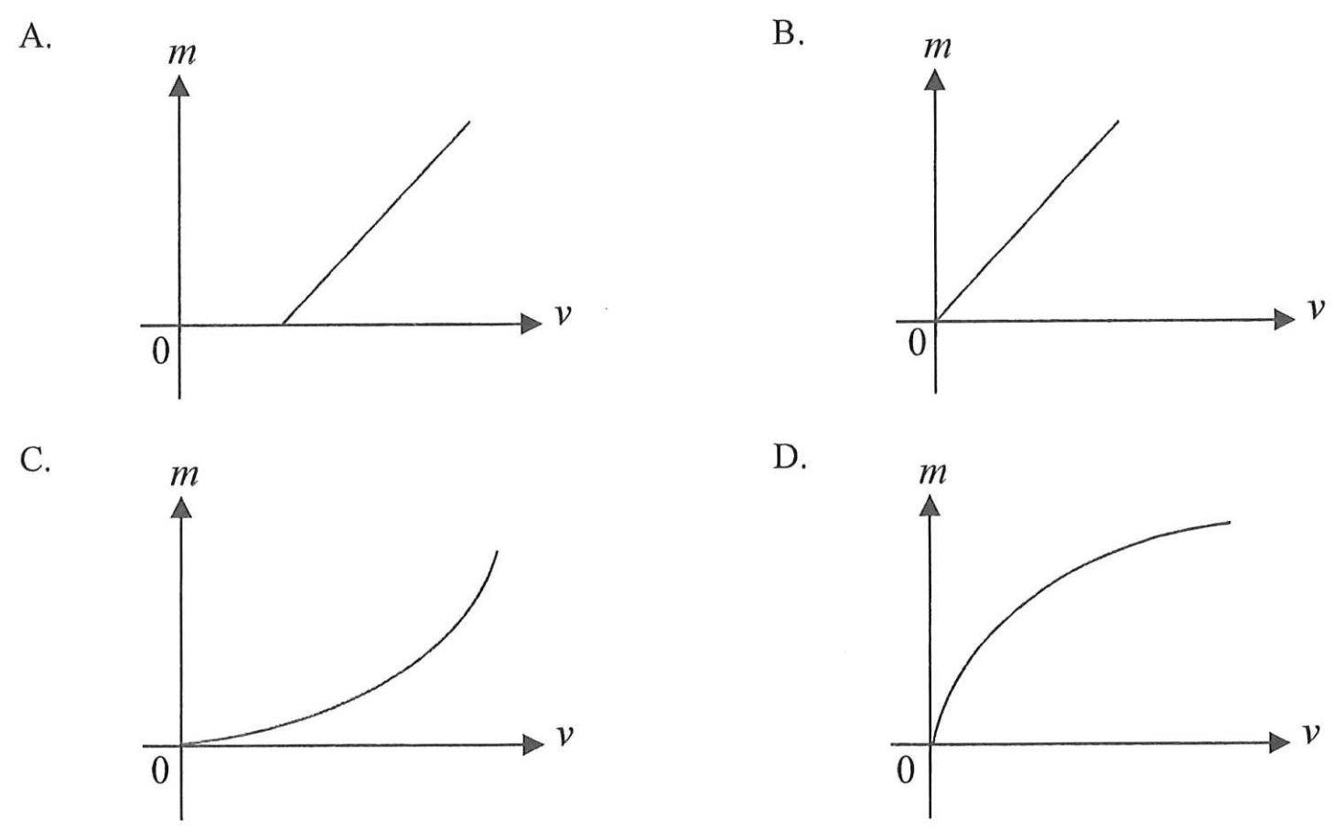

26-19. A monochromatic light beam is directed to a double slit and a fringe pattern is formed. Which of the following physical phenomena is/are involved ?
(1) dispersion
(2) diffraction
(3) interference
A. (1) only B. (3) only
C. (1) and (2) only D. (2) and (3) only

*26-20. A beam of monochromatic light is incident normally on a diffraction grating. Second-order diffracted beams are found at 48° to the incident direction as shown in the figure. Find the highest order of diffracted beam that can be observed.
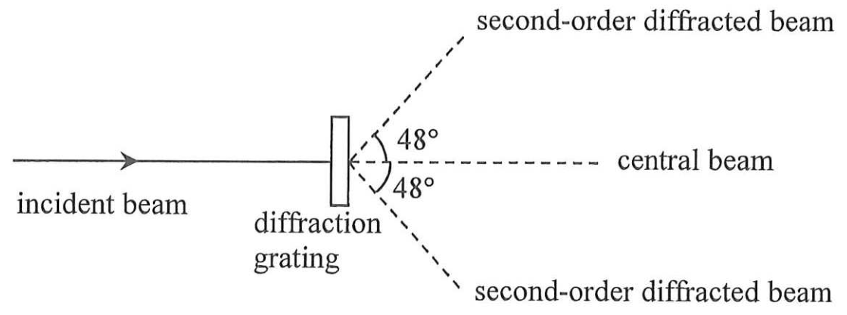
A. 2nd order B. 3rd order
C. 4th order D. 5th order

26-21. Two small charged spheres exert an electrostatic force of magnitude F on each other. If the amount of charge on each sphere is doubled and the distance between them is also doubled, the magnitude of the electrostatic force becomes
A. $\frac{F}{2}$ B. F
C. 2F D. 4F

26-22.
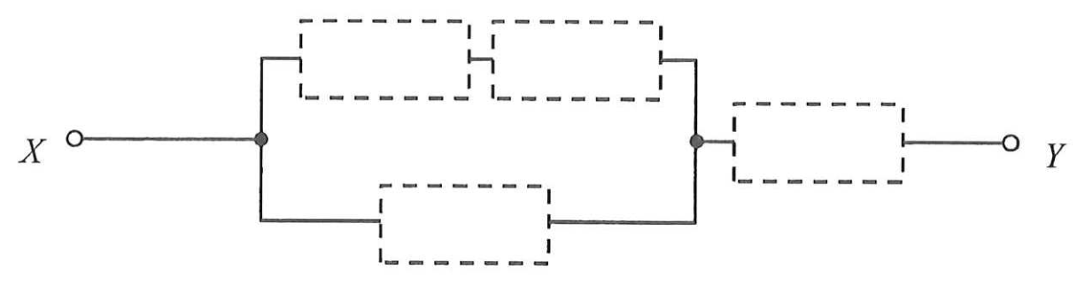
Four resistors of resistance 10 Ω, 20 Ω, 30 Ω and 40 Ω respectively are installed in the empty places in the above circuit. What is the minimum possible equivalent resistance across X and Y ?
A. 19.2 Ω B. 25.6 Ω
C. 28.8 Ω D. 32.2 Ω

26-23.
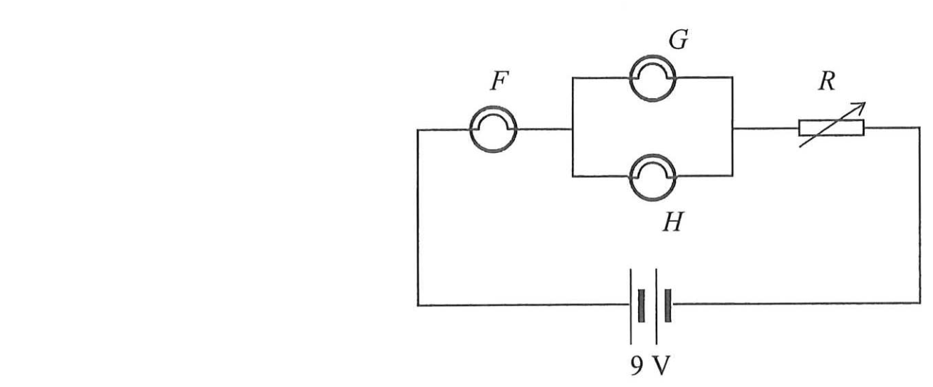
In the circuit above, light bulbs F, G and H are identical and the battery is ideal. Rheostat R is initially set to maximum resistance. The maximum voltage across each bulb without burning out is 2 V, and a burnt-out bulb becomes an open circuit. Initially all bulbs light up. If the resistance of R is gradually reduced to zero, which of the bulbs will burn out in the process ?
A. only bulb F B. only bulbs G and H
C. none of them D. all of them

26-24.
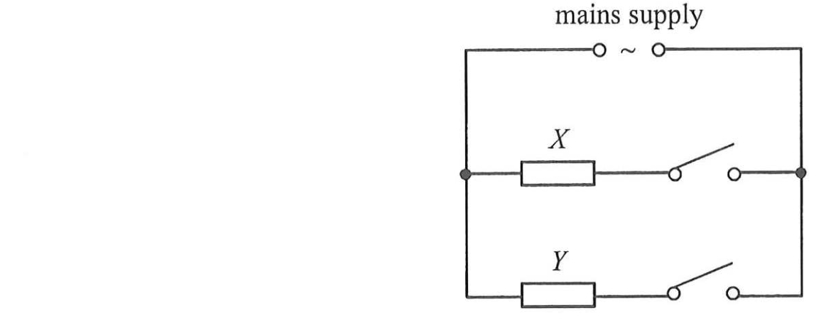
The above shows a simplified diagram of the circuit in a heater. It consists of two heating elements X and Y. The time taken for the heater to heat a certain amount of water from room temperature to 100 °C is as follows.
only X is connected | 180 s
only Y is connected | 300 s
How long does it take to heat the same amount of water from room temperature to 100 °C if both X and Y are connected ?
A. 105 s B. 113 s
C. 154 s D. 240 s

26-25. In household appliances, the function of the earth wire is
A. to provide a return path for the current during normal operations.
B. to provide a return path for the current when the neutral wire is disconnected.
C. to break the circuit when the live wire touches the metal case.
D. to provide a low-resistance path when the live wire touches the metal case.

26-26.
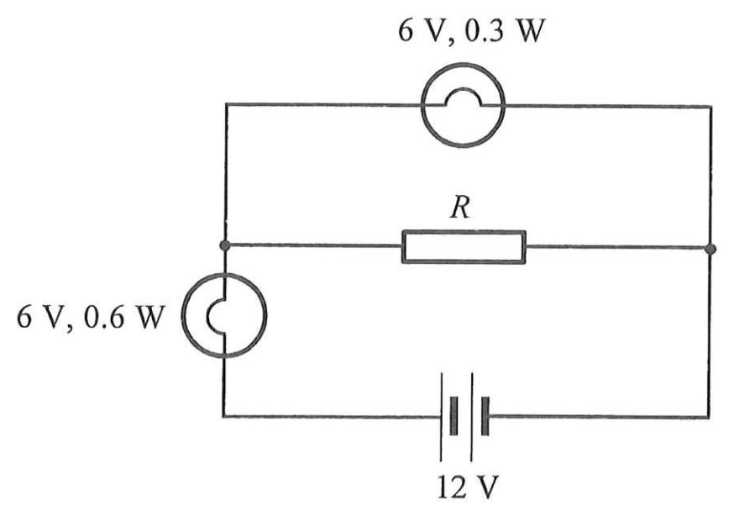
If both light bulbs work at their rated values as shown, find the resistance of R.
A. 30 Ω B. 60 Ω
C. 90 Ω D. 120 Ω

26-27. An equilateral triangular wire loop with sides of 3 cm is placed in a uniform magnetic field of 0.8 T. One of the sides of the loop is parallel to the field as shown. A current of 0.1 A flows through the loop. Find the net magnetic force acting on the loop.
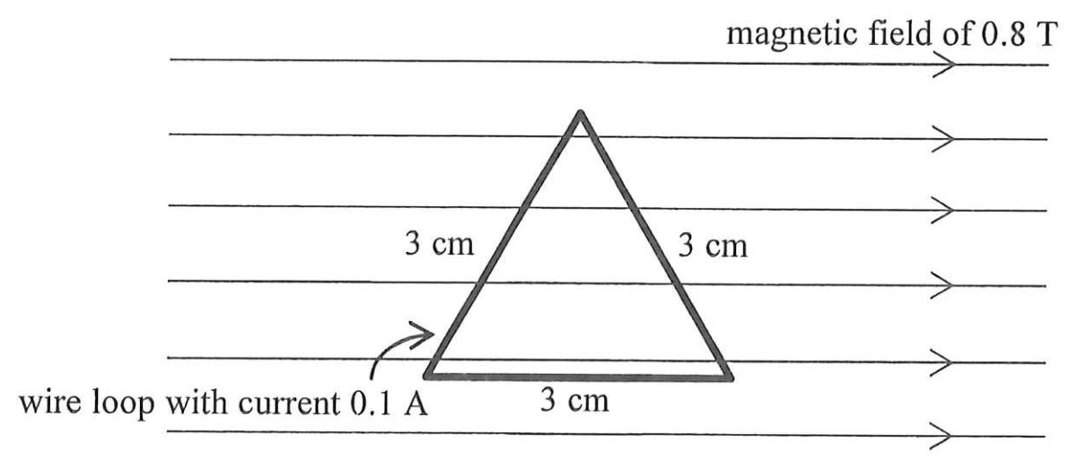
A. 0 N B. 2.8 × 10⁻³ N
C. 5.6 × 10⁻³ N D. 7.6 × 10⁻³ N

*26-28. The input terminals of a transformer are connected to a 220 V mains supply. Its output power is 18 W and its output voltage is 5.0 V. If the efficiency of the transformer is 85%, what is the current drawn from the mains supply ?
A. 0.070 A B. 0.082 A
C. 0.096 A D. 0.55 A

*26-29. A particle with charge q travels horizontally at speed v without deflection through a region of uniform electric and magnetic field as shown.
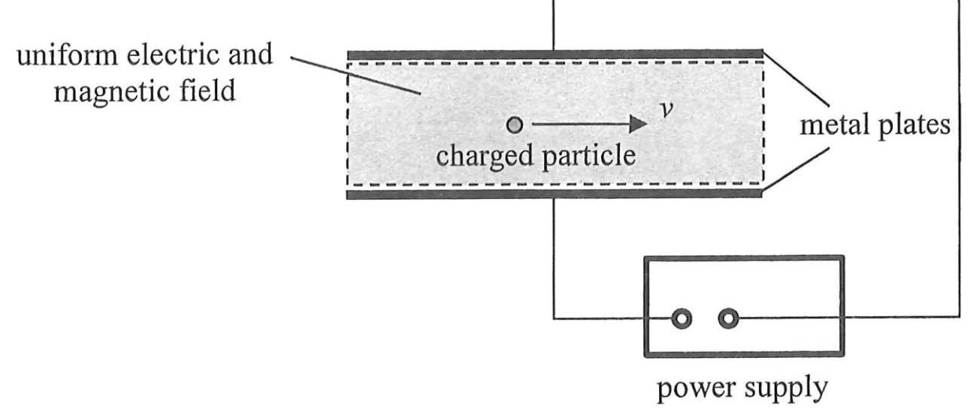
The electric field is set up by the potential difference across the two parallel metal plates. The magnetic field B is applied perpendicular to the paper. The whole set-up is in vacuum. Which of the following combinations allow the particle to travel horizontally without deflection through the region ? Neglect the effects of gravity.
 | charge of  particle | speed of  particle | magnetic field
(1) | q | 2v | $\frac{B}{2}$
(2) | −q | v | B
(3) | 2q | v | B
A. (1) and (2) only B. (2) and (3) only
C. (1) and (3) only D. (1), (2) and (3)

*26-30. A rectangular copper loop PQRS, with its plane perpendicular to a uniform magnetic field of flux density B, is moving with velocity v in a direction perpendicular to the field as shown. The length and width of the loop are h and k respectively.
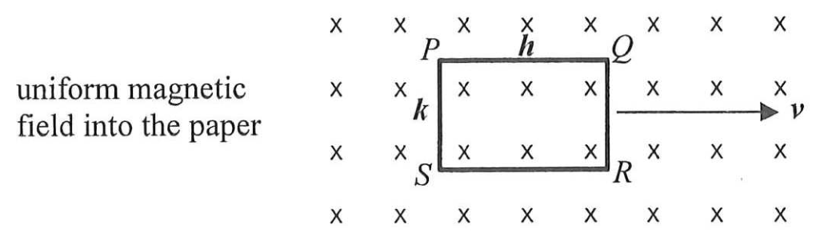
Which of the following statements is/are correct ?
(1) The potential difference across PQ is Bhv.
(2) The potential difference across QR is Bkv.
(3) There is no induced current flowing through the loop.
A. (1) only B. (2) only
C. (1) and (3) only D. (2) and (3) only

*26-31. Coil A and coil B are placed close and facing each other with the number of turns of coil B being doubled that of coil A. Coil A is connected to an a.c. source while coil B is connected to an ideal a.c. voltmeter as shown. The voltmeter shows a reading after the a.c. source is turned on.
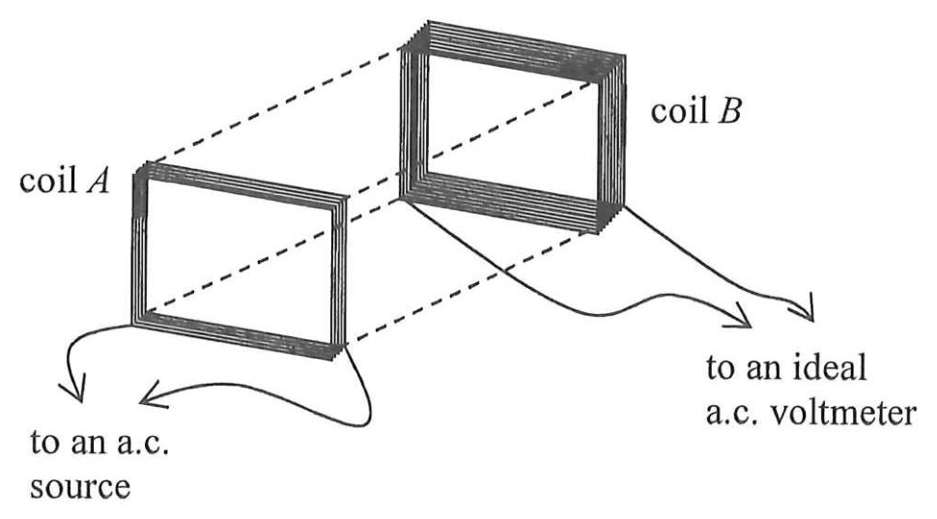
Which of the following will increase the voltmeter reading ?
(1) The voltage of the a.c. source is increased.
(2) A thicker wire is used in coil B.
(3) A thin and large plastic sheet is placed between the two coils and parallel to them.
A. (1) only B. (3) only
C. (1) and (2) only D. (2) and (3) only

26-32. Which of the following units is used for measuring the radiation equivalent dose of a patient receiving radiotherapy treatment ?
A. sievert (Sv)
B. becquerel (Bq)
C. joule (J)
D. watt per square metre (W m⁻²)

*26-33. Consider the following nuclear reaction:
²₁H + ³₁H → ⁴₂He + ¹₀n
Using the data below, estimate the energy released when 5 g of ²₁H completely reacts with ³₁H through the reaction.
mass of ²₁H = 2.0136 u
mass of ³₁H = 3.0155 u
mass of ⁴₂He = 4.0015 u
mass of ¹₀n = 1.0087 u
A. 3 × 10⁻¹² J B. 3 × 10⁻¹⁰ J
C. 4 × 10¹² J D. 2 × 10¹⁸ J

END OF SECTION A

