2026 HKDSE Paper 1B
Section B: Answer ALL questions. Parts marked with * involve knowledge of the extension component. Write your answers in the spaces provided. Take g = 9.81 m s⁻².
26-01. A mountaineer arrives at a location X, which is 3000 m above sea level. At X, the melting point of ice is 0 °C and the boiling point of water is 90 °C. The mountaineer needs to heat 0.50 kg of melting ice to its boiling point using a heater.
(a) Estimate the energy required. | (2 marks)
Given: specific latent heat of fusion of ice = 3.34 × 10⁵ J kg⁻¹
specific heat capacity of water = 4200 J kg⁻¹ °C⁻¹
______________________________________________________________________________
______________________________________________________________________________
______________________________________________________________________________
______________________________________________________________________________
______________________________________________________________________________
______________________________________________________________________________
______________________________________________________________________________
______________________________________________________________________________
(b) The power output of the heater is 2 kW. Estimate the time required. | (2 marks)
______________________________________________________________________________
______________________________________________________________________________
______________________________________________________________________________
______________________________________________________________________________
______________________________________________________________________________
______________________________________________________________________________
______________________________________________________________________________
______________________________________________________________________________
(c) Explain why the temperature of water remains at the boiling point after the water starts to boil, even when the heater is still on. | (1 mark)
______________________________________________________________________________
______________________________________________________________________________
______________________________________________________________________________
______________________________________________________________________________
*26-02. A sealed syringe contains neon gas of volume 5.0 cm³ and pressure 1.0 × 10⁵ Pa. The gas is then compressed slowly to 2.0 cm³ while the temperature remains at 27 °C. Take the neon gas as an ideal gas.
(a) Find the pressure of the gas after being compressed. | (2 marks)
______________________________________________________________________________
______________________________________________________________________________
______________________________________________________________________________
______________________________________________________________________________
______________________________________________________________________________
______________________________________________________________________________
______________________________________________________________________________
______________________________________________________________________________
(b) (i) Find the average kinetic energy of the gas molecules. | (2 marks)
______________________________________________________________________________
______________________________________________________________________________
______________________________________________________________________________
______________________________________________________________________________
______________________________________________________________________________
______________________________________________________________________________
______________________________________________________________________________
______________________________________________________________________________
(ii) The mass of one mole of neon gas is 0.020 kg. Find the root-mean-square speed of the gas molecules. | (2 marks)
______________________________________________________________________________
______________________________________________________________________________
______________________________________________________________________________
______________________________________________________________________________
______________________________________________________________________________
______________________________________________________________________________
______________________________________________________________________________
______________________________________________________________________________
26-03. A uniform metal rod PQ of weight 12 N and length 0.80 m is hinged smoothly to the edge of a table at P as shown in Figure 3.1. One end of a light inextensible string is attached to Q and the other end is fixed to a heavy box placed on the table such that the rod is kept horizontal. The string makes 36° with the rod.
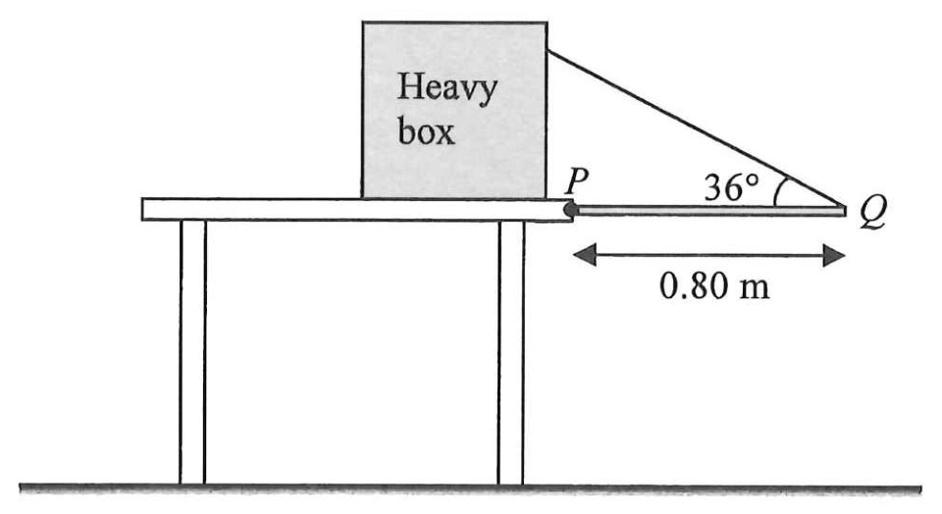
Figure 3.1
(a) Find the tension of the string. | (2 marks)
______________________________________________________________________________
______________________________________________________________________________
______________________________________________________________________________
______________________________________________________________________________
______________________________________________________________________________
______________________________________________________________________________
______________________________________________________________________________
______________________________________________________________________________
The string is cut. The rod falls, strikes a small ball resting on the floor and exerts a horizontal force on it towards the left, as shown in Figure 3.2. After the collision, the ball moves to the left with speed 1.6 m s⁻¹.
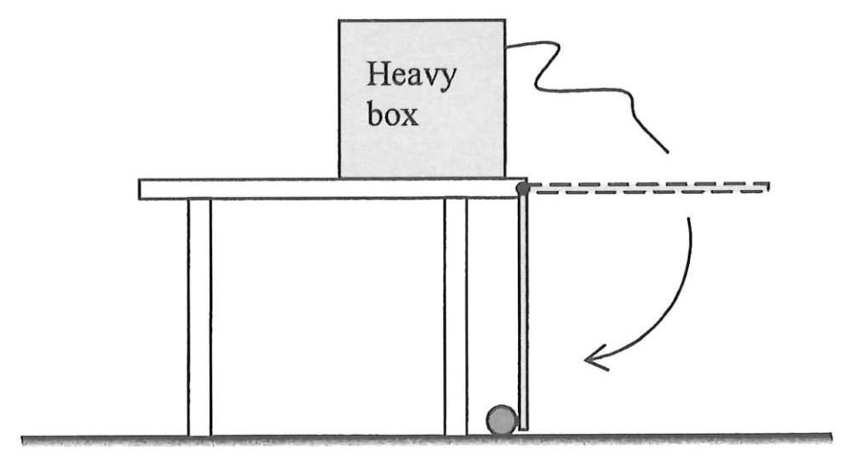
Figure 3.2
(b) (i) If the mass of the ball is 0.05 kg and the collision time is 0.008 s, find the magnitude of the average force acting on the ball by the rod. | (2 marks)
______________________________________________________________________________
______________________________________________________________________________
______________________________________________________________________________
______________________________________________________________________________
______________________________________________________________________________
______________________________________________________________________________
______________________________________________________________________________
______________________________________________________________________________
(ii) Explain why the momentum of the ball is not conserved before and after the collision. | (1 mark)
______________________________________________________________________________
______________________________________________________________________________
______________________________________________________________________________
______________________________________________________________________________
26-04. Figure 4.1(a) shows a smooth track ABCD consisting of a sloping part AB and a horizontal semicircular part BCD fixed on a table. Point A is at 0.80 m above the table. The top view of the track is shown in Figure 4.1(b).
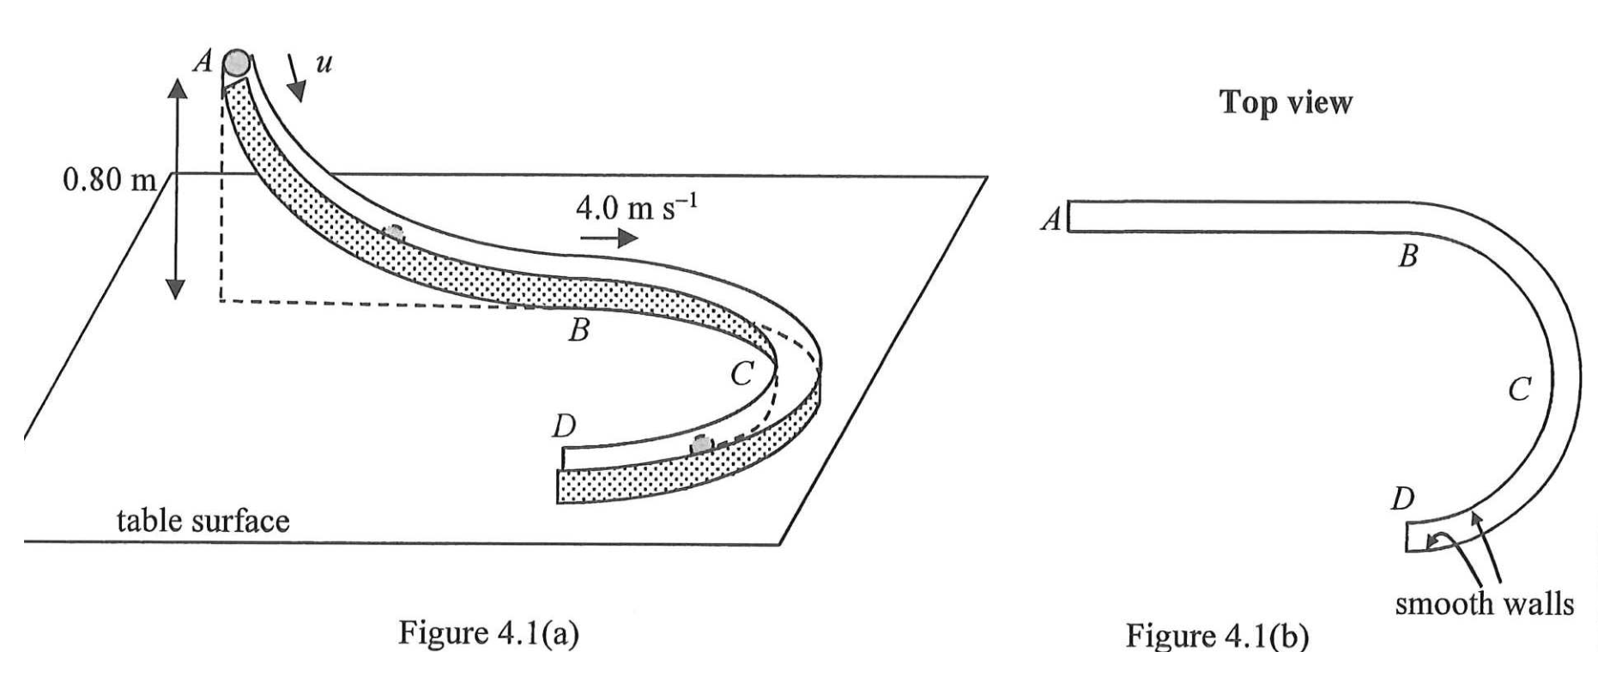
A small sphere is projected along the track with speed u at A. It moves along the track and passes B at 4.0 m s⁻¹. Neglect air resistance. (g = 9.81 m s⁻²)
(a) By using the law of conservation of energy, find u. | (2 marks)
______________________________________________________________________________
______________________________________________________________________________
______________________________________________________________________________
______________________________________________________________________________
______________________________________________________________________________
______________________________________________________________________________
______________________________________________________________________________
______________________________________________________________________________
*(b) The sphere then moves along BCD with constant speed 4.0 m s⁻¹. The radius of BCD is 0.20 m.
(i) Explain why, even though the speed of the sphere remains constant, its acceleration is not zero during the motion described above. | (1 mark)
______________________________________________________________________________
______________________________________________________________________________
______________________________________________________________________________
______________________________________________________________________________
(ii) Estimate the magnitude of the acceleration of the sphere. | (1 mark)
______________________________________________________________________________
______________________________________________________________________________
______________________________________________________________________________
______________________________________________________________________________
(iii) What force provides the centripetal force for the sphere ? | (1 mark)
______________________________________________________________________________
______________________________________________________________________________
______________________________________________________________________________
______________________________________________________________________________
26-05. In a ripple tank, circular water waves are produced by two dippers S₁ and S₂ connected to a vibrator. The vibrator works in a way that S₁ and S₂ always vibrate in opposite directions as shown in Figure 5.1. The frequency of the vibration is 10 Hz and the wavelength λ of the waves is 2.0 cm.
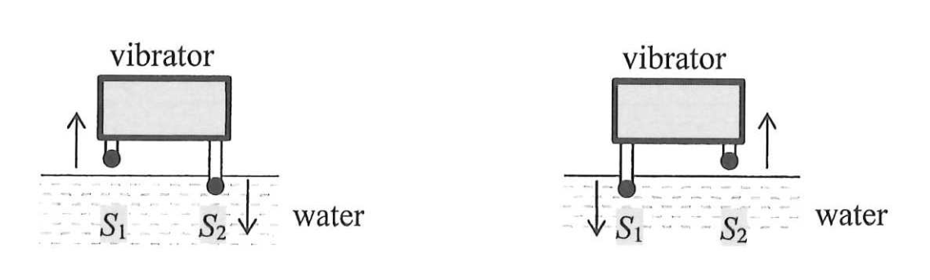
Figure 5.1
(a) Find the wave speed of the waves. | (1 mark)
______________________________________________________________________________
______________________________________________________________________________
______________________________________________________________________________
______________________________________________________________________________
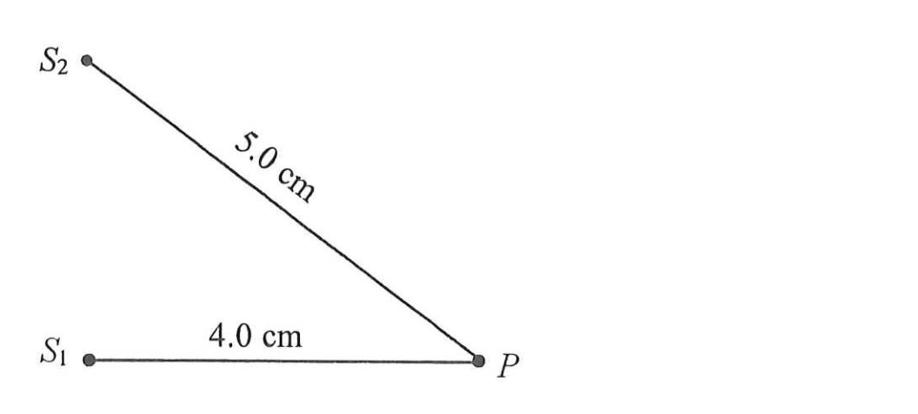
Figure 5.2
(b) (i) P is a point at the water surface as shown in Figure 5.2. Express the path difference at P from S₁ and S₂ in terms of λ. | (2 marks)
______________________________________________________________________________
______________________________________________________________________________
______________________________________________________________________________
______________________________________________________________________________
______________________________________________________________________________
______________________________________________________________________________
______________________________________________________________________________
______________________________________________________________________________
(ii) Explain briefly what type of interference occurs at P. | (2 marks)
______________________________________________________________________________
______________________________________________________________________________
______________________________________________________________________________
______________________________________________________________________________
______________________________________________________________________________
______________________________________________________________________________
______________________________________________________________________________
______________________________________________________________________________
(c) If the depth of the water in the ripple tank is increased while other conditions remain unchanged, deduce how the wavelength of the waves will be affected. | (2 marks)
______________________________________________________________________________
______________________________________________________________________________
______________________________________________________________________________
______________________________________________________________________________
______________________________________________________________________________
______________________________________________________________________________
______________________________________________________________________________
______________________________________________________________________________
26-06. A student uses the set-up in the figure below to investigate the relation between the loudness of sound and the distance from the source of sound. The distance between the loudspeaker and the microphone is d. The loudness of the sound relates to the amplitude A of the oscilloscope trace.
The student hypothesises that A is inversely proportional to d² ( A ∝ 1/d² ).
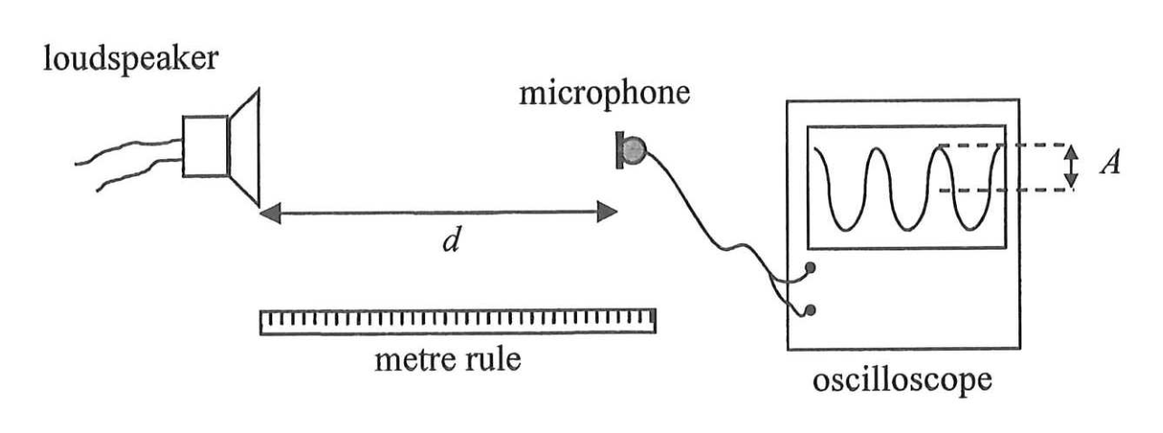
Describe
(I) the procedure of the experiment;
(II) how the data should be analysed using a graphical method to verify whether the hypothesis ( A ∝ 1/d² ) is valid. | (5 marks)
______________________________________________________________________________
______________________________________________________________________________
______________________________________________________________________________
______________________________________________________________________________
______________________________________________________________________________
______________________________________________________________________________
______________________________________________________________________________
______________________________________________________________________________
______________________________________________________________________________
______________________________________________________________________________
______________________________________________________________________________
______________________________________________________________________________
______________________________________________________________________________
______________________________________________________________________________
______________________________________________________________________________
______________________________________________________________________________
______________________________________________________________________________
______________________________________________________________________________
______________________________________________________________________________
______________________________________________________________________________
26-07. Read the following passage about electrostatic adhesive wallpaper and answer the questions that follow.
Electrostatic adhesive wallpaper is a wall covering that uses static electricity for adhesion, without the need for traditional glues or pastes. The wallpaper is typically made from a material that can retain electric charges on its surface and is charged through friction during production, allowing it to adhere directly to smooth, clean surfaces like painted walls or glass.
The wallpaper can be easily applied or removed. After removal, the wallpaper does not leave residue or damage the underlying surface. Therefore, the wallpaper is especially suitable for quick updates and temporary setups. Another advantage of the wallpaper is its reusability. It preserves its adhesive properties after being removed and can be reapplied.
(a) Describe how the electrostatic adhesive wallpaper can adhere to a painted wall that is initially neutral. | (2 marks)
______________________________________________________________________________
______________________________________________________________________________
______________________________________________________________________________
______________________________________________________________________________
______________________________________________________________________________
______________________________________________________________________________
______________________________________________________________________________
______________________________________________________________________________
(b) Explain briefly why the wallpaper preserves its adhesive properties after being removed. | (2 marks)
______________________________________________________________________________
______________________________________________________________________________
______________________________________________________________________________
______________________________________________________________________________
______________________________________________________________________________
______________________________________________________________________________
______________________________________________________________________________
______________________________________________________________________________
(c) The wallpaper does not adhere well to the wall in a humid environment. Explain briefly. | (1 mark)
______________________________________________________________________________
______________________________________________________________________________
______________________________________________________________________________
______________________________________________________________________________
26-08. A tungsten filament light bulb is connected to a 220-V supply. The following graph shows the variation of the resistance R of the bulb with time t after it is switched on.
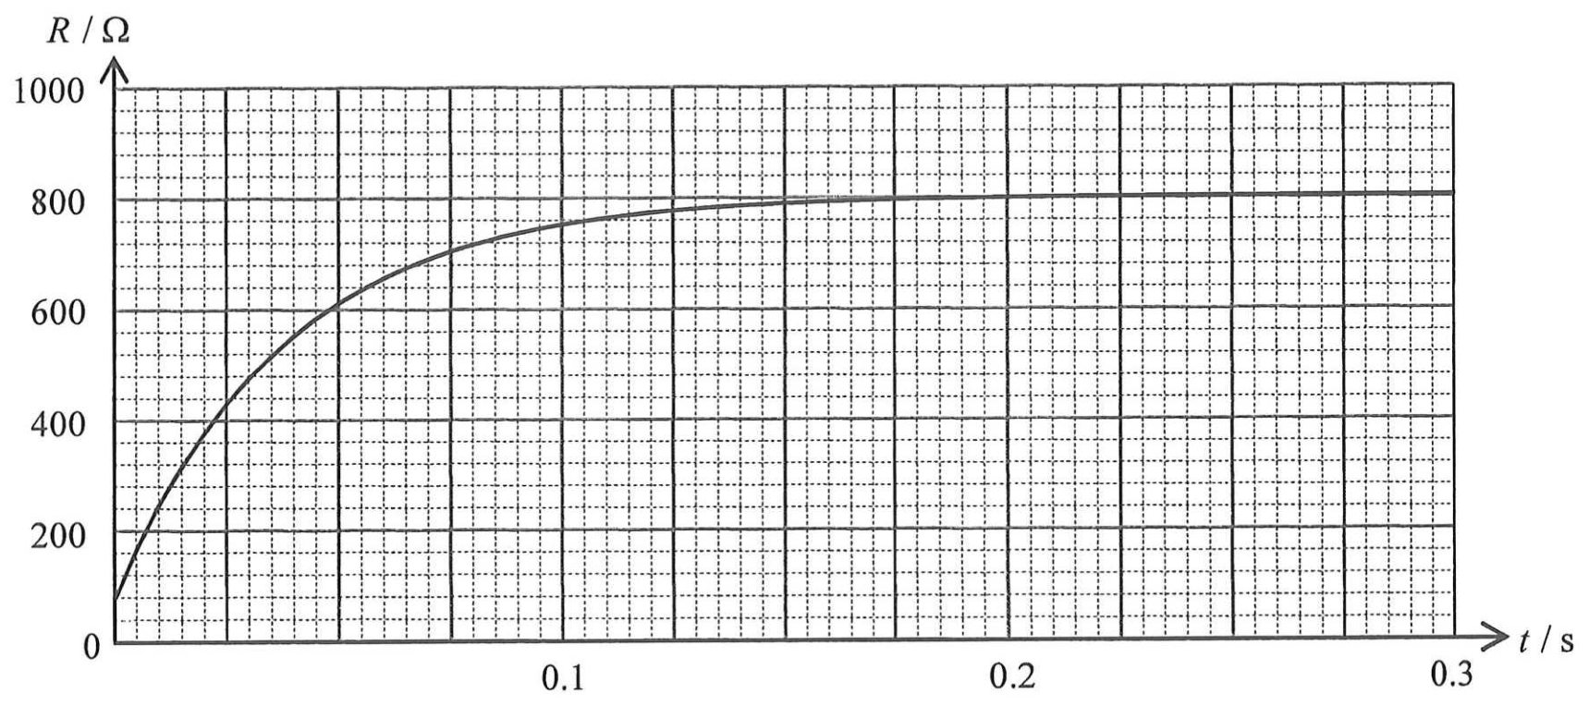
(a) The bulb works at its rated value after R becomes stable. Estimate the rated power of the bulb. | (2 marks)
______________________________________________________________________________
______________________________________________________________________________
______________________________________________________________________________
______________________________________________________________________________
______________________________________________________________________________
______________________________________________________________________________
______________________________________________________________________________
______________________________________________________________________________
(b) Explain why R initially increases and becomes stable after a period of time. | (3 marks)
______________________________________________________________________________
______________________________________________________________________________
______________________________________________________________________________
______________________________________________________________________________
______________________________________________________________________________
______________________________________________________________________________
______________________________________________________________________________
______________________________________________________________________________
______________________________________________________________________________
______________________________________________________________________________
______________________________________________________________________________
______________________________________________________________________________
(c) The filament of the bulb has a length of 0.56 m and a uniform cross-section of diameter 0.022 mm. Find the resistivity of the filament at t = 0 s. | (2 marks)
______________________________________________________________________________
______________________________________________________________________________
______________________________________________________________________________
______________________________________________________________________________
______________________________________________________________________________
______________________________________________________________________________
______________________________________________________________________________
______________________________________________________________________________
*26-09. A long, straight wire carries a sinusoidal a.c. of r.m.s. current I_{rms} of 5 A. A search coil with 500 turns, each having an area of 4.0 × 10⁻⁴ m², is placed 0.20 m away from the wire, as shown below. The wire and the search coil are in the same plane.
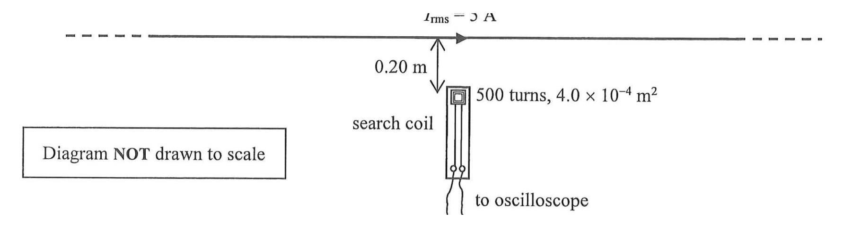
(a) Find the peak current of the a.c. | (1 mark)
______________________________________________________________________________
______________________________________________________________________________
______________________________________________________________________________
______________________________________________________________________________
(b) Estimate the maximum magnetic flux linkage produced by the wire through the search coil. | (3 marks)
______________________________________________________________________________
______________________________________________________________________________
______________________________________________________________________________
______________________________________________________________________________
______________________________________________________________________________
______________________________________________________________________________
______________________________________________________________________________
______________________________________________________________________________
______________________________________________________________________________
______________________________________________________________________________
______________________________________________________________________________
______________________________________________________________________________
(c) A student claims that the search coil can be used to measure the resultant magnetic field produced by the Earth and the wire. Explain briefly whether this claim is correct. | (2 marks)
______________________________________________________________________________
______________________________________________________________________________
______________________________________________________________________________
______________________________________________________________________________
______________________________________________________________________________
______________________________________________________________________________
______________________________________________________________________________
______________________________________________________________________________
26-10. Figure 10.1 shows a rain sensor mounted on the windshield glass of a car. It senses rainwater on the glass and automatically turns on the windshield wipers.
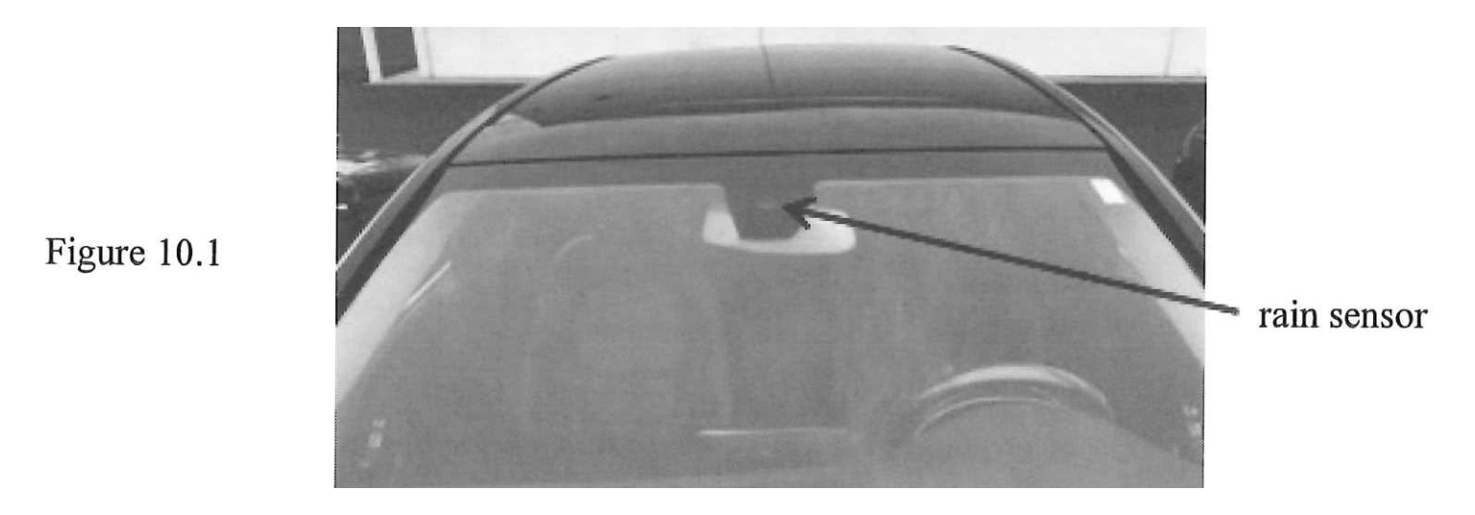
As shown in Figure 10.2, the rain sensor is composed of a light emitting diode (LED) and an infra-red sensor. The LED emits an infra-red signal and the infra-red sensor measures the intensity of the signal. When the intensity changes, the wipers are activated. An infra-red ray from the LED incident at surface A at 45°, and the infra-red ray finally received by the infra-red sensor are drawn in Figure 10.2. Assume surface A is parallel to surface B. It is given that the critical angle of the glass for infra-red is 44.0°.
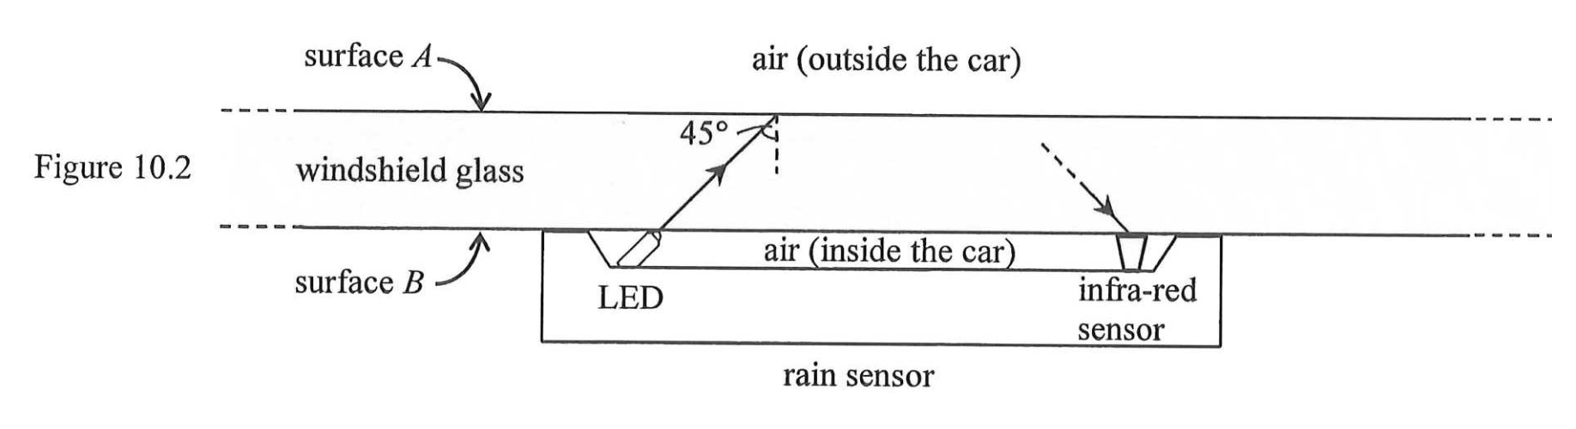
(a) Explain how the infra-red ray in Figure 10.2 travels from the LED to the infra-red sensor. | (4 marks)
______________________________________________________________________________
______________________________________________________________________________
______________________________________________________________________________
______________________________________________________________________________
______________________________________________________________________________
______________________________________________________________________________
______________________________________________________________________________
______________________________________________________________________________
______________________________________________________________________________
______________________________________________________________________________
______________________________________________________________________________
______________________________________________________________________________
______________________________________________________________________________
______________________________________________________________________________
______________________________________________________________________________
______________________________________________________________________________
(b) When it rains, some raindrops settle on the glass surface, as illustrated in Figure 10.3(a). Figure 10.3(b) shows an enlarged view of the region where the infra-red ray is incident on the glass-water interface.
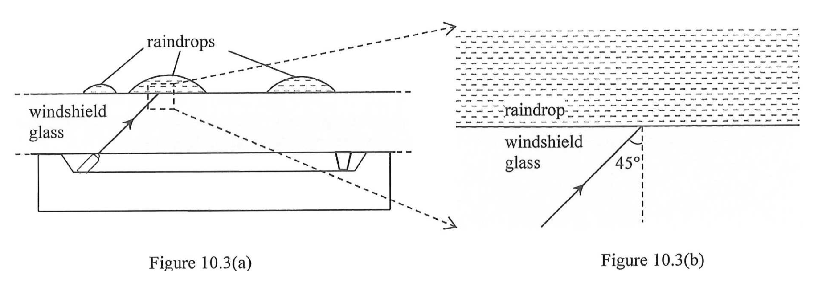
(i) Given that the refractive index of water for the infra-red is 1.26, find the critical angle of the glass-water interface for the infra-red ray. | (3 marks)
______________________________________________________________________________
______________________________________________________________________________
______________________________________________________________________________
______________________________________________________________________________
______________________________________________________________________________
______________________________________________________________________________
______________________________________________________________________________
______________________________________________________________________________
______________________________________________________________________________
______________________________________________________________________________
______________________________________________________________________________
______________________________________________________________________________
(ii) Sketch in Figure 10.3(b) how the infra-red ray propagates after being incident on the glass-water interface. | (2 marks)
______________________________________________________________________________
______________________________________________________________________________
(iii) The wipers are activated when the intensity of the signal received by the infra-red sensor changes. Explain briefly how the intensity changes. | (2 marks)
______________________________________________________________________________
______________________________________________________________________________
______________________________________________________________________________
______________________________________________________________________________
______________________________________________________________________________
______________________________________________________________________________
______________________________________________________________________________
______________________________________________________________________________
26-11. A drone carries a 0.50-kg block by connecting it with a light and inextensible string as shown in Figure 11.1. The size of the block is negligible. (g = 9.81 m s⁻²)
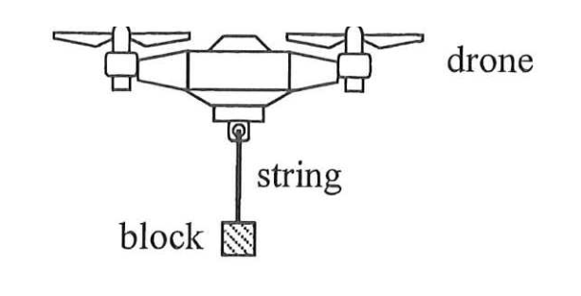
Figure 11.1
(a) At time t = 0 s, the block is at rest on the ground and the string is taut. The drone then moves vertically with the block. The velocity-time graph of the block is shown below, taking upwards as positive.
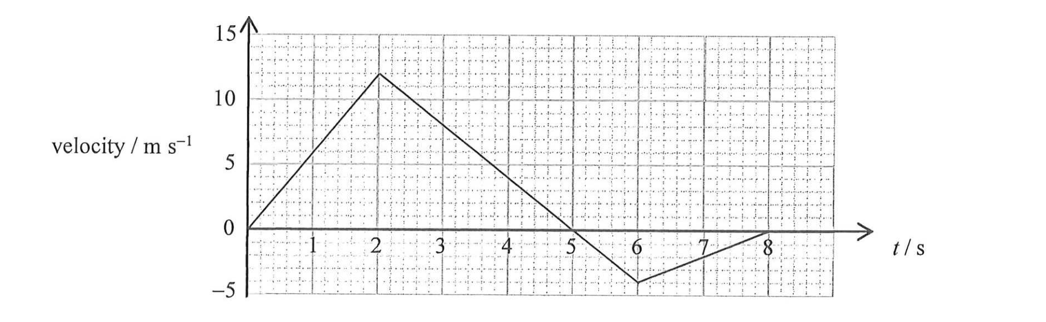
(i) Find the maximum height that the block can reach from t = 0 to 8 s. | (2 marks)
______________________________________________________________________________
______________________________________________________________________________
______________________________________________________________________________
______________________________________________________________________________
______________________________________________________________________________
______________________________________________________________________________
______________________________________________________________________________
______________________________________________________________________________
(ii) Sketch the displacement-time graph of the block from t = 0 to 5 s. The displacement at t = 2 s is marked. Labelling of values is not required and the displacement at t = 0 s is taken to be zero. | (2 marks)
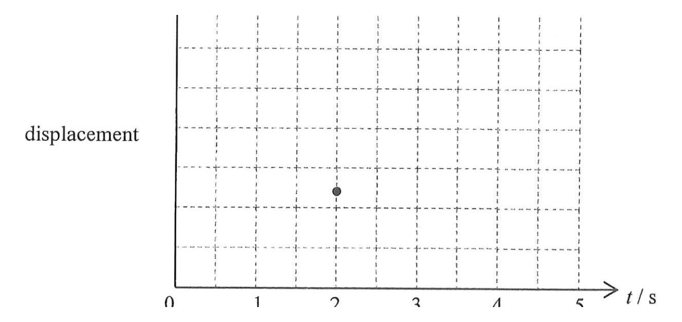
(iii) Find the tension of the string at t = 5 s. | (3 marks)
______________________________________________________________________________
______________________________________________________________________________
______________________________________________________________________________
______________________________________________________________________________
______________________________________________________________________________
______________________________________________________________________________
______________________________________________________________________________
______________________________________________________________________________
______________________________________________________________________________
______________________________________________________________________________
______________________________________________________________________________
______________________________________________________________________________
*(b) The drone now flies upward and forward. When the block is 32 m above the ground, the string breaks. Figure 11.2 shows the moment immediately after the break, where the block has a velocity of 20 m s⁻¹ at an angle of 30° above the horizontal. Neglect air resistance.
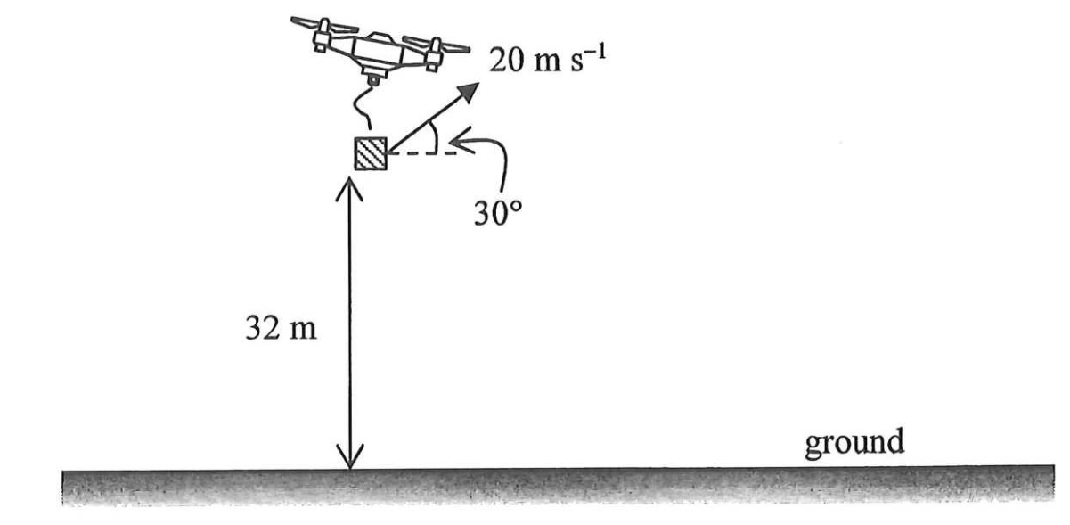
Figure 11.2
(i) Draw an arrow in the figure below to represent the direction of the acceleration of the block at that moment. | (1 mark)
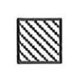
______________________________________________________________________________
______________________________________________________________________________
(ii) Find the horizontal displacement of the block from that moment until just before it reaches the ground. | (3 marks)
______________________________________________________________________________
______________________________________________________________________________
______________________________________________________________________________
______________________________________________________________________________
______________________________________________________________________________
______________________________________________________________________________
______________________________________________________________________________
______________________________________________________________________________
______________________________________________________________________________
______________________________________________________________________________
______________________________________________________________________________
______________________________________________________________________________
(iii) Describe the energy conversion of the block from that moment until just before it reaches the ground. | (2 marks)
______________________________________________________________________________
______________________________________________________________________________
______________________________________________________________________________
______________________________________________________________________________
______________________________________________________________________________
______________________________________________________________________________
______________________________________________________________________________
______________________________________________________________________________
26-12. (a) Bismuth-213 (Bi-213) is a radionuclide currently undergoing clinical trials for cancer treatment. It is prepared in liquid and injected into the human body, where it targets and destroys cancer cells. Figure 12.1 shows a decay series of Bi-213.
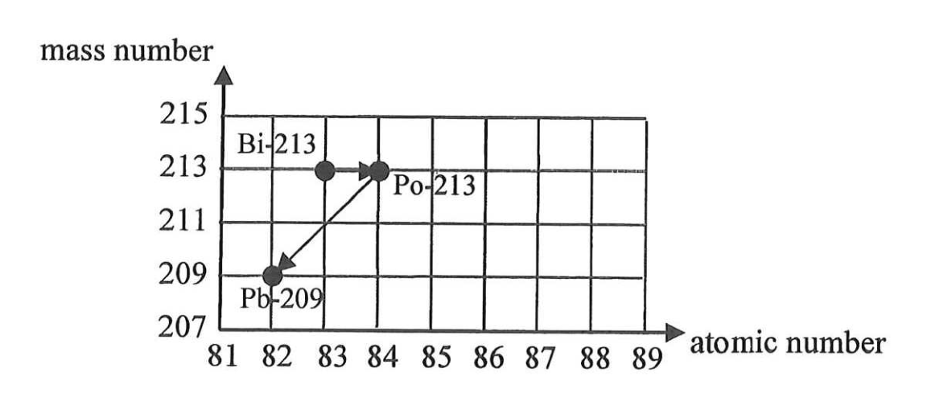
Figure 12.1
(i) Write the nuclear equations corresponding to each of these two decay processes. | (2 marks)
______________________________________________________________________________
______________________________________________________________________________
______________________________________________________________________________
______________________________________________________________________________
______________________________________________________________________________
______________________________________________________________________________
______________________________________________________________________________
______________________________________________________________________________
*(ii) The half-life of Bi-213 is 46 minutes. At time t = 0 s, its number of undecayed nuclei is 8.0 × 10¹¹. Find its activity (in Bq) at t = 0 s. | (2 marks)
______________________________________________________________________________
______________________________________________________________________________
______________________________________________________________________________
______________________________________________________________________________
______________________________________________________________________________
______________________________________________________________________________
______________________________________________________________________________
______________________________________________________________________________
*(iii) Find the percentage decrease in the activity after 200 minutes. | (2 marks)
______________________________________________________________________________
______________________________________________________________________________
______________________________________________________________________________
______________________________________________________________________________
______________________________________________________________________________
______________________________________________________________________________
______________________________________________________________________________
______________________________________________________________________________
(b) In hospital, technicians wear protective gloves to handle liquid radioactive materials, such as those containing Bi-213. To monitor radiation exposure, they wear a specialised ring on their finger, as shown in Figure 12.2(a). Each ring contains a small chip in a plastic enclosure (Figure 12.2(b)), which detects and records radiation doses. The rings are collected every three months to monitor the radiation exposure of the technicians.
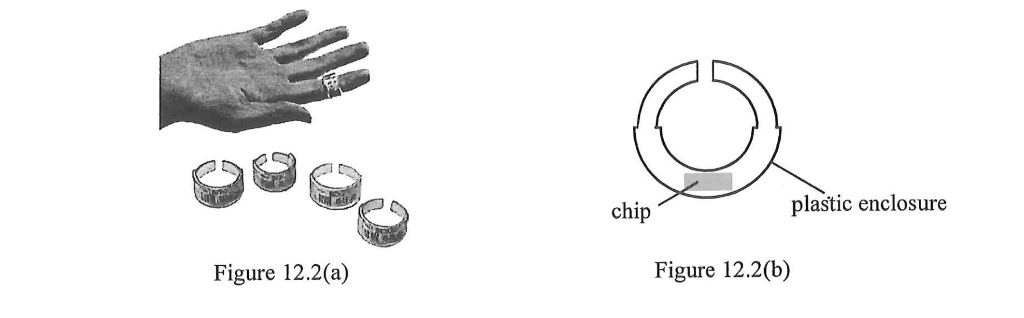
(i) Compared to placing it in a badge worn on the chest, what is the advantage of placing the chip in the ring worn on the hand ? | (1 mark)
______________________________________________________________________________
______________________________________________________________________________
______________________________________________________________________________
______________________________________________________________________________
(ii) The ring should be worn under the gloves. Explain briefly. | (1 mark)
______________________________________________________________________________
______________________________________________________________________________
______________________________________________________________________________
______________________________________________________________________________
(iii) Which type(s) of radiation (α, β or γ) can reach the chip of the ring ? | (1 mark)
______________________________________________________________________________
______________________________________________________________________________
______________________________________________________________________________
______________________________________________________________________________
END OF PAPER
Sources of materials used in this paper will be acknowledged in the HKDSE Question Papers booklet published by the Hong Kong Examinations and Assessment Authority at a later stage.

