ER diagram analysis

The ER diagram of our project is shown as follows:

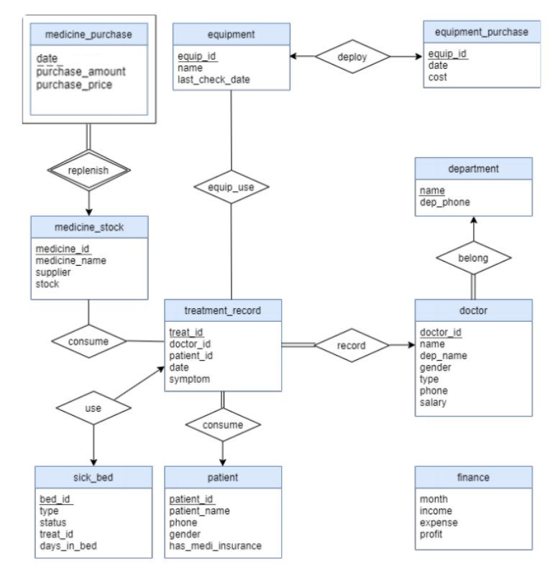

As you can see, there are 10 entities and 8 relationships in total in our ER diagram. We will talk about all the relevant entities, attributes and relationships together with some constraints and properties.

First, every hospital must purchase and stock medicine. We assume that we need to know the date, amount and price when we purchase medicine, so the attributes of medicine_purchase entity include date, purchase_amount and purchase_price, where the primary key is date. However, we cannot identify every entity of medicine purchase using these attributes, which means the medicine_purchase entity is a weak entity. The identifying entity of it is medicine_stock entity. The medicine_stock entity records all the information of medicine of the hospital system including medicine id, medicine name, supplier and stock. Therefore, the attributes of medicine_stock are medicine_id, medicine_name, supplier and stock, where the medicine_id is the primary key of the entity. We use the medicine_id as the discriminator attribute to uniquely identify the weak entity, medicine_purchase. We assume that all the medicine purchased must be stocked but the medicine stocked may get from other ways instead of purchasing. Based on this assumption and the property of weak entity, the relationship between these two entities is replenish and the relationship is total-to-partial and many-to-one towards the identifying entity set medicine_stock.

Second, when doctors give treatment to patients, the record of the treatment will be saved. Therefore, we create a entity called treatment_record. The attributes of it are treat_id, doctor_id, patient_id, date and symptom, where the treat_id is the primary key. These attributes includes all the information needed for a treatment. Some treatment may need to consume some kinds of medicine and some may not use any medicine. And not all the medicine in the stock will already be used in treatment and many medicine may be used in many treatments. Therefore, the relationship between the medicine_stock entity and treatment_record entity is consume and the relationship is many-to-many and partial-to partial. And there must exist sick beds in every hospital. To manage these sick beds, we creates an entity called sick_bed. The attributes of it includes bed_id, type, status, treat_id and days_in_bed, where the primary key is bed_id. Some patients are severe, so the treatment of them offered by doctors will suggest them to be hospitalized, which means the sick beds of the hospital will be used. Not all the sick beds have already been used and not all the treatments will use the sick beds, so the relationship between the sick_bed entity and treatment_record entity is use and the relationship is one-to-one and partial-to-partial.

Third, the treatment is offered by doctors to patients, so there must exist patients and doctors in the hospital. We create two entities: patient and doctor to manage the information of these two kinds of people. The attributes of doctor entities are doctor_id, name, dep_name, gender, type, phone and salary, where doctor_id is the primary key. The attributes of patient entities are patient_id, patient_name, phone, gender, has_medi_insurance, where the patient_id is the primary key. These two entities are connected by using the treatment_record entity. Treatments must be offered by doctors and some doctors have already offer a lot of treatments. However, some doctors may not offer any treatment for some reasons like they are new in the hospital. Therefore, the relationship between the treatment_record entity and doctor entity is record and the relationship is many-to-one and total-to-partial. For patients, all the treatments must be offered to patients. Some patients may take treatments many times and some patients may not take any treatment. Therefore, the relationship between the treatment_record entity and the patient entiy is take and the relationship is many-to-one and total-to-partial.

Fourth, there are a lot of medicine equipment in hospital. Some of them are purchased. Therefore, we create two entities called equipment and equipment_purchase. The attributes of equipment_purchase are equip_id, date and cost, where the primary key is equip_id. The attributes of equipment are equip_id, name and last_check_date, where the equip_id is the primary key. Not all the equipment is purchased and the equipment purchased cannot be used directly because it needs time to deploy. Therefore, the relationship between the equipment entity and the equipment_purchase entity is one-to-one and partial-to-partial. As you can see, some treatments may use equipment. Some equipment may be used in many treatments. And there still exists some treatments which do not need to use the equipment. And some equipment may not already be used in treatment. Therefore, the relationship between the equipment and treatment_record is equip_use and the relationship is many-to-many and part-to-part.

Fifth, all the doctors must belong to some departments in the hospital. Therefore, we create a entity called department. The attributes of it are name and dep_phone, where the name is the primary key. There are a lot of doctors in many departments. And there are some departments where no doctors exist. Therefore, the relationship between the department entity and the doctor entity is belong and the relationship is one-to-many and partial-to-total.

Last but not least, there is a special entity called finance to store the finance information of the hospital. Because it has something to do with a lot of entities and we want to make the ER diagram of our system clear and concise, we make this entity alone. The attributes of it are month, income, expense and profit, where the month is the primary key.

These are all the contents of our ER diagram analysis.