Title: Efficient Cost-reduced with High-quality Image of Imperceptible Steganography Using Modulo and Magic Cube
First of all, we really appreciate the valuable comments from the reviewer. We did our utmost to revise our paper to have it quality for the publication requirements of IEEE ACCESS. We refined our manuscript according to the considered comments and all revised parts were highlighted in underlined manners. The response lists that follow below are made to summarize the reviewer.

Comments from the Reviewers:
In response to Reviewer #1
Summaries of comments/responses for Reviewer #1:
---------------------------------------------------------------------------------
Comment(1):
In the abstract. It is mentioned that 'The experimental results demonstrated that the proposed method has a higher capacity for imperceptibility ' The statement is not clear.
Response:
It is our very good chance to learn your positive words for its possible publication in this journal. We do appreciate you to get the paper reading better. The sentence is now corrected as “The experimental results demonstrated that the proposed method has a higher capacity than previous works. Meanwhile, our method also maintains the high imperceptibility”.

We have updated the manuscript and corrected the statement in the abstract. The corrected sentence is with underline highlighting indicating changes.

Comment(2):
As per the table 2, the value of N is not specified for references 8, 13?
Response:
The Ref. 8 does not use N as one parameter in their method. The N of Ref. 13 is 4.

As your good observations, we have changed some words and we also added the “N=4”
after checking Ref. 13 in the Table 2.

Comment(3):
A comparison of results of variation of PSNR with respect to the variation of Embedding capacity would have ben better to defend the proposed method.
Response:
It is more comprehensive to show our credited contributions. We are very appreciated your helps to highlight our key points in the studied works. We have modified Table 2 to show the comparison of average PSNR and bpp of six methods.

We updated the manuscript with modified Table 2 on page 7 and adding Figure 7 on page 8.

In response to Reviewer #2
Summaries of comments/responses for Reviewer #2
---------------------------------------------------------------------------------
Comment (1):
This article has an interesting idea, but it is very badly written and concise. For this reason, a major review is needed as follows:
- In related work, you should also consider classical methods such as chaos-based methods. Authors refer to the following articles in this section:
1- https://doi.org/10.1016/j.jisa.2017.04.004
2- https://doi.org/10.1007/s11042-018-6584-2
Authors should show the insertion and extraction process as a complete flowchart and pseudo-code to be used by all readers of this article.

Response:
You bring the good and positive ideas to make the presentations better for its possible publication. Thank you very much. Yes, by your words, we learn your good words to improve this study work. We have added the flowcharts of embedding and extraction phase so as to enhance the understanding when reading our paper to make up our paper writing. The pseudo-code list is also in the sections of embedding and extraction phase.

We have added the Figure 4 and Figure 5 to show the flowcharts of embedding and extraction phase.

Comment (2):
Also show the resistance of the proposed method against image processing attacks and evaluate it with other similar methods.
Response:
You offer yet another concern in information hiding studies. We learn it to put it to be the relative works when discussing with similar papers as your concerns. The methods we took as comparisons are with the same category of capacity and imperceptibility. Because the steganography always concerns about capacity and imperceptibility, not the robustness against image processing.

We did an academic comparison with the study papers to highlight our key contributions in the ways of capacity and imperceptibility. The resistance of image processing attacks is discussed in other studied objectives, ex. watermarking, information hiding. So we only take PSNR (peak signal-to-noise ratio) and bpp (bit per pixel) as comparisons.

Comment (3):
Compared methods are not enough. Search the research literature and use articles published in recent years.
Response:
Be with your good words to highlight our contributions, we have taken two relative papers to compare the performance.

The papers named “High-Capacity Embedding Method Based on Double-Layer Octagon-Shaped Shell Matrix” and “Enhanced adaptive data hiding method using LSB and pixel value differencing” are taken to compare the performance to the proposed method. The comparisons are shown in Table 2 and Figure 7.

In response to Reviewer #3
Summaries of comments/responses for Reviewer #3:
--------------------------------------------------------------------------------

Comment:
The paper proposes a new method for hiding data into images, which is called steganography. For such methods, as authors say, there are concerns like imperceptibility, embedding capacity and speed. As a matter of fact, for a steganographic method to be sound, imperceptibility--which may also be called as the security of the scheme--must be proven. However, in this paper, there is no justification that thoroughly explains why/how the proposed scheme offers imperceptibility. Unfortunately, in cryptography, if there is no security proof/justification, there is no scientific progress.

Response:
You give us very great words to highlight our contributions, we are very appreciated your helps and supports. Some discussions are in parts of imperceptibility and security, to be with your agreements.
Imperceptibility:
The most popular benchmark for imperceptibility is PSNR (peak signal-to-noise ratio). According to the following papers, the standard measurement of PSNR is 30dB at least. This means that the secret which is stored behind the host-image is imperceptible to human vision. In the experimental results of the proposed method, the PNSR values are over than 30 dB.

- S. J. Wang, “Steganography of capacity required using modulo operator for embedding secret image,” Appl. Math. Comput., Vol. 164, pp. 99-116, 2005.
- A. Chatterjee, S. K. Ghosal and R. Sarkar, “LSB based steganography with OCR: an intelligent amalgamation,” Multimed tools Appl. 79, pp. 11747-11765, 2020.
- M. S Subhedar and V. H. Mankar, “Secure image steganography using framelet transform and bidiagonal SVD,” Multimed tools Appl. 79, pp. 1865-1886, 2020.
- H. -S. Leng, C. -J. Tsai and T. -J. Wu, “A Multilayer Steganographic Method Using Improved Exploiting Modification Directions Scheme,” in IEEE Access, vol. 10, pp. 468-485, 2022, doi: 10.1109/ACCESS.2021.3136883.

Security:
When the stego-image is altered, the secret data can not be lossless recovered. We take the stego-image to perform blur and sharpen processing, the experiment result shows as Figure 1. Almost half of the secret data is destroyed after image processing. Therefore, if the stego image is attacked, the secret message cannot be extracted correctly.

 |  | 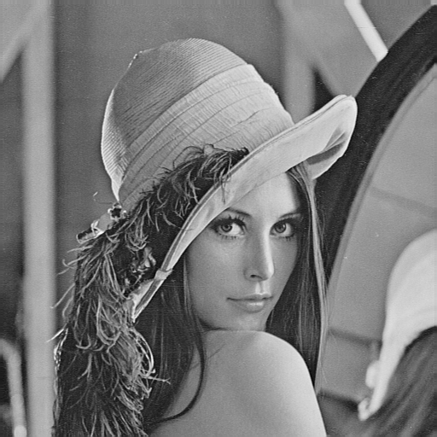
Normal stego-image | Blurred stego-image | Sharpened stego-image
PSNR=44.3 dB  secret recovered error rate=0% | PSNR=28.5 dB  secret recovered error rate=49.95% | PSNR=34.8 dB  secret recovered error rate=49.96%
Figure 1. The experiment result of stego-image after image processing

