Date of publication xxxx 00, 0000, date of current version xxxx 00, 0000.
Digital Object Identifier 10.1109/ACCESS.2017.Doi Number
Efficient Cost-reduced with High-quality Image of Imperceptible Steganography Using Modulo and Magic Cube
Hung-Jui Ko¹, Cheng-Ta Huang^{2,3}, Hsueh-Wen Tseng¹, Shiuh-Jeng WANG*
¹ Department of Computer Science and Engineering, National Chung-Hsing University, Taichung, Taiwan
² International Bachelor Program in Informatics, Yuan Ze University, Taoyuan, Taiwan
³ Department of Information Management, Yuan Ze University, Taoyuan, Taiwan
* Department of Information Management, Central Police University, Taoyuan, Taiwan
Corresponding author: Shiuh-Jeng WANG (e-mail: dopwang@gmail.com).
This work was supported by the Ministry of Science and Technology, Taiwan, under Contract MOST 110-2221-E-015-001-MY3.
ABSTRACT Information hiding techniques are used to hide confidential data in digital carriers. It is difficult for malicious users to detect the existence of confidential data within the digital carriers. Audios, images, or videos can call be digital carriers. Information hiding includes steganography and watermarking. Watermarking is used for copyright protection. Steganography is used to protect confidential data transmission from malicious attackers. Imperceptibility and capacity are always the major concerns in steganography. In this paper, we propose an efficient steganography method for images using modulus operation and magic cube. The partial secret message bits are converted into decimals and then mapped to a predefined cube. The coordinates of the mapped position were embedded into the cover image using modulus operation. We obtain the stego-image quality better than 42 dB, while the payload is 3 bpp. The experimental results demonstrated that the proposed method has a higher capacity than previous works. Meanwhile, our method also maintain high imperceptibility. Furthermore, modulus operation can reduce the computational overhead of the proposed method.
INDEX TERMS Information hiding, steganography, modulus operation, magic cube.

- INTRODUCTION
The rapid and continual development of communication technologies has facilitated and accelerated the transfer of data. However, it has also become easier for an attacker to copy, alter, or destroy the transmitted data. Thus, the protection of data confidentiality, both in its place and during transmission, is a crucial issue. Encryption and information hiding are two major techniques in information security for maintaining data secrecy. Encryption is a data transformation method that encrypts data into cipher text and a meaningless form that cannot be read unless the key to decrypt the encryption is possessed. Information hiding techniques are concerned with hiding secret data within a digital carrier in an invisible manner. The digital carrier may be audio, image, or video. Information hiding has two main branches: steganography and watermarking. Watermarking focuses on the protection of ownership. This study focuses on steganography and uses images as a cover to hide secret data. Steganography conceals the secret data inside a cover image so that nobody can even know that secret data exist.
Image steganography is a common method that is used the most extensively compared to other types of steganography. This is because images have a large amount of redundant data that can be used to hide secret data easily. In image steganography, the original image is known as the cover image, whereas the stego-image is the image that results from embedding secret data inside the original image. The cover and stego-images should be similar so that it is difficult for an unauthorized person to recognize the stego-image.
The primary objectives of steganography are imperceptibility, the embedding capacity of the hidden message, and a low computational overhead. Many studies have been conducted in this domain in recent years. In 2003, Wu and Tsai presented a steganographic scheme that offers good imperceptibility to stego-images using pixel-value differencing [1]. In this scheme, a cover image is partitioned into non-overlapping blocks of two consecutive pixels. The difference value is calculated from the values of the two pixels in each block. This method can produce imperceptible stego-images using least significant bit (LSB) substitution schemes. In 2005, Wang proposed a method based on modulus operations to hide secret data in a cover image [2]. Wang used the modulus as a threshold value that indicates how many bits of the secret image are incorporated into the cover image. Zhang and Wang proposed the exploiting modification direction (EMD) method in 2006 [3]. In the EMD method, each secret digit in a (2n+1)-ary notational system is carried by n cover pixels and, at most, only one pixel is increased or decreased by 1. Two-dimensional hyper-cubes and modulo are used to determine the pixel changes in the cover image. In 2013, Kuo and Wang proposed the generalized EMD (GEMD) method [4]. The GEMD also uses n cover pixels in a group, but it exhibits a better embedding capacity than EMD. In 2018, Liu et al. proposed an enhanced GEMD method [5], in which a group of n cover pixels is divided into multiple groups. Their experiment demonstrated that the embedding capacity could exceed that of the GEMD method. In certain scenarios, the capacity of Liu et al.’s method could reach 2 bits per pixel (bpp), whereas GEMD can only achieve 1.5. The EMD method provides high imperceptibility but low capacity. Shen and Huang combined pixel value differencing and improved EMD to develop a new scheme in 2015 [6]. This scheme increases the capacity but sacrifices several visual qualities. Sahu and Swain [7] adopted pixel value differencing and the modulus function to propose a data-hiding approach. The proposed approach has two variants: PVDMF 1 and PVDMF 2. Both variants use the difference between a pair of consecutive pixels to embed the secret data based on an adaptive range table. The average peak signal-to-noise ratio (PSNR) of PVDMF 1 was 42.04 and the bpp was 2.2. The average PSNR of PVDMF 2 was 38.36 and the bpp was 3.1. The method of Sahu and Swain resulted in an increase in the capacity, but a decrease in the image quality.
In 2014, Chang et al. proposed a turtle shell-based scheme for data hiding [8]. Their method uses a reference matrix known as a turtle shell. The secret digit is embedded into each cover pixel pair under the guidance of the turtle shell. Kurup et al. improved the capacity by changing the reference matrix into an octagon in 2015 [9]. Liu et al. [10] extended the turtle shell matrix structure to a different matrix model to achieve superior capacity and image quality. In 2020, a hybrid image steganography technique based on LSB substitution and enhanced modified signed digit (EMSD) algorithms was proposed by Solak [11]. Solak improved Liu et al.’s EMSD method [12] by incorporating LSB substitution. Solak’s method uses the number of adjacent pixels and LSBs to control the capacity and visual imperceptibility. Meanwhile, Lee et al. proposed a method based on a magic cube [13], which achieved an average PSNR and bpp of 44 dB and 2.25, respectively.
The method proposed in this paper is based on the approaches of Lee et al. [13], and the contributions of this study are as follows: (i) We present a more computationally efficient steganography method. (ii) This method is more flexible for information embedding. (iii) The proposed method produces high quality in the stego-image. The remainder of this paper is organized as follows: In Section 2, we discuss related works based on steganography, followed by the details of our proposed method in Section 3. The experimental results are presented in Section 4, and the conclusions are outlined in Section 5.

- RELATED WORKS
- Chang et al.'s scheme
Chang et al. proposed a turtle shell-based scheme for data hiding in 2014 [8]. This method uses a matrix known as a turtle shell. The turtle shell is defined as a hexagon containing eight different digits from 0 to 7, including two digits inside the hexagon, which are referred to as back digits, and six digits on the edges of the hexagon, known as edge digits. A turtle shell matrix with a size of 256 × 256 is constructed for data embedding.
The construction rules are as follows: first, the values of elements in the same row change according to the gradient ascent/descent with a magnitude of “1”; second, the values of elements in the same column change according to the gradient ascent/descent with alternate magnitudes of “2” and “3”. Fig. 1 depicts an example of a reference matrix, M, based on turtle shells. The data hider can embed the secret data into the cover image after the matrix is created. Using the stego-image and matrix, the receiver can extract the secret data accurately.
Assume that a secret binary stream S is embedded into a cover image I with a size of W × H according to the turtle shell matrix M. The size of matrix M is 256 × 256. Let (p_{i}, p_{i+1}) and (q_{i}, q_{i+1}) be the pair of cover and stego-pixels, respectively. Furthermore, M(p_{i}, p_{i+1}) and M(q_{i}, q_{i+1}) are the two numbers in matrix M. The secret data S = {s₁,s₂,…,s_{n}}, where n is the total number of octal digits. If S_{t} = M (p_{i}, p_{i+1}), the current pixel pair corresponds exactly to the secret octal digit. If S_{t} ≠ M (p_{i}, p_{i+1}), we need to find the closest M(q_{i}, q_{i+1}) that is equal to S_{t} . Subsequently, we must replace (p_{i}, p_{i+1}) with (q_{i}, q_{i+1}) in the cover image to embed the octal digit S_{t}. When the secret data need to be extracted, it is only necessary to obtain the value of M(q_{i}, q_{i+1}). The embedding and extraction phases can be performed quickly. However, in Chang et al.'s scheme, the pair has to be 2 pixels and the secret digits range from (000)₂ to (111)₂. Therefore, the bpp is limited to 1.5.
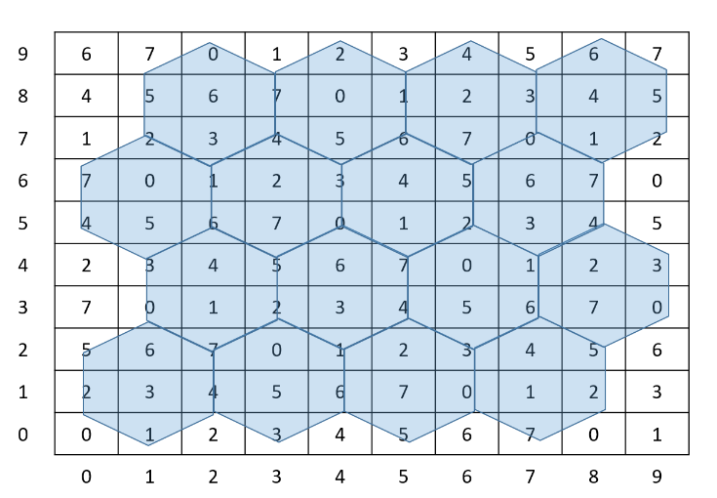
- Matrix based on turtle shells

A pencil-shaped steganographic method was proposed by Lee et al. in 2017 [14]. This method transforms the matrix into a pencil-shaped matrix that contains 16 different digits. Thus, each cover pixel pair can carry 4-bit secret data and the embedding capacity can reach 2 bpp. Their method exhibits a higher capacity but a lower PSNR compared to the scheme of Chang et al.
- Solak’s scheme
In 2020, Solak proposed a high embedding capacity data-hiding technique based on EMSD and LSB substitution algorithms [11]. The purpose of this method is to increase the embedding capacity while the stego-image maintains acceptable visual quality. The embedding scheme can be described as follows:
Input: W × H size of cover image, adjacent pixels n, k value for LSBs, secret data (SD).
Output: W × H size of stego-image.
Step 1: Calculate the number of integers M_{i} that can be represented by an i-bit.
Step 2: The n adjacent pixels are obtained from the cover image.
Step 3: Calculate the temporary pixel values.
Step 4: Check whether the temporary pixel is less than 0 or greater than 255.
Step 5: Calculate the gEMSD value by accumulating the temporary pixels after the modulus operation with M_{i}.
Step 6: Calculate each difference value (diff) between gEMSD and SD.
Step 7: Convert the diff value into a binary system and use the modified weight minimization algorithm for the EMSD algorithm.
Step 8: Calculate the temporary stego-pixel values by adding the diff values.
Step 9: n × k bits of data are obtained from the secret data.
Step 10: Hide a k-bit SD for each pixel using LSB substitution.
Step 11: Repeat steps 2 to 10 until all of the secret data are embedded into the cover image. Finally, a stego-image is obtained.
Solak’s extraction scheme can be described as follows:
Input: W × H size of stego-image, adjacent pixels n, k value for LSBs.
Output: Secret data (SD).
Step 1: Calculate the number of integers M_{i} that can be represented by an i-bit.
Step 2: The n adjacent pixels are obtained from the stego-image.
Step 3: Extract k bits of secret data from n adjacent stego-pixels.
Step 4: Calculate the temporary stego-pixel values for the EMSD algorithm.
Step 5: Calculate the secret data (SDi) using the modulus operation with M_{i}.
Step 6: Repeat steps 2 to 5 until all of the secret data are extracted from the stego-image.
Solak’s scheme takes advantage of the EMSD technique and uses LSB substitution to increase the capacity. This method can adjust the capacity by manipulating the number of adjacent pixels and LSBs; however, the visual imperceptibility is sacrificed.
- Lee et al.'s scheme
Lee et al. proposed a three-dimensional (3D) magic cube-based scheme in 2020 [13]. Their embedding scheme can be described as follows:
Input: W × H size of cover image, secret message (S).
Output: W × H size of stego-image.
Step 1: The cover image is divided into 2 × 2 non-overlapping blocks, each of which is represented by four cover pixels (p₁, p₂, p₃, p₄).
Step 2: A 4 × 4 3D magic cube is constructed as M. The coordinates have the numbers 0 to 63 and there are 64 unrepeated random values. The magic cube is then filled in a 256 × 256 × 256 3D array, as illustrated in Fig. 2.
Step 3: The secret message S is divided into {s₁, s₂}, where s₁ is 3 bits and s₂ is 6 bits.
Step 4: P₁’s LSB is substituted with s₁ to become q₁.
Step 5: Calculate the absolute differences of q₁ and (p₂, p₃, p₄) to obtain (d₁, d₂, d₃).
Step 6: If s₂ = M(d₁, d₂, d₃), then (q₂, q₃, q₄) = (p₂, p₃, p₄). If s2 ≠ M(d₁, d₂, d₃), find the s₂ position in this magic cube and the adjacent magic cubes, and then determine which has the shortest distance. The coordinate of s₂ that has the shortest distance is M(d’₁, d’₂, d’₃). Subsequently, (q₂, q₃, q₄) becomes (p₁ - d’₁, p₁ - d’₂, p₁ - d’₃).
Step 7: The original pixels (p₁, p₂, p₃, p₄) are changed into stego-pixels (q₁, q₂, q₃, q₄).
The above steps are repeated until all of the secret messages are hidden and stego-image I’ is the output.
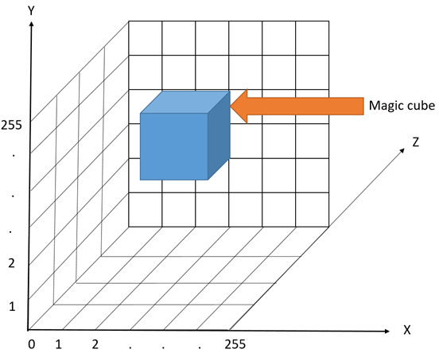
- Magic cube and 3D array

Lee et al.'s extraction scheme can be described as follows:
Input: W × H size of stego-image, magic cube M.
Output: Secret message (S).
Step 1: The stego-image is divided into 2 × 2 non-overlapping blocks, each of which is represented by four cover pixels (q₁, q₂, q₃, q₄).
Step 2: The magic cube M is filled in a 256 × 256 × 256 3D array, as shown in Fig. 2.
Step 3: Calculate the absolute difference of (q₂, q₃, q₄) with q₁. For example, d’₁ = q₁ - q₂, d’₂ = q₁ - q₃, d’₃ = q₁ - q₄.
Step 4: The position value of M(d’₁, d’₂, d’₃) is the secret data s₂.
Step 5: Extract the LSBs from q1 and transform these into decimals to obtain the secret data s₁.
Step 6: Combine s₁ and s₂ to obtain the secret data S.
Lee et al.’s scheme uses a 3D matrix as a magic cube. The magic cube can store 0 to 63 digits. That is, this scheme can exhibit greater capacity than that of Chang et al. However, the scheme of Lee et al. has to calculate the shortest Euclidean distance for all adjacent cubes. Every cube has six faces, and at least four adjacent cubes are required to calculate the shortest path. Therefore, excessive computational resources are necessary.
The above schemes are summarized in Table 1. A trade-off always occurs between the visual imperceptibility and capacity. Moreover, the computational effort is a concern. In practice, an efficient data-hiding scheme with high capacity is required.

TABLE I
Comparison of steganographic schemes
Scheme | Algorithm | Advantage | Disadvantage
Chang et al. [8] | Turtle shell | Good imperceptibility | Limited capacity
Solak [11] | EMSD and LSB | Adjustable capacity | Lower image quality
Lee et al. [13] | Magic cube | Higher capacity | High computational overhead

Proposed method
The proposed method is based on a magic cube and the modulus operation, wherein the modification amount of the pixels is determined by secret message bits and the coordinates of the magic cube.
- Preliminary phase
In the preliminary phase, the cover image is divided into non-overlapping blocks and an N × N × N magic cube is created. The operation of the preliminary phase is as follows:
Step 1: Divide an input image I of size W × H is into non-overlapping 2 × 2 pixel blocks.
Step 2: Create an N × N × N 3D array as a cube using the pseudo-random key SK. This cube is denoted as M and it is filled with unrepeated numbers from 0 to N × N × N - 1. An example of a 4 × 4 × 4 cube is illustrated in Fig. 3.

- Embedding phase
The operation of the embedding phase is as follows:
Step 1: The secret messages for each pixel block are denoted as S. We divide S into {S₀, S₁}. S₀ < N × N × N and 0 < S₁ < 27. Furthermore, d is the total number of digits of S₁ in binary form.
Step 2: The pixel block is denoted as (p₁, p₂, p₃, p₄).
Step 3: We look up S₀ in M and determine M(C₁, C₂, C₃) = S₀. P₁, P₂, and P₃ are modified by the modulus operation.
Ri = Pi mod N, i = 1, 2, 3
If R_{i} > C_{i}, Q_{i} = P_{i} - R_{i} - C_{i}
Else if R_{i} < C_{i}, Q_{i} = P_{i} - N - C_{i}
Else Q_{i} = P_{i}
Then, we obtain (Q₁, Q₂, Q₃).
Step 4: The minimum values of Q₁, Q₂, and Q₃ are subtracted from P₄ and then calculated by the modulus operation.
[P₄ - min(Q₁, Q₂, Q₃)] mod d = r
If r > S₁
Q₄ = P₄ - (r - S₁)
Else if r < S₁
Q₄ = P₄ + (S₁ - r)
Else Q₄ = P₄
Step 5: We acquire (Q₁, Q₂, Q₃, Q₄) as the stego-pixel block.
The above steps are repeated until all of the secret messages are embedded. The stego-image is obtained when the embedding operation is completed. The flowchart of embedding phase is illustrated in Fig. 4.
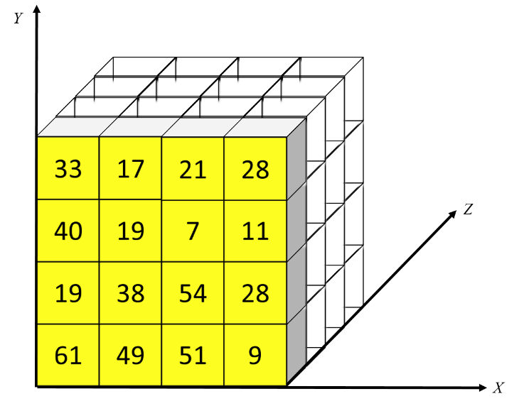
- 4 × 4 × 4 cube
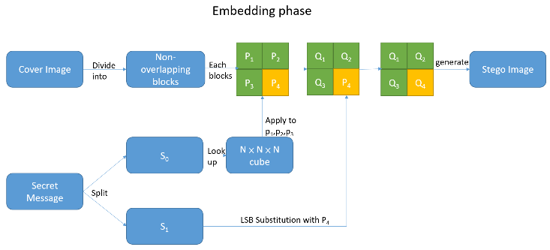

- The flowchart of embedding phase

- Extraction phase
The operation of the extraction phase is as follows:
Step 1: Divide the stego-image into non-overlapping 2 × 2 pixel blocks.
Step 2: Use the pseudo-random key SK to generate the N × N × N cube M.
Step 3: Each pixel block is denoted as (Q₁, Q₂, Q₃, Q₄). Extract the LSBs (C’₁, C’₂, C’₃) from (Q₁, Q₂, Q₃).
Step 4: Look up M(C’₁, C’₂, C’₃) and acquire the partial secret message S₀.
Step 5: S₁ = [Q₄ - min(Q₁, Q₂, Q₃)] mod p
Step 6: Combining S₀ and S₁, we obtain the secret message S of this block.
The above steps are repeated until all of the secret messages are extracted. The flowchart of extraction phase is illustrated in Fig. 5.

- Example of embedding phase
We consider an example to describe the embedding phase. One pixel block is (p₁, p₂, p₃, p₄) = (151, 154, 153, 152) and the secret message is (110110110)₂. The N × N × N cube M is generated, as illustrated in Fig. 3.
The secret message can be divided into S₀ = (110110) ₂ = 54 and S₁ = (110) ₂ = 6. When we look up S₀ in Fig. 2, we obtain M(C₁, C₂, C₃) = M(3, 1, 0) = 54. As 151 mod 4 = 3 = R₁ and 3 is equal to C₁, Q₁ = P₁ = 151. As 154 mod 4 = 2 = R₂ and 2 is greater than C₂, Q₂ = P₂ - R₂ + C₂; thus, Q₂ = 153. As 153 mod 4 = 1 and 1 is greater than C₃, Q₃ = P₃ -1 + C3; thus, Q₃ = 152. As 153 mod 4 = 1 and 1 is greater than C3, Q₃ = P₃ -1 + C₃; thus, Q₃ = 152.

- Example of extraction phase
We obtain the stego-pixel blocks (Q₁, Q₂, Q₃, Q₄) = (151, 153, 152, 157). Thus, the pseudo-random key SK can be used to generate cube M. Q1 mod 4 = 3, Q2 mod 4 = 1, and Q3 mod 4 = 0. When we look up M(3, 1, 0), we can obtain S₀ = 54. S₁ = [157 - min(151, 153, 152)] mod 4 = 6. By combining S₀ and S₁, we obtain the secret message of this stego-pixel block.

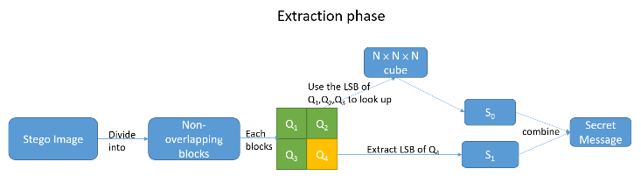
FIGURE 5. The flowchart of extraction phase

Experimental results
The test images are presented in Fig. 6. Each image size was 512 × 512 pixels. We used the PSNR and bpp as evaluation standards.
We evaluated the quality of the stego-image using the PSNR. The common benchmark for the embedding capacity (EC) is the maximum number of embedding bits. We also applied the bpp as a benchmark. The PSNR and bpp are defined as follows:
PSNR: The PSNR is most commonly used to evaluate the quality of a stego-image relative to the original image. The PNSR is calculated as follows:

$$PSNR \left(dB\right)=10\log_{10}\frac{{255}^{2}}{MSE} (1)$$

bpp: The bpp is used to evaluate the number of bits that are embedded in one pixel. H and W denote the height and width of the cover image, respectively. The bpp is defined as follows:

$$bpp=\frac{Total embedding bits}{H×W} (2)$$

Table 2 presents the experimental results of our proposed method compared to those of other studies. The proposed method exhibited a better PSNR. Even when the bpp was increased to 4, the PSNR of the proposed method still exceeded 36 dB. The comparison of average PSNR and bpp is shown in Fig. 7. The proposed method produced better PSNR and bpp than those of the schemes of Chang et al. and Lee et al. Compared to Solak's scheme[11], Lee et al.[15] and Hussain et al. [16], the proposed method had a little lower bpp but a much better PSNR. In the proposed method, the cube can contain more digits; that is, the capacity can be increased. The modulus operation and pixel differencing can also cause the pixels to change less.

Table 3 displays the comparisons of the PSNR and EC for the six standard test images using Lee et al.’s scheme and the proposed method. The proposed method achieved an embedding rate of 2.25 bpp and an average PSNR of 43.99 dB.
In Table 4, the execution time of the proposed method is compared with that of Lee et al.'s scheme. Lee et al. used many cubes in a 3D array as a reference matrix. To obtain the shortest distance, it is necessary to locate the value and to calculate the Euclidean distance of the coordinate many times. In our experiment, the scheme of Lee et al. was 40% slower than the proposed method. Therefore, the proposed method exhibited higher efficiency.
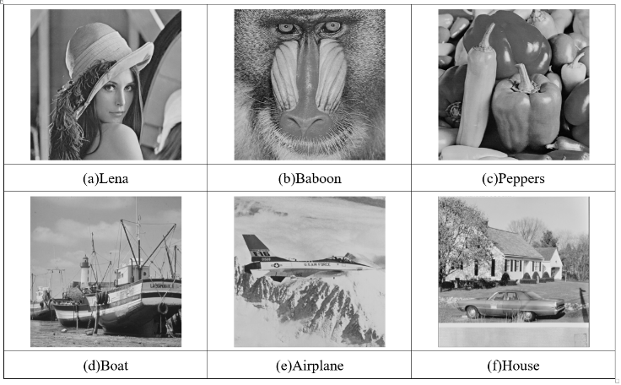
- The test images

Conclusions
An improved magic cube data-hiding method based on the modulus operation has been proposed to enhance the embedding capacity. The partial secret messages are mapped to a predefined cube and the coordinates are embedded into a cover image. The other secret messages are hidden in a cover image by calculating the difference with the minimum pixel. The proposed method not only increases the capacity but also reduces the computational overhead. The capacity can be adjusted by changing the size of the predefined cube. When it is necessary to hide 3 bits in one pixel, the PSNR can be maintained higher than 40 dB. The proposed method does not require substantial computational effort; it also exhibits a lower computational overhead than previous methods. Compared to other schemes, the proposed method is efficient and has good visual imperceptibility with more secret messages.

TABLE 2
Comparisons of PSNR and bpp for test images

Image |  | Lena | Baboon | Peppers | Boat | Airplane | House | Average
Chang et al. [8] | PSNR | 49.42 | 49.39 | 49.40 | 49.40 | 49.39 | 49.40 | 49.40
Chang et al. [8] | bpp | 1.5 | 1.5 | 1.5 | 1.5 | 1.5 | 1.5 | 1.5
Lee et al. [13] (N=4) | PSNR | 43.97 | 44.09 | 44.00 | 44.03 | 43.95 | 44.0 | 44.0
Lee et al. [13] (N=4) | bpp | 2.25 | 2.25 | 2.25 | 2.25 | 2.25 | 2.25 | 2.25
EMSD+LSB  (k=1,n=2)[11] | PSNR | 43.47 | 43.47 | 43.45 | N/A | 43.47 | 43.43 | 43.46
EMSD+LSB  (k=1,n=2)[11] | Bpp | 2.404 | 2.404 | 2.404 | N/A | 2.404 | 2.404 | 2.404
EMSD+LSB  (k=2,n=6) [11] | PSNR | 36.7 | 36.69 | 36.68 | N/A | 36.67 | 36.71 | 36.69
EMSD+LSB  (k=2,n=6) [11] | bpp | 3.074 | 3.074 | 3.074 | N/A | 3.074 | 3.074 | 3.074
EMSD+LSB  (k=3,n=6) [11] | PSNR | 30.61 | 30.63 | 30.66 | N/A | 30.64 | 30.58 | 30.62
EMSD+LSB  (k=3,n=6) [11] | Bpp | 4.074 | 4.074 | 4.074 | N/A | 4.074 | 4.074 | 4.074
Double-Layer Octagon[15] | PSNR | 37.52 | 37.51 | 37.53 | 37.51 | 37.51 | 37.52 | 37.51
Double-Layer Octagon[15] | Bpp | 3.05 | 3.05 | 3.05 | 3.05 | 3.05 | 3.05 | 3.05
LSB+PVD[16] | PSNR | 33.49 | 31.94 | 33.12 | 32.09 | 32.23 | N/A | 32.57
LSB+PVD[16] | Bpp | 4.04 | 4.09 | 4.03 | 4.07 | 4.01 | N/A | 4.04
Proposed method(N=4) | PSNR | 44.67 | 44.67 | 44.66 | 44.68 | 44.66 | 44.67 | 44.67
Proposed method(N=4) | bpp | 2.25 | 2.25 | 2.25 | 2.25 | 2.25 | 2.25 | 2.25
Proposed method(N=8) | PSNR | 42.28 | 42.29 | 42.28 | 42.29 | 42.31 | 42.26 | 42.28
Proposed method(N=8) | bpp | 3 | 3 | 3 | 3 | 3 | 3 | 3
Proposed method(N=16) | PSNR | 36.43 | 36.52 | 36.51 | 36.54 | 36.59 | 36.50 | 36.52
Proposed method(N=16) | bpp | 4 | 4 | 4 | 4 | 4 | 4 | 4

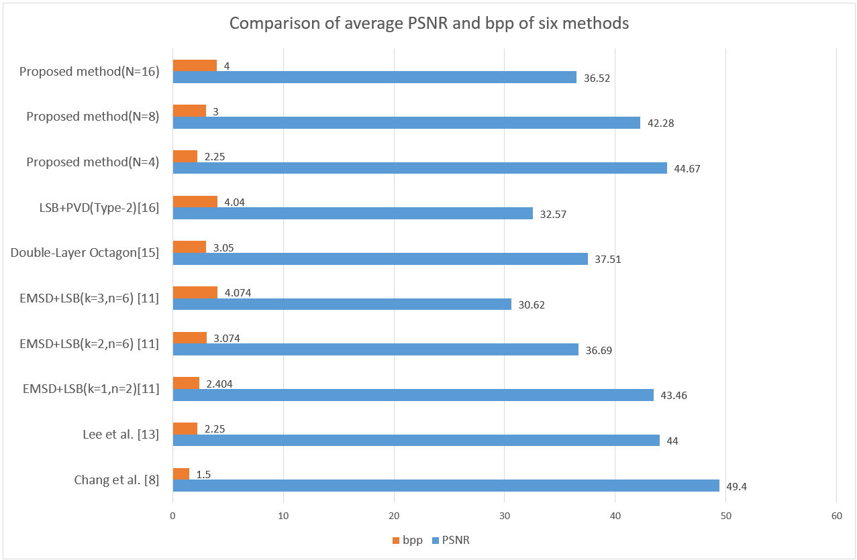
- The comparison of average PSNR and bpp of six methods.

TABLE 3
Comparisons of EC for test images

Image | Lee et al. [13] |  | Proposed method
Image | PSNR | EC(bits) | PSNR | EC(bits)
Lena | 43.97 | 589,824 | 44.67 | 589,824
Baboon | 44.09 | 589,824 | 44.67 | 589,824
Peppers | 44.00 | 589,824 | 44.66 | 589,824
Boat | 44.03 | 589,824 | 44.68 | 589,824
Airplane | 43.95 | 589,824 | 44.66 | 589,824
House | 44.00 | 589,824 | 44.67 | 589,824
Average | 44.00 | 589,824 | 44.67 | 589,824

TABLE 4
Comparisons of execution time in seconds

Image | Lee et al. [13] | Proposed method | Image size | Magic cube size
Lena | 6.98 | 4.19 | 512 × 512 | 4 × 4 × 4
Baboon | 7.02 | 4.09 | 512 × 512 | 4 × 4 × 4
Peppers | 7.48 | 4.07 | 512 × 512 | 4 × 4 × 4
Boat | 6.97 | 4.13 | 512 × 512 | 4 × 4 × 4
Airplane | 6.93 | 4.16 | 512 × 512 | 4 × 4 × 4
House | 6.94 | 4.14 | 512 × 512 | 4 × 4 × 4
Average | 7.05 | 4.13 | 512 × 512 | 4 × 4 × 4

REFERENCES
[1] D.C. Wu and W.H. Tsai, “A steganographic method for images by pixel-value differencing,” Pattern Recognition Letters, vol. 24, pp.1613-1626, 2003.
[2] S. J. Wang, “Steganography of capacity required using modulo operator for embedding secret image,” Appl. Math. Comput., Vol. 164, pp. 99-116, 2005.
[3] X. Zhang and S. Wang, “Efficient steganographic embedding by exploiting modification direction,” IEEE Commun. Lett., vol. 10, no. 11, pp. 781-783, Nov. 2006.
[4] W. C. Kuo and C. C. Wang, “Data hiding based on generalized exploiting modification direction method,” The Imaging Science Journal, vol. 61, no. 6, pp. 484-490, Nov. 2013.
[5] Y. Liu, C. Yang, and Q. Sun, “Enhance embedding capacity of generalized exploiting modification directions in data hiding,” IEEE Access, vol. 6, pp. 5374-5378, 2018.
[6] S.-Y. Shen and L.-H. Huang, "A data hiding scheme using pixel value differencing and improving exploiting modification directions", Computers & Security, vol. 48, pp. 131-141, Feb. 2015.
[7] A. K. Sahu, G. Swain, “An optimal information hiding approach based on pixel value differencing and modulus Function,” Wireless Personal Commun., vol. 108, pp. 159–174, 2019.
[8] C. C. Chang, Y. Liu and T. S. Nguyen, “A novel turtle shell based scheme for data hiding,” in Proc. 10th Int. Conf. Intell. Inf. Hiding Multimedia Signal Process., Kitakyushu, Japan, Aug. 2014, pp. 89-93.
[9] S. Kurup, A. Rodrigues, and A. Bhise, “Data hiding scheme based on octagon shaped shell,” in Proc. Int. Conf. Adv. Comput., Commun. Inform.(ICACCI), Kochi, India, Aug. 2015, pp. 1982-1986.
[10] L. Liu, C. C. Chang, and A. Wang, “Data hiding based on extended turtle shell matrix construction method,” Multimed Tools and Appl., vol. 76, no. 10, pp. 12233-12250, 2017.
[11] S. Solak, “High embedding capacity data hiding technique based on EMSD and LSB substitution algorithms,” IEEE Access, vol. 8, pp. 166513-166524, 2020.
[12] Y. X. Liu, C. N. Yang, Q. D. Sun, S. Y. Wu, S. S. Lin, and Y. S. Chou, “Enhanced embedding capacity for the SMSD-based data-hiding method,” Signal Process., Image Commun., vol. 78, pp. 216-222, Oct. 2019.
[13] C. Lee, J. Shen, S. Agrawal, Y. Wang, and Y. Lee, "Data hiding method based on 3D magic cube," IEEE Access, vol. 8, pp. 39445-39453, 2020.
[14] C. F. Lee, Y. X. Wang, and A. T. Shih, “Image steganographic method based on pencil-shaped pattern,” in Proc. ICMWT., Singapore, 2017, pp. 639-644.
[15] C. F. Lee, J. J. Shen, S. Agrawal, and Y. H. Li, “High-capacity embedding method based on double-layer octagon-shaped shell matrix,” Symmetry, vol.13, no.4, 2021.
[16] M. Hussain, Q. Riaz, S. Saleem, A. Ghafoor, and K. H. Jung, “Enhanced adaptive data hiding method using LSB and pixel value differencing,” Multimed Tools Appl., vol. 80, pp. 20381-20401, 2021.

 | HUNG-JUI KO received the master’s degree in information management from the Central Police University, Taiwan, in 2003. He is currently pursuing the doctor’s degree with the Department of Computer Science and Engineering, National Chung-Hsing University, Taiwan. His research interests include information hiding and digital forensics.
 | CHENG-TA HUANG received the Ph.D. degree in computer science and information engineering from the National Central University, Taiwan, in 2013.  He is currently an Assistant Professor of International Bachelor Program in Informatics and Department of Information Management, Yuan Ze University, Taiwan. His research interests include information security and Image processing.
 | HSUEH-WEN TSENG received the Ph.D. degree in computer science and information engineering from the National Taiwan University, Taiwan.  He is currently a Professor of Computer Science and Engineering, National Chung-Hsing University, Taiwan. His research interests include wireless networks, communication protocol design, networked applications and services and cloud computing and networking.
 | SHIUH-JENG WANG received the Ph.D. degree in electrical engineering from the National Taiwan University, Taiwan.  He is currently a Professor of information management, Central Police University, Taiwan. His research interests include information security, evidence ability and forensic analysis.

