九、项目(点餐)：Deepseek
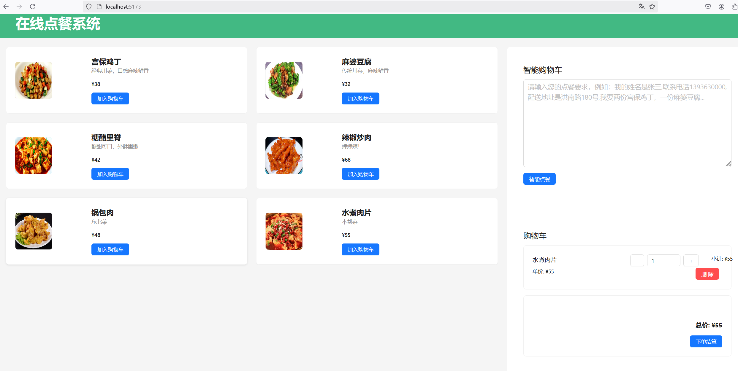

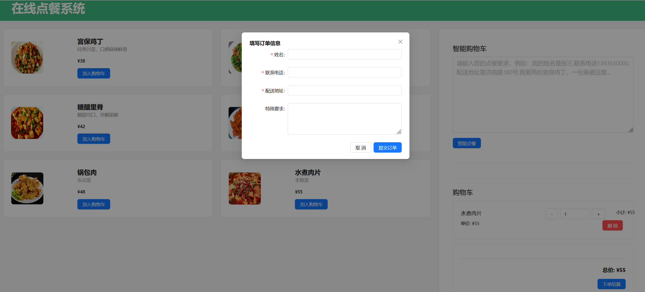

9.1 搭建项目
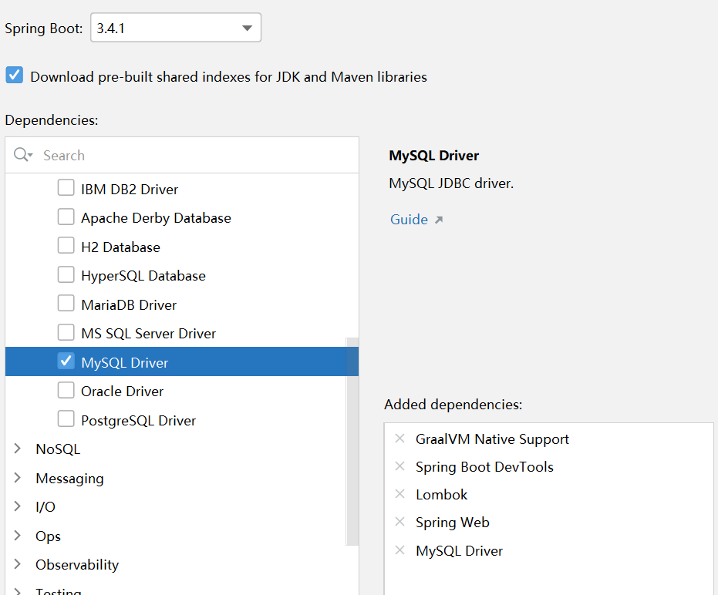
- pom
- <?xml version="1.0" encoding="UTF-8"?>
<project xmlns="http://maven.apache.org/POM/4.0.0" xmlns:xsi="http://www.w3.org/2001/XMLSchema-instance"
xsi:schemaLocation="http://maven.apache.org/POM/4.0.0 https://maven.apache.org/xsd/maven-4.0.0.xsd">
<modelVersion>4.0.0</modelVersion>
<parent>
<groupId>org.springframework.boot</groupId>
<artifactId>spring-boot-starter-parent</artifactId>
<version>3.4.7</version>
<relativePath/> <!-- lookup parent from repository -->
</parent>
<groupId>com.zmx</groupId>
<artifactId>takeout</artifactId>
<version>0.0.1-SNAPSHOT</version>
<name>takeout</name>
<description>takeout</description>
<url/>
<licenses>
<license/>
</licenses>
<developers>
<developer/>
</developers>
<scm>
<connection/>
<developerConnection/>
<tag/>
<url/>
</scm>
<properties>
<java.version>17</java.version>
<spring-ai.version>1.0.0</spring-ai.version>
<spring-ai-alibaba.version>1.0.0.2</spring-ai-alibaba.version>
</properties>
<dependencies>
<dependency>
<groupId>org.springframework.boot</groupId>
<artifactId>spring-boot-starter-web</artifactId>
</dependency>
<dependency>
<groupId>org.springframework.boot</groupId>
<artifactId>spring-boot-devtools</artifactId>
<scope>runtime</scope>
<optional>true</optional>
</dependency>
<dependency>
<groupId>com.mysql</groupId>
<artifactId>mysql-connector-j</artifactId>
<scope>runtime</scope>
</dependency>
<dependency>
<groupId>org.projectlombok</groupId>
<artifactId>lombok</artifactId>
<optional>true</optional>
</dependency>
<dependency>
<groupId>org.springframework.boot</groupId>
<artifactId>spring-boot-starter-test</artifactId>
<scope>test</scope>
</dependency>
<dependency>
<groupId>com.alibaba</groupId>
<artifactId>fastjson</artifactId>
<version>2.0.9</version>
</dependency>
<!--ETL Pipeline-->
<dependency>
<groupId>org.springframework.ai</groupId>
<artifactId>spring-ai-tika-document-reader</artifactId>
</dependency>
<!--mybatis-plus-->
<dependency>
<groupId>com.baomidou</groupId>
<artifactId>mybatis-plus-spring-boot3-starter</artifactId>
<version>3.5.12</version>
</dependency>
<!-- 阿里云 AI 相关依赖 -->
<dependency>
<groupId>com.alibaba.cloud.ai</groupId>
<artifactId>spring-ai-alibaba-starter-dashscope</artifactId>
</dependency>
<dependency>
<groupId>org.springframework.ai</groupId>
<artifactId>spring-ai-starter-model-deepseek</artifactId>
</dependency>
</dependencies>
<dependencyManagement>
<dependencies>
<dependency>
<groupId>org.springframework.ai</groupId>
<artifactId>spring-ai-bom</artifactId>
<version>${spring-ai.version}</version>
<type>pom</type>
<scope>import</scope>
</dependency>
<dependency>
<groupId>com.alibaba.cloud.ai</groupId>
<artifactId>spring-ai-alibaba-bom</artifactId>
<version>${spring-ai-alibaba.version}</version>
<type>pom</type>
<scope>import</scope>
</dependency>
</dependencies>
</dependencyManagement>
<build>
<plugins>
<plugin>
<groupId>org.apache.maven.plugins</groupId>
<artifactId>maven-compiler-plugin</artifactId>
<configuration>
<annotationProcessorPaths>
<path>
<groupId>org.projectlombok</groupId>
<artifactId>lombok</artifactId>
</path>
</annotationProcessorPaths>
</configuration>
</plugin>
<plugin>
<groupId>org.graalvm.buildtools</groupId>
<artifactId>native-maven-plugin</artifactId>
</plugin>
<plugin>
<groupId>org.springframework.boot</groupId>
<artifactId>spring-boot-maven-plugin</artifactId>
<configuration>
<excludes>
<exclude>
<groupId>org.projectlombok</groupId>
<artifactId>lombok</artifactId>
</exclude>
</excludes>
</configuration>
</plugin>
</plugins>
</build>
</project>
- 配置文件
- spring:
ai:
deepseek:
api-key: ${DEEPSEEK_API_KEY}
base-url: https://api.deepseek.com
chat:
options:
model: deepseek-chat

9.2 实体类

9.2.1 菜品类
@Schema
@Data
@TableName("dish")
@Accessors(chain = true)
public class Dish {
@TableId(value = "id", type = IdType.AUTO)
private Integer id;
@Schema( description = "菜品名称")
private String name;
@Schema(description = "菜品描述")
private String description;
@Schema( description = "菜品价格")
private BigDecimal price;
@Schema(description = "菜品分类")
private String category;
@Schema(description = "菜品图片地址")
private String imageUrl;
@Schema(description = "菜品是否可用")
private Boolean available = true;
}

9.2.3 订单类
@Schema
@Data
@TableName("orders")
public class Order {
@Schema(description = "主键id")
@TableId(value = "id", type = IdType.AUTO)
private Integer id;
@Schema(description = "顾客姓名")
private String customerName;
@Schema(description = "顾客电话")
private String customerPhone;
@Schema(description = "收货地址")
private String deliveryAddress;
@Schema(description = "订单总金额")
private BigDecimal totalAmount;
@Schema(description = "订单状态")
private String status;
@Schema(description = "下单时间")
@JsonFormat(pattern = "yyyy-MM-dd HH:mm:ss")
private LocalDateTime orderTime;
@Schema(description = "订单项列表")
private List<OrderItem> orderItems;
}

9.2.4 订单明细
@Schema
@Data
@TableName("order_item")
public class OrderItem {
@TableId(value = "id", type = IdType.AUTO)
private Integer id;
@Schema(description = "菜品")
private String dishName;
@Schema(description = "订单")
private Integer orderId;
@Schema(description = "数量")
private Integer quantity;
@Schema(description = "价格")
private BigDecimal price;
@Schema(description = "特殊要求")
private String specialInstructions;
}

9.3 DTO
- 便于数据封装和传输

9.3.1 客户下单明细
@Data
public class OrderItemRequest {
@Schema(description = "菜品ID")
private Integer dishId;
@Schema(description = "菜品数量")
private Integer quantity;
@Schema(description = "菜品特殊要求")
private String specialInstructions;
}

9.3.2 客户下单
@Schema
@Data
public class OrderRequest {
@Schema(description = "菜品详情")
private List<OrderItemRequest> items;
@Schema(description = "客户姓名")
private String customerName;
@Schema(description = "客户手机号")
private String customerPhone;
@Schema(description = "配送地址")
private String deliveryAddress;
}

9.4 mapper
@Mapper
public interface DishMapper extends BaseMapper<Dish> {}
---------------------------
@Mapper
public interface OrderMapper extends BaseMapper<Order> {}
---------------------------
@Mapper
public interface OrderItemMapper extends BaseMapper<OrderItem> {}

9.5 service

9.5.1 菜品
public interface DishService extends IService<Dish> {
//分类查找
List<Dish> findByCategory(String category);
//是否可用
List<Dish> findByAvailableTrue();
}
----------------------
@Service
public class DishServiceImpl extends ServiceImpl<DishMapper, Dish> implements DishService {
@Autowired
private DishMapper dishMapper;
@Override
public List<Dish> findByCategory(String category) {
return dishMapper.selectList(new LambdaQueryWrapper<Dish>()
.eq(Dish::getCategory, category));
}
@Override
public List<Dish> findByAvailableTrue() {
return dishMapper.selectList(new LambdaQueryWrapper<Dish>()
.eq(Dish::getAvailable, true));
}
}

9.5.2 订单
public interface OrderService extends IService<Order> {
// 根据客户手机号查询订单
List<Order> findByCustomerPhone(String customerPhone);
// 根据订单状态查询订单
List<Order> findByStatus(OrderStatus status);
//创建订单
Order createOrder(OrderRequest orderRequest);
}
--------------------------------------
@Service
public class OrderServiceImpl extends ServiceImpl<OrderMapper, Order> implements OrderService {
@Autowired
private OrderMapper orderMapper;
@Autowired
private DishService dishService;
@Autowired
private OrderItemService orderItemService;
@Override
public List<Order> findByCustomerPhone(String customerPhone) {
return orderMapper.selectList(new LambdaQueryWrapper<Order>()
.eq(Order::getCustomerPhone, customerPhone));
}
@Override
public List<Order> findByStatus(OrderStatus status) {
return orderMapper.selectList(new LambdaQueryWrapper<Order>()
.eq(Order::getStatus, status));
}
@Override
public Order createOrder(OrderRequest orderRequest) {
Order order = new Order();
order.setCustomerName(orderRequest.getCustomerName());
order.setCustomerPhone(orderRequest.getCustomerPhone());
order.setDeliveryAddress(orderRequest.getDeliveryAddress());
// 处理订单项
List<OrderItem> orderItems = orderRequest.getItems().stream()
.map(item -> {
// 获取菜品信息
Dish dish = dishService.getById(item.getDishId());
if (dish == null) {
throw new RuntimeException("菜品不存在: " + item.getDishId());
}
// 创建订单项
OrderItem orderItem = new OrderItem();
orderItem.setDishName(dish.getName());
orderItem.setQuantity(item.getQuantity());
orderItem.setPrice(dish.getPrice());
orderItem.setSpecialInstructions(item.getSpecialInstructions());
return orderItem;
})
.collect(Collectors.toList());
// 计算总金额
BigDecimal totalAmount = orderItems.stream()
.map(item -> item.getPrice().multiply(BigDecimal.valueOf(item.getQuantity())))
.reduce(BigDecimal.ZERO, BigDecimal::add);
// 设置订单总金额
order.setTotalAmount(totalAmount);
// 保存订单
orderMapper.insert(order);
// 设置订单项为前端显示订单的详细信息使用
order.setOrderItems(orderItems);
//保存订单项
orderItems.forEach(item -> item.setOrderId(order.getId()));
orderItemService.saveBatch(orderItems);
return order;
}
}

9.5.3 订单明细
public interface OrderItemService extends IService<OrderItem> {}
-------------------
@Service
public class OrderItemServiceImpl extends ServiceImpl<OrderItemMapper, OrderItem> implements OrderItemService {}

9.6 编写AI业务

9.6.1 AI订单
- 接口
- public interface OrderAiService {
//自然语音订单
OrderRequest aiOrder(String language);
}

- 实现类
- package com.zmx.ai.service.impl;
import com.zmx.ai.service.OrderAiService;
import com.zmx.dto.OrderRequest;
import com.zmx.mapper.DishMapper;
import org.springframework.ai.chat.client.ChatClient;
import org.springframework.ai.chat.client.advisor.MessageChatMemoryAdvisor;
import org.springframework.ai.chat.memory.MessageWindowChatMemory;
import org.springframework.ai.chat.prompt.PromptTemplate;
import org.springframework.ai.converter.BeanOutputConverter;
import org.springframework.ai.deepseek.DeepSeekChatOptions;
import org.springframework.ai.template.TemplateRenderer;
import org.springframework.core.io.ClassPathResource;
import org.springframework.core.io.Resource;
import org.springframework.stereotype.Service;
import java.util.Map;
import java.util.stream.Collectors;
@Service
public class DeepseekAiOrderService implements OrderAiService {
//菜品
private final DishMapper dishMapper;
private final ChatClient chatClient;
//构造方法注入
public DeepseekAiOrderService(DishMapper dishMapper, ChatClient.Builder
chatClientBuilder) {
this.dishMapper = dishMapper;
this.chatClient = chatClientBuilder
.defaultAdvisors(MessageChatMemoryAdvisor
.builder(MessageWindowChatMemory.builder().build()).build())
.defaultOptions(DeepSeekChatOptions.builder().temperature(0.6).build())
.build();
}
//系统的提示词
private final String SYSTEM_PROMPT = """
你是一个智能点餐助手，负责将用户的自然语言点餐内容转换为结构化的订单信息。
可用的菜品列表如下：
{dishes}
结构化订单信息的格式为：
{format}
""";
@Override
public OrderRequest aiOrder(String language) {
try {
//获取所有菜品
String dishesInfo = dishMapper.selectList(null).stream()
.map(dish -> String.format("ID:%d - %s,价格:%0.2f元",
dish.getId(), dish.getName(), dish.getPrice()))
.collect(Collectors.joining("\n"));
//转换格式
BeanOutputConverter<OrderRequest> beanOutputConverter =
new BeanOutputConverter<>(OrderRequest.class);
//格式化字符串
String format = beanOutputConverter.getFormat();
//菜品的转换
PromptTemplate promptTemplate = PromptTemplate
.builder()
.template(SYSTEM_PROMPT)
.variables(Map.of("dishes", dishesInfo, "format", format))
.build();
//LLM
String content = chatClient.prompt()
.system(promptTemplate.render())
.user(language)
.call()
.content();
//json返回
return beanOutputConverter.convert(content);
}catch (Exception e){
e.printStackTrace();
}
return null;
}
}

9.7 初始化数据
/**
* 初始化菜品数据
*/
@Component
public class DataInitializer implements CommandLineRunner {
@Autowired
private DishService dishService;
@Override
public void run(String... args) {
// 只有当没有菜品数据时才初始化
if (dishService.count() == 0) {
Dish[] dishes = {
new Dish()
.setName("宫保鸡丁")
.setDescription("经典川菜，口感麻辣鲜香")
.setPrice(new BigDecimal("38.00"))
.setCategory("川菜")
.setImageUrl("images/jbjd.png"),
new Dish()
.setName("麻婆豆腐")
.setDescription("传统川菜，麻辣鲜香")
.setPrice(new BigDecimal("32.00"))
.setCategory("川菜")
.setImageUrl("images/ljcr.png"),
new Dish()
.setName("糖醋里脊")
.setDescription("酸甜可口，外酥里嫩")
.setPrice(new BigDecimal("42.00"))
.setCategory("粤菜")
.setImageUrl("images/mpdf.png"),
new Dish()
.setName("辣椒炒肉")
.setDescription("辣辣辣！")
.setPrice(new BigDecimal("68.00"))
.setCategory("湘菜")
.setImageUrl("images/tclj.png")
};
dishService.saveBatch(Arrays.asList(dishes));
}
}
}

9.8 控制层

9.8.1 点餐
@RestController
@RequestMapping("/dishes")
@CrossOrigin
public class DishController {
@Autowired
private DishService dishService;
@GetMapping
public List<Dish> getAllDishes() {
return dishService.findByAvailableTrue();
}
/**
* 根据ID获取菜品信息
* @param id
* @return
* ResponseEntity是用于构建HTTP响应的类
*/
@GetMapping("/{id}")
public ResponseEntity<Dish> getDish(@PathVariable int id) {
Dish dish = dishService.getById(id);
if (dish == null){
//return new ResponseEntity<>(HttpStatus.NOT_FOUND);
return ResponseEntity.notFound().build();
}else {
//return new ResponseEntity<>(dish, HttpStatus.OK);
// 返回菜品信息
return ResponseEntity.ok(dish);
}
}
/**
*
* @param category
* @return
*/
@GetMapping("/category/{category}")
public List<Dish> getDishesByCategory(@PathVariable String category) {
return dishService.findByCategory(category);
}
}

9.8.3 订单管理
@RestController
@RequestMapping("/orders")
@CrossOrigin
public class OrderController {
@Autowired
private OrderService orderService;
@Autowired
private OrderAiService orderAiService;
@Autowired
private DishService dishService;
/**
* 创建订单
* @param orderRequest
* @return
*/
@PostMapping
public ResponseEntity<Order> createOrder(@RequestBody OrderRequest orderRequest) {
Order order = orderService.createOrder(orderRequest);
return ResponseEntity.ok(order);
}
/**
* 从自然语言创建订单
* @param naturalLanguageInput
* @return
*/
@PostMapping("/natural-language")
public ResponseEntity<Order> createOrderFromNaturalLanguage(@RequestBody String naturalLanguageInput) {
OrderRequest orderRequest = orderAiService.parseNaturalLanguageOrder(naturalLanguageInput);
Order order = orderService.createOrder(orderRequest);
return ResponseEntity.ok(order);
}
/**
* 获取订单
* @param id
* @return
*/
@GetMapping("/{id}")
public ResponseEntity<Order> getOrder(@PathVariable int id) {
return ResponseEntity.ok(orderService.getById(id));
}
/**
* 获取所有订单
* @return
*/
@GetMapping("/list")
public ResponseEntity<List<Order>> getAllOrders() {
return ResponseEntity.ok(orderService.list());
}
/**
* 获取某个顾客的订单
* @param phone
* @return
*/
@GetMapping("/customer/{phone}")
public ResponseEntity<List<Order>> getOrdersByPhone(@PathVariable String phone) {
return ResponseEntity.ok(orderService.list(new LambdaQueryWrapper<Order>()
.eq(Order::getCustomerPhone, phone)));
}
/**
* 更新订单状态
* @param id
* @param status
* @return
*/
@PutMapping("/{id}/status")
public ResponseEntity<Order> updateOrderStatus(
@PathVariable Long id,
@RequestParam OrderStatus status) {
Order order = orderService.getById(id);
//order.setStatus(status);
// 更新订单
orderService.updateById(order);
return ResponseEntity.ok(order);
}
}

