Master's Thesis

The Effectiveness of Unguided Self-Help
Cognitive Behavioral Interventions
for Adolescents with Depressive Symptoms:
A Meta-Analysis

청소년 우울 증상에 대한 비지도적 자가 도움
인지행동치료 개입의 효과성에 관한 메타분석

Meiling Li

Advisor: Professor Hyunsoo Kim

Department of Child Psychotherapy
Graduate School of Hanyang University

April 2026
Abstract
Major depressive disorder (MDD) is a growing public health concern among adolescents, with prevalence surging dramatically since the COVID-19 pandemic. Yet mental health services for adolescents remain severely constrained worldwide by shortages of specialized workforce, unaffordable treatment costs, and deep-rooted stigma. Unguided self-help interventions (USHIs), which equip individuals with basic tools and strategies without requiring direct therapist involvement, offer a potentially scalable and low-cost complement to conventional care. Cognitive Behavioral Therapy (CBT), as a well-established evidence-based treatment for adolescent depression, is the most extensively studied therapeutic framework delivered through self-help formats. However, the literature on unguided self-help CBT in adolescents remains fragmented, with relatively few syntheses focusing on this population and relatively little attention to how specific design features of the intervention shape outcomes.
This study aimed to (1) describe the research trends of unguided self-help CBT interventions for adolescents with depressive symptoms, (2) estimate the overall effectiveness of these interventions at post-intervention and follow-up, (3) examine whether effect sizes differ across subgroups defined by control type, support level, delivery modality, baseline severity, and age, and (4) describe dropout and acceptability.
A systematic literature search was conducted across PubMed, Embase (Elsevier), Cochrane CENTRAL, and APA PsycArticles, with the most recent search completed in April 2026. Randomized controlled trials (RCTs) targeting adolescents aged 10–19 with clinically meaningful depressive symptoms at baseline were eligible when the experimental arm was a CBT-based unguided self-help program containing cognitive appraisal, cognitive restructuring, and behavioral components, and the comparator was an inactive or attention/information control. Studies were screened in duplicate against PICOS-based criteria, and data were extracted for study characteristics, intervention features, outcome data, and risk of bias (RoB 2.0).
Standardized mean differences were computed as Hedges' g, with between-study heterogeneity assessed via the Q-test and I² statistic and overall effects estimated using random-effects models. Pre-specified subgroup analyses examined differences by control type (waitlist/TAU vs. attention or information-only control), support level, delivery modality, baseline severity, and age group. Sensitivity analyses examined the robustness of findings to the inclusion of dissertations and preprints. Publication bias was evaluated with funnel plots, Egger's regression, and Duval and Tweedie's trim-and-fill procedure. Statistical analyses were conducted in R 4.4.2 using the meta and metafor packages.
Keywords:
unguided self-help intervention; cognitive behavioral therapy; adolescents; depression; meta-analysis

Chapter 1. Introduction

1.1. Necessity and Purpose of the Study
Population-level evidence shows that the impact of major depressive disorder (MDD) extends far beyond the mood symptoms used to define it. This impact can be observed in three areas: subjective wellbeing, functional impairment, and comorbidity burden. For subjective wellbeing, depression has been associated with greater reductions in life satisfaction than debt, divorce, or diabetes (Birkjær et al., 2020). For functional impairment, the WHO World Mental Health Survey across fifteen countries reported that mental disorders, with depression and bipolar disorder showing the highest disability ratings, were rated as more disabling than commonly occurring physical disorders including cancer, diabetes, and heart disease, with the difference especially pronounced in social life and close relationships (Ormel et al., 2008). For comorbidity, depression rarely occurs in isolation. MDD and depressive symptoms show bidirectional associations with anxiety disorders, are linked to increased risk of coronary heart disease, and predict higher mortality among patients with cancer (Jacobson & Newman, 2017; Pinquart & Duberstein, 2010; Rugulies, 2002). These findings indicate that depression is not only a disorder of mood but also a condition that disrupts wellbeing, daily functioning, and broader health trajectories. This burden is particularly important for adolescents, because depression during this developmental period may interfere with education, social relationships, and the transition into adulthood. At the same time, the demand for adolescent mental health support has increasingly exceeded the capacity of existing services.
While adolescent mental health needs have risen sharply, the capacity of conventional services has remained limited. Within one year after the onset of COVID-19, the global prevalence of MDD and anxiety disorders increased by approximately 28% and 26% respectively, with the impact most pronounced among young people (COVID-19 Mental Disorders Collaborators, 2021). Three persistent barriers limit adolescent access to care. The first is workforce shortage. According to the WHO Mental Health Atlas, the global median number of child and adolescent psychiatrists is only 0.3 per 100,000 population, and falls below 0.1 per 100,000 in low-income countries (World Health Organization, 2021). The second is economic disadvantage. Global evidence shows that treatment coverage for MDD is especially low in low- and lower-middle-income settings, while adolescents from lower socioeconomic backgrounds also report higher levels of depressive symptoms (Moitra et al., 2022; Zhou et al., 2018). The third is stigma, which restricts help-seeking, since adolescents with mental health conditions may be perceived as lazy, weak, or socially undesirable (World Health Organization, 2022). The result is a structural mismatch. Adolescents are among those most affected by post-pandemic increases in depression, but many cannot access timely, affordable, and acceptable care.
Self-help interventions can help to address these three barriers. They require little or no direct therapist time, which reduces demand on the limited specialist workforce. They can also reach a large number of users at low cost, which may improve access for adolescents with limited financial resources. Since they can be used in private, they may also make stigma less of a barrier to seeking help. Self-help interventions can therefore reach adolescents who might otherwise stay outside the conventional treatment system. This direction is consistent with the WHO World Mental Health Report, which calls for accessible and scalable mental health support in settings where existing services are insufficient (World Health Organization, 2022).
Among the therapies that can be adapted to a self-help format, cognitive behavioral therapy (CBT) is particularly relevant. CBT is one of the most extensively studied psychological treatments for adolescent depression, and it is recommended in formal treatment guidelines for young people (National Institute for Health and Care Excellence, 2019). The CBT format is structured, manualized, and skills-based, which makes it well suited to self-directed use. Core CBT tasks include identifying negative thoughts, monitoring mood, and practicing coping strategies. These tasks can be organized into clear and sequential modules. The format is also developmentally appropriate for adolescents. During adolescence, abstract reasoning, metacognition, and self-regulation continue to develop, and these abilities support engagement with CBT-based tasks (Steinberg, 2005).
However, self-help interventions cover a broad spectrum, and the specific format most relevant to adolescents needs to be clarified. Among these formats, unguided self-help deserves particular attention. It should not be understood simply as a reduced or inferior version of guided intervention, because it aligns with the structural realities of adolescent help-seeking. For many adolescents, access to formal mental health care is mediated by adults and family systems. They often depend on caregivers for financial support, appointments, and transportation. Any intervention that requires repeated appointments, adult coordination, or caregiver awareness may therefore introduce additional barriers before treatment even begins.
These barriers are not only practical but also relational. Family involvement is not always a neutral pathway to care. Family processes, including low parental warmth, inter-parental conflict, over-involvement, aversiveness, and limited autonomy granting, have been associated with depression and anxiety in young people (Yap et al., 2014). Parents may therefore function not only as facilitators of care, but in some circumstances also as barriers to access (Platell et al., 2023). In such contexts, unguided self-help CBT may provide a practical route to structured psychological support when access through families or formal services is difficult. The ecological constraints of adolescent help-seeking, together with the developmental capacities discussed above, support examining unguided self-help CBT as a clinically and developmentally meaningful intervention format in its own right.
Existing meta-analytic evidence has established the relevance of self-help CBT for depression, but it remains insufficiently specific for adolescents using unguided formats. Recent reviews have begun to examine self-help CBT at the level of delivery modalities, treatment components, and non-therapeutic support features (Bjornstad et al., 2024; Furukawa et al., 2021; Tong et al., 2024). However, this design-level approach has not yet been adequately extended to this population, even though adolescents face distinctive developmental and ecological conditions when seeking help.
This leaves an important practical gap. For adolescent depression, it is not sufficient to ask whether self-help CBT is effective in general. It is also necessary to ask which unguided formats are effective, under what conditions, and with what forms of minimal support. The present meta-analysis addresses this gap by synthesizing randomized controlled trials of unguided self-help CBT for adolescents with depressive symptoms, and by examining whether intervention effects vary by control type, support level, delivery modality, and baseline severity. The aim of this study is to clarify not only whether unguided self-help CBT is effective for adolescent depression, but also which design features may be associated with stronger or weaker effects. The findings may inform clinicians, developers, and policymakers when considering whether features such as automated reminders or technical support should be incorporated into unguided programs for adolescents in resource-constrained settings.

1.2. Research Questions
This meta-analysis addresses the following research questions.

1.2.1. Primary Research Questions
• What are the research trends in unguided self-help CBT interventions for adolescents with depressive symptoms?
• What is the overall effect size of unguided self-help CBT in reducing adolescent depressive symptoms at post-intervention?
• To what extent are these effects maintained at follow-up?

1.2.2. Secondary Research Questions
To what extent does the effect size of unguided self-help CBT vary across the following pre-specified study-level characteristics:
• Control type (passive vs. minimally active control) [confirmatory] • Baseline depression severity [confirmatory] • Age group (10 to 13, 14 to 15, 16 to 19) [exploratory] • Presence or absence of human contact in the support package [exploratory]
Additional variation in effect sizes is examined through meta-regression of CBT component count and total intended dose, while delivery modality and component configuration are reported descriptively.

1.2.3. Extended Research Question
• What is the acceptability of unguided self-help CBT among adolescents with depressive symptoms, as indexed by differential dropout between experimental and control arms?

Chapter 2. Theoretical Background

2.1. Adolescent Depression
Depression is a mental disorder characterized by persistent low mood and a reduced capacity to experience pleasure. According to the Diagnostic and Statistical Manual of Mental Disorders, Fifth Edition (American Psychiatric Association, 2013), depression is a common mental health condition that affects emotion, cognition, and behavior. People with depression typically report sadness, fatigue, hopelessness, and helplessness, and they often show loss of interest, reduced energy, and decreased motivation for social interaction. Biological, environmental, and psychological factors contribute to its onset. A depressive episode is defined clinically as a mood disturbance lasting at least two weeks, with low mood as a central feature. Elevated scores on self-report psychological measures indicate the presence of symptoms but do not by themselves establish a diagnosis.
The DSM-5 classifies major depressive disorder as a single disorder with several specifiers. The clinician records severity (mild, moderate, or severe), the presence or absence of psychotic features, and whether the episode is single or recurrent. The nine diagnostic symptoms are depressed mood for most of the day, markedly diminished interest or pleasure, significant change in weight or appetite, insomnia or hypersomnia, psychomotor agitation or retardation, fatigue or loss of energy, feelings of worthlessness or excessive guilt, impaired concentration or indecisiveness, and recurrent thoughts of death or suicidal ideation. At least one of the first two symptoms must be present, together with several of the others, for at least two weeks.
Adolescent depression deserves special attention as a target for early intervention. Depressive episodes during adolescence are associated with greater risk of recurrence in adulthood, academic difficulty, social withdrawal, and suicidality (Thapar et al., 2012). The clinical presentation in adolescents may differ from that in adults. Irritability is more prominent, and somatic complaints, declining school performance, and changes in peer engagement are commonly reported. Adolescence is also the period during which young people form their identity, develop autonomy, and expand their peer networks. For this reason, untreated depression at this stage can disrupt important developmental tasks and produce consequences that extend well beyond the depressive episode itself.

2.2. Cognitive Behavioral Therapy
Cognitive Behavioral Therapy (CBT) emerged from the integration of cognitive therapy and behavior therapy during the late 1960s and 1970s. Beck's cognitive theory of depression proposed that depressed individuals show characteristic patterns of negative automatic thoughts and dysfunctional beliefs about the self, the world, and the future. These cognitive patterns are activated under stress and serve to maintain depressive mood and behavior (Beck, 1967; Beck, Rush, Shaw, & Emery, 1979). Behavior therapy, which developed in parallel, applied principles of reinforcement, punishment, and extinction in order to modify maladaptive behavioral patterns and to increase engagement in activities likely to produce positive reinforcement. The integration of these two traditions, together with the addition of emotion as a central variable, gave rise to CBT. In the CBT framework, cognition, behavior, and emotion are understood as three components that interact reciprocally, so that a change in any one of them influences the others.
When applied to depression, CBT typically combines several therapeutic components. These include cognitive restructuring, behavioral activation, problem-solving training, relaxation techniques, interpersonal skills training, and psychoeducation. Homework assignments and relapse-prevention planning are often added. Cognitive restructuring teaches patients to identify, evaluate, and modify maladaptive thoughts through techniques such as Socratic questioning and thought records. Behavioral activation addresses the behavioral withdrawal that is characteristic of depression by gradually increasing engagement in activities likely to yield reinforcement or a sense of accomplishment. Problem-solving training provides a structured procedure for defining problems, generating alternatives, selecting and implementing solutions, and evaluating outcomes. Relaxation techniques reduce physiological arousal. Interpersonal skills training addresses difficulties in assertive communication and relationship maintenance. Psychoeducation provides a coherent explanatory framework that supports the patient's engagement with treatment. For adolescents, CBT is endorsed by clinical guidelines (National Institute for Health and Care Excellence, 2019), and its short-term efficacy is supported by extensive evidence. Meta-analytic effects at post-treatment are typically in the small-to-moderate range (Weisz et al., 2017).

2.3. Self-Help Interventions
The historical roots of self-help for mental health extend back to early twentieth-century writings on self-management (Harwood & L'Abate, 2010). Self-help and professional help are best understood not as a dichotomy but as two endpoints of a continuum. At one end, individuals rely entirely on their own resources without any direct or indirect professional involvement, as in self-initiated change in addictive behaviors (Klingemann & Sobell, 2007). At the other end, individuals rely fully on professional guidance. A wide range of intermediate arrangements populates the space between these two endpoints (McFadden et al., 1992).
Within this continuum, self-help has been sub-classified in several ways. Harwood and L'Abate (2010) distinguish three forms. Self-care refers to practices that an individual initiates independently, such as improving sleep hygiene, practicing relaxation, taking up new hobbies, or spending time in nature. Self-support refers to situations in which a professional provides some degree of suggestion, monitoring, or guidance in order to help the individual sustain new practices. Self-change refers to situations in which an individual in a harmful state decides, with or without external assistance, to relinquish destructive behavior and adopt more adaptive alternatives.
For psychological interventions delivered through self-help formats, a more operationally useful distinction can be drawn between guided and unguided self-help. In guided self-help, a professional provides therapeutic guidance alongside the self-directed material. Examples include reviewing the patient's completed exercises, giving feedback on cognitive restructuring, or answering content-related questions. In unguided self-help, the intervention is delivered without such therapeutic guidance. Participants work through readings, exercises, videos, or interactive modules independently. They are typically supported only by written materials, automated prompts, or technical support unrelated to treatment content.
Unguided self-help has historically been associated with bibliotherapy, that is, structured workbooks or self-help books. With the growth of digital technology, however, the range of available formats has expanded considerably. Contemporary unguided self-help CBT programs are delivered through desktop computer programs, web-based platforms, smartphone applications, and automated text-messaging systems. Many programs incorporate audio, video, and interactive elements alongside text. When delivered electronically, programs may also include automated reminders, progress tracking, and similar features intended to promote engagement without substituting for therapist involvement.

2.4. Support Level in Self-Help Interventions
An important methodological contribution of recent research has been to separate non-therapeutic support from therapeutic guidance. Drawing on the component-level framework of Furukawa et al. (2021) and the analytical approach of Tong et al. (2024), the present study distinguishes four types of non-therapeutic support that may accompany a self-help intervention. Each type can in principle vary independently of whether the core therapeutic content is delivered with or without therapist involvement. The four types are defined as follows.
Initial face-to-face contact refers to in-person contact at the start of the intervention, such as an initial assessment or orientation session. This component is also coded as present when participants are concurrently receiving standard medical care and their physicians are aware of their trial participation, or when participants are referred to the trial from primary care.
Technical support refers to operational assistance with the platform, application, or materials. It does not include any guidance on the therapeutic content of the intervention.
Automated encouragement refers to pre-scripted, fixed prompts or messages that are generated by the program itself in order to encourage continued engagement. These prompts must not include guidance on therapeutic content.
Human encouragement refers to prompts or messages that are prepared and delivered by a person, for example through email, SMS, or telephone, in order to encourage engagement. Like automated encouragement, these prompts must not include guidance on therapeutic content. Peer support delivered through moderated discussion groups is also classified as human encouragement.
This separation is conceptually important because it distinguishes the intensity of human contact from the provision of therapeutic guidance. An intervention delivered without any therapist-led content can still include human encouragement. Conversely, an intervention with therapist-delivered content might rely on automated rather than human reminders. In the present meta-analysis, "unguided" is defined strictly in terms of the absence of therapist-delivered therapeutic content. That is, there is no cognitive restructuring delivered by a therapist, no therapist feedback on homework, and no therapist-led behavioral activation planning. Support level, which covers the four components listed above, is treated as a separate dimension and will be examined as a moderator.

2.5. Prior Meta-Analyses and Remaining Gaps
Several meta-analyses inform the present work. Each addresses a different part of the evidence base, and each leaves complementary questions open.
Bjornstad et al. (2024) conducted a systematic review and network meta-analysis comparing CBT delivery modalities for adolescent depressive symptoms. The included modalities were group CBT, individual CBT, remote CBT, guided self-help CBT, and unguided self-help CBT. They reported that most delivery modalities effectively reduced depressive symptoms at post-intervention, with effect sizes of broadly similar magnitude. Guided self-help received the most favorable short-term ranking, whereas unguided self-help received the most favorable long-term ranking. The review also noted that differences among delivery modalities were small and that evidence for remote CBT remained insufficient. However, their classification was based on delivery features and did not isolate the effects of non-therapeutic support. As a result, the relative contributions of the various support components within self-help formats could not be identified.
Furukawa et al. (2021) systematically examined the effects of individual components of internet-delivered CBT for depression, using a component network meta-analysis with individual participant data. They decomposed iCBT into seventeen components. They found that the apparent benefit of "guided" iCBT may derive from human encouragement, or from its combination with therapeutic guidance, rather than from therapeutic guidance alone. Behavioral activation was identified as one of the most consistently beneficial components. By contrast, relaxation as implemented in the trials they examined was found to be potentially detrimental. The study was limited to iCBT in adults and assumed that component effects were additive.
Tong et al. (2024) evaluated the effectiveness of self-guided interventions for adult depression by pooling aggregate data from 92 randomized trials, while drawing on the support-level classification developed by Furukawa et al. (2021). They reported that self-guided interventions produced a moderate reduction in depressive symptoms relative to inactive controls, that differences across support levels did not significantly affect outcomes, and that overall treatment acceptability was low. The included interventions covered a range of psychological approaches, and the population was restricted to adults, so adolescent-specific evidence was not examined.
The three reviews together point to several remaining gaps that the present meta-analysis aims to address. First, adolescent-specific evidence on unguided self-help CBT has not been comprehensively synthesized using a support-level framework that is independent from the guided/unguided distinction. Second, existing syntheses have generally not examined whether effect sizes differ systematically by control type, specifically between passive controls (waitlist, TAU, no treatment) and minimally active controls (attention or information-only), even though the choice of comparator can substantially shape apparent effect sizes. Third, depression in adolescence often overlaps with adjacent presentations such as suicidality, self-harm, and bereavement-related emotional difficulties (Herrman et al., 2022). Suicidal ideation is a recognized component of depressive symptomatology, self-harm frequently co-occurs with depressive disorders, and bereavement-related presentations may overlap with or precipitate depressive episodes. By including trials in which depression was assessed as a central outcome alongside these presentations, the present study aims to characterize the reach of unguided self-help CBT across the clinically proximal range in which it is actually deployed.

Chapter 3. Methods

3.1. Study Design and Reporting Standards
This meta-analysis was conducted in accordance with the Preferred Reporting Items for Systematic Reviews and Meta-Analyses (PRISMA) 2020 guidelines (Page et al., 2021). Eligibility criteria were pre-specified using the PICOS framework (Higgins et al., 2021), and a standardized data-extraction form was developed in advance to record study characteristics, intervention features, outcome data, and risk-of-bias judgments.

3.2. Literature Search Strategy
A systematic literature search was conducted across four electronic databases up to April 3, 2026: PubMed, Embase (Elsevier platform), the Cochrane Central Register of Controlled Trials (CENTRAL), and APA PsycArticles.
The search strategy was constructed from four concept blocks combined with the Boolean AND operator: (1) adolescent population, (2) depression, (3) cognitive behavioral therapy, and (4) unguided self-help and digital delivery modalities. Within each block, MeSH terms and free-text synonyms were combined with the Boolean OR operator. Block 4 was adapted from Tong et al. (2024) and included terms covering bibliotherapy, internet-based and computer-assisted interventions, mobile applications, smartphone applications, telehealth, and related digital formats. The full search strings were adapted to the syntax of each database. The PubMed strategy is presented in Appendix A as a worked example.
No restrictions were placed on language at the search stage, and non-English records were screened with translation support where feasible. No restrictions were placed on publication status. Grey literature, including doctoral dissertations and preprints, was retained at the search stage in order to enhance the comprehensiveness of the review and to reduce the risk of publication bias (Schöpfel & Rasuli, 2018).
To complement the database search, backward citation searching was performed by screening the reference lists of [N=6] relevant systematic reviews and meta-analyses (Bjornstad et al., 2024; Ma et al., 2024; Wang et al., 2023; Pennant et al., 2015; Grist et al., 2019; Reitegger et al., 2024) together with the reference lists of all included studies. All identified records were assessed against the same eligibility criteria applied to database-identified records. This procedure yielded one additional eligible study (Ackerson et al., 1998) that had not been retrieved through the database search.

3.3. Eligibility Criteria
Eligibility was specified using the PICOS framework. Inclusion criteria define which studies fall within the scope of the review. Exclusion criteria specify additional conditions that, although not directly captured by the inclusion criteria, would compromise attribution of effects to the intervention.

3.3.1. Scope of Eligible Studies
Studies were eligible for inclusion when they satisfied all of the following criteria.
Study design. Studies were required to be randomized controlled trials (RCTs), including pilot RCTs. Cluster-randomized designs were eligible, with between-cluster correlation accounted for in the analysis through design-effect correction using the intra-cluster correlation coefficient and the average cluster size.
Participants. The study population was required to consist of adolescents aged 10 to 19 years. Age eligibility was determined by the study's pre-specified recruitment or screening age range, which had to fall entirely within 10 to 19 years. Studies whose recruitment age range extended beyond this interval were not eligible, even when the sample mean age fell within it. Participants were required to show clinically meaningful depressive symptoms, depressive disorders, or elevated risk of depression at baseline.
Identification of depressive status. Depressive status was identified through one of two procedures. The first was a baseline score on a validated depression measure that met or exceeded a published clinical cutoff. The second was clinician-led identification of clinically significant depressive symptoms when no formal cutoff was applied. The list of validated measures and their cutoffs is provided in Section 3.3.3 and Table 1.
Interventions. The experimental intervention was required to be an unguided self-help program based on cognitive behavioral therapy (CBT). "Unguided" was defined strictly in terms of the absence of therapist-delivered therapeutic content. That is, there was no therapist-led cognitive restructuring, no therapist feedback on homework, and no therapist-led behavioral activation planning. Non-therapeutic human contact, such as initial assessment sessions, orientation meetings, motivational-interview-style check-ins, automated reminders, technical support, or referral from primary care, did not render an intervention guided. These features were instead recorded as support-level variables for subgroup analysis (see Section 3.7.3).
The intervention was required to contain cognitive restructuring (defined as the identification, evaluation, and modification of maladaptive thoughts) together with at least one behavioral component (behavioral activation, problem-solving). Component definitions followed the framework summarized in Section 2.4 and Appendix B. Interventions delivered through artificial-intelligence chatbots that autonomously deliver CBT content without human therapist involvement were eligible as a form of unguided self-help.
Comparators. The comparator arm was required to be a non-active control condition. Non-active controls included waitlist, treatment-as-usual (TAU), no treatment, attention control, and information-only control. TAU was interpreted as the standard care that a participant would have received regardless of trial participation, and was therefore treated as non-active. For subgroup analysis, the comparator was further classified as passive (waitlist, TAU, no treatment) or minimally active (attention control, information-only control), reflecting evidence that the choice of comparator can substantially shape apparent effect sizes.
Outcomes. Depressive symptoms were required to be reported as a primary outcome or as a primary treatment target. Depressive symptoms had to be measured at post-intervention using a validated self-report or clinician-rated instrument. Study-specific composites derived from validated diagnostic interviews (e.g., K-SADS) were retained when reported as continuous symptom indices, with sensitivity analysis examining their influence. Studies focusing on adjacent clinical presentations, specifically suicidality, self-harm, or bereavement-related emotional difficulties, were considered eligible only when depressive symptoms were explicitly assessed and reported as a central study outcome. This criterion reflects the clinical proximity of these presentations to depression: suicidal ideation is a recognized component of depressive symptomatology, self-harm frequently co-occurs with depressive disorders, and bereavement-related presentations may overlap with or precipitate depressive episodes (Herrman et al., 2022).
Data requirements. Studies had to report sufficient statistical information (means, standard deviations or equivalents, and sample sizes) to permit computation of standardized mean differences. Where the required statistics were missing, corresponding authors were contacted; studies for which the missing statistics could not be obtained were excluded.
Publication type. Peer-reviewed journal articles, doctoral dissertations, and preprints were eligible. Conference abstracts and protocol-only publications were excluded because they do not carry outcome data sufficient for effect-size computation. Where multiple publications reported on a single trial, the report containing the primary outcome data was retained as the primary record. Where a single trial was reported across multiple papers (e.g., Stice et al., 2008/2010; Rohde et al., 2014/2015), data were extracted from all reports of that trial and merged under a single study identifier.

3.3.2. Additional Exclusion Conditions
Even when a study satisfied the inclusion criteria above, it was excluded under the following conditions.
Confounding comorbid conditions. A study was excluded if its sample had a comorbid medical or psychiatric condition that could itself directly cause or physiologically confound changes in depressive symptoms. For example, untreated hypothyroidism was treated as confounding because normalization of thyroid function would alter depressive symptoms independently of the intervention. Studies whose samples were primarily defined by active psychotic symptoms or by a diagnosed personality disorder were also excluded, because these presentations can compromise the validity of self-report depression assessment and can interfere with the cognitive and behavioral processes required for engagement with a self-help CBT program.
Samples with substantially limited generalizability. Studies whose samples were drawn from populations differing substantially from the general adolescent population in ways directly relevant to self-help CBT response were excluded. For example, samples consisting exclusively of pregnant adolescents were excluded because hormonal, social, and clinical circumstances differ substantially from those of the general adolescent population, and the response to self-help CBT in such samples may not generalize.
Outcome assessment. Studies in which depression was not assessed using a validated self-report or clinician-rated measure were excluded, because the absence of a validated measure precludes meta-analytic synthesis of standardized effect sizes.
Pharmacotherapy components. Studies in which the experimental arm was medication-assisted or required pharmacotherapy as a treatment component were excluded, because the effect of the CBT component cannot be isolated from the effect of medication.
Theoretical framework mismatch. Studies whose interventions shared surface-level features with CBT but were grounded in a fundamentally different theoretical framework were excluded. Examples include Acceptance and Commitment Therapy, Mindfulness-Based Cognitive Therapy delivered without behavioral activation or problem-solving, and pure cognitive bias modification.

3.3.3. Validated Depression Measures and Severity Classification
To ensure consistency in baseline severity classification across studies, a standardized list of validated depression measures and their published clinical cutoffs was prepared in advance (Table 1). For studies that established eligibility through a baseline cutoff, the cutoff served as both an eligibility threshold and a severity anchor. For studies that established eligibility through clinician judgment without a formal cutoff, the same cutoff table was used to classify baseline severity from the reported baseline mean. Severity was classified as subclinical (baseline mean below the clinical cutoff), mild-to-moderate, moderate, or severe.
Where a single trial was reported across multiple papers (e.g., Stice et al., 2008/2010; Rohde et al., 2014/2015), data were extracted from all reports of that trial and merged under a single study identifier.
Table 1. Validated Depression Measures and Clinical Cutoffs Used for Baseline Eligibility and Severity Classification
Measure | Full Name | Target Population | Range | Mild | Moderate | Severe | Clinical Cutoff
PHQ-9 | Patient Health Questionnaire-9 | Adolescents / adults | 0–27 | 5–9 | 10–14 | 15–27 | ≥10
PHQ-A | PHQ — Adolescent version | Adolescents | 0–27 | 5–9 | 10–14 | 15–27 | ≥10
PHQ-8 | Patient Health Questionnaire-8 | Adolescents / adults | 0–24 | 5–9 | 10–14 | 15–24 | ≥10
BDI-II | Beck Depression Inventory-II | Age ≥13 | 0–63 | 14–19 | 20–28 | 29–63 | ≥14 (also ≥20)
CDI | Children's Depression Inventory | Ages 7–17 | 0–54 | — | — | — | ≥13 (also ≥19, ≥20)
CDI-2 | Children's Depression Inventory-2 | Ages 7–17 | 0–56 | — | — | — | T-score ≥65
CES-D | Center for Epidemiologic Studies Depression Scale | Adolescents / adults | 0–60 | — | — | — | ≥16
CESD-R | CES-D, Revised | Adolescents / adults | 0–60 | — | — | — | ≥16
CDRS-R | Children's Depression Rating Scale, Revised | Ages 6–17 | 17–113 | — | — | — | ≥40 (clinician-rated)
MFQ | Mood and Feelings Questionnaire (long form) | Ages 6–17 | 0–66 | — | — | — | ≥27
SMFQ | Short Mood and Feelings Questionnaire | Ages 6–17 | 0–26 | — | — | — | ≥8 (also ≥11, ≥12)
RCDS | Reynolds Child Depression Scale | Ages 8–13 | 30–120 | — | — | — | ≥74 (T-score ≥60)
RADS-2 | Reynolds Adolescent Depression Scale, 2nd ed. | Ages 11–20 | 30–120 | — | — | — | ≥76 (T-score ≥61)
K10 | Kessler Psychological Distress Scale | Adolescents / adults | 10–50 | 16–21 | 22–29 | 30–50 | ≥22
Note. An em-dash (—) indicates that the measure is typically used with a single validated cutoff rather than with graduated severity bands. Where multiple cutoffs are in use, the most commonly cited is listed first, with alternatives in parentheses. The Clinical Cutoff column reflects the threshold used for establishing baseline eligibility; baseline severity for subgroup analysis (Subclinical, Mild-to-Moderate, Moderate, Severe) is classified using these cutoffs together with the reported baseline mean and standard deviation.

3.4. Study Selection
Records identified through the database search and through citation searching were exported to a reference manager (NoteExpress) and deduplicated. Titles and abstracts were screened against the eligibility criteria. Records clearly outside the scope of the review, such as adult-only samples, non-CBT interventions, or non-RCT designs, were excluded at this stage. Full texts were obtained for all potentially eligible records and were screened against the complete criteria set. Reasons for exclusion at the full-text stage were recorded using a standardized set of codes (E1 to E12) covering design, population, intervention, comparator, outcome, and data-availability issues, and an exclusion log was maintained throughout the screening process. Study selection results are reported in the PRISMA 2020 flow diagram in Chapter 4.

3.5. Data Extraction
Data were extracted into a standardized form comprising three linked sheets: Study_Info (study-level characteristics), Outcome_Data (effect-size inputs at each time-point), and RoB 2.0 (risk-of-bias judgments). Bibliographic and numerical fields with low ambiguity were supported by automated extraction with subsequent human verification. Judgment-dependent fields, including intervention features, severity classification, and risk-of-bias domain ratings, were determined through manual reading of each study by the author.
The following fields were extracted for each included study.
Bibliographic and study-level characteristics. Author, publication year, country, program name, publication type (journal, dissertation, or preprint), and funding source.
Participant characteristics. Randomized sample size in the intervention and control arms, age range, mean age, percentage female, recruitment setting (clinical, school, community, social media, or mixed), inclusion criteria as reported, the diagnostic or screening measure used, and baseline severity classification.
Intervention characteristics. Total duration, session length and frequency, format (individual or group), delivery modality (bibliotherapy, computer program, mobile application, text-messaging, or web-based), CBT components present, and support level. CBT components were recorded using standardized abbreviations drawn from the component framework of Furukawa et al. (2021): cr (cognitive restructuring), ba (behavioral activation), ps (problem-solving), rx (relaxation), ist (interpersonal skills training), pe (psychoeducation), hw (homework), rp (relapse prevention), 3w (third-wave elements), and pr (behavioral therapy for insomnia). Support level was coded according to the four-component scheme described in Section 2.4: initial face-to-face contact, technical support, automated encouragement, and human encouragement.
Control characteristics. Control type was recorded at the granular level reported in the primary study (waitlist, waitlist with active monitoring, TAU, attention control, information-only control, or assessment-only control), and was subsequently collapsed to a two-level subgroup variable for analysis: passive control (waitlist, TAU, no treatment) versus minimally active control (attention or information-only).
Outcome data. For each available time-point (post-intervention and any follow-up assessment), the following fields were extracted: the number of participants contributing data at that time-point (completers rather than randomized N), pre- and post-intervention means and standard deviations for both arms, the measure used, the type of reported mean (raw, ANCOVA-adjusted, estimated marginal, or change score), and the type of reported standard deviation (raw, ANCOVA-adjusted, or back-calculated from confidence intervals). When only adjusted means or marginal means were reported, this was recorded and noted as a potential source of underestimation of variance. When change scores were reported directly, these were used in preference to back-calculated change scores. Classification of follow-up assessments into time windows for analysis is described in Section 3.7.
Risk-of-bias fields. See Section 3.7.
A flag-and-continue protocol was used during extraction. When a judgment call could not be resolved on first reading, the issue was flagged in the Notes column and extraction proceeded to the next field. Flagged items were then revisited in a consolidated pass at the end of the extraction phase.
Three additional fields were extracted to support the sensitivity and meta-regression analyses described in Section 3.7.3: intent (indicated prevention versus treatment), depression role (primary versus secondary treatment target), and total intended dose in hours derived from session number and average session length.

3.6. Classification of Follow-up Time Points
Because included trials reported follow-up assessments at heterogeneous time intervals, and because several trials provided multiple post-intervention measurements, follow-up data were grouped into discrete time windows prior to analysis. Following the Cochrane Handbook recommendations for handling repeated measurements on the same participants (Higgins et al., 2021), and adopting time-point classifications commonly used in previous meta-analyses of adolescent depression interventions (Hetrick et al., 2015; Stockings et al., 2016), three windows were defined: short-term follow-up (1 to 3 months from baseline), medium-term follow-up (4 to 6 months from baseline), and long-term follow-up (12 months from baseline or longer). Time was measured from baseline rather than from the end of the intervention, because intervention durations varied across trials and a baseline-anchored metric provided a consistent reference across studies.
When a single trial reported multiple follow-up assessments within the same window, one assessment was selected for each window according to the following rules. For the short- and medium-term windows, the assessment closest to the midpoint of the window was retained. For the long-term window, the 12-month assessment was prioritized; when 12-month data were not available, the available long-term assessment closest to 12 months was used. The remaining assessments were retained in the database for descriptive reporting but were not entered into the corresponding pooled analysis, in order to avoid unit-of-analysis errors arising from the inclusion of multiple non-independent estimates from a single trial.

3.7. Risk of Bias Assessment
Risk of bias was assessed using the Cochrane Risk of Bias 2 tool for randomized trials (RoB 2.0; Sterne et al., 2019). Each study received a judgment of Low risk, Some concerns, or High risk across five domains: D1 (the randomization process), D2 (deviations from intended interventions), D3 (missing outcome data), D4 (measurement of the outcome), and D5 (selection of the reported result). The overall risk-of-bias judgment was derived from the domain-level ratings according to the RoB 2.0 algorithm. A written justification was recorded for each domain-level judgment.

3.8. Data Synthesis and Statistical Analysis

3.8.1. Effect-Size Calculation
Effect sizes were calculated as Hedges' g, the standardized mean difference with small-sample correction (Hedges & Olkin, 1985). For each study and time-point, g was computed from the change scores (post minus pre) in each arm, together with the corresponding standard deviations and sample sizes. Where a study reported the change score directly, this value was used in preference to back-calculation. Where only ANCOVA-adjusted post-intervention means and their confidence intervals were available, the change-score standard deviation was back-calculated from the confidence interval. The use of back-calculated standard deviations was recorded in the Notes column and acknowledged as a potential source of underestimation of variance. Effect sizes were interpreted following Cohen (1988): values of approximately 0.2, 0.5, and 0.8 indicate small, medium, and large effects respectively, with negative values indicating improvement in the control arm relative to the experimental arm.

3.8.2. Pooling and Heterogeneity
Because the included trials varied in population characteristics, intervention composition, and dosage, between-study variance was assumed a priori to be non-zero. All pooled estimates were therefore computed using a random-effects model. The restricted maximum-likelihood (REML) estimator was used to estimate between-study variance (τ²). Heterogeneity was quantified using the Q-statistic, I², and τ². I² values of approximately 25%, 50%, and 75% were interpreted as indicating low, moderate, and substantial heterogeneity respectively (Higgins et al., 2003). Prediction intervals were reported alongside 95% confidence intervals to convey the range of effects expected in a new setting.

3.8.3. Subgroup and Sensitivity Analyses
Planned subgroup analyses were conducted for control type and baseline depression severity. Control type was classified as passive control (waitlist, treatment as usual, no treatment, and waitlist with active monitoring) or minimally active control (attention control and information-only control). Waitlist with active monitoring was classified as passive on the basis that monitoring did not provide therapeutic content. Baseline severity was grouped according to the four-level classification defined in Section 3.3.3, derived from each study's reported baseline mean and the corresponding clinical cutoff in Table 1. Baseline severity categories containing fewer than three studies were treated descriptively rather than subjected to formal between-subgroup comparison.
Additional exploratory subgroup analyses examined whether pooled effects differed according to selected intervention and delivery features. These were the presence or absence of non-therapeutic human contact within the support package, and the presence or absence of three CBT components, namely relaxation, problem-solving, and homework requirement. Non-therapeutic human contact included initial face-to-face orientation, human-delivered reminders or encouragement, and peer-moderated support, and excluded any therapist-delivered therapeutic content such as cognitive restructuring guidance, homework feedback, or treatment-related coaching. These component-level contrasts were pre-specified as exploratory rather than confirmatory. Cognitive restructuring was not examined as a single-component contrast because it was an inclusion criterion. Behavioural activation was not examined as a single-component contrast because it was present in the substantial majority of included programs, leaving the absent subgroup with insufficient studies for between-subgroup inference. Differences between subgroups in both planned and exploratory tiers were tested using the Q-between statistic from a mixed-effects subgroup model.
Age group, delivery modality, full CBT component configuration, and estimated intended weekly dose were summarized descriptively in Section 4.2 and discussed narratively in Section 5.3. Formal subgroup analysis by age was not conducted because included samples were concentrated in mid-adolescence. Estimated intended weekly dose was reported where codable; self-paced or on-demand interventions without a fixed intended dosing schedule were coded as not estimable.
Five sensitivity analyses were pre-specified to examine the robustness of the main findings. First, the pooled estimate was recomputed restricting to peer-reviewed journal articles, in order to examine the influence of including dissertations and preprints. Second, the pooled estimate was recomputed under a clinically restricted subset, defined as the subset of trials with baseline severity meeting an established clinical cutoff and with a treatment-focused rather than indicated-prevention intent; trials failing either condition were excluded. Third, the pooled estimate was recomputed restricting to trials in which depressive symptoms were the primary treatment target, with trials in which depression was assessed alongside another primary target (such as self-harm, suicidal ideation, peer violence, or insomnia) excluded. Fourth, the pooled estimate was recomputed excluding minimal-intensity programs, defined as those with an estimated intended weekly dose of 15 minutes per week or less. Self-paced or on-demand interventions without a fixed intended weekly dose were retained in this analysis rather than excluded, on the basis that not estimable does not equate to low dose. Fifth, a leave-one-out sensitivity analysis was conducted to identify any single study disproportionately influencing the pooled effect.
If sufficient codable dose information was available across included trials, an exploratory meta-regression was conducted using estimated intended weekly dose in minutes per week as a continuous predictor. This analysis was interpreted cautiously because dose was estimated from intervention protocols rather than observed participant usage data, and because the number of trials with codable dose information was limited.
For cluster-randomized trials included in the synthesis, the effective sample size was adjusted using the design-effect formula (Higgins et al., 2021). The intra-cluster correlation coefficient was drawn from the primary report where available, and otherwise from a published reference value for adolescent mental-health cluster trials.

3.7.4. Publication Bias
Publication bias was evaluated graphically through inspection of a contour-enhanced funnel plot, and statistically through Egger's regression test for funnel-plot asymmetry (Egger et al., 1997). Where asymmetry was detected, the trim-and-fill procedure (Duval & Tweedie, 2000) was applied to estimate the effect size adjusted for potential missing studies. The inclusion of dissertations and preprints was intended to reduce, although not to eliminate, the potential for publication bias attributable to selective publication.

3.7.5. Acceptability
Acceptability was operationalized as differential dropout between the experimental and control arms, quantified as the relative risk of dropout in the experimental arm relative to the control arm. Dropout was defined as the proportion of participants randomized to an arm who did not provide data at the primary post-intervention time-point. A relative risk greater than 1 indicates that dropout was higher in the experimental arm than in the control arm; a value less than 1 indicates the reverse.

3.7.6. Software
All statistical analyses were conducted in R version 4.4.2 (R Core Team, 2024) using the meta and metafor packages (Balduzzi et al., 2019; Viechtbauer, 2010). Risk-of-bias judgments and visualizations were produced using the Cochrane RoB 2 Excel tool and associated R utilities. Forest plots, funnel plots, and subgroup forest plots were generated using the forest and funnel functions of the meta package.

Chapter 4. Results
This chapter will report the results of the meta-analysis following the Cochrane reporting framework: study selection (PRISMA flow diagram), study characteristics, risk of bias across studies, overall effects at post-intervention and follow-up, subgroup analyses, sensitivity analyses, publication bias, and acceptability. The statistical analyses are conducted in R 4.4.2 and will be inserted upon completion.

4.1. Study Selection (PRISMA Flow)
Figure 1. Prisma Flow Diagram of Study Selection

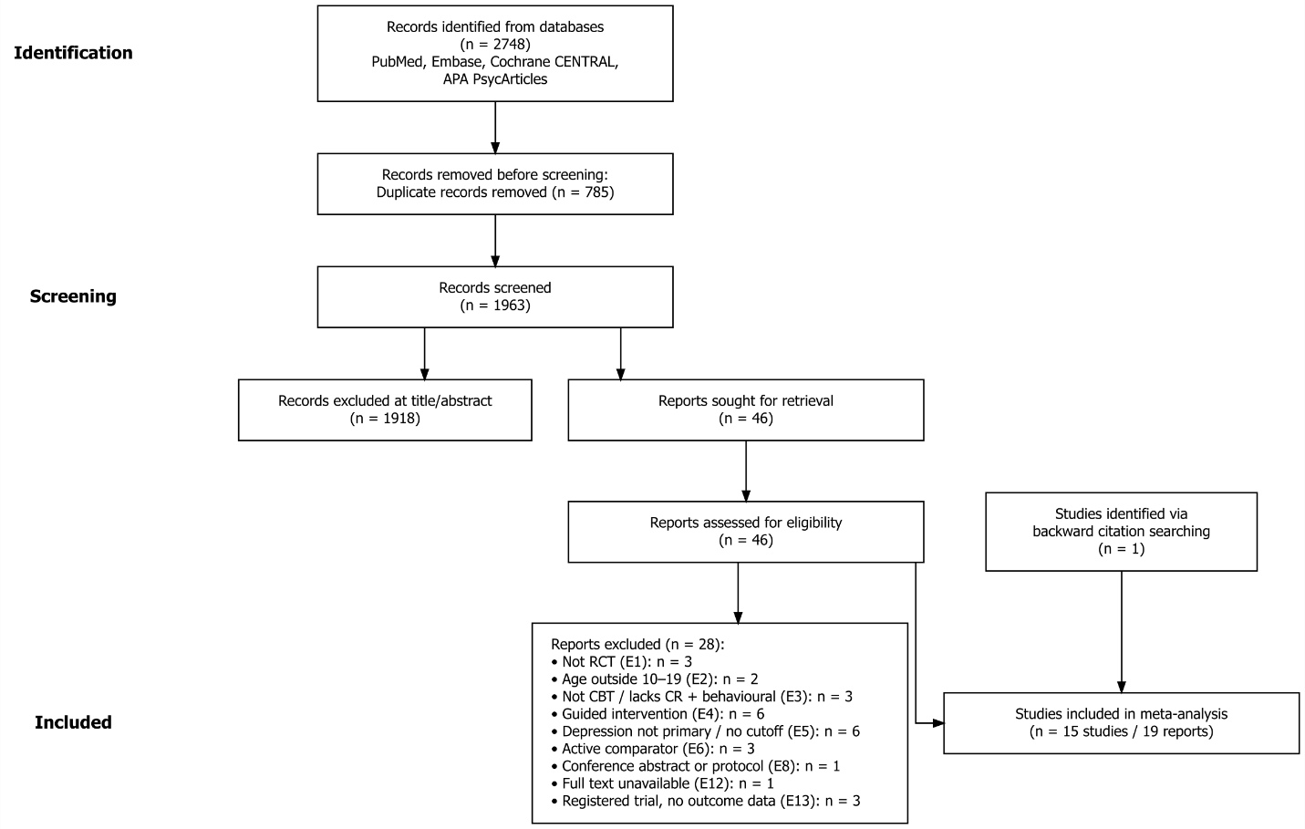

A total of 2,748 records were retrieved from four databases from database inception to April 3, 2026, of which 785 duplicates were removed. The remaining 1,963 records were screened, and 46 full-text articles were assessed for eligibility. In the initial database search, 14 studies met all inclusion criteria. One additional eligible study was identified through backward citation searching of six systematic reviews related to the current study. Therefore, a total of 15 studies were included in the final meta-analysis (see Figure 1).

4.2. Study Characteristics

4.2.1. General Information of Included Studies
Sixteen studies (reported across 20 publications) met the eligibility criteria. Of these, 15 contributed to the main meta-analysis; one cluster-randomized pilot trial conducted among Inuit youth in Nunavut (Bohr et al., 2023) did not report an intra-cluster correlation coefficient and was therefore reserved for sensitivity analysis (Section 4.6). The 15 studies in the main analysis were published between 1998 and 2025 and conducted in six countries: the United States (k = 5), the United Kingdom (k = 3), New Zealand (k = 3), Australia (k = 2), the Netherlands (k = 1), and Hong Kong, China (k = 1). Twelve studies were peer-reviewed journal articles, two were doctoral dissertations (Fleming et al., 2012; Makarushka, 2012), and one was a preprint (O'Dea et al., 2025). All studies adopted randomized controlled designs, predominantly two-arm parallel-group RCTs at the individual level. Funding sources were heterogeneous, including national research councils (NIHR, NIH/NIMH, NHMRC), government health departments (New Zealand Ministry of Health, Hong Kong Lotteries Fund), philanthropic foundations, and university or institutional support. 是不是要加年代对比

4.2.2 Participant Characteristics
A total of 15 randomized controlled trials contributed to the main analysis, with 2,073 participants providing post-treatment data (intervention: n = 1,024; control: n = 1,049). Sample sizes at post-treatment ranged from 22 (Ackerson et al., 1998) to 284 (O'Dea et al., 2025). Most samples were drawn from high-income contexts; one trial was conducted in Hong Kong, China (Ip et al., 2016), and several included culturally specific or under-represented populations, such as adolescents excluded from mainstream education in New Zealand (Fleming et al., 2012), adolescents recruited from emergency departments following peer-violence exposure (Ranney et al., 2018), and adolescents recruited from CAMHS following repeated self-harm (Stallard et al., 2024). Among studies reporting sex distribution, samples were predominantly female, ranging from 41.0% (Stasiak et al., 2014) to 100.0% (Poppelaars et al., 2016), with a weighted average of approximately 70.6%. Baseline depressive severity ranged from mild to severe across trials, with most samples falling within the mild-to-moderate range as defined by each measure's clinical cutoff.
The handling of co-occurring symptoms varied across trials. Several programs were explicitly designed for, or recruited samples defined by, mixed clinical presentations: BlueIce targeted adolescents with repeated self-harm where depression was a secondary outcome (Stallard et al., 2024); iDOVE recruited adolescents presenting to the emergency department with peer-violence exposure and depressive symptoms (Ranney et al., 2018); WeClick recruited on the basis of general adolescent mental health concerns without a depression severity threshold (O'Dea et al., 2020). Most other trials neither targeted nor systematically excluded comorbidity, recruiting on the basis of elevated depressive symptoms regardless of co-occurring anxiety or other internalizing symptoms. Active psychosis, bipolar disorder, current acute suicidality, and ongoing concurrent psychotherapy were the most consistently applied exclusion criteria.
Recruitment pathways were heterogeneous. School-based recruitment was the most common channel (k = 7), followed by clinical referral from primary care, CAMHS, or emergency departments (k = 4), school-and-community combined recruitment (k = 2), community-based facilitator recruitment in remote settings (k = 2; including Bohr 2023), and online or social-media advertisement (k = 1; O'Dea 2020).

4.2.3 Intervention Characteristics
The 15 trials evaluated 11 distinct intervention programs, with SPARX, Stressbusters, and the Feeling Good bibliotherapy each evaluated in multiple trials. Delivery modalities spanned bibliotherapy (k = 3; Feeling Good, evaluated in Ackerson et al., 1998, Stice et al., 2010, and Rohde et al., 2015), stand-alone computer programs and serious games (k = 7; SPARX in Fleming 2012, Merry 2012, Poppelaars 2016, and Bohr 2023; Stressbusters in Smith 2015 and Wright 2020; The Journey in Stasiak 2014), web-based platforms (k = 2; Grasp the Opportunity in Ip 2016 and Blues Blaster in Makarushka 2012), mobile applications (k = 3; BlueIce in Stallard 2024, WeClick in O'Dea 2020, ClearlyMe in O'Dea 2025), and text-messaging delivery (k = 1; iDOVE in Ranney 2018). Program duration ranged from a single in-person session followed by 8 weeks of automated text messaging (iDOVE) to 8 months of web-based modules (Grasp the Opportunity). Most programs were designed to be completed within a 4–8 week window, although several mobile-app interventions (BlueIce, ClearlyMe) operated on a self-paced model with continued open access.
All programs included cognitive restructuring as a core component, paired with at least one behavioral component, in line with the operational definition of CBT applied at the eligibility stage (Section 3.3). Across the 15 trials, behavioral activation was the most frequently co-occurring component (k = 12), followed by problem-solving (k = 11), homework practice (k = 11), psychoeducation (k = 9), relaxation (k = 9), relapse prevention (k = 7), interpersonal skills training (k = 5), and third-wave elements (k = 4). Component count per program ranged from 2 (Grasp the Opportunity, Ip et al., 2016) to 9 (SPARX in Merry et al., 2012).
Cultural adaptation was reported for one program in the main analysis. Grasp the Opportunity (Ip et al., 2016) is a Chinese-language adaptation of CATCH-IT for Hong Kong adolescents, in which the interpersonal psychotherapy and motivational interview modules of the original protocol were omitted to align the program with local cultural and educational contexts. SPARX itself was originally co-developed with Māori cultural input in New Zealand (Merry et al., 2012). The remaining programs were developed and evaluated within their original cultural and linguistic settings without explicit cross-cultural adaptation procedures.

4.2.4 Comparator Characteristics
Control conditions across the 15 trials encompassed waitlist (k = 6; including one trial with active monitoring, Poppelaars et al., 2016), treatment-as-usual (k = 2; Stallard et al., 2024 and Merry et al., 2012), attention control (k = 5; Ip 2016, O'Dea 2025, Ranney 2018, Stasiak 2014, Wright 2020), information-only or assessment-only control (k = 3; Stice 2010, Makarushka 2012, Rohde 2015). Waitlist conditions in two trials offered the active intervention after the waiting period, with consequences for follow-up comparability (Smith et al., 2015; Ackerson et al., 1998); these trials therefore did not contribute follow-up data to the synthesis. Attention controls included supportive-expressive group sessions, computerized psychoeducation matched for length and format (Stasiak et al., 2014), self-help websites (Wright et al., 2020), and educational materials on depression. Treatment-as-usual conditions varied substantially across health systems, ranging from CAMHS-delivered counseling (Stallard et al., 2024) to primary-care counseling averaging approximately five sessions (Merry et al., 2012).
For the confirmatory subgroup analysis specified in Section 3.7, control conditions were collapsed into two categories per the pre-specified scheme: passive control (waitlist, TAU, no treatment, assessment-only; k = 9) versus minimally active control (attention control or information-only; k = 7). Waitlist with active monitoring was classified as passive on the grounds that monitoring did not deliver therapeutic content.

4.2.5 Outcome Characteristics
Depressive symptoms were assessed using a range of validated self-report instruments, including the BDI/BDI-II, CES-D/CESD-R, CDRS-R, MFQ/MFQ-C, PHQ-9/PHQ-A, and RADS-2; one trial (Rohde et al., 2015) used a study-specific 16-item composite derived from K-SADS clinician-administered ratings. Twelve studies reported follow-up data beyond post-treatment, distributed across short-term (1–3 months; k = 3, N = 246), medium-term (4–6 months; k = 8, N = 1,323), and long-term (12 months or longer; k = 5, N = 845) windows, with the longest follow-up extending to 24 months (Rohde et al., 2015; Stice et al., 2010).

4.3. Risk of Bias of Included Studies
Risk-of-bias judgements for all included studies are presented in Figure 2. Overall, most studies were judged as having some concerns. Specifically, ten studies were rated as raising some concerns, three were judged to be at high overall risk of bias, and two were judged to have low overall risk of bias.
Among the ten studies judged as having some concerns overall, six were driven by a single domain-level concern and four by concerns across multiple domains, corresponding to 60% and 40%, respectively. The most frequent source of some-concern judgements was Domain 2, bias due to deviations from intended interventions. This pattern largely reflected the open-label design of unguided self-help trials, particularly when interventions were compared with non-active or minimally active control conditions. The specific combinations of domains driving these judgements varied across studies. Domain 2 appeared most frequently, followed by concerns related to selection of the reported result (D5) and missing outcome data (D3), while concerns in randomization (D1) and outcome measurement (D4) were less frequent.
All studies judged as being at high overall risk of bias were driven by Domain 3, missing outcome data. These included Bohr et al. (2023), Wright et al. (2020), and Ackerson et al. (1998). Therefore, the pooled findings should be interpreted with caution, particularly in relation to attrition and incomplete outcome data. Of these three high-risk studies, Bohr et al. (2023) was retained only for the sensitivity analysis owing to the absence of an intracluster correlation coefficient. The main pooled estimate is therefore influenced by two high-risk studies, Wright et al. (2020) and Ackerson et al. (1998).
Figure 2. Risk of Bias Appraisal for Individual Studies

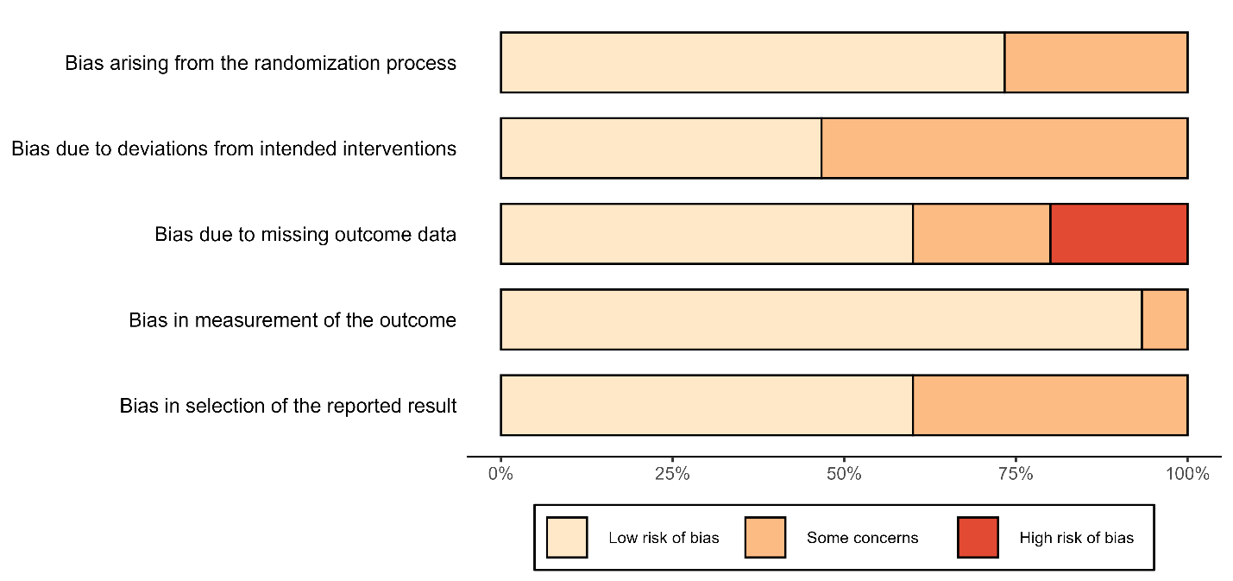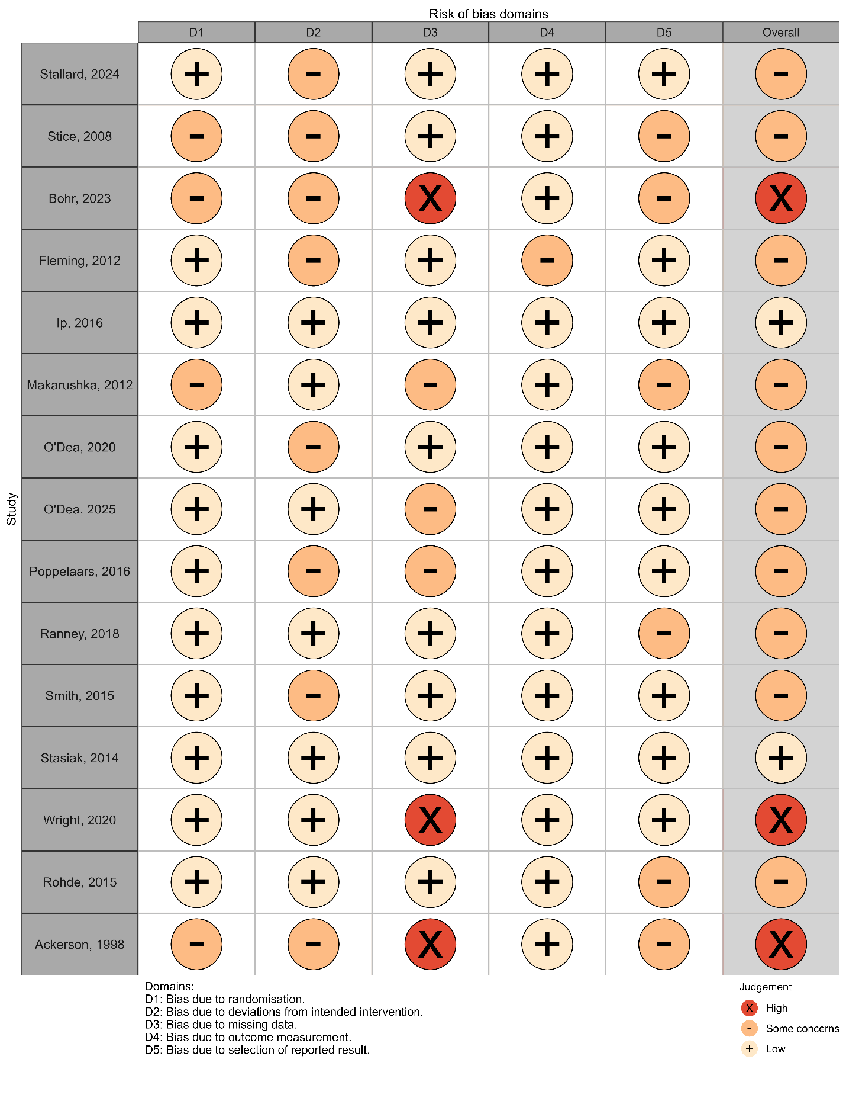

4.4. Overall Effects at Post-Intervention and Follow-up
4.4.1 Overall Effects at post-intervention
Fourteen studies contributed effect sizes at post-intervention. Under a random-effects model using the REML estimator and Hartung-Knapp adjustment, the pooled Hedges' g was 0.27, 95% CI [0.06, 0.47], t(13) = 2.80, p = .015, indicating a benefit of unguided self-help CBT interventions over control conditions (Figure 3).
Inspection of the forest plot revealed substantial dispersion in individual study estimates, ranging from g = −0.17 (O'Dea et al., 2020) to g = 1.51 (Fleming et al., 2012). Of the 14 trials, 12 yielded point estimates favoring the intervention condition, whereas two (O'Dea et al., 2020; Poppelaars, 2016) produced estimates near zero. Five trials had confidence intervals that excluded zero (Ackerson et al., 1998; Fleming et al., 2012; Makarushka, 2012; Smith et al., 2015; O'Dea et al., 2025), whereas the remaining nine trials did not reach statistical significance at the individual-study level. Two trials, Ackerson et al. (1998) and Fleming et al. (2012), produced effect estimates substantially larger than most other studies, together with relatively wide confidence intervals, suggesting that they may have influenced the pooled estimate. Their influence is examined in the leave-one-out sensitivity analysis reported in Section 4.6.
Figure 3. Forest Plot of Studies at Post-Intervention
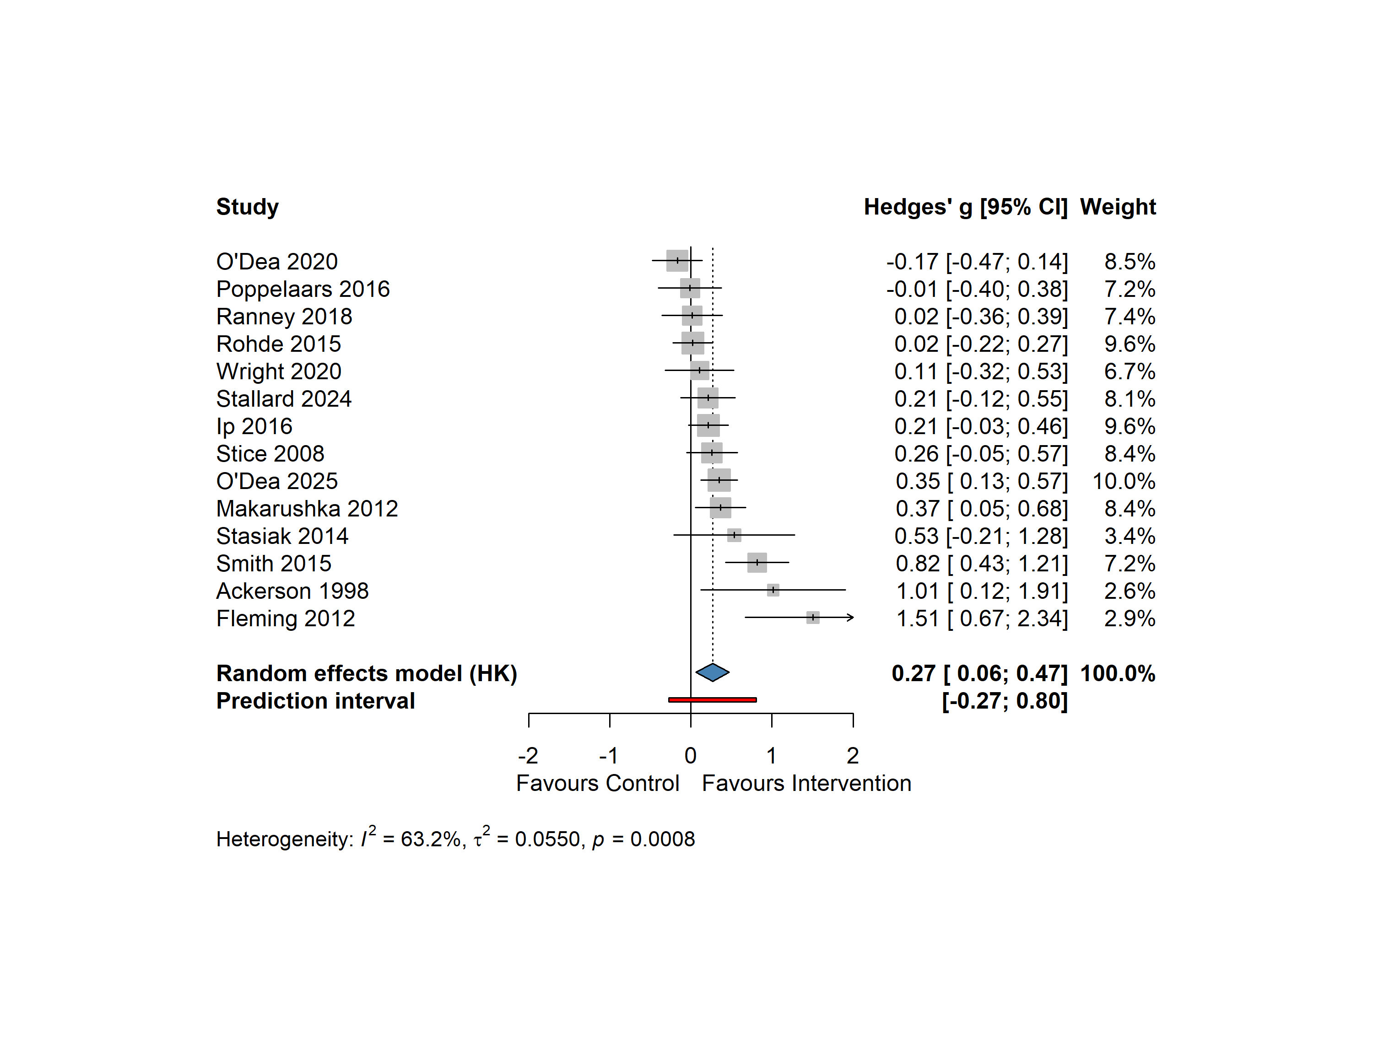
Note. Forest plot of unguided self-help CBT versus inactive control or minimally active control for adolescent depressive symptoms at post-intervention. Studies are ordered by ascending Hedges' g. Squares represent point estimates of individual studies, with size proportional to study weight in the random-effects model. Horizontal lines represent 95% confidence intervals; arrows indicate intervals extending beyond the plot range. The blue diamond represents the random-effects pooled estimate using Hartung-Knapp adjustment. The red bar represents the 95% prediction interval. CI = confidence interval; HK = Hartung-Knapp.

Between-study heterogeneity was moderate to high, Q(13) = 35.34, p < .001, I² = 63.2%, 95% CI [34.6%, 79.3%], τ² = 0.055, 95% CI [0.020, 0.425]. The corresponding τ value was 0.23, indicating that the dispersion of true effects across studies was nearly as large as the pooled effect itself (g = 0.27). This implies that even after accounting for sampling error, substantial between-study variability in true effects remained. The 95% prediction interval ranged from −0.27 to 0.80, suggesting that the true effect in a comparable future trial could plausibly range from a small negative effect to a moderate positive effect. This variability supports the need for the subgroup analyses, exploratory meta-regression, and sensitivity analyses reported in Sections 4.6 and 4.7.
Whether this post-intervention effect was sustained across follow-up timepoints is examined in the subsequent sections (Sections 4.4.2–4.4.4).

Table 2. Test of Heterogeneity: Post-Intervention
k | Hedges’ g [95% CI] | t (df) | p | Q (df) | p (Q) | I² [95% CI] | τ² | 95% PI
14 | 0.27 [0.06, 0.47] | 2.80(13) | .015 | 35.34 (13) | < .001 | 63.2%  [34.6, 79.3] | 0.055 | [−0.27, 0.80]

Note. k = number of studies; CI = confidence interval; PI = prediction interval. Pooled estimates were computed using a random-effects model with REML estimator and Hartung-Knapp adjustment.

4.4.2 Overall Effects for different Lengths of follow-up
Short-term follow-up
Three studies (O'Dea et al., 2020; Poppelaars et al., 2016; Stasiak et al., 2014) contributed effect sizes at short-term follow-up (≤3 months post-intervention). Under a random-effects model with REML estimator and Hartung-Knapp adjustment, the pooled Hedges' g was 0.015 (95% CI [−0.34, 0.37], t(2) = 0.18, p = .875), indicating no detectable benefit of unguided self-help CBTs over control conditions at this timepoint (Figure 4).
Between-study heterogeneity was negligible (Q(2) = 0.85, p = .653; I² = 0.0%, 95% CI [0.0%, 89.6%]; τ² = 0.000). However, the wide confidence interval around I² reflects the limited precision of heterogeneity estimates when the number of studies is small (Borenstein et al., 2017). The 95% prediction interval extended from −0.53 to 0.56, similarly reflecting substantial uncertainty rather than informative dispersion.
These short-term findings should be interpreted with considerable caution.

Figure 4. Forest Plot of Studies at Short-Term Follow-UP
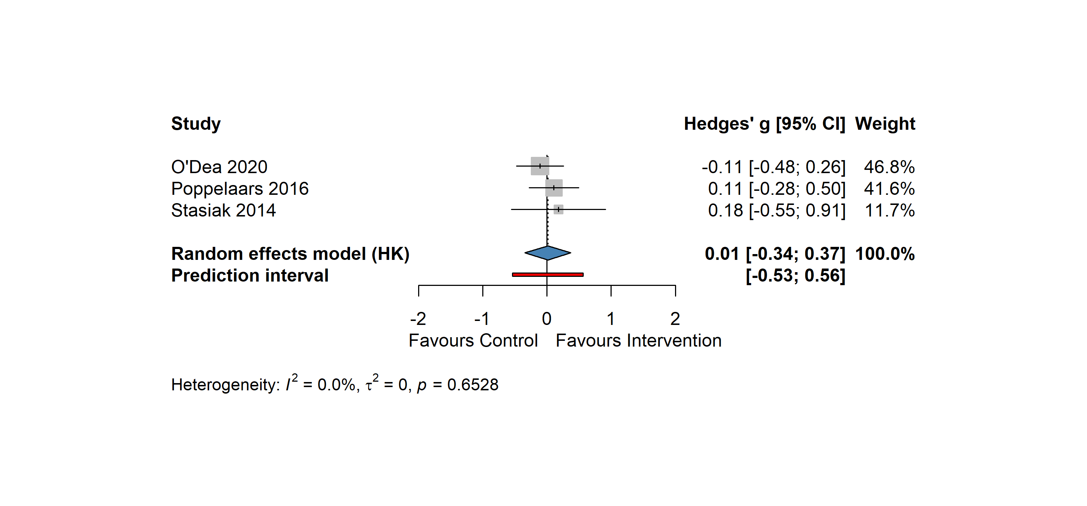
Note. Forest plot of unguided self-help CBT versus inactive control or minimally active control for adolescent depressive symptoms at post-intervention. Studies are ordered by ascending Hedges' g. Squares represent point estimates of individual studies, with size proportional to study weight in the random-effects model. Horizontal lines represent 95% confidence intervals; arrows indicate intervals extending beyond the plot range. The blue diamond represents the random-effects pooled estimate using Hartung-Knapp adjustment. The red bar represents the 95% prediction interval. CI = confidence interval; HK = Hartung-Knapp.

Mid-term follow-up
Seven studies (Ranney et al., 2018; Poppelaars et al., 2016; Stallard et al., 2024; Makarushka, 2012; O’Dea et al., 2025; Stice et al., 2008; Rohde et al., 2015) contributed to pooled effect size of mid-term follow-up (>3 to ≤6 months post-intervention). Under a random-effects model with REML estimator and Hartung-Knapp adjustment, the pooled Hedges' g was 0.113 ( 95% CI [0.004, 0.223], t(6) = 2.55, p = .043), favoring unguided self-help CBTs over control conditions at this timepoint (Figure 5). Compared with the post-intervention effect (g = 0.27), the mid-term follow-up effect was much smaller, suggesting that the initial benefits of the intervention were not fully maintained over time.
Inspection of the forest plot revealed less dispersion in individual study estimates compared with the post-intervention analysis, ranging from g = −0.07 (Ranney et al., 2018) to g = 0.29 (Makarushka, 2012). Five studies showed point estimates favoring the intervention, whereas two yielded negative point estimates. All individual confidence intervals crossed zero, indicating that none of the studies reached statistical significance on its own.
Between-study heterogeneity was low across all three indicators, Q(6) = 3.48, p = .747, I² = 0.0%, 95% CI [0.0%, 70.8%], τ² = 0.000, 95% CI [0.000, 0.050]. The wide upper bound of the I² confidence interval (70.8%) reflects the limited precision of heterogeneity estimates when the number of studies is moderate (Borenstein et al., 2017), but the three indicators were consistent and jointly supported low between-study variability. The 95% prediction interval ranged from −0.03 to 0.26, suggesting that the true effect in a comparable future trial would most likely fall within a small positive range, with little chance of a null or negative effect.

Figure 5. Forest Plot of Studies at Mid-Term Follow-UP
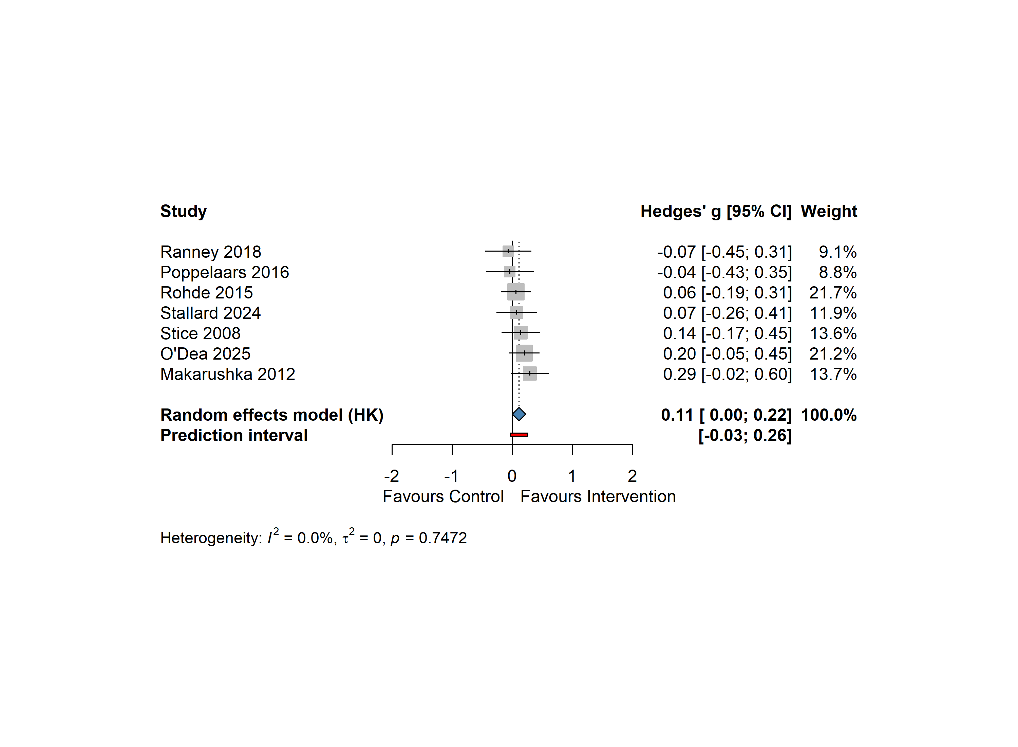
Note. Forest plot of unguided self-help CBT versus inactive control or minimally active control for adolescent depressive symptoms at post-intervention. Studies are ordered by ascending Hedges' g. Squares represent point estimates of individual studies, with size proportional to study weight in the random-effects model. Horizontal lines represent 95% confidence intervals; arrows indicate intervals extending beyond the plot range. The blue diamond represents the random-effects pooled estimate using Hartung-Knapp adjustment. The red bar represents the 95% prediction interval. CI = confidence interval; HK = Hartung-Knapp.

Long-term follow-up
Five studies (Stice et al., 2010; Ip et al., 2016; Poppelaars et al., 2016; Wright et al., 2020; Rohde et al., 2015) contributed effect sizes at long-term follow-up (≥12 months post-intervention). Where a study reported multiple long-term assessments, the longest available timepoint was used. Under a random-effects model with REML estimator and Hartung-Knapp adjustment, the pooled Hedges' g was 0.148, 95% CI [−0.082, 0.379], t(4) = 1.78, p = .149, indicating no detectable benefit of unguided self-help CBT interventions over control conditions at this timepoint (Figure 6).
Inspection of the forest plot revealed moderate dispersion in individual study estimates, ranging from g = −0.05 (Wright et al., 2020) to g = 0.36 (Ip et al., 2016). Three studies showed point estimates favoring the intervention, while two yielded negative point estimates close to zero. Only one study (Ip et al., 2016) reached statistical significance at the individual-study level, with a moderate effect size and a relatively narrow confidence interval; the remaining four studies produced confidence intervals that crossed zero. The influence of Ip et al. (2016) on the pooled estimate is further examined in the leave-one-out sensitivity analysis (Section 4.6).
Between-study heterogeneity was low to moderate, Q(4) = 5.97, p = .201, I² = 33.0%, 95% CI [0.0%, 74.6%], τ² = 0.014, 95% CI [0.000, 0.247]. Although τ² was small, the I² point estimate of 33% and the wide upper bound of its confidence interval (74.6%) suggest some unresolved between-study variability that could not be ruled out given the small number of studies (Borenstein et al., 2017). The 95% prediction interval ranged from −0.27 to 0.56, indicating considerable uncertainty about the direction and magnitude of the true effect in a comparable future trial.
Figure 6. Forest Plot of Studies at Long-Term Follow-UP
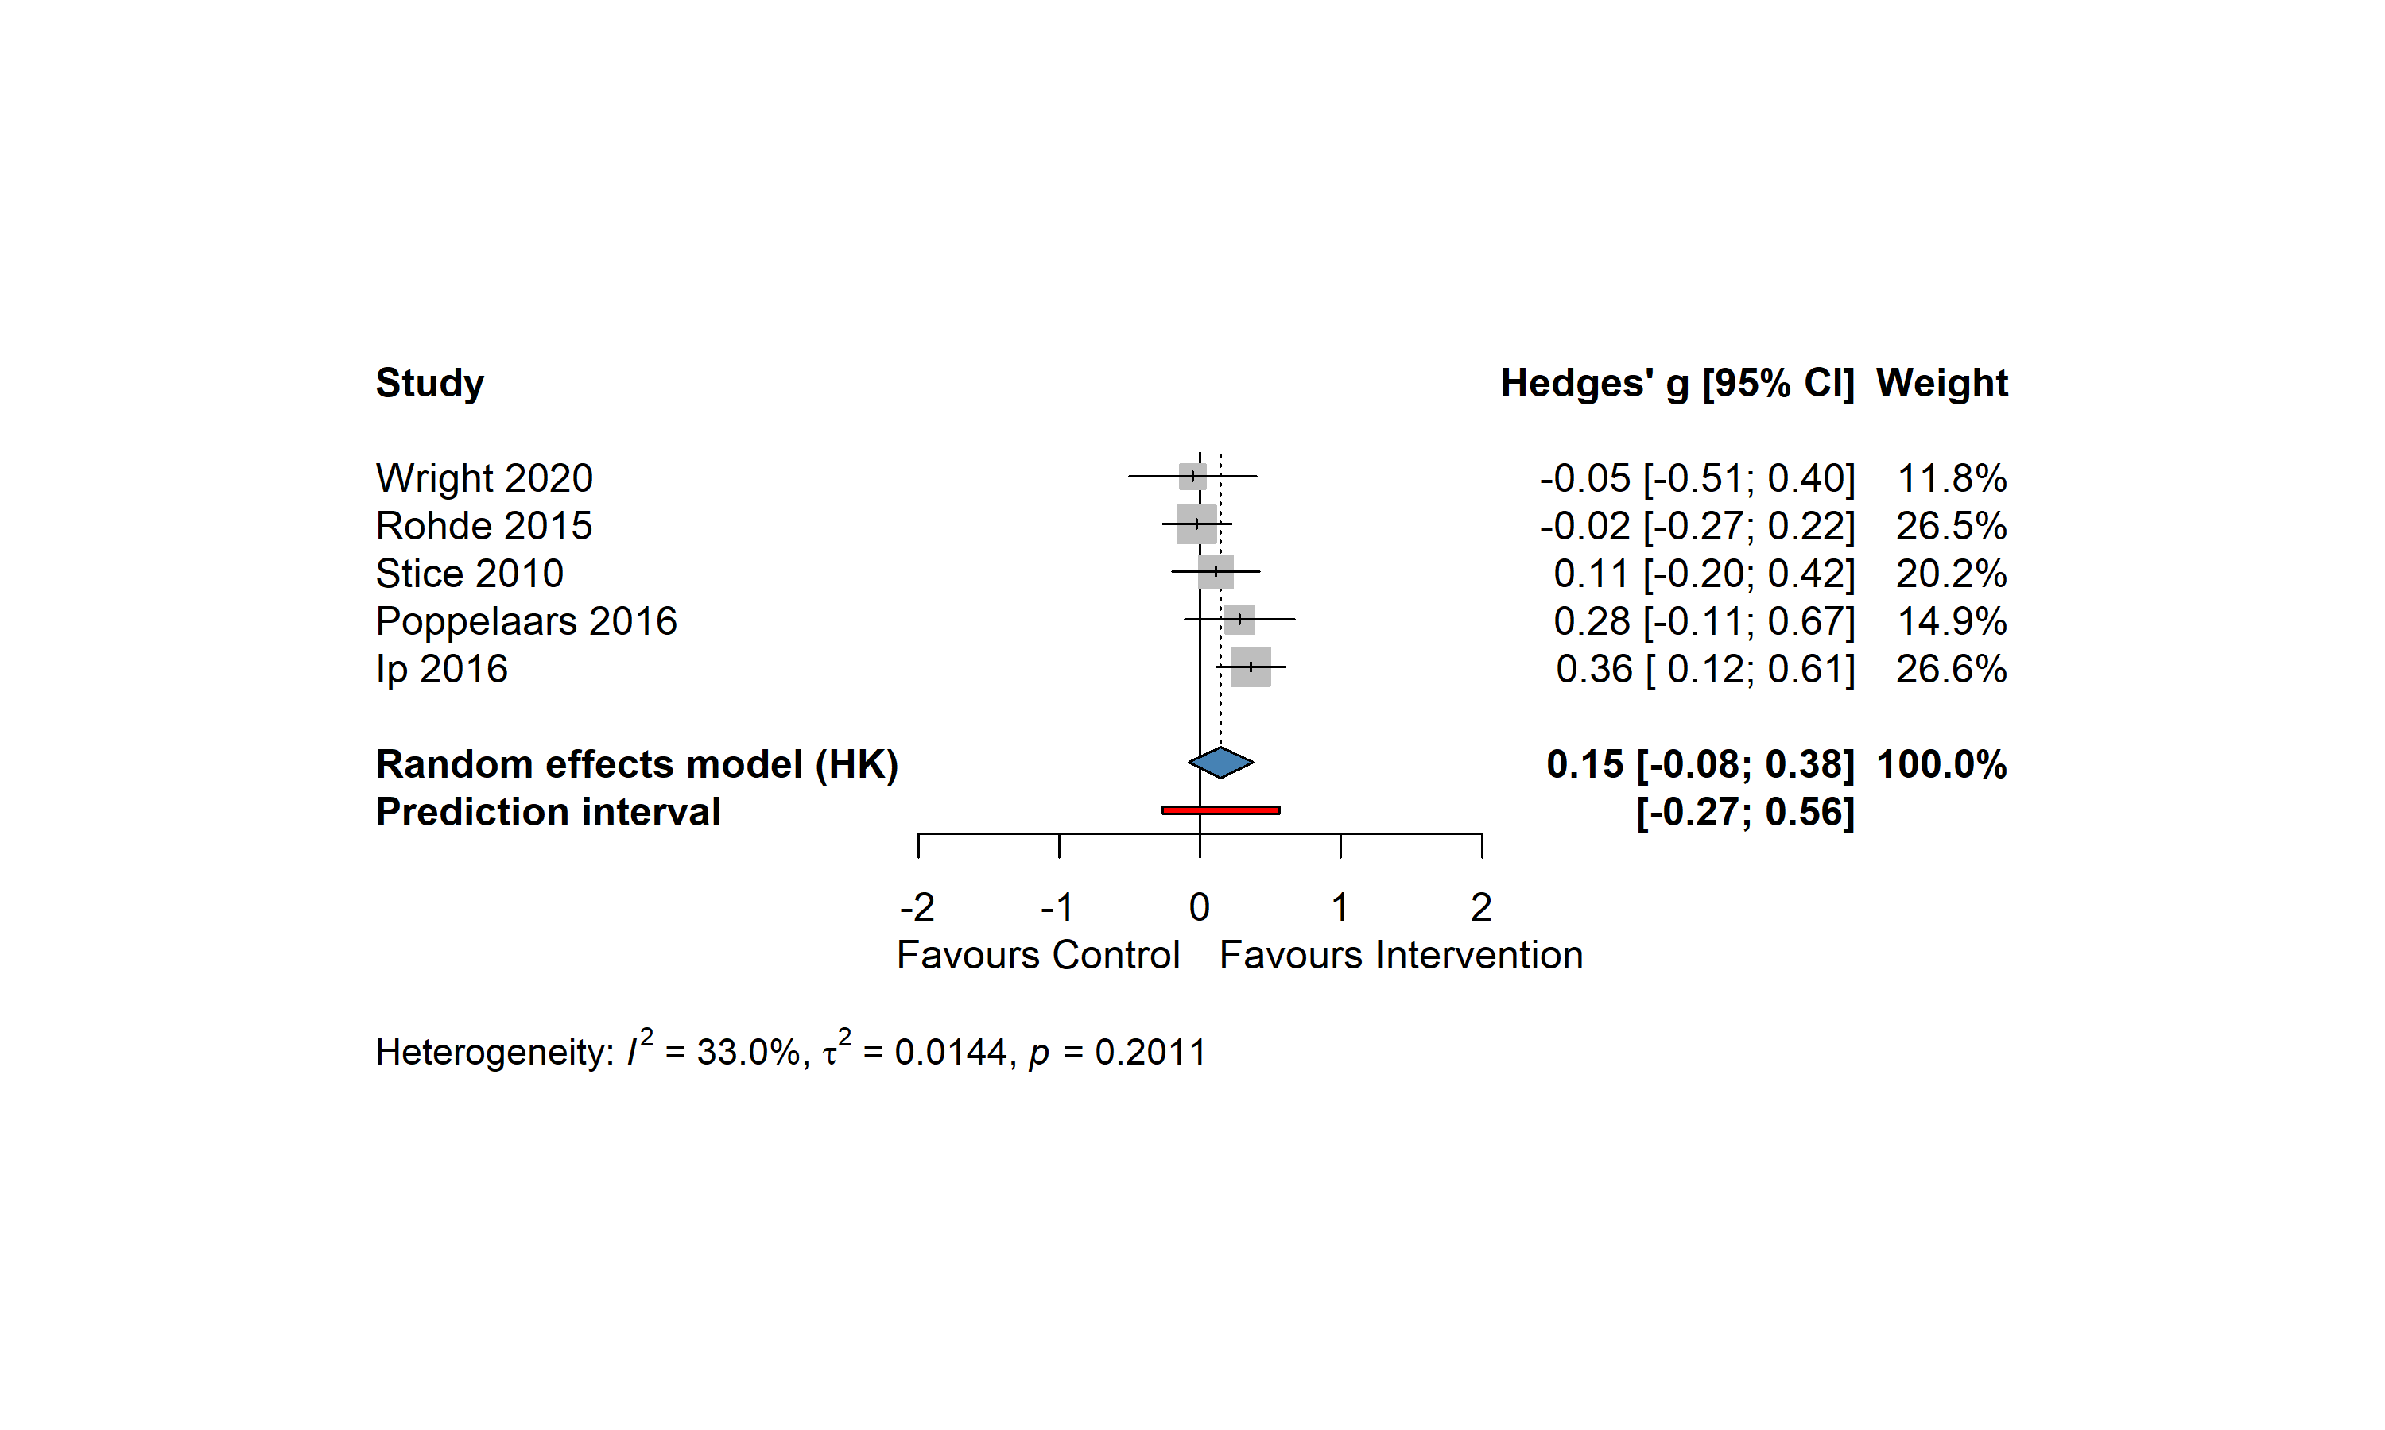
Note. Forest plot of unguided self-help CBT versus inactive control or minimally active control for adolescent depressive symptoms at post-intervention. Studies are ordered by ascending Hedges' g. Squares represent point estimates of individual studies, with size proportional to study weight in the random-effects model. Horizontal lines represent 95% confidence intervals; arrows indicate intervals extending beyond the plot range. The blue diamond represents the random-effects pooled estimate using Hartung-Knapp adjustment. The red bar represents the 95% prediction interval. CI = confidence interval; HK = Hartung-Knapp.

Table 3. Test of Heterogeneity at Follow-UPs
Timepoint | k | Hedges’ g [95% CI] | t (df) | p | Q (df) | p (Q) | I² [95% CI] | τ² | 95% PI
Short | 3 | 0.015 [-0.34, 0.37] | 0.18(2) | .875 | 0.85(2) | .653 | 0.0% [0.0, 89.6] | 0.000 | [−0.53, 0.56]
Mid | 7 | 0.113 [0.004, 0.223] | 2.55(6) | .043 | 3.48(6) | .747 | 0.0% [0.0, 70.8] | 0.000 | [-0.03, 0.26]
Long | 5 | 0.148 [-0.08, 0.38] | 1.78(4) | .149 | 5.97(4) | .201 | 33.0% [0.0, 74.6] | 0.014 | [-0.27, 0.56]

Note. k = number of studies; CI = confidence interval; PI = prediction interval; τ² = between-study variance; I² = proportion of total variation due to heterogeneity. Pooled estimates were computed using a random-effects model with restricted maximum-likelihood (REML) estimator and Hartung-Knapp adjustment. Short = short-term follow-up (≤3 months); Mid = mid-term follow-up (>3 to ≤6 months); Long = long-term follow-up (>6 months).

4.5. Subgroup Analyses
[Placeholder for subgroup forest plots by control type, baseline severity, age group, and presence of human contact, together with meta-regression results for component count and total dose.]

4.6. Sensitivity and Robustness Analyses

4.6.1 Outlier detection
4.6.2 Leave-one-out influence analysis
4.6.3 Planned sensitivity analyses
[Placeholder for sensitivity analysis results.]

4.7. Acceptability (Differential Dropout)
[Placeholder for differential dropout analysis.]

4.8. Publication Bias
A contour-enhanced funnel plot was constructed to assess potential small-study effects (Figure X). Visual inspection suggested some asymmetry: high-precision studies clustered around the pooled estimate, whereas the three least precise trials (Fleming, 2012; Ackerson, 1998; Stasiak, 2014) were located on the positive side of the plot, with no comparable small-sample trials on the negative side. The contour shading indicated that the corresponding mirror region on the left would fall mainly within the non-significant zone (p > .10). If studies were missing from this region, such a pattern would be consistent with selective non-publication of small, non-significant trials, although other sources of asymmetry, such as heterogeneity or methodological differences between studies, could not be ruled out.
Egger’s regression test showed a non-significant trend toward funnel plot asymmetry, t(12) = 1.85, p = .089. Because the effect size was a standardized mean difference (SMD), a modified test proposed by Pustejovsky and Rodgers (2019), which adjusts for the artifactual dependence between SMDs and their standard errors, was additionally conducted. This modified test was also not statistically significant, t(12) = 1.69, p = .117.

Figure X. Contour-Enhanced Funnel Plot
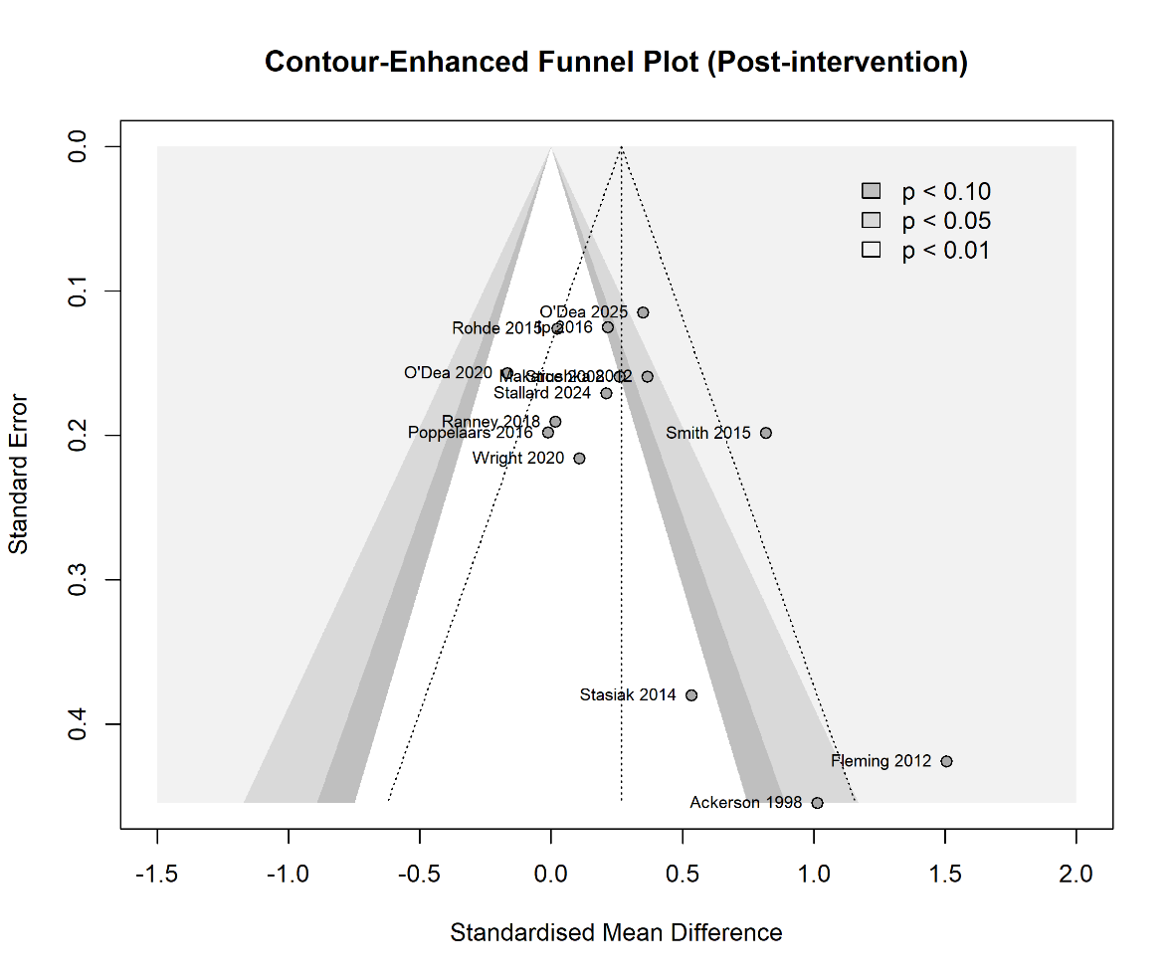
Note. Each circle represents one study included in the post-intervention meta-analysis. The x-axis shows the standardized mean difference (Hedges’ g), with positive values indicating effects favoring unguided self-help CBT. The y-axis shows the standard error, with more precise studies appearing toward the top of the plot. The vertical dotted line represents the pooled random-effects estimate, and the diagonal dotted lines indicate the expected funnel around the pooled effect. Shaded contours indicate regions of statistical significance for a two-sided test against the null effect (p < .10, p < .05, and p < .01).

Trim-and-fill analysis using the L₀ estimator imputed two potentially missing studies on the negative side of the funnel plot. The adjusted pooled estimate was attenuated from g = 0.27 to g = 0.21, and the confidence interval crossed zero, 95% CI [−0.04, 0.47] (Table X). The prediction interval also widened from [−0.27, 0.80] to [−0.50, 0.93], alongside an increase in between-study heterogeneity (τ² = 0.055 to 0.102). Taken together, the formal regression tests did not provide statistically significant evidence of funnel plot asymmetry; however, the contour-enhanced funnel plot and trim-and-fill results suggest that small-study effects cannot be ruled out. Therefore, the pooled post-intervention effect should be interpreted cautiously.

Table X. Trim-and-Fill Sensitivity Analysis at Post-Intervention
model | Imputed k | Hedges’ g | 95% CI | 95% PI | Q (df)
Observed | — | 0.27 | [0.06, 0.47] | [−0.27, 0.80] | 35.34 (13)
Adjusted | 2 | 0.21 | [−0.04, 0.47] | [−0.50, 0.93] | 48.14 (15)

Note. Trim-and-fill (L₀ estimator) imputed two hypothetical studies on the negative tail (g = −0.61, mirror of Ackerson 1998; g = −1.10, mirror of Fleming 2012). Adjusted estimate based on k = 16 (14 observed + 2 imputed) using a random-effects model with Hartung–Knapp adjustment. PI = prediction interval.

Figure X. Trim-and-Fill Funnel Plot
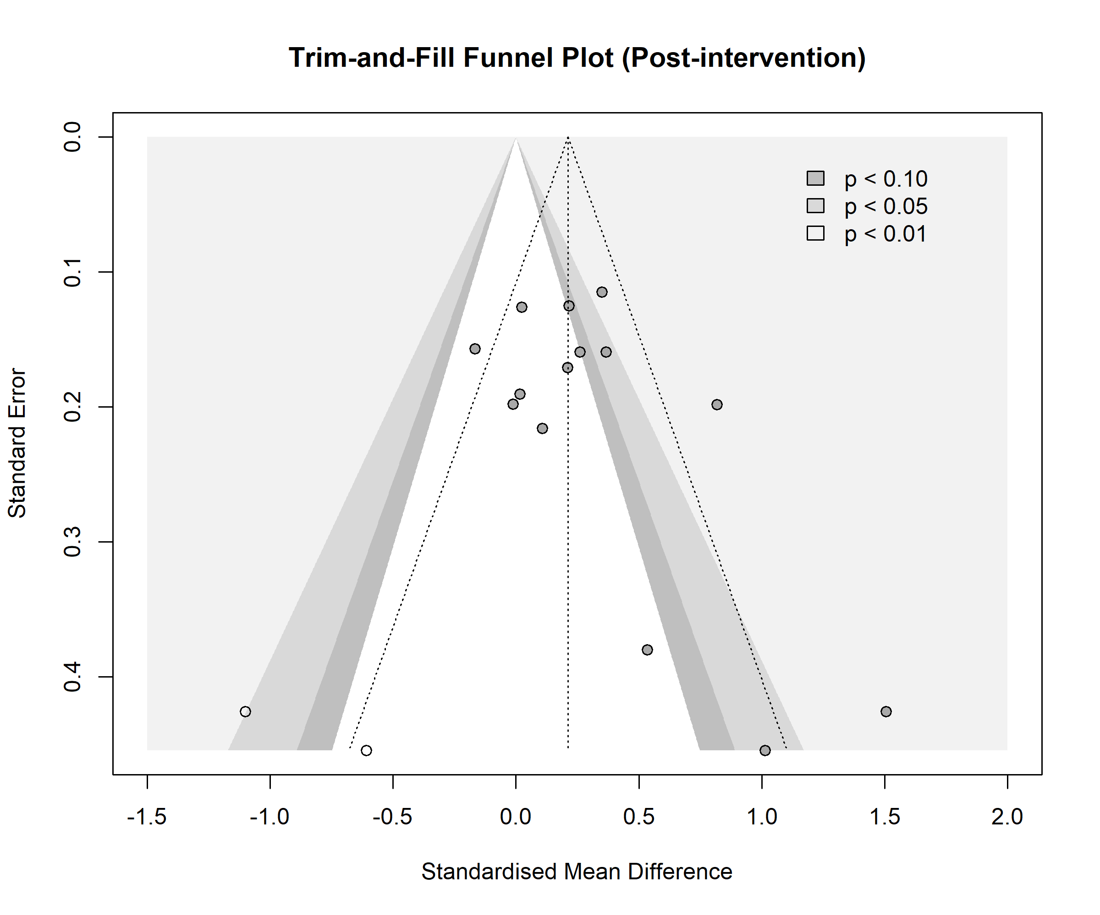
Note. Grey circles indicate observed studies, and open circles indicate studies imputed by the trim-and-fill procedure. The x-axis shows the standardized mean difference, with positive values favoring unguided self-help CBT; the y-axis shows the standard error. The vertical dotted line represents the trim-and-fill adjusted pooled estimate. Shaded contours indicate regions of statistical significance for a two-sided test against the null effect.

Chapter 5. Discussion and Conclusion

5.1. Summary of Findings
[Placeholder: principal findings mapped to research questions.]

5.2. Comparison with Prior Reviews
[Placeholder: comparison with Bjornstad et al. (2024), Furukawa et al. (2021), and Tong et al. (2024).]

5.3. Interpretation of Subgroup, Sensitivity, and Meta-Regression Findings

5.3.1 Subgroup findings (control type, baseline severity, age, human contact)
These analyses were interpreted as exploratory because CBT components co-occurred within multi-component intervention packages and therefore cannot be interpreted as estimates of the independent causal effect of individual components.

5.3.2 Sensitivity analyses (publication type, strict cutoff, treatment vs. prevention, depression primary vs. secondary, dose intensity, effect size format, leave-one-out)

5.3.3 Meta-regression and descriptive characterization (component count, total dose, delivery modality, component configuration)

5.4. Limitations
[Placeholder for limitations, including: small number of trials meeting the inactive-control criterion post-2023; heterogeneity in support-level reporting; reliance on back-calculated SDs for some trials; and use of study-level subgroup analysis rather than individual participant data.]
• 2.0 Domain 2（deviations from intended interventions）在多数纳入研究中只能被判为 Some concerns。这是该领域的结构性特征，而非个别研究的方法缺陷。
• Risk-of-bias 评估在 Domain 5 上依赖了 trial registration 作为 pre-specification 的代理证据，未对每项研究的完整 protocol 进行核查。

5.5. Implications and Future Directions
[Placeholder for clinical and research implications.]

5.6. Conclusion
[Placeholder for summary conclusion.]

References
American Psychiatric Association. (2013). Diagnostic and statistical manual of mental disorders (5th ed.). American Psychiatric Publishing.
Balduzzi, S., Rücker, G., & Schwarzer, G. (2019). How to perform a meta-analysis with R: A practical tutorial. Evidence-Based Mental Health, 22, 153–160.
Beck, A. T. (1967). Depression: Clinical, experimental, and theoretical aspects. Harper & Row.
Beck, A. T., Rush, A. J., Shaw, B. F., & Emery, G. (1979). Cognitive therapy of depression. Guilford Press.
Bjornstad, G., Sonthalia, S., Rouse, B., et al. (2024). A comparison of the effectiveness of cognitive behavioural interventions based on delivery features for elevated symptoms of depression in adolescents: A systematic review. Campbell Systematic Reviews, 20, e1376.
Cohen, J. (1988). Statistical power analysis for the behavioral sciences (2nd ed.). Lawrence Erlbaum.
COVID-19 Mental Disorders Collaborators. (2021). Global prevalence and burden of depressive and anxiety disorders in 204 countries and territories in 2020 due to the COVID-19 pandemic. The Lancet, 398(10312), 1700–1712.
Duval, S., & Tweedie, R. (2000). A nonparametric "trim and fill" method of accounting for publication bias in meta-analysis. Journal of the American Statistical Association, 95(449), 89–98.
Egger, M., Davey Smith, G., Schneider, M., & Minder, C. (1997). Bias in meta-analysis detected by a simple, graphical test. BMJ, 315(7109), 629–634.
Furukawa, T. A., Suganuma, A., Ostinelli, E. G., Andersson, G., Beevers, C. G., Shumake, J., … Cuijpers, P. (2021). Dismantling, optimising, and personalising internet cognitive behavioural therapy for depression: A systematic review and component network meta-analysis using individual participant data. The Lancet Psychiatry, 8(6), 500–511.
Gulliver, A., Griffiths, K. M., & Christensen, H. (2010). Perceived barriers and facilitators to mental health help-seeking in young people: A systematic review. BMC Psychiatry, 10, Article 113. https://doi.org/10.1186/1471-244X-10-113
Harwood, T. M., & L'Abate, L. (2010). Self-help in mental health: A critical review. Springer.
Hedges, L. V., & Olkin, I. (1985). Statistical methods for meta-analysis. Academic Press.
Herrman, H., Patel, V., Kieling, C., et al. (2022). Time for united action on depression: A Lancet–World Psychiatric Association Commission. The Lancet, 399(10328), 957–1022.
Hetrick, S. E., Cox, G. R., Witt, K. G., Bir, J. J., & Merry, S. N. (2016). Cognitive behavioural therapy (CBT), third-wave CBT and interpersonal therapy (IPT) based interventions for preventing depression in children and adolescents. Cochrane Database of Systematic Reviews, 2016(8), CD003380.
Higgins, J. P. T., Thomas, J., Chandler, J., Cumpston, M., Li, T., Page, M. J., & Welch, V. A. (Eds.). (2021). Cochrane handbook for systematic reviews of interventions (Version 6.2). Cochrane.
Higgins, J. P. T., Thompson, S. G., Deeks, J. J., & Altman, D. G. (2003). Measuring inconsistency in meta-analyses. BMJ, 327(7414), 557–560.
Jacobson, N. C., & Newman, M. G. (2017). Anxiety and depression as bidirectional risk factors for one another: A meta-analysis of longitudinal studies. Psychological Bulletin, 143(11), 1155–1200.
Klingemann, H., & Sobell, L. C. (Eds.). (2007). Promoting self-change from addictive behaviors: Practical implications for policy, prevention, and treatment. Springer.
McFadden, L., Seidman, E., & Rappaport, J. (1992). A comparison of espoused theories of self- and mutual-help: Implications for mental health professionals. Professional Psychology: Research and Practice, 23(6), 515–520.
Moitra, M., Santomauro, D., Collins, P. Y., et al. (2022). The global gap in treatment coverage for major depressive disorder in 84 countries from 2000–2019: A systematic review and Bayesian meta-regression analysis. PLoS Medicine, 19(2), e1003901.
National Institute for Health and Care Excellence. (2019). Depression in children and young people: Identification and management (NG134). NICE.
Ormel, J., Petukhova, M., Chatterji, S., et al. (2008). Disability and treatment of specific mental and physical disorders across the world. The British Journal of Psychiatry, 192(5), 368–375.
Page, M. J., McKenzie, J. E., Bossuyt, P. M., Boutron, I., Hoffmann, T. C., Mulrow, C. D., … Moher, D. (2021). The PRISMA 2020 statement: An updated guideline for reporting systematic reviews. BMJ, 372, n71.
Pinquart, M., & Duberstein, P. R. (2010). Depression and cancer mortality: A meta-analysis. Psychological Medicine, 40(11), 1797–1810.
Platell, M., Cook, A., & Martin, K. (2023). How parents can help or hinder access to mental health services for young people. Children and Youth Services Review, 144, 106723.
Pustejovsky, J. E., & Rodgers, M. A. (2019). Testing for funnel plot asymmetry of standardized mean differences. Research Synthesis Methods, 10(1), 57–71. https://doi.org/10.1002/jrsm.1332
Radez, J., Reardon, T., Creswell, C., Lawrence, P. J., Evdoka-Burton, G., & Waite, P. (2021). Why do children and adolescents (not) seek and access professional help for their mental health problems? A systematic review of quantitative and qualitative studies. European Child & Adolescent Psychiatry, 30, 183–211.
R Core Team. (2024). R: A language and environment for statistical computing. R Foundation for Statistical Computing.
Rugulies, R. (2002). Depression as a predictor for coronary heart disease: A review and meta-analysis. American Journal of Preventive Medicine, 23(1), 51–61.
Schöpfel, J., & Rasuli, B. (2018). Are electronic theses and dissertations (still) grey literature in the digital age? A FAIR debate. The Electronic Library, 36(2), 208–219.
Steinberg, L. (2005). Cognitive and affective development in adolescence. Trends in Cognitive Sciences, 9(2), 69–74.
Sterne, J. A. C., Savović, J., Page, M. J., Elbers, R. G., Blencowe, N. S., Boutron, I., … Higgins, J. P. T. (2019). RoB 2: A revised tool for assessing risk of bias in randomised trials. BMJ, 366, l4898.
Stockings, E. A., Degenhardt, L., Dobbins, T., Lee, Y. Y., Erskine, H. E., Whiteford, H. A., & Patton, G. (2016). Preventing depression and anxiety in young people: A review of the joint efficacy of universal, selective and indicated prevention. Psychological Medicine, 46(1), 11–26
Thapar, A., Collishaw, S., Pine, D. S., & Thapar, A. K. (2012). Depression in adolescence. The Lancet, 379(9820), 1056–1067.
Tong, L., Panagiotopoulou, O.-M., Cuijpers, P., & Karyotaki, E. (2024). The effectiveness of self-guided interventions in adults with depressive symptoms: A systematic review and meta-analysis. eBioMedicine, 105, 105208.
Viechtbauer, W. (2010). Conducting meta-analyses in R with the metafor package. Journal of Statistical Software, 36(3), 1–48.
Weisz, J. R., Kuppens, S., Ng, M. Y., Eckshtain, D., Ugueto, A. M., Vaughn-Coaxum, R., … Fordwood, S. R. (2017). What five decades of research tells us about the effects of youth psychological therapy: A multilevel meta-analysis and implications for science and practice. American Psychologist, 72(2), 79–117.
World Health Organization. (2020). Depression. WHO.
World Health Organization. (2021). Mental health atlas 2020. World Health Organization.
World Health Organization. (2022). World mental health report: Transforming mental health for all. WHO.
Yap, M. B. H., Pilkington, P. D., Ryan, S. M., & Jorm, A. F. (2014). Parental factors associated with depression and anxiety in young people: A systematic review and meta-analysis. Journal of Affective Disorders, 156, 8–23.
Zhou, Q., Fan, L., & Yin, Z. (2018). Association between family socioeconomic status and depressive symptoms among Chinese adolescents: Evidence from a national household survey. Psychiatry Research, 259, 81–88.

Appendix A. Search Terms
The search strategy was constructed from four concept blocks combined with AND. Within each block, terms were combined with OR. Full search strings were adapted for each database's syntax; the PubMed strategy is presented here as a worked example.

Block #1. Adolescent
"Adolescent"[MeSH] OR adolescent[Title/Abstract] OR adolescents[Title/Abstract] OR adolescence[Title/Abstract] OR youth[Title/Abstract] OR youths[Title/Abstract] OR teen[Title/Abstract] OR teens[Title/Abstract] OR teenager[Title/Abstract] OR teenagers[Title/Abstract]

Block #2. Depression
"Depressive Disorder"[MeSH] OR "Depression"[MeSH] OR depression[Title/Abstract] OR depressive[Title/Abstract] OR dysthymia[Title/Abstract] OR "mood disorder"[Title/Abstract] OR "affective disorder"[Title/Abstract]

Block #3. Cognitive Behavioral Therapy
"Cognitive Behavioral Therapy"[MeSH] OR "cognitive behavioral therapy"[Title/Abstract] OR "cognitive behaviour therapy"[Title/Abstract] OR CBT[Title/Abstract] OR "cognitive therapy"[Title/Abstract]

Block #4. Unguided Self-Help / Delivery Modality
(adapted from Tong et al., 2024) "Bibliotherapy"[MeSH] OR bibliotherap*[Title/Abstract] OR "self-help"[Title/Abstract] OR "self help"[Title/Abstract] OR selfhelp[Title/Abstract] OR workbook[Title/Abstract] OR manual[Title/Abstract] OR "Telemedicine"[MeSH] OR "Mobile Applications"[MeSH] OR "Therapy, Computer-Assisted"[MeSH] OR telehealth[Title/Abstract] OR e-health[Title/Abstract] OR m-health[Title/Abstract] OR mhealth[Title/Abstract] OR ehealth[Title/Abstract] OR "internet-based"[Title/Abstract] OR "web-based"[Title/Abstract] OR online[Title/Abstract] OR app[Title/Abstract] OR smartphone[Title/Abstract] OR digital[Title/Abstract]

Combined Strategy
#1 AND #2 AND #3 AND #4

Appendix B. CBT Component Abbreviations
CBT components were coded using the component framework of Furukawa et al. (2021). The abbreviations used in the Study_Info data-extraction sheet are as follows:
Abbreviation | Component | Definition
cr | Cognitive restructuring | The integrated process of identifying, evaluating, and modifying maladaptive thoughts. The three steps form a single skill sequence rather than separable components, and are typically taught and practiced together using techniques such as Socratic questioning, thought records, and guided imagery.
ba | Behavioral activation | Systematically increasing engagement in activities likely to produce positive reinforcement or a sense of accomplishment, via activity monitoring and scheduling.
ps | Problem-solving | A stepwise approach to personal problems: defining the problem, generating alternatives, selecting and implementing solutions, and evaluating outcomes.
rx | Relaxation | Techniques aimed at reducing physiological tension, most commonly Jacobson's progressive muscle relaxation or applied relaxation.
ist | Interpersonal skills training | Training in adaptive social behaviors, including assertiveness training, active listening, and conflict resolution.
pe | Psychoeducation | Information about the nature, causes, and course of depression, framed within a coherent therapeutic model.
hw | Homework | Between-session or between-module assignments requiring application of skills in the participant's own environment.
rp | Relapse prevention | Review of learned skills and construction of a concrete plan for handling foreseeable future challenges.
3w | Third-wave elements | Mindfulness, acceptance, and self-compassion components drawn from third-wave CBT approaches.
pr | Behavioral therapy for insomnia | Sleep restriction and stimulus control procedures targeting insomnia co-occurring with depression.

Appendix C. Exclusion Reason Codes
At the full-text screening stage, excluded studies were assigned a standardized exclusion reason code. The codes are defined as follows:
Code | Reason for Exclusion
E1 | Not a randomized controlled trial
E2 | Participant age range extends outside 10–19 years
E3 | Intervention is not CBT-based or lacks required CBT components (cognitive restructuring and at least one behavioral component)
E4 | Intervention includes therapist-delivered therapeutic content (i.e., guided rather than unguided)
E5 | Depression is neither a primary outcome nor a primary target, or no baseline cutoff met
E6 | Comparator is an active treatment (psychological or pharmacological) rather than a non-active control
E7 | Insufficient data to compute effect size
E8 | Conference abstract or protocol-only publication
E9 | Comorbid condition directly confounds depression outcome (e.g., hypothyroidism)
E10 | Sample population substantially limits generalizability (e.g., pregnant adolescents)
E11 | Duplicate publication of an already-included study
E12 | Full text unavailable after author contact

Appendix D. Characteristics of Included Interventions
This appendix summarizes the characteristics of the self-help intervention programs evaluated in the RCTs included in this review. Part D.1 presents a concise index of the programs together with country, primary mental-health domain, and delivery modality. Part D.2 provides a detailed narrative description of each program, including its structure, content, and constituent CBT components. Where a program was evaluated across multiple trials, all corresponding references are listed together to make the many-to-one mapping between trials and programs explicit.

D.1. Summary Index of Included Intervention Programs
# | Program (References) | Country | Mental Health Domain | Delivery Modality
1 | Blueblaster (Makarushka, 2011) | USA | Depression | Internet
2 | BlueIce (Stallard et al., 2024) | UK | Self-harm (with depression) | Mobile app
3 | CATCH-IT (Saulsberry, 2013; Soares et al., 2022; Gladstone et al., 2024) | USA / Netherlands | Depression | Internet
4 | ClearlyMe (O'Dea et al., 2023) | Australia | Depression | Mobile app
5 | COPE (Melnyk et al., 2015) | USA | Depression; Anxiety | Internet
6 | Feeling Good (Stice et al., 2008, 2010; Rohde et al., 2014, 2015; Ackerson et al., 1998) | USA | Depression | Bibliotherapy
7 | Grasp the Opportunity (Ip et al., 2016) | Hong Kong, China | Depression | Internet
8 | iCBT (Sekizaki et al., 2019) | Japan | Depression; Anxiety | Internet
9 | iDOVE (Ranney et al., 2018) | USA | Peer violence; Depression | Text-messaging
10 | MEMO (Whittaker et al., 2012, 2017) | New Zealand | Depression | Internet (SMS/MMS)
11 | Mello (Bell et al., 2023) | Australia | Depression; Anxiety | Mobile app
12 | MoodGYM (Calear et al., 2009; Neil et al., 2009; O'Kearney et al., 2009; Sethi, Campbell, & Ellis, 2010) | Australia | Depression | Internet
13 | Reframe-IT (Robinson et al., 2014, 2014a, 2014b) | Australia | Depression; Suicidal ideation | Internet
14 | Sleep Ninja (Werner-Seidler et al., 2023) | Australia | Insomnia (with depression) | Mobile app
15 | Spark v.2.2 (Peake et al., 2024) | Australia | Depression | Mobile app
16 | SPARX (Fleming et al., 2012, 2019; Merry et al., 2012; Bohr & Merry et al., 2016; Poppelaars et al., 2016; Perry et al., 2017; Lucassen et al., 2020; Bohr et al., 2023) | New Zealand | Depression | Computer program (game)
17 | Stressbuster (Smith et al., 2015; Wright et al., 2017, 2020) | UK | Depression | Computer program
18 | The Journey (Stasiak et al., 2014) | New Zealand | Depression | Computer program (game)
19 | WeClick (O'Dea et al., 2020) | Australia | Mental health (incl. depression) | Mobile app
Note. Countries indicate where the primary trial was conducted; where programs have been adapted and evaluated across multiple settings, the country list reflects the set of national contexts represented by the included trials. Delivery modality reflects the principal medium of content delivery.

D.2. Detailed Description of Each Program
For each program evaluated in the included trials, Table D.2 summarizes the program's content structure and the CBT components it contains. CBT components are listed using the terminology used in the primary reports. Content descriptions are synthesized from the primary reports of the intervention as cited in Part D.1.
Program | Content | CBT Components
Blueblaster | Blueblaster is an interactive depression education program consisting of 6 modules with 5 daily mini-sessions each. Each session follows a multi-modal structure: a video and graphic illustration introduce the lesson goal; a flash animation provides instruction, followed by a second animation for reinforcement; a comic strip demonstrates practical application; a testimonial video illustrates relevance; and the session concludes with a summary statement, comprehension quizzes, and a wrap-up video. Module topics include defining depression, mood monitoring, increasing fun activities, increasing positive thinking, recognizing negative thinking, and decreasing negative thinking. | Cognitive restructuring; Behavioral activation; Psychoeducation; Relaxation
BlueIce | BlueIce is a password-protected, prescription-based application targeting young people who self-harm, integrating approaches from CBT and DBT. The application contains three sections. On entry, the user rates their mood; if low, they are routed to a mood-lifting section (also accessible from the main menu) offering eight personalized activities: Get Active (physical activity), Do Something (enjoyable activities), Chill and Relax (mindfulness audio), Thinking Traps (thought records), Good Times (positive memory album), Contact Friends (supportive contacts), Listen and Relax (uplifting music), and Ride it Out (DBT distress-tolerance techniques, including ice-dive exercises). After this section, the user re-rates their mood; if mood remains low, the app guides them to a final section providing emergency support contact information. | Cognitive restructuring; Behavioral activation; Third-wave components
CATCH-IT | Competent Adulthood Transition with Cognitive-behavioral, Humanistic, and Interpersonal Training (CATCH-IT) delivers resiliency training through 14 web-based modules designed to increase protective behaviors and reduce vulnerability. Content is delivered through first-person narratives to enhance engagement and retention. In the Hong Kong adaptation (Grasp the Opportunity), the interpersonal psychotherapy modules and motivational interview/brief advice components were omitted. | Cognitive restructuring; Behavioral activation; Interpersonal skills training; Initial face-to-face contact
ClearlyMe | ClearlyMe is a free, self-directed, non-sequential smartphone app based on CBT for depression management, developed by the Black Dog Institute (UNSW Sydney). Its content comprises 37 brief activities (under 10 minutes each) and 9 themed collections (under 20 minutes each), covering psychoeducation, cognitive restructuring, emotion awareness, activity scheduling, relaxation, and mindfulness. Key features include MoodCheck (mood tracking), MindHacks (in-the-moment coping strategies), and adolescent-led video stories on mental health experiences. Support systems include in-app reminders, favorites/save functions, a Get Help referral section, and on-demand technical support. | Cognitive restructuring; Behavioral activation; Relaxation; Psychoeducation; Third-wave components; Automated encouragement; Technical support
COPE | Creating Opportunities for Personal Empowerment (COPE) teaches users to reframe negative beliefs into positive ones in order to feel better and behave more healthily. The program covers: an introduction to the COPE program and the thinking-feeling-behaving triangle (ABC model) with positive self-talk; self-esteem and positive self-talk; stress and coping, including signs of anxiety and depression; problem-solving and goal-setting (a four-step process); managing emotions through positive thinking and communication, including mental imagery and guided visualization; coping with stressful situations; and a concluding integration session. | Cognitive restructuring; Behavioral activation; Interpersonal skills training; Problem-solving; Third-wave components; Homework
Feeling Good | Feeling Good is a bibliotherapy intervention based on Burns' self-help book. It provides practical tools and techniques empowering readers to manage their own mental health. Through real-life stories it illustrates how distorted thinking affects emotion and how to challenge and reframe such thoughts. Key ideas include: feelings are dictated by thoughts; shifting thought patterns promotes mental clarity; recognizing cognitive distortions allows one to regain control over emotional health; the triple-column technique challenges negative thinking; and structuring daily goals rebuilds confidence and disrupts depressive cycles. | Cognitive restructuring; Psychoeducation; Homework; Relapse prevention; Relaxation
Grasp the Opportunity | Grasp the Opportunity is a Chinese internet intervention adapted from CATCH-IT for Hong Kong adolescents. The program comprises 10 modules targeting four core goals: improving negative cognition, reducing negative behaviors, strengthening resilience, and reinforcing positive behaviors. | Cognitive restructuring; Behavioral activation; Relaxation
iCBT | This Japanese iCBT intervention combines group education with computer-based CBT training. The group education lecture covers the relationship between cognition, mood, and behavior; introduces CBT; and presents its benefits as stress-management skills with real-life examples. Group work and discussion focus on cognitive restructuring, with participants completing column worksheets to identify their own automatic thoughts and discussing counter-evidence and adaptive thoughts. The iCBT training component delivers cognitive restructuring via an online platform (http://www.cbtjp.com). | Cognitive restructuring; Psychoeducation; Homework; Initial face-to-face contact; Automated encouragement
iDOVE | The iDOVE program is a computerized intervention for adolescents recruited from a pediatric emergency department with peer violence exposure and depressive symptoms. It begins with a brief (15–20 minute) computer-guided session in the Emergency Department, followed by an 8-week automated text-message curriculum. The initial face-to-face session includes motivational interviewing and CBT-informed feedback, feedback on peer violence and depressive symptoms, encouragement of goal-setting and self-reflection, an introduction to basic CBT concepts and their relation to the participant's experience of peer violence and depression, and an overview of the text-message component. The follow-up SMS messages include daily mood check-ins, psychoeducational content, reminders, crisis support, and behavioral prompts or motivational messages. | Cognitive restructuring; Behavioral activation; Psychoeducation; Initial face-to-face contact; Automated encouragement; Technical support
MEMO | MEMO is a fully automated CBT-based web/mobile program delivered via a mixture of text, video, and cartoon messages. Fifteen key CBT-derived messages are delivered at a rate of 2 messages per day for 9 weeks. Key messages include: feelings result from thoughts and actions; one can take control of mental state; staying active improves overall happiness; engage in enjoyable activities; avoid procrastination; practice relaxation; spend time with people you enjoy; avoid unnecessary conflict; seek help when needed; focusing only on weakness leads to negative feelings; events affect us through interpretation; one can choose positive or negative perspectives; negative thoughts can be managed; stress-management techniques are available; and problem-solving skills can be learned and applied. Short videos demonstrate how thoughts influence mood, featuring adolescents and celebrities describing applications; cartoons present the key messages in alternative story formats; homework is assigned as weekly challenges. | Cognitive restructuring; Behavioral activation; Problem-solving; Relaxation; Homework
Mello | Mello offers real-time assessment and tailored intervention strategies to disrupt repetitive negative thinking (RNT) in young people with depression and anxiety. Key features include: randomized notifications three times daily (9am–9pm); check-ins assessing current RNT levels, mood state, ongoing activities, and location; algorithmic recommendation of appropriate CBT activities based on level of stuck thinking, current mood, context, and activity level. Each recommended activity takes 2–12 minutes and is delivered via animations with guided text or audio — including mindfulness exercises, problem-solving techniques, defusion strategies, worry-time scheduling, thought challenging, and self-compassion practices. After each activity, users report updated RNT levels and rate helpfulness; a profile analysis shows patterns between RNT and contextual factors; all therapy activities are accessible on demand. | Cognitive restructuring; Behavioral activation; Relaxation; Problem-solving; Third-wave components
MoodGYM | MoodGYM comprises five modules plus a workbook. Module 1: Feelings — Why You Feel the Way You Do (20 min) explores the connection between thoughts and emotions, identifies emotional impacts of negative thinking, and introduces the WUTIWUF principle (What You Think Is What You Feel). Module 2: Thoughts — Changing the Way We Think (25 min) covers types of dysfunctional thinking and strategies to challenge them, common challenges in authority and intimate relationships, and techniques for improving self-esteem. Module 3: Unwarping — Changing Warped Thoughts (30 min) addresses methods to reframe dysfunctional thought patterns and enhance self-esteem through engagement in positive experiences. Module 4: Destressing — Recognizing Triggers and Coping Strategies (variable duration) covers trigger identification, relaxation techniques (with downloadable resources), and problem-solving frameworks. Module 5: Relationships — Navigating Breakups and Parental Influence (25 min). A workbook with 29 interactive quizzes and diaries allows users to retake quizzes and track progress over time. | Cognitive restructuring; Problem-solving; Interpersonal skills training; Relaxation; Psychoeducation
Reframe-IT | Reframe-IT is an online CBT intervention designed for high-school students at risk of suicide. Its 8-module structure delivers one module per week, with two activities and homework per week; a message board is used for communication with therapists; factsheets supplement content. Modules cover schedule setting; emotional recognition and resilience to distress; identification of negative automatic thoughts; behavioral activation including help-seeking, activity scheduling, and relaxation; problem-solving, especially for managing suicidal ideation; detecting and challenging problematic thinking; and cognitive restructuring. Each participant has access to a personalized webpage with an adult host character delivering therapy content, factsheets, downloadable relaxation files, and a list of local and national helplines. Note: Reframe-IT includes therapist interaction via the message board and is therefore evaluated for eligibility on the basis of whether that interaction constitutes therapeutic guidance. | Cognitive restructuring; Behavioral activation; Problem-solving; Relaxation; Psychoeducation; Homework; Technical support
Sleep Ninja | Sleep Ninja is a CBT-I application tailored for adolescents with insomnia. The app is designed for daytime use and includes six structured training sessions delivered through ~10-minute weekly chats with a virtual character over 6 weeks. Chat content educates users about sleep and its importance, helps identify habits that contribute to poor sleep (including sleep environment, daytime routine, and bedtime routine), and teaches evidence-based behavioral and cognitive strategies. Weekly adjustments follow a sleep-restriction formula based on Sleep Efficiency (SE = time asleep / time in bed × 100): SE < 80 → reduce bed time by 15 min; 80 ≤ SE ≤ 85 → no change; SE > 85 with daytime sleepiness → increase bed time by 15 min. App features include encouraging session reminders, personalized chat content, and personalized treatment based on one week of baseline sleep data. Note: Primary target is insomnia; eligibility depends on whether depression is a primary outcome with baseline cutoff met. | Behavioral activation; Cognitive restructuring; Relaxation; Psychoeducation; Automated encouragement
Spark | Spark (version 2.2) is a CBT-based smartphone application. A character named Limbot guides users to complete activities outside the application. Users are encouraged to schedule daily activities and reflect on their impact on mood. Within the app, participants read text, answer questions, input text, and complete interactive activities. Version 2.2 comprises four levels: Level 1 — Introduction to Behavioral Activation; Level 2 — Mood Tracking; Level 3 — Mindfulness and Activity Scheduling; Level 4 — Problem-Solving and Activity Scheduling. | Behavioral activation; Psychoeducation; Problem-solving; Relapse prevention
SPARX | Smart, Positive, Active, Realistic, X-factor thoughts (SPARX) is an interactive computer game originally designed for Māori youth in remote areas of New Zealand. The avatar in the game has the mission of removing the gloom and negativity cast by GNATs (Gloomy Negative Automatic Thoughts) and restoring balance in a virtual world. Seven levels are delivered across 4–7 weeks: Level 1 (Cave Province — finding hope): introduction to depression and the CBT model, background to the game, and breathing relaxation. Level 2 (Ice Province — being active): behavioral activation, progressive muscle relaxation, interpersonal communication skills. Level 3 (Volcano Province — dealing with emotions): tackling strong emotions, listening and negotiation skills. Level 4 (Mountain Province — overcoming problems): problem-solving procedures, cognitive restructuring (identifying SPARX), negotiation skills. Level 5 (Swamp Province — recognizing unhelpful thoughts): cognitive restructuring (identifying GNATs). Level 6 (Bridgeland Province — challenging unhelpful thoughts): cognitive restructuring (challenging negative thoughts), negotiation skills. Level 7 (Canyon Province — bringing it all together): recap of all skills, mindfulness for distress tolerance, relapse prevention. At the beginning and end of each level, the user receives guidance, including mood tracking, real-life challenges, education, and homework. | Cognitive restructuring; Behavioral activation; Psychoeducation; Relaxation; Interpersonal skills training; Problem-solving; Third-wave components; Homework; Initial face-to-face contact; Technical support
Stressbuster | Stressbuster is a computer-based intervention using interactive multimedia (animations and videos) suitable for the target age group. The program consists of 8 sessions, each lasting 45 minutes, delivered sequentially with each session building on the previous, and guided throughout by a narrator. Session topics include introduction to the program and its goals, behavioral activation, emotional regulation, identifying thoughts, challenging thoughts, problem-solving, enhancing social skills, and relapse prevention. In each session, users log in, submit completed homework and their current mood, learn the session topic, watch videos in which teen actors demonstrate techniques, complete interactive exercises, and receive personalized homework assignments. Printable customized handouts and knowledge sheets covering mental-health practices are also provided. | Cognitive restructuring; Behavioral activation; Problem-solving; Interpersonal skills training; Psychoeducation; Homework; Relapse prevention
The Journey | The Journey is a fantasy game-based intervention in which players select and customize their avatars and embark on an immersive quest through enchanted lands. CBT content is systematically integrated into the game; module completion awards points and mini-games serve as post-section rewards. The program consists of seven modules of 25–30 minutes each, each focusing on a distinct CBT topic: Introduction to the CBT Model; Behavioral Activation; Problem Solving; Cognitive Restructuring I; Cognitive Restructuring II; Cognitive Restructuring III; and Summary and Relapse Prevention. Each module begins with a mood assessment, followed by a quiz on the previous module, goal-setting, and interactive elements including exercises, animations, and instructional videos; it concludes with a content summary and a challenge (homework) assignment. A comprehensive guidebook provides module summaries, space for goal-setting, reflection questions, and weekly journaling-based challenges. | Cognitive restructuring; Behavioral activation; Problem-solving; Relaxation; Psychoeducation; Homework
WeClick | WeClick is an interactive storytelling application featuring four characters, each confronting different relationship challenges and adolescent issues: family conflicts, peer conflicts, intimate relationship difficulties, and concerns other than relationships (substance use, self-esteem issues, low mood, and anxiety). The user selects a character and progresses through activities designed to develop skills for overcoming negative thinking patterns and enhancing problem-solving. On completing each story, the user obtains a personalized character profile with guidance regarding whom to turn to for support, strategies for emotional balance, methods for seeking help, and techniques for remaining calm. WeClick is entirely self-paced with built-in weekly reminders to encourage engagement. | Cognitive restructuring; Problem-solving; Interpersonal skills training; Automated encouragement

