Subgroup Analyses of Post-Intervention Effect Sizes
Table 5
Moderator | Level | k | g | 95% CI | p | I² (%) | pᵇ
Control type | Passive | 7 | 0.35 | [-0.13, 0.83] | .123 | 79.0 | .499
 | Minimally active | 7 | 0.21 | [0.05, 0.37] | .019 | 10.2
Baseline severity | Low | 9 | 0.29 | [0.04, 0.53] | .026 | 57.0 | .883
 | High | 5 | 0.25 | [-0.34, 0.85] | .305 | 76.1
Human contact | No | 8 | 0.25 | [-0.01, 0.50] | .056 | 61.5 | .741
 | Yes | 6 | 0.32 | [-0.17, 0.81] | .157 | 70.9
Relaxation | Present | 5 | 0.37 | [-0.20, 0.93] | .147 | 64.7 | .557
 | Absent | 9 | 0.23 | [-0.02, 0.48] | .069 | 64.6
Problem-solving | Present | 7 | 0.33 | [-0.12, 0.78] | .123 | 78.0 | .615
 | Absent | 7 | 0.23 | [0.01, 0.45] | .046 | 18.2
Homework | Present | 9 | 0.37 | [0.05, 0.70] | .030 | 69.1 | .160
 | Absent | 5 | 0.14 | [-0.12, 0.39] | .210 | 49.4
Relapse prevention | Present | 6 | 0.36 | [-0.03, 0.75] | .062 | 67.0 | .468
 | Absent | 8 | 0.22 | [-0.09, 0.52] | .139 | 64.6
Interpersonal skills training | Present | 7 | 0.26 | [-0.08, 0.61] | .107 | 73.0 | .914
 | Absent | 7 | 0.29 | [-0.07, 0.65] | .100 | 54.4
Note. k = number of studies; g = Hedges’ g (random-effects, Hartung-Knapp); CI = confidence interval; I² = heterogeneity. All models used REML with a common τ² across subgroups. ᵇ p-value for the test of between-subgroup differences.

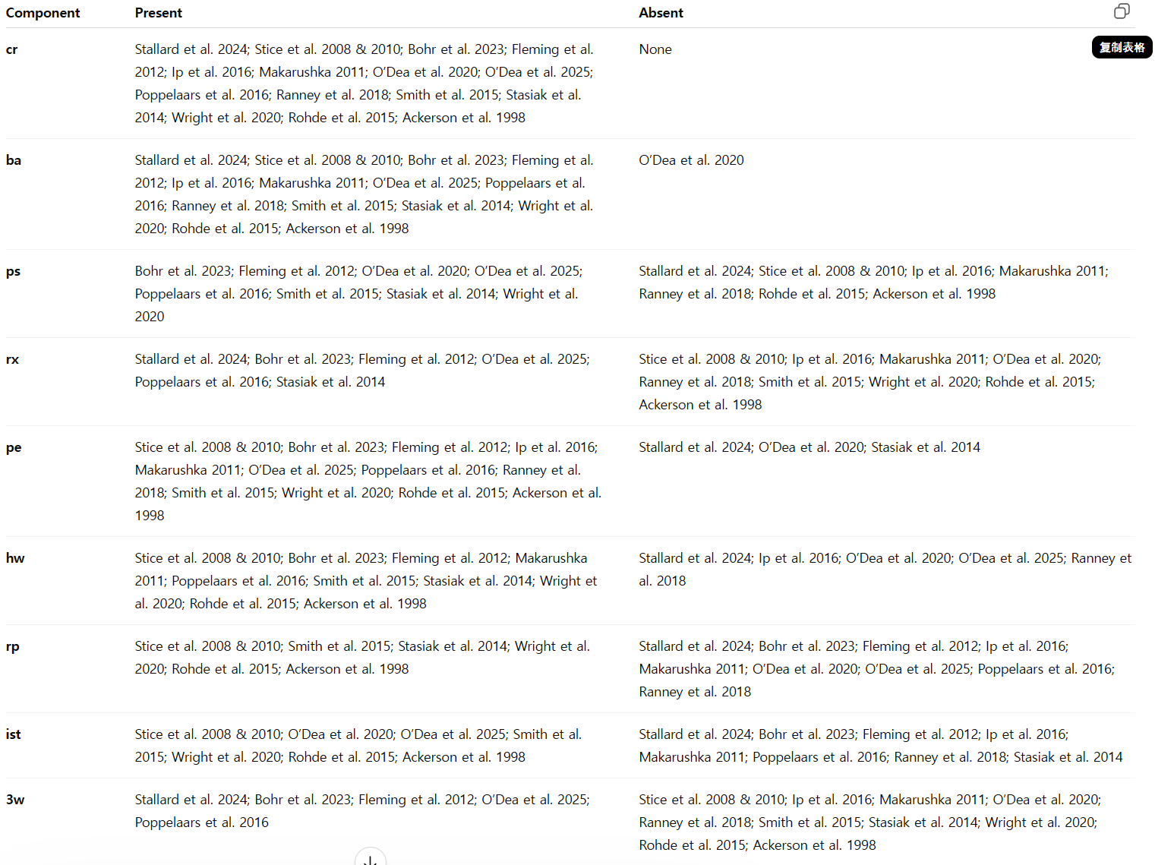

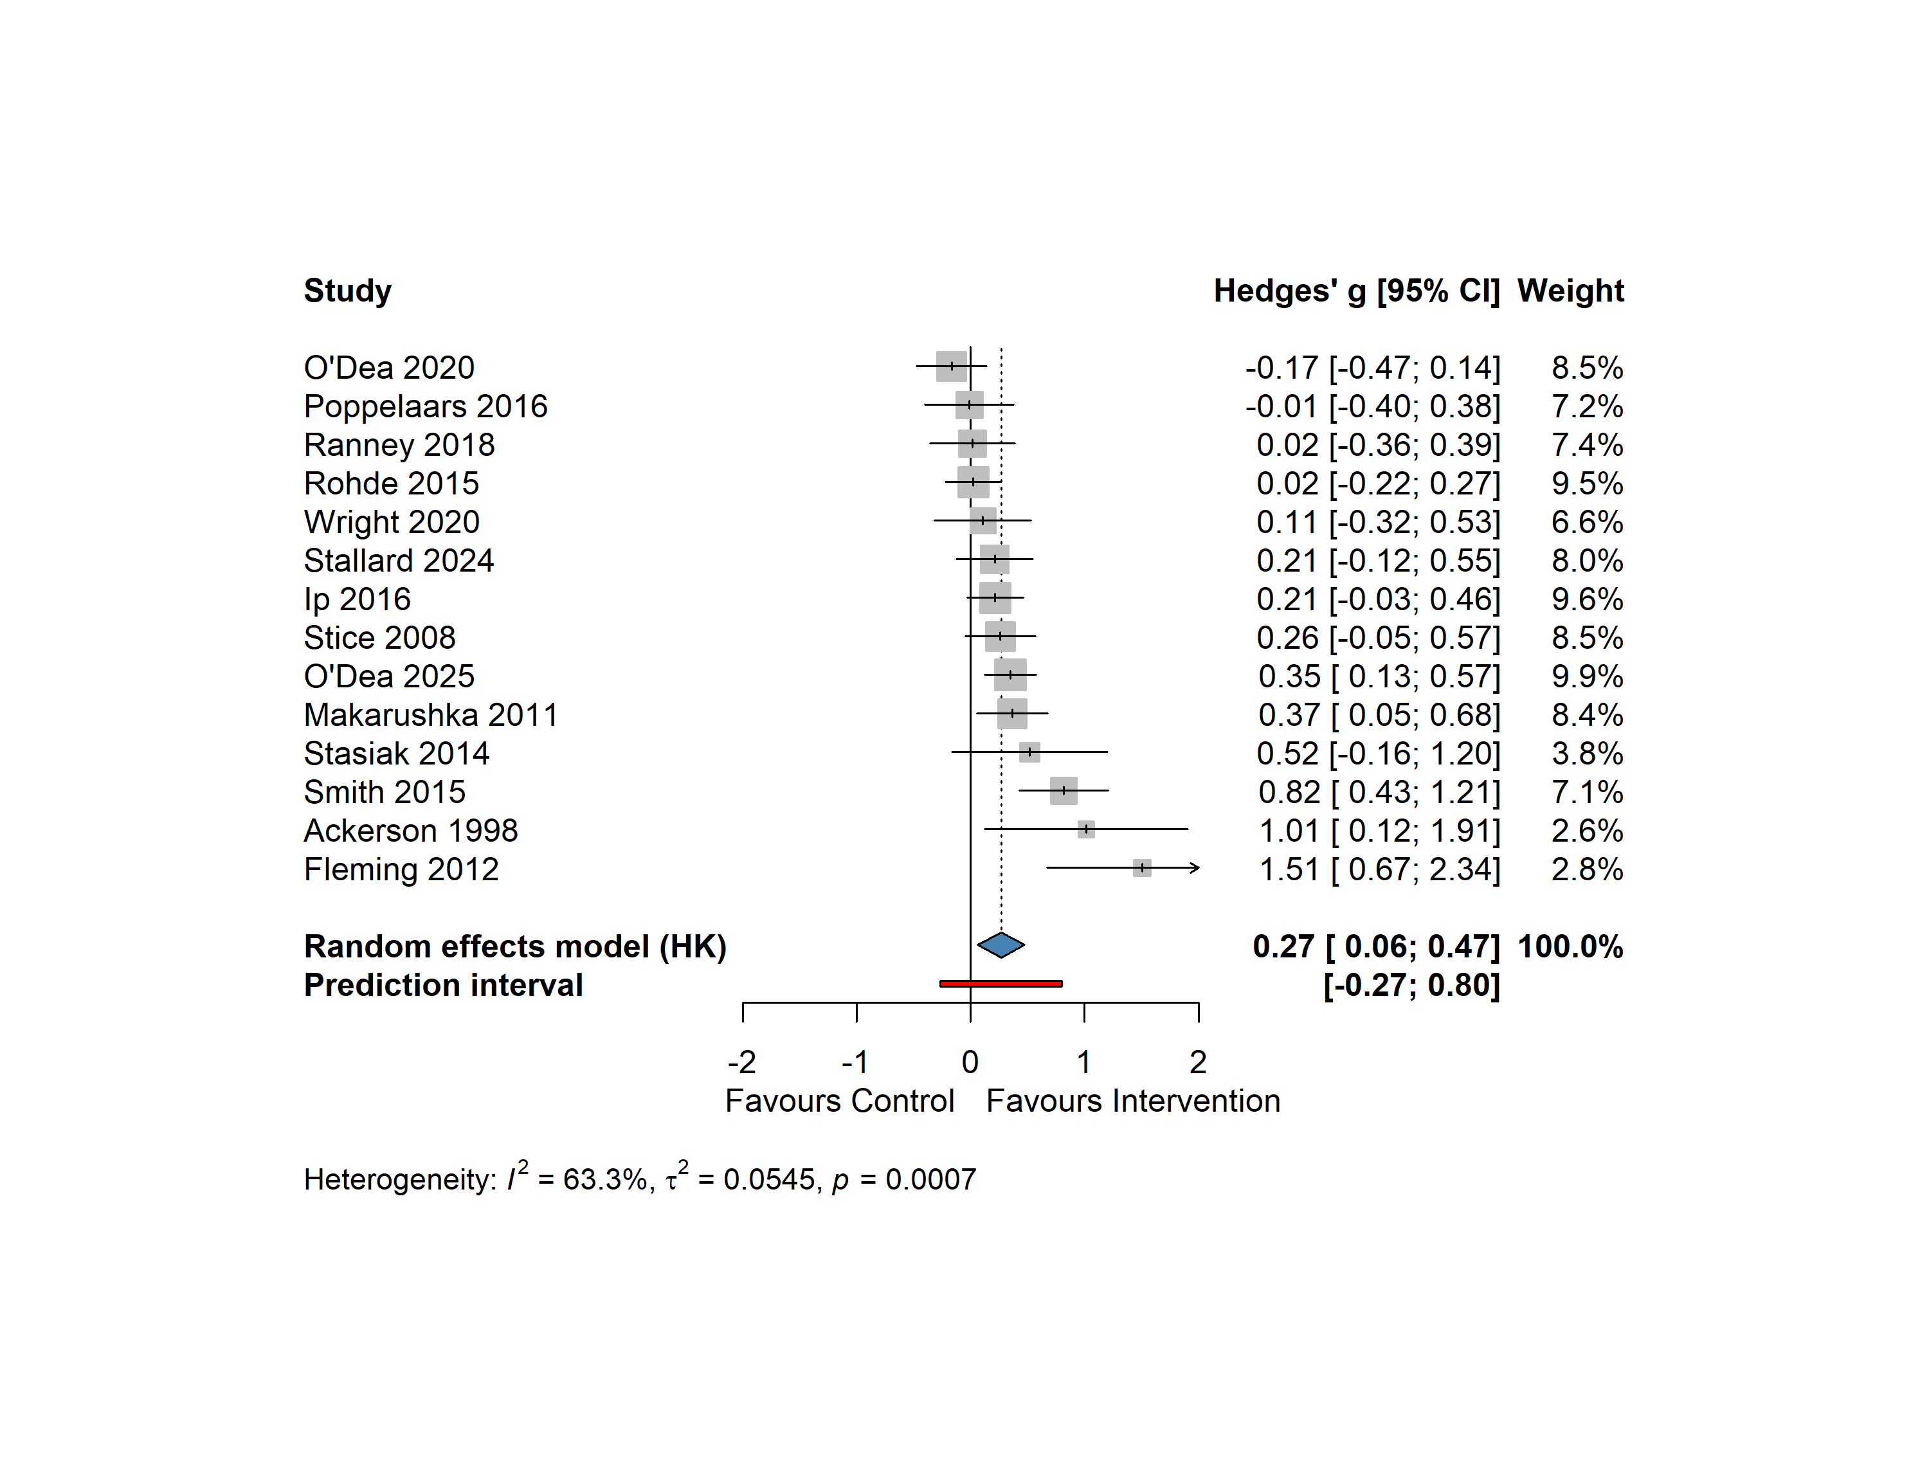
Moderator | Level | k | g | 95% CI | p | I² (%) | pᵇ
Control type | Passive | 7 | 0.35 | [-0.13, 0.83] | .123 | 79.0 | .499
 | Minimally active | 7 | 0.21 | [0.05, 0.37] | .019 | 10.2
Baseline severity | Low | 9 | 0.29 | [0.04, 0.53] | .026 | 57.0 | .883
 | High | 5 | 0.25 | [-0.34, 0.85] | .305 | 76.1
Human contact | No | 8 | 0.26 | [0.04, 0.48] | .024 | 58.1 | .851
 | Yes | 5 | 0.31 | [−0.37, 0.99] | .273 | 74.3
Relaxation | Present | 5 | 0.37 | [-0.20, 0.93] | .147 | 64.7 | .557
 | Absent | 9 | 0.23 | [-0.02, 0.48] | .069 | 64.6
Problem-solving | Present | 7 | 0.33 | [-0.12, 0.78] | .123 | 78.0 | .615
 | Absent | 7 | 0.23 | [0.01, 0.45] | .046 | 18.2
Homework | Present | 9 | 0.37 | [0.05, 0.70] | .030 | 69.1 | .160
 | Absent | 5 | 0.14 | [-0.12, 0.39] | .210 | 49.4
Relapse prevention | Present | 6 | 0.36 | [-0.03, 0.75] | .062 | 67.0 | .468
 | Absent | 8 | 0.22 | [-0.09, 0.52] | .139 | 64.6
Interpersonal skills training | Present | 7 | 0.26 | [-0.08, 0.61] | .107 | 73.0 | .914
 | Absent | 7 | 0.29 | [-0.07, 0.65] | .100 | 54.4
Note. k = number of studies; g = Hedges’ g (random-effects, Hartung-Knapp); CI = confidence interval; I² = heterogeneity. All models used REML with a common τ² across subgroups. ᵇ p-value for the test of between-subgroup differences.

Chapter 5. Discussion and Conclusion This meta-analysis evaluated the overall effects of unguided self-help CBT interventions on depressive symptoms in adolescents, a population whose access to psychological support is often constrained. The number of eligible studies is small (k = 15), and may pose some limitation on more brutal conclusion. To handle this problem, this meta-analysis additionally conducted a series of post-hoc measures to give out more clear picture to the reader. 5.1. Summary of Findings Research trend: Overall, adolescent depression self-help interventions appear to show several clear trends. First, in terms of publication period, comparable studies were nearly absent before the late 1990s, and the frequency of studies has soared in 2010 and has not increased substantially since then. Second, in terms of research design, the field seems to have gone through three broad phases. The first phase, before and around 2010, was characterized by relatively small sample sizes but large effect sizes (Ackerson et al., 1998; Stice et al., 2008 & 2010; Fleming et al., 2012). The main delivery modality was the published print copy, Feeling Good. In the second phase, the intervention medium became more diverse, and study designs moved closer to real-world conditions, considering practical utility from different starting points and in different ways. This phase can be divided into three strands: first, studies that intentionally recruited from specific non-mainstream settings (Fleming et al., 2012; Ranney et al., 2018); second, a more heterogeneous group of studies that took partial steps toward real-world conditions, each in a different way, for example by adopting a fully unguided format, by streamlining recruitment, or by recruiting a more diverse population (Makarushka, 2011; Rohde et al., 2015; Poppelaars et al., 2016; Ip et al., 2016);and third, studies that screened help-seeking adolescents in mainstream school settings, simulated the supervision procedures used in mainstream service contexts, and adopted a dosage level closer to that of traditional face-to-face therapy (Stasiak et al., 2014; Smith et al., 2015). The third phase began after 2020. Excluding the small-sample study that was removed from the main analysis, mobile-based delivery began to dominate during this period, and overall sample sizes were larger than in any previous phase. Studies in this period also opened up more fully, no longer imposing setting-based restrictions: researchers began to simulate adolescents' natural help-seeking pathways, and even the details of adolescents' interactions during recruitment were designed to occur as naturally as possible. At the same time, intervention dosage was no longer modeled on traditional face-to-face interventions, and signs of a reduction in dosage began to emerge. 这里提一下这个trend导致各组效应量大小变成了什么样 敏感性分析和发表偏倚这部分写一下，我懒得写了。 尽管Fleming这个研究被指定为一个小样本的离群研究，并且风险偏倚因为D4标注为高，发表偏倚上的表现值得怀疑，但是该研究的目标对象体现了较高的治疗需求，D5 被标注为低风险，并不代表这个研究是一个没有真实效应的研究。这点值得提醒。 然后是smith和wright同一项目，poppelaar和fleming同一项目效应天差地别的分析。 The overall effect size and sustainability: Consistent with previous evidence on unguided self-help interventions (Bjornstad et al., 2024), the present meta-analysis found that unguided self-help CBT produced a small but statistically significant effect on adolescents’ depressive symptoms at post-intervention. According to the empirical benchmarks for psychotherapy trials targeting depression in children and adolescents proposed by Nordahl-Hansen et al. (2024), the pooled effect fell in the upper part of the small range and approached the threshold for a medium effect. At follow-up, the pooled estimates were smaller, with g = 0.12 at short-term follow-up and g = 0.16 at long-term follow-up. At first glance, these results may seem to suggest that the intervention effect was broadly maintained over time. However, this interpretation should be treated with caution. The follow-up analyses were not based on the same set of studies repeatedly measured across time. Instead, they were calculated from different and only partially overlapping subsets of trials. Therefore, these pooled estimates cannot directly show whether the effect of any specific intervention was sustained from post-intervention to follow-up. The study-level patterns also did not show a consistent temporal trend. Among the trials that reported more than one follow-up assessment, some showed a reduction in effect after the intervention ended, whereas others showed different patterns. For example, the effect in Ip et al. increased over time; the large Rohde trial fluctuated only slightly around zero across five successive time points; and Poppelaars et al. showed a non-linear, saw-tooth pattern across assessments (−0.01, +0.11, −0.04, +0.28). Given the small number of studies and the wide confidence intervals at individual time points, these inconsistent trajectories are more plausibly interpreted as reflecting sampling variability than a clear pattern of maintenance or decline. Taken together, the findings suggest that unguided self-help CBT may produce a small post-intervention benefit for adolescent depressive symptoms. The follow-up estimates further suggest that this benefit may be at least partially maintained after the intervention ends. However, this interpretation should be accepted with caution, as the follow-up evidence was based on a small number of contributing studies and the within-study trajectories were not fully consistent across trials. These analyses were therefore likely underpowered, and the durability of the intervention effect remains promising, but not yet firmly established. 效应量如何随不同变量变化： 我们检验了这些平行研究是如何随着控制组类别、基线严重程度、年龄组、非治疗性人类支持水平变化、治疗组件、剂量、delivery medium变化的，其中年龄组由于分布过于以15周岁为中心分布，且平均年龄都在15周岁左右而失去了意义，剂量因为透明报告的研究过少也失去了做meta回归的意义，delivery medium因为研究总量小种类多也失去了单独做亚组分析的意义，而改为描述性的补充讨论。 总体来说，没有任何亚组之间产生了显著的差距，意味着任何变量都不能很好地指明效应的来源。但是我们人就发现了一些值得注意的结果。 首先，总体来看，除去基线严重程度，我们的结果基本和先前研究报告的趋同。 对照组为wl的虽然没有ma的效应量大（wl中，ma小；根据n打头的作者），但是异质性低，且显著，而wl为对照组的研究异质性为高，结果显示为并不显著。假如我们仔细观察，会发现这些ma的研究和报告长期随访的研究高度重合，且均为样本量中至大的研究，效应量集中且趋同，而控制组聚集了早期的小样本大效应研究，后期中大样本低效应研究，并不能真实反映两者是否在各自领域达到了显著与否，加上文献数少，我们没有power确定这个各自的研究结果有多显著。除此之外Frukawa等人的研究警告wl由于一些机制的原因并不是一个中性的控制组，相反会拉低原本可能会发生的自然回升，所以对于控制组的中等效应我们应该相应降低期待。 基线严重程度并没有如同Tong的结果呈现的那样出现了很大的差距，可能是因为以下几个原因：1. 除了几个被安排在临床背景下的重症研究，其余的研究的假设基本都是建立在很有可能是因为处在偏严重的（中重度到重度的）研究比轻症（轻中度）的研究少了太多，导致重度呈现出现了偏差。 我们还考察了人类接触和治疗组成成分对于效果的影响。结果【这里说明一下，效果的情况 Human contact No 8 0.25 [-0.01, 0.50] .056 61.5 .741 Yes 6 0.32 [-0.17, 0.81] .157 70.9 ，我懒得写了】，这几乎和Tong的研究结果趋同，说明在青少年的自助情境下也会出现这种情况。Moderators of the post-intervention effect (RQ-S1 to RQ-S4). None of the eight subgroup analyses yielded a statistically significant between-group difference (all p_between > .15). This should not be read as evidence that these characteristics are unimportant. Subgroup tests are substantially underpowered with only 14 studies divided across two levels, and the analyses lacked the statistical power to detect between-group differences of plausible magnitude. Moreover, because subgroup membership was not randomized, these comparisons are observational and cannot support causal claims about any single intervention feature. 剂量的标注并不完整，8项研究并没有清晰标注自己的剂量，所以我们并没按计划完成对剂量的meta回归。但是就我们掌握的剂量而言，没有发现剂量和效果量大小的关系，也并没有发现剂量和组成成分的数量存在量上的相关。对于成分上的结果，我们能借鉴的只有数量的部分，对于各个成分的效果量大小，我们无法进一步和Furukawa的研究进一步对话。 传达手段上（能得出的就是上面最先提到过的部分，然后反过来写到这，就是phase那段） Acceptability： 介入组的脱落率整体高于控制组32%，且研究间的差距非常大，有的研究可以很高，有的中大样本又趋近于零。剔出O’Dea 2025以后，这个脱落率降到了只比控制组高11%，说明在RR中这个研究是高影响力的研究。再看整体，我们会发现，高脱落率研就基本都是后期的模拟现实情况的低大样本研究，哪些处于临床的，尤其是学校提供场地、身旁有老师在的研究脱落率会非常低，即便这些研究的剂量可能会高。除此之外，没有进行控制的研究里也不乏那种第二阶段里面治疗需求导致脱落率低的例子。 5.3. Interpretation of Subgroup, Sensitivity, and Meta-Regression Findings 5.3.1 Subgroup findings (control type, baseline severity, age, human contact) These analyses were interpreted as exploratory because CBT components co-occurred within multi-component intervention packages and therefore cannot be interpreted as estimates of the independent causal effect of individual components. 整个 meta-analysis 的高异质性几乎全集中在 Passive 那 7 个研究里。再往里看,Passive 组挤着 Fleming(1.5)、Ackerson(1.0)、Smith(0.82)这几个小样本老研究的大效应,是它们把这组搅乱的。 I² 落差不是"对照设计"造成的,是"一批小样本离群研究恰好都落在 Passive 组"造成的。证据是 problem-solving 那组也有一模一样的 I² 落差(78% vs 18%),而那批研究和 Passive 组高度重叠(SPARX 多用等待组)。所以这是同一群离群研究在不同切法下露的同一张脸,不是 control type 本身在调节。 5.4. Limitations 第一，严格控制研究背景尽可能接近青少年的求助生态，但是也产生了纳入研究数量不够乐观的情况。这是很多后续问题只能这种解决的根本原因。具体产生的问题如下：1. 为了解决进入亚组以后changescore的效力问题，虽然按照osteinell的研究方案pooled了change score，但是是否真的可以垂直平移到本研究依旧是未知的；2. 进入亚组分析和回归分析时，很多先前研究已经做出来的更严谨的框架没能真的在本研究中展开，而是选择性地根据关键特征进行了合并，导致的结果就是组内的异质性很大，解释会极其受限，跟前人研究的对话也不够充分。 第二，大部分研究是来自西方先进国家，尽管出现了Ip这种本土化的研究，并且她效应量不低且出现了干净的延迟增长的，且许多研究尽量混合了不同阶级不同民族的人，但是背景仍旧单一，对于能否顺利将结果迁移，仍就是未知的。 第三，在做这项meta分析的过程中，作者明显感觉到了收到了方法论上的限制，虽然借助了新的研究提供的，例如wl并不是中性的、效应量在抑郁症心理治疗领域的解读方法，但是还有很多完成、未完成、因为作者有限的精力没有找到的参照。最典型的困难就是风险评估。作者在2.0 Domain 2（deviations from intended interventions）在多数纳入研究中只能被判为 Some concerns。虽然这是该领域的结构性特征，而非个别研究的方法缺陷，但是基于医学上的RoB做起心理治疗风险评估扔就有诸多限制，比如D2和D4会因为心理治疗上双盲可行性极低等限制导致风险一起上升，完全违背了RoB的精神，也不利于读者了解风险。 5.5. Implications and Future Directions 对于这类介入的设计者的建议：我们的初步结果显示越是考虑现实效用的大样本研究的效应量其实并不高，但这不意味着我们要放弃，相反我们要时刻记得effectiveness和efficacy是有区别的，可及性和真正的效应之间的关系其实十米不可分的，我们要记得以人为本才是我们设计的初衷。集体怎么做呢？作者有如下的建议：我们也可以在设计的过程中刻画一个具体的形象，问问自己什么样抑郁青少年才是我们的服务对象，而不是一开始就只铆钉特定的“被证明有效的成分”。另外，我们可以把高监督和场地限制这些明显有利于降低脱落率提升效应量的因素融进设计里，而不是附加于研究的研究设计里。此外，Ip的高效用和随访期间效应力（也是这些研究里唯一干净提升的研究）可能也在暗示我们本土化的重要性。最后，这些研究明显开始与GPT-3开始对公众开放以前，而在2024年下半年之后“把AI当做治疗师”的讨论度断崖上升，一些研究已经对用户的使用进行了评估，大部分研究得出拟人是使用满意度的重要指标之一，鉴于当今的AI普及率，今后的研究者务必要把这个时代背景也纳入考虑范围内。 对于做此类meta分析，包括心理干预类的meta分析的研究者的建议如下：在学习meta分析的时候，可以关注在这里进行前沿研究的作者的研究，例如Frukawa，Cuijpers，数学家Harres参与的研究，在研究过程中产生困惑，可以先尝试检索有没有solid的解决方案。他们在近些年已经在这个领域取得了一些进展。在作者困惑于RoB判定的时候，偶然发现他们已经定制了一套适用于心理治疗meta分析的RoB风险评估步骤和算法，在作者还在写这段文字的时候还处于同行评审的阶段，读者可以持续追踪，并且跟进学习。 5.6. Conclusion [Placeholder for summary conclusion.]