# 控制板

<https://detail.tmall.com/item.htm?spm=a1z0d.6639537/tb.1997196601.4.4d1f7484g3ceFo&id=596119282497&skuId=4311366423934>

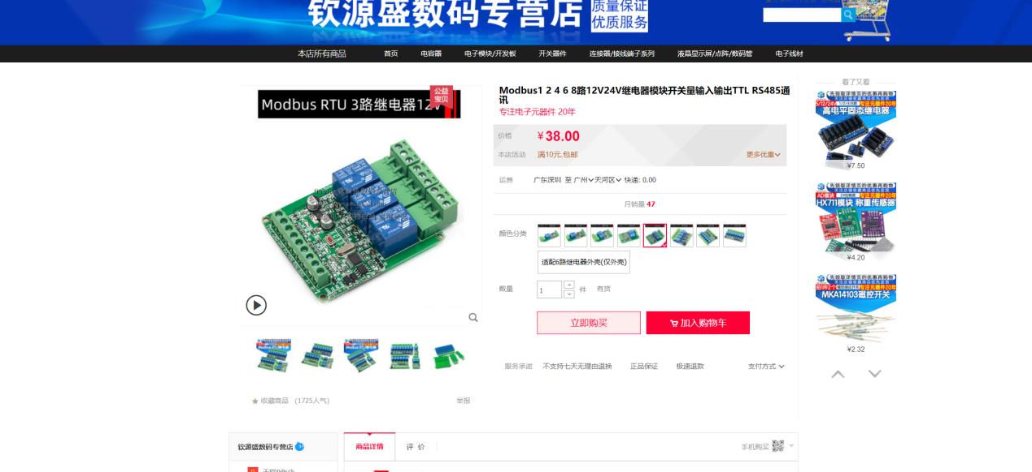

# 语音板

<https://item.taobao.com/item.htm?spm=a230r.1.14.16.5f5c5dedKlgQJI&id=651268702495&ns=1&abbucket=11#detail>

