**Intelligent Data Analysis CS5152/6052**

**Homework #2**

**Due Date(s): Problem #1 is due by March 30th, 9PM; Problem #2 is due by April 4th, 9PM.**

Consider the data in a 2-dimensional space given in the attached file. It includes points belonging to two different classes. A plot of the data points showing their distribution is attached with the asignment. Perform the following tasks with this dataset.

Include your response to each part of a homework question in a single pdf file and upload it on Blackboard. There are two assignments created on Blackboard, one for responses to Question#1 and the other for Question#2. Two separate submissions are required by their respective due dates.

1. Your task is to design a good classifier for this data set. You can use only one of the following two toolboxes: Scikit library (Python), or Matlab. For this question we are going to find a non-linear SVM classifier that fits this data. Perform the following steps and report your work and results as stated below.
   1. Use non-linear SVM with Radial-basis kernel, to design classifier for the two classes of this dataset. Randomly select 75%% of the data points as training data and use the remaining 25% as the test data. Create and test an SVM model for at least 6 different values of the regularization parameter (this parameter is named differently in each toolbox, read the documentation for your toolbox). For each of the six runs, show the chosen parameter value, confusion matrix, and accuracy, and precision values. Plot the accuracy, precision, and recall values for the six parameter values.

Gamma=1

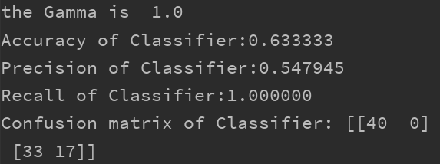

Gamma = 0.5

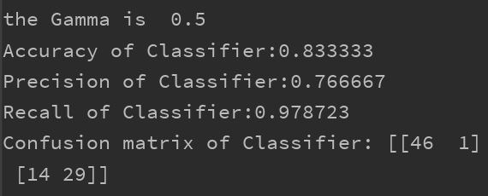

Gamma = 0.75

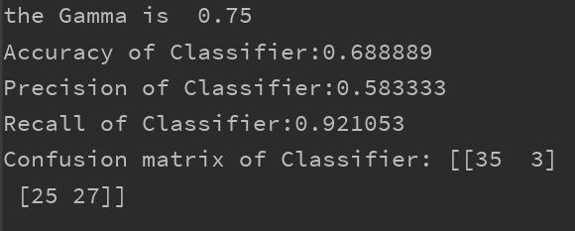

Gamma = 0.6

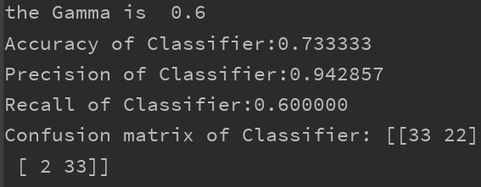

Gamma = 0.55

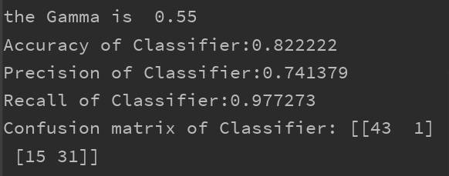

Gamma = 0.525

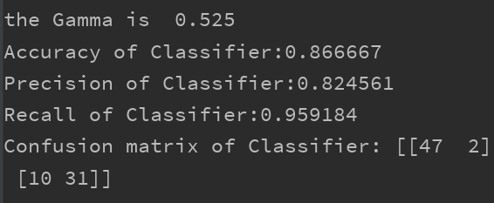

Base on the output shown, when gamma = 0.525, the accuracy will be the highest.

* 1. Select the model having the highest accuracy value from the six models generate above. For this model consider all the points of the 100X100 grid as the test points. Find the class for each of these test points. Use two different colors for denoting the predicted class label for a point and create the plot with corresponding colors for each point of the full grid. Your output will be a grid in which each point will be plotted using one of the two colors.

We choose gamma = 0.525 which gives the highest accuracy is 0.86667.

Blue points are class 1

Red points are class 2

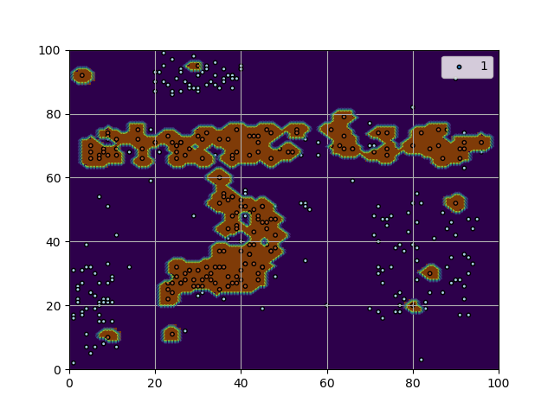

For all data in the grid:

Blue points are class 1

Red points are class 2

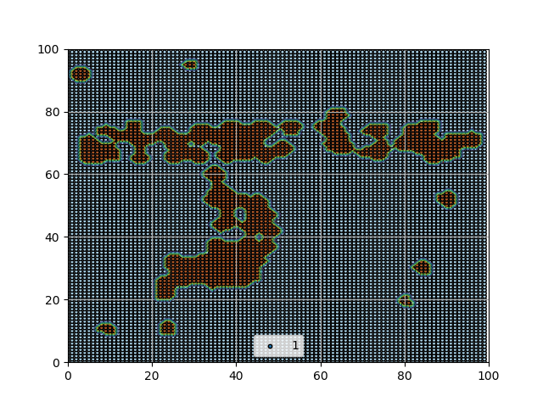

* 1. The grid generated in (b) above shows the boundaries learned by the classifier to predict the two classes. Comment on the following:
     1. How efficient and effective are these boundaries, given data distribution of the two classes.

The boundaries can **effectively** divide two classes. Base on the output plot the boundaries are **not efficient**, the boundary divides the data into small area that some of the area only contain one data point.

* + 1. On a plot of original data points draw the ideal boundaries that you would like to see from your intuitive point of view. Give reason for your choosing the boundaries that you drawn.

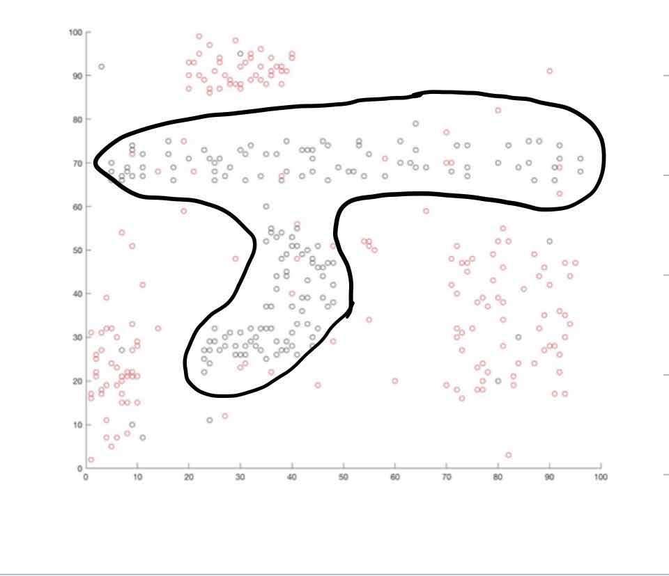

I will divide the plot as shown in the figure, the boundary can efficient and effective dived the two classes of data.

* + 1. Which classifier, in your view, can learn the boundaries closest to the intuitive ones you have suggested? Give reasons for your answer.

Non-linear SVM and KNN are both ok with learning the boundaries but in this model, SVM fits the model too much, so I choose KNN with low k value which will not classify the data too much.

* 1. What is the role of the regularization parameter and how does it work? (Maximum 200 words)

The regularization parameter can control the results. In this model, the regularization is gamma, it can control the radius of the area that influenced by support vectors. In conclusion, it will control the shape of output boundaries.

Code for 1:

import numpy as np  
import matplotlib.pyplot as plt  
from sklearn import svm  
import pandas as pd  
from sklearn.preprocessing import StandardScaler  
gammavalue=float(input('gamma= '))  
data = pd.read_excel('D:/LEARN/GRADUATE2020/IDA/assignment2/HW2Data.xlsx',header=None)  
clf = svm.NuSVC(gamma=gammavalue)  
x = data[[0,1]]  
y = data[3]  
#change the gamma as the parameter  
x_train = x.sample(int(0.75*len(x)))  
x_test = x.loc[x.index.difference(x_train.index)]  
y_train = y.loc[x_train.index]  
y_test = y.loc[x.index.difference(y_train.index)]  
  
#fit model  
clf.fit(x_train,y_train)  
#test model  
from sklearn.metrics import precision_score  
from sklearn.metrics import recall_score  
from sklearn.metrics import confusion_matrix  
y_test_p = clf.predict(x_test)  
print('the Gamma is ',gammavalue)  
print ('Accuracy of Classifier:%f'%clf.score(x_test,y_test))  
print('Precision of Classifier:%f'%precision_score(y_test,y_test_p))  
print('Recall of Classifier:%f'%recall_score(y_test,y_test_p))  
print('Confusion matrix of Classifier:', confusion_matrix(y_test,y_test_p))  
  
  
##question b  
scaler =StandardScaler()  
x_b = x  
y_b = y  
y_b_p = clf.predict(x_b)  
# plot the decision function for each datapoint on the grid  
xx, yy = np.meshgrid(np.linspace(0, 100, 100),  
 np.linspace(0, 100, 100))  
  
# evaluate decision function in a grid  
Z = clf.predict(np.c_[xx.ravel(), yy.ravel()])  
Z = Z.reshape(xx.shape)  
gamma = 0.8125  
  
plt.imshow(Z, interpolation='nearest',  
 extent=(xx.min(), xx.max(), yy.min(), yy.max()), aspect='auto',  
 origin='lower', cmap=plt.cm.PuOr_r)  
contours = plt.contour(xx, yy, Z, linewidths=0.5,linestyles='dashed')  
plt.scatter(x_b.values[:,0], x_b.values[:,1],s=10,c=y_b_p, cmap=plt.cm.Paired,edgecolors='k')  
  
plt.grid(True)  
plt.legend(y_b_p)  
plt.axis([0, 100, 0, 100])  
plt.show()  
  
  
# print ('Accuracy of Classifier:%f'%clf.score(x,y_b_p))  
# print('Precision of Classifier:%f'%precision_score(y,y_b_p))  
# print('Recall of Classifier:%f'%recall_score(y,y_b_p))  
# print('Confusion matrix of Classifier:'%confusion_matrix(y,y_b_p))  
  
  
# for all data in grid  
  
plt.imshow(Z, interpolation='nearest',  
 extent=(xx.min(), xx.max(), yy.min(), yy.max()), aspect='auto',  
 origin='lower', cmap=plt.cm.PuOr_r)  
k = list(range(0,100))  
#create data for all  
every1=[]  
every2 = k*100  
for i in k:  
 every1 = [i] * 100+every1  
xxinput = np.column_stack((every1,every2))  
y_all = clf.predict(xxinput)  
fig = plt.figure()  
contours = plt.contour(xx, yy, Z, linewidths=0.5,linestyles='dashed')  
plt.scatter(xxinput[:,0],xxinput[:,1],s=10,c=y_all, cmap=plt.cm.Paired,edgecolors='k')  
plt.axis([0, 100, 0, 100])  
plt.show()  
  
plt.grid(True)  
plt.legend(y_all)

1. Now use the same data set for the following sequence of steps.
   1. For this problem consider only the (x,y) coordinates of the data points and ignore their class labels. Perform k-means clustering of these data points for values of k to be 3, 5, 7, 9, and 11. For each value of k run the clustering algorithm (Scikit or Matlab only) 6 times (with initial cluster centers being selected randomly) and report the following: (i) total SSE for each clustering run, (ii) Average SSE and its standard deviation for each k value, and (iii) the minimum and maximum SSE values for each value of k.

i:

1:

number is 3 , the SSE is : 144037.22795882093

number is 5 , the SSE is : 71341.0489043845

number is 7 , the SSE is : 44857.75217158108

number is 9 , the SSE is : 31140.517822099697

number is 11 , the SSE is : 24529.60569983741

2:

number is 3 , the SSE is : 144037.22795882093

number is 5 , the SSE is : 71332.51539973082

number is 7 , the SSE is : 44857.855199968304

number is 9 , the SSE is : 31158.520220041257

number is 11 , the SSE is : 24495.7433543797

3:

number is 3 , the SSE is : 144037.22795882093

number is 5 , the SSE is : 71332.51539973082

number is 7 , the SSE is : 44857.75217158108

number is 9 , the SSE is : 31140.517822099697

number is 11 , the SSE is : 24564.216283587044

4:

number is 3 , the SSE is : 144039.2375813634

number is 5 , the SSE is : 71334.54527644317

number is 7 , the SSE is : 44861.63071086092

number is 9 , the SSE is : 31140.517822099697

number is 11 , the SSE is : 24603.797953441364

5:

number is 3 , the SSE is : 144037.22795882093

number is 5 , the SSE is : 71334.54527644317

number is 7 , the SSE is : 44857.75217158108

number is 9 , the SSE is : 31155.01407995702

number is 11 , the SSE is : 24492.179449198862

6:

number is 3 , the SSE is : 144049.98731884072

number is 5 , the SSE is : 71341.0489043845

number is 7 , the SSE is : 44861.63071086092

number is 9 , the SSE is : 31117.839274184367

number is 11 , the SSE is : 24521.469909009353

average SSE for each:

720188.1494166472

356675.1702567325

224292.74242557248

155735.0877662974

122685.54274044439

* 1. Consider the best clustering obtained for k=5. Each data point is assigned a cluster number by your clustering algorithm. Plot all the given data points on the grid after assigning a different color/symbol to members of each cluster. Write the cluster-specific SSE for each individual cluster on the plot.
  2. Comment on the cluster boundaries obtained by your clustering algorithm, focusing on how they are different from your intuitive idea of five clusters from this dataset.
  3. On the data plot, mark the boundaries of the five clusters that you think are intuitively distinct clusters. Justify the boundaries you have drawn, giving reasons for preferring the boundaries you have drawn.
  4. Compute the Rand Index between the clustering used in parts (b) and (d) above. Show your work and steps performed to arrive at the Rand Index value. How can we interpret the meaning of the Rand index obtained by you?