**Intelligent Data Analysis CS5152/6052**

**Homework #3**

**Due Date: April 22nd, 9PM**

Consider the graph shown in the attached file and answer the following questions in its context.

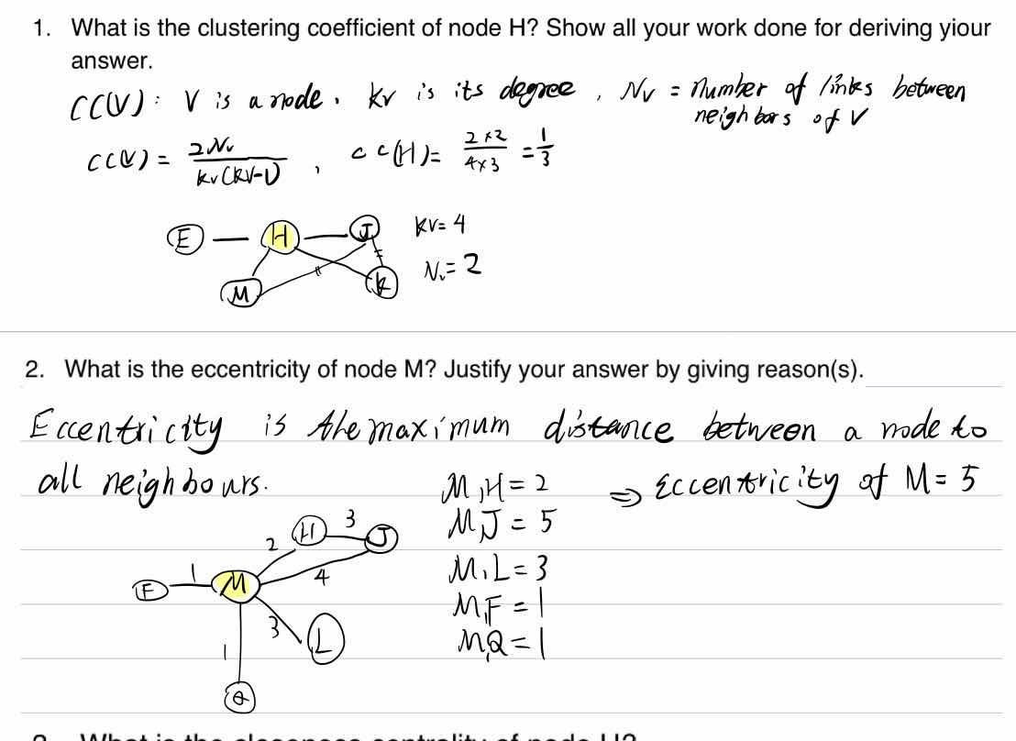

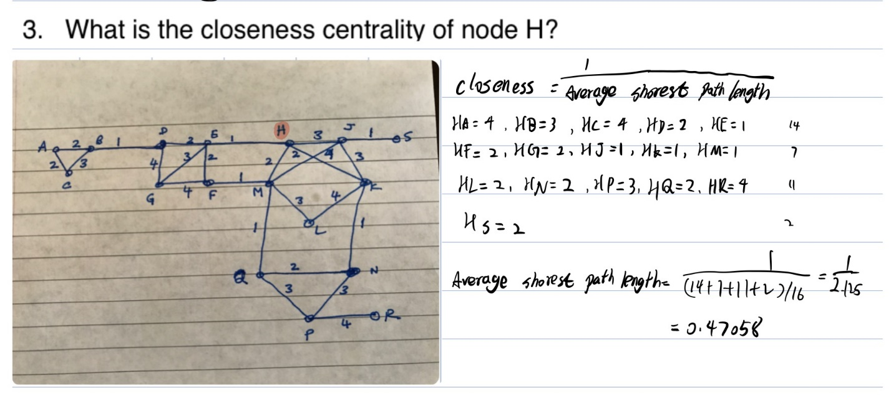

4. Consider the MCL algorithm covered in class. Apply the same algorithm on the graph attached with this assignment. Include self-loops with a label of ‘1” at every node. You may have to write a small script in Matlab of Python to execute the MCL algorithm. Submit the script written by you along with your answers. Run the MCL algorithm on the given graph for the following inflation values: 1.1, 1.3, 1.5, 1.7, and 2.1. and stop each run after 10 iterations of inflation and expansion. For each run show the following:

* 1. The final adjacency matrix.

The following nodes number (0 1 2 3 4 5 6 7 8 9 10 11 12 13 14 15 16)are according to the string names:A,B,C,D,E,F,G,H,J,K,L,M,N,P,Q,R,S

* + 1. Inflation=1.1

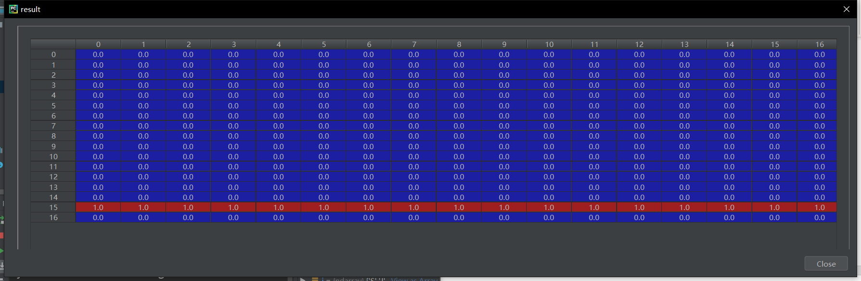

* + 1. Inflation=1.3

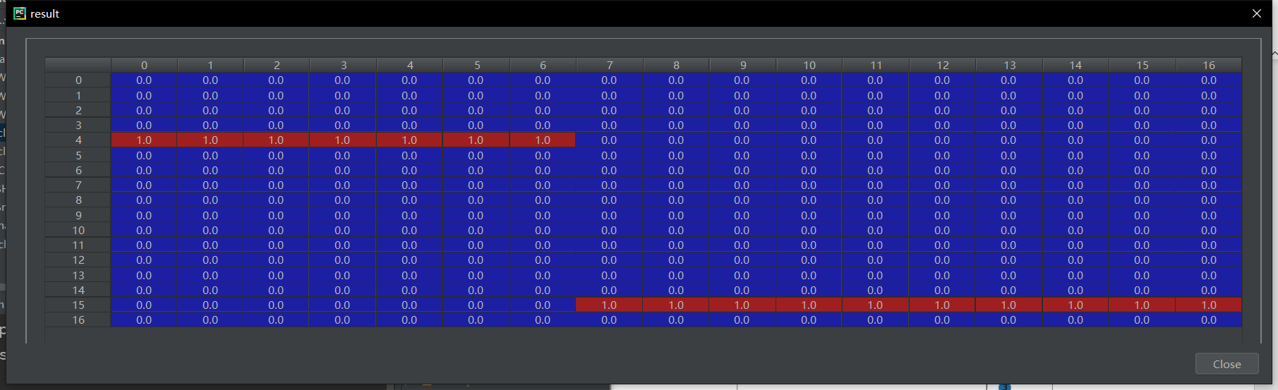

* + 1. Inflation=1.5

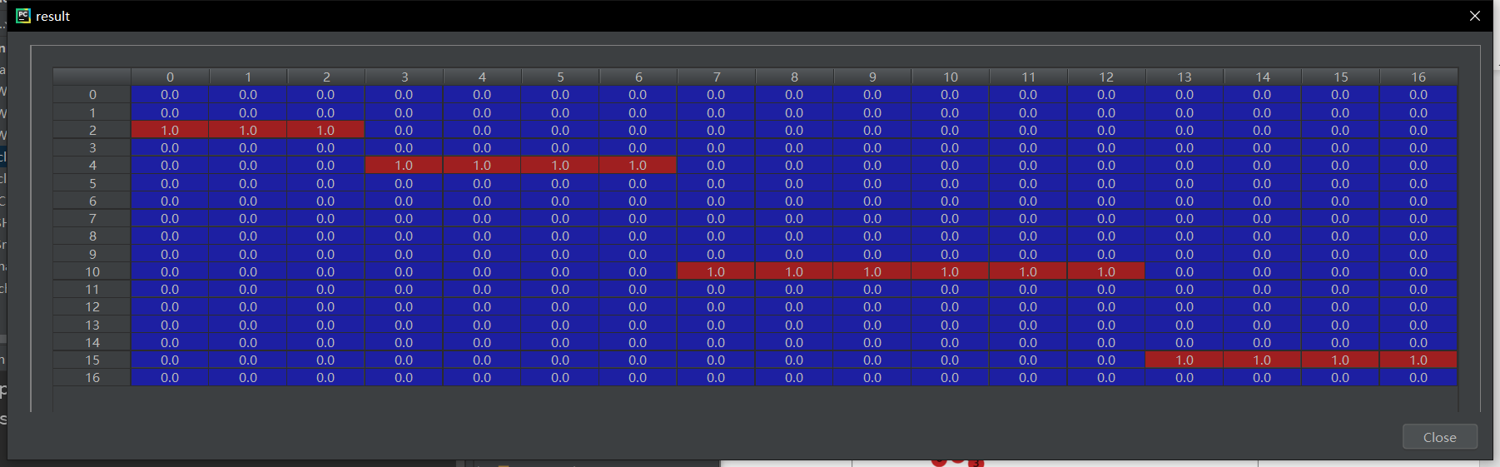

* + 1. Inflation=1.7

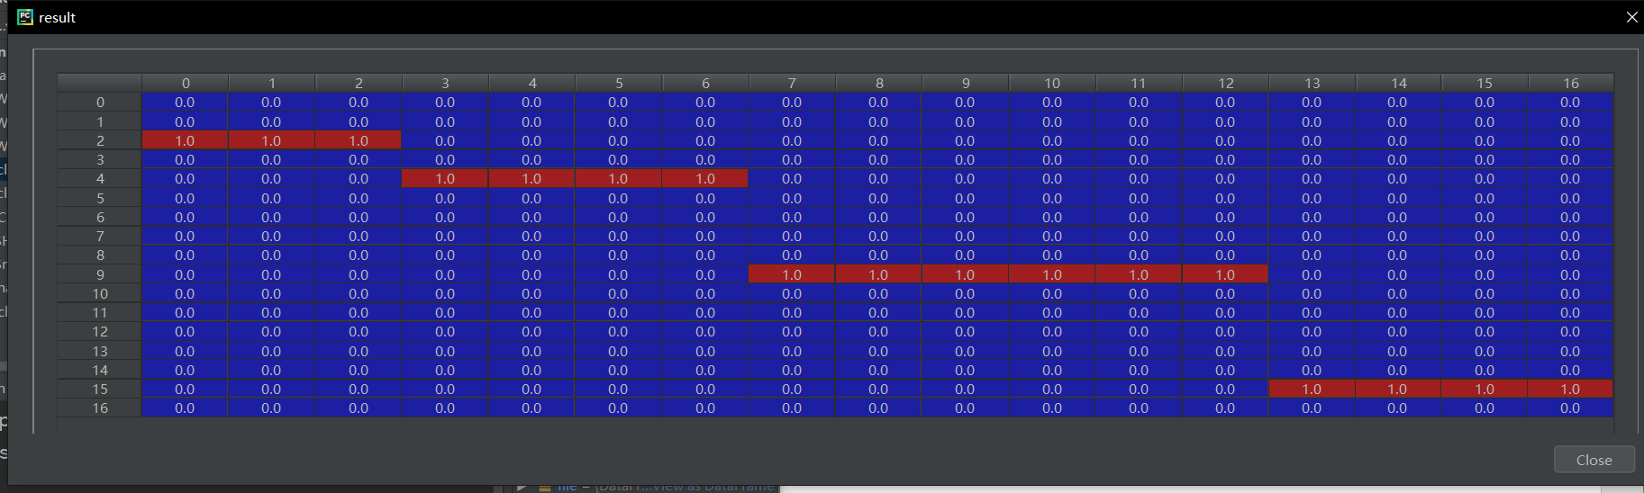

* + 1. Inflation=2.1

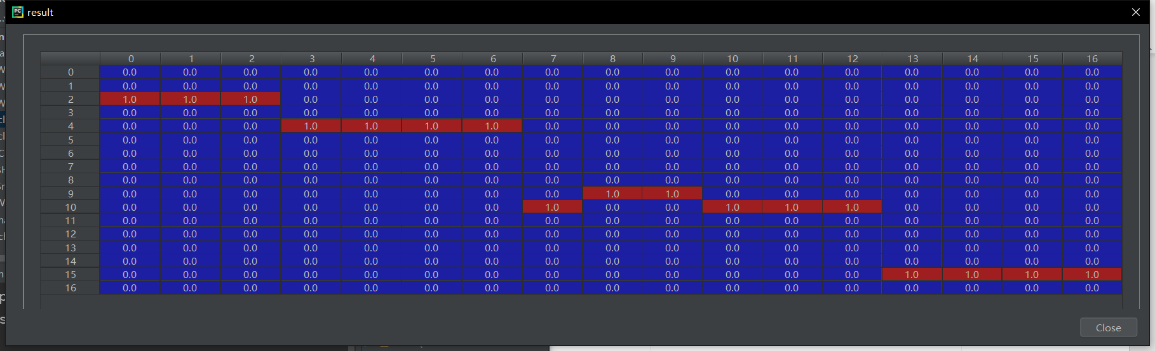

* 1. The communities of nodes that you see in this final version of the adjacency matrix.
     1. Inflation=1.1

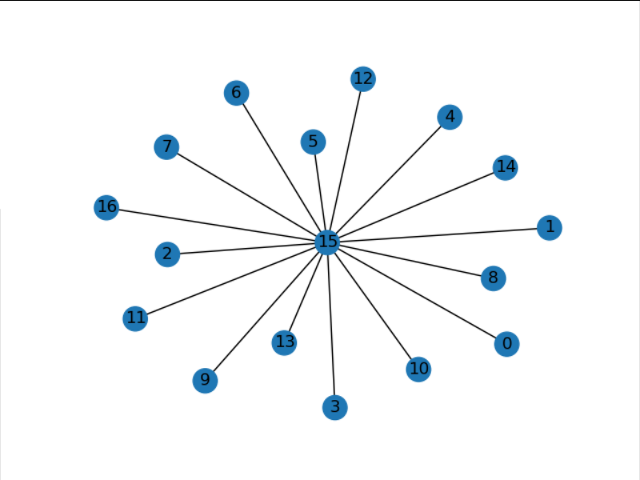

* + 1. Inflation=1.3

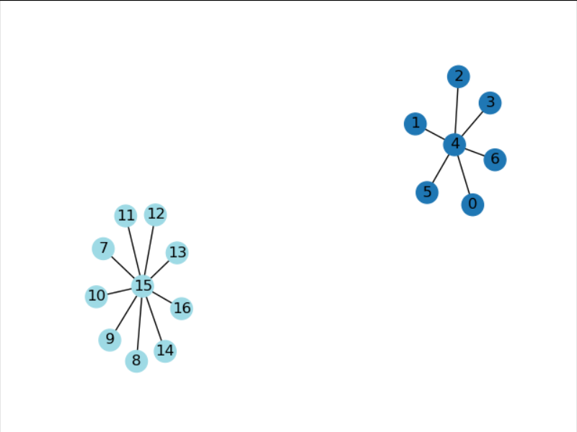

* + 1. Inflation=1.5

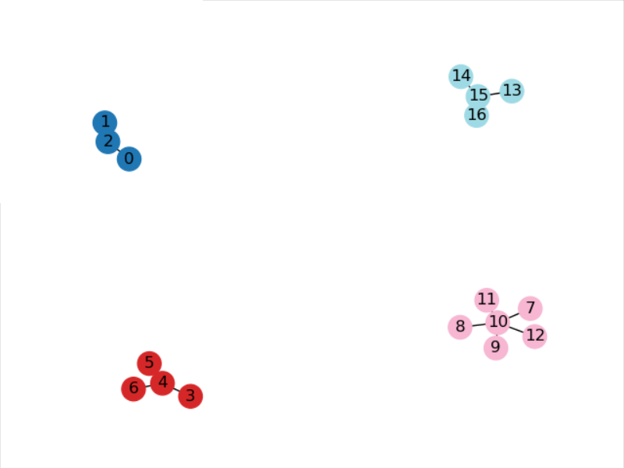

* + 1. Inflation=1.7

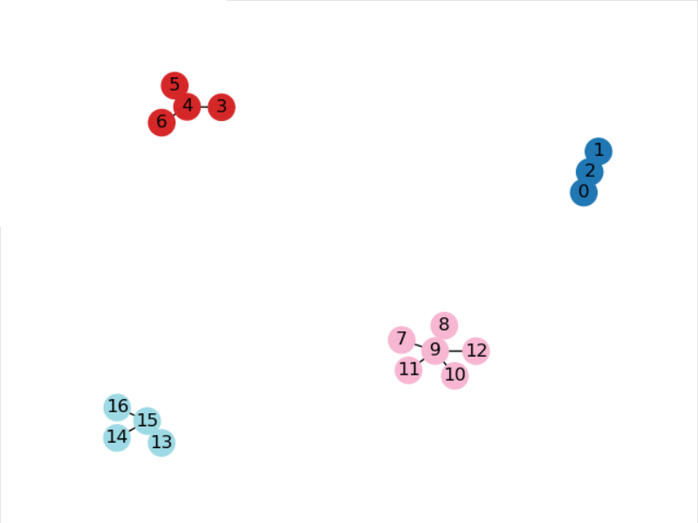

* + 1. Inflation=2.1
  1. On a copy of the original graph (enclosed with this assignment) encircle each cluster found by your algorithm.

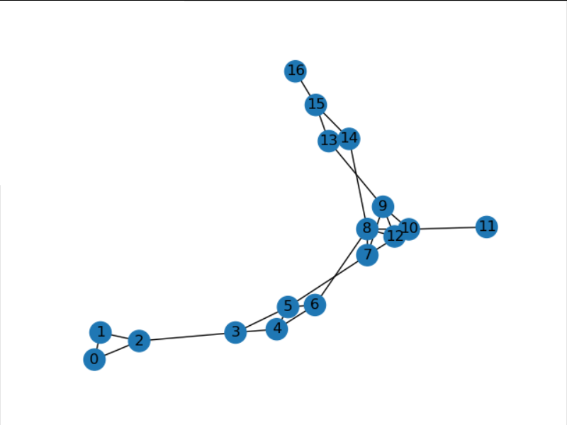

* 1. Is this clustering intuitive according to you? Would you have preferred to see a somewhat different community structure? If yes, then what communities would you have liked to find and how would you achieve that? Justify your answer.

Coed：import numpy as np  
import markov_clustering as mc  
import networkx as nx  
import pandas as pd  
  
file=pd.read_excel(open('D:/LEARN/GRADUATE2020/IDA/assignment3/mcl.xlsx','rb'),sheet_name='Sheet3')  
matrix=np.array(file)  
g=nx.Graph()  
innum=2.1 #change inflation values  
for i in matrix:  
 g.add_edge(i[0],i[1],weight=i[2])  
a=nx.to_numpy_array(g)  
result=mc.run_mcl(a,inflation=innum)  
for j in range(9):  
 result=mc.run_mcl(result,inflation=innum)  
  
clusters=mc.get_clusters(result)  
#title=[('A',float),('B',float),('C',float),('D',float),('E',float),('F',float),('G',float),('H',float),('J',float),('K',float),('L',float),('M',float),('N',float),('P',float),('Q',float),('R',float),('S',float)]  
mc.draw_graph(result,clusters,with_labels=True)