**引言**

当手机由竖屏切换成横屏时我们通常需要调整程序的UI布局以适应屏幕；或者更进一步当手机的方向发生变化时，如果我们也想让程序的UI随之改变该怎么做呢？那么本文就为大家介绍一种思路。

**使用sensor感知方向变化**

现在QML中已经可以直接使用Sensor了，不需要我们自己再通过c++代码的方式间接访问。我们获得当前手机方向信息后，就把当前状态设置为对应状态，而后我们就可以根据不同的状态进行布局了。

OrientationSensor {  
id: orientation  
active: **true**  
   
onReadingChanged: {  
 **if** (reading.orientation == OrientationReading.TopUp)  
content.state = "TopUp";  
 **else** **if** (reading.orientation == OrientationReading.TopDown)  
content.state = "TopDown";  
 **else** **if** (reading.orientation == OrientationReading.LeftUp)  
content.state = "LeftUp";  
 **else** **if** (reading.orientation == OrientationReading.RightUp)  
content.state = "RightUp";  
 **else** **if** (reading.orientation == OrientationReading.FaceUp)  
content.state = "FaceUp";  
 **else** **if** (reading.orientation == OrientationReading.FaceDown)  
content.state = "FaceDown";  
 **else**  
content.state = "";  
 }  
 }

**切换布局**

根据状态设置每一个矩形的宽度，从而适应屏幕的变化。

Flow {  
anchors.top: parent.top  
anchors.left: parent.left  
anchors.right: parent.right  
anchors.margins: 10  
spacing: 4  
Rectangle {  
width: (content.state == "LeftUp" || content.state == "RightUp") ? (parent.width-8)/3 : (parent.width-4)/2  
height: 60  
color: "yellow"  
Text {  
text: "1"  
color: "black"  
font.pointSize: 10  
anchors.centerIn: parent  
 }  
 }  
 *// ...以下省略*

**程序截图**

[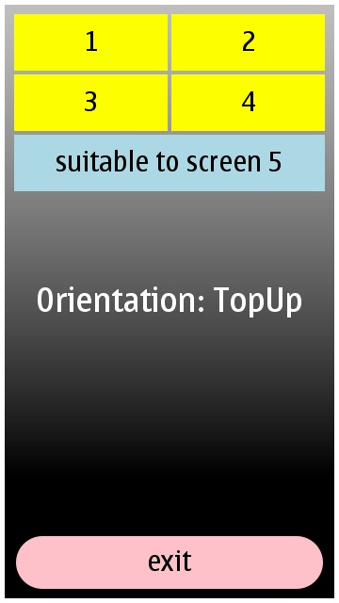](http://www.developer.nokia.com/Community/Wiki/File:Shuping.jpg)

[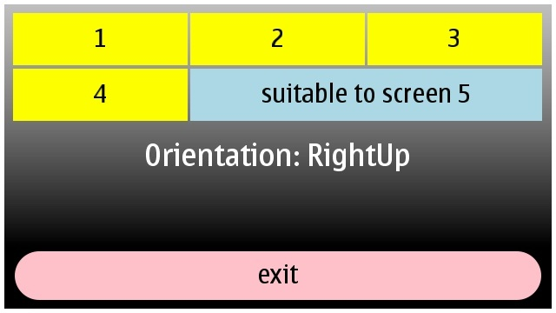](http://www.developer.nokia.com/Community/Wiki/File:Hengping.jpg)