ListView 和 Adapter 的基础
工作原理:
- ListView 针对List中每个item，要求 adapter “给我一个视图” (getView)。
- 一个新的视图被返回并显示
如果我们有上亿个项目要显示怎么办？为每个项目创建一个新视图？NO!这不可能！
实际上Android为你缓存了视图。
Android中有个叫做Recycler的构件，下图是他的工作原理：
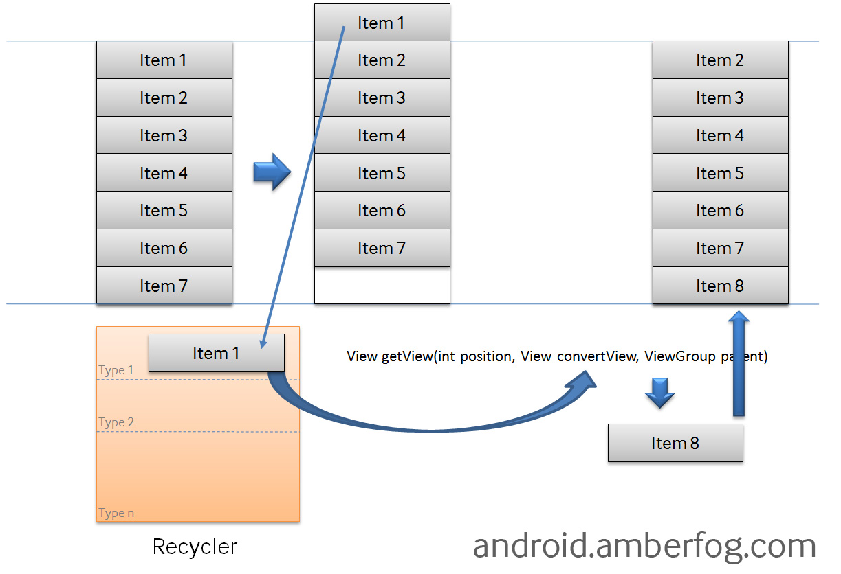
- 如果你有10亿个项目(item)，其中只有可见的项目存在内存中，其他的在Recycler中。
- ListView先请求一个type1视图(getView)然后请求其他可见的项目。convertView在getView中是空(null)的。
- 当item1滚出屏幕，并且一个新的项目从屏幕低端上来时，ListView再请求一个type1视图。convertView此时不是空值了，它的值是item1。你只需设定新的数据然后返回convertView，不必重新创建一个视图。
请看下面的示例代码，这里在getView中使用了System.out进行输出
1  2  3  4  5  6  7  8  9  10  11  12  13  14  15  16  17  18  19  20  21  22  23  24  25  26  27  28  29  30  31  32  33  34  35  36  37  38  39  40  41  42  43  44  45  46  47  48  49  50  51  52  53  54  55  56  57  58  59  60  61  62  63  64  65 | public class MultipleItemsList extends ListActivity {  private MyCustomAdapter mAdapter;  @Override  public void onCreate(Bundle savedInstanceState) {  super.onCreate(savedInstanceState);  mAdapter = new MyCustomAdapter();  for (int i = 0; i < 50; i++) {  mAdapter.addItem("item " + i);  }  setListAdapter(mAdapter);  }  private class MyCustomAdapter extends BaseAdapter {  private ArrayList mData = new ArrayList();  private LayoutInflater mInflater;  public MyCustomAdapter() {  mInflater = (LayoutInflater)getSystemService(Context.LAYOUT_INFLATER_SERVICE);  }  public void addItem(final String item) {  mData.add(item);  notifyDataSetChanged();  }  @Override  public int getCount() {  return mData.size();  }  @Override  public String getItem(int position) {  return mData.get(position);  }  @Override  public long getItemId(int position) {  return position;  }  @Override  public View getView(int position, View convertView, ViewGroup parent) {  System.out.println("getView " + position + " " + convertView);  ViewHolder holder = null;  if (convertView == null) {  convertView = mInflater.inflate(R.layout.item1, null);  holder = new ViewHolder();  holder.textView = (TextView)convertView.findViewById(R.id.text);  convertView.setTag(holder);  } else {  holder = (ViewHolder)convertView.getTag();  }  holder.textView.setText(mData.get(position));  return convertView;  }  }  public static class ViewHolder {  public TextView textView;  }  }

执行程序，然后在Logcat中查看日志

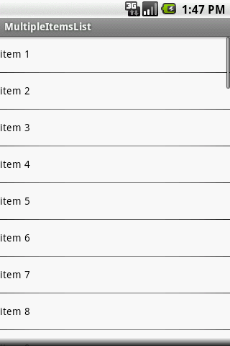
getView 被调用 9 次 ，convertView 对于所有的可见项目是空值（如下）

02-05 13:47:32.559: INFO/System.out(947): getView 0 null
02-05 13:47:32.570: INFO/System.out(947): getView 1 null
02-05 13:47:32.589: INFO/System.out(947): getView 2 null
02-05 13:47:32.599: INFO/System.out(947): getView 3 null
02-05 13:47:32.619: INFO/System.out(947): getView 4 null
02-05 13:47:32.629: INFO/System.out(947): getView 5 null
02-05 13:47:32.708: INFO/System.out(947): getView 6 null
02-05 13:47:32.719: INFO/System.out(947): getView 7 null
02-05 13:47:32.729: INFO/System.out(947): getView 8 null

然后稍微向下滚动List，直到item10出现：
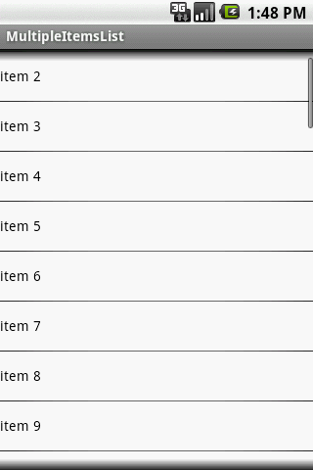

convertView仍然是空值，因为recycler中没有视图（item1的边缘仍然可见，在顶端）

02-05 13:48:25.169: INFO/System.out(947): getView 9 null

再滚动List
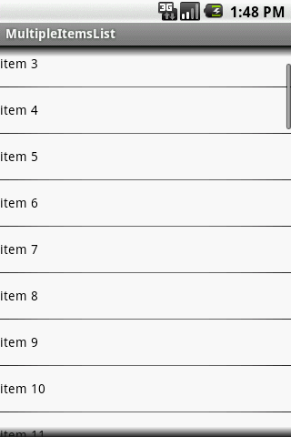

convertView不是空值了！item1离开屏幕到Recycler中去了，然后item11被创建

02-05 13:48:42.879: INFO/System.out(947): getView 10 android.widget.LinearLayout@437430f8

再滚动：
02-05 14:01:31.069: INFO/System.out(947): getView 11 android.widget.LinearLayout@437447d0
02-05 14:01:31.142: INFO/System.out(947): getView 12 android.widget.LinearLayout@43744ff8
02-05 14:01:31.279: INFO/System.out(947): getView 13 android.widget.LinearLayout@43743fa8
02-05 14:01:31.350: INFO/System.out(947): getView 14 android.widget.LinearLayout@43745820
02-05 14:01:31.429: INFO/System.out(947): getView 15 android.widget.LinearLayout@43746048
02-05 14:01:31.550: INFO/System.out(947): getView 16 android.widget.LinearLayout@43746870
02-05 14:01:31.669: INFO/System.out(947): getView 17 android.widget.LinearLayout@43747098
02-05 14:01:31.839: INFO/System.out(947): getView 18 android.widget.LinearLayout@437478c0
02-05 14:03:30.900: INFO/System.out(947): getView 19 android.widget.LinearLayout@43748df0
02-05 14:03:32.069: INFO/System.out(947): getView 20 android.widget.LinearLayout@437430f8
convertView 如我们所期待的非空了，在item11离开屏幕之后，它的视图(@437430f8)作为convertView容纳item21了

不同的项目布局(item layout)
我们再举一个稍微复杂的例子，在上例的list中加入一些分隔线
你需要做这些:
- 重(@Override)写 getViewTypeCount() – 返回你有多少个不同的布局
- 重写 getItemViewType(int) – 由position返回view type id
- 根据view item的类型，在getView中创建正确的convertView
即，
1 getItemViewType(int)传入position需要传出自己定义的对应项类型（item or seperator）
2 getViewTypeCount()返回有多少种布局,这样就好将视图放入recycler中利用了
3 getView重载的时候要用getItemViewType进行判断类型，并给与不同的布局
以下是代码：

1  2  3  4  5  6  7  8  9  10  11  12  13  14  15  16  17  18  19  20  21  22  23  24  25  26  27  28  29  30  31  32  33  34  35  36  37  38  39  40  41  42  43  44  45  46  47  48  49  50  51  52  53  54  55  56  57  58  59  60  61  62  63  64  65  66  67  68  69  70  71  72  73  74  75  76  77  78  79  80  81  82  83  84  85  86  87  88  89  90  91  92  93  94  95  96  97  98  99  100 | public class MultipleItemsList extends ListActivity {  private MyCustomAdapter mAdapter;  @Override  public void onCreate(Bundle savedInstanceState) {  super.onCreate(savedInstanceState);  mAdapter = new MyCustomAdapter();  for (int i = 1; i < 50; i++) {  mAdapter.addItem("item " + i);  if (i % 4 == 0) {  mAdapter.addSeparatorItem("separator " + i);  }  }  setListAdapter(mAdapter);  }  private class MyCustomAdapter extends BaseAdapter {  private static final int TYPE_ITEM = 0;  private static final int TYPE_SEPARATOR = 1;  private static final int TYPE_MAX_COUNT = TYPE_SEPARATOR + 1;  private ArrayList mData = new ArrayList();  private LayoutInflater mInflater;  private TreeSet mSeparatorsSet = new TreeSet();  public MyCustomAdapter() {  mInflater = (LayoutInflater)getSystemService(Context.LAYOUT_INFLATER_SERVICE);  }  public void addItem(final String item) {  mData.add(item);  notifyDataSetChanged();  }  public void addSeparatorItem(final String item) {  mData.add(item);  // save separator position  mSeparatorsSet.add(mData.size() - 1);  notifyDataSetChanged();  }  @Override  public int getItemViewType(int position) {  return mSeparatorsSet.contains(position) ? TYPE_SEPARATOR : TYPE_ITEM;  }  @Override  public int getViewTypeCount() {  return TYPE_MAX_COUNT;  }  @Override  public int getCount() {  return mData.size();  }  @Override  public String getItem(int position) {  return mData.get(position);  }  @Override  public long getItemId(int position) {  return position;  }  @Override  public View getView(int position, View convertView, ViewGroup parent) {  ViewHolder holder = null;  int type = getItemViewType(position);  System.out.println("getView " + position + " " + convertView + " type = " + type);  if (convertView == null) {  holder = new ViewHolder();  switch (type) {  case TYPE_ITEM:  convertView = mInflater.inflate(R.layout.item1, null);  holder.textView = (TextView)convertView.findViewById(R.id.text);  break;  case TYPE_SEPARATOR:  convertView = mInflater.inflate(R.layout.item2, null);  holder.textView = (TextView)convertView.findViewById(R.id.textSeparator);  break;  }  convertView.setTag(holder);  } else {  holder = (ViewHolder)convertView.getTag();  }  holder.textView.setText(mData.get(position));  return convertView;  }  }  public static class ViewHolder {  public TextView textView;  }  }

运行程序，你会看到每4个item一个分割线
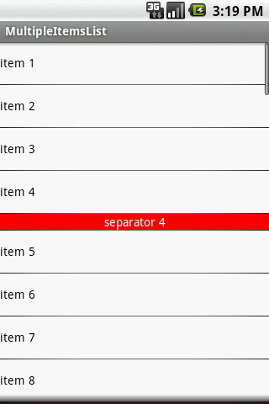
看看日志，无异常，所有的convertView都是空的

02-05 15:19:03.080: INFO/System.out(1035): getView 0 null type = 0
02-05 15:19:03.112: INFO/System.out(1035): getView 1 null type = 0
02-05 15:19:03.130: INFO/System.out(1035): getView 2 null type = 0
02-05 15:19:03.141: INFO/System.out(1035): getView 3 null type = 0
02-05 15:19:03.160: INFO/System.out(1035): getView 4 null type = 1
02-05 15:19:03.170: INFO/System.out(1035): getView 5 null type = 0
02-05 15:19:03.180: INFO/System.out(1035): getView 6 null type = 0
02-05 15:19:03.190: INFO/System.out(1035): getView 7 null type = 0
02-05 15:19:03.210: INFO/System.out(1035): getView 8 null type = 0
02-05 15:19:03.210: INFO/System.out(1035): getView 9 null type = 1
滚动list：
02-05 15:19:54.160: INFO/System.out(1035): getView 10 null type = 0
02-05 15:19:57.440: INFO/System.out(1035): getView 11 android.widget.LinearLayout@43744528 type = 0
02-05 15:20:01.310: INFO/System.out(1035): getView 12 android.widget.LinearLayout@43744eb0 type = 0
02-05 15:20:01.880: INFO/System.out(1035): getView 13 android.widget.LinearLayout@437456d8 type = 0
02-05 15:20:02.869: INFO/System.out(1035): getView 14 null type = 1
02-05 15:20:06.489: INFO/System.out(1035): getView 15 android.widget.LinearLayout@43745f00 type = 0
02-05 15:20:07.749: INFO/System.out(1035): getView 16 android.widget.LinearLayout@43747170 type = 0
02-05 15:20:10.250: INFO/System.out(1035): getView 17 android.widget.LinearLayout@43747998 type = 0
02-05 15:20:11.661: INFO/System.out(1035): getView 18 android.widget.LinearLayout@437481c0 type = 0
02-05 15:20:13.180: INFO/System.out(1035): getView 19 android.widget.LinearLayout@437468a0 type = 1
02-05 15:20:16.900: INFO/System.out(1035): getView 20 android.widget.LinearLayout@437489e8 type = 0
02-05 15:20:25.690: INFO/System.out(1035): getView 21 android.widget.LinearLayout@4374a8d8 type = 0
convertView对于分割线是空的，直到第一个分割线可见，当其离开屏幕，视图去到Recycler并且convertView开始起作用。

