Android 用纯代码实现复杂界面
分类： Android/OMS2012-11-29 09:49 2407人阅读 评论(0) 收藏 举报
在开发Android应用时有时会遇到纯代码实现复杂界面的需求，本文通过实例来演示，希望能对大家有所帮助
界面截图：
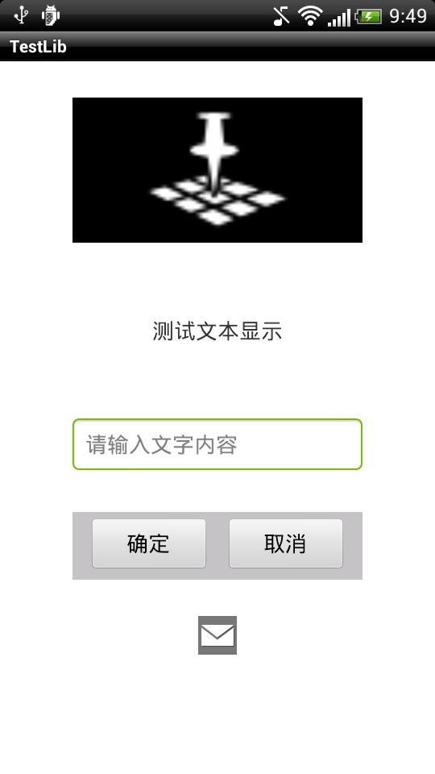

XML布局文件：
[html] view plaincopy
- <?xml version="1.0" encoding="utf-8"?>
- <ScrollView
- xmlns:android="http://schemas.android.com/apk/res/android"
- android:layout_width="fill_parent"
- android:layout_height="fill_parent"
- android:background="@android:color/white">

- <LinearLayout
- android:layout_width="fill_parent"
- android:layout_height="fill_parent"
- android:orientation="vertical"
- android:gravity="center">
- <ImageView
- android:layout_width="240dip"
- android:layout_height="120dip"
- android:layout_margin="30dip"
- android:layout_gravity="center_horizontal"
- android:background="@android:color/black"
- android:scaleType="fitCenter"
- android:adjustViewBounds="true"
- android:src="@android:drawable/ic_dialog_map"/>
- <TextView
- android:layout_width="fill_parent"
- android:layout_height="wrap_content"
- android:layout_margin="30dip"
- android:layout_gravity="center_horizontal"
- android:gravity="center_horizontal"
- android:textSize="18sp"
- android:text="测试文本显示"/>
- <EditText
- android:layout_width="240dip"
- android:layout_height="wrap_content"
- android:layout_margin="30dip"
- android:layout_gravity="center_horizontal"
- android:hint="请输入文字内容"
- android:maxLength="200"
- android:textSize="18sp"/>
- <LinearLayout
- android:id="@+id/button_layout"
- android:layout_width="240dip"
- android:layout_height="wrap_content"
- android:layout_gravity="center_horizontal"
- android:background="#c6c3c6"
- android:minHeight="54dip"
- android:orientation="horizontal"
- android:paddingTop="4dip"
- android:paddingBottom="4dip"
- android:paddingLeft="2dip"
- android:paddingRight="2dip" >
- <Button
- android:text="确定 "
- android:layout_width="wrap_content"
- android:layout_height="wrap_content"
- android:layout_gravity="left"
- android:layout_marginLeft="10dip"
- android:layout_marginRight="5dip"
- android:layout_weight="1"
- android:maxLines="2"
- android:textSize="18sp" />
- <Button
- android:text="取消"
- android:layout_width="wrap_content"
- android:layout_height="wrap_content"
- android:layout_gravity="right"
- android:layout_marginLeft="5dip"
- android:layout_marginRight="10dip"
- android:layout_weight="1"
- android:maxLines="2"
- android:textSize="18sp"/>
- </LinearLayout>
- <RelativeLayout
- android:layout_width="fill_parent"
- android:layout_height="wrap_content"
- >
- <ImageView
- android:id="@+id/ImageBottom"
- android:layout_width="wrap_content"
- android:layout_height="wrap_content"
- android:layout_below="@id/button_layout"
- android:layout_centerHorizontal="true"
- android:layout_margin="30dip"
- android:background="#FF777777"
- android:scaleType="fitCenter"
- android:adjustViewBounds="true"
- android:src="@android:drawable/ic_dialog_email"/>
- </RelativeLayout>

- </LinearLayout>

- </ScrollView>
通过纯代码实现XML同样的效果：
[java] view plaincopy
- import android.app.Activity;
- import android.content.Context;
- import android.graphics.Color;
- import android.os.Bundle;
- import android.text.InputFilter;
- import android.text.InputFilter.LengthFilter;
- import android.view.Gravity;
- import android.view.ViewGroup;
- import android.view.ViewGroup.LayoutParams;
- import android.widget.Button;
- import android.widget.EditText;
- import android.widget.ImageView;
- import android.widget.ImageView.ScaleType;
- import android.widget.LinearLayout;
- import android.widget.RelativeLayout;
- import android.widget.ScrollView;
- import android.widget.TextView;

- public class ActivityInfo extends Activity {

- @Override
- protected void onCreate(Bundle savedInstanceState) {
- // TODO Auto-generated method stub
- super.onCreate(savedInstanceState);
- // setContentView(R.layout.info);

- initUI();
- }

- public final void initUI(){
- ScrollView main = new ScrollView(this);
- main.setLayoutParams(new LayoutParams(LayoutParams.FILL_PARENT, LayoutParams.FILL_PARENT));
- main.setBackgroundColor(Color.WHITE);

- //根布局参数
- LinearLayout.LayoutParams layoutParamsRoot = new LinearLayout.LayoutParams(LinearLayout.LayoutParams.FILL_PARENT,LinearLayout.LayoutParams.FILL_PARENT);
- layoutParamsRoot.gravity = Gravity.CENTER;
- //根布局
- LinearLayout layoutRoot = new LinearLayout(this);
- layoutRoot.setLayoutParams(layoutParamsRoot);
- layoutRoot.setOrientation(LinearLayout.VERTICAL);

- //上边距（dp值）
- int topMargin = dip2px(this, 30);
- //imageMain宽度（dp值）
- int widthMain = dip2px(this, 240);
- //imageMain高度（dp值）
- int heightMain = dip2px(this, 120);

- //imageMain布局参数
- LinearLayout.LayoutParams layoutParamsImageMain = new LinearLayout.LayoutParams(widthMain,heightMain);
- layoutParamsImageMain.topMargin = topMargin;
- layoutParamsImageMain.bottomMargin = topMargin;
- layoutParamsImageMain.leftMargin = topMargin;
- layoutParamsImageMain.rightMargin = topMargin;
- layoutParamsImageMain.gravity=Gravity.CENTER_HORIZONTAL;
- //初始化ImageView
- ImageView imageMain = new ImageView(this);
- imageMain.setScaleType(ScaleType.FIT_CENTER);
- imageMain.setAdjustViewBounds(true);
- imageMain.setBackgroundColor(Color.BLACK);
- imageMain.setImageResource(android.R.drawable.ic_dialog_map);
- layoutRoot.addView(imageMain, layoutParamsImageMain);

- //textInfo布局参数
- LinearLayout.LayoutParams layoutParamsTextInfo = new LinearLayout.LayoutParams(LayoutParams.FILL_PARENT,LayoutParams.WRAP_CONTENT);
- layoutParamsTextInfo.topMargin = topMargin;
- layoutParamsTextInfo.bottomMargin = topMargin;
- layoutParamsTextInfo.leftMargin = topMargin;
- layoutParamsTextInfo.rightMargin = topMargin;
- layoutParamsTextInfo.gravity=Gravity.CENTER_HORIZONTAL;
- //初始化textInfo
- TextView textInfo = new TextView(this);
- textInfo.setGravity(Gravity.CENTER_HORIZONTAL);
- textInfo.setTextSize(18);
- layoutRoot.addView(textInfo, layoutParamsTextInfo);

- //editInfo布局参数
- LinearLayout.LayoutParams layoutParamsEditInfo = new LinearLayout.LayoutParams(widthMain,LayoutParams.WRAP_CONTENT);
- layoutParamsEditInfo.topMargin = topMargin;
- layoutParamsEditInfo.gravity=Gravity.CENTER_HORIZONTAL;
- //初始化editInfo
- EditText editInfo = new EditText(this);
- editInfo.setHint("请输入文字内容");
- //设置可输入的最大长度
- InputFilter[] filters = {new LengthFilter(200)};
- editInfo.setFilters(filters);
- editInfo.setTextSize(18);
- layoutRoot.addView(editInfo, layoutParamsEditInfo);

- //上边距（dp值）
- int minHeight = dip2px(this, 54);
- //上padding（dp值）
- int topPadding = dip2px(this, 4);
- //左padding（dp值）
- int leftPadding = dip2px(this, 2);
- //按钮布局
- LinearLayout layoutButton = new LinearLayout(this);
- layoutButton.setLayoutParams(layoutParamsEditInfo);
- layoutButton.setOrientation(LinearLayout.HORIZONTAL);
- layoutButton.setBackgroundColor(Color.parseColor("#c6c3c6"));
- layoutButton.setMinimumHeight(minHeight);
- layoutButton.setPadding(leftPadding, topPadding, leftPadding, topPadding);
- layoutButton.setId(100000001);

- //buttonOK布局参数
- LinearLayout.LayoutParams layoutParamsButtonOK = new LinearLayout.LayoutParams(LayoutParams.WRAP_CONTENT,LayoutParams.WRAP_CONTENT);
- layoutParamsButtonOK.gravity = Gravity.LEFT;
- layoutParamsButtonOK.leftMargin = dip2px(this, 10);
- layoutParamsButtonOK.rightMargin = dip2px(this, 5);
- layoutParamsButtonOK.weight = 1;
- //Button确定
- Button buttonOK = new Button(this);
- buttonOK.setLayoutParams(layoutParamsButtonOK);
- buttonOK.setMaxLines(2);
- buttonOK.setTextSize(18);
- buttonOK.setText("确定");
- layoutButton.addView(buttonOK);

- //buttonCancel布局参数
- LinearLayout.LayoutParams layoutParamsButtonCancel = new LinearLayout.LayoutParams(LayoutParams.WRAP_CONTENT,LayoutParams.WRAP_CONTENT);
- layoutParamsButtonCancel.gravity = Gravity.RIGHT;
- layoutParamsButtonCancel.leftMargin = dip2px(this, 5);
- layoutParamsButtonCancel.rightMargin = dip2px(this, 10);
- layoutParamsButtonCancel.weight = 1;
- //Button取消
- Button buttonCancel = new Button(this);
- buttonCancel.setLayoutParams(layoutParamsButtonCancel);
- buttonCancel.setMaxLines(2);
- buttonCancel.setTextSize(18);
- buttonCancel.setText("取消");

- layoutButton.addView(buttonCancel);

- layoutRoot.addView(layoutButton, layoutParamsEditInfo);

- //RelativeLayout布局参数
- LinearLayout.LayoutParams layoutParamsBottom = new LinearLayout.LayoutParams(LayoutParams.FILL_PARENT,LayoutParams.WRAP_CONTENT);
- RelativeLayout layoutBottom = new RelativeLayout(this);
- layoutBottom.setLayoutParams(layoutParamsBottom);

- RelativeLayout.LayoutParams paramsImageBottom = new RelativeLayout.LayoutParams(LayoutParams.WRAP_CONTENT, LayoutParams.WRAP_CONTENT);
- paramsImageBottom.addRule(RelativeLayout.BELOW, 100000001);
- paramsImageBottom.addRule(RelativeLayout.CENTER_HORIZONTAL, RelativeLayout.TRUE);
- paramsImageBottom.setMargins(topMargin, topMargin, topMargin, topMargin);

- //初始化ImageView
- ImageView imageBottom = new ImageView(this);
- imageBottom.setScaleType(ScaleType.FIT_CENTER);
- imageBottom.setAdjustViewBounds(true);
- imageBottom.setBackgroundColor(0xFF777777);
- imageBottom.setImageResource(android.R.drawable.ic_dialog_email);
- layoutBottom.addView(imageBottom, paramsImageBottom);
- layoutRoot.addView(layoutBottom);

- //TODO TEST
- // imageMain.setBackgroundResource(android.R.drawable.ic_dialog_map);
- textInfo.setText("测试文本显示");

- main.addView(layoutRoot);
- setContentView(main);
- }

- /**
- * 根据手机的分辨率从 dp 的单位 转成为 px(像素)
- */
- public static int dip2px(Context context, float dpValue) {
- final float scale = context.getResources().getDisplayMetrics().density;
- return (int) (dpValue * scale + 0.5f);
- }

- /**
- * 根据手机的分辨率从 px(像素) 的单位 转成为 dp
- */
- public static int px2dip(Context context, float pxValue) {
- final float scale = context.getResources().getDisplayMetrics().density;
- return (int) (pxValue / scale + 0.5f);
- }

- }

