Overview

This technical report analyzes how mortality attributable to influenza seasons in the United States has varied over time, using data from CDC WONDER. The report includes main findings, a description of the dataset, the rationale behind each methodological choice, and a discussion of limitations.

The goal of this task is to:
Create a fully documented and reproducible analysis that produces clear visualizations of mortality attributable to influenza seasons in the United States and how it has varied over time. The final output should make it easy for a reader to understand:
- When influenza-attributable mortality was high or low (across seasons/years)
- How patterns differ by age
- How sensitive the visual conclusions are to scale/zoom choices (for example, zooming into particular age ranges or using alternative scaling to reveal patterns)
Findings
National influenza mortality exhibits substantial year-to-year volatility. The largest spike during the 25-year period occurred in the 2017–2018 season, when the national mortality rate approached 4 deaths per 100,000 population. Other notable high-mortality seasons include 2014–2015 and 2023–2024. My estimates are broadly consistent with findings from Doshi (2008), who reported 3.0 deaths per 100,000 population in 1967–1968, with mortality rates remaining lower than that in subsequent years.
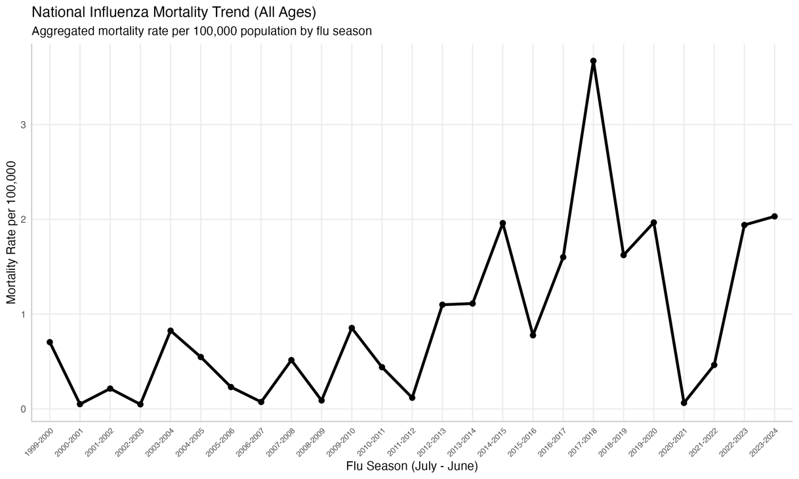

Influenza mortality is heavily skewed toward the oldest segments of the population, a pattern consistent across nearly every high-severity season.
- Elderly Vulnerability: The 85+ years age group consistently experiences the highest mortality rates, peaking at over 75 deaths per 100,000 during the 2017–2018 season. The 75–84 years and 65–74 years groups follow as the next most impacted cohorts.
- Youth Trends: In contrast, mortality rates for individuals under age 45 are extremely low in comparison to the elderly. While these groups still experience seasonal fluctuations, their rates often remain below 1 death per 100,000.
- Consistency of Spikes: Major "bad" flu years (like 2014–2015 and 2017–2018) show synchronized spikes across almost all age groups.
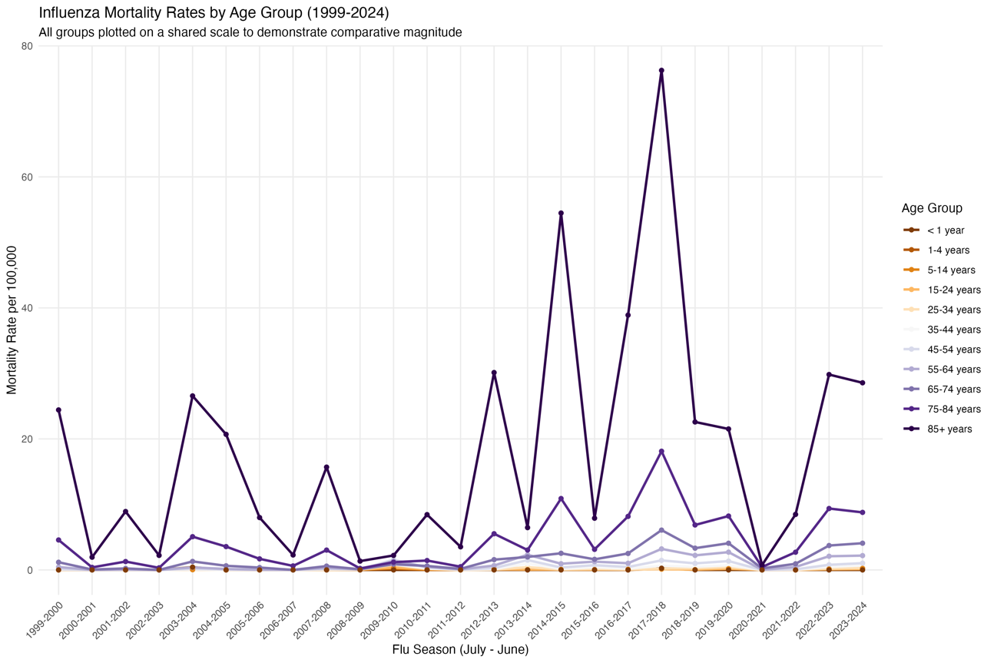
The interpretation of influenza data is highly sensitive to how the Y-axis is scaled. When all age groups are plotted on a shared scale (0–80 per 100k), the mortality of younger groups (0–44 years) appears as a flat line near zero and is not sensitive to flu seasons at all. By "zooming in" on individual age groups using independent Y-axes (free scales), the seasonal volatility in younger groups becomes visible.
For example, in the 15–24 years group, a free scale reveals a distinct mortality spike during the 2009–2010 H1N1 pandemic, a detail that is completely invisible on a fixed national scale. In the 1–4 years group, free scaling shows that while their mortality is low (peaking at ~0.4 per 100k), they still experience clear seasonal cycles that mirror the national trend.
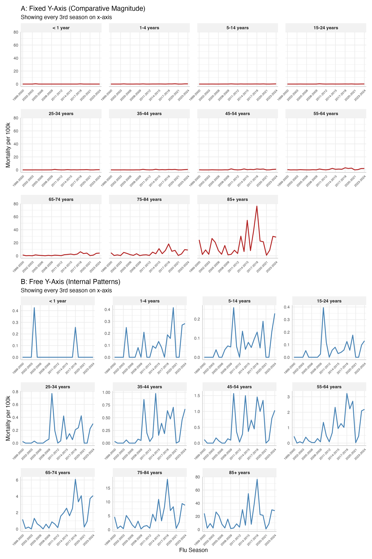
Below are more technical details to generate the graphs and conclusions.
Dataset Description
The data for this analysis were obtained from the Centers for Disease Control and Prevention (CDC) WONDER Online Database. This database provides mortality counts based on death certificates for U.S. residents, as well as annual number of population estimates. Two primary datasets were used to construct the full 25-year time series from 1999 to 2024:
- Data from 1999 to 2020 come from Multiple Cause of Death, 1999-2020 (D77)
https://wonder.cdc.gov/mcd-icd10.html
- Data from 2018 to 2024 come from Multiple Cause of Death, 2018-Present (D157)
https://wonder.cdc.gov/mcd-icd10-expanded.html
Methodology
- Cause of Death: The analysis filters for ICD-10 codes J09 (avian influenza), J10 (influenza due to identified virus), and J11 (influenza, virus not identified).

- Definition of Flu Seasons: Influenza is a seasonal illness, and elevated mortality due to the outbreak can occur across calendar years (Doshi, 2008). Rather than using standard calendar years (January–December), data was aggregated into Flu Seasons (July 1–June 30). This approach captures the full lifecycle of the winter peak in the United States, preventing a single outbreak from being split across two reporting years. I examine trends from the 1999–2000 season through the 2023–2024 season. Data from the first half of 1999 and the second half of 2025 are excluded because only six months of those seasons are available, rendering them incomplete.

- Measures: The report utilizes raw death counts and population estimates to calculate mortality rates per 100,000 population. Population estimates are derived from the average of two consecutive years within the season. Death counts are derived from summing up the death counts from all the months within the season.

- Demographics: Data is grouped by ten-year age groups to identify disparities in risk across ages.

- Visual Forms: I generate three graphs to show how the visual conclusions vary by different scales

  - Total Plot: A single-line plot shows the overall mortality rate for all ages combined, highlighting severe years such as the 2017–2018 season.
  - Combined Plot: All age groups are plotted on a single Y-axis (0 to 80 deaths per 100,000).
  - Comparison Plot: Two faceted views were created. One uses a fixed scale for direct comparison, while the "free y-axis" view allows for the visualization of internal patterns in younger age groups whose mortality rates would otherwise appear as flat lines on a larger scale.

Limitations and Caveats
- Data Suppression: CDC Wonder suppressed the death counts when the counts is smaller than 10. I treated the suppressed as 0 when I sum the monthly counts up. This means my final numbers are likely lower than the actual totals. Future researchers might choose to estimate these missing counts differently to find a higher possible range.

- ICD Code: Prior literature has used various criteria to define influenza-attributable mortality. It is well established that the number of influenza-related deaths cannot be determined solely from deaths coded as influenza (Thompson et al, 2009). Many influenza-associated deaths occur one or two weeks after the initial infection due to secondary bacterial infections or because influenza exacerbates underlying chronic conditions. For this task, I adopt a narrower definition to provide a lower-bound estimate. Future research could expand the definition to generate higher-bound estimates.

- Population ageing: Because this study covers a 25-year period (1999–2024), the “All Ages” mortality rate may be affected by the aging of the “Baby Boomer” generation. Influenza-related deaths are disproportionately concentrated among older adults, so an upward trend in national mortality could reflect population aging rather than an increase in the virus’s virulence or shortcomings in public health interventions. As a result, the raw national mortality rate may give the misleading impression that influenza risk is rising over time, when the trend is actually driven by demographic shifts.

- Data aggregation: A further limitation is the aggregation of mortality data into 12-month seasonal blocks. While this provides a clear year-over-year comparison, it obscures the intensity and duration of specific outbreaks. Influenza mortality is characterized by extreme “spikes” concentrated within a 11-week window (Viboud, 2004). By averaging these deaths over a full year, the resulting mortality rates may underrepresent the acute strain placed on the healthcare system during peak months.

References
Doshi P. Trends in recorded influenza mortality: United States, 1900-2004. Am J Public Health. 2008 May;98(5):939-45. doi: 10.2105/AJPH.2007.119933. Epub 2008 Apr 1. Erratum in: Am J Public Health. 2009 Aug;99(8):1353-4. PMID: 18381993; PMCID: PMC2374803.
Thompson, W. W., Moore, M. R., Weintraub, E., Cheng, P. Y., Jin, X., Bridges, C. B., ... & Shay, D. K. (2009). Estimating influenza-associated deaths in the United States. American journal of public health, 99(S2), S225-S230.
Viboud C, Boëlle PY, Pakdaman K, Carrat F, Valleron AJ, Flahault A. Influenza epidemics in the United States, France, and Australia, 1972-1997. Emerg Infect Dis. 2004 Jan;10(1):32-9. doi: 10.3201/eid1001.020705. PMID: 15078594; PMCID: PMC3322745.

