**Sono | Documentation**

# Didn't you add it? [here](https://discord.com/oauth2/authorize?client_id=833559792105553920&permissions=1133584&scope=bot)

# **Meet Sono**

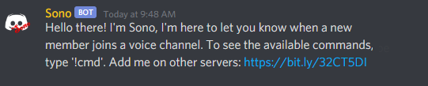

**Sono is a bot that plays a sound from YouTube when a certain user joins a voice channel.**

Please do not use sounds that exceed 15 seconds, as they may cause some bugs.

* It does not have so many commands, but these are enough. ;)
  + s!add

s!add user_mention url - is used to add a user with a specific URL in a list. (aliases: a)

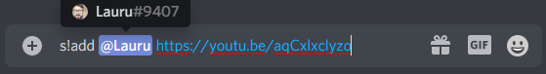

Sono will respond with

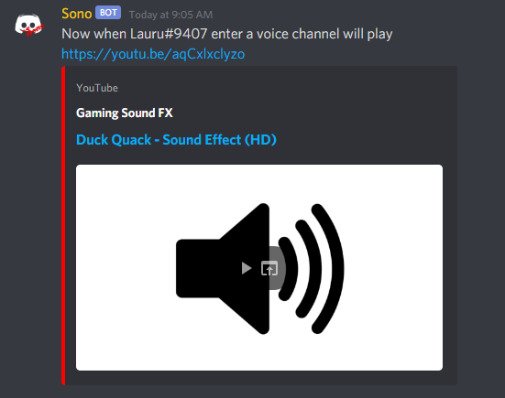

* + s!delete

s!delete user_mention - is used to remove a user from the list. (aliases: del, d)

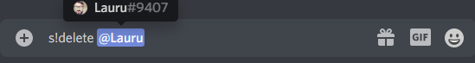

Sono will respond with



* + s!reset

s!reset - is used to remove all users from the list. (aliases: r, res)

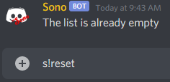

* + s!clear

s!clear amount - is an aditional command made for clearing the chat. (aliases: c)



* + s!list

s!list - show the list of the user wich will get a sound on join.

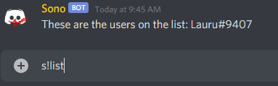

* + s!debug

s!debug - show information about the bot

Like this

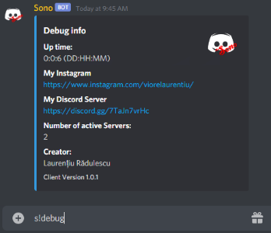

Once you have been added to the list, when you join in a voice channel, Sono will enter after you and play the sound you gave.

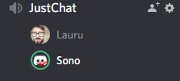

For sugestions on how should i improve the bot, dm me on discord. I am Lauru#9407.