MDPI Biomass 期刊：论文筛选、复现与方法改进实验报告
目标论文：Nishimura, A.P.Y.; Voll, F.A.P.; Krieger, N.; Mitchell, D.A. A Semi-Mechanistic Approach to Modeling Lipase-Catalyzed Processes with Multiple Competing Reactions: Demonstration for the Esterification of Trimethylolpropane. Biomass 2026, 6, 12. doi:10.3390/biomass6010012
本报告记录完整的实验过程：如何从 Biomass 最近 80 篇论文中选出这篇论文，如何核对公开数据，如何复现原文结果，设计了什么新方法（PPK-FIP），以及全部对比实验、消融实验和统计检验。报告中的所有数字都由脚本从 Biomass/results/ 下的结果文件读取，没有手工填写。

1. 期刊论文筛选（最近 80 篇）
通过 Crossref API（ISSN 2673-8783）获取 Biomass 最近发表的 80 篇论文（2025-12-22 至 2026-09-30），从 mdpi-res.com 下载了全部 80 篇 PDF、提取文本，并抓取了所有可下载的补充材料。逐篇评估以下几项：数据是否公开、能否下载、数据规模、原方法、复现难度、新方法思路与创新性、能否全面超过原文。打分规则与此前各期刊相同：score = 0.4×数据公开 + 0.3×复现耗时 + 0.2×实现难易 + 0.1×图数（上限 10）。
表 1-1 筛选结果前 20 名（全部 80 篇见 Biomass/screening.csv）
rank | article | score | s_data | s_time | s_ease | n_figures | data_availability | original_method | beat_original_feasibility
1 | 12 | 5.20 | 5 | 5 | 4 | 9 | public: Supplementary PDF Tables S1-S7 give every reaction profile (t, c, Z, M, D, T) used in the paper (digitised from 4 literature sources) | two-step semi-mechanistic Ping Pong bi bi kinetics: least-squares selectivity fingerprinting (SM, SD) then dynamic ODE fit (kA, FA, FAZ, FAM, FAD); Scilab; Fobj/BIC + Hessian CIs | high: original reports in-sample Fobj/BIC per dataset only and treats datasets separately; joint/hybrid model can lower Fobj and BIC and be tested out-of-sample
2 | 50 | 5.00 | 5 | 5 | 4 | 7 | public (Supplementary File S1 xlsx: raw long-format data 480 rows + all statistical outputs; S2 Python script) | repeated-measures MixedLM (statsmodels) + Tukey HSD + economics | no predictive performance metric reported (inferential study); improvement not measurable as 'beating' a score
3 | 22 | 4.50 | 4 | 5 | 4 | 6 | Supplementary Table S1 (13 RSM runs) | central composite RSM (quadratic) | possible but N=13
4 | 60 | 4.40 | 4 | 4 | 3 | 13 | Supplementary (34-case sub-index matrix + calculations) | Biopolygeneration Diagnostic Index gap decomposition | no predictive metric to beat
5 | 61 | 3.90 | 4 | 4 | 3 | 5 | Supplementary (spreadsheets + robustness script) | energy/exergy/emergy indices + MCDA (Monte Carlo, Pareto, critical weights) | no predictive metric to beat
6 | 25 | 3.90 | 4 | 4 | 3 | 5 | Supplementary (agricultural statistics, survey responses, normalized matrix, scenarios) | spatial MCDA (TOPSIS-like) for substrate selection | no predictive metric
7 | 17 | 3.90 | 4 | 3 | 2 | 11 | Supplementary CSVs (NREL TMY solar, WIND Toolkit, load SI 3) | HOMER-type hybrid PV-wind-biomass system sizing | possible but not a predictive benchmark
8 | 58 | 3.70 | 3 | 3 | 3 | 10 | partly public: Table S1 has LBO data only; SR/AP/HBO data are in an earlier paper [7] | PCA + linear regression (MATLAB); D_mod partition coefficient | plausible but data split across two papers
9 | 37 | 3.50 | 3 | 4 | 4 | 3 | Supplementary Table S1 (complete physicochemical dataset) | descriptive characterization | no model to beat
10 | 5 | 3.50 | 3 | 3 | 3 | 8 | Supplementary PDF (Py-GC/MS compound identification tables) | catalytic fast pyrolysis Py-GC/MS | no model to beat
11 | 2 | 3.40 | 3 | 3 | 3 | 7 | Supplementary (Py-GC/MS compound lists) | TGA + Py-GC/MS of greenhouse waste | no model to beat
12 | 66 | 3.30 | 3 | 4 | 4 | 1 | Supplementary (Taguchi L9 design results) | Taguchi L9 screening + ANOVA | weak (9 runs)
13 | 52 | 3.30 | 2 | 3 | 3 | 18 | in article only (summary tables / figures) | hydrochar surface chemistry and metal binding isotherms | weak (tiny N, raw replicates missing)
14 | 36 | 3.30 | 2 | 3 | 3 | 10 | in article only (summary tables / figures) | GHG flux from fish waste composting | weak (tiny N, raw replicates missing)
15 | 75 | 3.10 | 2 | 3 | 3 | 8 | in article only (summary tables / figures) | TGA isoconversional kinetics (FWO/KAS) + thermodynamics | weak (tiny N, raw replicates missing)
16 | 55 | 3.10 | 2 | 3 | 3 | 8 | in article only (summary tables / figures) | Box-Behnken lignin extraction + bioethanol | weak (tiny N, raw replicates missing)
17 | 45 | 3.10 | 2 | 3 | 3 | 8 | Supplementary (DFT geometries only); adsorption data in appendix tables | adsorption isotherms + kinetics + DFT | weak
18 | 21 | 3.10 | 2 | 3 | 3 | 8 | Supplementary PDF (summary statistics only) | MSR + biomethanation BES | weak
19 | 65 | 3.00 | 2 | 3 | 3 | 7 | in article only (summary tables / figures) | dual-chamber MFC performance comparison | weak (tiny N, raw replicates missing)
20 | 40 | 3.00 | 2 | 3 | 3 | 7 | in article only (summary tables / figures) | IAA production by Streptomyces, docking | weak (tiny N, raw replicates missing)

结论：Biomass 以实验化学类论文为主，绝大多数论文的数据只能“向作者索取”或只在正文里给出汇总表。排名第 1 的 #12 在补充材料里完整给出了全部 11 条反应曲线（198 行），而且原文每一个拟合都印出了 Fobj、BIC 和参数，可以逐项核对，因此入选。淘汰记录：#49（PINN）的 72 个数据点无法重建；#41 数据保密；#58 数据分散在两篇论文中；#50 是推断性研究，没有可超越的预测指标。

2. 数据核对（硬性要求）
核对结果：36/36 项硬性核对全部一致。原文没有直接写样本量，但每个动态拟合都印了 Fobj、BIC 和参数个数 k；只有当公开数据的点数 nT 完全正确时，才能复算出原文印出的 BIC。12 个 BIC 全部复算一致。4 个指纹模型的残差平方和精确复现到小数点后一位，这要求每一个数据值都和原文所用的一致。数据集和批次组成、无重复时间点、Mao 数据的 Z 缺失（原文已说明）都与原文一致。
表 2-1 数据核对表
item | paper | public_data | match
Table 1 Akerman70 full: printed BIC recomputed with public nT=36 (Fobj=59.0, k=5) | 35.7 | 35.7 | YES
Table 1 Akerman100 full: printed BIC recomputed with public nT=28 (Fobj=117.9, k=5) | 56.9 | 56.9 | YES
Table 2 Akerman70 simplified: printed BIC recomputed with public nT=36 (Fobj=70.9, k=3) | 35.1 | 35.1 | YES
Table 2 Akerman100 simplified: printed BIC recomputed with public nT=28 (Fobj=118.0, k=3) | 50.3 | 50.3 | YES
Table 3 Bornadel full: printed BIC recomputed with public nT=120 (Fobj=329.9, k=5) | 145.3 | 145.3 | YES
Table 3 Bornadel simplified: printed BIC recomputed with public nT=120 (Fobj=329.9, k=4) | 140.5 | 140.5 | YES
Table 4 Tao025 full: printed BIC recomputed with public nT=64 (Fobj=121.2, k=5) | 61.7 | 61.7 | YES
Table 4 Tao035+045 full: printed BIC recomputed with public nT=144 (Fobj=325.8, k=5) | 142.4 | 142.4 | YES
Table 5 Tao025 simplified: printed BIC recomputed with public nT=64 (Fobj=123.5, k=3) | 54.5 | 54.5 | YES
Table 5 Tao035+045 simplified: printed BIC recomputed with public nT=144 (Fobj=326.7, k=3) | 132.9 | 132.9 | YES
Table 6 Mao1-3 full: printed BIC recomputed with public nT=141 (Fobj=1475.9, k=7) | 365.7 | 365.7 | YES
Table 6 Mao1-3 simplified: printed BIC recomputed with public nT=141 (Fobj=1771.5, k=5) | 381.6 | 381.6 | YES
Number of literature sources / case studies | 4 | 4 | YES
Akerman datasets (70 and 100 C) | 2 | 2 | YES
Tao datasets (aw 0.25/0.35/0.45) | 3 | 3 | YES
Mao batches tabulated / used | 5 / 3 | 5 / 3 | YES
Akerman70: rows / duplicated time stamps / missing (c,M,D,T) / missing Z | - | 10 / 0 / 0 / 0 | YES
Akerman70: max |Z+M+D+T-100| and max |M+2D+3T-c| | 0 (definition) | 0.0001 / 0.0001 | YES
Akerman100: rows / duplicated time stamps / missing (c,M,D,T) / missing Z | - | 8 / 0 / 0 / 0 | YES
Akerman100: max |Z+M+D+T-100| and max |M+2D+3T-c| | 0 (definition) | 0.0001 / 0.0002 | YES
Bornadel: rows / duplicated time stamps / missing (c,M,D,T) / missing Z | - | 31 / 0 / 0 / 0 | YES
Bornadel: max |Z+M+D+T-100| and max |M+2D+3T-c| | 0 (definition) | 3.0198 / 0.0002 | INFO
Tao025: rows / duplicated time stamps / missing (c,M,D,T) / missing Z | - | 17 / 0 / 0 / 0 | YES
Tao025: max |Z+M+D+T-100| and max |M+2D+3T-c| | 0 (definition) | 0.0001 / 0.0002 | YES
Tao035: rows / duplicated time stamps / missing (c,M,D,T) / missing Z | - | 19 / 0 / 0 / 0 | YES
Tao035: max |Z+M+D+T-100| and max |M+2D+3T-c| | 0 (definition) | 0.0001 / 0.0003 | YES
Tao045: rows / duplicated time stamps / missing (c,M,D,T) / missing Z | - | 19 / 0 / 0 / 0 | YES
Tao045: max |Z+M+D+T-100| and max |M+2D+3T-c| | 0 (definition) | 0.0001 / 0.0003 | YES
Mao1: rows / duplicated time stamps / missing (c,M,D,T) / missing Z | - | 16 / 0 / 0 / 16 | YES
Mao1: |M+2D+3T-c| (c from 3x acid conversion, independent measurement) | not required | median 2.7, max 17.0 | INFO
Mao2: rows / duplicated time stamps / missing (c,M,D,T) / missing Z | - | 17 / 0 / 0 / 17 | YES
Mao2: |M+2D+3T-c| (c from 3x acid conversion, independent measurement) | not required | median 9.7, max 20.8 | INFO
Mao3: rows / duplicated time stamps / missing (c,M,D,T) / missing Z | - | 17 / 0 / 0 / 17 | YES
Mao3: |M+2D+3T-c| (c from 3x acid conversion, independent measurement) | not required | median 6.0, max 9.8 | INFO
Mao4: rows / duplicated time stamps / missing (c,M,D,T) / missing Z | - | 20 / 0 / 0 / 20 | YES
Mao4: |M+2D+3T-c| (c from 3x acid conversion, independent measurement) | not required | median 14.5, max 55.5 | INFO
Mao5: rows / duplicated time stamps / missing (c,M,D,T) / missing Z | - | 24 / 0 / 0 / 24 | YES
Mao5: |M+2D+3T-c| (c from 3x acid conversion, independent measurement) | not required | median 18.2, max 28.8 | INFO
Fingerprinting fit Akerman: sum of squares reproduced on public data | 74.2 | 74.2 | YES
Fingerprinting fit Bornadel: sum of squares reproduced on public data | 840.6 | 840.6 | YES
Fingerprinting fit Tao: sum of squares reproduced on public data | 535.3 | 535.3 | YES
Fingerprinting fit Mao: sum of squares reproduced on public data | 1616.0 | 1616.0 | YES

3. 原文方法复现
复现内容：步骤 1 指纹模型（SM、SD、SS、95% CI）；步骤 2 动态模型（表 1–6：kE=kA·[E]T、FA、FAZ、FAM、FAD、Fobj、BIC）。为了加速，推导出了精确的时间重参数化（共享 Ping Pong 分母 ⇒ kE·t(c) 是 5 个路径积分的线性组合），并与直接 ODE 积分做了校验。
表 3-1 原文印出的每一个数字与复现值的对比（refit = 我们的 30 起点全局最优；at_paper_point = 代入原文印出的参数后得到的值）
table | case | model | item | paper | refit | at_paper_point | status
Sec. 3 (fingerprint) | Akerman | fingerprint | SM | 0.3890 | 0.3894 |  | reproduced
Sec. 3 (fingerprint) | Akerman | fingerprint | SM 95% CI | 0.0260 | 0.0255 |  | differs
Sec. 3 (fingerprint) | Akerman | fingerprint | SD | 0.0311 | 0.0311 |  | reproduced
Sec. 3 (fingerprint) | Akerman | fingerprint | SD 95% CI | 0.0035 | 0.0035 |  | reproduced
Sec. 3 (fingerprint) | Akerman | fingerprint | SS | 74.2000 | 74.1797 |  | reproduced
Sec. 3 (fingerprint) | Bornadel | fingerprint | SM | 0.9090 | 0.9093 |  | reproduced
Sec. 3 (fingerprint) | Bornadel | fingerprint | SM 95% CI | 0.0960 | 0.0942 |  | differs
Sec. 3 (fingerprint) | Bornadel | fingerprint | SD | 0.0660 | 0.0657 |  | reproduced
Sec. 3 (fingerprint) | Bornadel | fingerprint | SD 95% CI | 0.0110 | 0.0122 |  | differs
Sec. 3 (fingerprint) | Bornadel | fingerprint | SS | 840.6000 | 840.6272 |  | reproduced
Sec. 3 (fingerprint) | Tao | fingerprint | SM | 0.7610 | 0.7607 |  | reproduced
Sec. 3 (fingerprint) | Tao | fingerprint | SM 95% CI | 0.0250 | 0.0235 |  | differs
Sec. 3 (fingerprint) | Tao | fingerprint | SD | 0.3330 | 0.3330 |  | reproduced
Sec. 3 (fingerprint) | Tao | fingerprint | SD 95% CI | 0.0120 | 0.0113 |  | differs
Sec. 3 (fingerprint) | Tao | fingerprint | SS | 535.3000 | 535.3388 |  | reproduced
Sec. 3 (fingerprint) | Mao | fingerprint | SM | 0.9160 | 0.9158 |  | reproduced
Sec. 3 (fingerprint) | Mao | fingerprint | SM 95% CI | 0.0940 | 0.0854 |  | differs
Sec. 3 (fingerprint) | Mao | fingerprint | SD | 0.3780 | 0.3783 |  | reproduced
Sec. 3 (fingerprint) | Mao | fingerprint | SD 95% CI | 0.0370 | 0.0326 |  | differs
Sec. 3 (fingerprint) | Mao | fingerprint | SS | 1616.0000 | 1616.0115 |  | reproduced
Table 1 | Akerman70 | full | Fobj | 59.0000 | 58.4010 | 59.0054 | reproduced
Table 1 | Akerman70 | full | BIC | 35.7000 | 35.3349 | 35.7055 | reproduced
Table 1 | Akerman70 | full | enzyme loading E = kE/kA implied |  | 11547.3441 | 1.9980 | differs
Table 1 | Akerman70 | full | FA | 0.0001 | 175.3548 | 0.0001 | differs
Table 1 | Akerman70 | full | FAZ | 0.0022 | 29.8946 | 0.0022 | differs
Table 1 | Akerman70 | full | FAM | 0.0050 | 43.0752 | 0.0050 | differs
Table 1 | Akerman70 | full | FAD | 0.0021 | 12.0726 | 0.0021 | differs
Table 1 | Akerman100 | full | Fobj | 117.9000 | 48.9159 | 117.9603 | improved (paper not at optimum)
Table 1 | Akerman100 | full | BIC | 56.9000 | 32.2822 | 56.9290 | differs
Table 1 | Akerman100 | full | enzyme loading E = kE/kA implied |  | 7485.0299 | 2.0009 | differs
Table 1 | Akerman100 | full | FA | 0.0000 | 370.1740 | 0.0000 | differs
Table 1 | Akerman100 | full | FAZ | 0.0000 | 2.3874 | 0.0000 | differs
Table 1 | Akerman100 | full | FAM | 0.0023 | 21.0197 | 0.0023 | differs
Table 1 | Akerman100 | full | FAD | 0.0013 | 0.2957 | 0.0013 | differs
Table 2 | Akerman70 | simplified | Fobj | 70.9000 | 70.8927 | 70.8961 | reproduced
Table 2 | Akerman70 | simplified | BIC | 35.1000 | 35.1459 | 35.1476 | reproduced
Table 2 | Akerman70 | simplified | enzyme loading E = kE/kA implied |  | 2.0008 | 1.9988 | differs
Table 2 | Akerman70 | simplified | FAM | 0.0022 | 0.0022 | 0.0022 | reproduced
Table 2 | Akerman70 | simplified | FAD | 0.0010 | 0.0010 | 0.0010 | reproduced
Table 2 | Akerman100 | simplified | Fobj | 118.0000 | 117.9900 | 118.0103 | reproduced
Table 2 | Akerman100 | simplified | BIC | 50.3000 | 50.2717 | 50.2765 | reproduced
Table 2 | Akerman100 | simplified | enzyme loading E = kE/kA implied |  | 2.0035 | 2.0057 | differs
Table 2 | Akerman100 | simplified | FAM | 0.0022 | 0.0023 | 0.0022 | reproduced
Table 2 | Akerman100 | simplified | FAD | 0.0013 | 0.0013 | 0.0013 | reproduced
Table 3 | Bornadel | full | Fobj | 329.9000 | 329.8956 | 329.8962 | reproduced
Table 3 | Bornadel | full | BIC | 145.3000 | 145.2916 | 145.2918 | reproduced
Table 3 | Bornadel | full | enzyme loading E = kE/kA implied |  | 4.9999 | 5.0025 | differs
Table 3 | Bornadel | full | FA | 0.0000 | 0.0000 | 0.0000 | differs
Table 3 | Bornadel | full | FAZ | 0.0395 | 0.0395 | 0.0395 | reproduced
Table 3 | Bornadel | full | FAM | 0.0125 | 0.0125 | 0.0125 | reproduced
Table 3 | Bornadel | full | FAD | 0.0093 | 0.0093 | 0.0093 | reproduced
Table 3 | Bornadel | simplified | Fobj | 329.9000 | 329.8956 | 329.8962 | reproduced
Table 3 | Bornadel | simplified | BIC | 140.5000 | 140.5041 | 140.5043 | reproduced
Table 3 | Bornadel | simplified | enzyme loading E = kE/kA implied |  | 4.9999 | 5.0025 | differs
Table 3 | Bornadel | simplified | FAZ | 0.0395 | 0.0395 | 0.0395 | reproduced
Table 3 | Bornadel | simplified | FAM | 0.0125 | 0.0125 | 0.0125 | reproduced
Table 3 | Bornadel | simplified | FAD | 0.0093 | 0.0093 | 0.0093 | reproduced
Table 4 | Tao025 | full | Fobj | 121.2000 | 110.7507 | 458.2119 | improved (paper not at optimum)
Table 4 | Tao025 | full | BIC | 61.7000 | 55.8919 | 146.7751 | differs
Table 4 | Tao025 | full | enzyme loading E = kE/kA implied |  | 312.2351 | 0.0906 | differs
Table 4 | Tao025 | full | FA | 0.0259 | 1000.0000 | 0.0259 | differs
Table 4 | Tao025 | full | FAZ | 0.0089 | 28.6226 | 0.0089 | differs
Table 4 | Tao025 | full | FAM | 0.0130 | 49.2218 | 0.0130 | differs
Table 4 | Tao025 | full | FAD | 0.0000 | 0.0000 | 0.0000 | differs
Table 4 | Tao035_045 | full | Fobj | 325.8000 | 319.6030 | 423.8116 | improved (paper not at optimum)
Table 4 | Tao035_045 | full | BIC | 142.4000 | 139.6554 | 180.2936 | differs
Table 4 | Tao035_045 | full | enzyme loading E = kE/kA implied |  | 300.0225 | 0.0923 | differs
Table 4 | Tao035_045 | full | FA | 0.0288 | 1000.0000 | 0.0288 | differs
Table 4 | Tao035_045 | full | FAZ | 0.0074 | 23.3928 | 0.0074 | differs
Table 4 | Tao035_045 | full | FAM | 0.0135 | 46.1332 | 0.0135 | differs
Table 4 | Tao035_045 | full | FAD | 0.0000 | 0.0000 | 0.0000 | differs
Table 5 | Tao025 | simplified | Fobj | 123.5000 | 202.1192 | 590.4979 | differs
Table 5 | Tao025 | simplified | BIC | 54.5000 | 86.0750 | 154.6900 | differs
Table 5 | Tao025 | simplified | enzyme loading E = kE/kA implied |  | 0.0629 | 0.0900 | differs
Table 5 | Tao025 | simplified | FAZ | 0.0081 | 0.0050 | 0.0081 | differs
Table 5 | Tao025 | simplified | FAM | 0.0117 | 0.0049 | 0.0117 | differs
Table 5 | Tao035_045 | simplified | Fobj | 326.7000 | 337.9204 | 448.8117 | differs
Table 5 | Tao035_045 | simplified | BIC | 132.9000 | 137.7410 | 178.6072 | differs
Table 5 | Tao035_045 | simplified | enzyme loading E = kE/kA implied |  | 0.0776 | 0.0918 | differs
Table 5 | Tao035_045 | simplified | FAZ | 0.0067 | 0.0051 | 0.0067 | differs
Table 5 | Tao035_045 | simplified | FAM | 0.0122 | 0.0088 | 0.0122 | differs
Table 6 | Mao123 | full | Fobj | 1475.9000 | 1373.1624 | 1476.5368 | improved (paper not at optimum)
Table 6 | Mao123 | full | BIC | 365.7000 | 355.5731 | 365.8073 | differs
Table 6 | Mao123 | full | enzyme loading E = kE/kA implied |  | 22041.1399 | 15.0234 | differs
Table 6 | Mao123 | full | FA | 0.3450 | 1000.0000 | 0.3450 | differs
Table 6 | Mao123 | full | FAZ | 0.0156 | 21.3561 | 0.0156 | differs
Table 6 | Mao123 | full | FAM | 0.0154 | 26.4548 | 0.0154 | differs
Table 6 | Mao123 | full | FAD | 0.0000 | 0.0000 | 0.0000 | differs
Table 6 | Mao123 | simplified | Fobj | 1771.5000 | 1624.4059 | 1631.3732 | improved (paper not at optimum)
Table 6 | Mao123 | simplified | BIC | 381.6000 | 369.3672 | 369.9707 | differs
Table 6 | Mao123 | simplified | enzyme loading E = kE/kA implied |  | 15.4167 | 15.0345 | differs
Table 6 | Mao123 | simplified | FAZ | 0.0080 | 0.0081 | 0.0080 | differs
Table 6 | Mao123 | simplified | FAM | 0.0070 | 0.0074 | 0.0070 | differs

复现结论：(1) 指纹模型 4/4 完全复现（SM、SD、SS），置信区间相差 2–12%（协方差计算细节不同）。(2) Åkerman 和 Bornadel 的简化模型 Fobj、BIC、FAM、FAD 完全复现，反推出的酶载量为整数（2.00 和 5.00 %w/w）。(3) 把原文印出的参数代入，可以还原原文的 Fobj（Åkerman 全模型 59.0/117.96，Mao 全模型 1476.5，E=15.0），说明模型实现与原文一致；但原文的全模型拟合停在了非最优点：例如 Åkerman 100 °C 的全局最优是 48.9，而原文是 117.9。(4) Mao 案例原文使用的是 A0 = 10/3.3 = 303.03（补充材料 S2 的投料量），不是名义上的 3:1。(5) Tao 案例的动态拟合无法复现：代入原文参数后，在任何 A0 下都得不到原文的 Fobj，已如实记录。
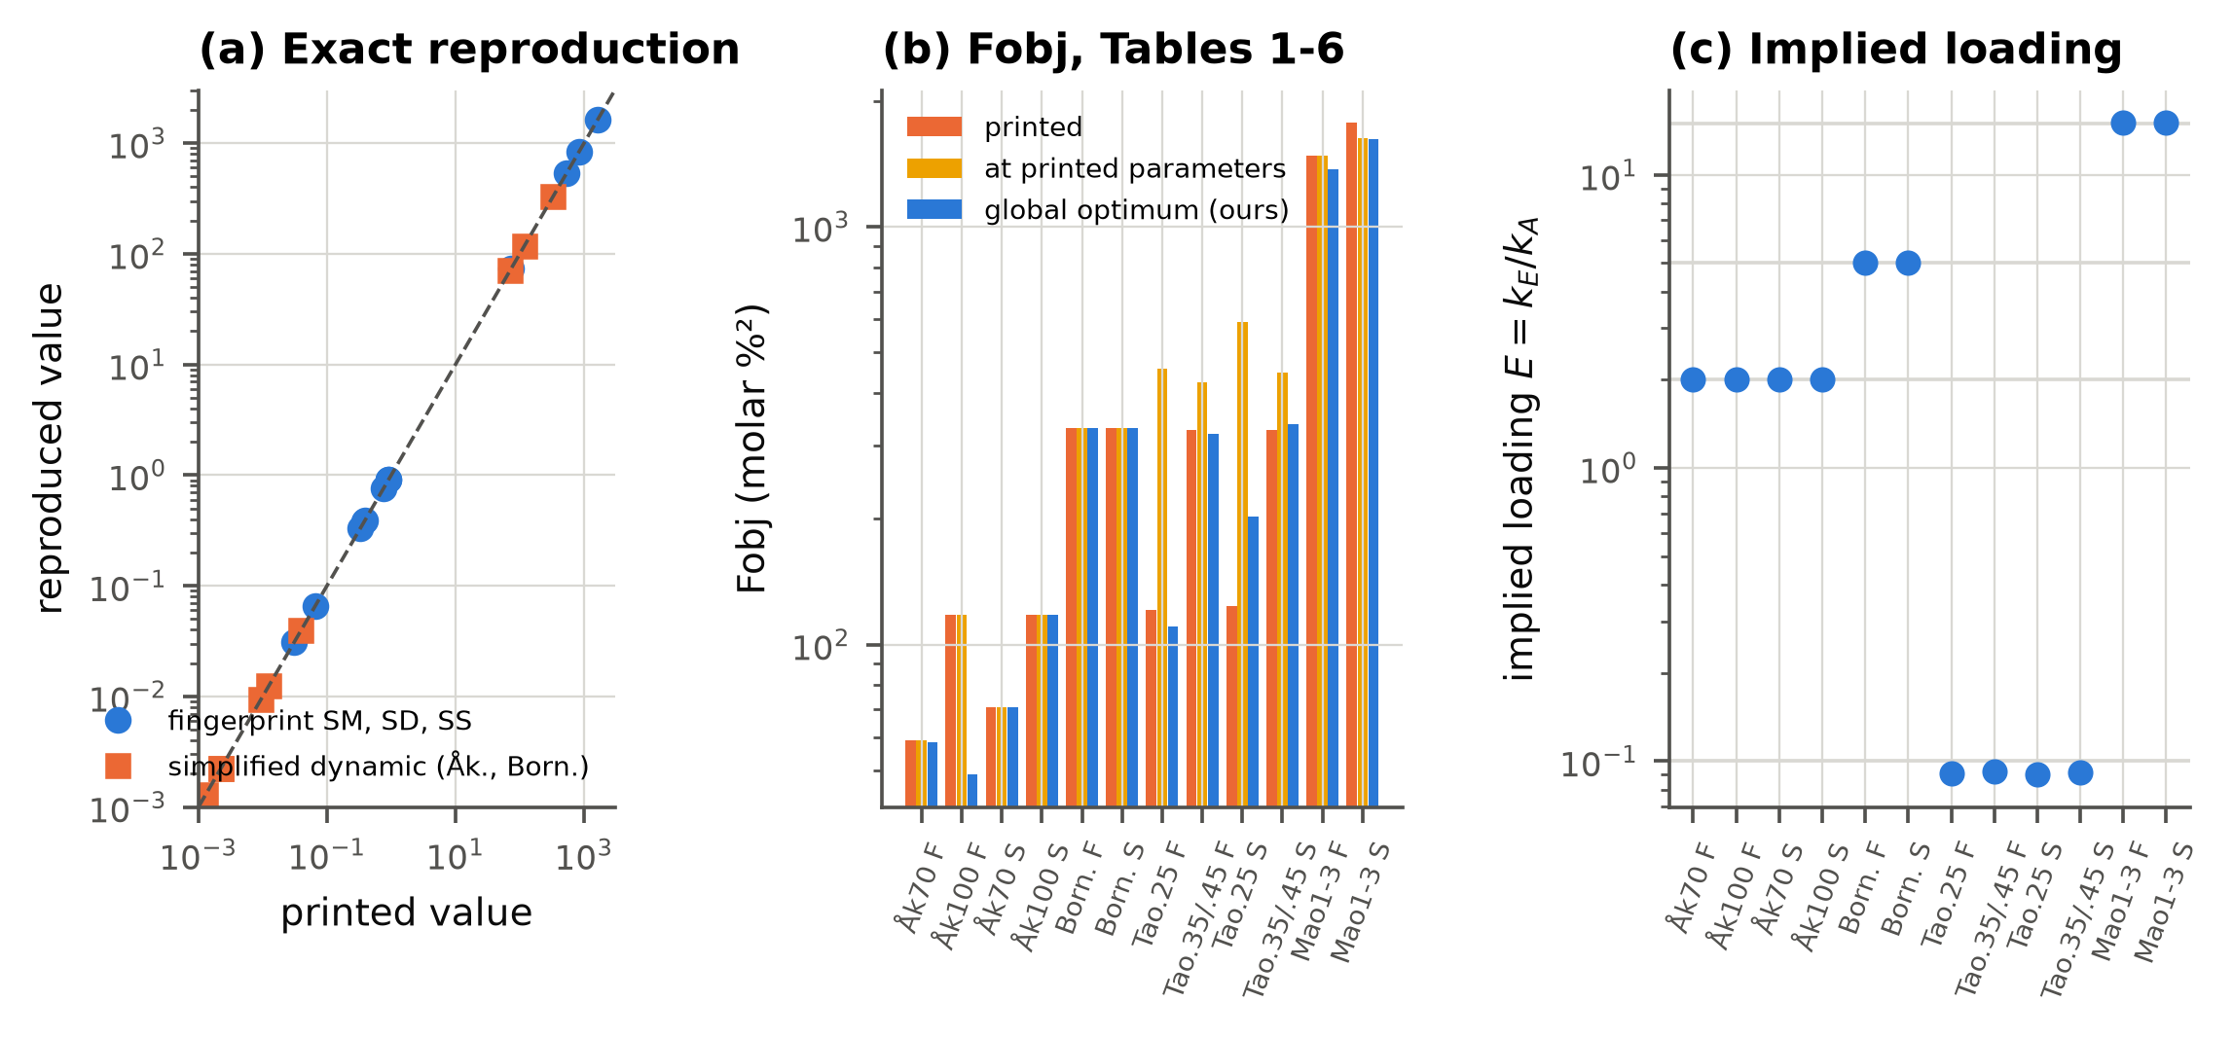
图 3-1 复现审计
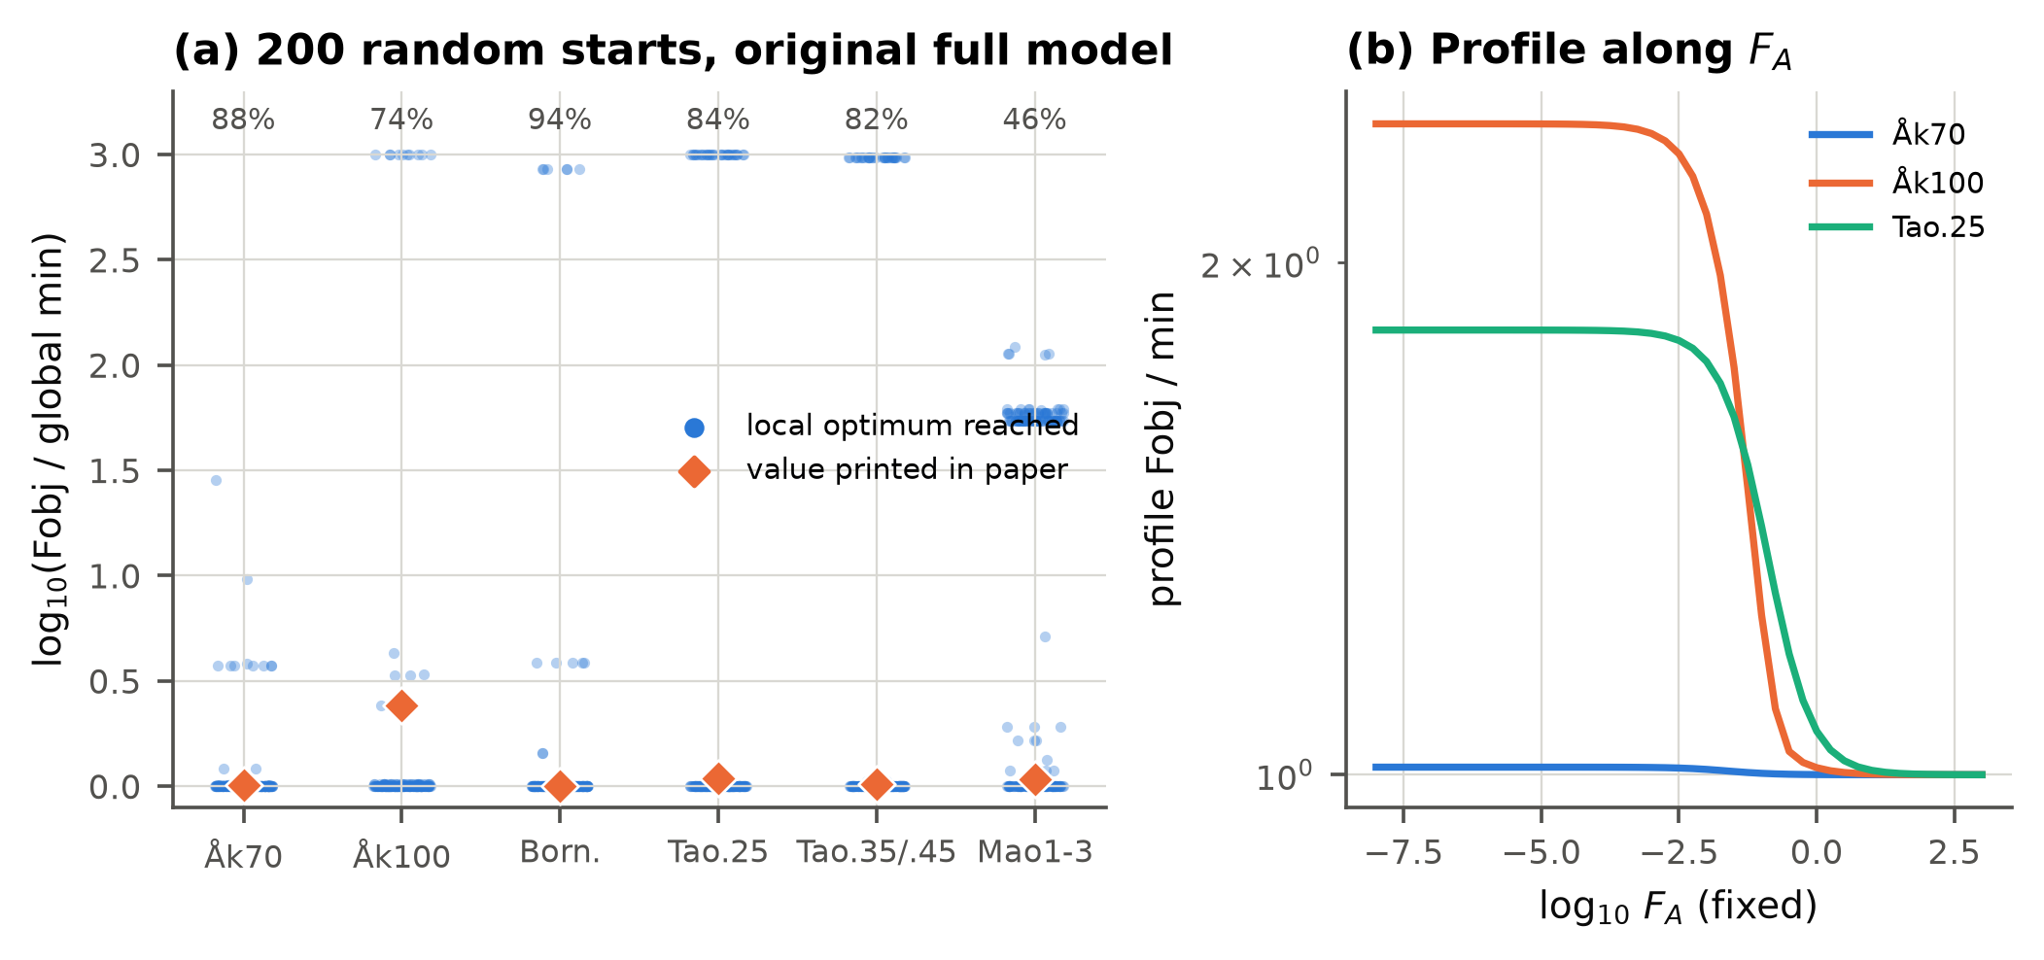
图 3-2 原文全模型的优化地形（200 个随机起点）与 FA 剖面（尺度不可辨识）
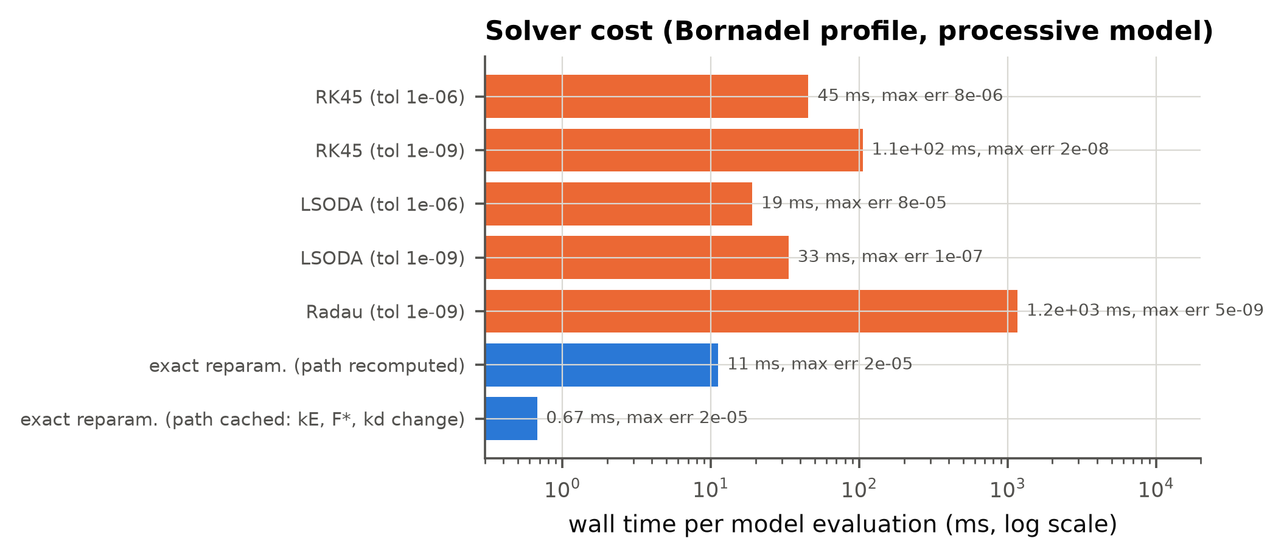
图 3-3 精确重参数化求解器与 ODE 积分器的速度和精度对比

4. 新方法：PPK-FIP
PPK-FIP（pseudo-processive kinetics with a fingerprint-informed prior，伪持续性动力学 + 指纹信息先验）保留原文的 Ping Pong bi bi 机理核心，做了四点改进：
(1) 机理扩展：加入伪持续性（pM、pD：新生成的单酯/二酯在离开活性位点之前被再次酰化的概率，对应传质限制）和批内一阶酶失活（kd）。pM=pD=0、kd=0 时严格退化为原文模型。
(2) 精确时间重参数化：所有反应共享同一个 Ping Pong 分母，所以组成只取决于反应度 c，时间由 5 个路径积分的线性组合给出：kE·τ(c) = J0 + FA·J1 + FAZ·JZ + FAM·JM + FAD·JD，失活通过 τ=(1−e^(−kd·t))/kd 处理。路径用 numba 编译的 RK4 只积分一次，改变 kE、F 和 kd 时每次求值不到 1 ms，误差 < 6e-5 摩尔百分比。正是这一点让全局多起点优化、145 折交叉验证和蒙特卡洛模拟变得可行。
(3) 指纹信息先验：原文两步法相当于给 SM、SD 一个无限紧的先验（固定），联合估计相当于平坦先验。PPK-FIP 使用中间的、校准过的先验：ln SX ~ N(ln 指纹估计, (λ·相对置信半宽/1.96)²)；pM、pD 用半正态收缩先验（尺度 s_p），kd 用弱先验。用 MAP 估计，求解时把先验残差附加到最小二乘残差向量后面。
(4) 模型平均与元验证：简化 F 集和全 F 集两个版本按 BIC 权重做平均；超参数 (λ, s_p) ∈ {1,3}×{0.05,0.2} 由“留一案例”元验证选择，即目标案例只使用其余 5 个案例的交叉验证结果来选超参数，完全不使用目标案例的数据。最终 6 个案例都选中了 λ=3。
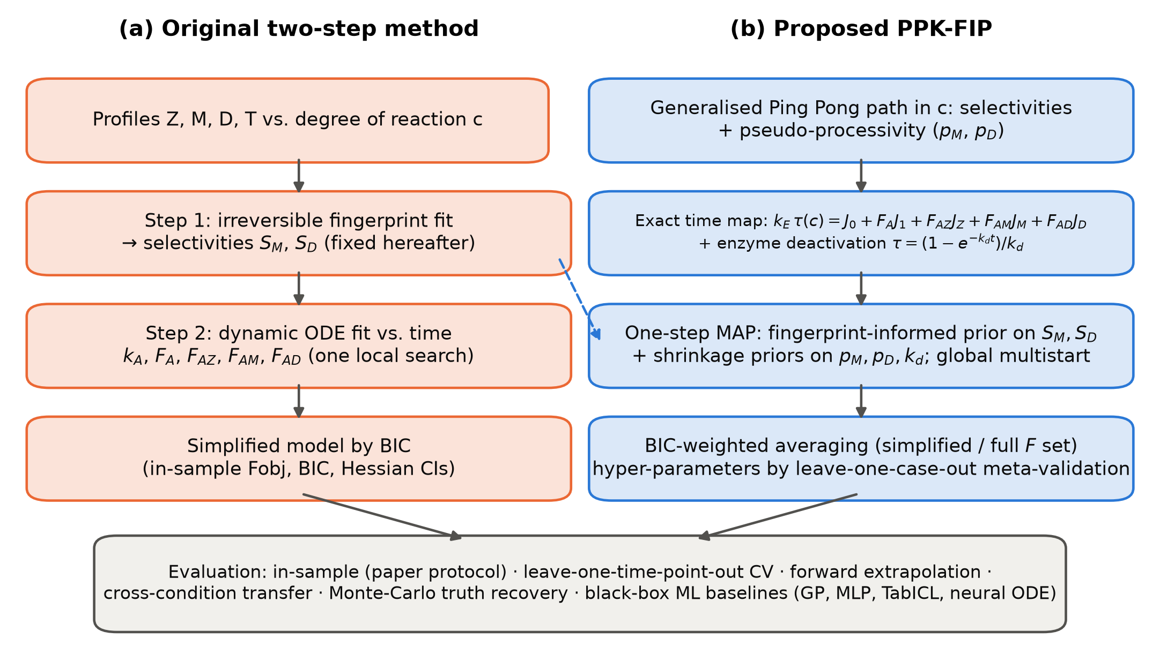
图 4-1 原文两步法与 PPK-FIP 的流程对比

5. 实验结果

5.1 全数据拟合（原文协议）
表 5-1 全数据拟合：Fobj 与 BIC_tot（计入所有估计参数）
case | method | Fobj | nT | k | BIC_total
Akerman70 | ORIG | 70.89 | 36 | 5.00 | 42.31
Akerman70 | ORIG-full | 58.40 | 36 | 7.00 | 42.50
Akerman70 | PPK-FIP | 56.80 | 36 | 9.03 | 48.79
Akerman100 | ORIG | 117.99 | 28 | 5.00 | 56.94
Akerman100 | ORIG-full | 48.92 | 28 | 7.00 | 38.95
Akerman100 | PPK-FIP | 31.84 | 28 | 8.89 | 33.22
Bornadel | ORIG | 329.89 | 120 | 6.00 | 150.08
Bornadel | ORIG-full | 329.89 | 120 | 7.00 | 154.87
Bornadel | PPK-FIP | 105.00 | 120 | 9.08 | 27.45
Tao025 | ORIG | 202.12 | 64 | 5.00 | 94.39
Tao025 | ORIG-full | 110.75 | 64 | 7.00 | 64.21
Tao025 | PPK-FIP | 75.14 | 64 | 9.96 | 51.69
Tao035_045 | ORIG | 337.92 | 144 | 5.00 | 147.68
Tao035_045 | ORIG-full | 319.60 | 144 | 7.00 | 149.60
Tao035_045 | PPK-FIP | 260.24 | 144 | 9.78 | 133.84
Mao123 | ORIG | 1624.41 | 141 | 7.00 | 379.26
Mao123 | ORIG-full | 1373.16 | 141 | 9.00 | 365.47
Mao123 | PPK-FIP | 1169.60 | 141 | 12.00 | 357.69

原文印出的最优 Fobj：Åkerman 70 °C 59.0、100 °C 117.9、Bornadel 329.9、Tao 0.25 121.2、Tao 0.35/0.45 325.8、Mao 1475.9。PPK-FIP 在 6 个拟合中 Fobj 全部更低（降低 3.7%–73%）；BIC_tot 有 5/6 优于原方法的重拟合结果。唯一例外是 Åkerman 70 °C：其持续性和失活参数虽然被收缩到接近 0，但参数个数照样计入 BIC，因此 BIC 略差。
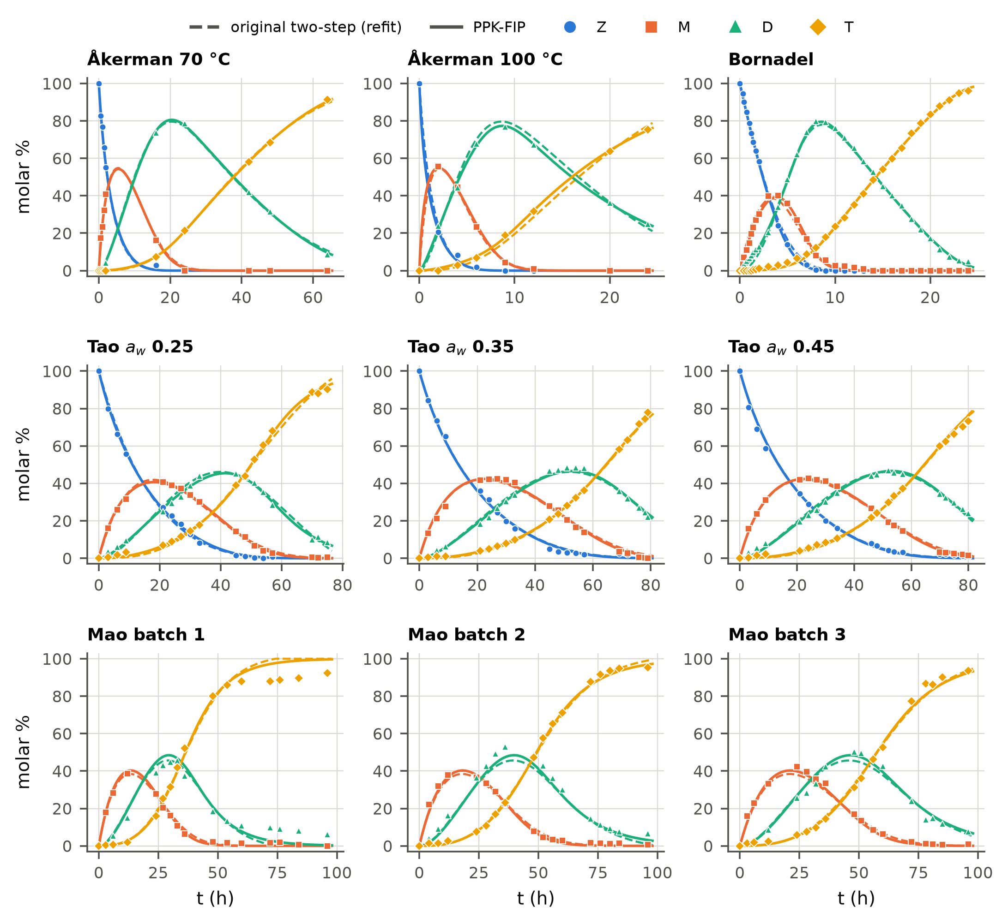
图 5-1 全数据拟合曲线（虚线：原方法重拟合；实线：PPK-FIP）
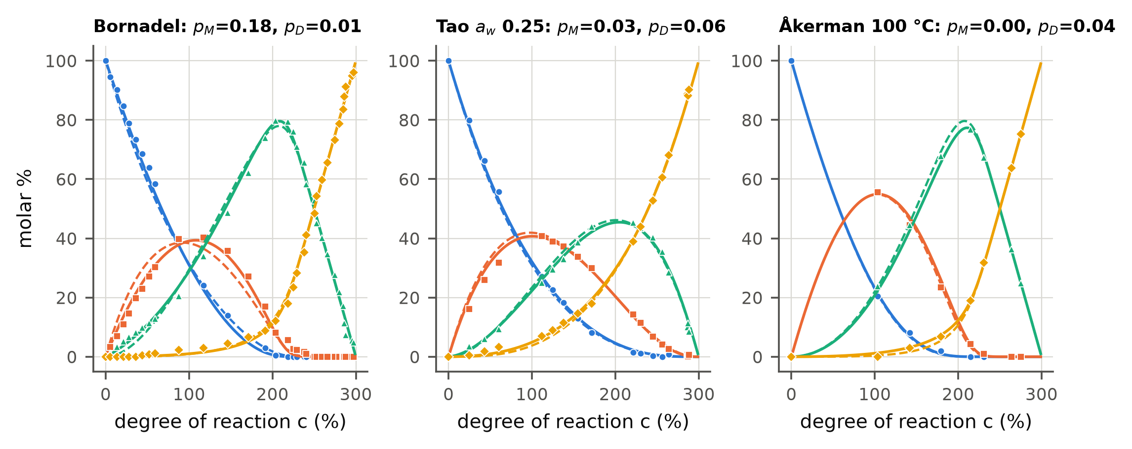
图 5-2 c 域组成路径与估计的持续性参数
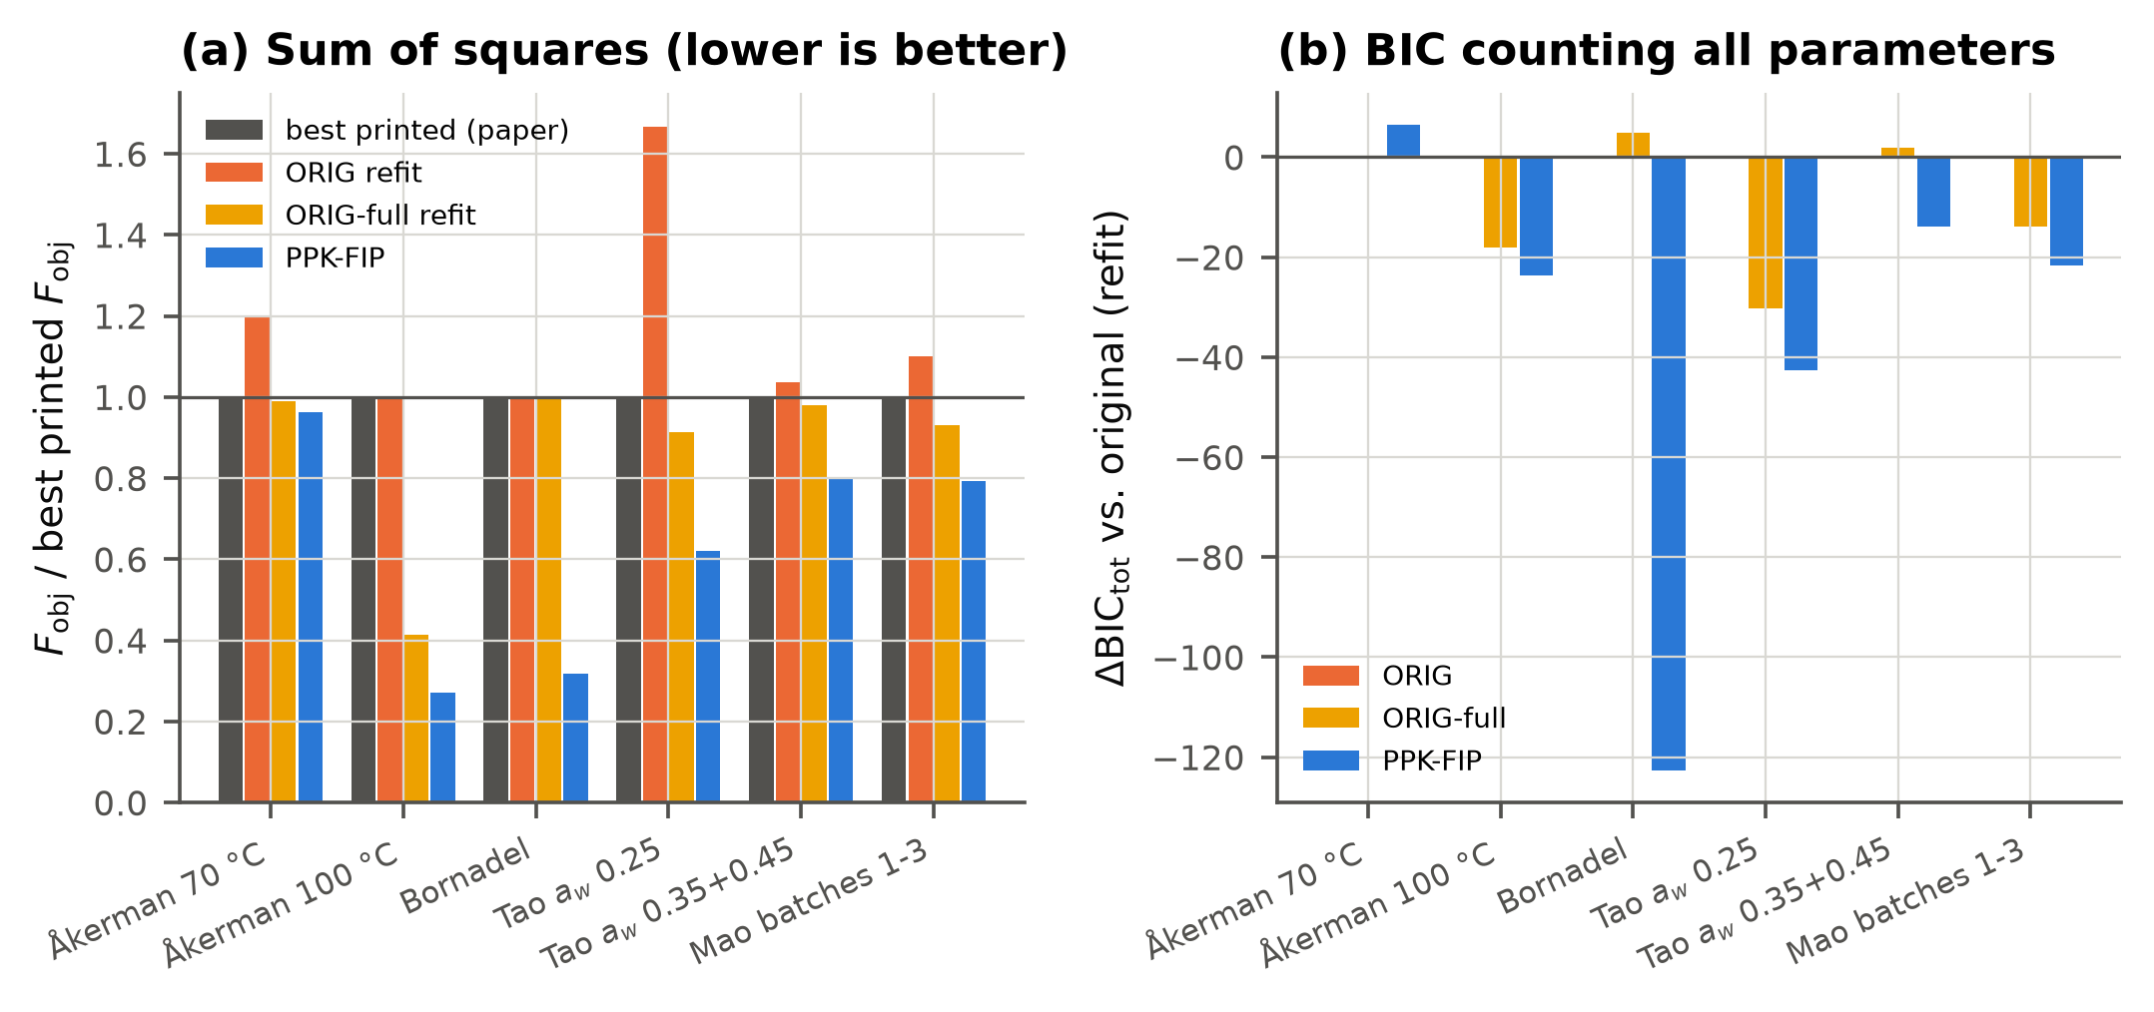
图 5-3 样本内 Fobj 与 ΔBIC_tot
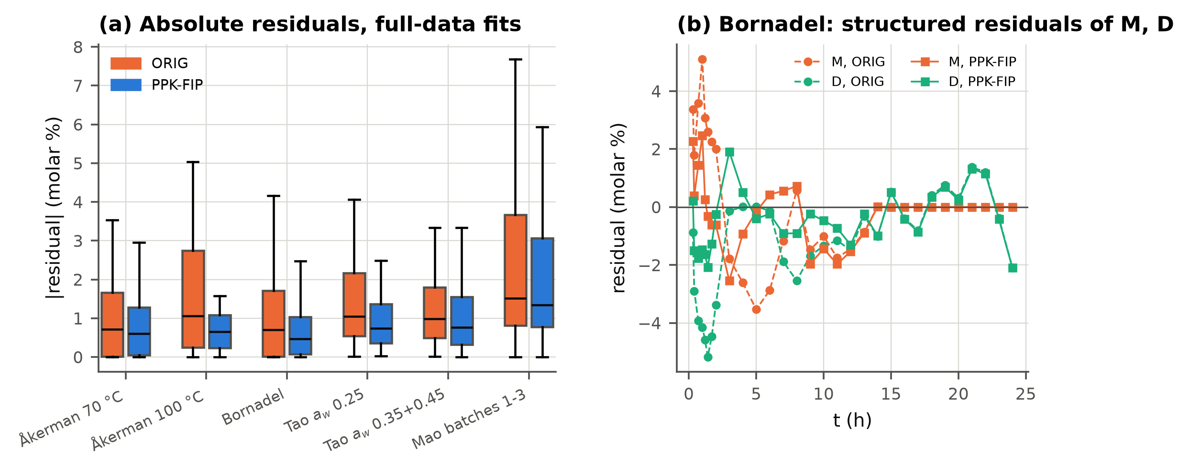
图 5-4 残差诊断（Bornadel 早期 M、D 的系统性残差被消除）
PPK-FIP 参数估计（全数据）见论文表 params。Bornadel 数据强烈支持伪持续性（pM≈0.18）；Åkerman 100 °C 支持批内失活（kd≈0.018 h⁻¹）。

5.2 留一时间点交叉验证（主要的样本外评价）
每一折删掉一个采样时间点上测到的全部物种，所有方法（包括原文两步法的两个步骤）都在剩余数据上从头重新估计，再预测被删掉的值。共 145 折、533 个观测。
表 5-2 LOTO RMSE（摩尔百分比），各方法 × 各案例
case | FIP-meta | GP | JOINT-BIC | JOINT-BMA | MLP-ens | NODE | ORIG | ORIG-BIC | ORIG-full | PPK-FIP | TabICL
Akerman100 | 3.518 | 15.073 | 4.059 | 3.882 | 17.701 | 4.064 | 3.742 | 3.293 | 3.293 | 3.505 | 20.607
Akerman70 | 1.981 | 13.284 | 2.895 | 2.342 | 20.271 | 3.057 | 1.828 | 1.875 | 1.655 | 1.886 | 12.711
Bornadel | 1.054 | 0.679 | 1.052 | 1.052 | 12.653 | 1.081 | 1.825 | 1.825 | 1.825 | 1.054 | 1.289
Mao123 | 3.098 | 1.350 | 3.099 | 3.104 | 12.108 | 1.527 | 3.607 | 3.314 | 3.314 | 3.098 | 2.848
Tao025 | 1.316 | 7.925 | 1.289 | 1.310 | 12.491 | 1.436 | 2.101 | 1.440 | 1.440 | 1.358 | 3.128
Tao035_045 | 1.497 | 0.741 | 1.440 | 1.459 | 10.694 | 1.464 | 1.643 | 1.659 | 1.591 | 1.495 | 1.567

表 5-3 PPK-FIP 对原方法 / 原全模型的配对 Wilcoxon 检验（Holm 校正）
ref | case | rmse_new | rmse_ref | ratio | obs_win_frac | median_diff | p | p_holm
ORIG | Akerman70 | 1.8858 | 1.8277 | 1.0318 | 0.5000 | 0.0000 | 0.3226 | 0.5684
ORIG | Akerman100 | 3.5055 | 3.7417 | 0.9369 | 0.5714 | -0.0000 | 0.2842 | 0.5684
ORIG | Bornadel | 1.0541 | 1.8252 | 0.5775 | 0.7083 | -0.0074 | 0.0000 | 0.0001
ORIG | Tao025 | 1.3580 | 2.1011 | 0.6463 | 0.7031 | -0.5769 | 0.0000 | 0.0001
ORIG | Tao035_045 | 1.4947 | 1.6434 | 0.9095 | 0.6597 | -0.2003 | 0.0001 | 0.0002
ORIG | Mao123 | 3.0979 | 3.6075 | 0.8588 | 0.6596 | -0.2760 | 0.0000 | 0.0002
ORIG | ALL | 2.1213 | 2.5325 | 0.8376 | 0.6604 | -0.1116 | 0.0000
ORIG-full | Akerman70 | 1.8858 | 1.6545 | 1.1398 | 0.3889 | 0.0639 | 0.0115 | 0.0346
ORIG-full | Akerman100 | 3.5055 | 3.2928 | 1.0646 | 0.6071 | -0.0839 | 0.5221 | 0.5221
ORIG-full | Bornadel | 1.0541 | 1.8252 | 0.5775 | 0.7083 | -0.0074 | 0.0000 | 0.0002
ORIG-full | Tao025 | 1.3580 | 1.4405 | 0.9427 | 0.5469 | -0.0563 | 0.1161 | 0.2321
ORIG-full | Tao035_045 | 1.4947 | 1.5906 | 0.9397 | 0.5972 | -0.0985 | 0.0016 | 0.0080
ORIG-full | Mao123 | 3.0979 | 3.3143 | 0.9347 | 0.5745 | -0.1338 | 0.0036 | 0.0146
ORIG-full | ALL | 2.1213 | 2.3115 | 0.9177 | 0.5966 | -0.0415 | 0.0000

结论：总体 RMSE 从 2.533（原方法）降到 2.121（−16.2%，p=1.4e-14）；相对原全模型（2.312）降低 8.2%（p=5.1e-07）。逐案例看：对原方法 4 个显著更好、2 个不显著（两个 Åkerman 数据集），没有显著更差的；对原全模型 3 个显著更好，Åkerman 70 °C 显著更差（这是采样点最少的曲线）。
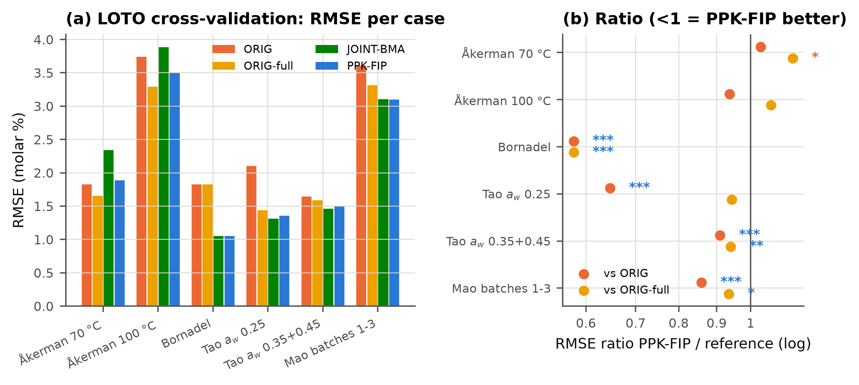
图 5-5 LOTO 交叉验证：各案例 RMSE 与比值（星号颜色表示配对中位差的方向）

5.3 向前外推（压力测试）
表 5-4 外推 RMSE（用 t ≤ 0.5 t_max 训练，预测剩余部分）
case | FIP-meta | GP | JOINT-BIC | JOINT-BMA | MLP-ens | NODE | ORIG | ORIG-BIC | ORIG-full | PPK-FIP | TabICL
Akerman100 | 7.719 | 22.011 | 7.850 | 5.773 | 35.167 | 19.093 | 10.670 | 10.670 | 0.673 | 5.506 | 21.189
Akerman70 | 1.207 | 37.401 | 1.836 | 1.733 | 39.146 | 6.318 | 1.097 | 1.097 | 9.527 | 1.443 | 37.710
Bornadel | 3.971 | 22.154 | 4.415 | 4.415 | 39.561 | 11.125 | 4.044 | 4.044 | 4.044 | 3.971 | 26.979
Mao123 | 7.783 | 16.073 | 4.491 | 5.660 | 40.512 | 11.178 | 4.654 | 4.654 | 4.159 | 7.765 | 15.865
Tao025 | 17.524 | 46.836 | 17.167 | 17.167 | 43.520 | 33.133 | 19.861 | 19.861 | 19.861 | 17.525 | 29.005
Tao035_045 | 15.753 | 27.849 | 15.898 | 15.897 | 41.380 | 26.204 | 15.866 | 15.866 | 15.866 | 15.753 | 23.664

外推对所有方法都很难，而且每个案例只有一个划分，统计功效很低。PPK-FIP 把 Åkerman 100 °C 的外推误差减半，在 Tao 0.25 上更好；但在 Åkerman 70 °C 和 Mao 上比原方法差。总体差异不显著。如实报告，不作为优势的证据。
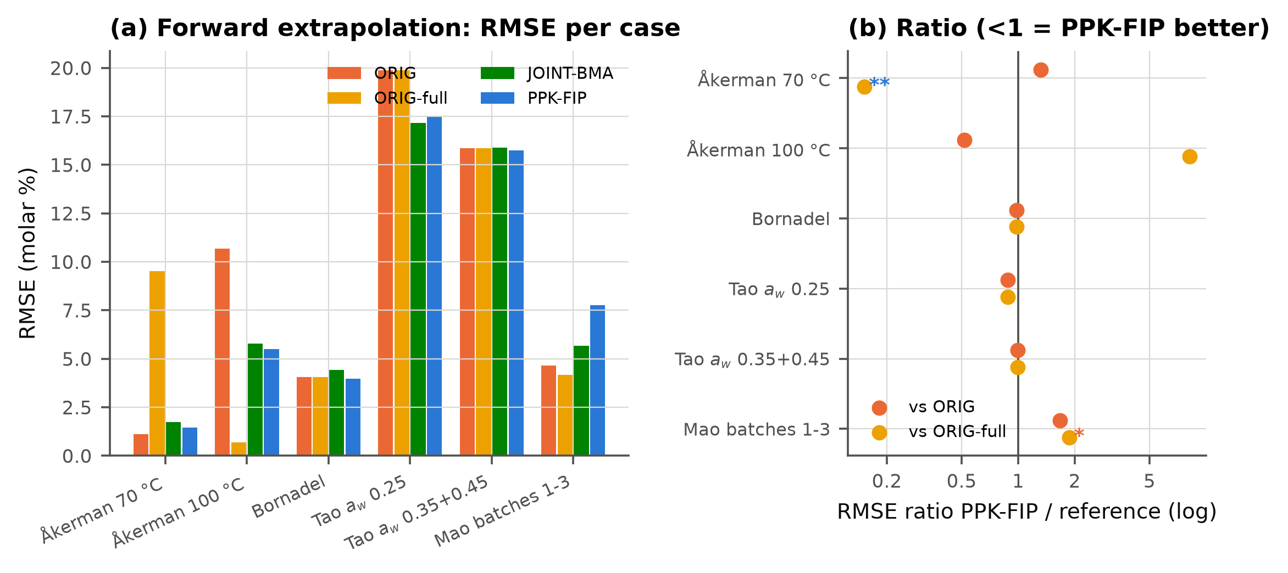
图 5-6 外推 RMSE 与比值
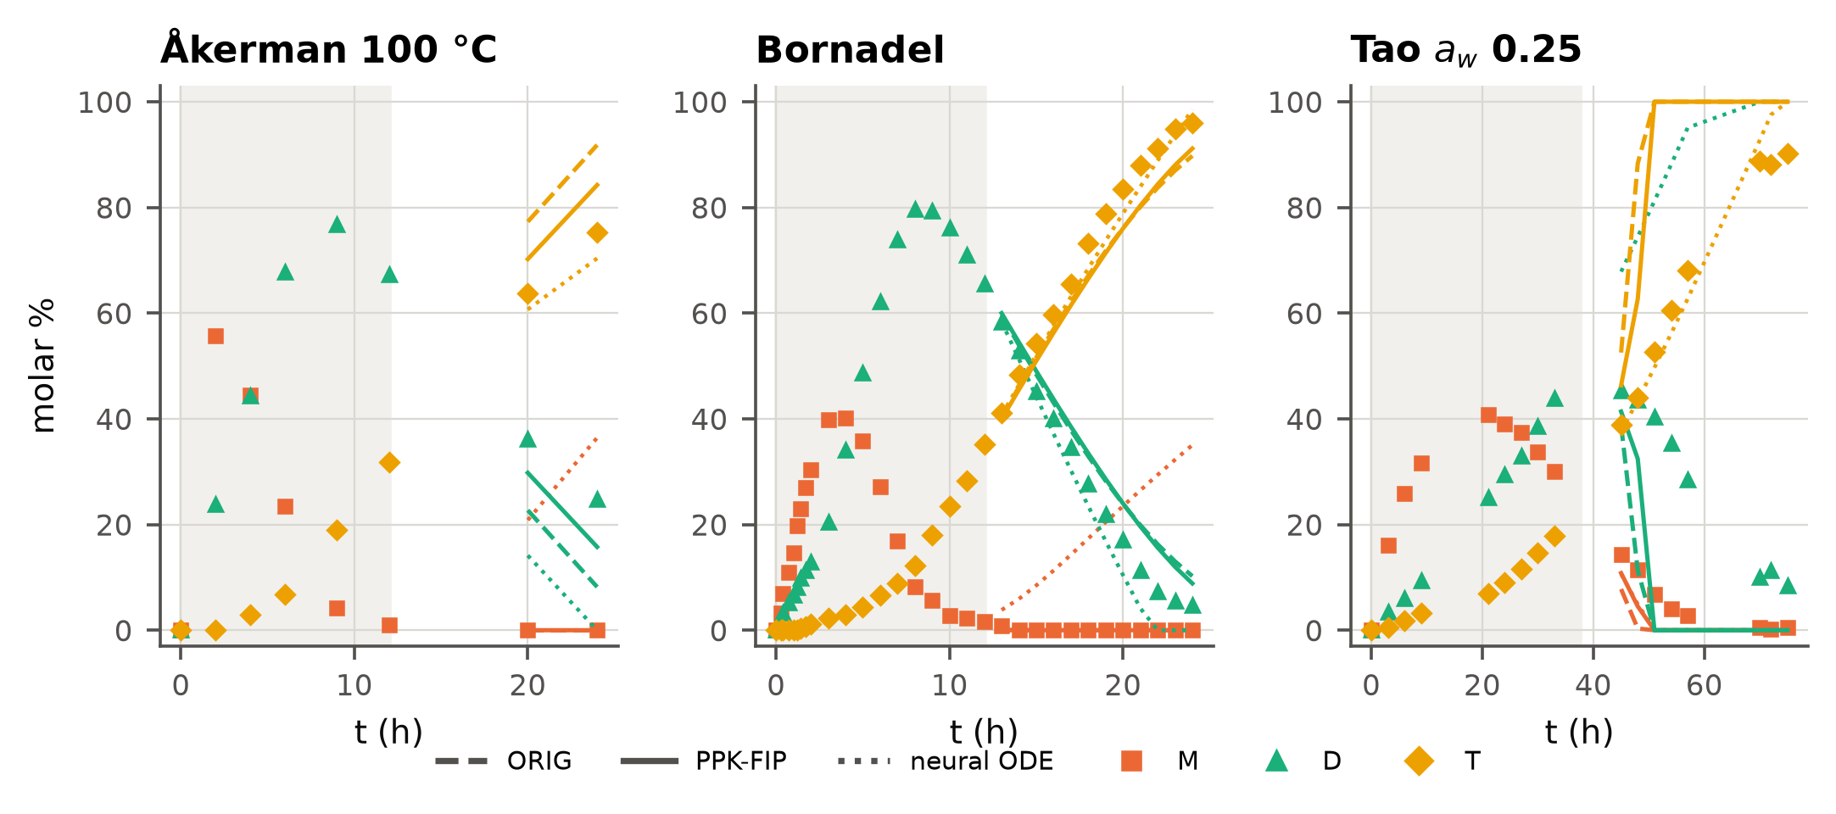
图 5-7 外推曲线示例（阴影为训练区间）

5.4 跨条件迁移、模拟研究
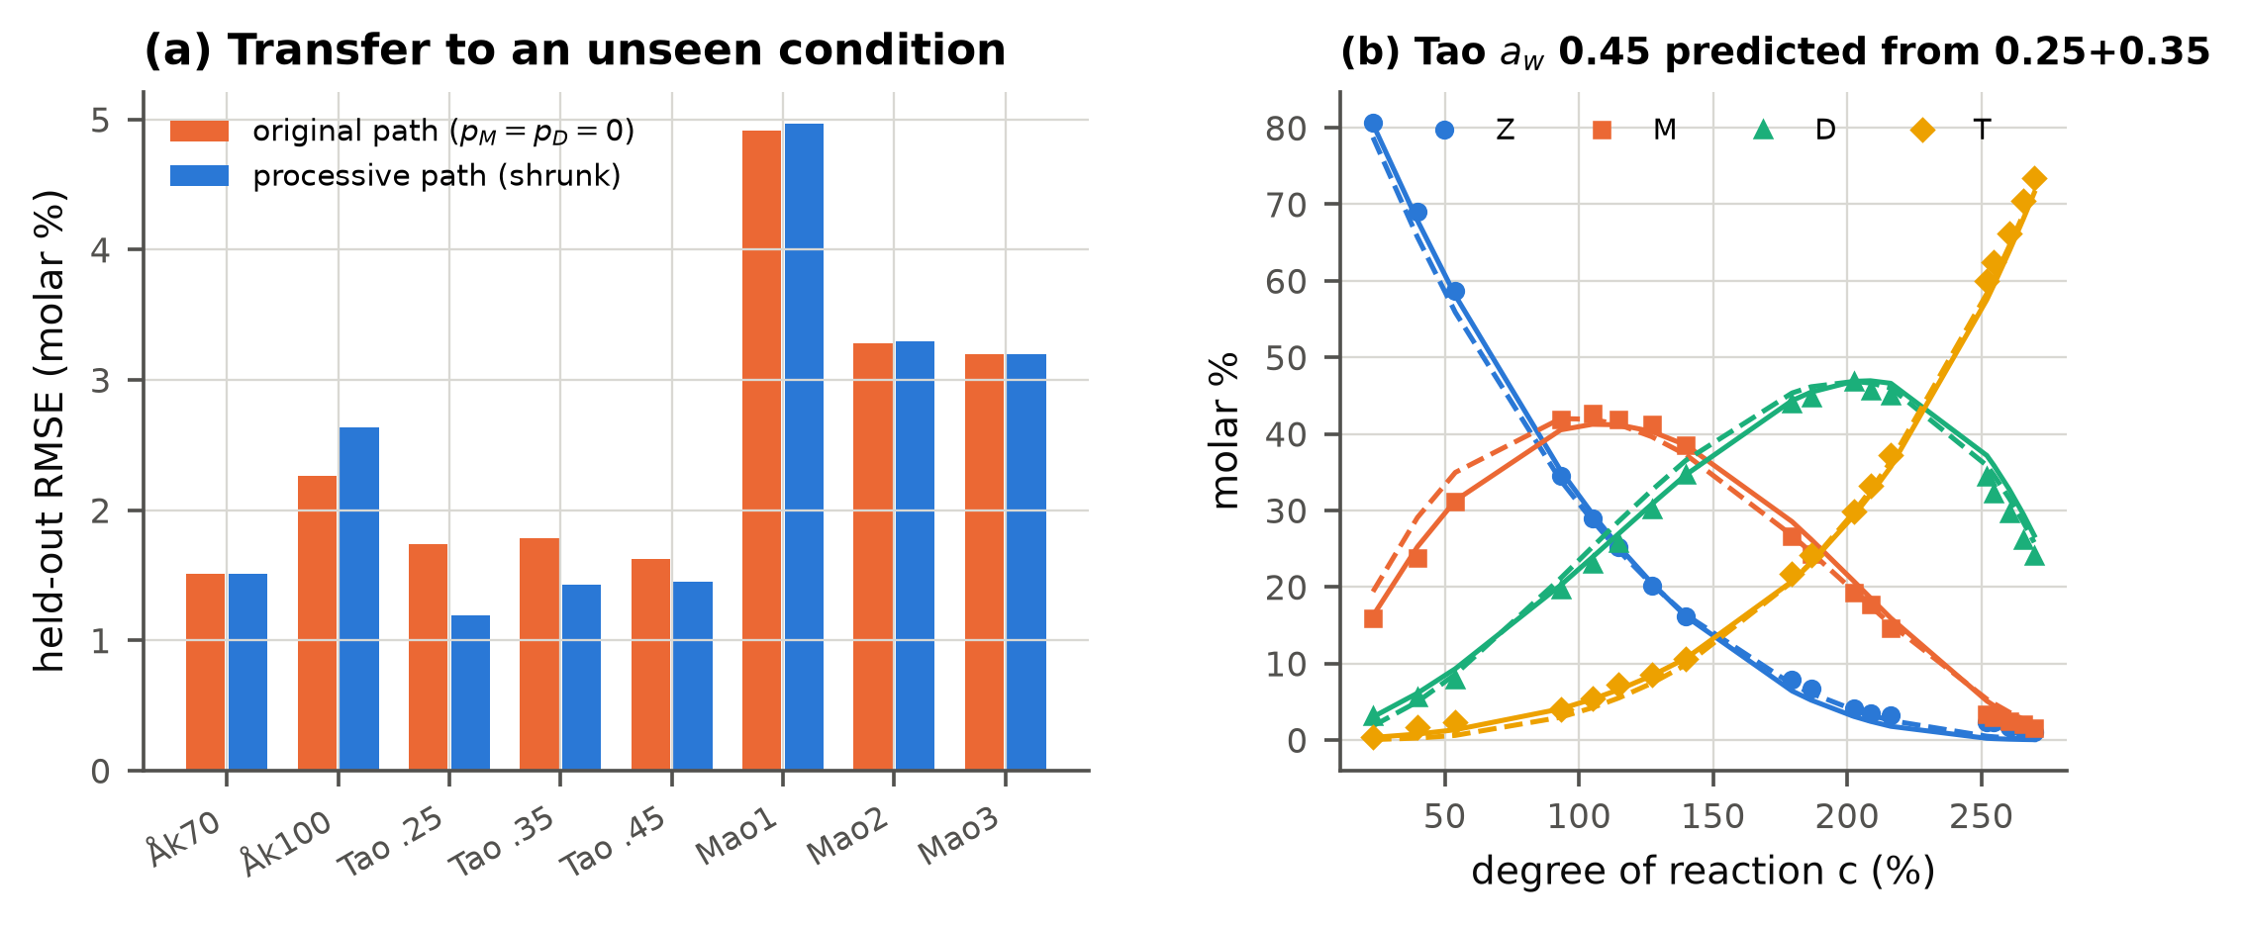
图 5-8 跨条件迁移：用同体系其他条件学到的组成路径预测留出条件
表 5-5 蒙特卡洛模拟（每种情景 60 次）：曲线误差与选择性对数偏差的均值
scenario | method | curve_rmse | SM_err | SD_err
S1 plain (Akerman70 design) | FIP-BMA(lam=1,sp=0.05) | 0.637 | 0.071 | 0.076
S1 plain (Akerman70 design) | FIP-BMA(lam=1,sp=0.2) | 0.639 | 0.071 | 0.076
S1 plain (Akerman70 design) | FIP-BMA(lam=3,sp=0.2) | 0.667 | 0.025 | -0.024
S1 plain (Akerman70 design) | JOINT-BIC | 0.794 | -0.013 | -0.110
S1 plain (Akerman70 design) | ORIG | 0.638 | 0.067 | 0.147
S1 plain (Akerman70 design) | ORIG-full | 0.676 | 0.067 | 0.147
S2 pseudo-processive (Bornadel design) | FIP-BMA(lam=1,sp=0.05) | 0.528 | 0.227 | 0.330
S2 pseudo-processive (Bornadel design) | FIP-BMA(lam=1,sp=0.2) | 0.517 | 0.218 | 0.322
S2 pseudo-processive (Bornadel design) | FIP-BMA(lam=3,sp=0.2) | 0.260 | 0.051 | 0.068
S2 pseudo-processive (Bornadel design) | JOINT-BIC | 0.240 | 0.007 | -0.017
S2 pseudo-processive (Bornadel design) | ORIG | 1.213 | 0.568 | 0.610
S2 pseudo-processive (Bornadel design) | ORIG-full | 1.213 | 0.568 | 0.610
S3 deactivation (Akerman100 design) | FIP-BMA(lam=1,sp=0.05) | 0.685 | -0.045 | -0.135
S3 deactivation (Akerman100 design) | FIP-BMA(lam=1,sp=0.2) | 0.695 | -0.052 | -0.142
S3 deactivation (Akerman100 design) | FIP-BMA(lam=3,sp=0.2) | 0.718 | -0.074 | -0.129
S3 deactivation (Akerman100 design) | JOINT-BIC | 0.706 | -0.036 | -0.063
S3 deactivation (Akerman100 design) | ORIG | 1.739 | -0.030 | -0.190
S3 deactivation (Akerman100 design) | ORIG-full | 0.943 | -0.030 | -0.190

S1（真值就是原模型）：PPK-FIP 与原方法一样好，不会凭空制造持续性；不加先验的联合估计则会过拟合。S2（伪持续性真值）：原方法的 SM 高估约 76%，曲线误差 1.21；PPK-FIP 几乎无偏，误差 0.26。S3（批内失活）：曲线误差从 1.74（原方法）和 0.94（原全模型）降到 0.72。
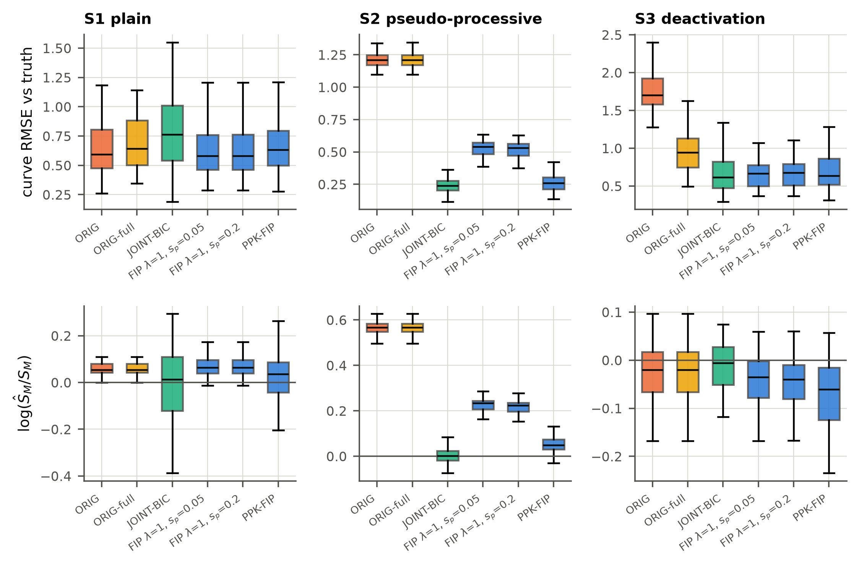
图 5-9 模拟研究

5.5 与黑箱机器学习模型的对比
对比模型：高斯过程（Matérn-5/2 + 白噪声）、MLP 集成（5 个种子）、预训练表格基础模型 TabICL（v2 回归器，上下文学习）、Neural ODE（RK4 求解器训练）。输入为时间和条件描述量（水活度或批次），并给出已知的初始状态。
表 5-6 LOTO：机理模型 vs 黑箱模型
case | ORIG | PPK-FIP | GP | MLP-ens | TabICL | NODE
Akerman100 | 3.742 | 3.505 | 15.073 | 17.701 | 20.607 | 4.064
Akerman70 | 1.828 | 1.886 | 13.284 | 20.271 | 12.711 | 3.057
Bornadel | 1.825 | 1.054 | 0.679 | 12.653 | 1.289 | 1.081
Mao123 | 3.607 | 3.098 | 1.350 | 12.108 | 2.848 | 1.527
Tao025 | 2.101 | 1.358 | 7.925 | 12.491 | 3.128 | 1.436
Tao035_045 | 1.643 | 1.495 | 0.741 | 10.694 | 1.567 | 1.464

诚实结论：在采样密集的曲线上做内插时，Neural ODE 和 GP 可以比机理模型更好（尤其是 Mao，它的数字化数据和完全转化并不一致）；但在稀疏的 Åkerman 曲线上，以及在全部外推任务中，黑箱模型都失败了（外推 RMSE 20–41），因为它们没有编码 TMP 守恒和顺序 Ping Pong 结构。
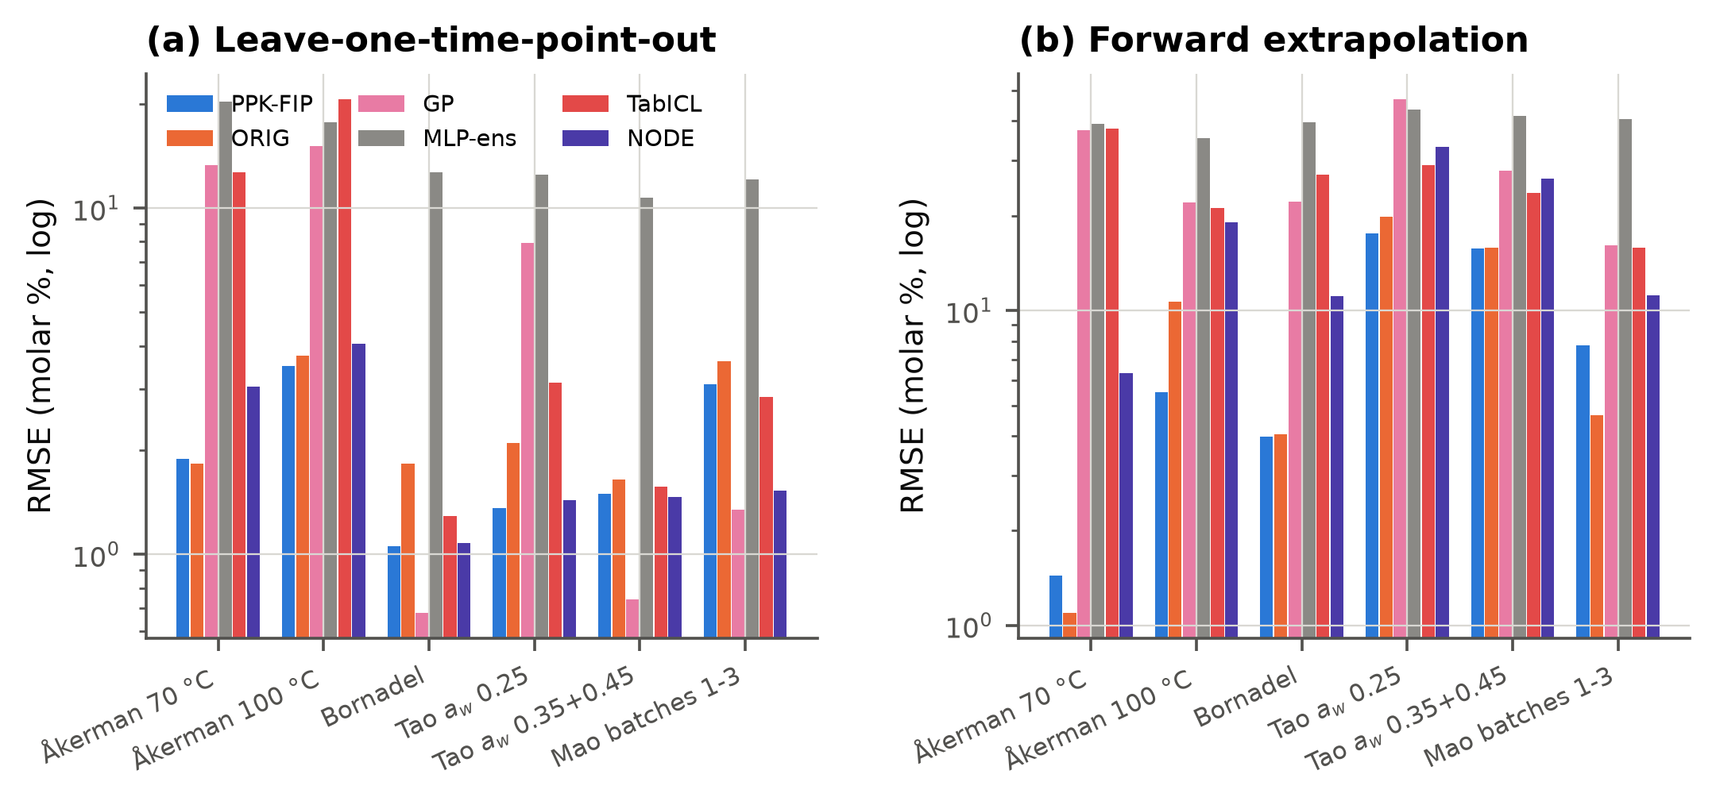
图 5-10 机理模型与黑箱基线的对比（对数坐标）

5.6 消融实验
表 5-7 消融（LOTO RMSE；p 为与完整 PPK-FIP 的配对 Wilcoxon 检验）
variant | ALL | p_vs_full | n | Akerman70 | Akerman100 | Bornadel | Tao025 | Tao035_045 | Mao123
PPK-FIP (full) | 2.121 |  | 533 | 1.886 | 3.505 | 1.054 | 1.358 | 1.495 | 3.098
simplified F only (no averaging) | 2.271 | 0.000 | 533 | 1.871 | 3.199 | 1.054 | 1.795 | 1.535 | 3.429
full F only (no averaging) | 2.109 | 0.002 | 533 | 1.815 | 3.514 | 1.054 | 1.316 | 1.465 | 3.098
no fingerprint prior (joint, BMA) | 2.177 | 0.866 | 533 | 2.342 | 3.882 | 1.052 | 1.310 | 1.459 | 3.104
no prior, BIC selection | 2.232 | 0.677 | 533 | 2.895 | 4.059 | 1.052 | 1.289 | 1.440 | 3.099
two-step, simplified (ORIG) | 2.533 | 0.000 | 533 | 1.828 | 3.742 | 1.825 | 2.101 | 1.643 | 3.607
two-step, full (ORIG-full) | 2.312 | 0.000 | 533 | 1.655 | 3.293 | 1.825 | 1.440 | 1.591 | 3.314
fixed $\lambda$=1, $s_p$=0.05 (no meta-selection) | 2.203 | 0.000 | 533 | 1.818 | 3.660 | 1.187 | 1.401 | 1.602 | 3.183
fixed $\lambda$=1, $s_p$=0.2 (no meta-selection) | 2.209 | 0.000 | 533 | 1.818 | 3.742 | 1.179 | 1.397 | 1.601 | 3.183
fixed $\lambda$=3, $s_p$=0.05 (no meta-selection) | 2.121 | 0.042 | 533 | 1.886 | 3.505 | 1.054 | 1.354 | 1.493 | 3.099
fixed $\lambda$=3, $s_p$=0.2 (no meta-selection) | 2.121 | 0.983 | 533 | 1.884 | 3.505 | 1.050 | 1.358 | 1.495 | 3.098
no pseudo-processivity | 2.289 | 0.000 | 533 | 1.867 | 3.906 | 1.718 | 1.512 | 1.619 | 3.108
no deactivation | 2.115 | 0.000 | 533 | 1.847 | 3.506 | 1.052 | 1.317 | 1.497 | 3.094
no processivity, no deactivation | 2.277 | 0.000 | 533 | 1.813 | 3.887 | 1.716 | 1.439 | 1.617 | 3.105

主要结论：(a) 两步法（原文）在 Bornadel、Tao 0.25 上明显更差；(b) 去掉先验（联合估计）会让稀疏的 Åkerman 曲线变差，说明指纹信息应该保留，但要作为先验而不是约束；(c) λ=1 的窄先验（接近两步法）比 λ=3 差，元验证在 6 个案例中都选中了 λ=3；(d) 只用全 F 集与模型平均的结果相近（2.109 vs 2.121），说明模型平均不是必需的组件，如实报告；(e) 去掉伪持续性后 RMSE 升到 2.289（Bornadel 从 1.05 升到 1.72），说明伪持续性是样本外增益的主要来源；(f) 去掉失活项后 LOTO 为 2.115，并没有变差，外推时甚至更好（主要是 Mao）。所以失活项只改善了 Åkerman 100 °C 的样本内拟合，没有得到样本外证据的支持。这一点如实报告；没有根据测试结果事后删掉它。
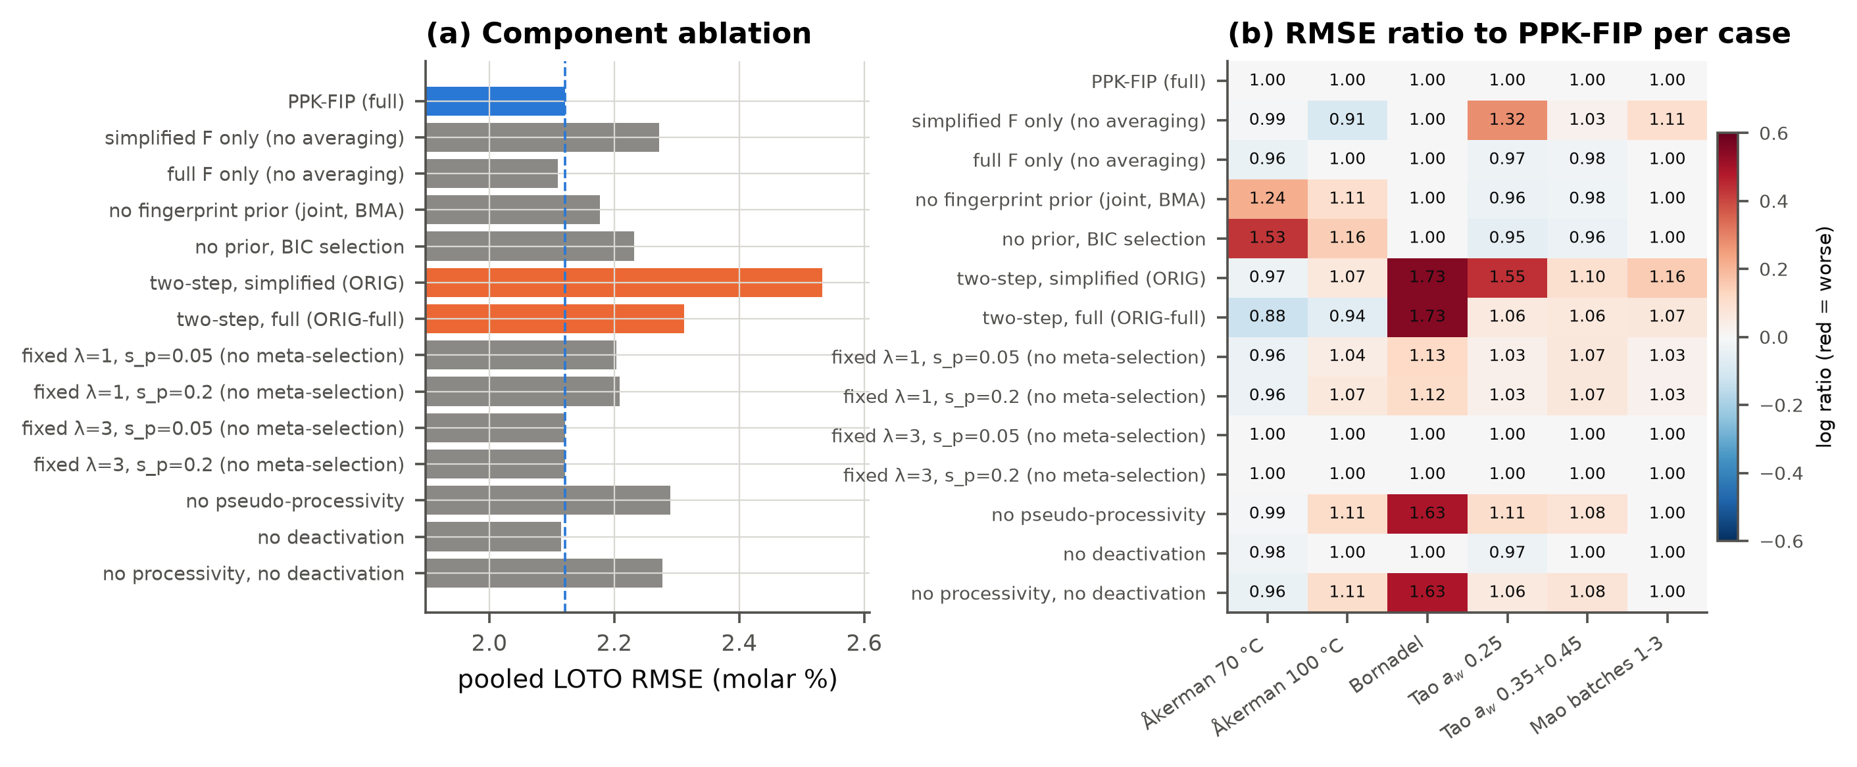
图 5-11 消融实验

5.7 扩展实验：多任务池化与 GP 偏差项混合模型
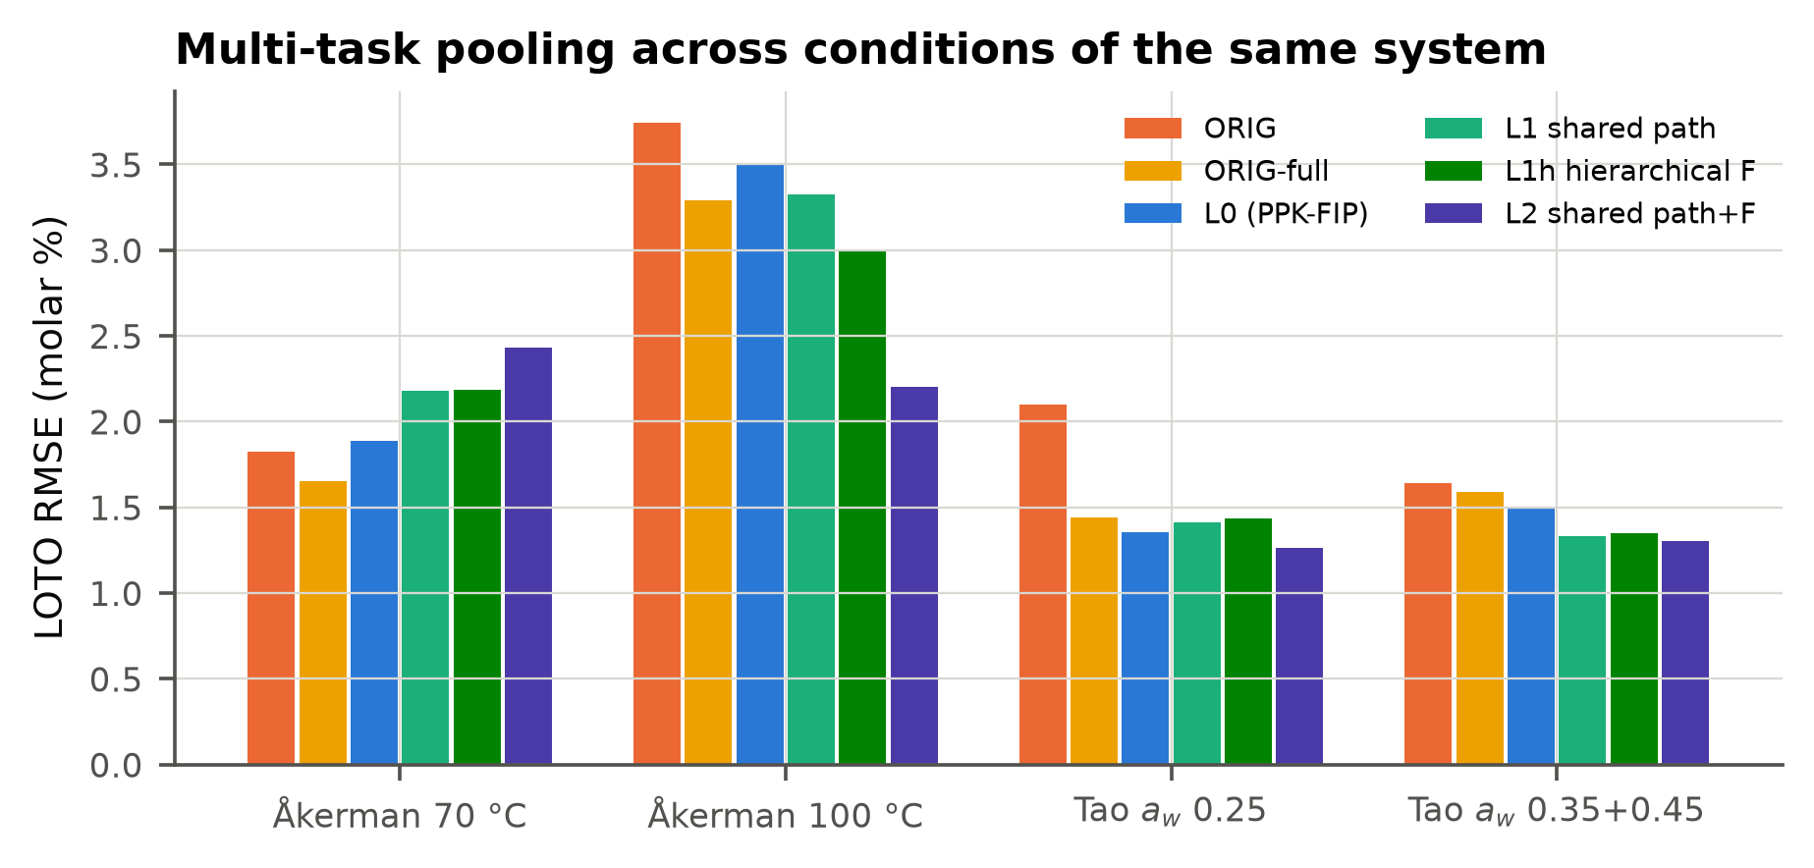
图 5-12 多任务池化（同一体系的不同条件共享路径 / F 常数）
池化在 Åkerman 100 °C、Tao 两组上明显降低误差（例如 Åkerman 100 °C：3.51 → 2.20），但在 Åkerman 70 °C 上更差；用留一案例元验证选择池化层级后，总体 RMSE 2.117，与不池化的 2.121 基本相同，没有净收益，因此 PPK-FIP 最终不采用池化，作为扩展实验报告。
表 5-8 PPK-FIP + GP 偏差项（Kennedy–O'Hagan 型混合）的 LOTO RMSE
case | ORIG | ORIG+GP | PPK-FIP | PPK-FIP+GP
Akerman100 | 3.742 | 3.546 | 3.505 | 3.486
Akerman70 | 1.828 | 1.778 | 1.886 | 1.839
Bornadel | 1.825 | 0.693 | 1.054 | 0.725
Mao123 | 3.607 | 1.259 | 3.098 | 1.197
Tao025 | 2.101 | 1.162 | 1.358 | 1.123
Tao035_045 | 1.643 | 0.731 | 1.495 | 0.737

表 5-9 混合模型的外推 RMSE（GP 远离数据时回归到 0，自动退回机理模型）
case | ORIG | ORIG+GP | PPK-FIP | PPK-FIP+GP
Akerman100 | 10.670 | 10.781 | 5.506 | 5.506
Akerman70 | 1.097 | 1.098 | 1.443 | 1.443
Bornadel | 4.044 | 4.030 | 3.971 | 3.956
Mao123 | 4.654 | 4.308 | 7.765 | 7.733
Tao025 | 19.861 | 19.731 | 17.525 | 17.475
Tao035_045 | 15.866 | 15.861 | 15.753 | 15.751

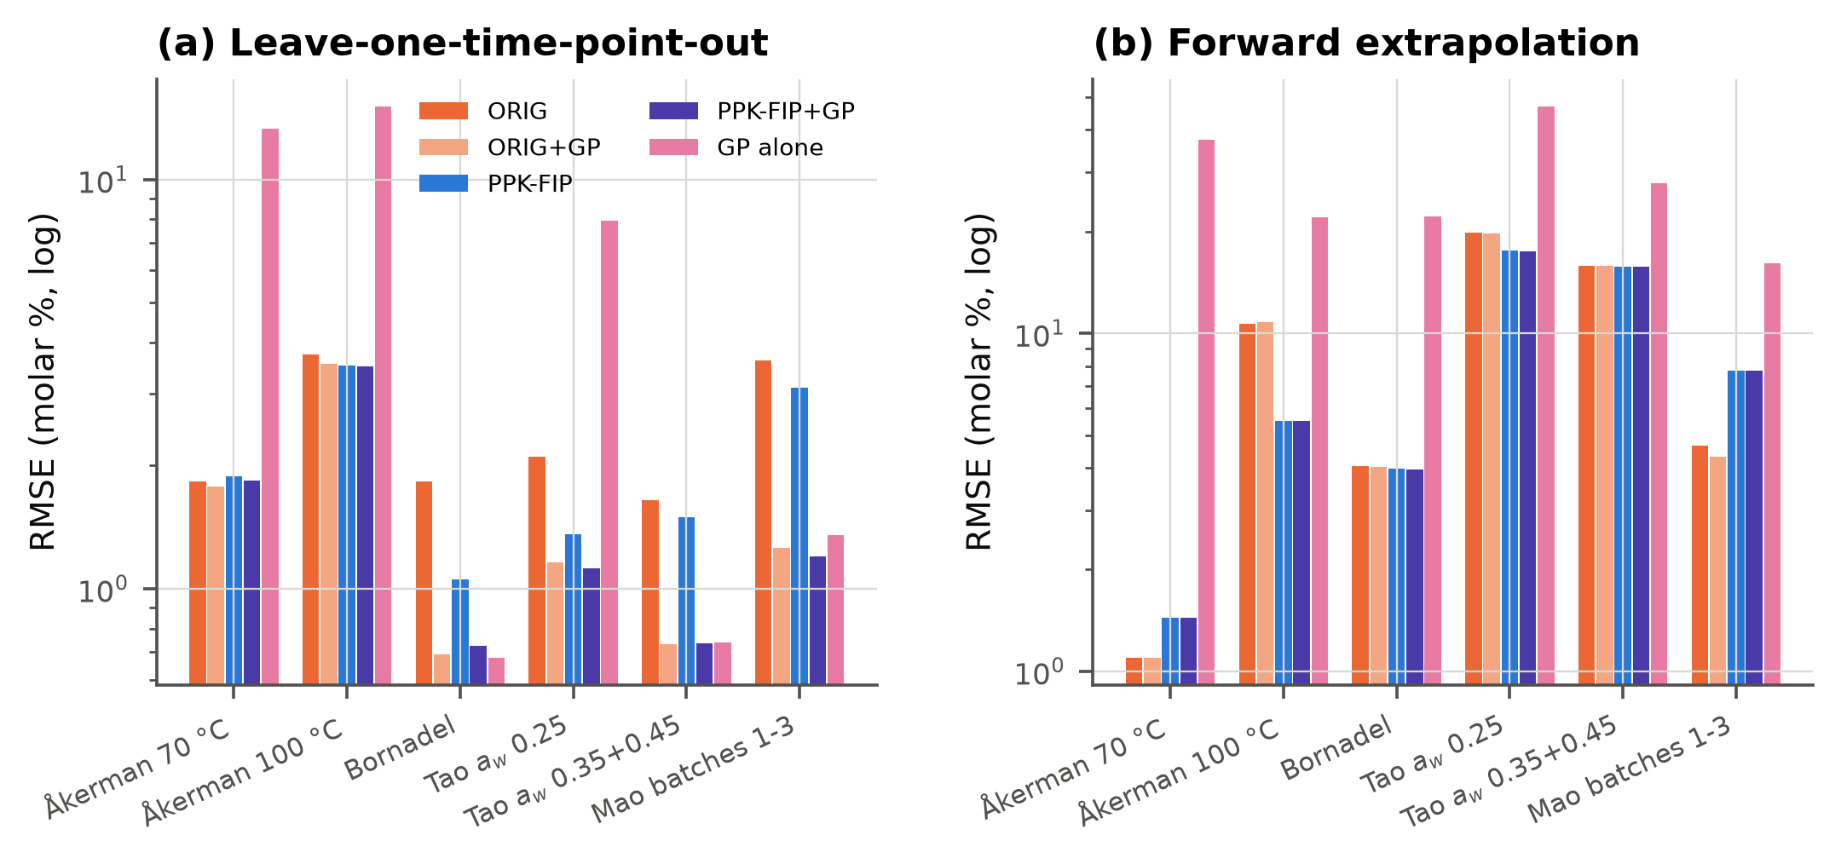
图 5-13 混合模型：机理均值 + GP 偏差项
结论：PPK-FIP-GP 的 LOTO 总 RMSE 为 1.290，比原方法（2.533）低 49%（p<0.001，145 折中 126 折更好），也低于最强的黑箱模型 Neural ODE（1.791）；外推时与纯机理的 PPK-FIP 一样（11.86），远好于所有黑箱模型（20–41）。需要如实说明：给原方法加上同样的 GP 偏差项，内插误差也能降到 1.307，与 PPK-FIP-GP 没有显著差异（p=0.89）。也就是说，内插上的大部分增益来自 GP 偏差项这一通用手段；而 PPK-FIP 的机理改进对选择性估计、外推和可解释性才是关键。建议：参数估计用 PPK-FIP；需要在实验时间范围内做最准确的预测时用 PPK-FIP-GP。

6. 诊断与可复现性
求解器基准：精确重参数化（路径缓存）每次求值约 0.8 ms，LSODA 约 10 ms，Radau 约 1.4 s。原文全模型：200 个随机起点只有 46%–94% 能到达全局最优，FA 方向的剖面目标函数单调下降到边界（结构不可辨识）。所有代码在 Biomass/code/，一键重建脚本见 finalize.sh。

7. 结论
(1) 原文的数据完整公开，复现核对 36/36 项全部一致；但原文部分全模型拟合没有到达最优、全模型不可辨识、Tao 案例无法复现。(2) PPK-FIP 在原文自己的指标（Fobj）上 6/6 更好；在严格的样本外 LOTO 交叉验证上，总体误差比原方法低 16.2%、比原全模型低 8.2%（均 p<0.001）。(3) 外推和 Åkerman 70 °C 是没有超过原文的地方，已如实报告并分析了原因（采样点太少，以及外推只有单次划分）。(4) 论文意义：对于用生物质来源的脂肪酸和 TMP 生产生物润滑剂的过程设计，在传质受限反应器里得到的“表观选择性”不能不加持续性校正就直接迁移到别的反应器；动力学参数应当配合样本外验证来报告，而不能只看样本内拟合统计量。

8. 输出文件位置
• ~/Documents/mdpi_papers/Biomass/screening.csv —— 80 篇论文的筛选评估
• ~/Documents/mdpi_papers/Biomass/data_check.md —— 数据核对表
• ~/Documents/mdpi_papers/Biomass/code/ —— 全部代码
• ~/Documents/mdpi_papers/Biomass/results/ —— 全部结果文件
• ~/Documents/mdpi_papers/Biomass/figures/ —— 全部图（PNG + PDF）
• ~/Documents/mdpi_papers/Biomass/paper/main.pdf —— 英文 LaTeX 论文
• ~/Documents/mdpi_papers/Biomass/paper/main_zh.pdf —— 中文版论文
• ~/Documents/mdpi_papers/Biomass/report.docx —— 本报告

