User’s Guide

To run “Stellar Studies” lesson double click file “Stellar_Studies.jar”. Your computer has to have installed and configured Java 8 to use this program.

The program employs tabbed window layout. To complete the lesson you have to go through all the tabs from left to right starting at “Home” tab and ending at “Test” tab.



The program will present you with study materials for grade 9 astronomy lesson and then test your new knowledge in practice test showing you your mistakes and then in final test marked automatically by the program.

**Details:**

# “Home”

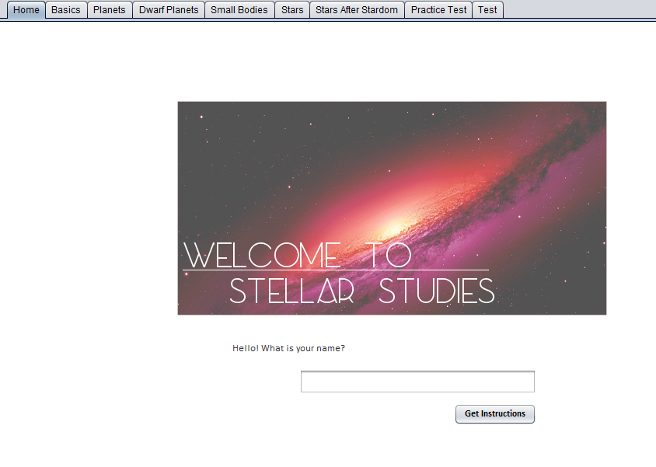

Please enter your name and press the button to submit it. You will receive a short instructional message, after you read it, please carry on to the rest of the program.

# “Basics”

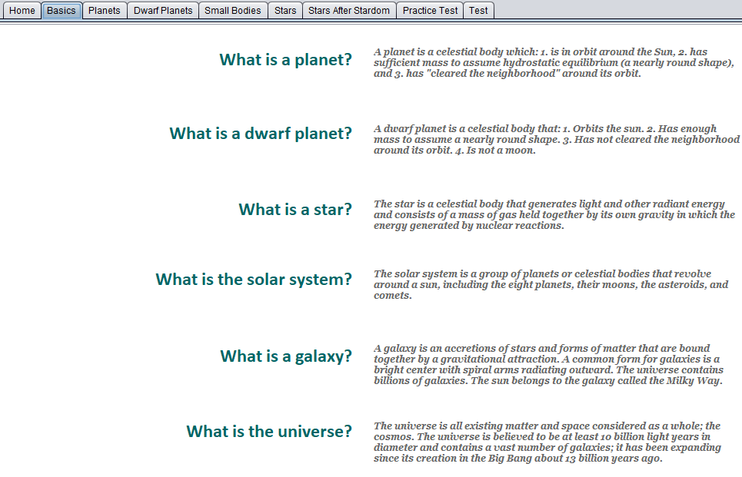

Here is background information that you will need to proceed to the rest of the tabs. Explaining what each of the objects, and the further tabs are examples, and better understanding of them.

# “Planets”

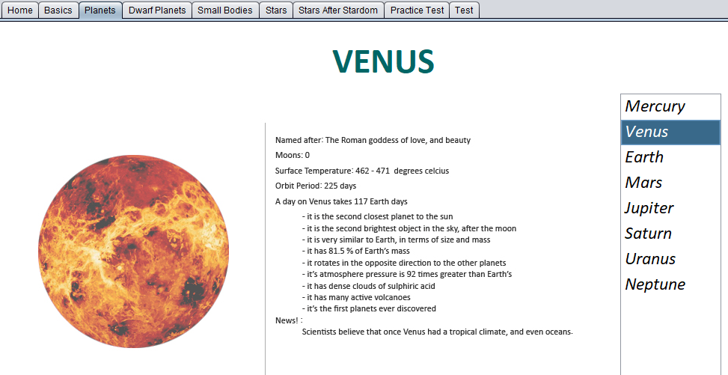

Choose a planet from the list on the right, to read more about each of them. The news fact is any recent information that has come up about the planets.

# “Dwarf Planets”

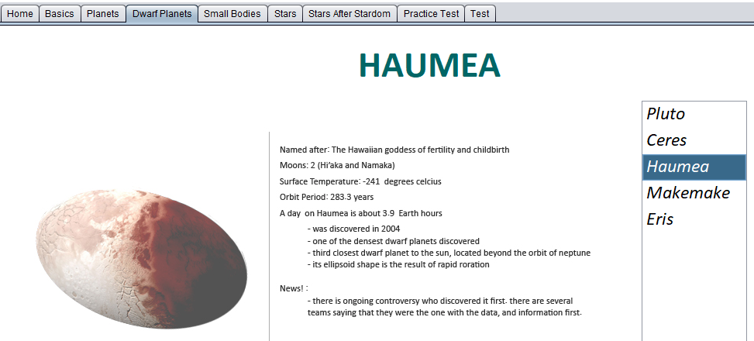

Choose a dwarf planet from the list on the right, to read more about each of them. The news fact is any recent information that has come up about the dwarf planets.

# “Small Bodies”

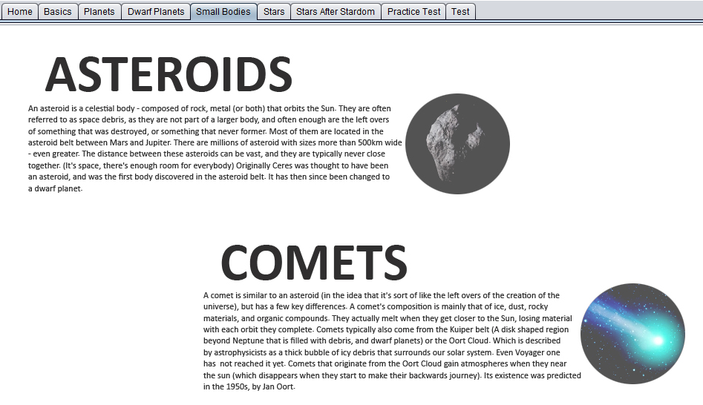

Scroll down the tab to learn more about asteroids, comets, meteorites, meteors, and so on.

# “Starts”

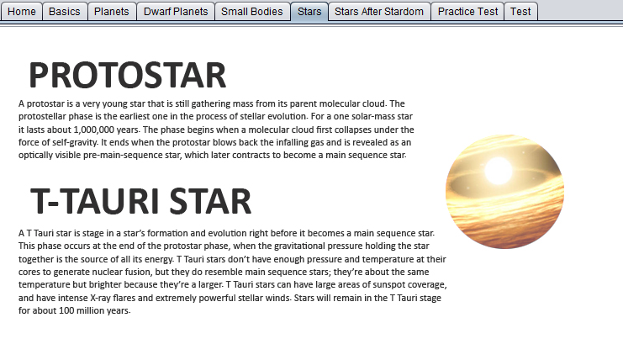

This tab gives you information about stars classification and characteristics. Use vertical scroll control to learn all available information.

# “Stars After Stardom”

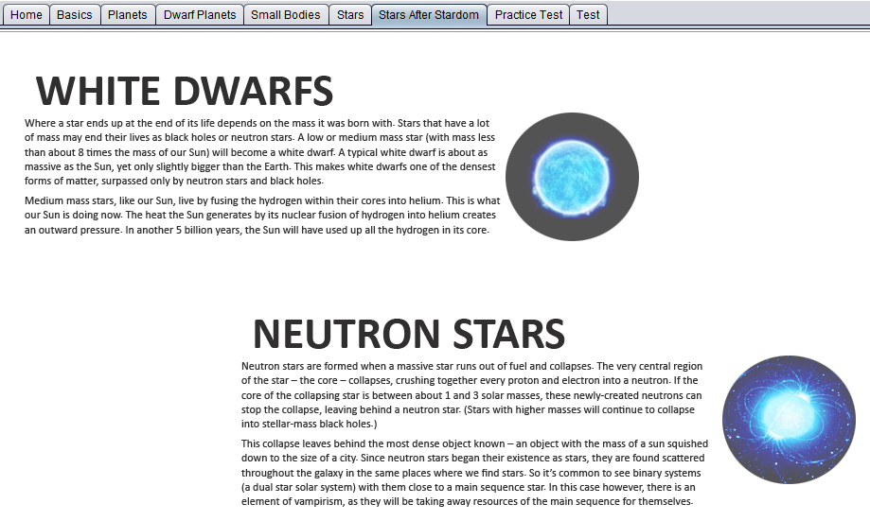

This tab gives you a basic understanding about life cycle of main sequence stars and stars that didn’t become stars. Use vertical scroll control to learn all available information.

# “Practice Test”

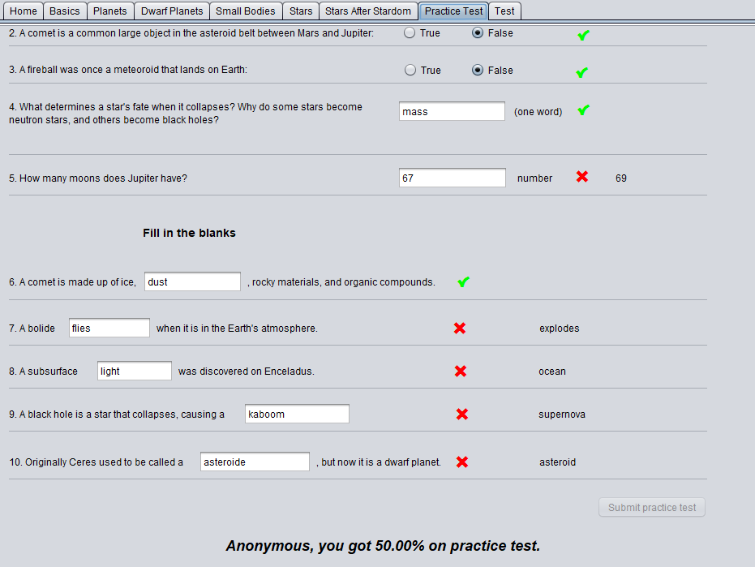

“Practice test” allows you to check your knowledge, it shows you if your answers were correct or incorrect and displays correct answers when you make mistakes.

# “Test”

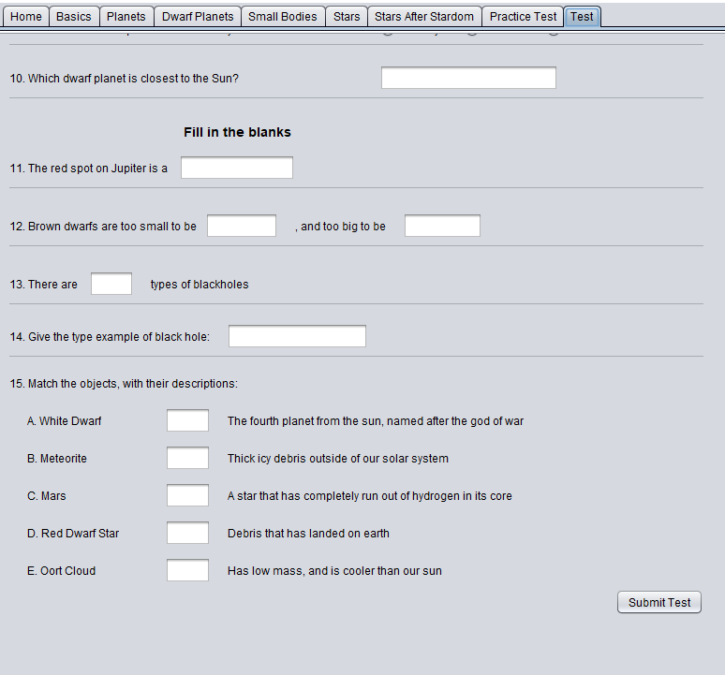

This is the final test! Evaluate your new knowledge. Please give answers on all questions and press “Submit Test” button. The program will show your score below the button. Use vertical scroll element to see the whole test.