

**DevOps Bootcamp**

**Liability Manager**

**Date of Submission:** 22/3/2024

**Reporting Period:** Final Report

Group members: Alaa Harmoush, Dani Kais

Instructors: Elie Tahchi

Technical Advisor: Jana Kerbaj

Contents

**Section I: Overview of the Project** 3

Objective 3

**Section II: Summary of the Website Design** 4

In Depth Description of The Website 4

Technology Used: 5

Version Control Integration: 6

Automation 6

Problems Faced 7

Leason Learned 7

**Section III: Distribution of Tasks per Team Member** 8

# **Section I: Overview of the Project**

The Liability Manager website aims to provide comprehensive financial tracking and reporting tools for owners, sales teams, and the company as a whole. By leveraging cutting-edge capabilities such as sales tracking, income and spending tracking, and an AI-powered accounting report generator, the website offers a novel approach to optimizing financial management procedures.

**Key Features and Principles:**

1. Financial Management Principles:

* Ensures accuracy, transparency, and efficiency in tracking costs, income, and sales.

1. Data Security Measures:

* Implements strong data security measures to safeguard private financial data and comply with regulations like GDPR and CCPA.

1. User Experience (UX) Design:

* Adheres to UX design principles to provide a simple and intuitive interface, enhancing user engagement and facilitating seamless navigation.

1. Integration of Artificial Intelligence (AI):

* Utilizes AI algorithms to reduce manual labor, improve accuracy, and automate the preparation of accounting reports.

**Comment Integration:**

# Objective

# **Section II: Summary of the Website Design**

## In Depth Description of The Website

"Liability Manager" is a comprehensive online accounting system designed to streamline financial management for businesses of all sizes. With its user-friendly interface and robust features, Liability Manager empowers entrepreneurs and organizations to efficiently track income, net income, expenses, and overall company performance.

Key Features:

1. Financial Tracking: Gain insights into your company's financial health with real-time tracking of income and expenses. Easily monitor cash flow and identify areas for optimization.

2. Company Performance Analysis: Utilize powerful analytics tools to assess company performance over time. Identify trends, forecast future earnings, and make data-driven decisions to drive growth.

3. Banking Management: Simplify banking tasks by managing multiple accounts, transactions, and reconciliations within the platform. Ensure accuracy and efficiency in financial transactions.

4. Project Timeline Viewing: Visualize project timelines and milestones to effectively manage tasks and deadlines. Track progress, allocate resources, and ensure projects stay on schedule.

5. Customer Management: Seamlessly manage customer relationships by organizing contact information, tracking interactions, and monitoring sales transactions. Gain insights into customer preferences and purchasing behavior.

6. Inventory Management: Keep track of products and items sold with robust inventory management features. Monitor stock levels, track sales, and streamline ordering processes to optimize inventory management.

7. Secure Access: Protect sensitive financial data with advanced security measures, including user authentication and encryption protocols. Rest assured knowing your information is safe and secure.

Whether you're a small business owner or a seasoned entrepreneur, Liability Manager provides the tools and insights you need to effectively manage your finances, streamline operations, and drive business success. Experience the power of efficient financial management with Liability Manager today.

## Technology Used:

We Used Git as VCS (Version Control System)

We Used Jira for Distribution of tasks

Programing Languages:

1. HTML
2. PHP
3. CSS
4. JavaScript
5. Yaml
6. Docker File

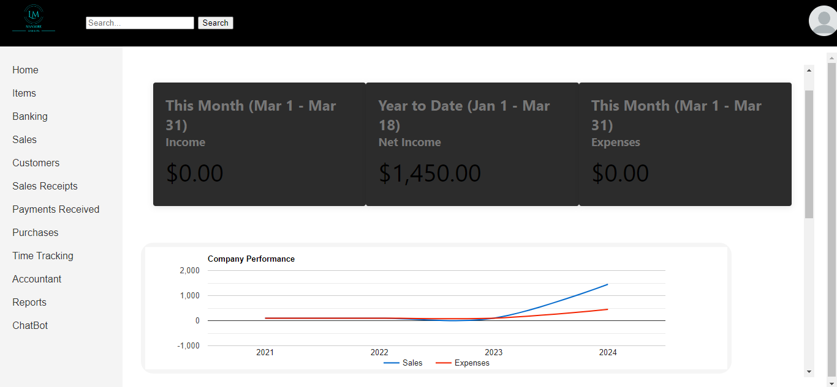

## Version Control Integration:

We Used Git to connect to GitHub and Push Pull and Edit Our website and work on the code as a team

Branching Strategy:

We implemented the Best branching strategy for our project to ensure a streamlined and efficient development process. This strategy, also known as Gitflow, is a robust branching model that provides clear guidelines for managing feature development, release preparation, and hotfix deployment in a collaborative environment. Here's how it works:

1. Main Branches
2. Prod: Acting as the Production Environment
3. Dep: this Branch acting as the Deployment Branch
4. Supporting Branches
5. Feature Branches : its from the Dep branch For Creating New Features

## Automation

To Automated Build Process we used Multiple tools Such As :

1. GitHub Workflows that will automatically run the main.yaml file that is responsible for Creating the images of our Website on docker Hub
2. Jinkins that will automatically run After we Push on GitHub and will wait 2 minutes so that the new images are built inside the docker Hub then it will run Pull the docker images and Push them to minikube
3. Docker: Docker is used to Containerization is a technique used to package an application and its dependencies into a standardized unit called a container
4. K8S: Also knows as Kubernetes
5. Prometheus: Used to read the Data From the Node For monitoring Purposes
6. Graphana: For Visualization to see what Prometheus is reading
7. For testing We used SQL injections And Cross Side Scripting

To Not Forget what we want and For Further Details we created w website for Ducumentation

## Problems Faced

We faced Some Problems:

1 - Budling images the problem was in the code we Used Ai Tools to help us Fix it

2 - Connecting Jenkins to miniKube we solved it by adding the configuration File in the Jinkins workflow

3 – merging when merging it was not automatically running the main.yaml file on the other branch to fix it was adding an on merge command

## Leason Learned

If you cant solve it yourself Google IT and Being dripline is the key for victory

## 

# **Section III: Distribution of Tasks per Team Member**

|  |  |  |
| --- | --- | --- |
| Task | Alaa harmoush | Dani Kais |
| Yaml files |  | X |