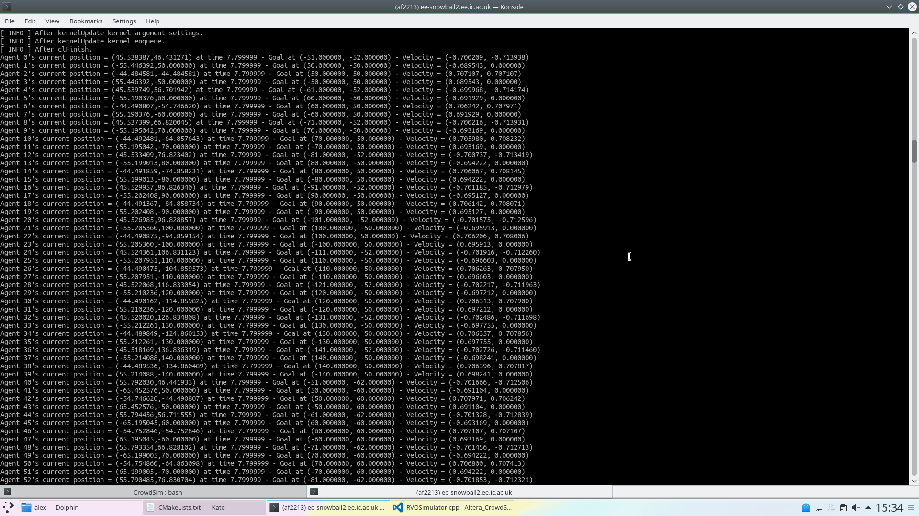
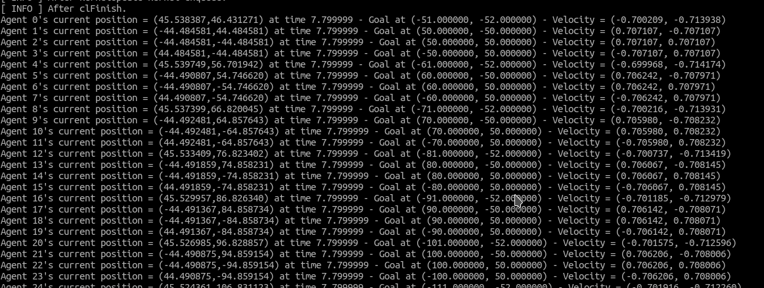
Step 13 (top nalla, bottom emulated): Note that y velocity is 0 – could possibly due to the differing signs in the position/goal ? Although this might be a coincidence as it is every other agent.

Frame 200 in both simulations. Nalla left, emulated right.

