**Assessment 5th May 2018, Liam Isles**

Created very basic java code with a maths class that had four methods, one for each type of sum (add, subtract, divide and multiply). Also had a main method in its own class that would execute the methods to check they worked and would print result. Then created a repository on my desktop and pushed the file up to my GitHub, this image is the uploaded file.

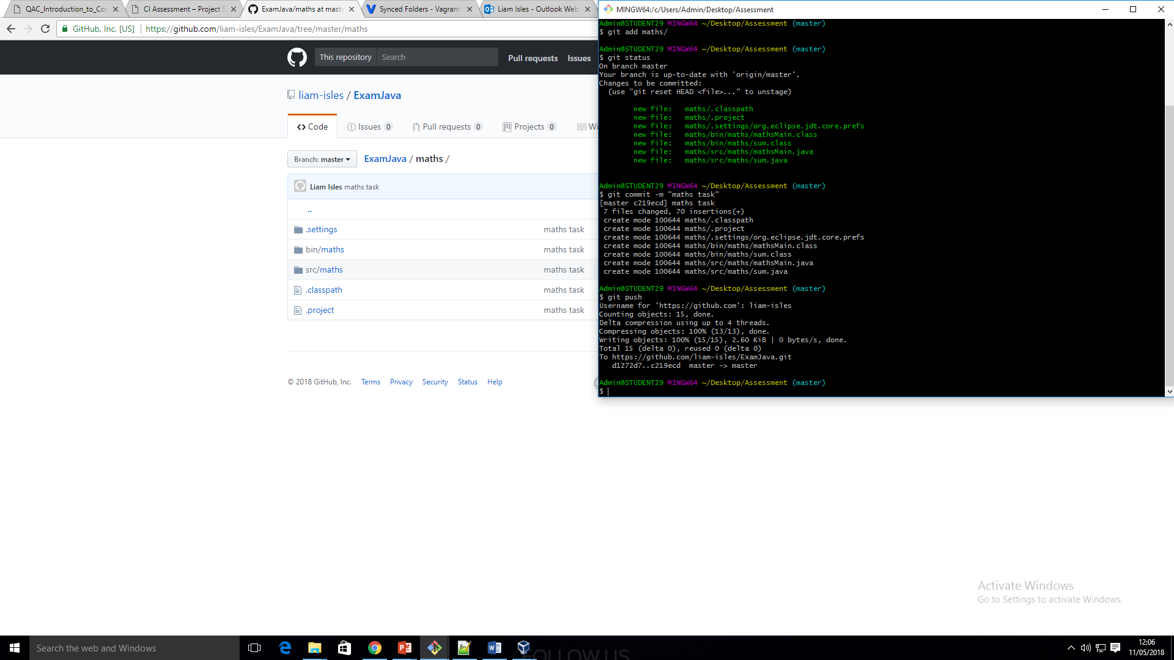

Here I have set up my repository on my host machine with GitHub so that I can upload my java mathematics task.

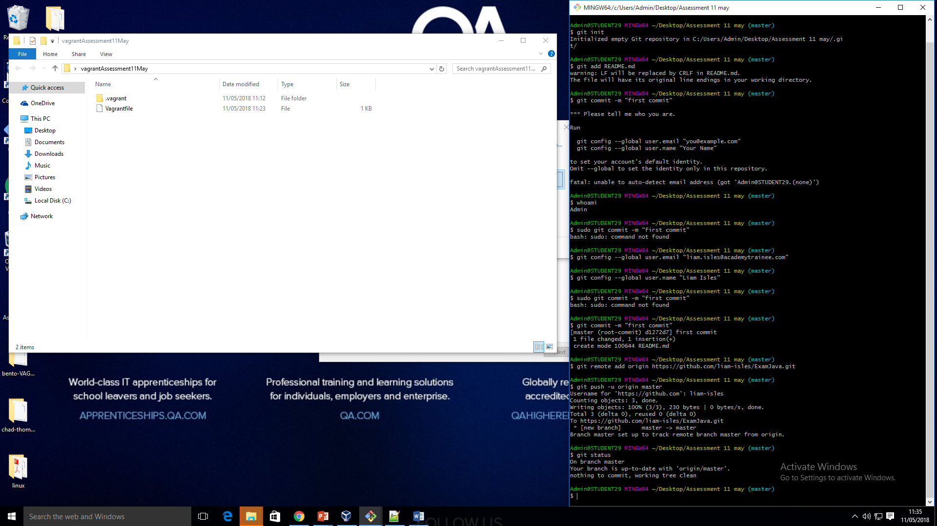

Here is my first set up of my two virtual machines using vagrant. I am able to access and use them via ssh on my terminal:

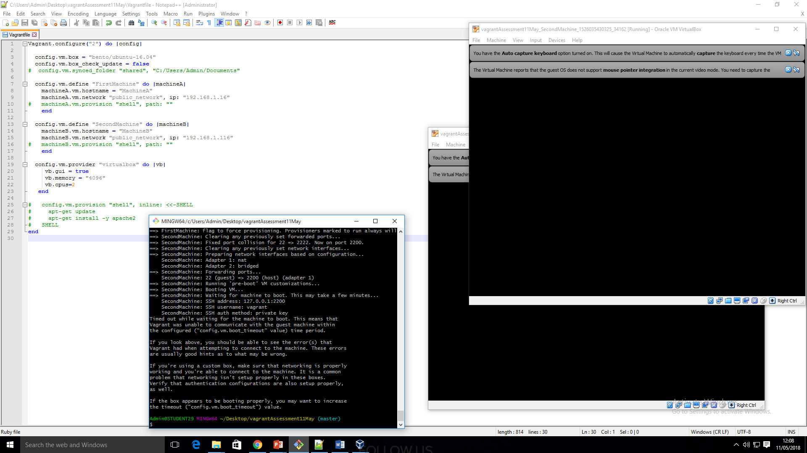

First script to install Java and Git, saved into assessment folder for easier referencing in the vagrant code:

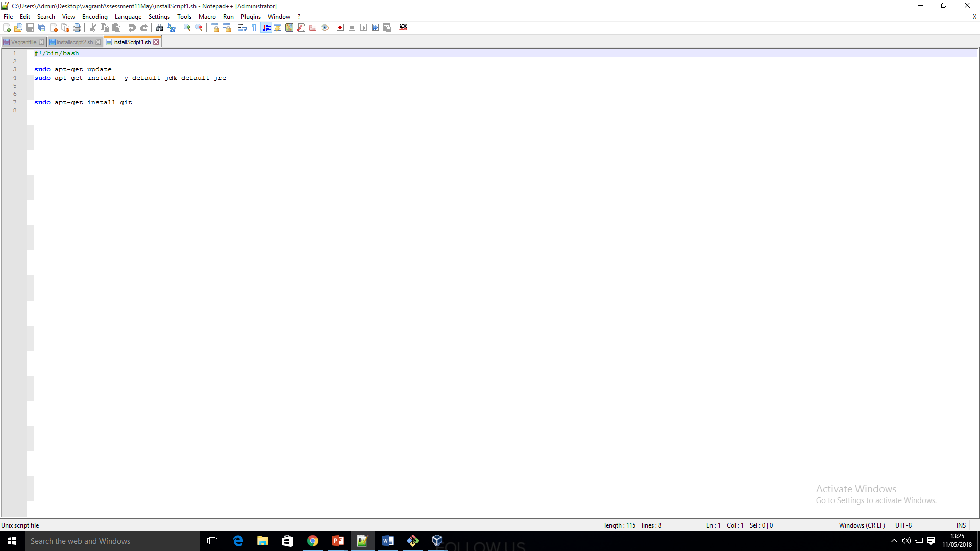

Script installing Java, Git, Maven and Jenkins:

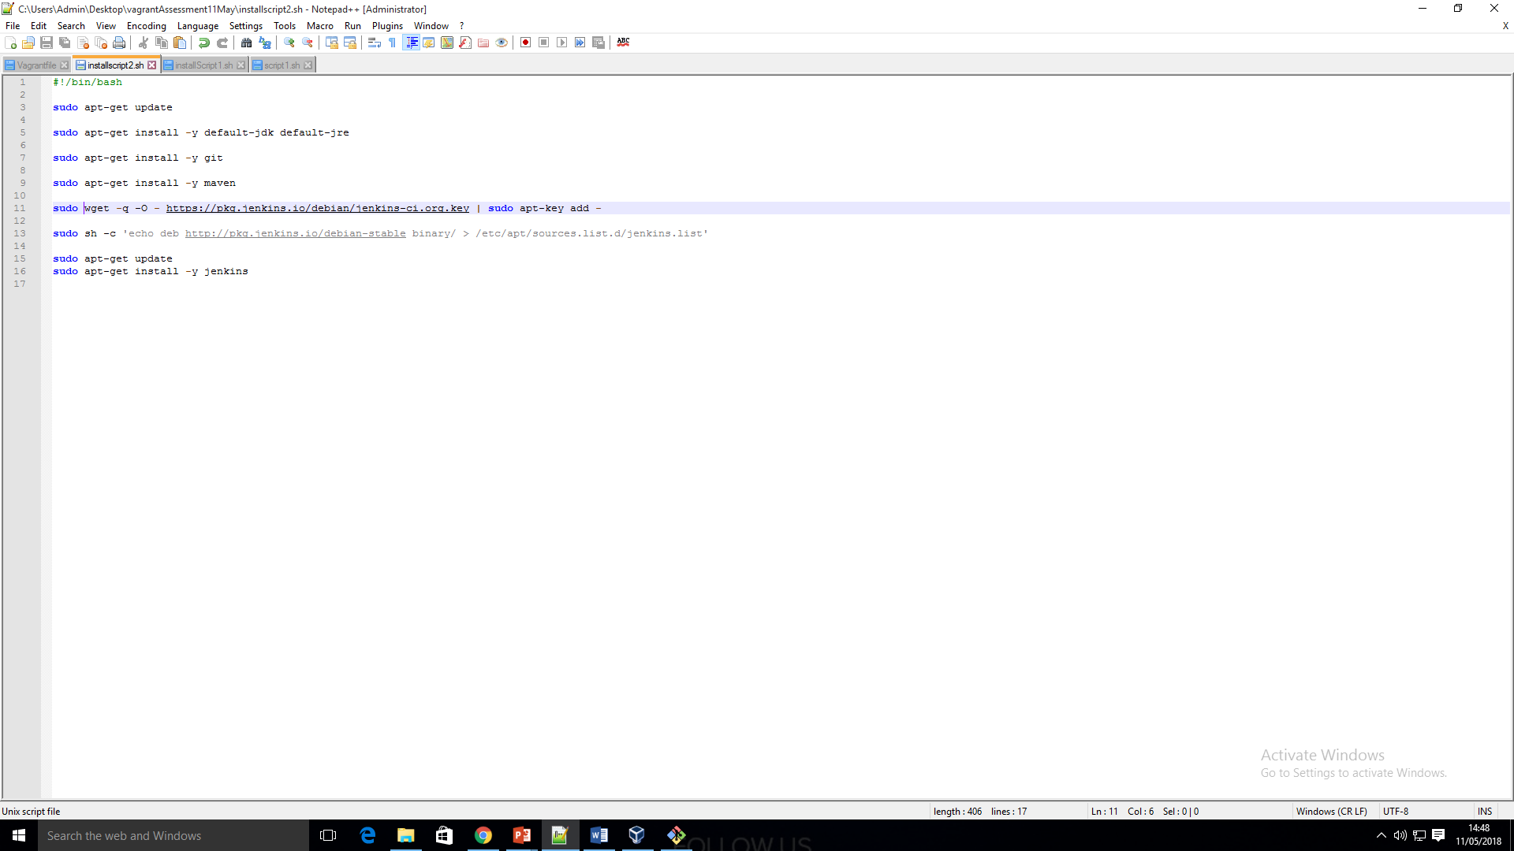

Finished vagrant code with scripts:

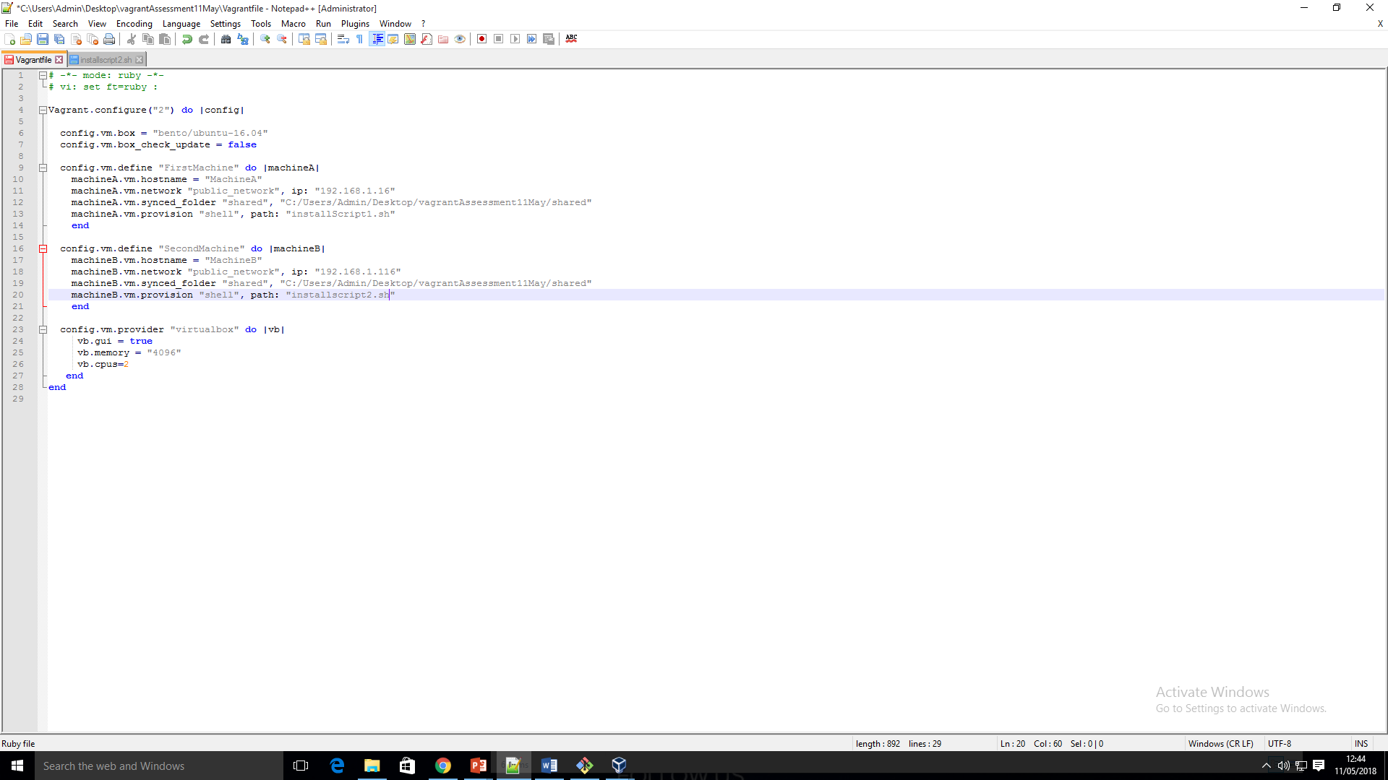

Using SSH to access first machine and check that Java and Git are installed:

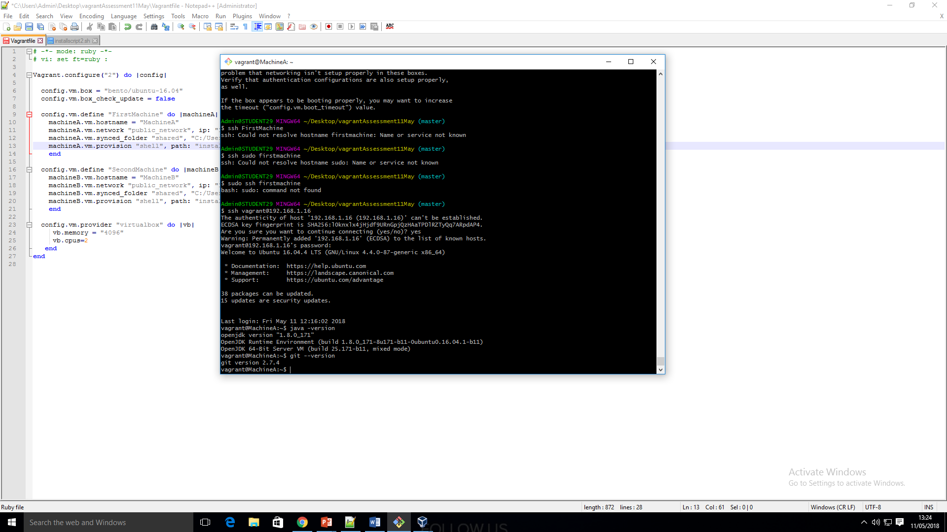

Inside MachineA I have pulled my directory successfully from GitHub:

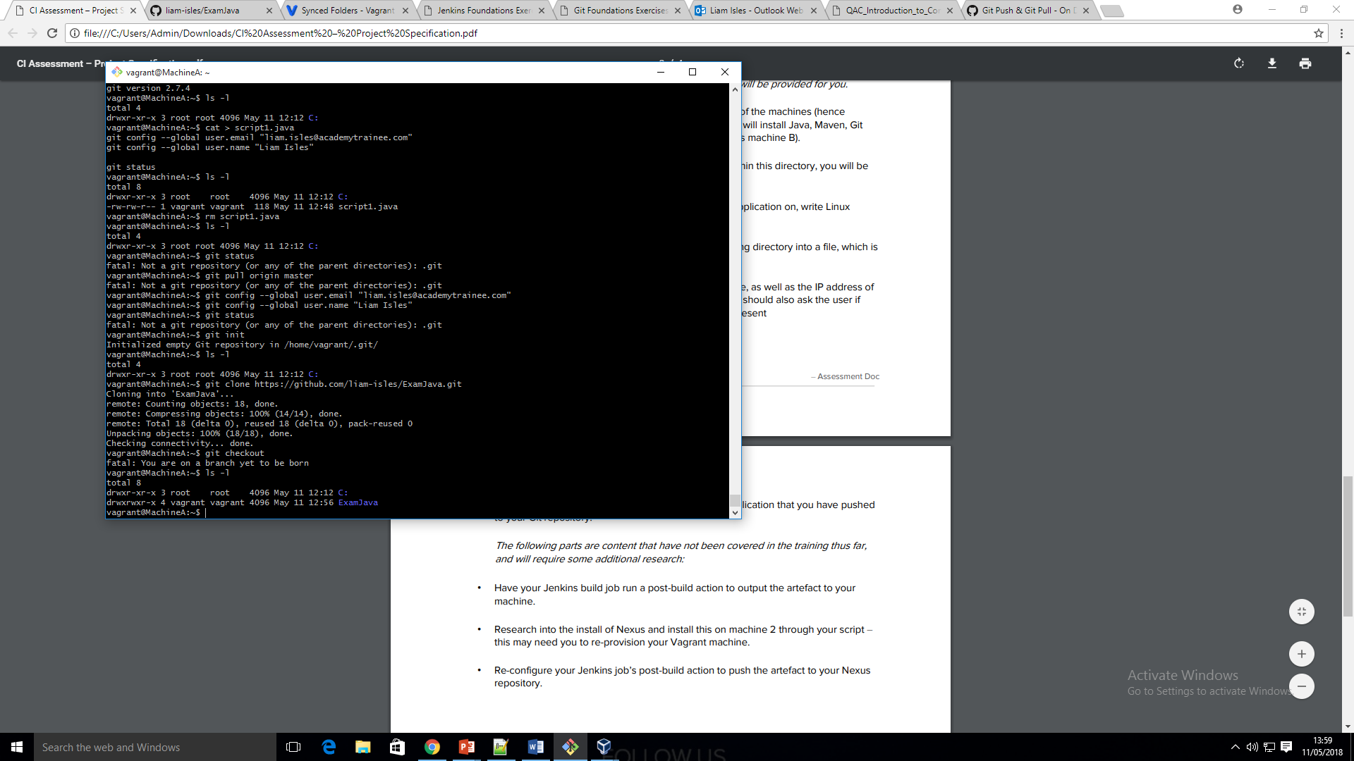

Machine B has maven successfully installed also:

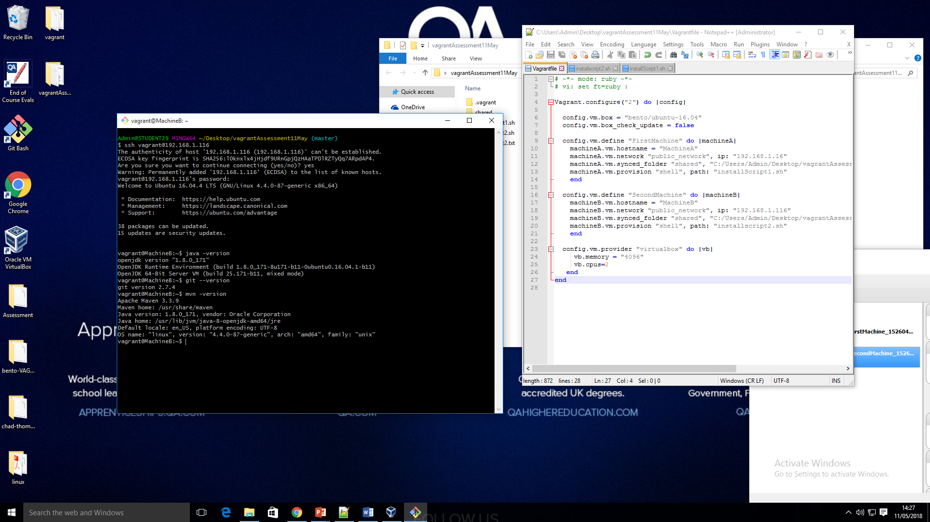

Script for script1 of task:

