**Assignment_02**

This assignment implements a backend service for performing automatic closed captioning on media files. The goal is to demonstrate the application of thread-safe programming concepts within a Java environment.

**Implementation Details**

* **Main Class**: Simulates the submission of recordings for processing.
* **Controller**: Manages a queue and worker threads to handle recordings concurrently.
* **Worker**: Simulates sending recordings to an external service and receiving closed captioning.

**Observations**

While implementing the worker, it was necessary to simulate network delays and processing times to mimic real-world behavior. The use of a blocking queue ensured thread safety and controlled the number of concurrent processes.

**Conclusion**

The program successfully simulates a backend service for closed captioning, demonstrating the use of concurrency and thread-safe programming in Java.

Did not use the attached file as I assumed it was just a class assignment doc (on Brightspace for the assignment – as such it may look slightly different

Errors running gradle with unknown variable pathing – found the /bin path for $JAVA_HOME$ was not configured correctly in the system variables

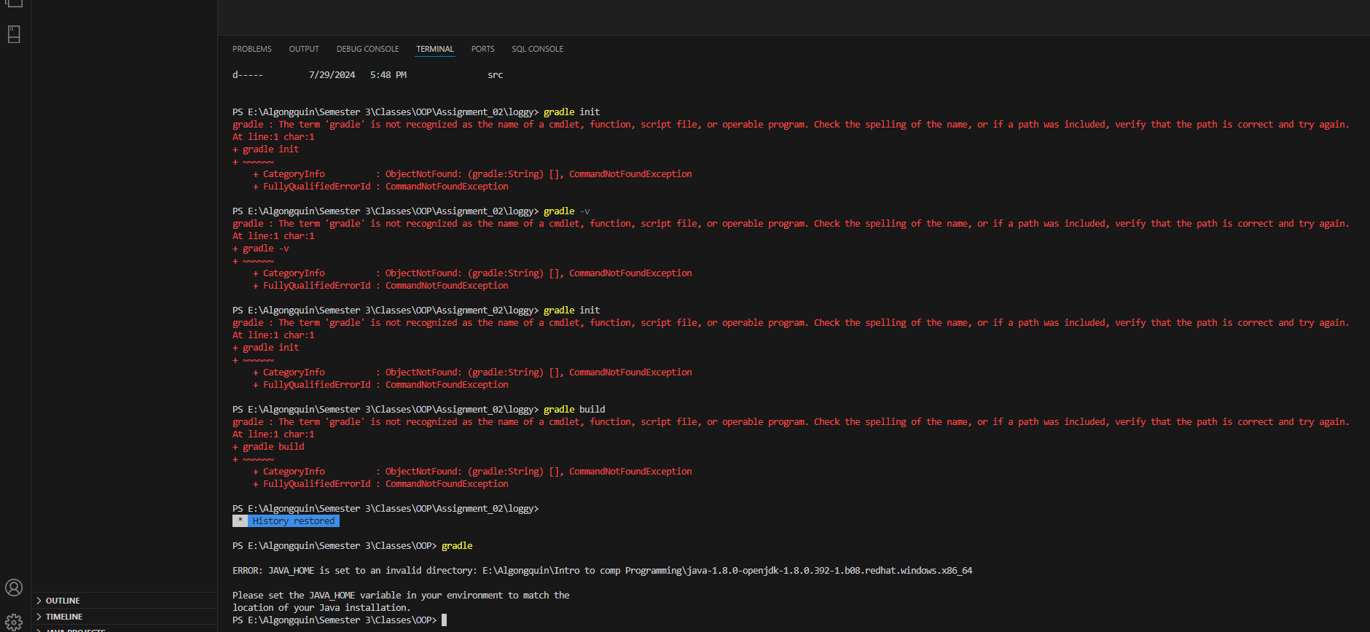

Corrected;

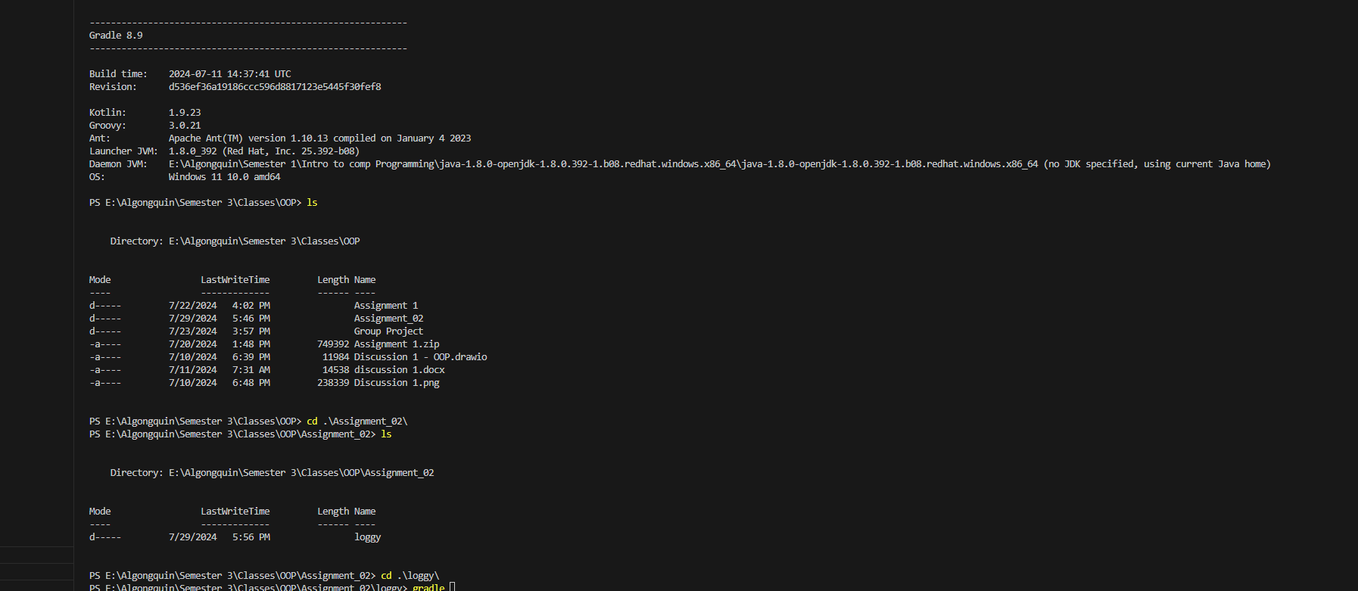

Gradle init

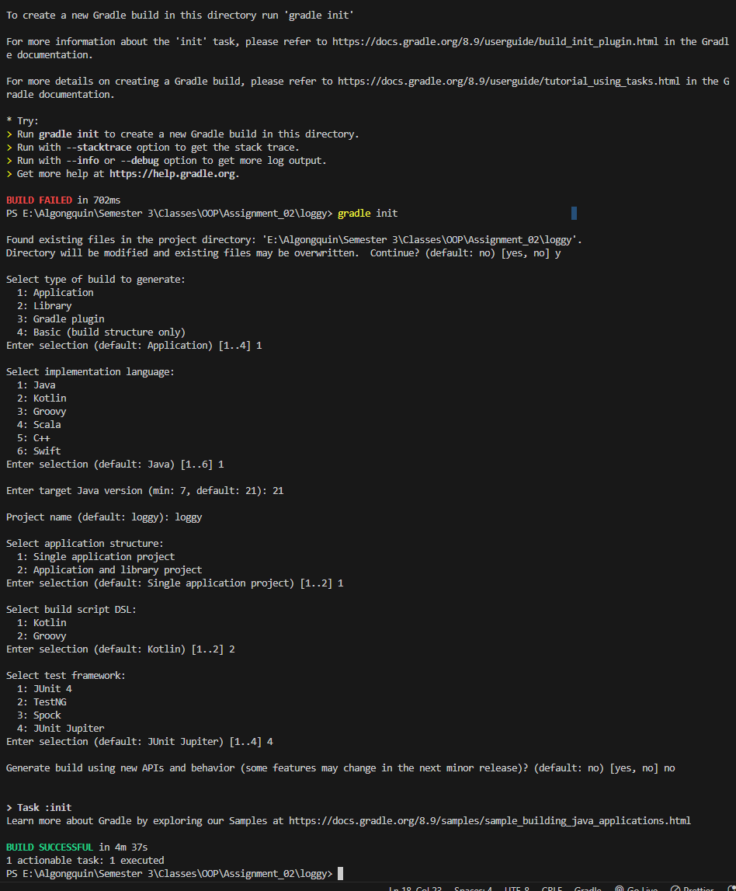

Gradle build

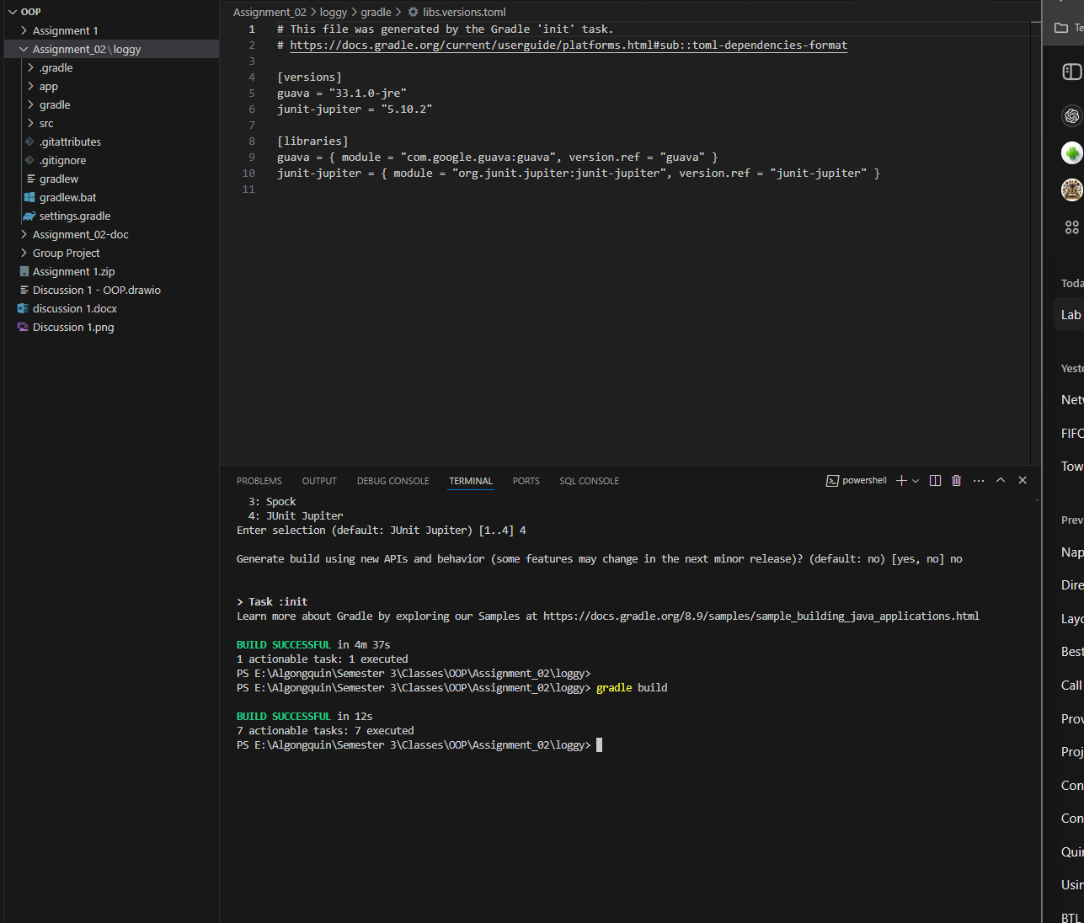

Run and Debug

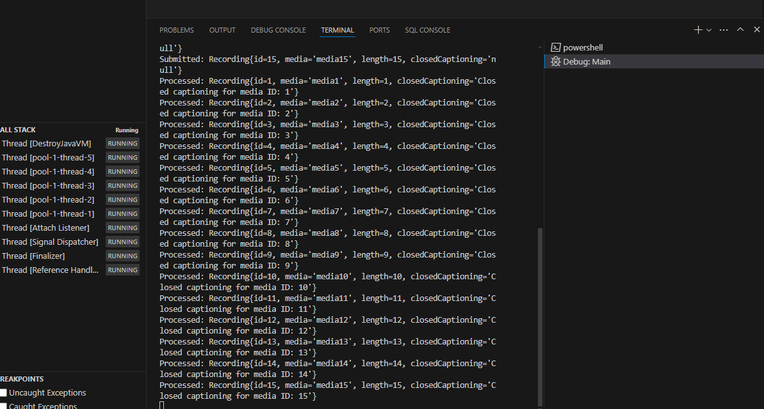

Project Run

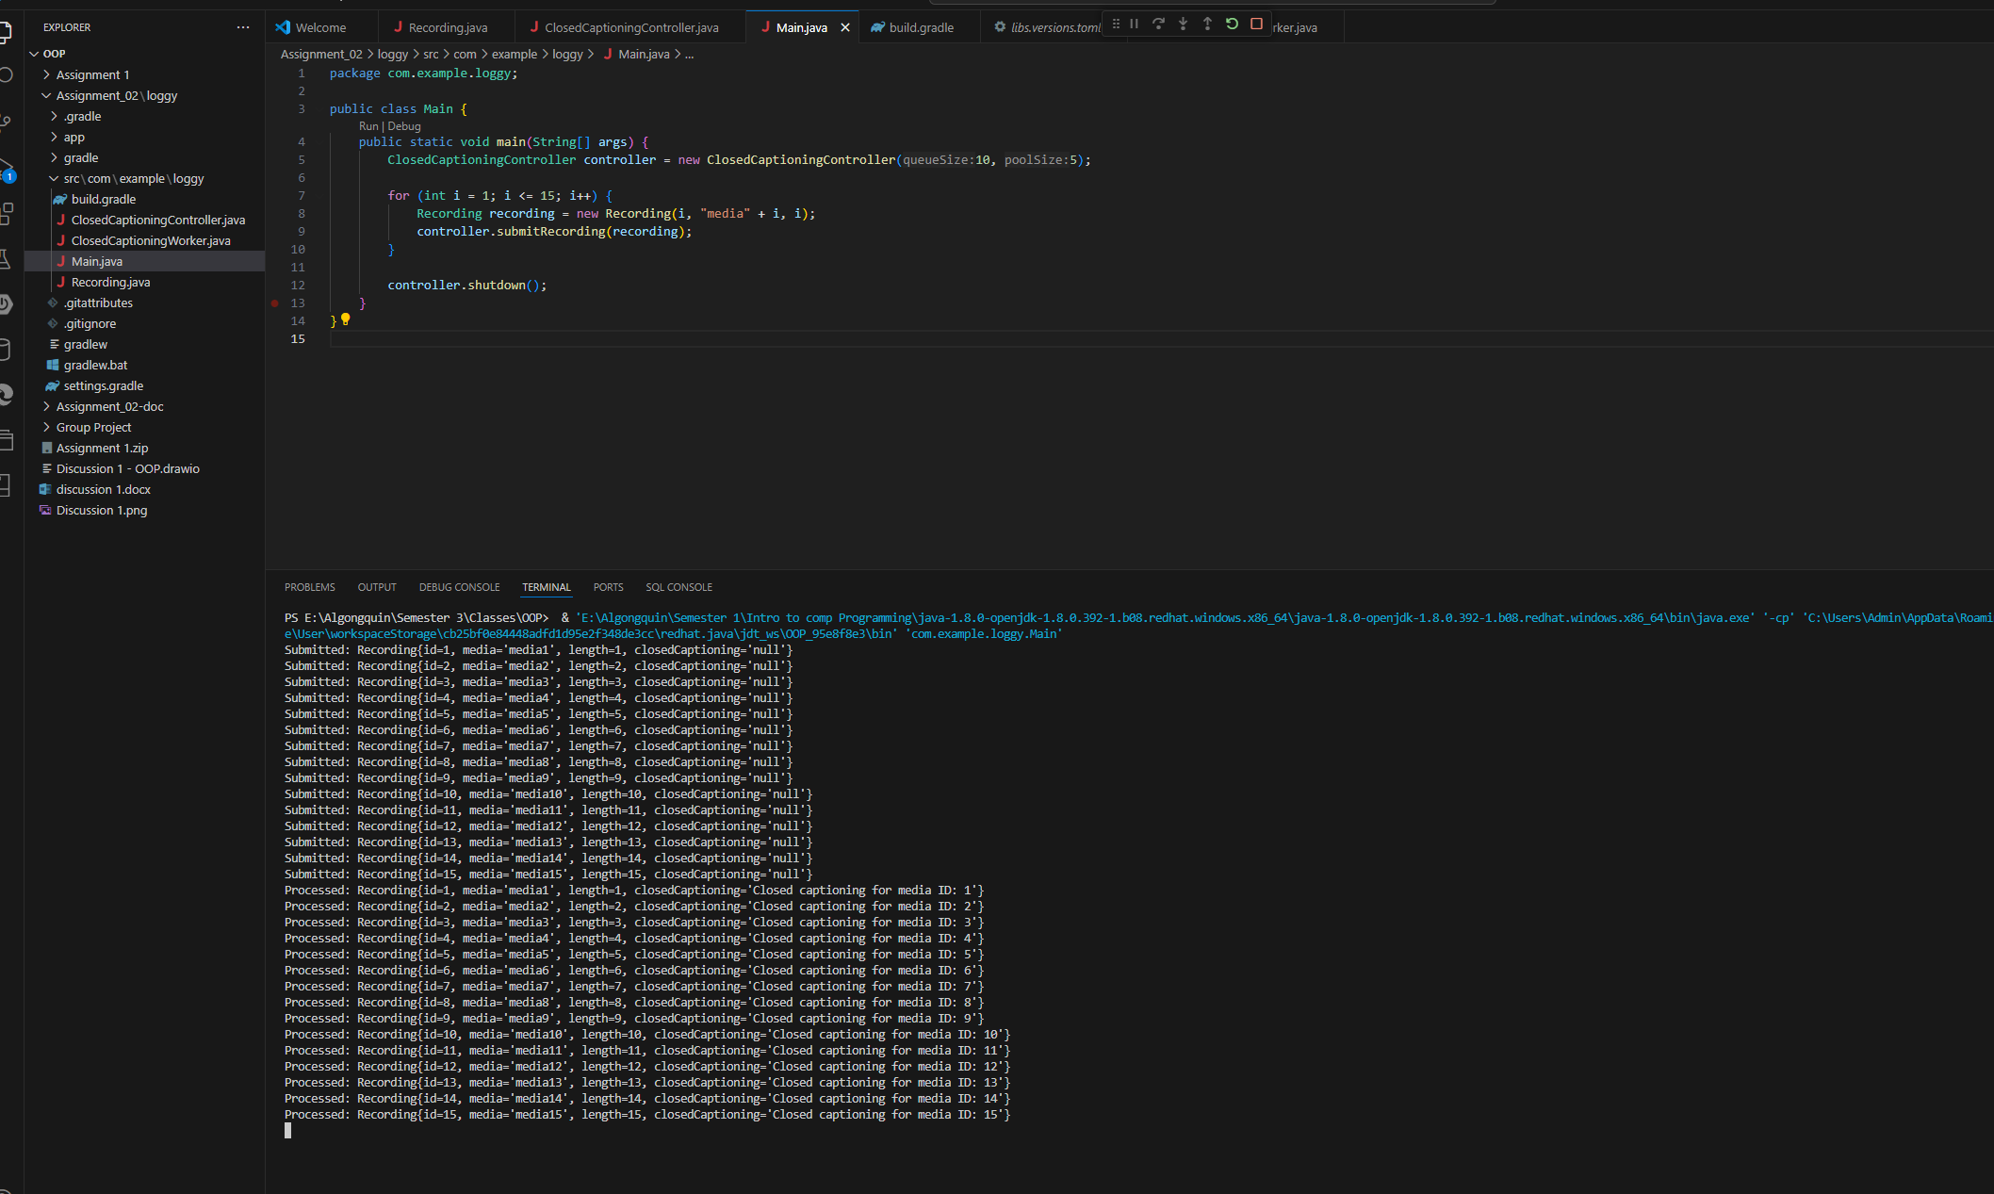

Secondary Testing class created for future testing etc.

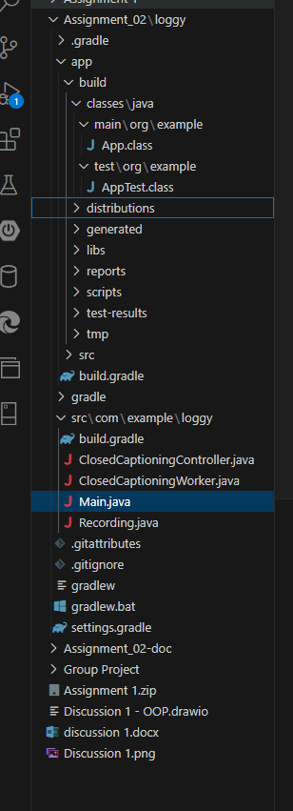

Other Changes;

Initially did not include a send to external service but added after scanning project requirements

Added Log.java and string info in Main.java after reading the Readme in the file attached on Brightspace as I was just going off the page contents prior to that.

