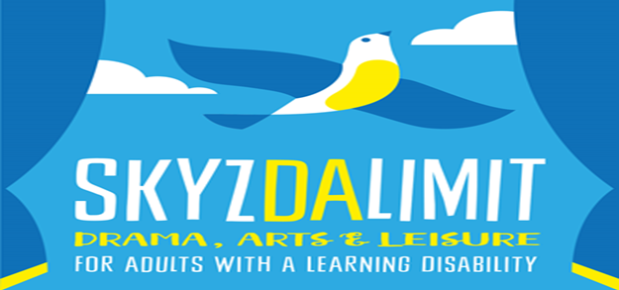
MEMBER REGISTRATION FORM
To be completed by Member/Parent/Carer
Please note all information will be stored confidentially by Skyzdalimit.
Member’s name
DOB
Home Address
Postcode
Parent/Carer name
Address if different from above
Contact Numbers (home & mobile)

Health Information
Registered GP name, address & phone number
Details of any allergies or medication we should know about
Please provide details of: health/behaviour/disabilities that we need to know about in order to ensure the members’ safety and well-being.
Please provide details of any other information that you feel we should know about.

Declaration: I would like ………………………………………..to be enrolled in Skyzdalimit Theatre Group ( and give permission for him/her to take part in all the Group’s activities, if someone else signing on behalf). I understand that Members are expected to attend the programme on Mondays from 7-8.30/9pm (with a carer if one-one support is required).
All group facilitators have had or are in the process of having all the relevant legal checks required for working with vulnerable adults. In an emergency and/or if I cannot be contacted I am willing for ……………………………. to receive necessary hospital or dental treatment including anaesthetic. Y/N (please circle)
Signed (Parent/Carer) ……………………………………………………………………………………………
To be completed by new Skyzdalimit Member
Things that interest me:

Skyzdalimit rules
- Listen to the drama/music/games leader and facilitators
- Respect the venue’s facilities and equipment and treat with care
- Show kindness and respect to others in the group
- Don’t leave the room or building without informing the facilitators during the drama group session
- No fighting, swearing or doing things in a way that will upset other people or disrupt the group
- Ask the drama/music/games leader or a facilitator if you need help with anything
- Wear loose clothing, e.g. tracksuit bottoms and T shirt
- No food/drink is to be brought as water is provided.
- HAVE FUN!
Member’s agreement – I agree to the Skyzdalimit rules
Signed (Member) …………………………………………………………………………………………………………….
Consent slip
I consent */ do not consent to (name)……………………………………………………………………
(Delete where applicable)Being photographed / video filmed and for the material to be used for promotional and evaluating purposes.
Signed (Parent / Carer) …………………………………………………………………………
Date…………………………………………………………
Skyzdalimit is an inclusive theatre group for people with a learning disability or autism

