1-1-1

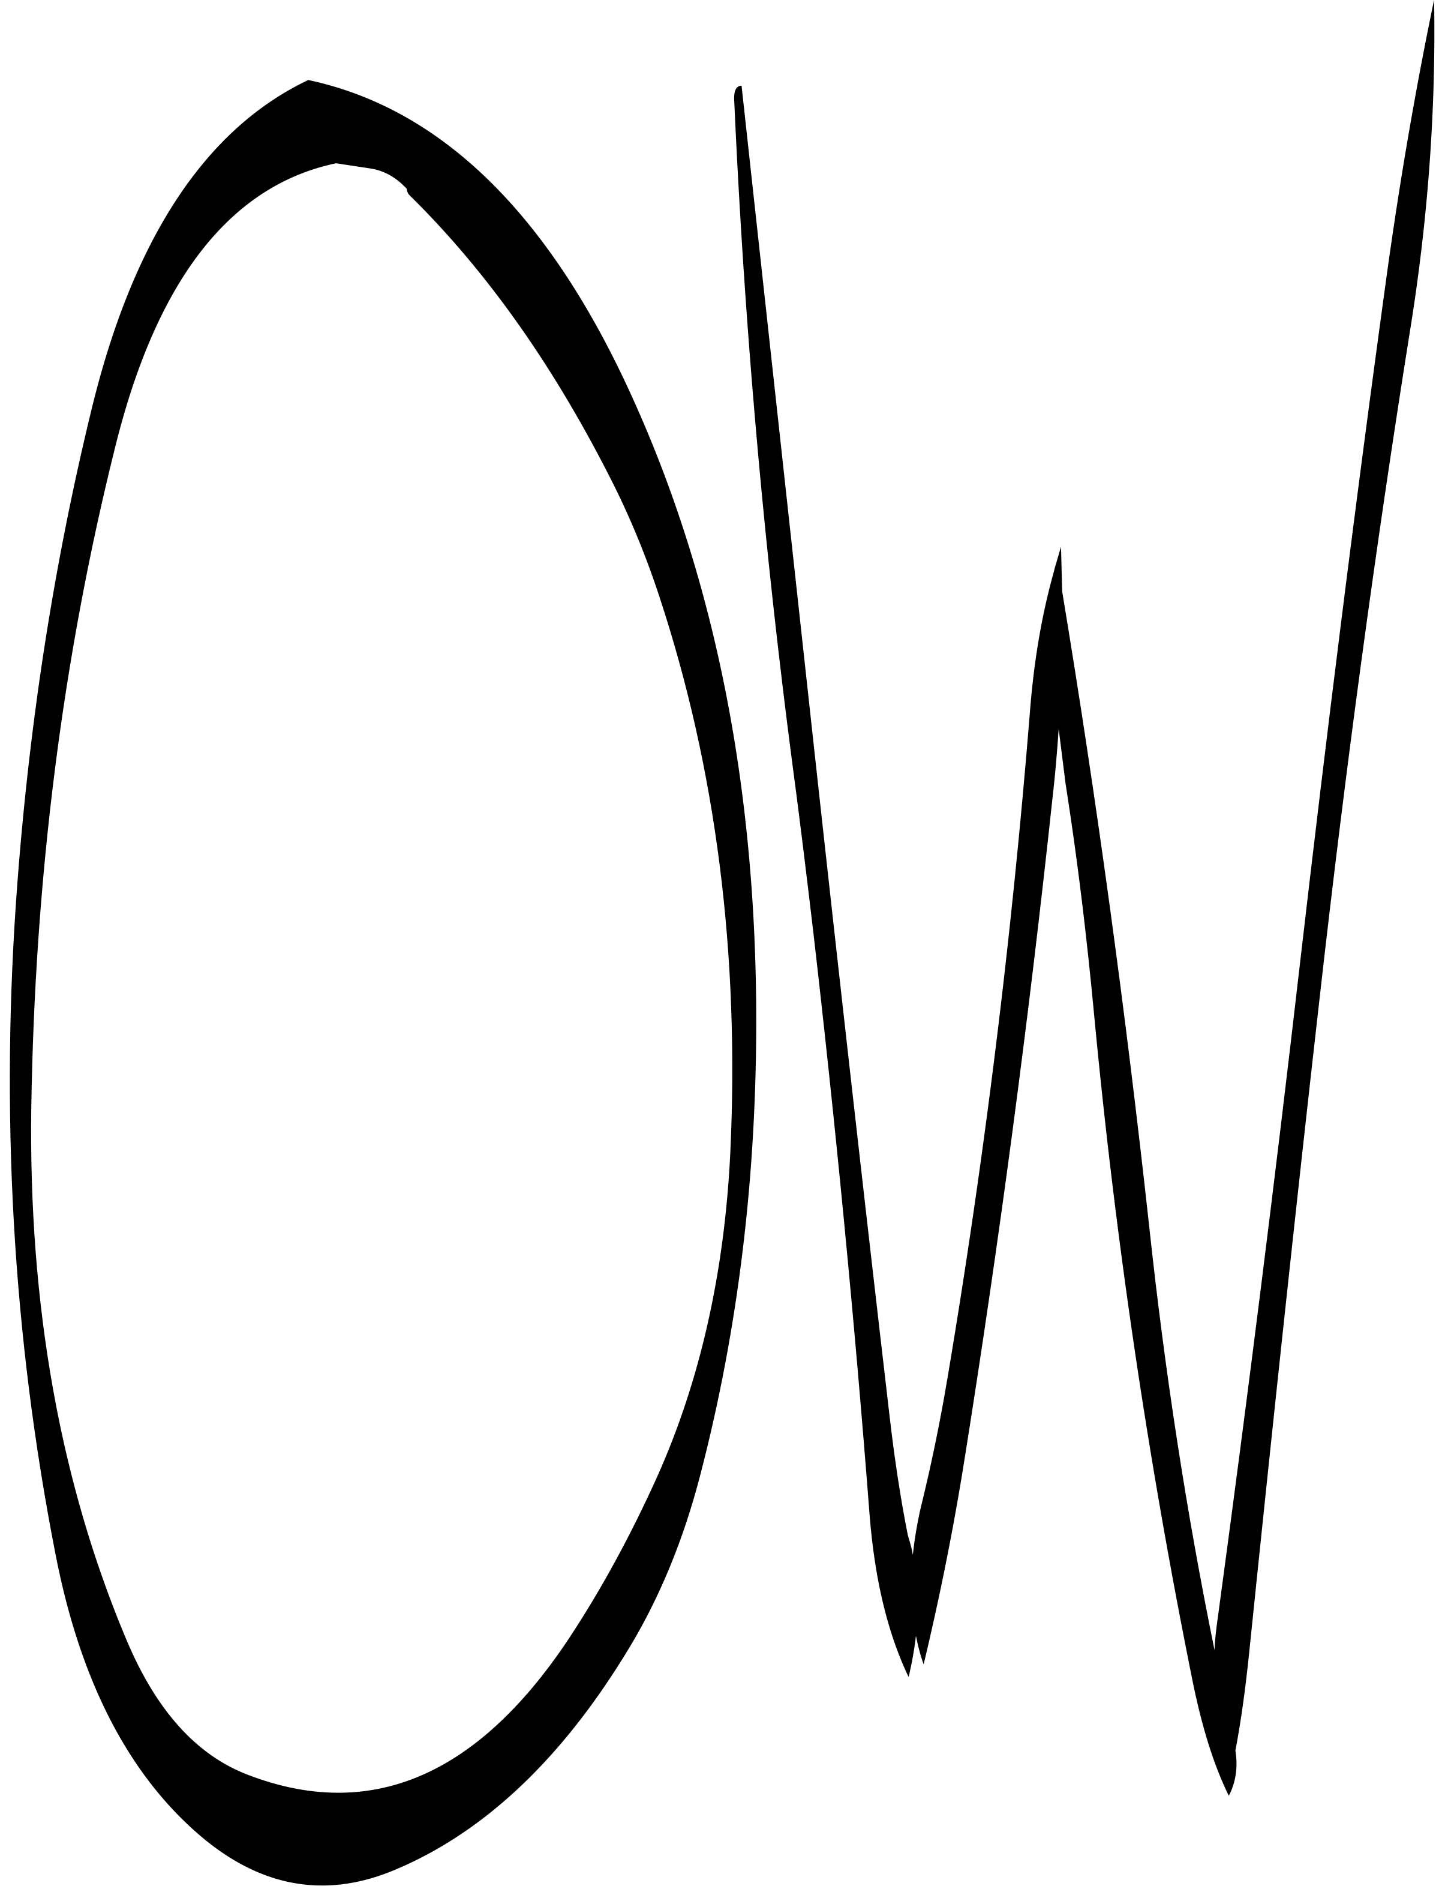

1-2-1

I am what I owe

And that would be attention

For example

To the dead,

My dear departed.

What moves me most, these days,

In the little blackbird,

Is the way it listens

What it hears

That it just has to sing.

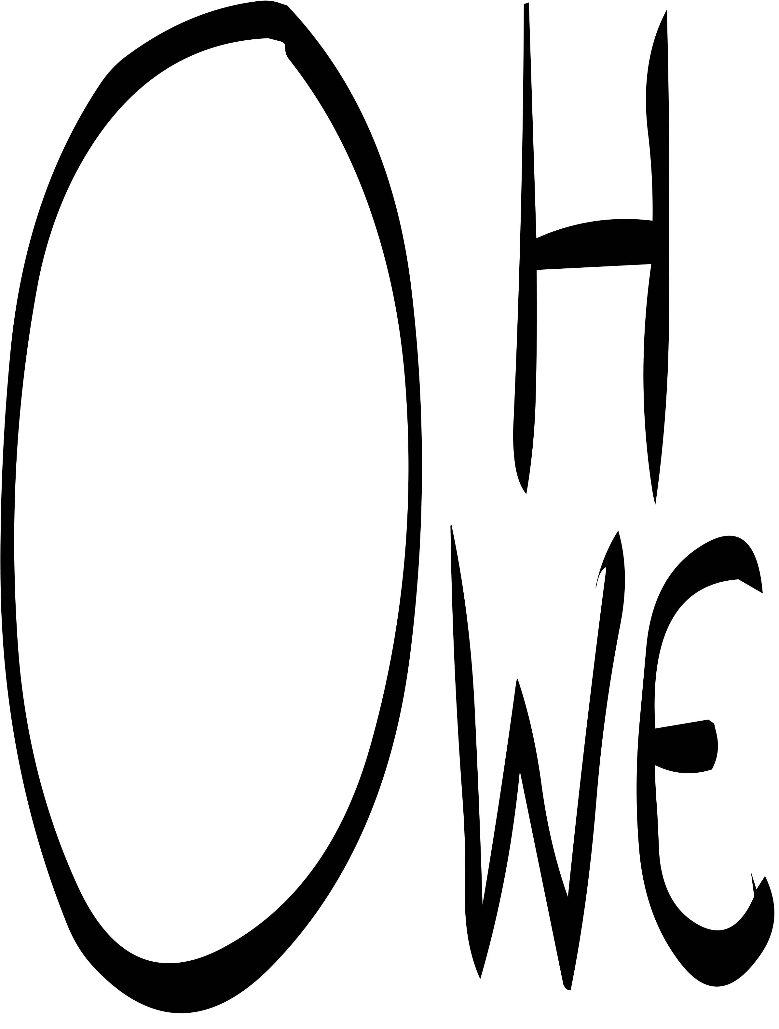

1-2-3

This ape is woke

He's 60s hip, or she.

Their token app is free

To talk up.

Take and ope.

