**Home, in on the Range**

break

They can buff their CV, but

The Regius Professor

Of Bluster and Bluff

Has no time for the wikid,

The anorak autodidact.

Fair enough.

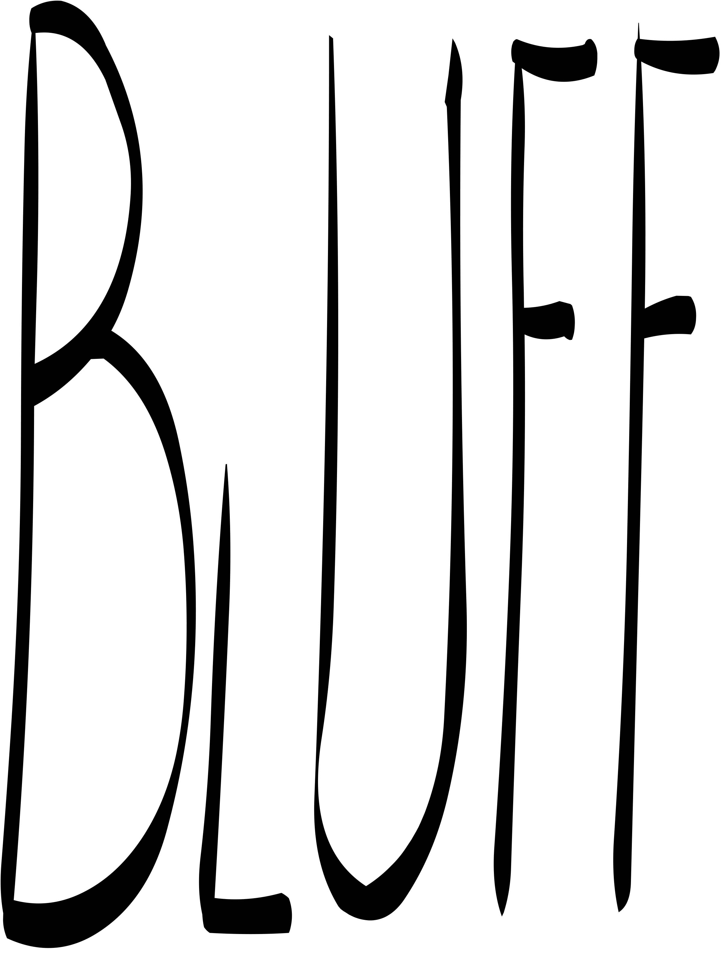

break

break

The ruminant encapsulates

A lifetime's browsing in its beef.

And I give you this brief.

